Part A Results

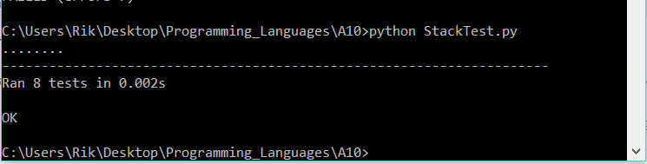

Part C Results

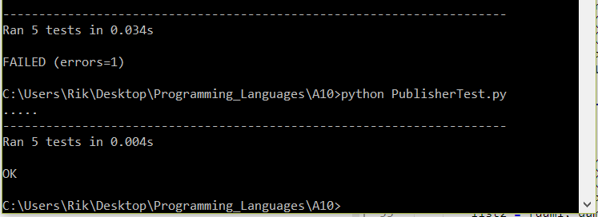

Part D Results

