# A7.py - program with functions to generate a string with three

# random lowercase letters, and returns a list of a specified size

# conforming to a regex string

# uses xeger library from here "https://github.com/crdoconnor/xeger"

# @author Erik Stryshak

# @sid 41069864

# @version 1.0

import random

import string

import re

from xeger import Xeger

class TripleGen(object):

def __init__(self, regex_string, count):

self.regex_string = regex_string

self.count = count

def genRandomTriple(self):

# use random and string classes to generate three random

# lowercase letters and return a concatenated string

ch_one = random.choice(string.ascii_lowercase)

ch_two = random.choice(string.ascii_lowercase)

ch_three = random.choice(string.ascii_lowercase)

return ch_one + ch_two + ch_three

def genFilteredTriple(self, regex_string, count):

# using the Xeger library, generate "count" random strings

# that adhere to the regex string passed in

return_list = []

for x in range(0, count):

str_gen = Xeger(limit=10)

return_list.append(str_gen.xeger(regex_string))

return return_list

def getList(self):

# calls the genFilteredTriple method with this object's

# regex string and count

return self.genFilteredTriple(self.regex_string, self.count)

class MyIterator(object):

def __init__(self, iterator_list):

# constructor sorts the incoming list alphabetically

self.list = sorted(iterator_list)

self.next_pointer = 1

def next(self):

# use hasNext function to check if there is a next value

# if it does not exist, raise StopIteration

if self.hasNext():

self.next_pointer += 1

return self.list[self.next_pointer-1]

raise StopIteration

def hasNext(self):

# use size of the list and next_pointer to determine if

# there is a next value in the list

if len(self.list) < self.next_pointer + 1:

return False

return True

def main():

# create a TripleGen object

triple_gen = TripleGen("[bcdfgmnpr][aeiou][dgnprstwxyz]", 4)

print ("Regex string used: [bcdfgmnpr][aeiou][dgnprstwxyz]")

print ("Generating 4 random triples results in:")

print (triple_gen.getList()[0])

print (triple_gen.getList()[1])

print (triple_gen.getList()[2])

print (triple_gen.getList()[3])

print ("\nFunction genRandomTriple examples:")

print (triple_gen.genRandomTriple())

print (triple_gen.genRandomTriple())

print (triple_gen.genRandomTriple())

print (triple_gen.genRandomTriple())

print ("\nIterater Demonstration")

my_it = MyIterator(triple_gen.getList())

# should return 2nd, 3rd, and 4th elements

print ("Has next = " + str(my_it.hasNext()))

print ("Next element = " + my_it.next())

print ("Has next = " + str(my_it.hasNext()))

print ("Next element = " + my_it.next())

print ("Has next = " + str(my_it.hasNext()))

print ("Next element = " + my_it.next())

# should return false and throw StopIteration

print ("Has next = " + str(my_it.hasNext()))

print ("Next element = " + my_it.next())

if __name__ == "__main__":

main()

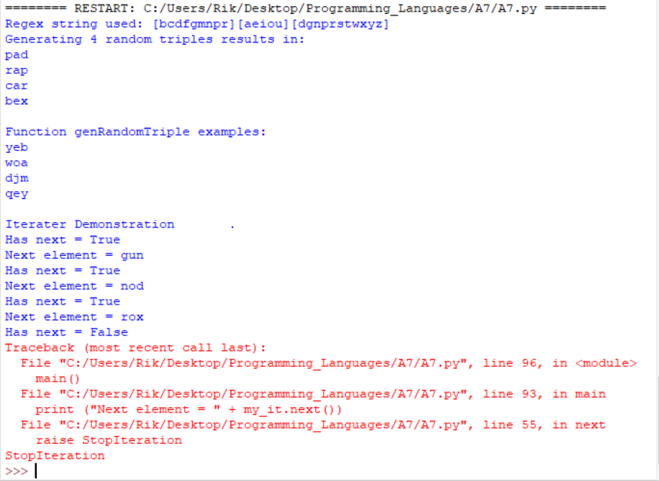

grammar triplegen;

stmt : TOKENONE VOWEL TOKENTWO

TOKENONE : [bcdfgmnpr]

VOWEL : [aeiou]

TOKENTWO : [dgnprstwxyz]