Erik Stryshak

grun Hello stmt -gui

hello rollo

^Z

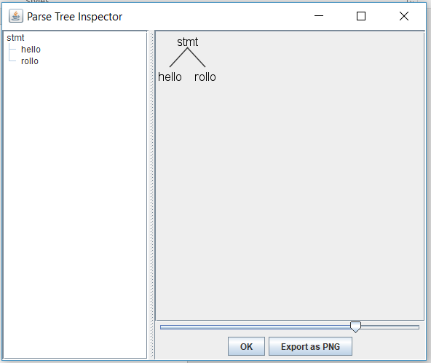

grun tarzan stmt -gui

tarzan run slowly

^Z

