CrowdCanvas
Solana-Powered Creative Consensus Platform

GROUP 12
Rishu Raj
2024SL93092

December 2025

REPO: https://github.com/therishuraj/CrowdCanvas

1. Executive Summary

CrowdCanvas transforms creative decision-making by democratizing design choices through Solana blockchain-powered micro-tasks. Brands and creators get authentic public feedback in hours, while contributors earn SOL for their opinions.

2. Problem Statement

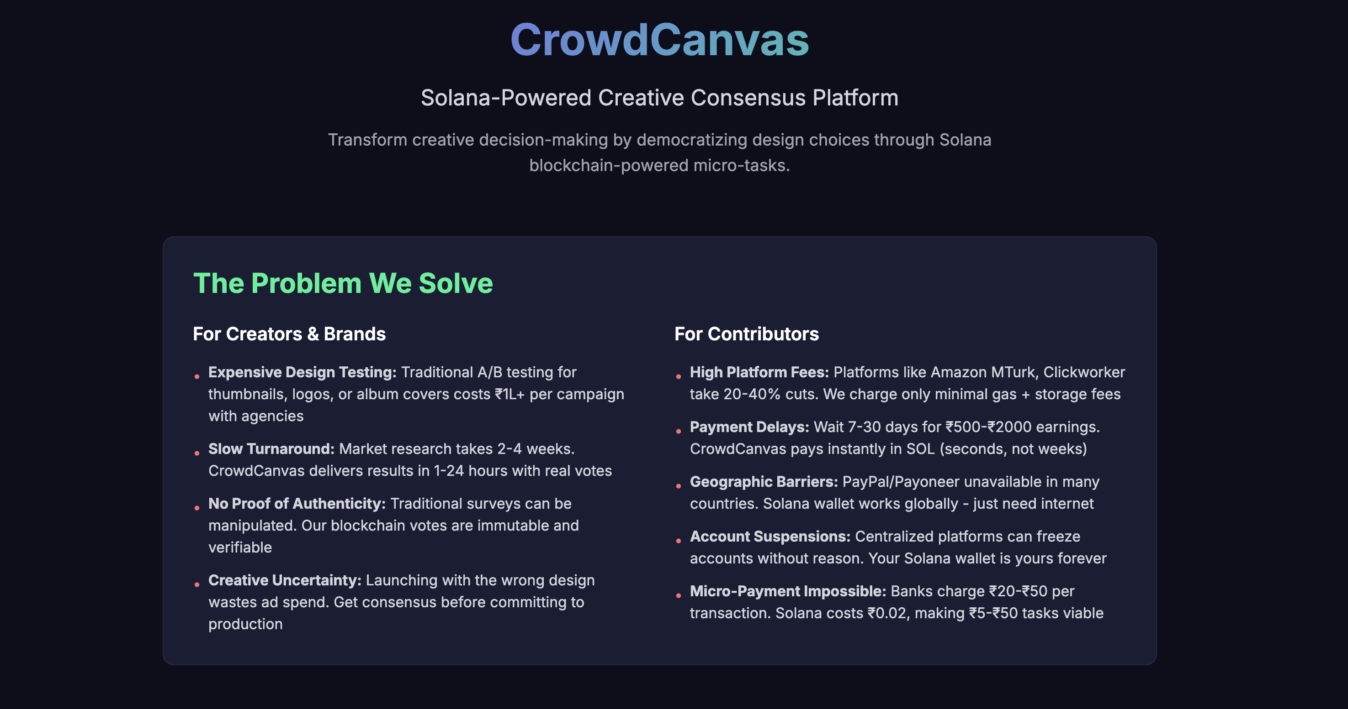

3. Market Gap
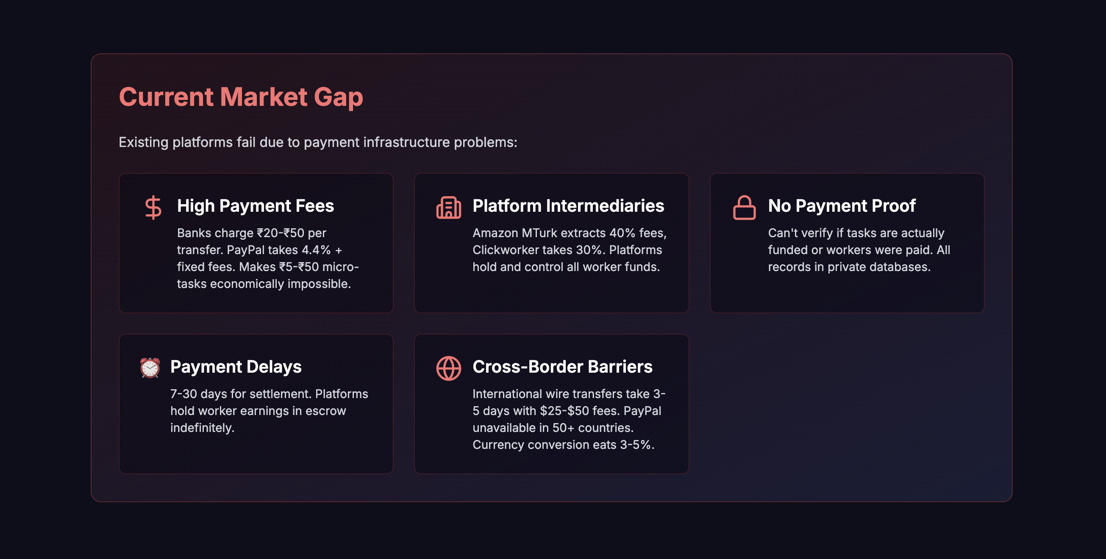

4. Solution Overview
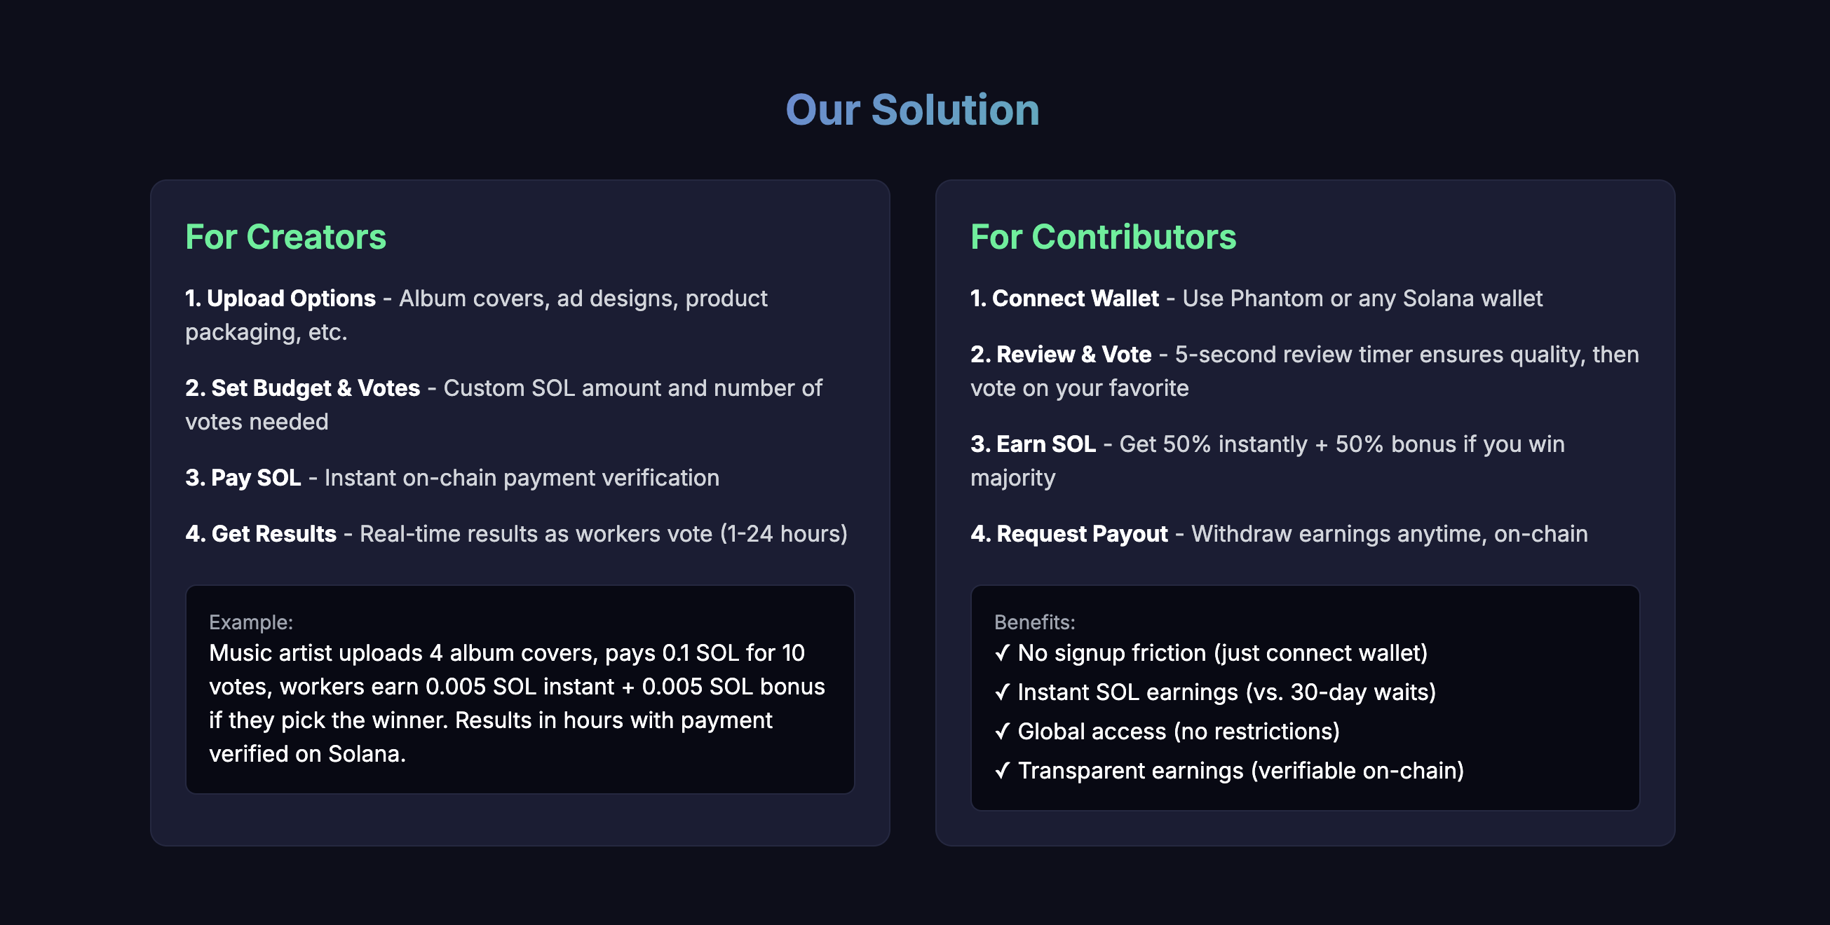

5. Why Blockchain
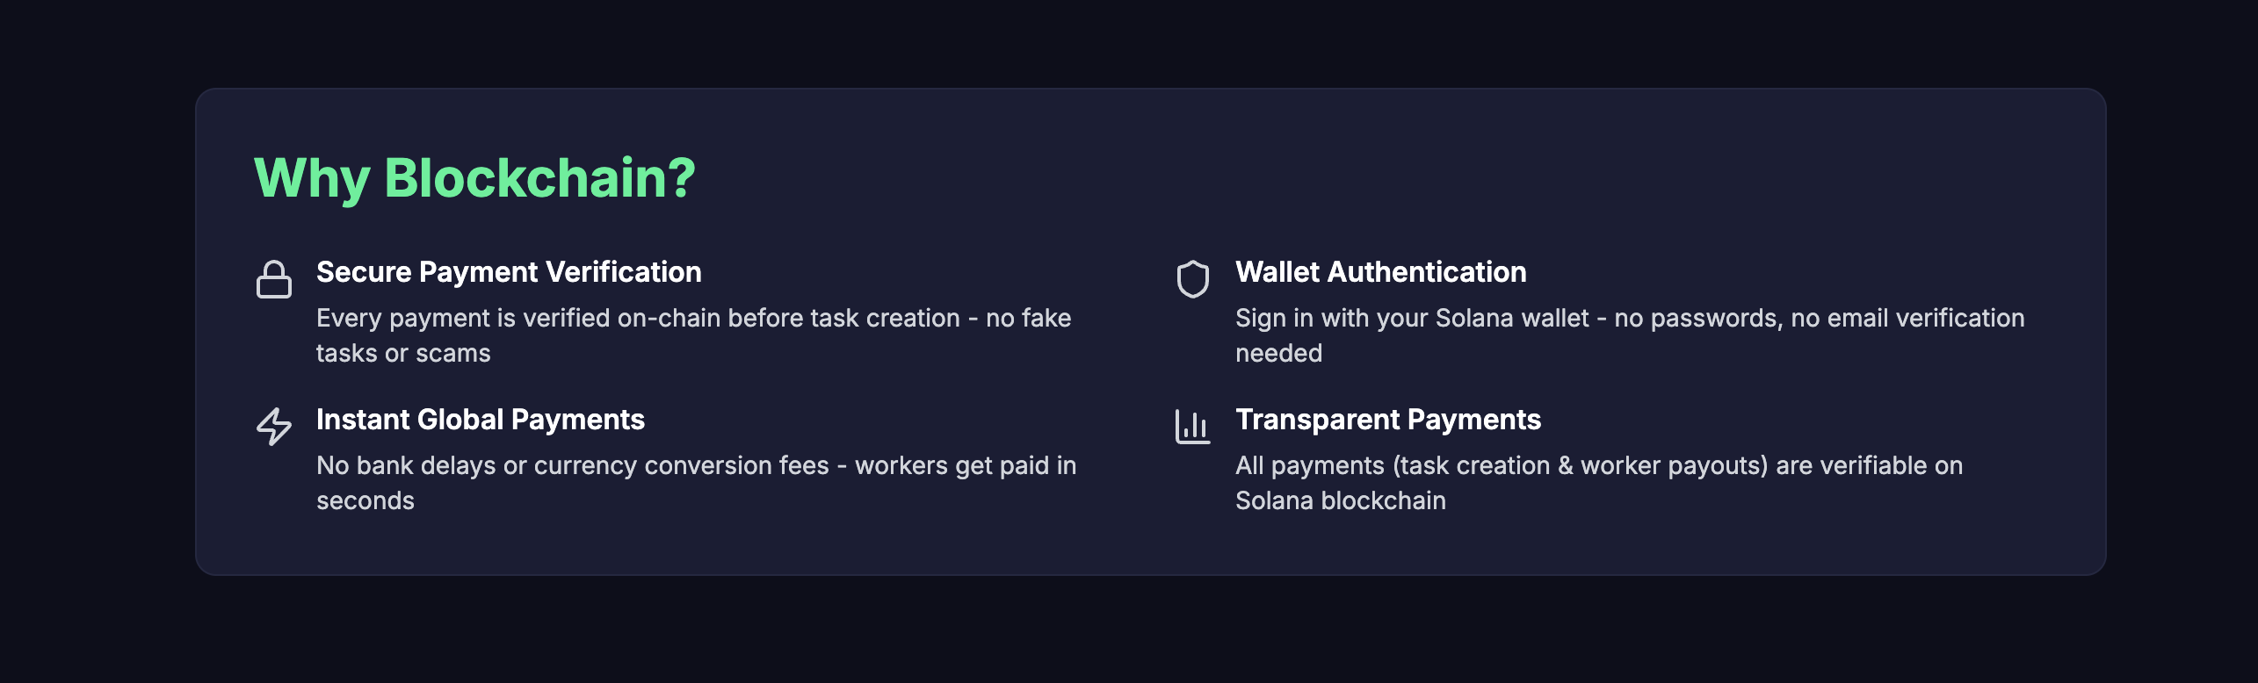
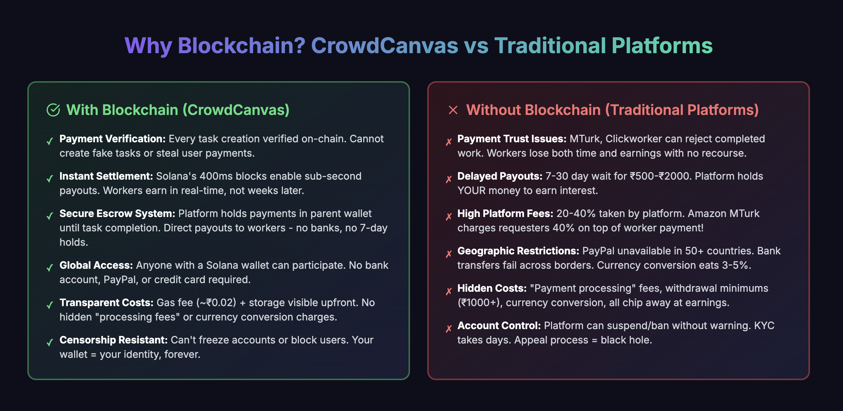

6. How it Works

For Creators:
- Step 1: Upload design options (album covers, logos, packaging)
- Step 2: Set budget and number of votes needed
- Step 3: Pay in SOL - verified on blockchain
- Step 4: Get results in 1-24 hours

For Contributors:
- Step 1: Connect Phantom wallet (no signup required)
- Step 2: Vote on creative tasks
- Step 3: Earn SOL instantly per vote
- Step 4: Request instant payout to wallet

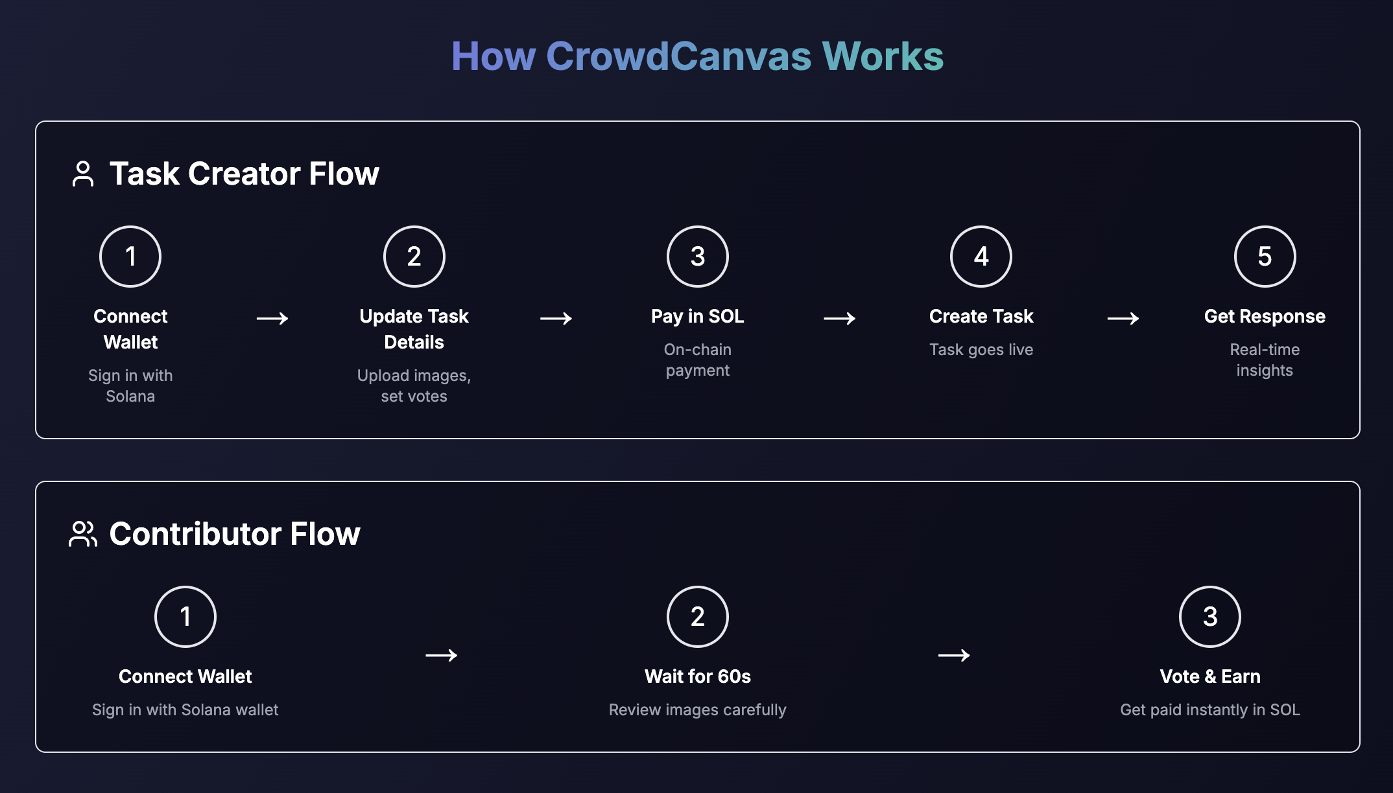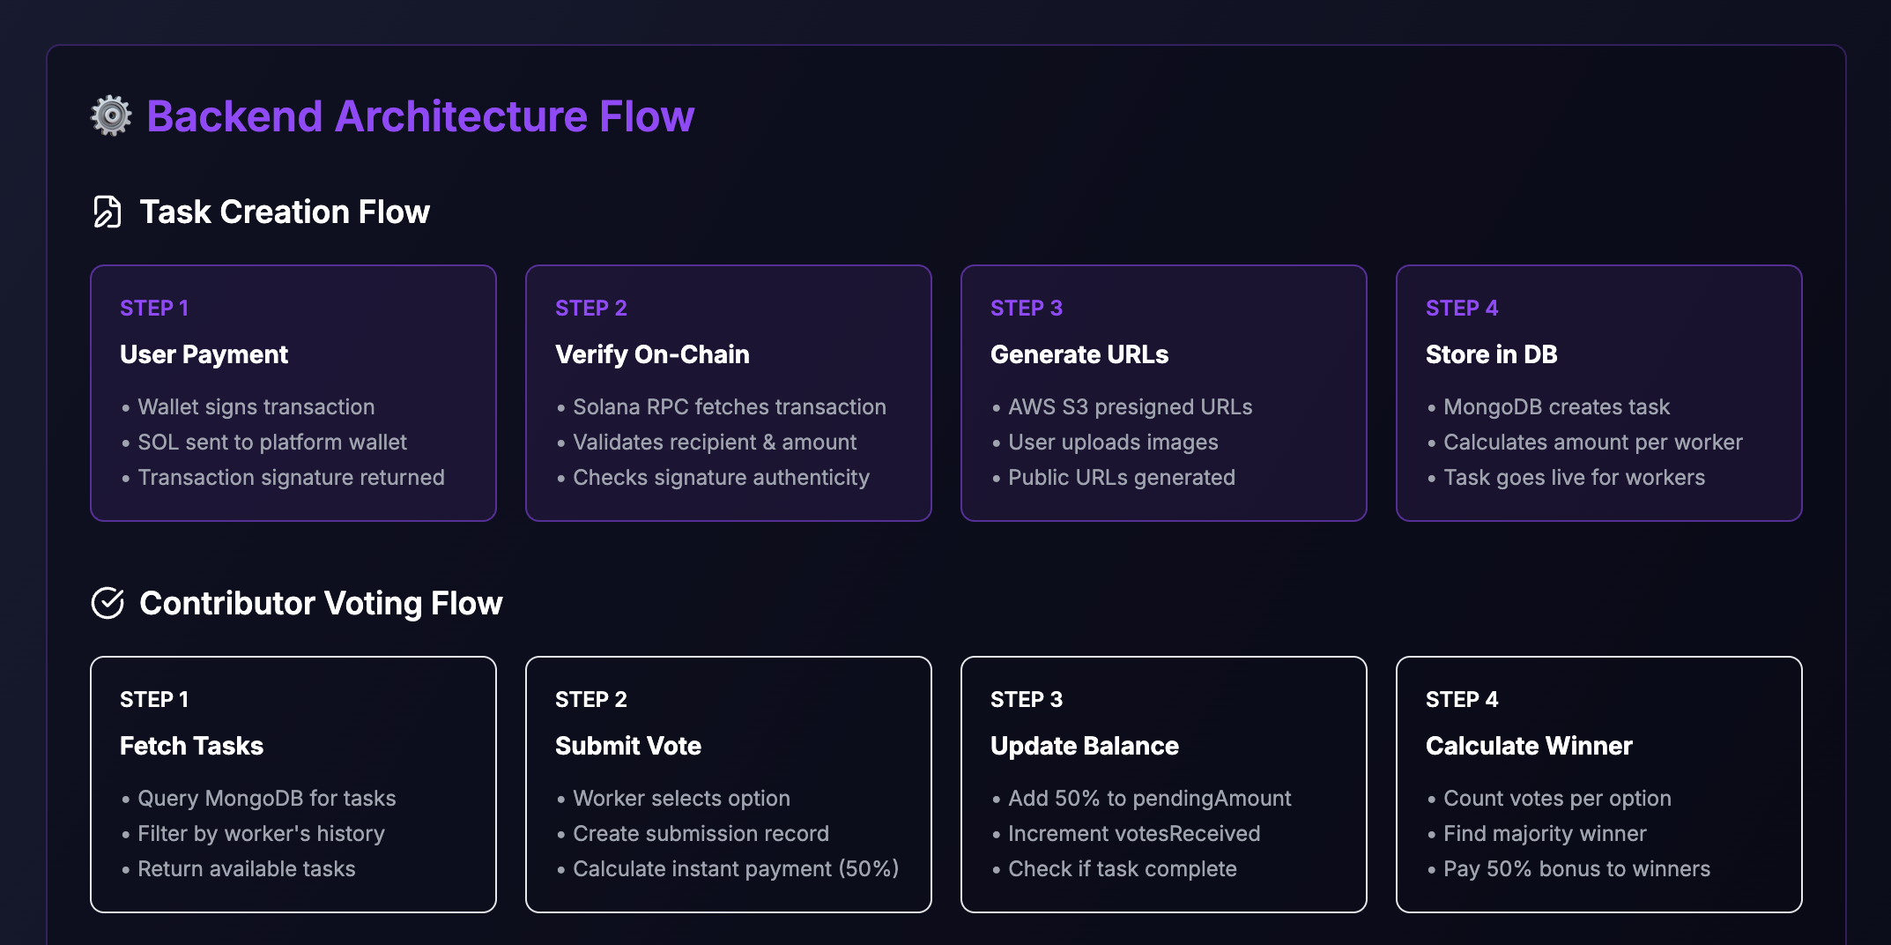
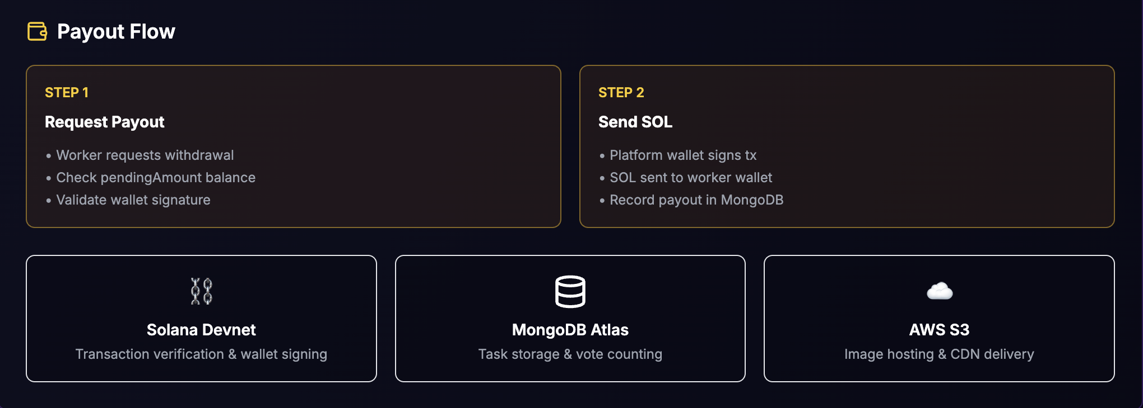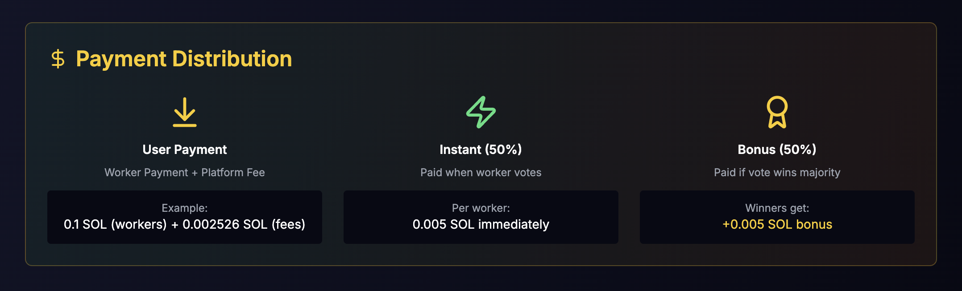

7. Why Solana

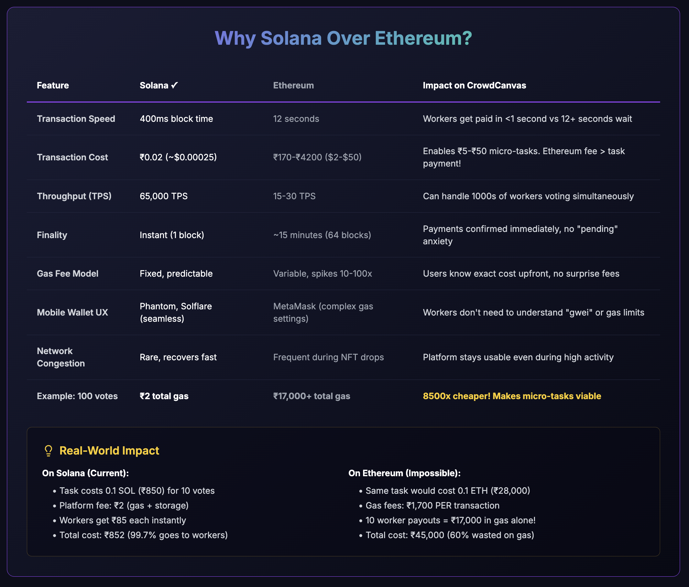

8. Unique

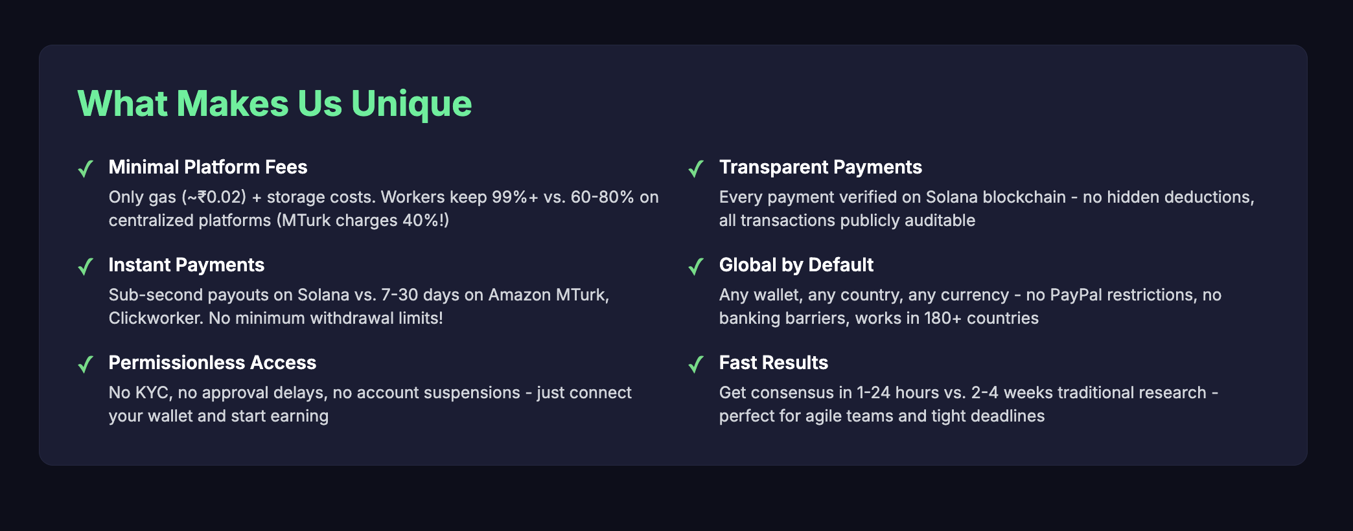

9. Real-World Use Cases



10. User Interface - Creator Dashboard

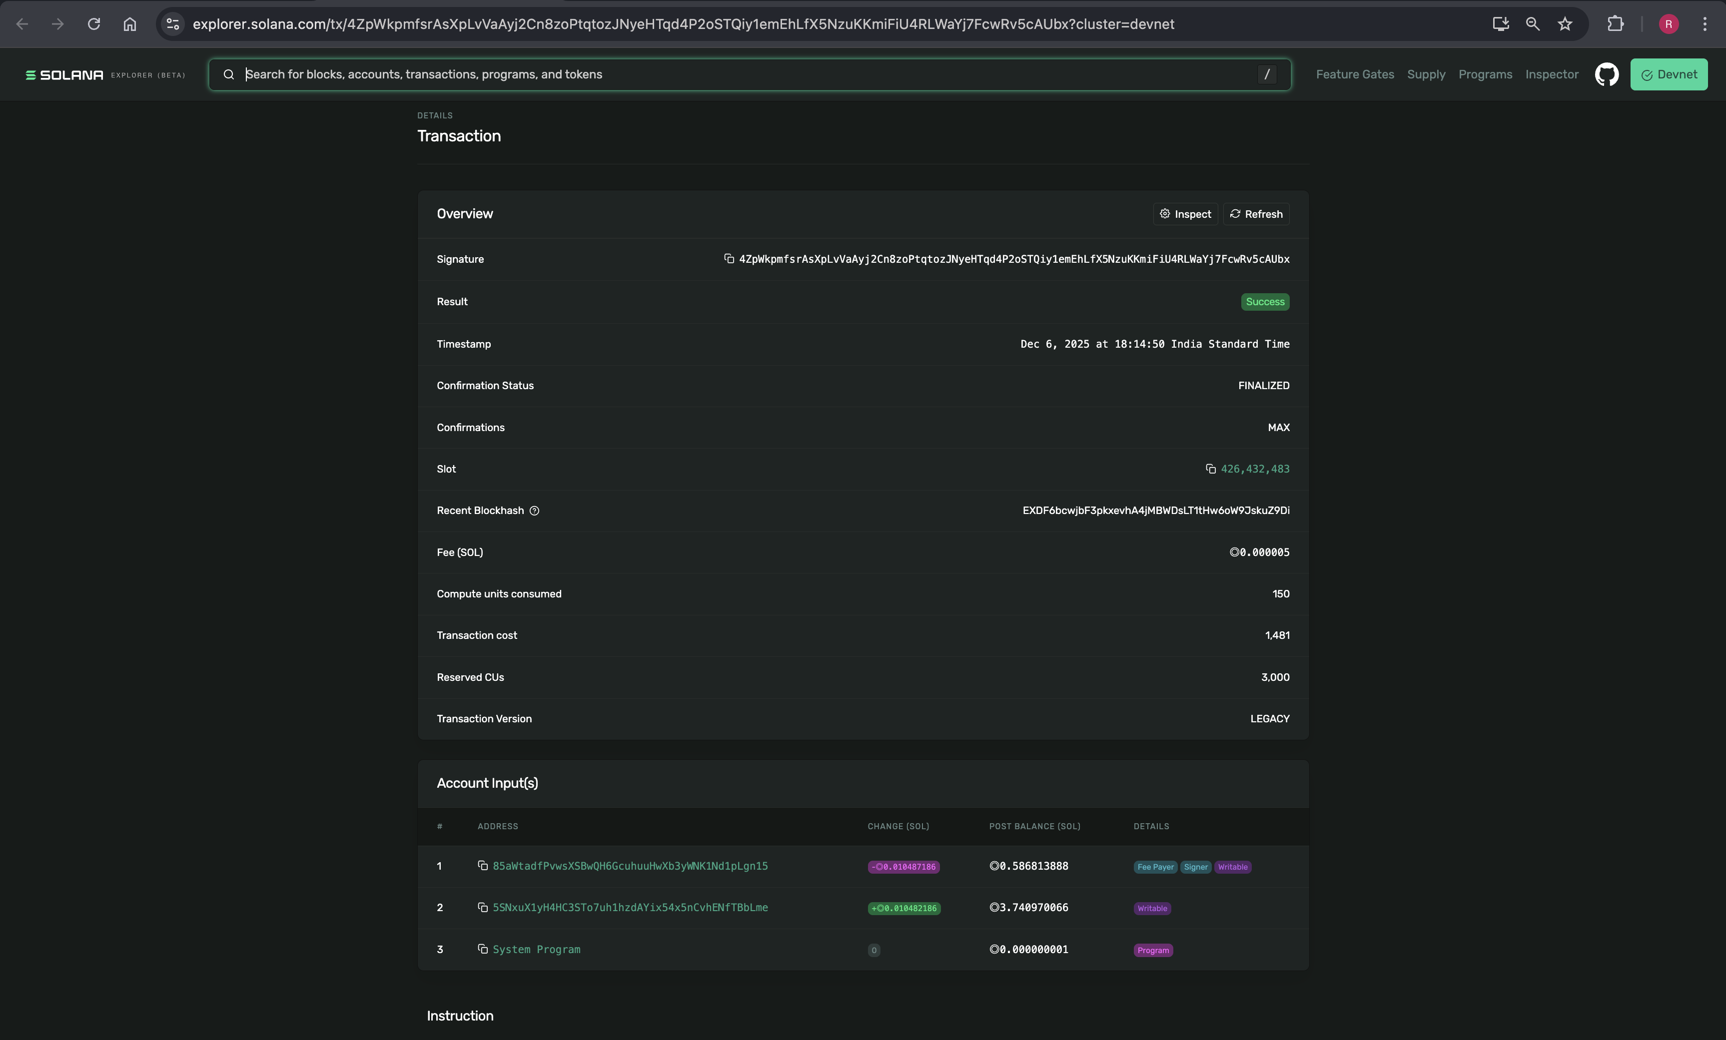

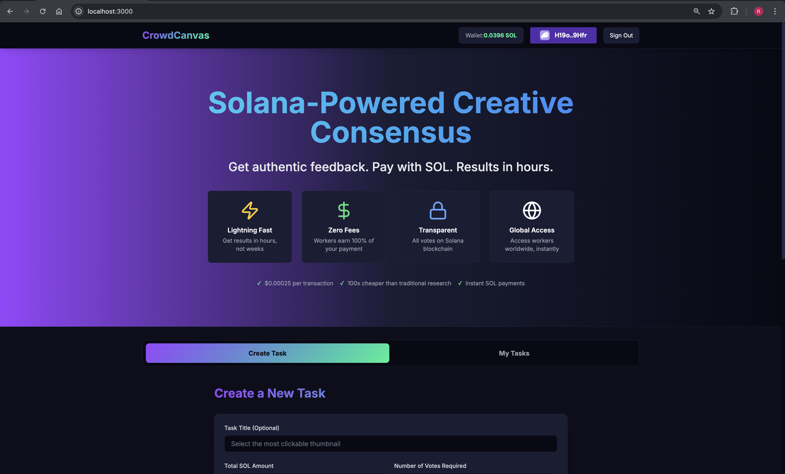

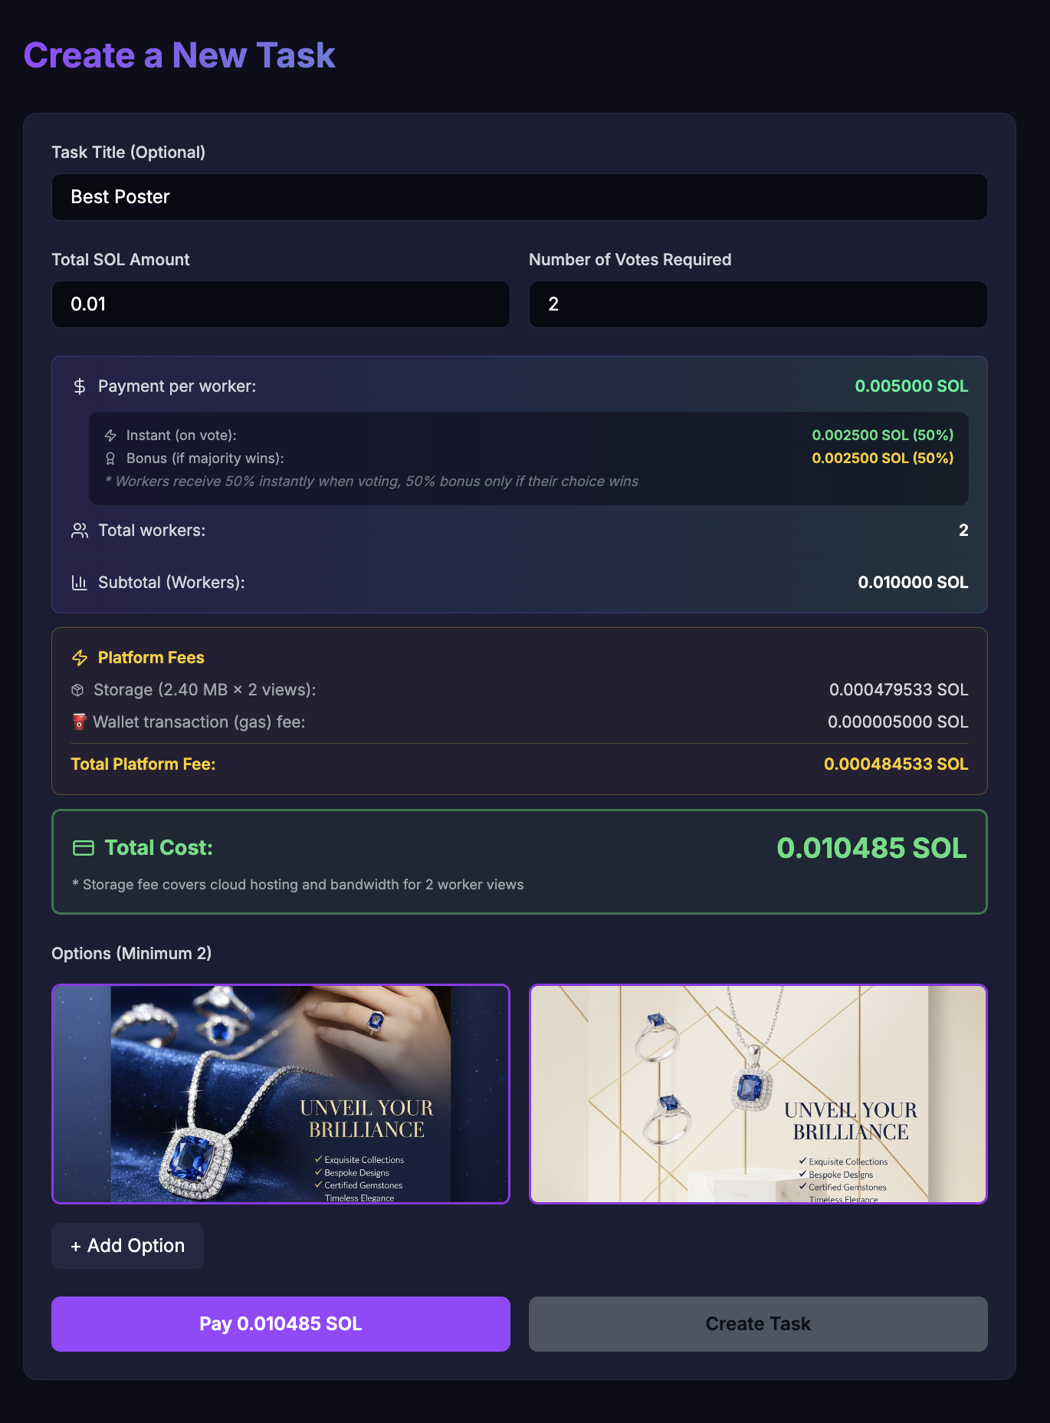

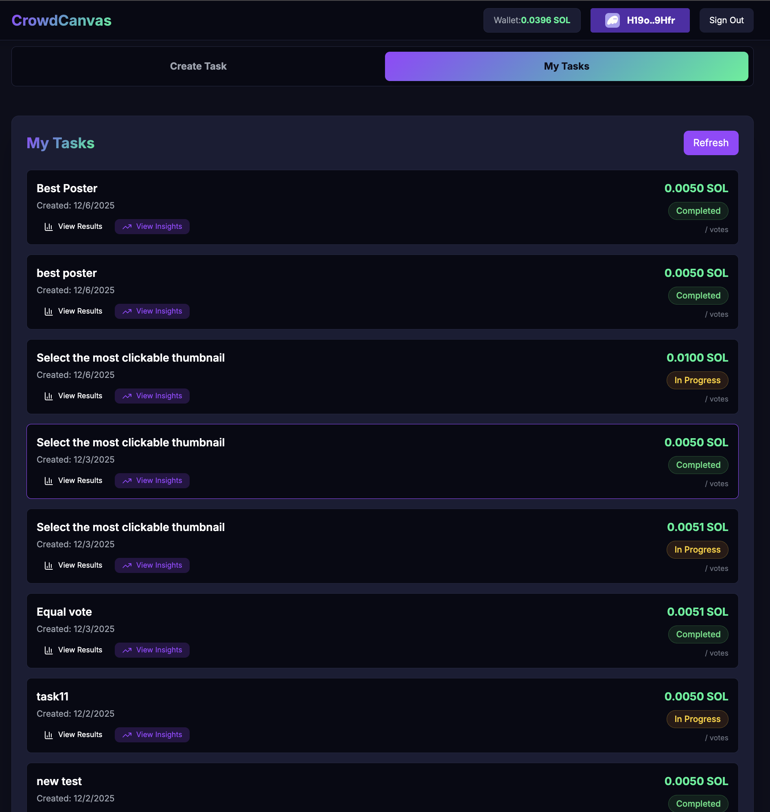

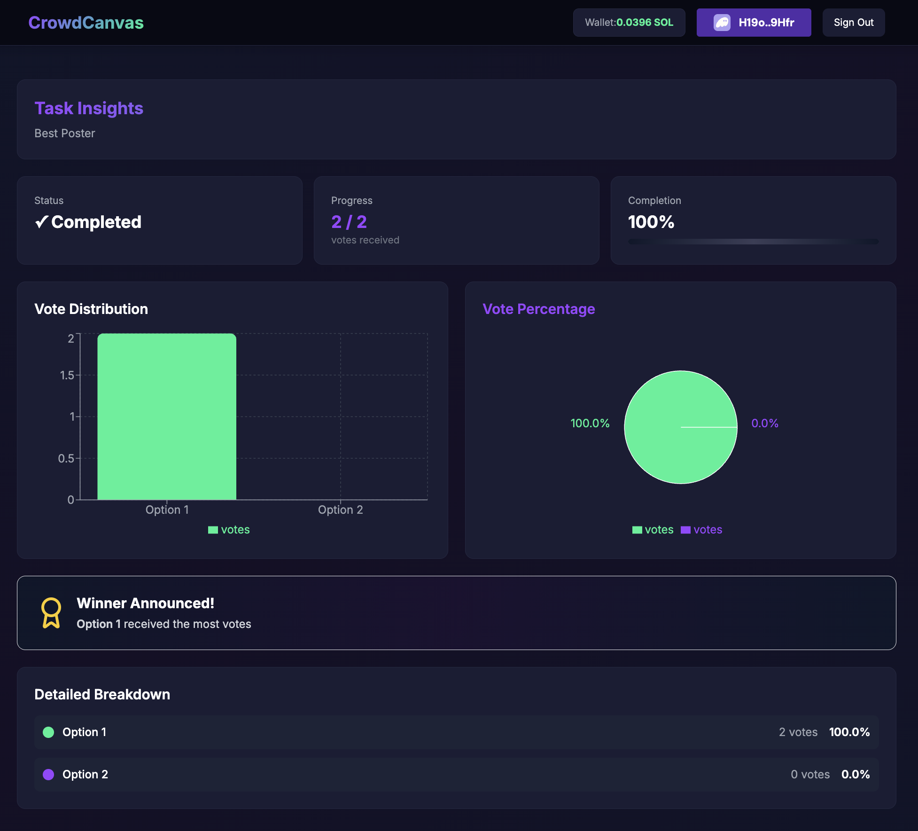

11. User Interface - Contributors Dashboard

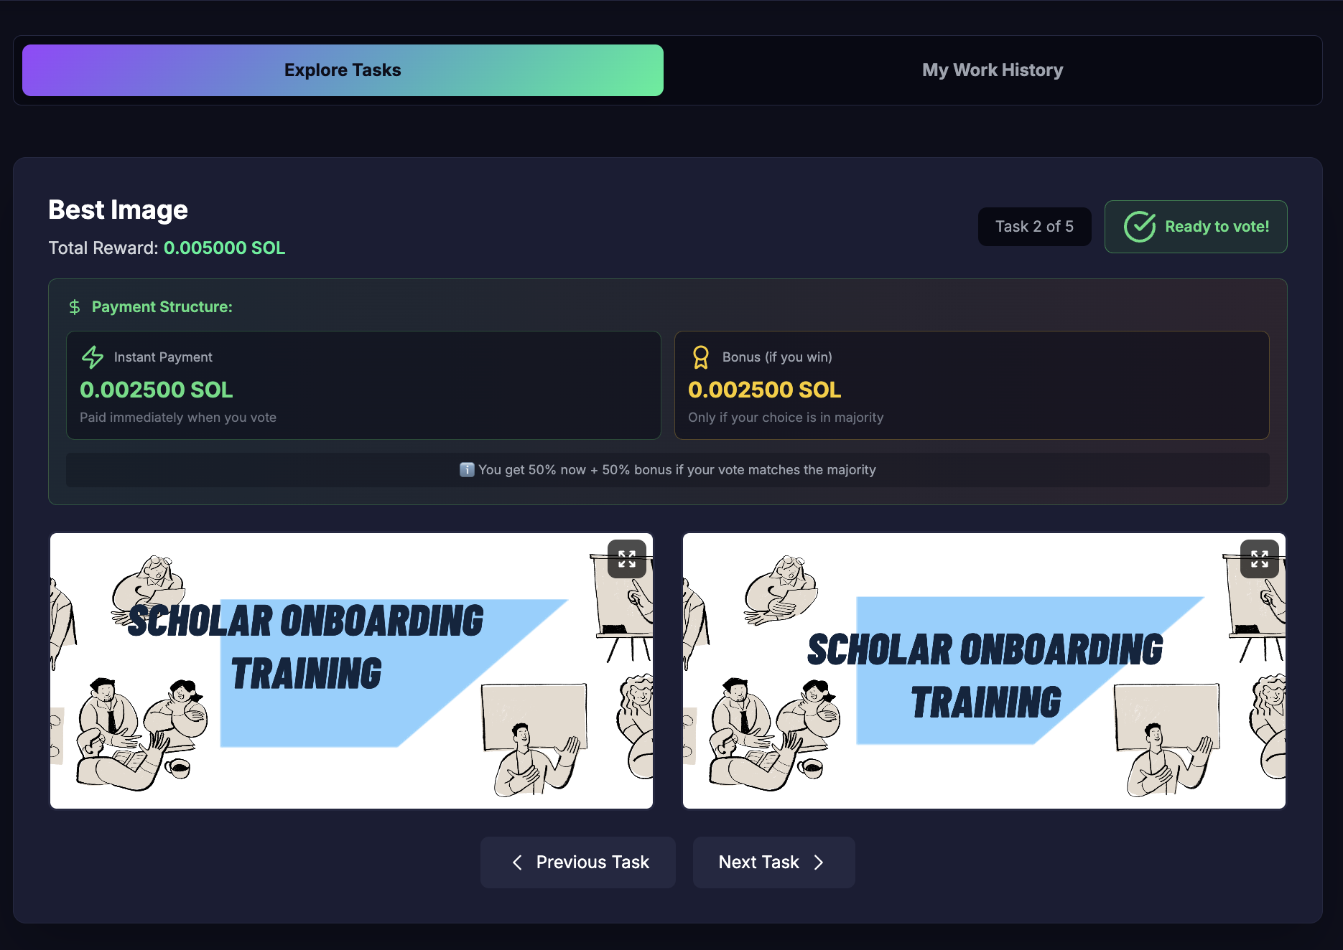

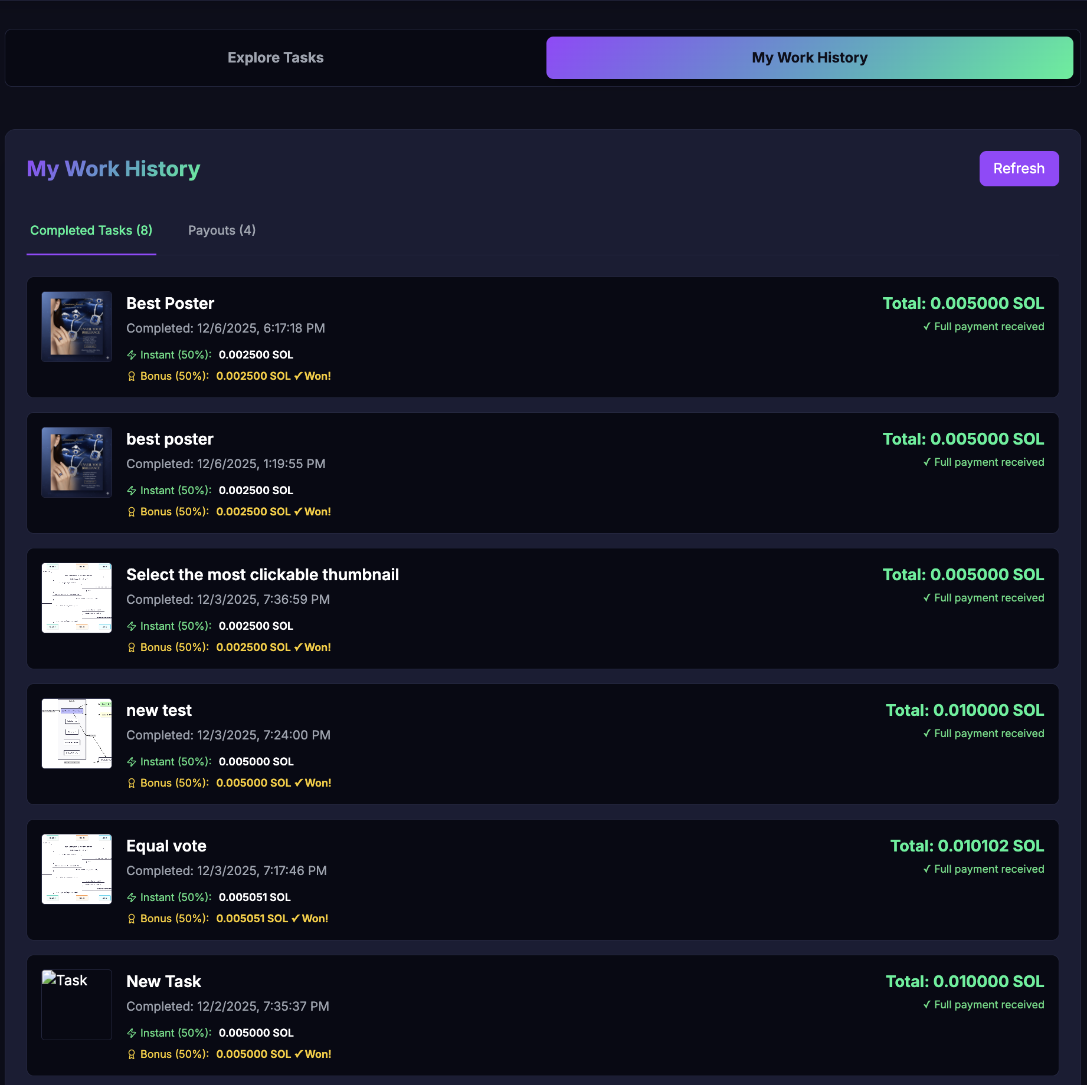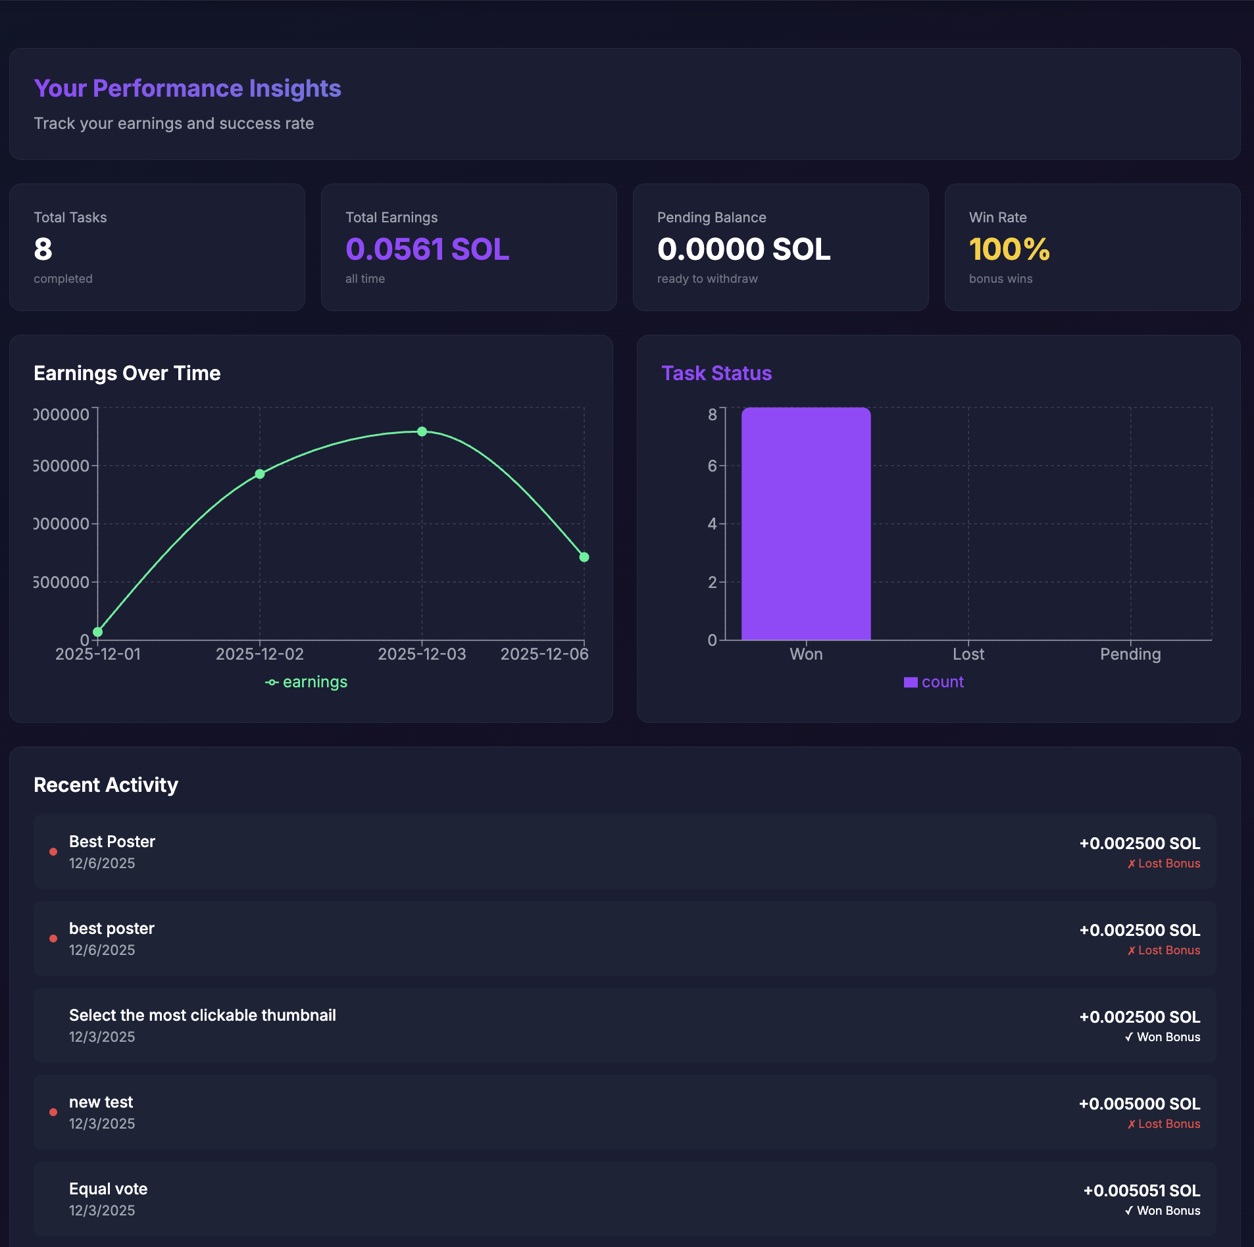

CrowdCanvas demonstrates how blockchain technology can create fairer, faster, and more transparent platforms that benefit both creators and contributors. Built on Solana for performance, powered by community for growth.

GROUP 12 | RISHU RAJ | 2024SL93092 | Blockchain Project

