WEEK 2 TASK
Exploratory Data Analysis
and Visualization
A reproducible Python EDA using the Iris dataset
Libraries: Pandas • Matplotlib • Scikit-learn
Dataset source: UCI Machine Learning Repository / scikit-learn copy

1. Executive Summary
This report presents a structured exploratory data analysis (EDA) of the Iris dataset. The objective is to move beyond simple descriptive statistics and use visual analysis to identify patterns, differences between species, relationships among numerical measurements, and potential anomalies. The analysis uses Python with Pandas, Matplotlib, and scikit-learn.
The Iris dataset contains 150 observations from three iris species—setosa, versicolor, and virginica—with four continuous measurements: sepal length, sepal width, petal length, and petal width. EDA shows that petal measurements provide substantially stronger separation between species than sepal measurements. In particular, petal length and petal width move together strongly and form visibly separated clusters, while sepal width shows weaker relationships with the other measurements.
The report documents the complete analytical process: dataset acquisition, structural inspection, descriptive statistics, class-balance analysis, grouped aggregation, distribution analysis, scatter plots, box plots, correlation analysis, anomaly screening, and critical interpretation. The emphasis is on explaining what each visualization reveals rather than producing charts without interpretation.

2. Dataset Selection and Acquisition
The Iris dataset was selected because it is a well-known public dataset originally associated with the UCI Machine Learning Repository and is distributed in scikit-learn as a standard educational dataset. It is compact enough for transparent inspection while still containing meaningful numerical relationships and a multiclass categorical target.
Source: UCI Machine Learning Repository — Iris dataset (DOI: 10.24432/C56C76).
from sklearn.datasets import load_iris
import pandas as pd
iris = load_iris(as_frame=True)
df = iris.frame.copy()
df["species"] = df["target"].map(dict(enumerate(iris.target_names)))
df = df.drop(columns=["target"])
df = df.rename(columns={
"sepal length (cm)": "sepal_length_cm",
"sepal width (cm)": "sepal_width_cm",
"petal length (cm)": "petal_length_cm",
"petal width (cm)": "petal_width_cm"
})
print(df.shape)
print(df.head())

3. Initial Data Exploration
The first stage establishes the structure and quality of the dataset before any aggregation or visualization.
print("Shape:", df.shape)
print(df.dtypes)
print(df.isna().sum())
print(df.describe())
print(df["species"].value_counts())
Item | Result | Interpretation
Observations | 150 | Small, manageable dataset for transparent EDA
Predictor variables | 4 numerical | All are continuous measurements in centimetres
Classes | 3 species | Balanced classification target
Rows per class | 50 each | No class-size imbalance
Missing values | 0 | No imputation required for this dataset

4. Descriptive Statistics
Grouped statistics make differences between species easier to see than overall statistics alone.
group_summary = (
df.groupby("species")
.agg(
mean_sepal_length=("sepal_length_cm", "mean"),
mean_sepal_width=("sepal_width_cm", "mean"),
mean_petal_length=("petal_length_cm", "mean"),
mean_petal_width=("petal_width_cm", "mean")
)
.round(2)
)
print(group_summary)
Species | Sepal L | Sepal W | Petal L | Petal W
setosa | 5.01 | 3.43 | 1.46 | 0.25
versicolor | 5.94 | 2.77 | 4.26 | 1.33
virginica | 6.59 | 2.97 | 5.55 | 2.03
Interpretation: setosa has the smallest average petal dimensions, while virginica has the largest. Versicolor generally occupies an intermediate position. The ordering is much clearer for petal length and width than for sepal width.

5. Visualization 1 — Sepal Relationship
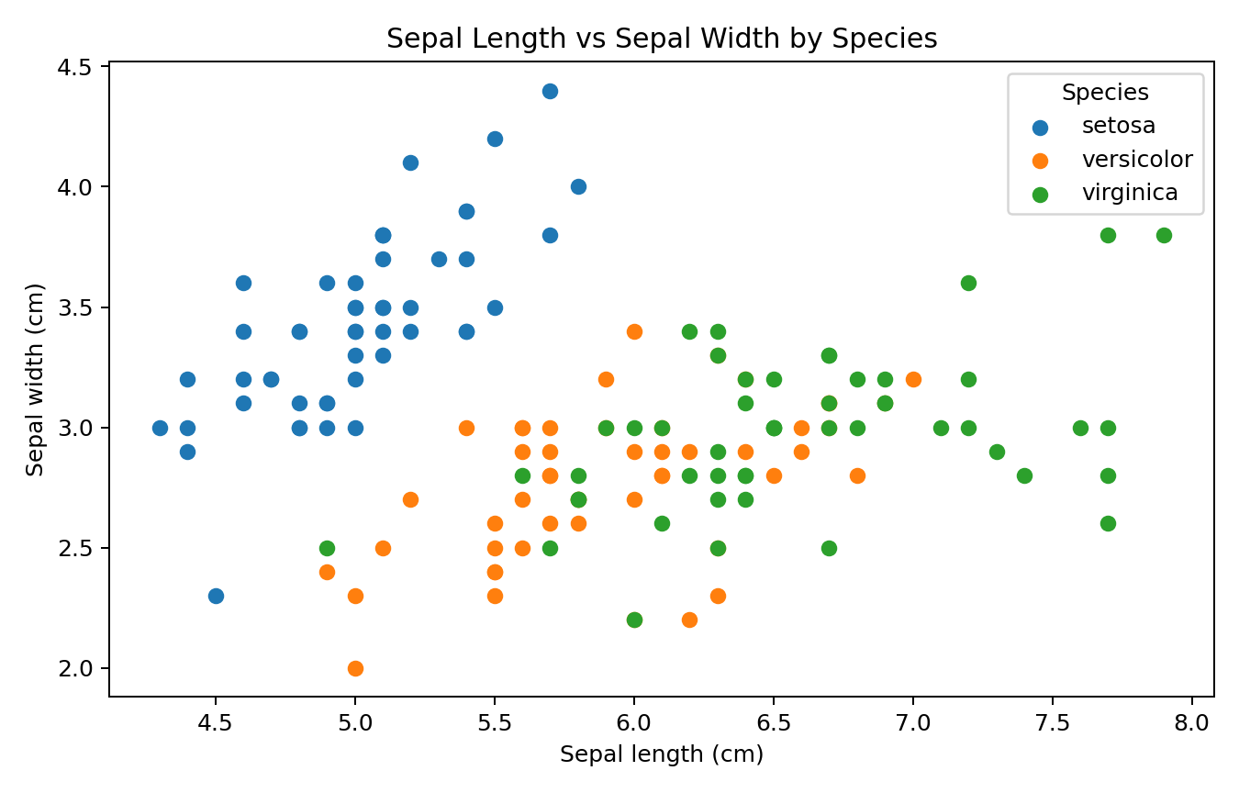
Figure 1. Sepal length versus sepal width, separated by species.
The sepal scatter plot shows partial overlap between species. Setosa tends to have shorter sepals and relatively wider sepals, while versicolor and virginica overlap substantially. This indicates that sepal measurements alone are less effective for visually separating the three classes.
for species in iris.target_names:
subset = df[df["species"] == species]
plt.scatter(subset["sepal_length_cm"],
subset["sepal_width_cm"],
label=species)
plt.title("Sepal Length vs Sepal Width by Species")
plt.xlabel("Sepal length (cm)")
plt.ylabel("Sepal width (cm)")
plt.legend(title="Species")
plt.show()

6. Visualization 2 — Petal Relationship
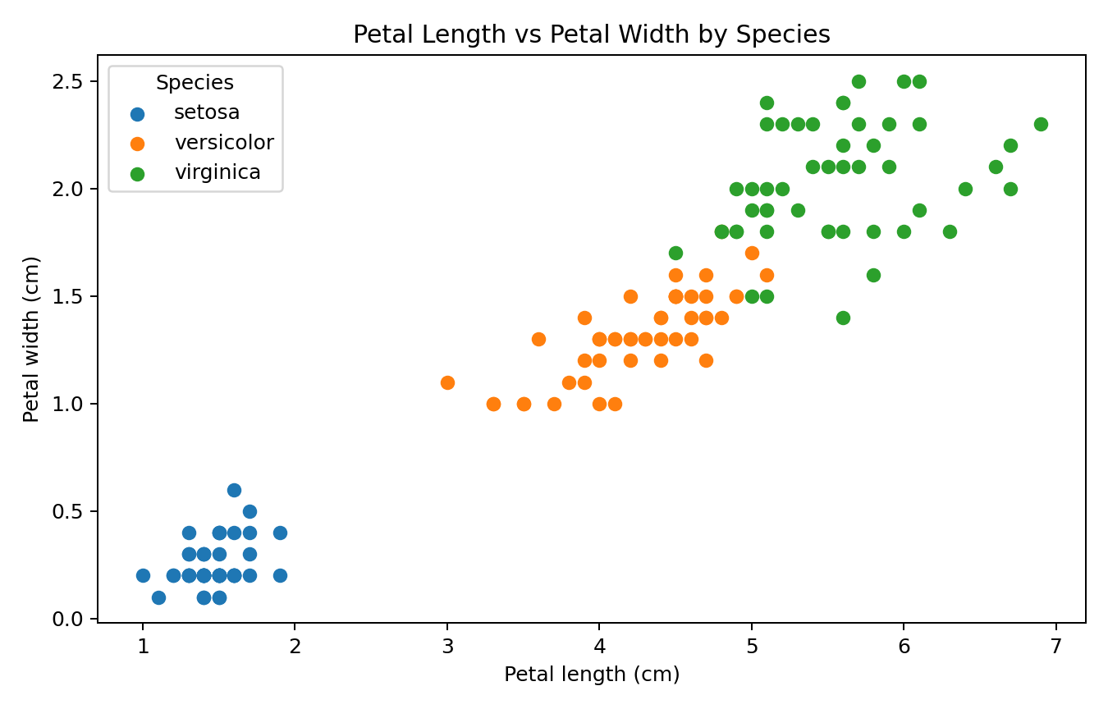
Figure 2. Petal length versus petal width by species.
The petal scatter plot is one of the strongest findings in the EDA. Setosa forms a clearly separated cluster with short and narrow petals. Versicolor and virginica are also much more distinguishable than they were in the sepal plot, although some boundary overlap remains. This suggests that petal dimensions contain strong information about species membership.

7. Visualization 3 — Grouped Mean Comparison
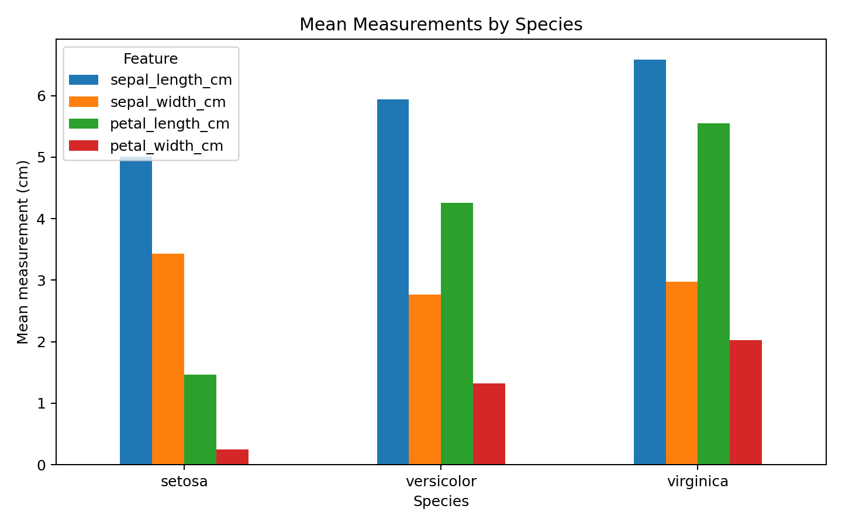
Figure 3. Mean sepal and petal measurements for each species.
Aggregating the measurements by species makes the overall pattern explicit. Virginica has the largest average petal length and width, setosa has the smallest, and versicolor lies between them. Sepal width does not follow the same simple increasing pattern, reinforcing the idea that not all variables contribute equally to class separation.

8. Visualization 4 — Distribution and Anomaly Analysis
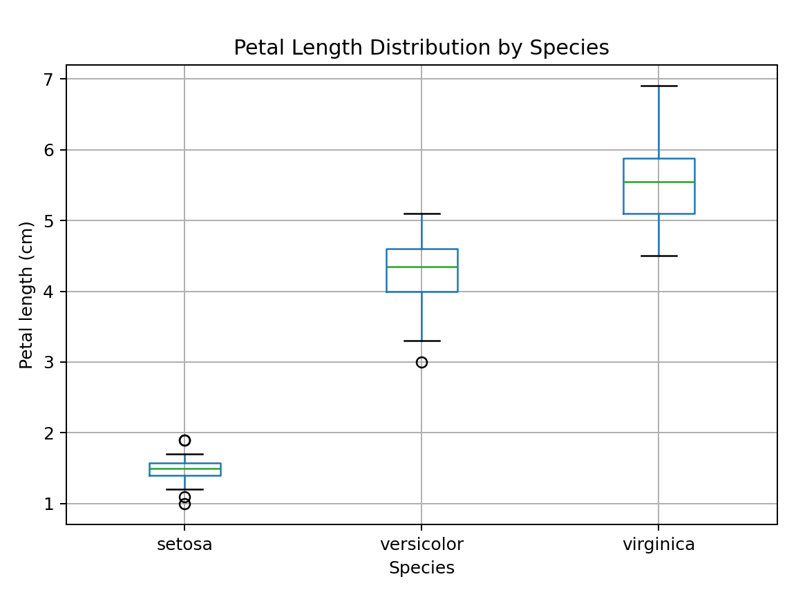
Figure 4. Box plot of petal length by species.
The box plot compares the central tendency, spread, and potential extreme observations for petal length. Setosa is tightly concentrated at low values, while virginica occupies a higher range. Versicolor is intermediate. A box plot is particularly useful because it exposes both the distribution and potential IQR-based outliers without hiding them behind averages.

9. Visualization 5 — Correlation Analysis
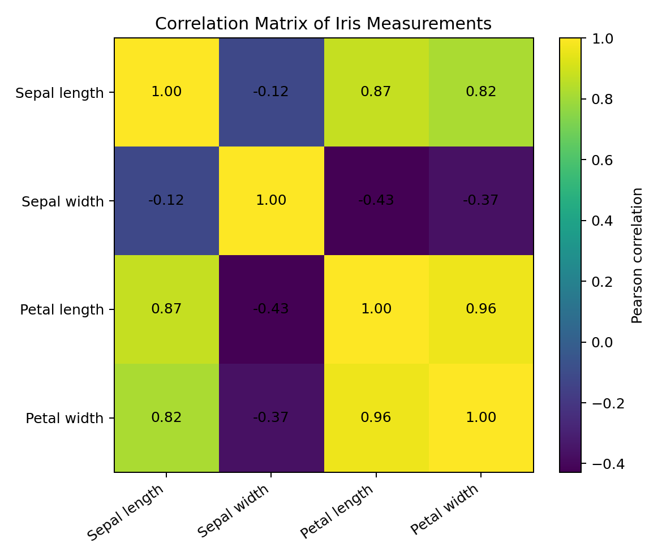
Figure 5. Pearson correlation matrix of the four numerical measurements.
The correlation matrix shows a very strong positive relationship between petal length and petal width. Sepal length is also positively related to the petal variables, while sepal width has weaker relationships with the remaining features. Correlation indicates association, not causation; these values should therefore be interpreted as measures of linear relationship rather than evidence that one biological measurement causes another.
numeric_cols = [
"sepal_length_cm", "sepal_width_cm",
"petal_length_cm", "petal_width_cm"
]
corr = df[numeric_cols].corr()
print(corr.round(2))

10. Visualization 6 — Distribution Shape
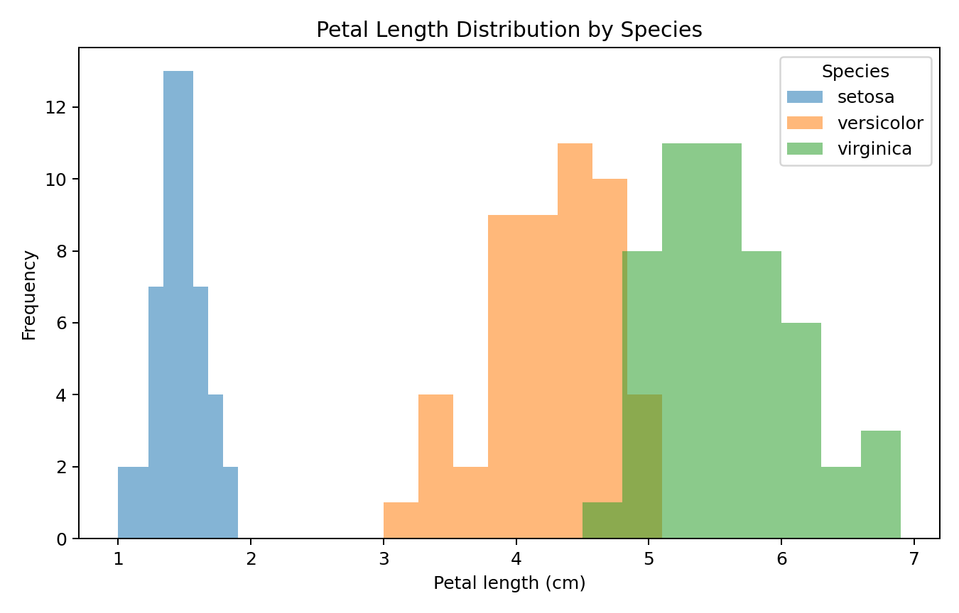
Figure 6. Petal length distributions by species.
The distribution view reinforces the cluster structure seen in the scatter plot. Setosa is concentrated at the lower end of petal length, while virginica is shifted toward larger values. Versicolor occupies the middle range. The amount of overlap indicates where a simple threshold could work and where classification would be more difficult.

11. Transformations and Aggregations
- Target encoding: the numeric target codes were mapped to readable species names.
- Column renaming: feature names were converted into consistent snake_case labels.
- Grouped aggregation: mean measurements were calculated separately for each species.
- Correlation aggregation: Pearson correlations were calculated across numerical variables.
- No scaling or normalization was applied because the purpose of this week is EDA rather than model training.

12. Key Findings
- The dataset is balanced, with 50 observations per species.
- There are no missing values in the Iris dataset, so imputation is unnecessary.
- Petal length and petal width provide strong visual separation among species.
- Setosa is the most clearly separated species in the feature space.
- Versicolor and virginica are more similar than setosa and therefore show greater overlap.
- Petal length and petal width have a strong positive linear relationship.
- Sepal width is less strongly correlated with the other measurements.
- Grouped means and distribution plots tell a consistent story: petal measurements are especially informative for distinguishing species.

13. Critical Interpretation
EDA is useful because it reveals structure that a table of averages can hide. The strongest visual evidence comes from comparing the two scatter plots: sepal measurements create overlapping clusters, whereas petal measurements produce much clearer separation. This does not prove that petals are the cause of species differences, nor does it guarantee perfect classification. It indicates that petal features are likely to be useful predictors in a subsequent supervised-learning task.
The correlation results should also be interpreted carefully. Strong correlation between petal length and width means the variables carry overlapping linear information. In a future regression or classification model, this could create redundancy, although the best feature-selection decision should be based on the specific modelling objective and validation results.

14. Limitations
- The Iris dataset is small and highly curated, so findings should not be generalized to large real-world datasets.
- The dataset contains only four numerical predictors, limiting the range of possible EDA questions.
- Correlation measures linear association and does not capture every possible nonlinear relationship.
- Visual separation does not guarantee that a classifier will perform perfectly on unseen observations.

15. Reproducibility and Code Quality
The accompanying Python script reproduces the calculations and visualizations in this report. The code uses explicit column names, reusable loops for species-specific plots, descriptive chart titles, axis labels, and legends. Keeping the code separate from the report also makes the analysis easier to review and rerun.
# Install dependencies
pip install -r week2_requirements.txt
# Run the EDA script
python week2_eda_visualization.py

16. Conclusion
The Week 2 EDA demonstrates how systematic exploration can convert a raw dataset into meaningful analytical insights. Descriptive statistics establish the baseline, grouped summaries reveal differences between categories, scatter plots expose relationships and clusters, box plots show distribution and potential anomalies, and correlation analysis quantifies linear relationships.
The most important conclusion is that petal measurements are substantially more discriminative across the three Iris species than sepal measurements. This finding provides a logical starting point for a future predictive modelling task while also illustrating why visualization and interpretation should precede model building.

17. Appendix — Complete EDA Script
# Week 2 — Exploratory Data Analysis and Visualization
# Dataset: Iris (UCI Machine Learning Repository / scikit-learn copy)
import pandas as pd
import matplotlib.pyplot as plt
from sklearn.datasets import load_iris
# 1. Load the public dataset
iris = load_iris(as_frame=True)
df = iris.frame.copy()
# Add readable target labels
df["species"] = df["target"].map(dict(enumerate(iris.target_names)))
df = df.drop(columns=["target"])
df = df.rename(columns={
"sepal length (cm)": "sepal_length_cm",
"sepal width (cm)": "sepal_width_cm",
"petal length (cm)": "petal_length_cm",
"petal width (cm)": "petal_width_cm"
})
# 2. Initial exploration
print("Shape:", df.shape)
print("\nData types:")
print(df.dtypes)
print("\nMissing values:")
print(df.isna().sum())
print("\nDescriptive statistics:")
print(df.describe())
print("\nClass distribution:")
print(df["species"].value_counts())
# 3. Grouped summary statistics
group_summary = (
df.groupby("species")
.agg(
mean_sepal_length=("sepal_length_cm", "mean"),
mean_sepal_width=("sepal_width_cm", "mean"),
mean_petal_length=("petal_length_cm", "mean"),
mean_petal_width=("petal_width_cm", "mean")
)
.round(2)
)
print("\nGrouped means:")
print(group_summary)
# 4. Scatter plot: sepal measurements
plt.figure(figsize=(8, 5))
for species in iris.target_names:
subset = df[df["species"] == species]
plt.scatter(
subset["sepal_length_cm"],
subset["sepal_width_cm"],
label=species
)
plt.title("Sepal Length vs Sepal Width by Species")
plt.xlabel("Sepal length (cm)")
plt.ylabel("Sepal width (cm)")
plt.legend(title="Species")
plt.tight_layout()
plt.show()
# 5. Scatter plot: petal measurements
plt.figure(figsize=(8, 5))
for species in iris.target_names:
subset = df[df["species"] == species]
plt.scatter(
subset["petal_length_cm"],
subset["petal_width_cm"],
label=species
)
plt.title("Petal Length vs Petal Width by Species")
plt.xlabel("Petal length (cm)")
plt.ylabel("Petal width (cm)")
plt.legend(title="Species")
plt.tight_layout()
plt.show()
# 6. Grouped bar chart
means = df.groupby("species")[
["sepal_length_cm", "sepal_width_cm",
"petal_length_cm", "petal_width_cm"]
].mean()
ax = means.plot(kind="bar", figsize=(9, 5))
ax.set_title("Mean Measurements by Species")
ax.set_xlabel("Species")
ax.set_ylabel("Mean measurement (cm)")
ax.legend(title="Feature")
plt.xticks(rotation=0)
plt.tight_layout()
plt.show()
# 7. Box plot
plt.figure(figsize=(8, 5))
df.boxplot(column="petal_length_cm", by="species")
plt.title("Petal Length Distribution by Species")
plt.suptitle("")
plt.xlabel("Species")
plt.ylabel("Petal length (cm)")
plt.tight_layout()
plt.show()
# 8. Correlation analysis
numeric_cols = [
"sepal_length_cm", "sepal_width_cm",
"petal_length_cm", "petal_width_cm"
]
corr = df[numeric_cols].corr()
print("\nCorrelation matrix:")
print(corr.round(2))
plt.figure(figsize=(7, 6))
plt.imshow(corr, aspect="auto")
plt.colorbar(label="Pearson correlation")
plt.xticks(range(4), numeric_cols, rotation=35, ha="right")
plt.yticks(range(4), numeric_cols)
for i in range(4):
for j in range(4):
plt.text(j, i, f"{corr.iloc[i, j]:.2f}",
ha="center", va="center")
plt.title("Correlation Matrix of Iris Measurements")
plt.tight_layout()
plt.show()
# 9. Distribution analysis
plt.figure(figsize=(8, 5))
for species in iris.target_names:
subset = df[df["species"] == species]
plt.hist(subset["petal_length_cm"], alpha=0.55,
label=species, bins=8)
plt.title("Petal Length Distribution by Species")
plt.xlabel("Petal length (cm)")
plt.ylabel("Frequency")
plt.legend(title="Species")
plt.tight_layout()
plt.show()
# 10. Basic anomaly check using IQR
for col in numeric_cols:
q1 = df[col].quantile(0.25)
q3 = df[col].quantile(0.75)
iqr = q3 - q1
lower = q1 - 1.5 * iqr
upper = q3 + 1.5 * iqr
count = ((df[col] < lower) | (df[col] > upper)).sum()
print(f"{col}: {count} IQR-flagged observations")
print("\nEDA completed.")

18. Submission Checklist
- DOCX report completed.
- Dataset source documented.
- Initial descriptive analysis included.
- Multiple visualizations included and interpreted.
- Charts include titles, axis labels, and legends where appropriate.
- Transformations and aggregations explained.
- Patterns, correlations, and anomalies discussed.
- Limitations and critical interpretation included.
- Python script provided for reproducibility.
- Requirements file provided.

Primary dataset reference: Fisher, R. A. (1936), The use of multiple measurements in taxonomic problems; Iris dataset distributed by the UCI Machine Learning Repository.

