WEEK 5 TASK
Deep Learning Application in Data Science
Handwritten Digit Classification using PyTorch

1. Executive Summary
This project applies a feed-forward neural network using PyTorch to classify handwritten digits from the public Digits dataset distributed by scikit-learn. The dataset contains 8×8 grayscale images represented by 64 numerical pixel features and ten target classes. The workflow covers data preparation, architecture design, training, validation, early stopping, evaluation, visualization, and critical analysis.

2. Problem Statement
Given 64 pixel-intensity values representing an 8×8 handwritten digit, the model predicts the digit from 0 through 9. This is a supervised multi-class classification problem. The compact dataset is appropriate for demonstrating deep learning concepts without requiring specialized hardware.

3. Dataset and Preprocessing
The Digits dataset contains 1,797 observations and 64 pixel features. Pixel values range from 0 to 16 and were divided by 16 to scale inputs approximately to [0,1]. An 80/20 stratified train/test split was used. An additional validation subset was created from the training data for early stopping.

4. Architecture Design
The network contains 64 input units, Dense(128) + ReLU, Dropout(0.25), Dense(64) + ReLU, Dropout(0.20), and a final Dense(10) output layer. CrossEntropyLoss consumes the output logits directly. ReLU provides nonlinear representation learning, while dropout reduces over-reliance on individual neurons.
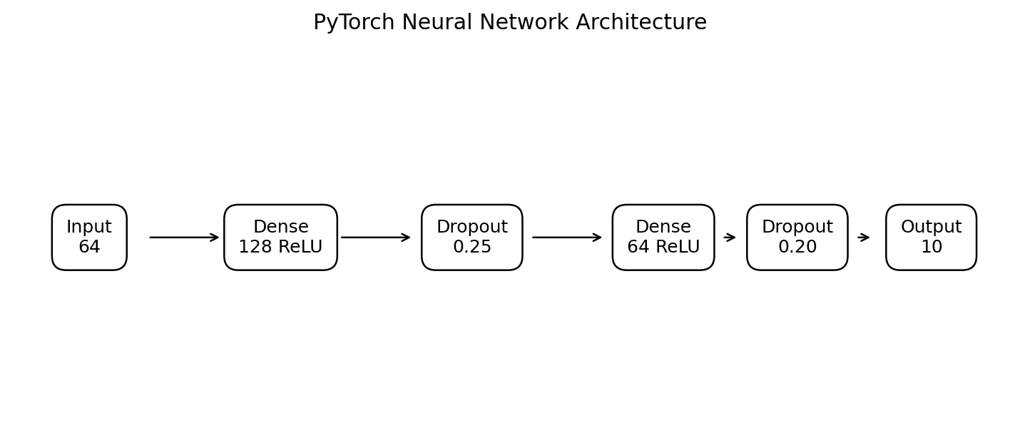
Figure 1. Network architecture schematic.

5. Architecture Rationale
A fully connected network was selected because the 8×8 dataset is compact and the objective is to demonstrate core neural-network concepts clearly. A CNN could exploit spatial structure more explicitly and would be a logical improvement for larger image datasets.

6. Training Configuration
Adam was used with learning rate 0.001 and weight decay 1e-4. CrossEntropyLoss was used for ten-class classification. Training was capped at 100 epochs with early stopping based on validation loss and patience of 10 epochs. Random seed 42 was used for reproducibility.

7. Training and Validation
The following curves show learning behavior and help diagnose underfitting or overfitting. Early stopping restores the model state associated with the best validation loss rather than automatically using the final epoch.
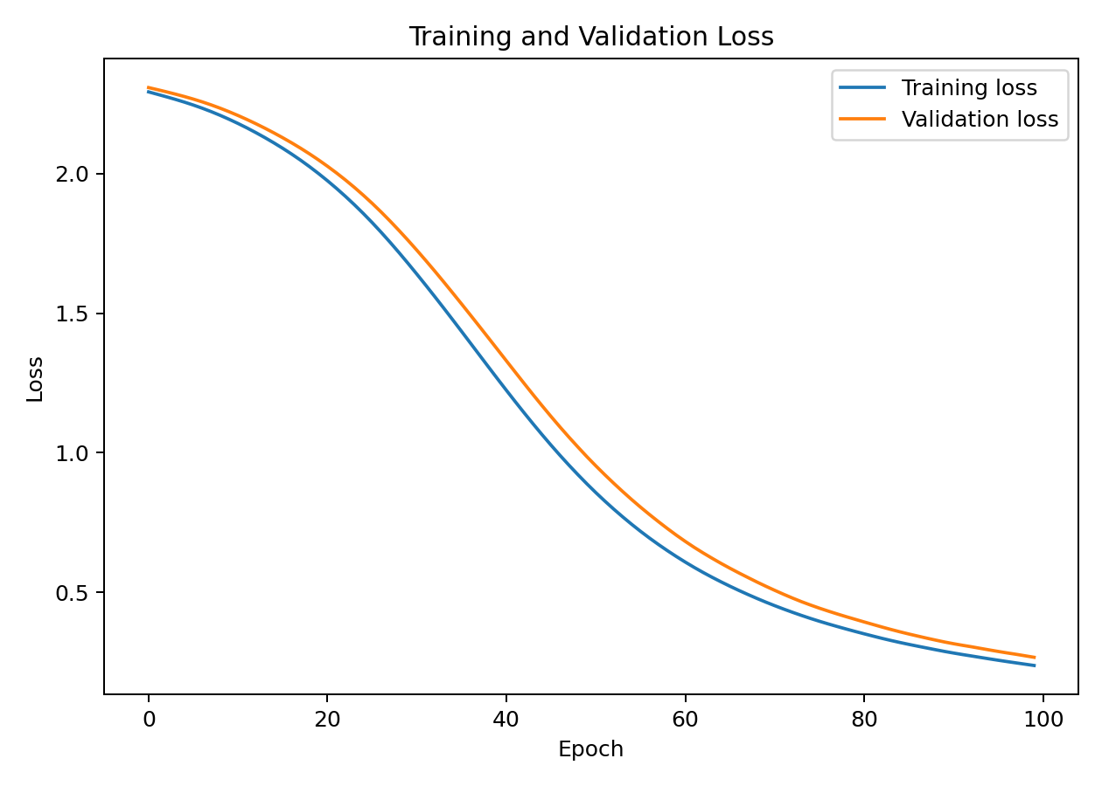
Figure 2. Training and validation loss.
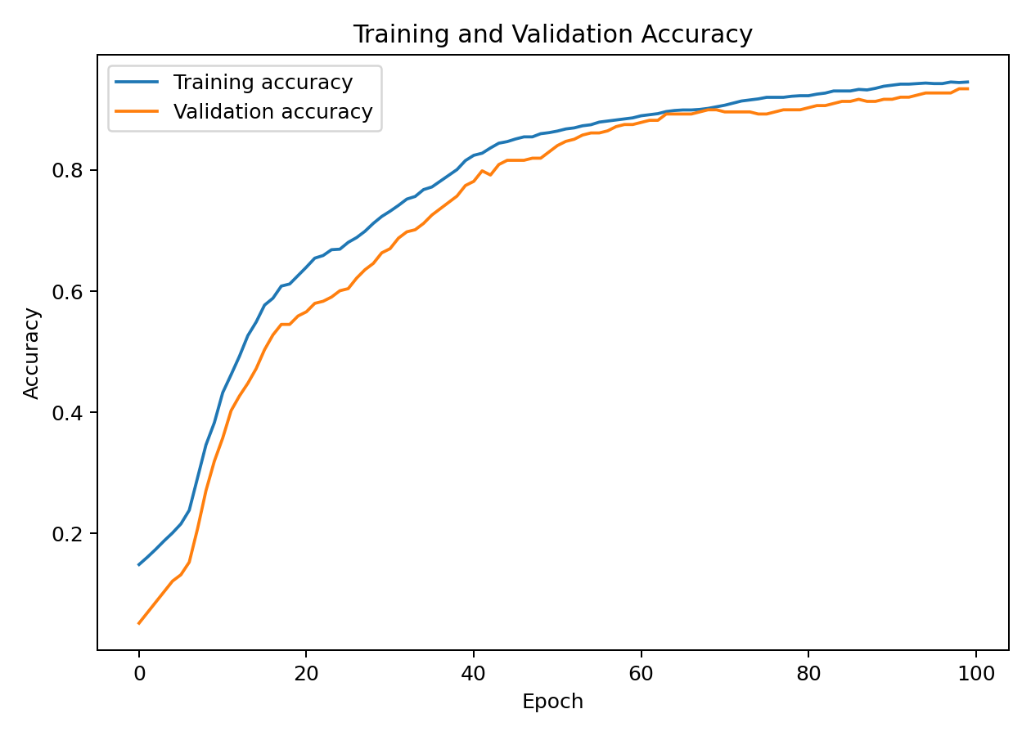
Figure 3. Training and validation accuracy.

8. Evaluation
The final model was evaluated on an untouched test set. Test accuracy in this run was 0.931. A confusion matrix is included to show class-level errors. The strong result reflects the fact that the Digits dataset is relatively clean and low-dimensional compared with production image-recognition problems.
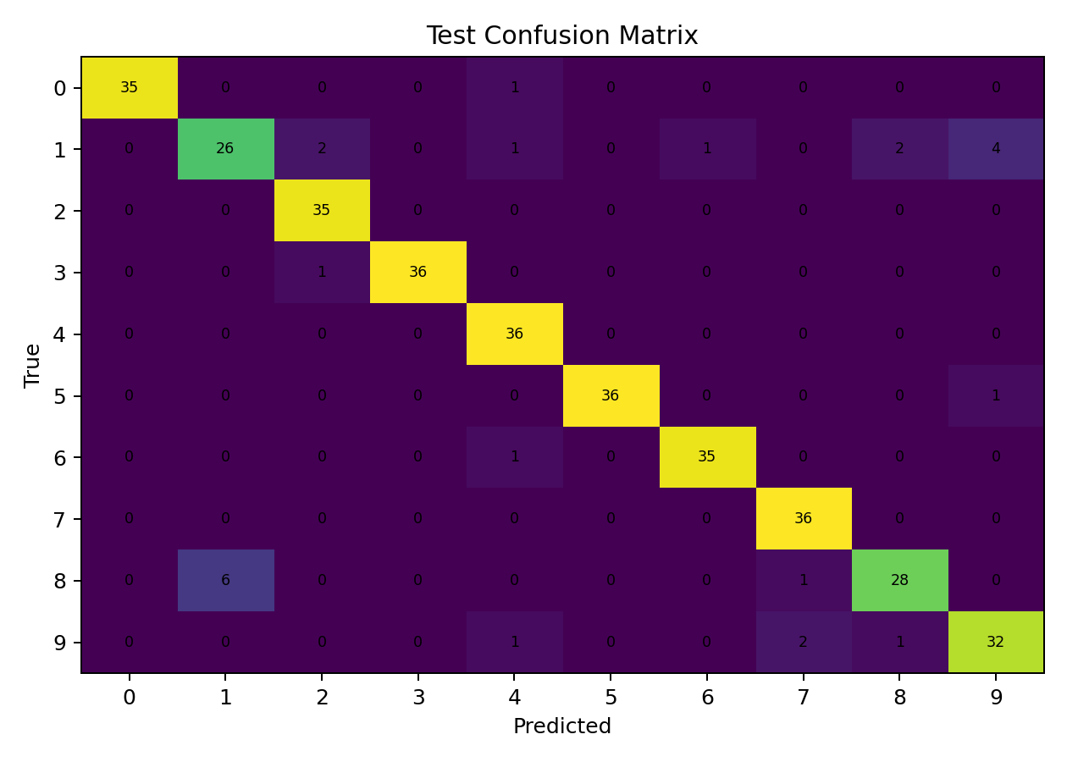
Figure 4. Test-set confusion matrix.

9. Challenges and Mitigation
Overfitting is an important challenge when training neural networks on modest datasets. Dropout, weight decay, validation monitoring, and early stopping were used to improve generalization. Resource constraints were addressed by using a small 8×8 dataset and compact network that can train on CPU.

10. Results Interpretation
The confusion matrix reveals which digit pairs are most difficult to distinguish. Similar handwriting patterns can create errors. The training and validation curves provide additional evidence about whether generalization remains stable during optimization.

11. Strengths
The project uses PyTorch, an explicit neural-network architecture, a held-out test set, validation monitoring, regularization, early stopping, reproducible random seeds, and visual diagnostics.

12. Limitations
The dataset is small and low resolution. The model is fully connected rather than convolutional and therefore does not explicitly exploit image locality. Results should not be generalized directly to larger, noisier handwriting datasets.

13. Possible Improvements
Future work could use a CNN, data augmentation, learning-rate scheduling, hyperparameter tuning, batch-based training, and larger datasets such as MNIST or Fashion-MNIST. More extensive model comparison could also assess whether the extra complexity produces meaningful gains.

14. Conclusion
This project demonstrates a complete deep-learning workflow using PyTorch. The neural network learns nonlinear representations of handwritten digit pixels, uses regularization to control overfitting, monitors validation performance, and evaluates generalization on unseen test data.

15. Core Python Code
# Week 5 — Deep Learning Application in Data Science
import numpy as np
import torch
from sklearn.datasets import load_digits
from sklearn.model_selection import train_test_split
from sklearn.metrics import accuracy_score, classification_report, confusion_matrix
torch.manual_seed(42)
digits = load_digits()
X = digits.data.astype(np.float32) / 16.0
y = digits.target
X_train, X_test, y_train, y_test = train_test_split(X,y,test_size=0.20,random_state=42,stratify=y)
model = torch.nn.Sequential(
torch.nn.Linear(64,128), torch.nn.ReLU(), torch.nn.Dropout(0.25),
torch.nn.Linear(128,64), torch.nn.ReLU(), torch.nn.Dropout(0.20),
torch.nn.Linear(64,10)
)
criterion=torch.nn.CrossEntropyLoss()
optimizer=torch.optim.Adam(model.parameters(),lr=0.001,weight_decay=1e-4)
rng=np.random.default_rng(42); idx=np.arange(len(X_train)); rng.shuffle(idx)
cut=int(0.8*len(idx)); tr_idx, val_idx=idx[:cut],idx[cut:]
Xt=torch.tensor(X_train); yt=torch.tensor(y_train,dtype=torch.long)
best_state=None; best_val=float("inf"); wait=0
for epoch in range(100):
model.train(); optimizer.zero_grad()
loss=criterion(model(Xt[tr_idx]),yt[tr_idx]); loss.backward(); optimizer.step()
model.eval()
with torch.no_grad(): val_loss=criterion(model(Xt[val_idx]),yt[val_idx]).item()
if val_loss < best_val-1e-4:
best_val=val_loss; best_state={k:v.clone() for k,v in model.state_dict().items()}; wait=0
else: wait += 1
if wait >= 10: break
model.load_state_dict(best_state); model.eval()
with torch.no_grad(): predictions=model(torch.tensor(X_test)).argmax(1).numpy()
print("Test accuracy:",accuracy_score(y_test,predictions))
print(classification_report(y_test,predictions))
print(confusion_matrix(y_test,predictions))

16. References
Scikit-learn Digits Dataset documentation.
PyTorch documentation for neural-network modules, Adam, dropout, and CrossEntropyLoss.

