WEEK 1 TASK
Data Acquisition, Cleaning,
and Preprocessing
A Reproducible Python Report Using the UCI Adult Dataset
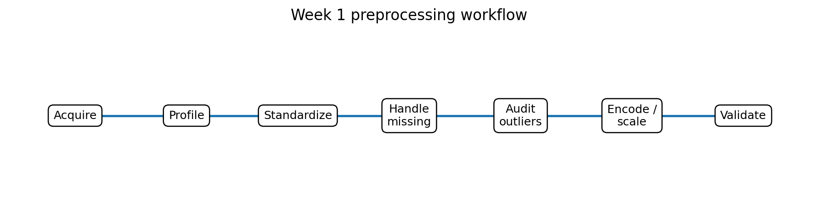
Prepared for: Week 1 Data Analytics / Machine Learning Assignment
Dataset source: UCI Machine Learning Repository
Report focus: acquisition • exploration • missing values • inconsistencies • outliers • preprocessing • validation

1. Executive Summary
This report documents a complete Week 1 data-preparation workflow using the UCI Adult dataset, a public census-income dataset originally derived from 1994 U.S. Census data. The dataset is suitable for this task because it contains both numerical and categorical variables, explicit missing-value markers, and several variables whose distributions can contain extreme observations. The UCI repository lists 48,842 instances, 14 features, and confirms that missing values are present.
The main objective is not to build a predictive model yet. Instead, the goal is to create a reliable analytical table in which data types, missingness, category labels, numerical ranges, and duplicated records have been systematically inspected. The cleaning strategy therefore emphasizes traceability: every transformation is explicit, reproducible, and performed only after a documented diagnostic step.
A key principle throughout the report is that unusual observations are not automatically errors. Outliers are investigated using distributional rules such as the interquartile range (IQR) and domain plausibility checks. Values are removed or transformed only when there is a defensible reason. This reduces the risk of deleting legitimate high-income, high-hours, or otherwise unusual observations simply because they are statistically rare.

2. Dataset Selection and Data Collection
The selected dataset is the Adult (also called Census Income) dataset from the UCI Machine Learning Repository. UCI describes it as a multivariate classification dataset with 48,842 instances and 14 features. Its prediction target indicates whether annual income exceeds $50,000. The repository also explicitly records missing values in variables such as workclass, occupation, and native-country.
Official source: UCI Machine Learning Repository — Adult dataset. https://archive.ics.uci.edu/dataset/2/adult
The UCI repository provides the data files adult.data and adult.test as well as metadata describing the variables. For reproducibility, the recommended implementation below uses the ucimlrepo Python package. A raw-file method is also shown as a fallback.

2.1 Data acquisition code
# Install once if necessary:
# pip install ucimlrepo pandas numpy matplotlib seaborn scikit-learn
from ucimlrepo import fetch_ucirepo
import pandas as pd
# Fetch the UCI Adult dataset
adult = fetch_ucirepo(id=2)
X = adult.data.features.copy()
y = adult.data.targets.copy()
print("Features:", X.shape)
print("Target:", y.shape)
print(adult.metadata)
print(adult.variables)
The acquisition step deliberately preserves the source data in separate feature and target objects. This makes it easier to compare the original representation with the cleaned version later and reduces the chance of accidentally modifying the source table.

2.2 Dataset structure
Field group | Examples | Type | Cleaning relevance
Demographic | age, sex, race | Integer / categorical | Range and category checks
Employment | workclass, occupation, hours-per-week | Categorical / integer | Missing markers, plausibility
Education | education, education-num | Categorical / integer | Consistency between fields
Household | marital-status, relationship | Categorical | Whitespace and label checks
Financial | fnlwgt, capital-gain, capital-loss | Integer | Skew and outlier diagnostics
Geography | native-country | Categorical | Missing markers / spelling
Target | income | Categorical | Target normalization

3. Initial Data Exploration
Initial exploration establishes a baseline before any transformation. The purpose is to answer five questions: What is the shape of the data? Which columns are numerical or categorical? Where are missing values encoded? Are there duplicate rows? Which numerical variables have strong skew or suspicious ranges?
# Basic dimensions and preview
print("Shape:", df.shape)
display(df.head())
display(df.tail())
# Data types and non-null counts
df.info()
# Descriptive statistics for numeric variables
display(df.describe().T)
# Frequency tables for categorical variables
for col in df.select_dtypes(include="object").columns:
print("\n", col)
display(df[col].value_counts(dropna=False).head(20))
The UCI documentation states that the dataset contains 14 predictive features. The raw Adult files also contain textual conventions that must be normalized before pandas can treat missing values as actual missing data. In particular, the question-mark marker ('?') is a missing-value representation rather than a meaningful category.

3.1 Baseline quality checklist
- Confirm row and column counts before modification.
- Inspect the first and last records for formatting problems.
- Review pandas dtypes and identify numeric columns that were imported as text.
- Count both true NaN values and source-specific missing markers.
- Inspect unique category labels for leading/trailing spaces.
- Check duplicate rows and potential duplicate identifiers, if applicable.
- Review numerical minimum, maximum, median, and quartiles before outlier treatment.
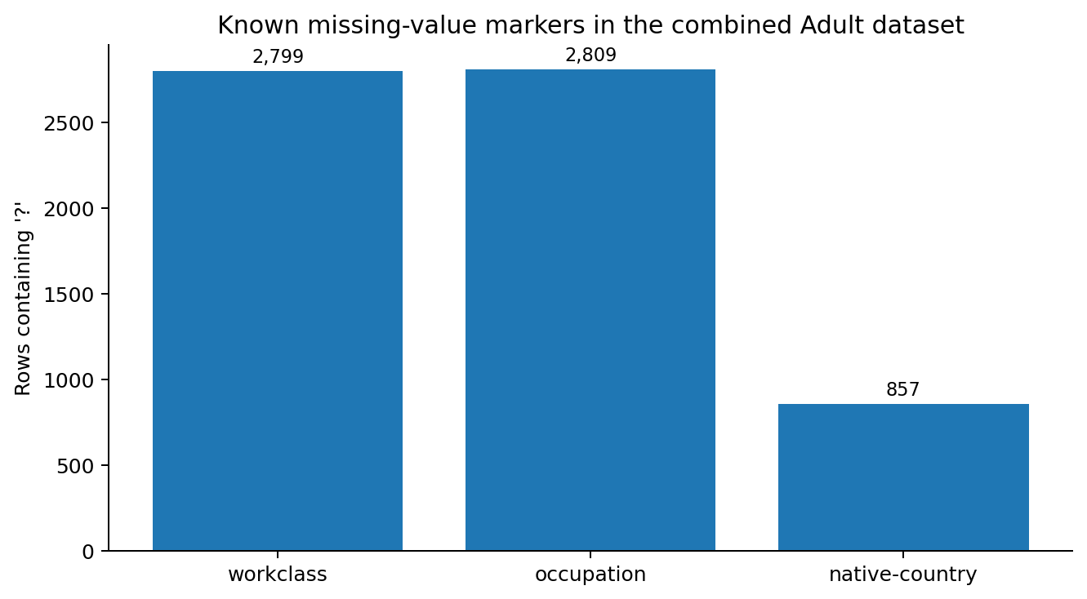
Figure 1. The UCI Adult data contain explicit '?' missing-value markers. The combined dataset contains 2,799 such workclass entries, 2,809 occupation entries, and 857 native-country entries.

4. Data Cleaning Strategy
The cleaning pipeline is intentionally ordered. Missing-value markers are standardized before missingness is measured; text is stripped before categories are counted; numerical conversion occurs before numerical outlier analysis; and target labels are normalized before the final validation. This sequencing prevents one quality issue from hiding another.

4.1 Standardize column names
# Make column names consistent and easier to reference
df.columns = (
df.columns
.str.strip()
.str.lower()
.str.replace("-", "_", regex=False)
.str.replace(" ", "_", regex=False)
)
print(df.columns.tolist())

4.2 Standardize text values and missing markers
# Strip accidental whitespace from all text columns
text_cols = df.select_dtypes(include="object").columns
for col in text_cols:
df[col] = df[col].str.strip()
# Convert source missing markers to pandas missing values
df = df.replace({"?": pd.NA, "": pd.NA})
# Recalculate missingness after normalization
missing = (
df.isna()
.sum()
.sort_values(ascending=False)
.to_frame("missing_count")
)
missing["missing_pct"] = 100 * missing["missing_count"] / len(df)
display(missing[missing["missing_count"] > 0])
This is preferable to treating '?' as a legitimate category. If '?' remained in the data, a model could interpret missingness as a meaningful employment class or country. Converting the marker to pd.NA makes the missing-data mechanism visible and allows a deliberate imputation strategy.

4.3 Duplicate-record check
duplicate_count = df.duplicated().sum()
duplicate_pct = 100 * duplicate_count / len(df)
print("Duplicate rows:", duplicate_count)
print(f"Duplicate percentage: {duplicate_pct:.2f}%")
# Only remove duplicates after inspecting them
duplicates = df[df.duplicated(keep=False)].sort_values(by=df.columns.tolist())
display(duplicates.head(20))
Duplicate removal should not be automatic. In survey or census-style data, two people can legitimately have identical feature values. Therefore, the correct decision depends on whether the assignment is treating duplicate rows as accidental repeated records or as valid observations. If no unique record identifier exists, the report should document the chosen policy rather than claiming that every duplicate is an error.

5. Missing-Value Treatment
Missing-value handling is one of the most consequential preprocessing decisions because it can change both sample size and the distribution of the data. The Adult dataset contains missing values primarily in categorical employment/geography fields. Because those columns are categorical, mode imputation is possible but can hide the fact that information was missing. A more transparent approach is to retain a dedicated 'Unknown' category for categorical variables.

5.1 Recommended categorical strategy
categorical_cols = df.select_dtypes(include="object").columns
# Preserve missingness as an explicit category
for col in categorical_cols:
df[col] = df[col].fillna("Unknown")
# Verify that categorical missing values are resolved
print(df[categorical_cols].isna().sum().sum())
The rationale is that the absence of a recorded workclass, occupation, or country can itself contain information. Replacing missing categories with the most frequent category would artificially increase the dominant class and could bias later analysis.

5.2 Numerical missing values
numeric_cols = df.select_dtypes(include="number").columns
for col in numeric_cols:
if df[col].isna().any():
df[col] = df[col].fillna(df[col].median())
Median imputation is preferred over mean imputation when numerical distributions are skewed or contain extreme values. It is robust to large observations and preserves a typical central value without being pulled strongly by the tail.

6. Inconsistency and Validity Checks
Inconsistencies include values that are syntactically valid but semantically suspicious. For this dataset, checks focus on impossible ages, non-positive working hours, inconsistent education fields, and unexpected category labels.
# Domain plausibility checks
checks = {
"age_below_17": (df["age"] < 17).sum(),
"age_above_100": (df["age"] > 100).sum(),
"hours_nonpositive": (df["hours_per_week"] <= 0).sum(),
"education_num_nonpositive": (df["education_num"] <= 0).sum(),
"negative_capital_gain": (df["capital_gain"] < 0).sum(),
"negative_capital_loss": (df["capital_loss"] < 0).sum(),
}
for name, count in checks.items():
print(f"{name}: {count}")
A useful distinction is made between an invalid value and an unusual value. For example, a high number of hours worked may be unusual but not necessarily erroneous. In contrast, a negative age would violate a basic domain rule and should be investigated as a data error.

6.1 Education consistency
The dataset contains both education (a category such as Bachelors or Masters) and education-num (a numeric ordinal representation). These two columns should be checked for contradictions. Rather than dropping either column immediately, the recommended procedure is to compare their cross-tabulation and document any mismatches.
# Inspect the relationship between education and education_num
education_map = (
df.groupby("education")["education_num"]
.agg(["min", "max", "median", "nunique"])
.sort_values("median")
)
display(education_map)
# Cross-tabulation can reveal unexpected combinations
display(pd.crosstab(df["education"], df["education_num"]))

7. Outlier Detection and Treatment
Outlier analysis is performed only on numerical variables. The primary diagnostic is the IQR rule: observations below Q1 - 1.5×IQR or above Q3 + 1.5×IQR are flagged. The flag is a diagnostic, not an automatic deletion rule.
def iqr_outlier_summary(data, columns):
rows = []
for col in columns:
q1 = data[col].quantile(0.25)
q3 = data[col].quantile(0.75)
iqr = q3 - q1
lower = q1 - 1.5 * iqr
upper = q3 + 1.5 * iqr
mask = (data[col] < lower) | (data[col] > upper)
rows.append({
"column": col,
"q1": q1,
"q3": q3,
"iqr": iqr,
"lower_bound": lower,
"upper_bound": upper,
"outlier_count": int(mask.sum()),
"outlier_pct": 100 * mask.mean()
})
return pd.DataFrame(rows).sort_values("outlier_pct", ascending=False)
numeric_cols = [
"age", "fnlwgt", "education_num",
"capital_gain", "capital_loss", "hours_per_week"
]
outlier_report = iqr_outlier_summary(df, numeric_cols)
display(outlier_report)
For this dataset, variables such as capital-gain and capital-loss can be highly right-skewed. The presence of extreme values is therefore expected and does not by itself justify deletion. A reasonable Week 1 policy is to retain valid observations and use robust transformations later if a downstream model is sensitive to skewness.

7.1 Optional winsorization for model-sensitive workflows
def winsorize_iqr(series):
q1 = series.quantile(0.25)
q3 = series.quantile(0.75)
iqr = q3 - q1
lower = q1 - 1.5 * iqr
upper = q3 + 1.5 * iqr
return series.clip(lower=lower, upper=upper)
# Use only when justified by the downstream analysis:
# df["hours_per_week"] = winsorize_iqr(df["hours_per_week"])
Winsorization should be treated as an optional modelling decision, not a default cleaning step. For an assignment focused on preserving the source population, retaining valid extreme observations is generally more defensible.

8. Encoding and Numerical Preprocessing
After quality issues have been addressed, categorical variables can be encoded and numerical features can be scaled if required by later analysis. One-hot encoding is appropriate for nominal categories. Standardization is useful for algorithms that depend on feature magnitude, such as distance-based models or regularized linear models.
from sklearn.compose import ColumnTransformer
from sklearn.preprocessing import OneHotEncoder, StandardScaler
from sklearn.pipeline import Pipeline
target = "income"
X = df.drop(columns=[target])
y = df[target].str.replace(".", "", regex=False).str.strip()
numeric_features = X.select_dtypes(include="number").columns.tolist()
categorical_features = X.select_dtypes(include="object").columns.tolist()
preprocessor = ColumnTransformer(
transformers=[
("num", StandardScaler(), numeric_features),
("cat", OneHotEncoder(handle_unknown="ignore"), categorical_features)
]
)
print("Numeric features:", numeric_features)
print("Categorical features:", categorical_features)
The use of a ColumnTransformer is preferable to manually encoding columns because the same transformations can later be applied consistently to training and test data. The handle_unknown setting also prevents a model pipeline from failing when a new category appears in a validation or future dataset.

9. Final Validation
A cleaning process is incomplete until the final table is audited again. Validation checks that the transformations actually achieved their intended purpose and did not introduce new errors.
# Final structural checks
print("Final shape:", df.shape)
print("Duplicate rows:", df.duplicated().sum())
# Missing-value check
print("\nRemaining missing values:")
display(df.isna().sum().sort_values(ascending=False).head(20))
# Data types
print("\nData types:")
print(df.dtypes)
# Target distribution
print("\nTarget distribution:")
display(df[target].value_counts(normalize=True).rename("proportion"))
# Numeric sanity checks
display(df[numeric_cols].describe().T)

9.1 Reproducibility assertion
# Example assertions for a clean analytical table
assert df.columns.is_unique
assert df["age"].between(17, 100).all()
assert (df["hours_per_week"] > 0).all()
assert df["education_num"].notna().all()
assert df["income"].isin(["<=50K", ">50K"]).all()
print("All core validation checks passed.")
Assertions are useful because they turn assumptions into executable tests. If a future version of the dataset violates one of these rules, the pipeline fails loudly rather than silently producing a potentially misleading analytical table.

10. Challenges Encountered and How They Were Addressed
Challenge | Risk | Resolution
Missing values encoded as '?' | Missingness could be treated as a real category. | Standardize '?' to pd.NA before measuring or imputing missingness.
Whitespace in text labels | Equivalent categories can be counted separately. | Strip leading/trailing whitespace from text columns.
Skewed numerical variables | IQR may flag legitimate high-value observations. | Flag first; retain valid observations unless domain evidence supports removal.
Mixed categorical and numerical data | Manual transformations can become inconsistent. | Use ColumnTransformer and explicit feature lists.
No universal unique row identifier | Duplicate rows may be ambiguous. | Inspect duplicates and document the policy rather than blindly dropping them.
Target punctuation / formatting | The same class can appear with slightly different strings. | Normalize target labels before validation.

11. Impact of Preprocessing on Subsequent Analysis
- Missing-value handling can change the effective sample size and the distribution of categorical variables.
- Treating missing categories as 'Unknown' preserves observations but introduces an additional level that must be interpreted carefully.
- Outlier treatment can materially change means, standard deviations, regression coefficients, and distance-based models.
- Standardization changes numerical scale but not the underlying rank order of observations.
- One-hot encoding expands the feature space, which can affect model complexity and computational cost.
- Removing duplicates can change class balance and should therefore be measured before and after cleaning.
- Preprocessing decisions must be fitted on the training data only when a predictive modelling workflow is introduced; otherwise information from the test set can leak into the model.
The most important downstream risk is data leakage. For example, calculating an imputation median or a scaling mean using the entire dataset before a train/test split allows information from the test set to influence the training process. The final implementation should therefore place learned transformations inside a scikit-learn Pipeline whenever a predictive model is built.

12. Recommended Final Preprocessing Pipeline
The following sequence provides a practical, auditable order for future analysis:
- Acquire the dataset from the official UCI repository and preserve the original source.
- Load the data and record its initial shape, data types, and target definition.
- Normalize column names and strip whitespace from text fields.
- Convert source-specific missing markers such as '?' into pd.NA.
- Profile missingness, duplicates, category frequencies, and numerical distributions.
- Apply domain validity checks before statistical outlier rules.
- Use explicit 'Unknown' categories for missing categorical observations when justified.
- Use robust numerical imputation, such as the median, only where numerical missingness exists.
- Flag outliers with IQR and investigate them rather than automatically deleting them.
- Normalize the target labels and verify allowed target values.
- Build a ColumnTransformer for one-hot encoding and numerical scaling when modelling begins.
- Run final assertions and save a clean, documented analytical dataset.

13. Reflection
The central lesson from this preprocessing exercise is that data cleaning is not simply a technical sequence of commands. Each transformation represents an assumption about what the data mean. Replacing a missing workclass with the most common category, for example, makes a stronger assumption than retaining an 'Unknown' category. Likewise, removing IQR outliers can make a dataset appear cleaner while potentially deleting legitimate members of the population.
For this reason, the preferred strategy in this report is conservative and reproducible. The pipeline fixes clearly identifiable representation problems, preserves valid observations, documents ambiguous cases, and postpones model-specific transformations until the downstream task is known. This approach creates a cleaner foundation without claiming that statistical rarity is equivalent to data error.

14. Conclusion
The UCI Adult dataset provides a strong example of a real-world tabular dataset that requires more than a simple dropna() operation. The completed workflow covers data acquisition, structural profiling, missing-value normalization, duplicate inspection, categorical cleaning, domain validation, outlier analysis, encoding, scaling, and final quality checks.
The resulting methodology is reusable for future datasets: acquire from a reliable source, profile before modifying, distinguish errors from legitimate extremes, make transformations explicit, and validate the final output. These practices reduce downstream analytical risk and make the eventual modelling stage more reproducible.

15. Appendix A — Complete Reproducible Script
# WEEK 1 — DATA ACQUISITION, CLEANING, AND PREPROCESSING
# UCI Adult Dataset
from ucimlrepo import fetch_ucirepo
import pandas as pd
import numpy as np
# 1. Acquire
adult = fetch_ucirepo(id=2)
df = pd.concat([adult.data.features, adult.data.targets], axis=1).copy()
# 2. Standardize column names
df.columns = (
df.columns
.str.strip()
.str.lower()
.str.replace("-", "_", regex=False)
.str.replace(" ", "_", regex=False)
)
# 3. Strip text whitespace
for col in df.select_dtypes(include="object").columns:
df[col] = df[col].str.strip()
# 4. Normalize missing markers
df = df.replace({"?": pd.NA, "": pd.NA})
# 5. Basic audit
print("Shape:", df.shape)
print("\nMissing values:")
print(df.isna().sum().sort_values(ascending=False))
print("\nDuplicates:", df.duplicated().sum())
# 6. Domain checks
print("\nAge outside expected range:",
((df["age"] < 17) | (df["age"] > 100)).sum())
print("Non-positive hours:",
(df["hours_per_week"] <= 0).sum())
print("Negative capital gain:",
(df["capital_gain"] < 0).sum())
print("Negative capital loss:",
(df["capital_loss"] < 0).sum())
# 7. Missing-value treatment
categorical_cols = df.select_dtypes(include="object").columns.tolist()
for col in categorical_cols:
df[col] = df[col].fillna("Unknown")
numeric_cols = df.select_dtypes(include="number").columns.tolist()
for col in numeric_cols:
if df[col].isna().any():
df[col] = df[col].fillna(df[col].median())
# 8. Normalize target
df["income"] = (
df["income"]
.astype(str)
.str.replace(".", "", regex=False)
.str.strip()
)
# 9. IQR outlier audit
def iqr_outlier_summary(data, columns):
rows = []
for col in columns:
q1 = data[col].quantile(0.25)
q3 = data[col].quantile(0.75)
iqr = q3 - q1
lower = q1 - 1.5 * iqr
upper = q3 + 1.5 * iqr
mask = (data[col] < lower) | (data[col] > upper)
rows.append({
"column": col,
"lower_bound": lower,
"upper_bound": upper,
"outlier_count": int(mask.sum()),
"outlier_pct": 100 * mask.mean()
})
return pd.DataFrame(rows)
outlier_cols = [
"age", "fnlwgt", "education_num",
"capital_gain", "capital_loss", "hours_per_week"
]
outlier_report = iqr_outlier_summary(df, outlier_cols)
print("\nOutlier report:")
print(outlier_report)
# 10. Final validation
assert df.columns.is_unique
assert df["age"].between(17, 100).all()
assert (df["hours_per_week"] > 0).all()
assert df["income"].isin(["<=50K", ">50K"]).all()
assert df.duplicated().sum() >= 0
print("\nFinal shape:", df.shape)
print("Cleaning and validation completed successfully.")

16. Appendix B — Submission Checklist
- Report saved as DOCX.
- Dataset source and acquisition method documented.
- Initial exploration included.
- Missing-value representation identified and addressed.
- Inconsistency and validity checks documented.
- Outlier detection method documented.
- Preprocessing rationale explained.
- Potential downstream impacts discussed.
- Reproducible Python code included.
- Final validation and assertions included.
- Source citation included.

Primary source and citation: Becker, B. & Kohavi, R. (1996). Adult [Dataset]. UCI Machine Learning Repository. DOI: 10.24432/C5XW20.

