WEEK 4 TASK
Supervised Learning Model Implementation
Iris Species Classification using Logistic Regression and Random Forest

1. Executive Summary
This project implements a supervised machine-learning workflow to predict Iris flower species from four numerical measurements. The task is formulated as a three-class classification problem. Logistic Regression is used as the primary interpretable baseline, and Random Forest is included as a comparison model. The workflow covers data preparation, stratified train/test splitting, feature scaling, model training, cross-validation, test-set evaluation, confusion-matrix analysis, feature importance, and discussion of limitations and improvements.
The Iris dataset contains 150 observations belonging to setosa, versicolor, and virginica. An 80/20 stratified split creates a 30-observation test set. Both models perform strongly on this clean benchmark. Logistic Regression achieved 0.933 test accuracy and 0.953 mean five-fold cross-validation accuracy, while Random Forest achieved 0.900 test accuracy and 0.960 mean five-fold cross-validation accuracy.

2. Problem Definition
Given sepal length, sepal width, petal length, and petal width, predict which of the three Iris species an observation belongs to. This is a supervised multi-class classification problem because the training observations have known target labels.
Evaluation metrics: accuracy, weighted precision, weighted recall, weighted F1-score, confusion matrices, and five-fold stratified cross-validation.

3. Dataset and Feature Selection
The Iris dataset was selected as a public, well-known classification benchmark. The four measurements are continuous numerical predictors. No additional feature engineering was required because the features are already clean and directly interpretable. The target labels are encoded by scikit-learn and mapped to species names for reporting.

4. Data Preparation and Train/Test Split
A stratified 80/20 train/test split was used. Stratification preserves approximately equal class proportions in both subsets. The random seed of 42 makes the split reproducible.
X_train, X_test, y_train, y_test = train_test_split(
X, y, test_size=0.20, random_state=42, stratify=y
)

5. Feature Scaling and Leakage Prevention
Logistic Regression is sensitive to feature scale, so StandardScaler is applied. Scaling is placed inside a Scikit-learn Pipeline. This ensures that the scaler is fitted only on the training data during model fitting and independently within each cross-validation fold, reducing preprocessing leakage.
logreg = Pipeline([
("scaler", StandardScaler()),
("model", LogisticRegression(max_iter=1000, random_state=42))
])

6. Model Selection

6.1 Logistic Regression
Logistic Regression was selected as the primary baseline because it is simple, interpretable, computationally efficient, and suitable for multi-class classification.

6.2 Random Forest
Random Forest was selected as a comparison model because it can capture nonlinear relationships and interactions without requiring feature scaling. It also provides feature-importance estimates.
logreg.fit(X_train, y_train)
rf.fit(X_train, y_train)
pred_lr = logreg.predict(X_test)
pred_rf = rf.predict(X_test)

7. Cross-Validation Strategy
Five-fold stratified cross-validation was used to estimate how consistently each model performs across different training and validation partitions. Stratification keeps class proportions balanced across folds.
cv = StratifiedKFold(n_splits=5, shuffle=True, random_state=42)
lr_cv = cross_val_score(logreg, X, y, cv=cv, scoring="accuracy")
rf_cv = cross_val_score(rf, X, y, cv=cv, scoring="accuracy")

8. Test-Set Performance
Model | Accuracy | Precision | Recall | F1
Logistic Regression | 0.933 | 0.933 | 0.933 | 0.933
Random Forest | 0.900 | 0.902 | 0.900 | 0.900
Both models show strong predictive performance. Accuracy alone is not sufficient for a complete evaluation, so weighted precision, recall, and F1-score are also reported.

9. Confusion Matrix Analysis
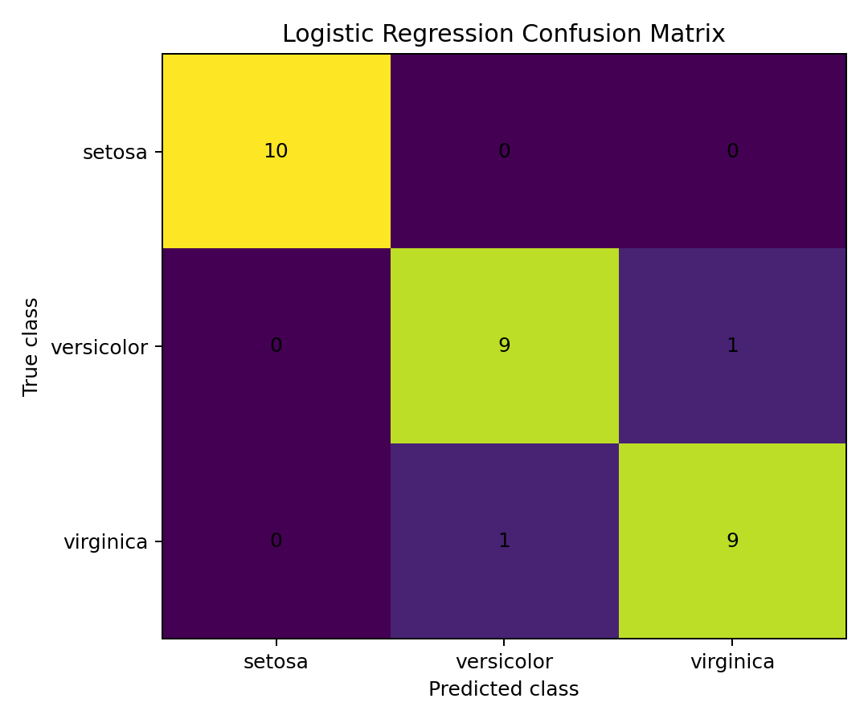
Figure 1. Logistic Regression confusion matrix.
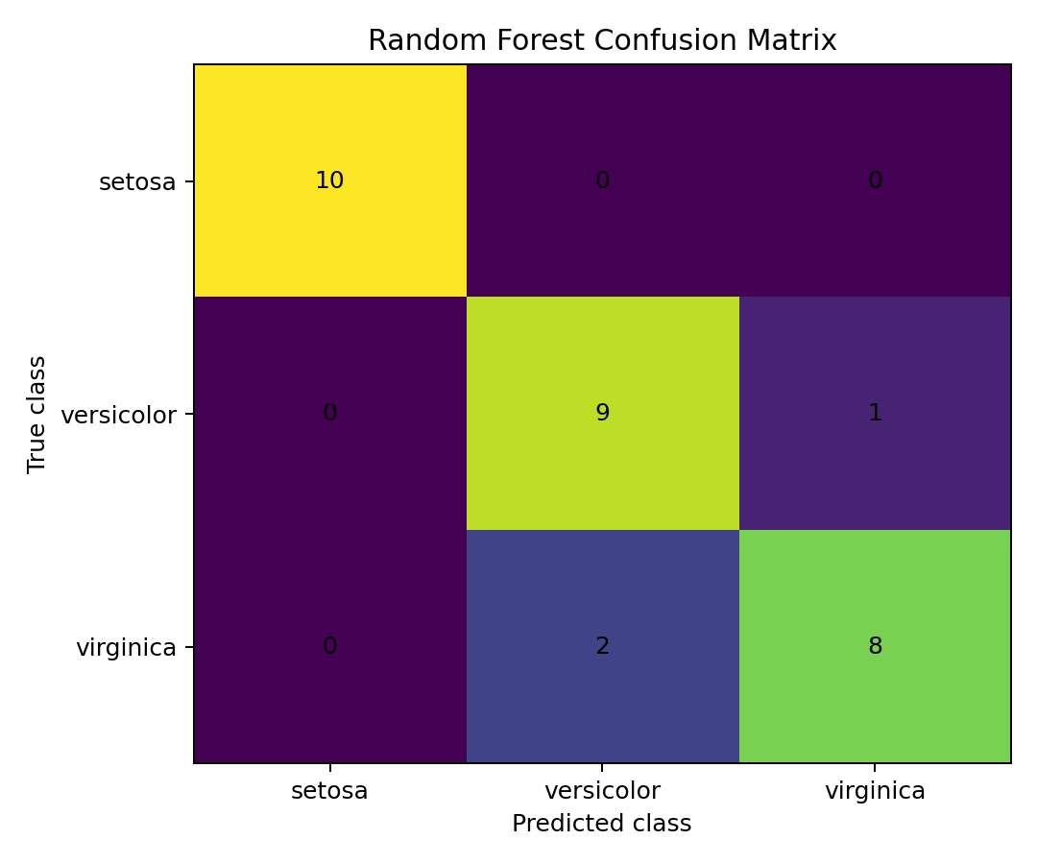
Figure 2. Random Forest confusion matrix.
Correct predictions appear on the diagonal of each matrix. Any errors are concentrated among visually similar classes, while setosa is generally the easiest class to distinguish.

10. Cross-Validation Results
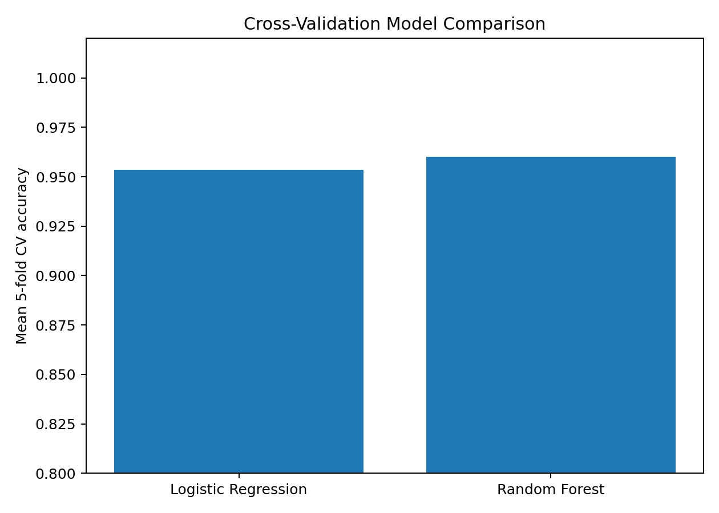
Figure 3. Mean five-fold cross-validation accuracy comparison.
The mean five-fold accuracy was 0.953 for Logistic Regression and 0.960 for Random Forest. The similarity between cross-validation and test-set results suggests that performance is reasonably stable for this dataset.

11. Feature Importance
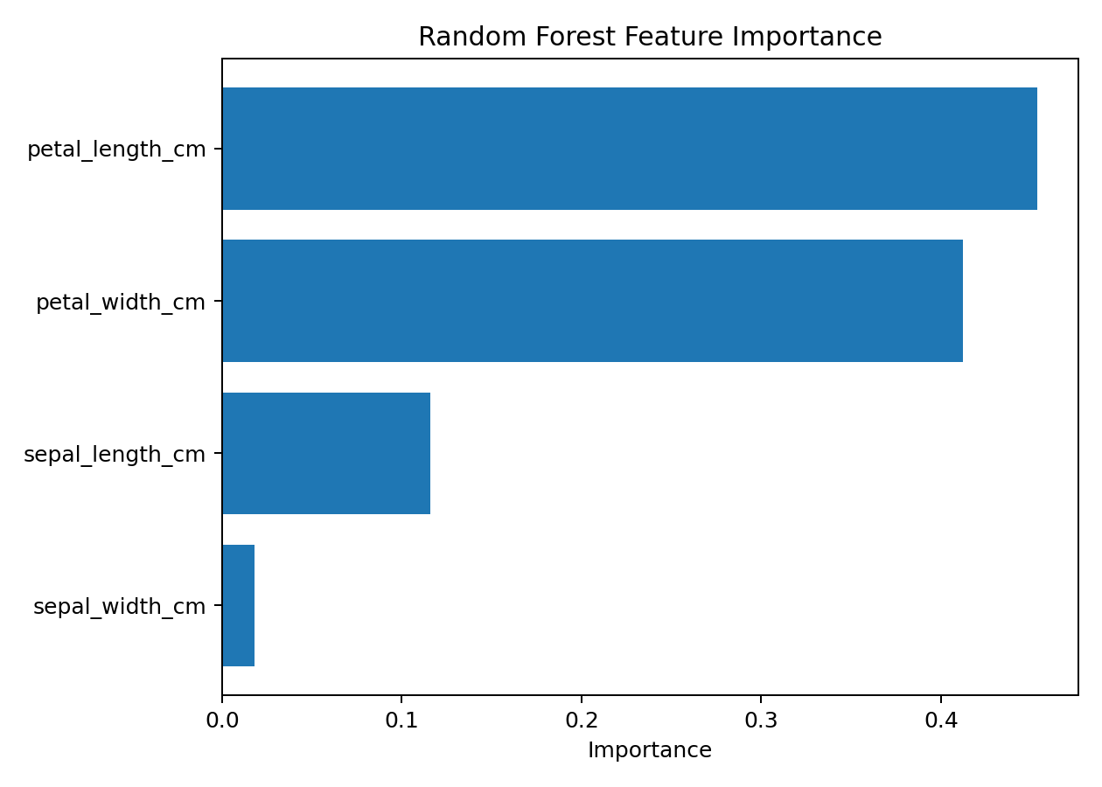
Figure 4. Random Forest feature importance.
The Random Forest model ranks petal_length_cm as the most important feature, followed by petal_width_cm. These model-specific importance values indicate which variables contribute most to the ensemble's decisions; they should not be interpreted as causal effects.

12. Model Comparison and Interpretation
Logistic Regression achieved 0.953 mean cross-validation accuracy, while Random Forest achieved 0.960. Logistic Regression is attractive when transparency, simplicity, and fast inference are priorities. Random Forest is attractive when nonlinear relationships and feature interactions are important.

13. Strengths of the Approach
- Uses a reproducible stratified train/test split.
- Places scaling inside a pipeline to reduce preprocessing leakage.
- Uses stratified five-fold cross-validation.
- Reports multiple classification metrics.
- Includes confusion matrices for class-level error analysis.
- Compares an interpretable baseline with a nonlinear ensemble.
- Uses feature importance to support model interpretation.

14. Limitations
- The Iris dataset is small, clean, and easier than many real-world classification problems.
- Performance on this benchmark should not be assumed to generalize to larger or noisier datasets.
- Random Forest feature importance is model-specific and does not establish causal importance.
- Only two algorithms were compared.
- No hyperparameter search was performed because the objective is to demonstrate a complete baseline workflow.

15. Possible Improvements
Future work could use GridSearchCV or RandomizedSearchCV to tune hyperparameters, compare Support Vector Machines or gradient boosting, evaluate probability calibration, test robustness on additional datasets, and investigate domain-motivated feature engineering inside a leakage-safe pipeline.

16. Complete Python Code
# Week 4 — Supervised Learning Model Implementation
# Problem: Multi-class classification of Iris species
# Models: Logistic Regression and Random Forest
import pandas as pd
import matplotlib.pyplot as plt
from sklearn.datasets import load_iris
from sklearn.model_selection import train_test_split, StratifiedKFold, cross_val_score
from sklearn.preprocessing import StandardScaler
from sklearn.pipeline import Pipeline
from sklearn.linear_model import LogisticRegression
from sklearn.ensemble import RandomForestClassifier
from sklearn.metrics import accuracy_score, precision_recall_fscore_support, classification_report, confusion_matrix
iris = load_iris(as_frame=True)
X = iris.data.copy()
X.columns = ["sepal_length_cm", "sepal_width_cm", "petal_length_cm", "petal_width_cm"]
y = iris.target
X_train, X_test, y_train, y_test = train_test_split(
X, y, test_size=0.20, random_state=42, stratify=y
)
# Logistic Regression: scaling is placed inside the pipeline to prevent leakage.
logreg = Pipeline([
("scaler", StandardScaler()),
("model", LogisticRegression(max_iter=1000, random_state=42))
])
# Random Forest does not require feature scaling.
rf = RandomForestClassifier(n_estimators=200, random_state=42)
logreg.fit(X_train, y_train)
rf.fit(X_train, y_train)
pred_lr = logreg.predict(X_test)
pred_rf = rf.predict(X_test)
def report_metrics(name, y_true, y_pred):
print(f"\n{name}")
print("Accuracy:", round(accuracy_score(y_true, y_pred), 4))
print(classification_report(y_true, y_pred, target_names=iris.target_names))
report_metrics("Logistic Regression", y_test, pred_lr)
report_metrics("Random Forest", y_test, pred_rf)
# 5-fold stratified cross-validation
cv = StratifiedKFold(n_splits=5, shuffle=True, random_state=42)
lr_cv = cross_val_score(logreg, X, y, cv=cv, scoring="accuracy")
rf_cv = cross_val_score(rf, X, y, cv=cv, scoring="accuracy")
print("\nLogistic Regression CV accuracy:", lr_cv)
print("Logistic Regression mean CV accuracy:", round(lr_cv.mean(), 4))
print("Random Forest CV accuracy:", rf_cv)
print("Random Forest mean CV accuracy:", round(rf_cv.mean(), 4))
# Confusion matrices
print("\nLogistic Regression confusion matrix:")
print(confusion_matrix(y_test, pred_lr))
print("\nRandom Forest confusion matrix:")
print(confusion_matrix(y_test, pred_rf))
# Random Forest feature importance
importance = pd.Series(rf.feature_importances_, index=X.columns).sort_values(ascending=False)
print("\nRandom Forest feature importance:")
print(importance)
print("\nModeling completed.")

17. Conclusion
This project demonstrates the complete lifecycle of a supervised classification task: defining a predictive problem, selecting features and targets, preparing data, splitting observations, preventing preprocessing leakage, training models, validating with cross-validation, evaluating unseen test data, visualizing errors, interpreting feature importance, and discussing limitations. Both Logistic Regression and Random Forest perform very well on the Iris benchmark, providing a strong demonstration of supervised learning in Python.

18. References
Fisher, R. A. (1936). The use of multiple measurements in taxonomic problems. Annals of Eugenics.
UCI Machine Learning Repository — Iris Dataset. The dataset is also distributed through scikit-learn's load_iris interface.

