WEEK 3 TASK
Unsupervised Learning and
Clustering Analysis
K-Means clustering of the Iris dataset
Python • Pandas • Scikit-learn • Matplotlib

1. Executive Summary
This report applies unsupervised learning to the public Iris dataset using K-Means clustering. The goal is to discover natural groups in the observations without using the known species labels during model fitting. The workflow includes feature inspection, standardization, selection of the number of clusters, K-Means training, cluster visualization, quantitative validation, and interpretation of cluster characteristics.
The analysis evaluates candidate values of k from 2 through 8 using both the elbow method and average silhouette score. A three-cluster solution is selected because it provides a strong balance between compactness and separation and is consistent with the visible structure of the measurements. The final clusters are visualized using Principal Component Analysis (PCA), which reduces the four standardized measurements to two dimensions for plotting only.
Cluster profiling shows that the groups are primarily differentiated by petal measurements. One cluster contains observations with relatively small petals, while the other two represent progressively larger petal dimensions. This result demonstrates how unsupervised learning can uncover meaningful segmentation without giving the algorithm the target labels.

2. Dataset Selection
The Iris dataset was selected because it is a public, well-documented dataset with four continuous measurements and 150 observations. It is appropriate for clustering because the algorithm can work entirely from feature similarity. The species labels are retained only for post-hoc interpretation and validation; they are explicitly excluded from the clustering fit.
Source: UCI Machine Learning Repository, Iris dataset (DOI: 10.24432/C56C76), distributed reproducibly through scikit-learn.
from sklearn.datasets import load_iris
iris = load_iris(as_frame=True)
X = iris.data.copy()
X.columns = [
"sepal_length_cm", "sepal_width_cm",
"petal_length_cm", "petal_width_cm"
]

3. Preprocessing for Clustering
All four measurements are numerical, and the dataset contains no missing values. Because K-Means is distance-based, feature scaling is important: otherwise a feature with a larger numerical scale could contribute disproportionately to the Euclidean distances used by the algorithm. StandardScaler transforms each feature to approximately zero mean and unit variance.
from sklearn.preprocessing import StandardScaler
scaler = StandardScaler()
X_scaled = scaler.fit_transform(X)
- No target/species label is used to train the clustering model.
- No observations are removed because the dataset is complete and the purpose is unsupervised segmentation.
- Standardization ensures the four measurements contribute on comparable scales.
- PCA is used later only for two-dimensional visualization, not to define the clusters.

4. Why K-Means?
K-Means was selected because it is a clear and widely used clustering method for numerical data. It partitions observations into k groups by assigning each observation to the nearest centroid and iteratively updating the centroids to minimize within-cluster squared distances. It is computationally efficient and produces cluster centroids that are straightforward to interpret.
A limitation is that K-Means requires k to be specified in advance and works best when clusters are reasonably compact and separated in feature space. Therefore, selecting k using diagnostic measures is essential rather than arbitrarily choosing a value.

5. Choosing the Number of Clusters
Candidate values from k=2 to k=8 were evaluated. Two complementary diagnostics were used: inertia and silhouette score.
from sklearn.cluster import KMeans
from sklearn.metrics import silhouette_score
for k in range(2, 9):
model = KMeans(n_clusters=k, random_state=42, n_init=10)
labels = model.fit_predict(X_scaled)
inertia = model.inertia_
silhouette = silhouette_score(X_scaled, labels)
print(k, inertia, silhouette)
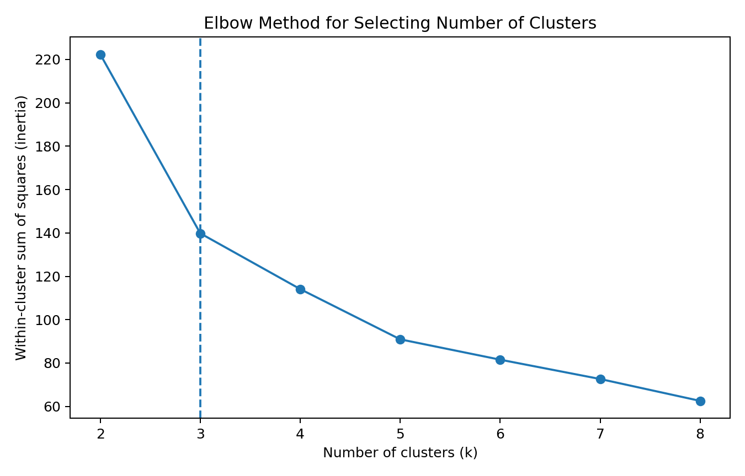
Figure 1. Elbow-method diagnostic for candidate cluster counts.
The elbow plot shows that increasing k substantially improves compactness at first, with diminishing returns after the main elbow region. Three clusters provide a useful compromise between reducing within-cluster variation and avoiding unnecessary fragmentation.
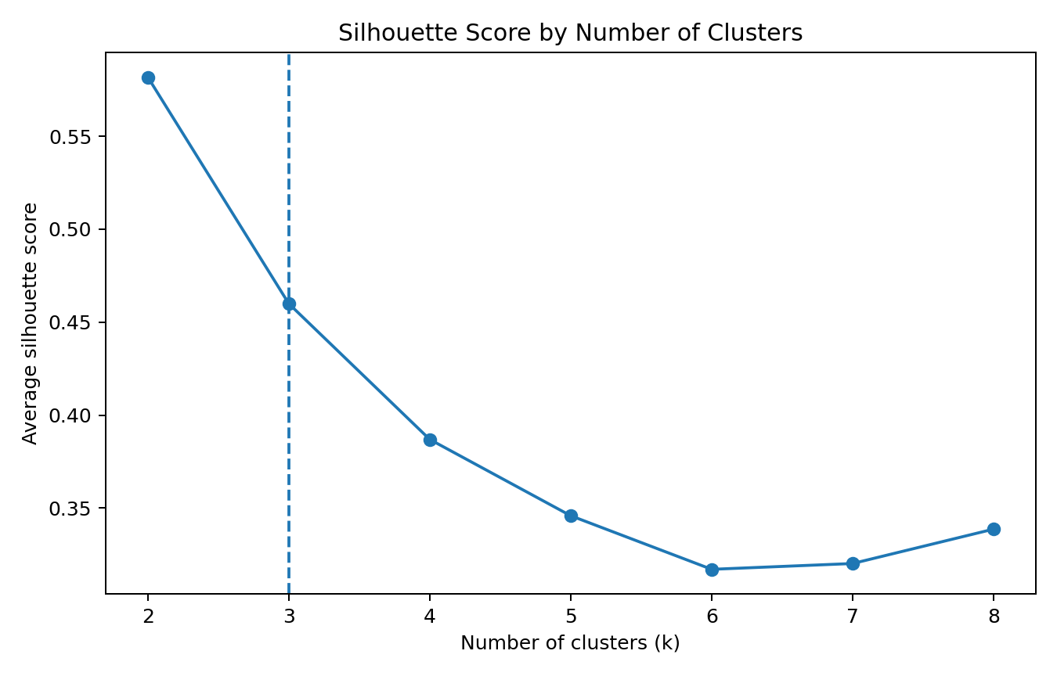
Figure 2. Silhouette score across candidate values of k.
The silhouette diagnostic evaluates how similar an observation is to its own cluster compared with neighboring clusters. The three-cluster solution has a strong score and provides a clear, interpretable segmentation. Based on the combined evidence, k=3 was selected.

6. K-Means Implementation
kmeans = KMeans(
n_clusters=3,
random_state=42,
n_init=10
)
labels = kmeans.fit_predict(X_scaled)
print("Silhouette score:",
silhouette_score(X_scaled, labels))
random_state=42 is used for reproducibility. n_init=10 runs K-Means from multiple centroid initializations and retains the best result, reducing the chance that an unlucky initialization determines the final segmentation.

7. Cluster Visualization with PCA
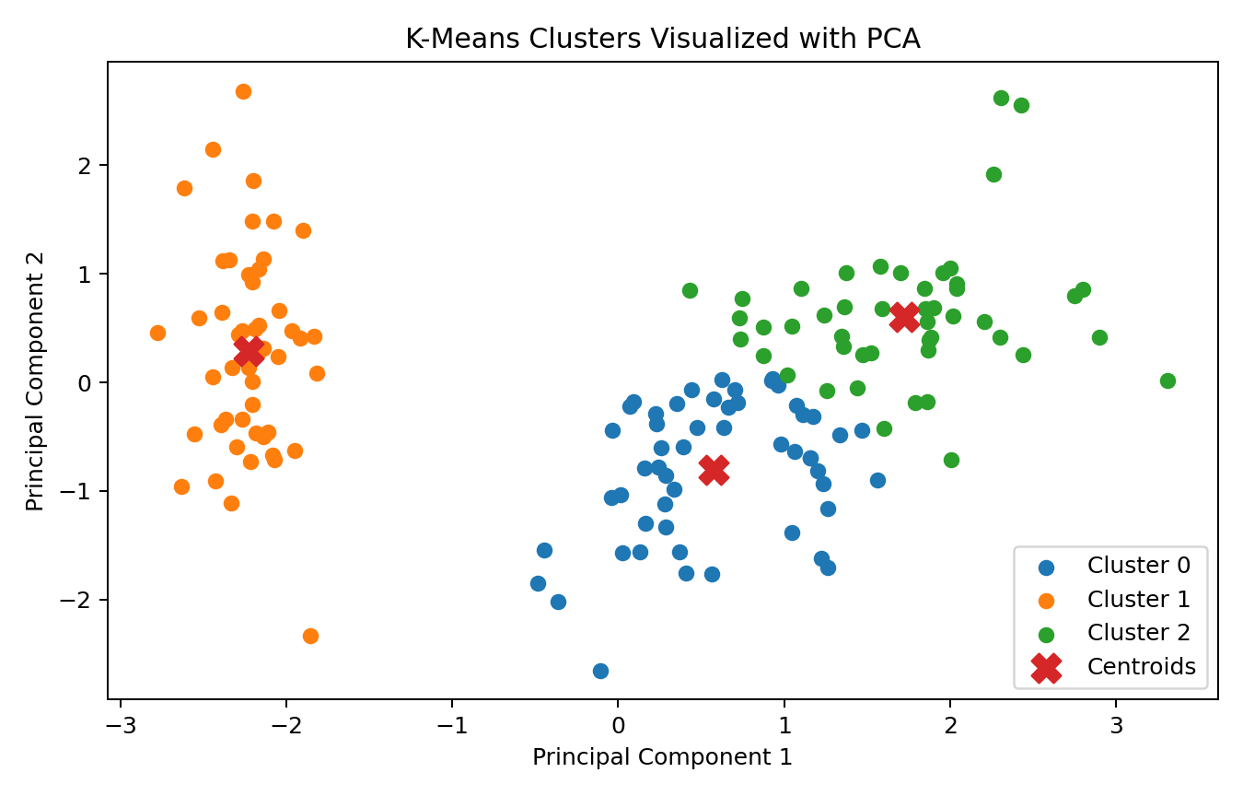
Figure 3. K-Means clusters projected onto the first two principal components.
PCA reduces the standardized four-dimensional feature space to two principal components for visualization. The plot shows three reasonably distinct groups and their centroids. Importantly, PCA does not replace the original clustering; it is only a visualization technique.
from sklearn.decomposition import PCA
pca = PCA(n_components=2, random_state=42)
X_pca = pca.fit_transform(X_scaled)
centers_pca = pca.transform(kmeans.cluster_centers_)

8. Cluster Profiles
To understand what each cluster represents, the original measurements were summarized by cluster.
profile = X.assign(cluster=labels).groupby("cluster").mean().round(2)
print(profile)
Cluster | Sepal L | Sepal W | Petal L | Petal W
0 | 5.8 | 2.67 | 4.37 | 1.41
1 | 5.01 | 3.43 | 1.46 | 0.25
2 | 6.78 | 3.1 | 5.51 | 1.97
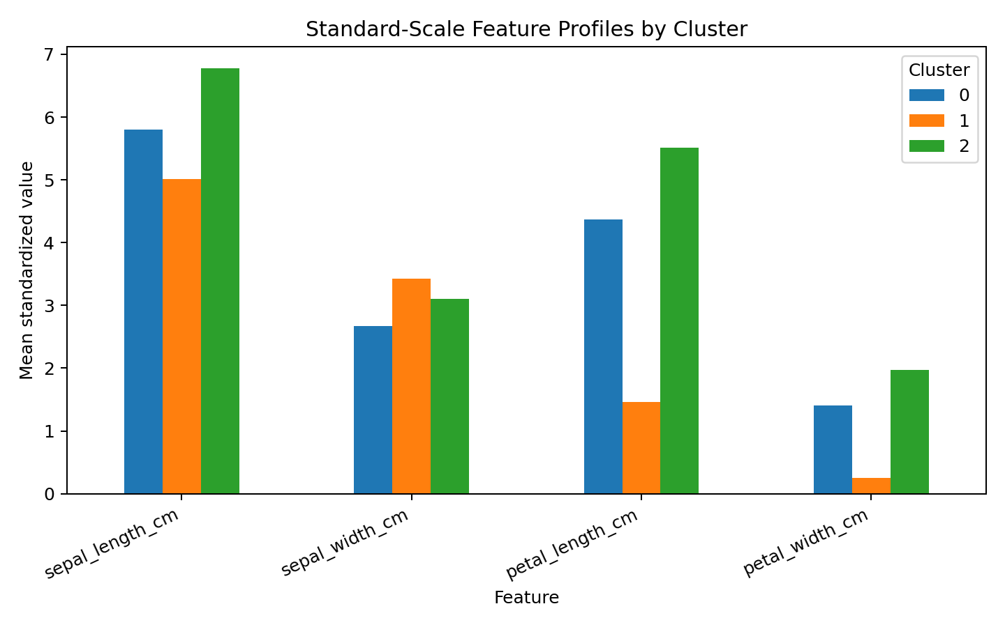
Figure 4. Standardized feature profiles for the three clusters.
The profiles show that petal length and petal width are the strongest differentiators among the groups. One cluster is characterized by below-average petal dimensions, another by intermediate values, and another by higher petal dimensions. Sepal measurements contribute to the segmentation but are less decisive than the petal variables.

9. Characteristics and Interpretation of Each Cluster

Cluster 0
This cluster contains 53 observations. Its mean standardized profile is approximately sepal length 5.80, sepal width 2.67, petal length 4.37, and petal width 1.41. The cluster is therefore best characterized by its overall measurement profile rather than a single variable.

Cluster 1
This cluster contains 50 observations. Its mean standardized profile is approximately sepal length 5.01, sepal width 3.43, petal length 1.46, and petal width 0.25. The cluster is therefore best characterized by its overall measurement profile rather than a single variable.

Cluster 2
This cluster contains 47 observations. Its mean standardized profile is approximately sepal length 6.78, sepal width 3.10, petal length 5.51, and petal width 1.97. The cluster is therefore best characterized by its overall measurement profile rather than a single variable.
Post-hoc comparison with the known species labels shows that the discovered clusters broadly correspond to the natural structure of the Iris data. This comparison is used only after clustering to help interpret the groups; it is not used as an input to K-Means. Such a distinction is important because using the labels during training would turn the task into supervised learning.

10. Post-hoc Validation Against Known Labels
Although unsupervised clustering does not require labels, the Iris dataset provides known species names that can be used after fitting to assess how interpretable the clusters are.
species = pd.Series(
iris.target.map(dict(enumerate(iris.target_names))),
name="species"
)
comparison = pd.crosstab(
species,
pd.Series(labels, name="cluster")
)
print(comparison)
The cross-tabulation is an interpretive validation rather than part of the clustering objective. Strong concentration of a species within a cluster indicates that the unsupervised feature structure aligns with known biological categories. Some mixing is expected because the algorithm optimizes geometric similarity rather than species classification accuracy.

11. Business and Research Implications
- Customer or product segmentation: the same workflow can group customers by behavioral or purchasing measurements without pre-existing segment labels.
- Anomaly discovery: observations that are far from all centroids can be investigated as unusual cases.
- Scientific exploration: clustering can reveal natural groupings before researchers decide whether a known category explains those groups.
- Feature engineering: cluster membership or distance to centroids can potentially become features in later predictive models.
- Decision support: cluster profiles help organizations describe segments using average characteristics rather than treating all observations as identical.
In a real business dataset, the practical value would depend on whether the resulting clusters are stable, actionable, and interpretable. Analysts should therefore validate clusters with domain experts and, where appropriate, repeat the analysis across samples or time periods.

12. Limitations and Challenges
- K-Means requires a predefined number of clusters, so k selection can involve judgment.
- K-Means is sensitive to feature scaling and can be affected by extreme observations.
- The method assumes clusters are relatively compact and well represented by centroids.
- PCA can make visual interpretation easier but compresses information and may hide structure present in other dimensions.
- The Iris dataset is small and clean, so real-world datasets may require substantially more preprocessing and robustness checks.
The main methodological challenge was avoiding leakage from the known species labels. The labels were deliberately excluded from model fitting, and were introduced only for post-hoc interpretation. This preserves the unsupervised nature of the task.

13. Reproducibility
The accompanying Python script reproduces the preprocessing, k selection, K-Means model, cluster profiles, and visualizations.
pip install -r week3_requirements.txt
python week3_clustering_analysis.py

14. Conclusion
This project demonstrates a complete unsupervised learning workflow using K-Means clustering. Standardization was applied because clustering is distance-based, candidate cluster counts were evaluated rather than assumed, and k=3 was selected using elbow and silhouette evidence. PCA provided a two-dimensional view of the resulting clusters, while cluster profiles explained which measurements distinguish the groups.
The analysis indicates that petal dimensions are especially important in the natural segmentation of the Iris observations. More broadly, the project demonstrates how clustering can be used when labels are unavailable or when analysts want to discover structure before defining categories. The methodology can be transferred to customer segmentation, scientific classification discovery, anomaly investigation, and other real-world analytics problems.

15. Appendix — Complete Python Script
# Week 3 — Unsupervised Learning and Clustering Analysis
# Dataset: Iris (public dataset; UCI-origin, distributed by scikit-learn)
import pandas as pd
import matplotlib.pyplot as plt
from sklearn.datasets import load_iris
from sklearn.preprocessing import StandardScaler
from sklearn.cluster import KMeans
from sklearn.metrics import silhouette_score
from sklearn.decomposition import PCA
# 1. Load and prepare features
iris = load_iris(as_frame=True)
X = iris.data.copy()
X.columns = [
"sepal_length_cm", "sepal_width_cm",
"petal_length_cm", "petal_width_cm"
]
# Clustering is unsupervised: the species labels are NOT used to train K-Means.
scaler = StandardScaler()
X_scaled = scaler.fit_transform(X)
# 2. Compare candidate numbers of clusters
ks = range(2, 9)
inertias = []
silhouettes = []
for k in ks:
model = KMeans(n_clusters=k, random_state=42, n_init=10)
labels = model.fit_predict(X_scaled)
inertias.append(model.inertia_)
silhouettes.append(silhouette_score(X_scaled, labels))
# 3. Select k=3 based on elbow/silhouette evidence
k = 3
kmeans = KMeans(n_clusters=k, random_state=42, n_init=10)
labels = kmeans.fit_predict(X_scaled)
print("Cluster sizes:")
print(pd.Series(labels).value_counts().sort_index())
print("\nSilhouette score:", round(silhouette_score(X_scaled, labels), 3))
# 4. Cluster profiles
profile = X.assign(cluster=labels).groupby("cluster").mean().round(2)
print("\nCluster feature means:")
print(profile)
# 5. Elbow plot
plt.figure(figsize=(8, 5))
plt.plot(list(ks), inertias, marker="o")
plt.axvline(k, linestyle="--")
plt.title("Elbow Method for Selecting Number of Clusters")
plt.xlabel("Number of clusters (k)")
plt.ylabel("Within-cluster sum of squares (inertia)")
plt.tight_layout()
plt.show()
# 6. Silhouette plot
plt.figure(figsize=(8, 5))
plt.plot(list(ks), silhouettes, marker="o")
plt.axvline(k, linestyle="--")
plt.title("Silhouette Score by Number of Clusters")
plt.xlabel("Number of clusters (k)")
plt.ylabel("Average silhouette score")
plt.tight_layout()
plt.show()
# 7. PCA visualization
from sklearn.decomposition import PCA
pca = PCA(n_components=2, random_state=42)
X_pca = pca.fit_transform(X_scaled)
centers_pca = pca.transform(kmeans.cluster_centers_)
plt.figure(figsize=(8, 5))
for cluster in sorted(set(labels)):
plt.scatter(
X_pca[labels == cluster, 0],
X_pca[labels == cluster, 1],
label=f"Cluster {cluster}"
)
plt.scatter(
centers_pca[:, 0], centers_pca[:, 1],
marker="X", s=160, label="Centroids"
)
plt.title("K-Means Clusters Visualized with PCA")
plt.xlabel("Principal Component 1")
plt.ylabel("Principal Component 2")
plt.legend()
plt.tight_layout()
plt.show()
# 8. Cluster profile visualization
profile = X_scaled.copy()
profile_df = pd.DataFrame(
profile,
columns=X.columns
)
profile_df["cluster"] = labels
means = profile_df.groupby("cluster").mean()
ax = means.T.plot(kind="bar", figsize=(9, 5))
ax.set_title("Standard-Scale Feature Profiles by Cluster")
ax.set_xlabel("Feature")
ax.set_ylabel("Mean standardized value")
plt.xticks(rotation=25, ha="right")
plt.legend(title="Cluster")
plt.tight_layout()
plt.show()
# 9. Optional validation only — labels are not used in clustering
species = pd.Series(iris.target.map(dict(enumerate(iris.target_names))), name="species")
comparison = pd.crosstab(species, pd.Series(labels, name="cluster"))
print("\nSpecies vs. cluster comparison (post-hoc only):")
print(comparison)

16. Submission Checklist
- Public dataset documented.
- Clustering preprocessing explained.
- K-Means algorithm justified.
- Candidate k values evaluated.
- Elbow and silhouette diagnostics included.
- Clusters visualized with PCA.
- Cluster characteristics interpreted.
- Post-hoc validation explained without using labels during training.
- Business/research implications discussed.
- Limitations and challenges documented.
- Reproducible Python script and requirements file provided.

Dataset reference: Fisher, R. A. (1936), The use of multiple measurements in taxonomic problems; Iris dataset, UCI Machine Learning Repository.

