WEEK 6 TASK
Integrative Capstone Project and Evaluation
Breast Cancer Diagnostic Analysis using Python

1. Executive Summary
This capstone integrates the main skills developed during the internship into one reproducible data-science pipeline. The project uses the public Breast Cancer Wisconsin (Diagnostic) dataset distributed through scikit-learn to investigate whether tumor measurements can support diagnostic classification. The workflow includes data acquisition, quality assessment, exploratory analysis, preprocessing, supervised classification, unsupervised clustering, evaluation, visualization, and recommendations.
The dataset contains 569 observations and 30 numerical predictor variables. Quality checks found 0 missing values and 0 duplicate rows. Logistic Regression achieved 0.982 test accuracy and Random Forest achieved 0.947. Five-fold cross-validation produced mean accuracies of 0.974 and 0.953, respectively. For unsupervised analysis, K-Means was evaluated from k=2 through k=7, with k=2 selected using the highest silhouette score (0.345).

2. Problem Statement
The practical question is whether measured characteristics of breast-cell nuclei can be used to classify observations into malignant or benign diagnostic categories. This is primarily a binary supervised-classification problem, complemented by unsupervised clustering to investigate whether natural groups exist in the standardized feature space.

3. Data Collection
The dataset is a public benchmark originating from the Breast Cancer Wisconsin (Diagnostic) dataset and is distributed through scikit-learn's dataset interface. Using the built-in public interface makes the analysis reproducible and avoids dependence on a local proprietary source.
Features include measurements such as radius, texture, perimeter, area, smoothness, compactness, concavity, symmetry, and related summary statistics.

4. Data Cleaning and Preprocessing
The first stage checked dimensions, data types, descriptive statistics, missing values, and duplicate rows. No missing values or duplicate records were detected in the loaded benchmark. Because the predictors are numerical and already structured, no categorical encoding was necessary. Standardization was applied before clustering and inside the Logistic Regression pipeline. Keeping scaling inside the supervised pipeline prevents test-set information from influencing the fitted transformation.
Core preprocessing code:
data = load_breast_cancer(as_frame=True)
df = data.frame.copy()
X = df.drop(columns="target")
y = df["target"]
X_train, X_test, y_train, y_test = train_test_split(
X, y, test_size=0.20, random_state=42, stratify=y
)
logreg = Pipeline([
("scaler", StandardScaler()),
("model", LogisticRegression(max_iter=3000))
])

5. Exploratory Data Analysis
The target distribution was inspected before modeling. Grouped means were also calculated to compare several clinically meaningful measurement families between the two classes.
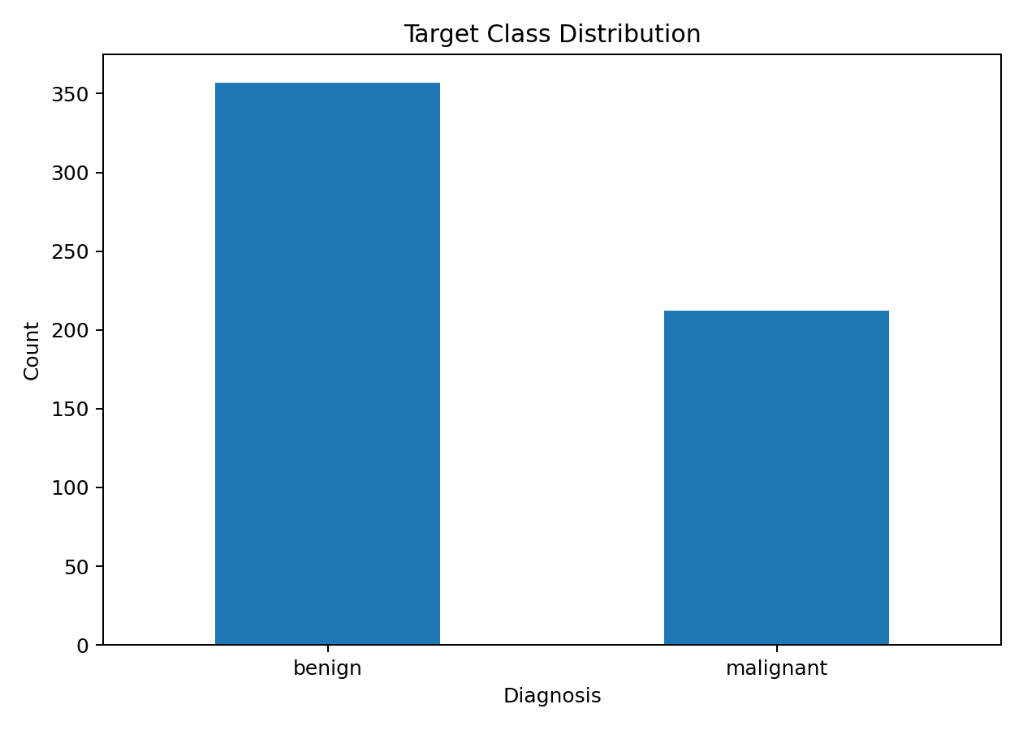
Figure 1. Distribution of malignant and benign observations.
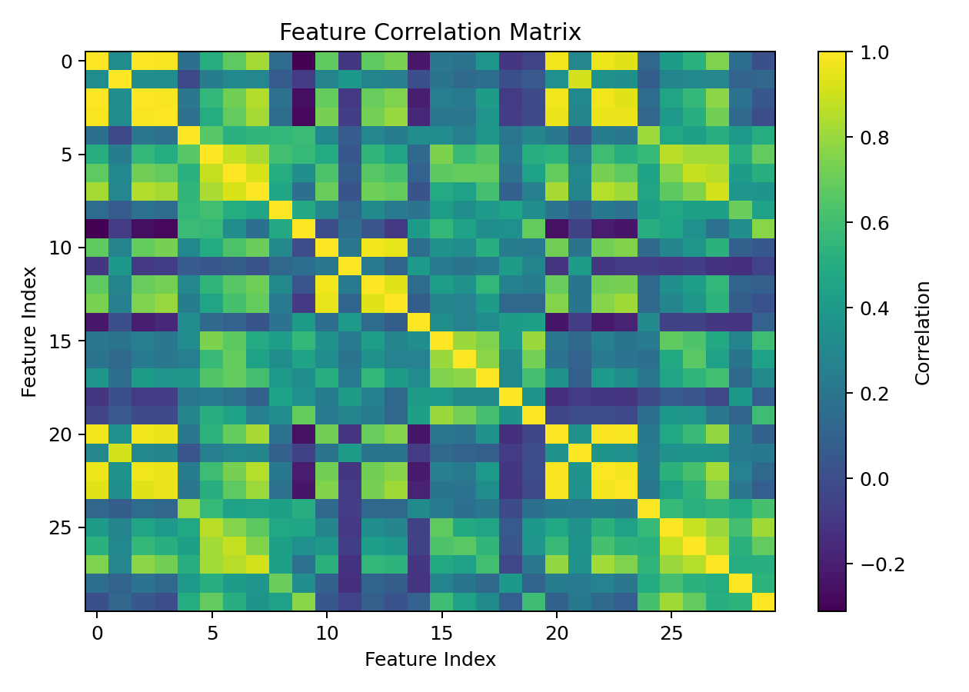
Figure 2. Correlation matrix across numerical predictors.
The correlation analysis shows substantial relationships among several measurements, which is expected because some variables are different summaries of related geometric properties. This supports the use of regularized or tree-based methods rather than assuming all predictors provide independent information.

6. Supervised Modeling

6.1 Logistic Regression
Logistic Regression was selected as an interpretable baseline. StandardScaler was included in a pipeline, and the model was trained on the stratified training subset.

6.2 Random Forest
Random Forest was selected as a nonlinear comparison model. It can capture interactions and nonlinear decision boundaries without requiring feature scaling.

6.3 Evaluation
Model | Accuracy | Precision | Recall | F1
Logistic Regression | 0.982 | 0.986 | 0.986 | 0.986
Random Forest | 0.947 | 0.958 | 0.958 | 0.958
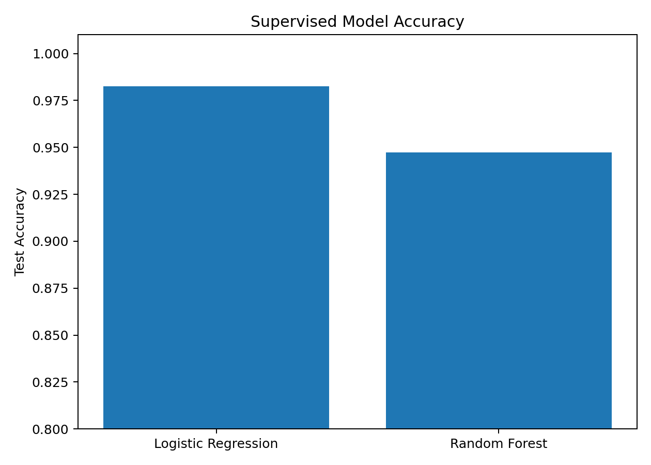
Figure 3. Test-set accuracy comparison.
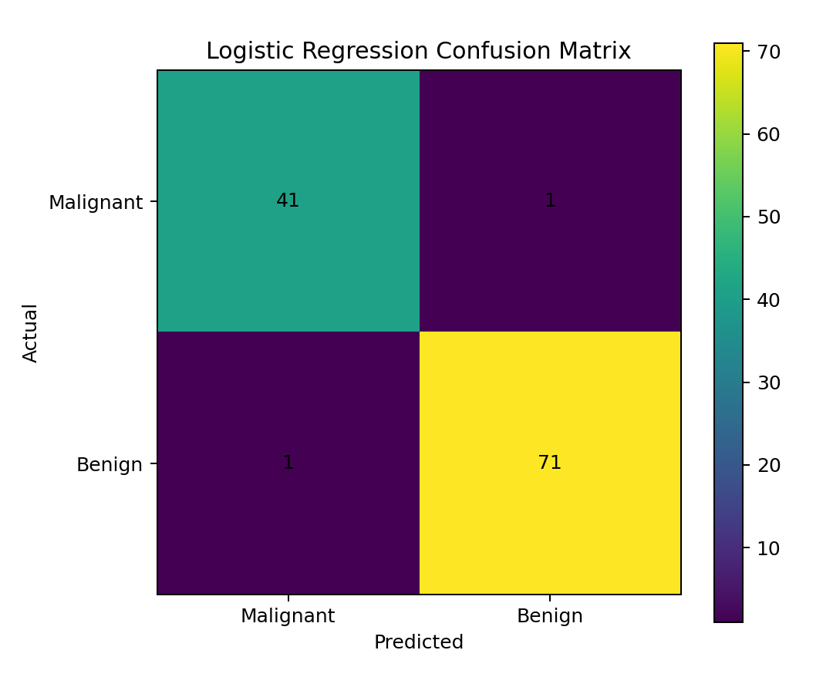
Figure 4. Logistic Regression confusion matrix.
Five-fold stratified cross-validation produced mean accuracy of 0.974 for Logistic Regression and 0.953 for Random Forest. Cross-validation provides a more stable estimate than relying on one train/test split.

7. Unsupervised Learning
To complement prediction, K-Means clustering was applied to standardized predictors. Candidate values from k=2 through k=7 were evaluated using silhouette score. The best score occurred at k=2, so that value was selected for the final clustering analysis. PCA was then used only for two-dimensional visualization of the high-dimensional standardized feature space.
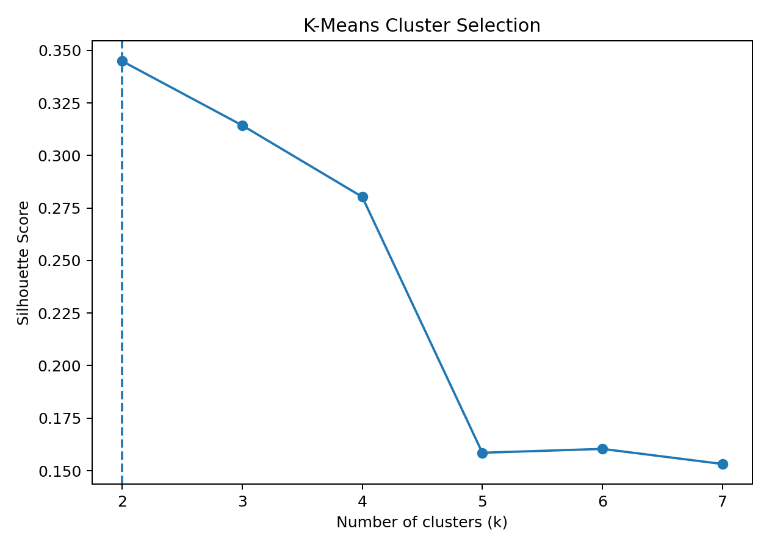
Figure 5. Silhouette scores used to select the number of clusters.
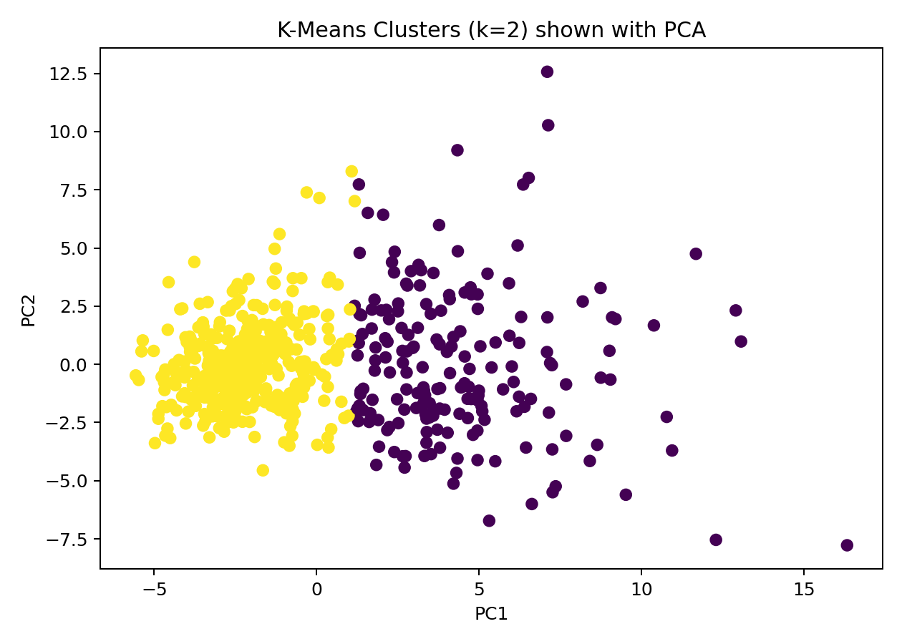
Figure 6. K-Means clusters visualized through the first two PCA components.
Cluster analysis is descriptive rather than a substitute for clinical diagnosis. The unsupervised results help investigate structure in the measurements but should not be treated as medical conclusions.

8. Key Insights
- Several numerical measurements are strongly correlated, indicating overlapping information among feature families.
- The supervised models achieve high predictive performance on this benchmark, demonstrating that the measured characteristics contain substantial information about the target class.
- Logistic Regression provides an interpretable baseline, while Random Forest provides a nonlinear alternative.
- Cross-validation confirms that model performance is reasonably stable across multiple stratified folds.
- K-Means clustering reveals structure in the standardized feature space, although unsupervised clusters should be interpreted cautiously and independently from the known target labels.

9. Challenges and How They Were Addressed
- High dimensionality: PCA was used only for visualization, preserving the original feature space for modeling.
- Feature scale differences: StandardScaler was used for Logistic Regression and clustering.
- Potential data leakage: scaling was placed inside the Logistic Regression pipeline, and the test set was held out before model evaluation.
- Model-selection uncertainty: five-fold stratified cross-validation was used alongside the held-out test set.
- Interpretation risk: clustering was treated as descriptive analysis rather than a diagnostic procedure.

10. Recommendations
For a real deployment, further work should include external validation, careful clinical review, calibration analysis, threshold selection based on the relative cost of false negatives and false positives, and stronger governance around medical-data privacy and model monitoring. From a technical perspective, hyperparameter tuning, feature selection, explainability methods, and comparison with gradient boosting or support-vector methods could improve the study.

11. Limitations
This is a benchmark dataset rather than a complete clinical workflow. The sample is relatively small, the features are engineered numerical summaries, and the results should not be generalized to unseen hospitals or populations without external validation. High test accuracy also does not imply that the model is clinically ready.

12. Conclusion
This capstone demonstrates an end-to-end Python data-science workflow: acquiring a public dataset, assessing quality, preprocessing, exploring distributions and correlations, building supervised models, validating and evaluating them, applying unsupervised clustering, visualizing results, and translating findings into cautious recommendations. The project combines the main techniques practiced during the internship into a single reproducible analysis.

13. Reproducible Python Code
# Week 6 — Integrative Capstone Project
# Breast Cancer Diagnostic Analysis: preprocessing, EDA, supervised classification, and clustering
import pandas as pd
import numpy as np
from sklearn.datasets import load_breast_cancer
from sklearn.model_selection import train_test_split, StratifiedKFold, cross_val_score
from sklearn.preprocessing import StandardScaler
from sklearn.pipeline import Pipeline
from sklearn.linear_model import LogisticRegression
from sklearn.ensemble import RandomForestClassifier
from sklearn.cluster import KMeans
from sklearn.decomposition import PCA
from sklearn.metrics import accuracy_score, precision_score, recall_score, f1_score, confusion_matrix, silhouette_score
# 1. Data acquisition
data = load_breast_cancer(as_frame=True)
df = data.frame.copy()
X = df.drop(columns="target")
y = df["target"]
# 2. Quality checks
print("Shape:", df.shape)
print("Missing values:", int(df.isna().sum().sum()))
print("Duplicates:", int(df.duplicated().sum()))
print(df.describe())
# 3. EDA
df["target_name"] = df["target"].map({0:"malignant", 1:"benign"})
print(df["target_name"].value_counts())
print(df.groupby("target_name")[["mean radius","mean texture","mean perimeter","mean area"]].mean())
# 4. Supervised learning
X_train, X_test, y_train, y_test = train_test_split(
X, y, test_size=0.20, random_state=42, stratify=y
)
logreg = Pipeline([
("scaler", StandardScaler()),
("model", LogisticRegression(max_iter=3000, random_state=42))
])
rf = RandomForestClassifier(n_estimators=300, random_state=42)
logreg.fit(X_train, y_train)
rf.fit(X_train, y_train)
for name, model in [("Logistic Regression", logreg), ("Random Forest", rf)]:
pred = model.predict(X_test)
print(name)
print("Accuracy:", accuracy_score(y_test, pred))
print("Precision:", precision_score(y_test, pred))
print("Recall:", recall_score(y_test, pred))
print("F1:", f1_score(y_test, pred))
print(confusion_matrix(y_test, pred))
cv = StratifiedKFold(n_splits=5, shuffle=True, random_state=42)
print("LR CV accuracy:", cross_val_score(logreg, X, y, cv=cv).mean())
print("RF CV accuracy:", cross_val_score(rf, X, y, cv=cv).mean())
# 5. Unsupervised learning
Xs = StandardScaler().fit_transform(X)
scores = []
for k in range(2, 8):
labels = KMeans(n_clusters=k, n_init=20, random_state=42).fit_predict(Xs)
scores.append((k, silhouette_score(Xs, labels)))
print("Silhouette scores:", scores)
k = max(scores, key=lambda x: x[1])[0]
labels = KMeans(n_clusters=k, n_init=20, random_state=42).fit_predict(Xs)
# 6. PCA visualization
Z = PCA(n_components=2, random_state=42).fit_transform(Xs)
print("Selected k:", k)

14. References
Scikit-learn documentation: Breast Cancer Wisconsin (Diagnostic) dataset and associated preprocessing/modeling utilities.
Wolberg, W. H., Street, W. N., Mangasarian, O. L. Breast Cancer Wisconsin (Diagnostic) dataset.

