GEMS icon (?)  gemsX.png |  |  |  | 

New(Clone)  NewCloneRecordIcon.png |  |   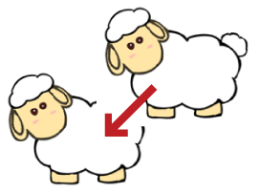 |  | 
New(Create)  NewCreateRecordIcon.png |  |  |  | 
Display selected record  SelectDisplayRecordIcon.png |   ✓ |  |  | 
Remake record data structure  RemakeRecordIcon.png |   ✓ |    |  | 
Calculate record data  CalculateRecordDataIcon.png | 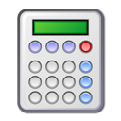  ✓ | 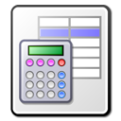 |  | 
Save current record  SaveCurrentRecordIcon.png |   ✓ |  |  | 
Delete current record  DeleteCurrentRecordIcon.png | ✓ |  |  | 
Plot data on graph dialog  PlotDataOnGraphIcon.png | ✓ | 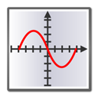 |  | 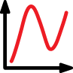
Print data to ASCII file  PrintDataToFileIcon.png |   ✓ |  |  | 
Show Help Contents  ShowHelpWindowIcon.png |   ✓ |  |  | 
Display next record  DisplayNextRecordIcon.png |   ✓ |  |  | 
Display previous record  DisplayPrevRecordIcon.png |   ✓ |  |  | 
Set filter for record keys  SetKeyTemplateIcon.png | ✓ |  | 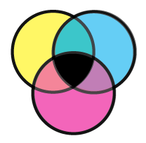 | 
Press to open Recipe Wizard for bulk chemical composition (BCC) of the system  RecipeWizardIcon.png | 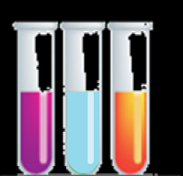✓ |    | 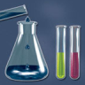 | 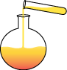
Press for detailed setup of the system and its bulk chemical composition (BCC)  DetailedCSDIcon.png |   ✓ | 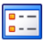 | 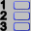  ✓ | 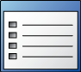
Press to check system definition and calculate bulk chemical composition (BCC)  CalculateBCCIcon.png | 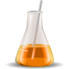  ✓ | NEW  |  | 
Press to calculate equilibrium using GEM IPM  CalculateGEMIcon.png | ✓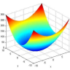 |  |   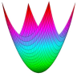 | 
Press to explore detailed GEM IPM results  ShowGEMResultsIcon.png |   ✓ |  |  | 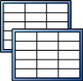
Switch to Computation of Equilibrium mode  EquilibriumModeIcon.png | ✓ |    | NEW  | 
Switch to Thermodynamic Database mode  DatabaseModeIcon.png |   ✓ |    |  | 
Home (help menu)  HomeInHelpMenu.png |   ✓ |  |  | 
HelpWindowMenu  SearchBackwardIcon.png  SearchForwardIcon.png |  |  |  |   

Main Menu Icons

Service Icons

Messages Information Icons  ErrorMessageIcon.png  WarningMessageIcon.png  InfoMessageIcon.png |  |  |  | 
Question Icon
QuestionMessageIcon.png
Cancel  CancelIcon.png |  |  |  | 
Other |  |    | 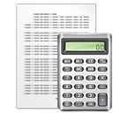

Module Icons
Independent Components (IComp)  ICompModuleIcon.png | ✓ | NEW  |   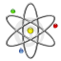 | 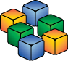
Dependent Components (DComp)  DCompModuleIcon.png | 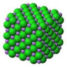✓ | NEW  | 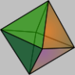 | 
Dependent Components (ReacDC)  ReacDCModuleIcon.png | 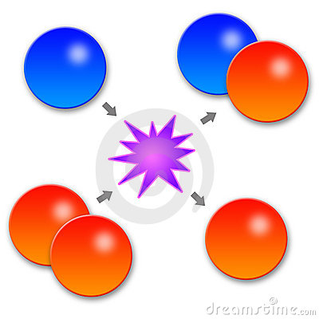  ✓ | NEW  |  | 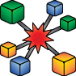
T/P Tabulations and Plots (RTparm)  RTparmModuleIcon.png | ✓ | NEW 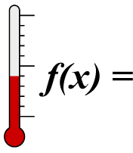 | 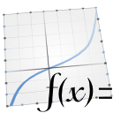   | 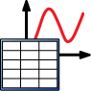
Thermodynamic Phases (Phase)  PhaseModuleIcon.png | 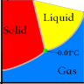 | NEW  | 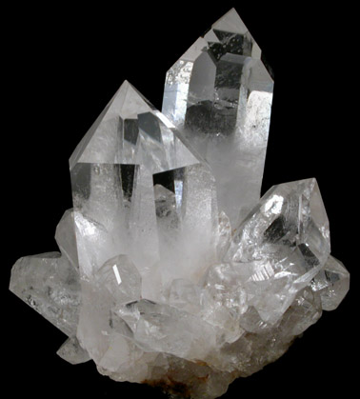   | 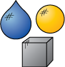
XXX (?)  PhaseDiagramModuleIcon.png | --- | --- | --- | NEW  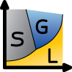
Predefined Compositions (Compos)  ComposModuleIcon.png |   ✓ | NEW  | 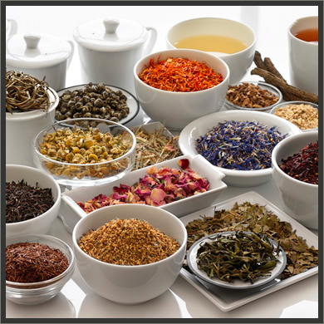 | 
Single Chemical System Equilibrium (SysEq)  SysEqModuleIcon.png | ✓ | NEW |  | 
Process Simulators (Process)  ProcessModuleIcon.png | ✓ | NEW  |  | 
Coupled Fluid-Mass Transport (GEM2MT)  GEM2MTModuleIcon.png | 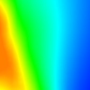✓ | 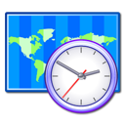 |  | 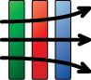
Data Samplers and Plotters (GtDemo)  GtDemoModuleIcon.png | 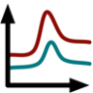 ✓ |  |  | 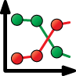
Dual Thermodynamics (DualTh)  DualThModuleIcon.png |  |  |  | 
Sensitivity Studies (UnSpace)  UnSpaceModuleIcon.png |  |  |  | 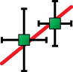
Modelling Project and Numerical Settings (Project)  ModelingProjectIcon.png |  ✓ |  | 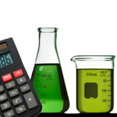 | 
Bibliography and Scripts (SDref)  SDrefModuleIcon.png |   ✓ |  |  | 

All icons must be resized to 96x96 and saved in png under names given in the table

