
How Mo works
How every number in Mo traces back to its source data and the method that calculated it.
Prepared by Aevah for BUILT · October 2026

In brief
Mo is BUILT's demand intelligence experience, built and operated by Aevah. It turns BUILT's retail sales data into forecasts, cannibalization reads, promotion and price reads, and retailer views that BUILT's teams can use directly.
For a finance team, a number is only as good as the ability to say where it came from. Mo is built so that every figure has an answer to that question:
Every number starts in source data.  Mo's figures are calculated from SPINS weekly retail sales and BUILT's own records, loaded with their full history into Mo's data store. | Every number has a defined method.  Each kind of figure comes from a set calculation or a trained model, described in this document, never from a language model. | Every number can be traced.  Forecasts and model scores are stored with the model version and the date that produced them. The cannibalization and price views show each result's source, model and date, and the forecast views show the last week of actual sales they use.

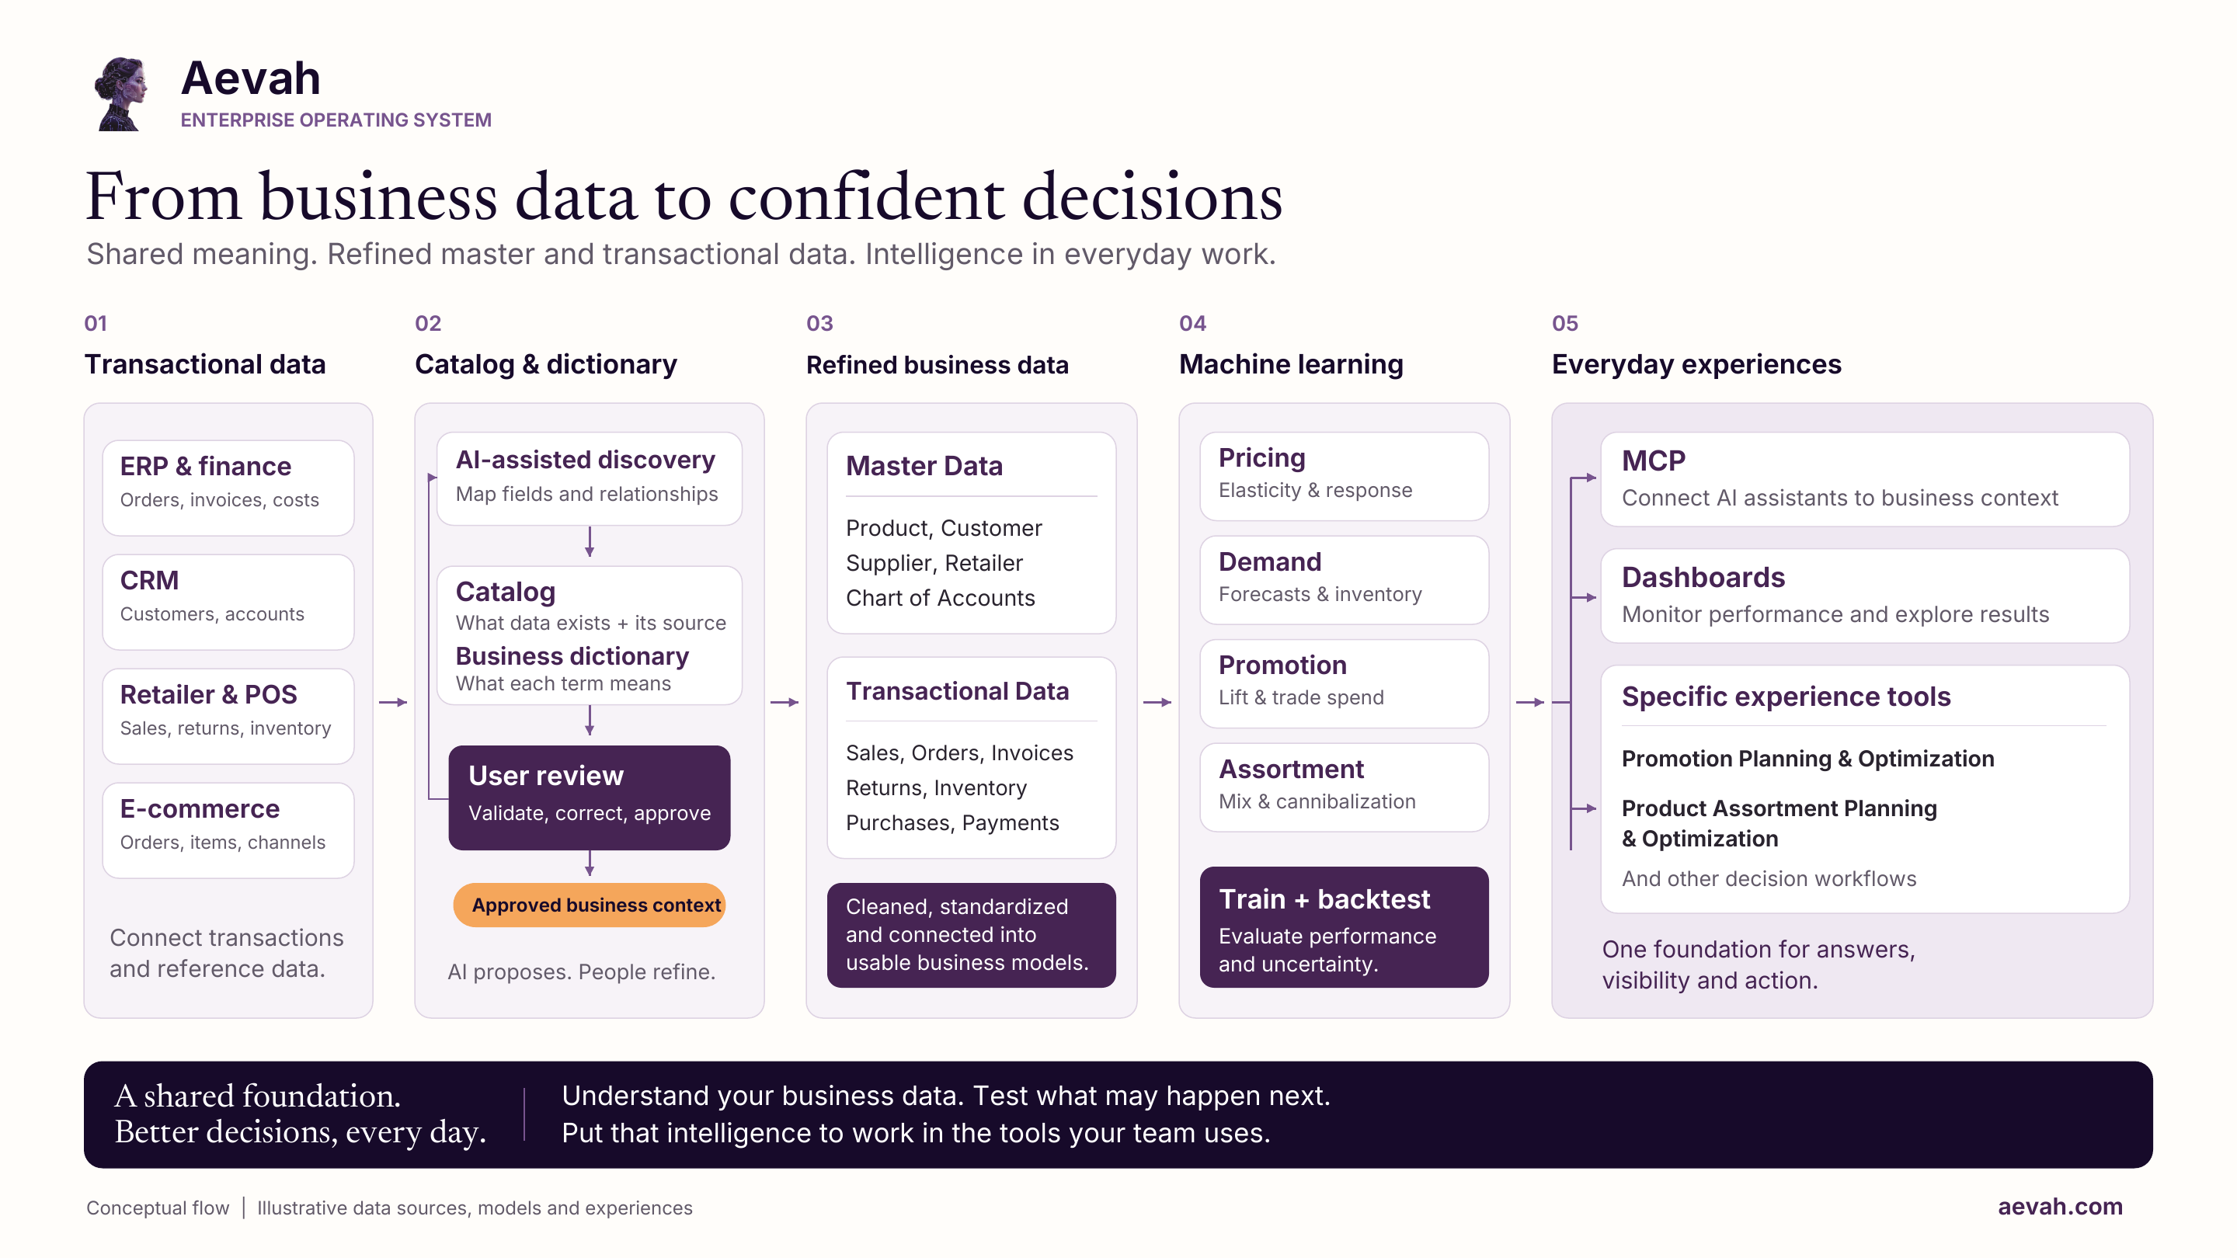
How Aevah turns business data into decisions: a conceptual view of the Aevah platform, with illustrative data sources, models and experiences. The rest of this document describes the path Mo follows for BUILT today.

Tracing a number back to its source
Mo's figures follow the same path from source data to the screen.
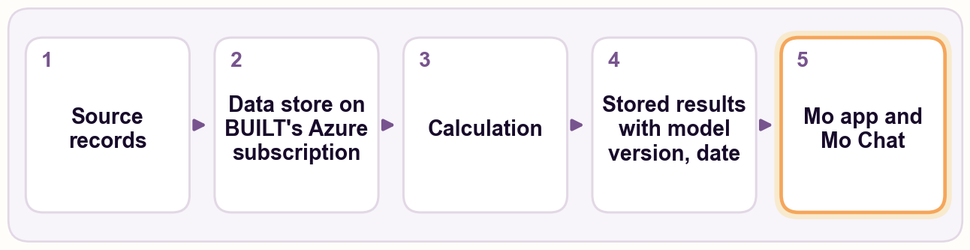
1 | Source records. SPINS weekly retail sales (the core), Circana for Costco, and BUILT's item master, including NetSuite item attributes, are loaded with all their fields and all the history delivered (weekly, from January 2023). BUILT's shipments and trade promotion calendar are being added and evaluated.
2 | The data store. Mo's data store, which holds the source records and the results the app reads, runs on BUILT's own Azure subscription.
3 | Calculation. Aevah prepares the records and runs Mo's calculations and models when new SPINS data arrives, and checks the results before release. When Aevah compared two preparation runs on the same SPINS data, the sales and distribution figures were identical in all 186,451 records both runs contained.
4 | Stored results. Model results are written back to the data store with the model version and the date they were produced. Each refresh replaces the previous results. Separately, Aevah keeps its own archive of saved forecasts, recorded before the sales data for the weeks they cover arrive, so they can later be checked against what actually sold; the first set was saved in October 2026.
5 | The Mo app and Mo Chat. Both read results only through fixed, predefined data requests. The cannibalization and price views show, for the result being viewed, its source (SPINS weekly sales), the model that produced it, where it is stored and when it was calculated. The forecast views state the last week of actual sales they use.

Example: following one forecast back
A planner looks at the 13-week forecast for one item at one retailer.
- The view states the last week of actual sales the forecast is based on.
- The forecast is a stored result in the data store, carrying the model version and the date it was produced.
- The model version names the trained model that produced it. Aevah's record for each model version lists its inputs: the item's recent sales and sales rate, its distribution at the retailer, prices and promotions, competing items on the shelf, the retailer, and the time of year.
- Those inputs are calculated from SPINS weekly records for that item, the retailer and the competing items around it, up to the stated week.
- Stored forecasts are not edited afterward. A forecast stays as produced until the next refresh replaces it, even if SPINS later revises the weeks it was based on.

How each kind of number is calculated
Figure | Source data | Method
Actual sales and distribution | SPINS weekly retail sales | Weekly figures as reported by SPINS: units, dollars, average prices, distribution and the number of stores selling each item
Everyday sales | SPINS weekly retail sales | SPINS's own baseline: its estimate of what sales would have been without promotions, used as reported
Demand forecast | SPINS weekly retail sales | Gradient-boosted decision trees (many small decision rules that each correct the last), with a separate model for each week ahead, 1 to 13 weeks; forecasts everyday sales and does not yet add expected promotion volume. Items that have stopped reporting use a simple expected-resume rule; items too new for the model get a simple trend forecast calculated when the view opens
Cannibalization score | SPINS weekly retail sales | A trained model scores how likely a newly launched item is to be drawing sales from each nearby item, BUILT's own and competitors', comparing up to 13 weeks after launch with the 13 weeks before (at least 8 of each); each score carries the three factors that most influenced it
Promotion response | SPINS promotion measures | How each item's sales have responded to past promotions, by type of promotion, from SPINS's own promotion measures
Price sensitivity | SPINS prices and units | A statistical model estimates whether sales tend to rise or fall with price changes, by item and retailer where there is enough price history; the direction is more reliable than the size, because most price changes happen during promotions
Mo Chat answers | Mo's stored results and source data | Retrieved through fixed, predefined data requests; the language model explains the figures it retrieves and does not produce Mo's forecasts or scores

How the numbers are checked
Aevah tests every forecasting change the way a finance team would want it tested:
- Rewind and compare. Aevah goes back to 18 earlier forecast dates, forecasts forward from each using only data up to that date, and compares with what actually sold, at the level of an item at a retailer, a retailer's month and BUILT's total month.
- Simple yardsticks. Every model is compared with rules a planner could use by hand, such as "assume recent sales continue" and "recent weekly sales per store × current store count".
- Predictions written down first. Before a test runs, Aevah records what it expects, so each result can be checked against what was expected.
- Challenge before reporting. Each forecasting result goes through a separate review step whose job is to try to break it. Results that do not survive are marked withdrawn in Aevah's records.
- A switching rule set in advance. The forecast BUILT sees changes only when a new method passes a rule written before testing: better on recent dates, consistent across forecast dates, no worse for established items, and no more prone to running high or low through the seasons.
- Forward confirmation. In October 2026, Aevah saved a set of forecasts before any sales data for the weeks they cover had arrived. They will be scored against what actually sold as that data arrives, with the full set expected early in 2027.
Mo's forecast changes only when a candidate passes this rule. Several alternatives, including neural networks and blends of methods, have been tested so far, and none has met every condition. Forecast accuracy is still being improved, and Aevah reports it only with the context below.
When Aevah reports accuracy, it states what was measured, at what level, how far ahead, compared with what simple rule, and on how much data, because the same forecast can look very different at an item level and a company level.

How Mo differs from generative AI
Generative AI tools built on large language models (LLMs) are remarkable at language: understanding questions, summarizing and explaining. They produce fluent text by predicting likely words, which makes them a strong interface but an unreliable source of business numbers. LLMs generate. Aevah operates.
 | Generative AI tools | Mo
Where numbers come from | Generated text; plausible but not calculated | Calculated by defined methods from BUILT's sales data
Tracing a number | Hard to tie an answer to a source | Source data, method, model version and date
Same question, same answer | Not guaranteed | Stored forecasts and scores stay the same until new data or a new model version is released; Mo Chat's wording can vary
Scale of data | What fits in a prompt | Millions of weekly records
Testing | Rarely tested against outcomes | Tested against what actually sold

Where Mo uses generative AI. Mo Chat uses an AI language model to understand questions and explain answers in plain English. It can only retrieve figures through a fixed set of predefined data requests; it cannot write its own queries. It is instructed to use figures from Mo's data and never to invent data. The language model does not calculate Mo's forecasts or scores.

Where Mo's forecasts and scores get their data
Source | What it provides | Status
SPINS weekly retail sales | Sales, prices, promotions and distribution for BUILT and the full category at more than 100 retail accounts | In use (the core)
Circana | Sales for Costco, which SPINS does not cover | Loaded into the data store
BUILT's item master | Items, product lines, pack details and NetSuite item attributes | In use
BUILT's NetSuite shipments | Shipments to retailers without store-level sales data | Being added and evaluated
BUILT's trade promotion calendar | Planned promotions by customer | Being added and evaluated

Retail sales data are weekly figures, delivered in batches several weeks after the fact, so Mo's forecast views state the last week of actual sales they use.

Keeping the numbers honest
SPINS revises past weeks of its data, most often its everyday (baseline) sales measure, which it can recalculate as far back as 35 weeks. When SPINS issues a full restatement, Aevah reloads the full history, and Mo's results are recalculated at the next refresh. A stored result reflects the SPINS data as of the date it was produced. Aevah has measured how much these revisions move past figures.
Saved forecasts can be compared with what actually sold once the sales data arrive. When Aevah finds an error in its own work, the correction is recorded in Aevah's records alongside the original result rather than quietly replaced.

Where Mo runs
Mo runs on BUILT's own Azure subscription.

