Meijer Account Brief
BUILT performance, 2026 launches, cannibalization and pricing at Meijer
Account: Meijer (Meijer's own 280 stores) · Channel: Food · Period: 13 weeks ending Sept 6, 2026 (June 14 – Sept 6), unless a table says otherwise · Data: SPINS weekly through Sept 6, 2026
Version 3 · issued October 16, 2026 · prepared by Aevah (Mo) for BUILT · combines the Oct 13 brief and its singles add-on

Summary
- BUILT keeps growing at Meijer. BUILT sold 1.7 packages (base units) per Meijer store per week in late 2023 and 17.4 this quarter; its share of bar units went from 0.4% to 2.6%.
- As the line widened, each item sells less per store: 5.6 packages per store per week at the Q2 2025 peak, with 3 main 4-packs, vs 3.7 now, with 5 main 4-packs plus 3 new flavors added in August.
- The newest two 4-packs (Peanut Butter Cup and Cookies N Cream, April 2026) were mostly new business. In their first three months, for every 100 packages they sold, the older three 4-packs sold roughly 10–40 fewer than expected, so roughly 60–90% of the pair's sales were new to BUILT. Each older 4-pack gave up about 12–16% of its expected sales.
- After the Cookie Dough launch in April 2025, the same pattern appeared and the older items' dip shrank after the first three months, so this first read may overstate the lasting effect.
- Meijer's result is within the normal range for BUILT launches at other grocery (Food-channel) retailers. Target and Walmart (Mass) could not be measured, because their launches came during store expansions.
- 4-count vs 1-count cannibalization cannot be measured yet. Meijer sells almost no singles, and too few launches elsewhere had both pack sizes on the shelf. A planned singles test at Meijer would answer it.
- During promotions, BUILT's sales at Meijer respond about twice as strongly as the typical protein-bar competitor's. BUILT's regular price, $2.28 a bar, sits at the premium end with Barebells and Quest.

1 — How BUILT is performing at Meijer
Meijer stores, every week Oct 2023 – Sept 6, 2026 · base units = packages sold at regular price (promotional lift removed); most BUILT packages at Meijer are 4-packs · per store = divided by all Meijer stores
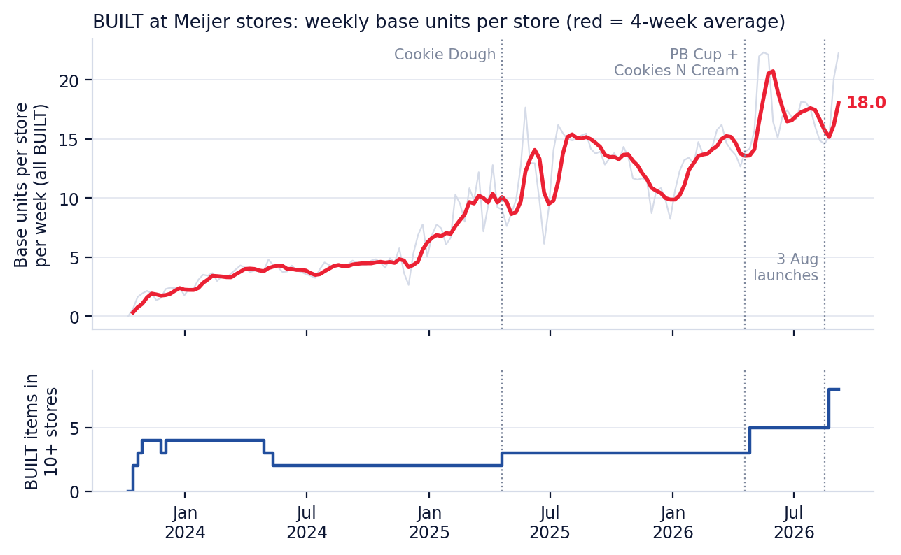
Weekly BUILT base units per Meijer store (gray = weekly, red = 4-week average) and the number of BUILT items selling in 10 or more stores. Dotted lines mark launches.
Quarter | Weekly base units (all BUILT) | Per Meijer store per week | Per item, per store selling, per week | Items in 10+ stores (avg) | BUILT share of bar units
Q4 2023 | 461 | 1.7 | 1.7 | 3.4 | 0.4%
Q1 2024 | 906 | 3.4 | 2.2 | 4.0 | 0.6%
Q2 2024 | 1,072 | 4.0 | 2.5 | 2.6 | 0.7%
Q3 2024 | 1,138 | 4.2 | 2.7 | 2.0 | 0.7%
Q4 2024 | 1,352 | 5.0 | 3.2 | 2.0 | 0.9%
Q1 2025 | 2,343 | 8.6 | 5.4 | 2.0 | 1.4%
Q2 2025 | 2,932 | 10.7 | 5.6 | 2.8 | 1.6%
Q3 2025 | 4,022 | 14.6 | 5.4 | 3.0 | 2.2%
Q4 2025 | 3,172 | 11.5 | 4.3 | 3.0 | 2.0%
Q1 2026 | 3,814 | 13.8 | 4.9 | 3.0 | 2.3%
Q2 2026 | 4,684 | 16.9 | 4.5 | 4.5 | 2.6%
Q3 2026 (10 weeks, to Sept 6) | 4,844 | 17.4 | 3.7 | 5.9 | 2.6%
Quarterly averages of weekly values. Items counts BUILT items selling in at least 10 Meijer stores that week. The latest quarter is partial and includes the three August flavors; leaving them out, sales per item per store would be about the same (3.8).

2 — Established 4-pack set: current distribution
Meijer stores · 13 weeks ending Sept 6, 2026 (June 14 – Sept 6) · five main 4-packs
Item | UPC | First sold at Meijer | Stores selling (avg) | % of Meijer stores | Base units per week | Per store selling per week | Avg price paid per bar | Regular price per bar | Weeks
Brownie Batter 4pk | 08-40229-30380 | Oct 08, 2023 | 258 | 92% | 1,198 | 4.6 | $2.26 | $2.29 | 13
Coconut 4pk | 08-40229-30381 | Oct 08, 2023 | 241 | 86% | 795 | 3.3 | $2.26 | $2.29 | 13
Cookie Dough 4pk | 08-40229-30558 | Apr 20, 2025 | 256 | 92% | 1,230 | 4.8 | $2.26 | $2.28 | 13
Peanut Butter Cup 4pk | 08-40229-30646 | Apr 19, 2026 | 238 | 85% | 790 | 3.3 | $2.25 | $2.28 | 13
Cookies N Cream 4pk | 08-40229-30581 | Apr 26, 2026 | 240 | 86% | 712 | 3.0 | $2.26 | $2.28 | 13
Price paid includes promotions; regular price is the non-promoted price. Salted Caramel 4pk, listed in the Sept version, has no sales in Meijer's own stores.

3 — Cannibalization: the newest two 4-packs vs the other three
Meijer stores · before = 13 weeks Jan 18 – Apr 12, 2026 · after = first three months, May 3 – Jul 26, 2026 (the two ramp-up weeks and the August launches are left out)
How we measure it: we compare each older item's sales after the launch with what it would have sold if it had moved in line with the rest of Meijer's bar category. The gap, divided by the new items' sales, is the share of the new items' sales that came out of BUILT's existing items. The rest is new business for BUILT: shoppers switching from other brands or buying more bars.
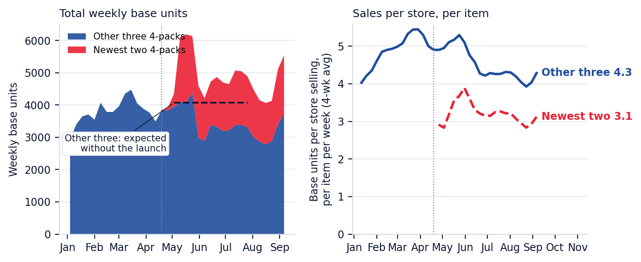
Left: total weekly base units of the newest two and the other three 4-packs; dashed line = what the other three would have sold without the launch. Right: base units per store selling, per item.
Item | Before: base units per week | After: expected | After: actual | Gap (per week) | Gap vs expected | Stores selling before | Stores selling after
Brownie Batter 4pk | 1,490 | 1,562 | 1,318 | −244 | −16% | 260 | 259
Coconut 4pk | 948 | 994 | 875 | −119 | −12% | 252 | 247
Cookie Dough 4pk | 1,447 | 1,517 | 1,313 | −203 | −13% | 259 | 257
Other three, total | 3,886 | 4,072 | 3,506 | −566 | −14%
Newest two (PB Cup + Cookies N Cream) | — | — | 1,534
Central estimate: the older three gave up about 37 packages for every 100 the newest two sold (34 counting sales per store only). With launches this size the measure is uncertain by about ±30, hence 'roughly 10–40'. The two launched one week apart, so their effects cannot be separated flavor by flavor.

Cookie Dough 4pk launch (April 2025) | Older items' gap per 100 Cookie Dough packages
weeks 2–14 | 37
weeks 15–27 | 11
weeks 28–40 | 21
Same measure for the previous Meijer launch: Brownie Batter and Coconut gave up sales in the first three months, and much less afterward. Both Meijer launches were in April, after BUILT's strongest season (Jan–Mar, with more promotions), which the method cannot fully separate from the launch.

Competitor items flagged by Mo's pair model (from the Sept version, provisional)
BUILT item | Same-flavor competitor items checked | Flagged as losing sales
Peanut Butter Cup 4pk | 48 | 6
Coconut 4pk | 13 | 11
Cookie Dough 4pk | 4 | 2
Cookies N Cream 4pk | 0 | —
Brownie Batter 4pk | 1 | 1
A model signal for each pair of items, low confidence and still being re-checked on Meijer's own stores. It answers 'which competitor items moved', not 'how many packages'. Read it next to the table above, not instead of it.

4 — 2026 launches at Meijer
Meijer stores · since each item's first week through Sept 6, 2026
Item | UPC | First sold at Meijer | Stores selling (avg) | % of Meijer stores | Base units per week | Per store selling per week | Avg price paid per bar | Regular price per bar | Weeks
Rocky Road 4pk | 08-40229-30696 | Aug 16, 2026 | 47 | 17% | 119 | 2.5 | $2.27 | $2.30 | 4
Orange Cream Pop 4pk | 08-40229-30697 | Aug 23, 2026 | 62 | 22% | 143 | 2.3 | $2.26 | $2.29 | 3
Mint Chip 4pk | 08-40229-30571 | Aug 23, 2026 | 61 | 22% | 135 | 2.2 | $2.26 | $2.29 | 3
Three to four weeks of sales; still ramping into stores. Too early to measure cannibalization; the first full read needs about 15 weeks after launch (SPINS data through early December 2026).

5 — Singles (1-count) at Meijer
Meijer stores · Oct 2023 – Sept 6, 2026
Item | UPC | First sold | Peak stores selling (month) | Last week with sales | Base units, last 13 weeks | Stores selling, last 13 weeks
Coconut 1pk | 08-40229-30037 | Oct 2023 | 19 (Feb 2024) | Sep 06, 2026 | 8 | 1
Brownie Batter 1pk | 08-40229-30362 | Oct 2023 | 21 (Feb 2024) | May 17, 2026 | 0 | 0
Meijer carried two singles in about 15–20 of its stores from Oct 2023 to Apr 2024, and in one or two stores since. The Sept version showed six singles at 21–31% distribution; that came from the wider Meijer trading area (all stores near Meijer), not Meijer's own stores.

4-count vs 1-count cannibalization
Not measurable yet. Meijer has no singles to compare against, and across all other retailers too few launches had both pack sizes on the shelf to give a reliable answer. The one clean case (a 4-pack launch at Publix in July 2024) drew a little from both pack sizes.
Check lane: a singles test in a defined set of Meijer stores, with a matched set of stores without it, would measure directly whether singles add to BUILT's sales at Meijer or draw from the 4-pack set.

6 — Meijer vs other retailers
Each retailer's own stores · BUILT launches since Apr 2023 with 13 weeks before and at least 8 weeks after · per-store measure (store expansions are not counted)
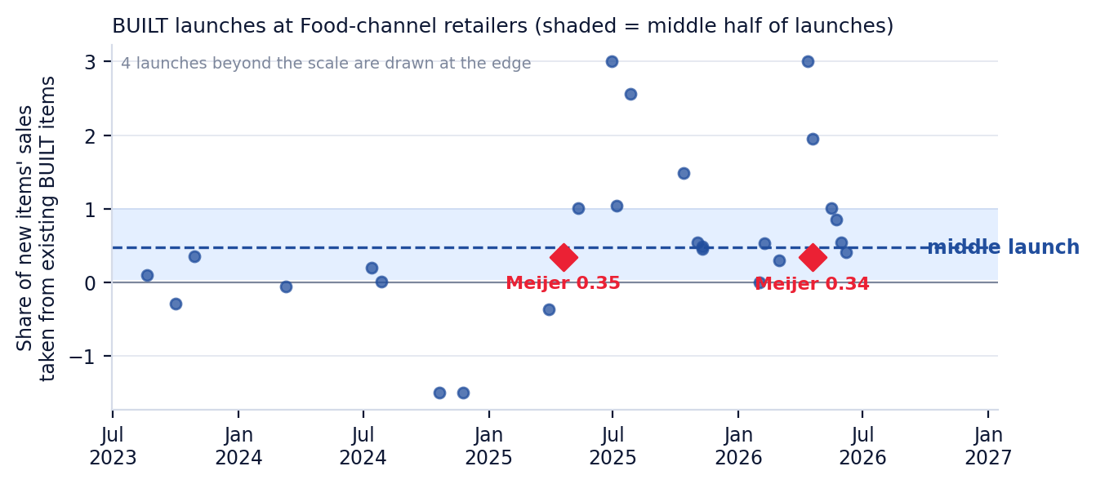
BUILT launches at Food-channel retailers over time. Each dot is one launch; the shaded band is the middle half of launches; red diamonds are Meijer.
Retailer / channel | Launches measured | Share of new items' sales taken from existing BUILT items | Reading
Meijer (Food) | 2 | 0.34–0.35 | Within the normal Food range
Other Food-channel retailers | 26 | middle launch 0.47; middle half 0.03–1.01 | Single launches vary widely; a launch is only measurable when it is big enough to stand out
Mass (Target, Walmart) | — | Not measurable | Launches came in large sets during store expansions
Drug, Convenience, Club | — | Not shown | Too few clean launches, or singles-only shelves
Target and Walmart are Mass, not Food. Every measured launch is listed in the appendix.

7 — Competitive position at Meijer
Meijer stores · 13 weeks ending Sept 6, 2026 (June 14 – Sept 6) · all nutrition and protein bars
Rank | Brand | Units (13 weeks) | Unit share | Avg price paid per bar | Items selling
1 | Clif Bar | 381,166 | 13.6% | $1.21 | 43
2 | Kind | 248,447 | 8.9% | $1.22 | 49
3 | Barebells | 221,887 | 7.9% | $2.49 | 21
4 | Clif Zbar | 153,760 | 5.5% | $0.94 | 17
5 | Gatorade | 133,348 | 4.8% | $1.98 | 12
6 | Quest | 131,618 | 4.7% | $2.30 | 28
7 | Larabar | 111,350 | 4.0% | $1.08 | 37
8 | Private Label | 110,189 | 3.9% | $0.78 | 19
9 | Clio | 109,201 | 3.9% | $0.76 | 13
10 | Atkins | 90,158 | 3.2% | $1.54 | 25
11 | Clif Builders | 88,210 | 3.2% | $1.63 | 18
12 | Pure Protein | 87,397 | 3.1% | $1.72 | 28
13 | Fulfil | 85,599 | 3.1% | $1.83 | 10
14 | Rxbar | 85,595 | 3.1% | $1.81 | 18
15 | Perfect Bar | 79,583 | 2.8% | $1.48 | 21
18 | BUILT | 68,543 | 2.5% | $2.26 | 9
BUILT ranks #18 of 60 brands by units at Meijer stores. Units are packages of any size; price per bar = dollars ÷ bars. Brand names as SPINS reports them.

8 — Price sensitivity
Meijer stores and other Food retailers · weekly price paid vs units per store, Sept 2024 – Sept 2026 · each item compared with itself over time, with week-to-week category swings removed
How to read it: the number shows how strongly units per store move when the price paid moves. Most price changes here are promotions, which often come with displays and ads, so these numbers describe the response to a deal, not to a permanent shelf-price change. The method makes every brand look somewhat more responsive than it is, the same way for each, so compare brands with each other rather than reading any one number as exact.
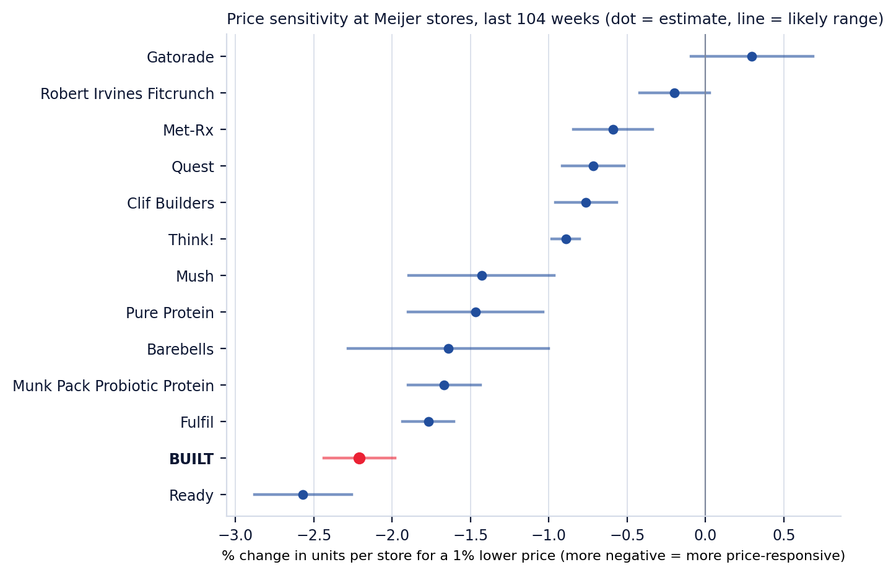
Protein-bar brands at Meijer (at least 15 g protein per bar and 20,000 units a year). BUILT in red; BUILT's range is narrower than it should be because three items carry most of its data.
Pack size (BUILT, other Food retailers) | Response to price | Range when any one retailer is left out
4-packs | −2.6 | −2.1 to −2.9
Singles | −1.0 | −0.8 to −1.2
Singles barely sell at Meijer, so this compares pack sizes at Food retailers that sell both (Ahold Delhaize, Albertsons Companies, Demoulas, Dierbergs, Giant Eagle, Hy-Vee, Kroger, Publix, Spartannash). 4-packs respond to deals much more than singles, which are bought on impulse.

Brand | Regular price per bar | Price index (BUILT = 100) | Response to price
Met-Rx | $2.50 | 110 | −0.6
Barebells | $2.50 | 109 | −1.6
Quest | $2.32 | 101 | −0.7
BUILT | $2.28 | 100 | −2.2
Gatorade | $1.98 | 87 | 0.3
Fulfil | $1.96 | 86 | −1.8
Munk Pack Probiotic Protein | $1.93 | 85 | −1.7
Think! | $1.88 | 82 | −0.9
Pure Protein | $1.73 | 76 | −1.5
Clif Builders | $1.66 | 73 | −0.8
Robert Irvines Fitcrunch | $1.53 | 67 | −0.2
Mush | $1.31 | 57 | −1.4
Ready | $1.24 | 54 | −2.6
Regular (non-promoted) price per bar, 13 weeks ending Sept 6, 2026 (June 14 – Sept 6), sales-weighted. The Sept version's −0.49 came from the Meijer trading area and a different method, so the two numbers are not comparable.

9 — Assortment recommendations (draft for discussion)
- Keep all five main 4-packs. The newest two added mostly new sales; the older three each gave up about 12–16% of their expected sales in the first three months, and BUILT's total at Meijer still grew.
- Give Rocky Road, Orange Cream Pop and Mint Chip time before judging them, and re-run this read when SPINS covers early December 2026. With eight 4-packs on shelf, expect sales per item to keep easing while the BUILT total grows; the question is whether the total grows faster than the overlap.
- Singles: propose a check-lane test in a defined set of Meijer stores, with a matched set of stores without it, so the effect on the 4-pack set can be measured rather than assumed.
- Promotions: BUILT's response to deals at Meijer is strong compared with the protein-bar set, so promotions are an effective volume lever. Regular price sits at the top of the set with Barebells and Quest.

10 — Singles at checkout: what other retailers show, and how to test it at Meijer

Singles: summary
- Of the 16 grocery accounts in BUILT's SPINS data, Meijer is the only one that sells BUILT 4-packs with almost no singles today: about 8 single units over the last 13 weeks (one item, in one store), against about 68,500 4-packs. Meijer started selling BUILT in October 2023 with two 4-packs and singles of the same two flavors; the singles were in about 15–20 of its roughly 270 stores until late April 2024, then dropped within a few weeks to one to three stores (section 10.1). Every other grocer in the data that sells 4-packs had singles first (data from January 2023). Among the grocery and mass retailers in the data (military commissaries aside), the only ones that later expanded singles to 10% or more of their stores after 4-packs were already on the shelf are Walmart and Target; like Meijer, both sell groceries alongside general merchandise.
- Both run singles as seasonal programs: in most stores for a few months, then back to a core of stores. Target put singles in roughly 70% of its stores for the 2025 holidays and in most stores again this summer.
- When Target added singles for the 2025 holidays, most of the singles bars were additional sales for BUILT. Its 4-packs sold somewhat less than expected, but the size cannot be pinned down because Target added four new 4-pack flavors at the same time. Depending on the comparison, between none and just under half of the singles bars came out of 4-packs.
- A typical grocer sells about 3.3 singles per item per store per week, a typical convenience chain about 2.0 (Wawa 4.5), and Target about 4.8 with singles in most stores. Singles sell for about 13% more per bar than 4-packs.
- At Meijer, 4 checkout singles in all stores could sell roughly 2,200–5,400 bars a week (scenarios below). In these scenarios, even if close to half came out of 4-packs, BUILT would gain bars and dollars. This is a scenario, not a forecast.
- Recommended: a 13-week test in a set of Meijer stores, compared with matched stores without singles, outside the holiday season, using Meijer's store-level sales.

10.1 — Meijer's own singles, 2023–24
Meijer has carried BUILT singles before: two items, Brownie Batter and Coconut (1.41 oz), the same flavors as its 4-packs, from October 2023 to June 2024. They sold about 2.6 units per item per store selling per week at regular price. In the same months a typical grocer sold about 4.0 and a typical convenience chain about 1.6; Walmart sold about 2.6, and Target had no singles yet. So Meijer's singles sold below the typical grocer then.
Single | UPC | Base units, Oct 2023 – Jun 2024 | Weeks sold | Per store selling per week
Brownie Batter 1.41 Oz | 08-40229-30362 | 1,270 | 33 | 2.7
Coconut 1.41 Oz | 08-40229-30037 | 1,132 | 38 | 2.5
SPINS, Meijer's own stores (RMA). Per store selling per week = base units / stores selling (regular-price sales), the same measure as the comparisons in this section.

At regular price, singles cost about 15% more per bar than Meijer's 4-packs (about 20% for Brownie Batter, 9% for Coconut); at the prices shoppers actually paid, including promotions, the gap was about 5%.
Did they take sales from 4-packs? This cannot be measured from SPINS. Singles were about 2% of Meijer's 4-pack sales counted in bars, or about 8% counted in packs (the most possible if every single bought replaced a whole 4-pack). Each single was in at most 25 stores, and SPINS does not show which stores carried them. Meijer's 4-pack sales were still building after launch (about 1,500 rising to about 4,000 bars a week) and moved about 8% in a typical week, so any effect on 4-packs cannot be separated out in Meijer's account totals. The store test in this section is the way to measure it.

Who is comparable to Meijer
Every grocery account with BUILT singles (Kroger, Publix, Albertsons, Hy-Vee, Giant Eagle, Wegmans and others) carried singles before 4-packs, so none shows what happens when singles join an established 4-pack set. Target and Walmart did exactly that, and like Meijer, they sell groceries alongside general merchandise.

How Target and Walmart run singles
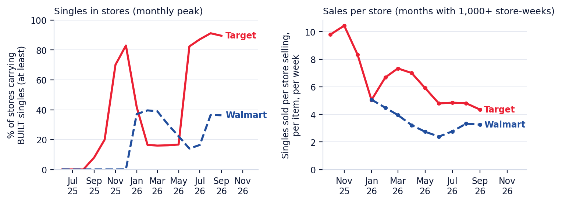
Left: share of stores carrying BUILT singles (the most widely stocked single; a floor on stores with any single). Right: singles sold per store selling, per item, per week.
- Target: singles in about 10% of stores in early October 2025, about 70% on average in November–December (53–83% week to week, including a holiday flavor), back to about 16% from February to May, then 82–91% from June to September 2026.
- Walmart: about 40% of stores in February–March 2026, fading gradually (26% in April, 9% in July), then about 37% again in August–September.
- The stores that keep singles in the off-season are self-selected strong stores, so their higher sales per store are not a benchmark for a full rollout.

Did singles take sales from 4-packs?
One season can be measured: Target's 2025 holiday program, compared with the weeks just before and after it, with the same 4-pack items at grocery retailers removing BUILT-wide seasonality.
What we can say | Detail
Direction | 4-packs sold somewhat less than expected while singles were in most stores
Size | Not pinned down: between none and just under half of the singles bars came out of 4-packs, depending on which weeks are compared
Why it is uncertain | Target added four new 4-pack flavors (late Sept – mid Oct 2025) right before the program
In every version | Most singles bars were additional bars for BUILT
Walmart | Not measurable: its singles fade in and out gradually, with no clean before and after
One retailer and one holiday season. This describes what happened there, not what will happen at Meijer's checkouts; SPINS does not show where in the store the singles were placed.

How much singles sell
Where | Singles sold per store selling, per item, per week
Typical grocer (middle of 15 grocery accounts) | 3.3
Typical convenience chain (middle of 15) | 2.0
Wawa | 4.5
Target (singles in most stores) | 4.8
Walmart (about one store in five on average, 9–37%) | 3.2
Last 13 weeks. Units per store selling per item: the right unit for planning a few checkout items. Middle = median retailer, so one large chain does not set the figure.

Flavors
Top singles at convenience chains | Per store selling per week | Chains selling it
Cookie Dough Chunk | 2.85 | 14
Brownie Batter | 2.74 | 15
Salted Caramel | 2.65 | 3
Coconut | 2.54 | 13
Peanut Butter | 2.38 | 11
Cookies N Cream | 2.37 | 9
Convenience stores are the closest SPINS view of impulse buying. Cookie Dough Chunk and Brownie Batter lead, with Coconut close behind; all three are main Meijer 4-pack flavors. Salted Caramel ranks third but only 3 chains sell it, and the gaps are small. At Target, Peanut Butter and Brownie Batter rank highest, but items in fewer stores show higher sales per store, so that ranking is not an apples-to-apples comparison.

Price
Retailer | Singles, per bar | 4-packs, per bar | Singles premium
Target | $2.50 | $2.22 | 13%
Walmart | $2.54 | $2.25 | 13%
Typical non-promoted price, last 13 weeks. Price and cannibalization are separate analyses.

What it could mean at Meijer (scenarios, not a forecast)
Assumptions: 4 singles at checkout in all 280 Meijer stores; sales per store from section 4; a single at about $2.52; Meijer's 4-pack bars at about $2.28 each; Meijer's 4-packs now sell about 69 bars per store per week. The share taken from 4-packs covers the range seen at Target (none to just under half). Sales rates come from stores that sold each item that week, often a retailer's stronger stores; applying them to all 4 items in all 280 stores every week is an upper reading. For comparison, across all its stores Target sells about 17 singles bars per store per week from 13 items, and Walmart about 8 from 16.
Sales per store | Share from 4-packs | Singles bars per week | Singles retail $ per week | Net new BUILT bars per week | Net new retail $ per week | Change in BUILT bars at Meijer
Low (typical convenience chain) | 0% | 2,237 | $5,637 | 2,237 | $5,637 | +12%
Low (typical convenience chain) | 25% | 2,237 | $5,637 | 1,678 | $4,359 | +9%
Low (typical convenience chain) | 45% | 2,237 | $5,637 | 1,230 | $3,337 | +6%
Mid (typical grocer) | 0% | 3,702 | $9,328 | 3,702 | $9,328 | +19%
Mid (typical grocer) | 25% | 3,702 | $9,328 | 2,776 | $7,214 | +14%
Mid (typical grocer) | 45% | 3,702 | $9,328 | 2,036 | $5,522 | +11%
High (Target's rate, applied to every store) | 0% | 5,356 | $13,496 | 5,356 | $13,496 | +28%
High (Target's rate, applied to every store) | 25% | 5,356 | $13,496 | 4,017 | $10,437 | +21%
High (Target's rate, applied to every store) | 45% | 5,356 | $13,496 | 2,946 | $7,989 | +15%
Retail dollars at shelf price, before Meijer's margin; BUILT's revenue is its selling price to Meijer. Estimates from other retailers' patterns; checkout placement may sell differently from where singles sit at those retailers. Before checkout placement fees and BUILT's cost per single bar.

How to test it at Meijer
- Put 3–4 singles at the checkouts in a set of test stores (the number to be set from Meijer's store-level sales so the test can detect a 5–10% change in 4-pack sales), and pick matched control stores with similar BUILT 4-pack sales and region.
- Keep the 4-pack lineup and promotions the same in test and control stores; new flavors are why Target's result is uncertain. Compare with at least 13 weeks before the test.
- Run at least 13 weeks, outside November–December, so holiday traffic does not blur the result.
- Measure, test vs control: BUILT 4-pack non-promoted units per store per week (did 4-packs lose?), singles sold per store per week, and total BUILT bars and dollars per store.
- This needs Meijer's store-level sales for the test and control stores. SPINS reports Meijer as one total, so it cannot show the difference between test and control stores.
- Decide on total BUILT bars and dollars per store, not on 4-packs alone: some overlap is expected and is fine as long as the total grows.

Singles: sources and caveats
- SPINS weekly data, each retailer's own stores (RMA), through Sept 6, 2026. Prepared by Aevah with Mo.
- SPINS does not record shelf location, so checkout and aisle placement cannot be separated anywhere in this section.
- Target and Walmart are the only analogs, with one measurable season (Target, holidays 2025). Results describe what happened there; they are not proof of cause and not a forecast for Meijer.
- The scenarios in section 5 multiply other retailers' sales per store by Meijer's store count; they are a sizing aid, and the store test is the way to measure Meijer itself.
- Internal to BUILT and Aevah. Not for distribution outside BUILT.

Appendix — every measured launch
Retailer (Food channel) | Launch | New items | Pack sizes | New items' base units per week | Share taken from existing BUILT items
Publix | Aug 2023 | 5 | mixed packs | 2,181 | 0.10
Albertsons Companies | Oct 2023 | 2 | 1-count launch | 90 | −0.29
Wegmans | Oct 2023 | 2 | mixed packs | 202 | 0.36
Wegmans | Mar 2024 | 2 | mixed packs | 1,575 | −0.05
Publix | Jul 2024 | 2 | 4-count launch | 2,829 | 0.20
Wakefern | Jul 2024 | 1 | 1-count launch | 252 | 0.01
Albertsons Companies | Oct 2024 | 2 | 1-count launch | 366 | −3.62
Wegmans | Nov 2024 | 2 | mixed packs | 1,677 | −2.93
Ahold Delhaize | Mar 2025 | 2 | mixed packs | 724 | −0.37
Meijer | Apr 2025 | 1 | 4-count launch | 1,266 | 0.35
Kroger | May 2025 | 7 | mixed packs | 8,883 | 1.01
Dierbergs | Jun 2025 | 3 | mixed packs | 211 | 3.42
Wegmans | Jul 2025 | 2 | mixed packs | 2,792 | 1.04
Hy-Vee | Jul 2025 | 3 | mixed packs | 2,134 | 2.56
Hy-Vee | Oct 2025 | 3 | mixed packs | 1,550 | 1.49
Dierbergs | Nov 2025 | 8 | mixed packs | 632 | 0.54
Giant Eagle | Nov 2025 | 5 | mixed packs | 1,854 | 0.45
Wegmans | Nov 2025 | 4 | mixed packs | 2,394 | 0.49
Kroger | Feb 2026 | 6 | mixed packs | 5,596 | 0.01
Publix | Feb 2026 | 3 | 1-count launch | 7,954 | 0.53
Dierbergs | Mar 2026 | 6 | mixed packs | 312 | 0.30
Save Mart | Apr 2026 | 6 | 1-count launch | 367 | 3.94
Meijer | Apr 2026 | 2 | 4-count launch | 1,534 | 0.34
Wegmans | Apr 2026 | 6 | mixed packs | 2,127 | 1.95
Hy-Vee | May 2026 | 4 | mixed packs | 1,637 | 1.01
Demoulas | May 2026 | 5 | 1-count launch | 1,781 | 0.86
Giant Eagle | May 2026 | 4 | 1-count launch | 680 | 0.54
Big Y | Jun 2026 | 9 | mixed packs | 885 | 0.42
Launches within three weeks of each other at a retailer are counted as one. A launch is measurable when the new items sold at least 10% as much as the existing items. Values below 0 or above 1 are possible and mostly reflect noise in single launches (existing items moving for other reasons).

Sources, method and what changed from the September version
- Data: SPINS weekly, Meijer's own stores (SPINS 'Meijer Corp – RMA') and each retailer's own stores for the comparisons, through Sept 6, 2026. Prepared by Aevah with Mo.
- This describes what happened around each launch; it is not proof of cause. Store resets, displays, promotions and competitor changes can move at the same time. Results are ranges, not exact points.
- Corrected from the Sept version: it mixed Meijer's own stores with the wider Meijer trading area (every store near Meijer). All numbers here use Meijer's own stores. This changes the singles section (Meijer has almost no singles), the price sensitivity (the earlier −0.49 came from the trading area and a different method) and the cannibalization rate (the earlier 46.9% was the share of item pairs a model flagged, not a share of sales). The Sept version's check-lane 'go' and 'fully incremental' singles readings are withdrawn until a test measures them.
- Cannibalization is measured from sales before and after each launch, against the rest of the bar category at the same retailer. Checked against made-up launch dates with no real launch: at Food retailers those move existing sales by about 12% by chance, which is why only launches big enough to stand out are counted.
- Price sensitivity is estimated from weekly price and unit changes over two years, item by item; most price changes are promotions. Price and cannibalization are separate analyses and are not combined.
- Internal to BUILT and Aevah. Not for distribution outside BUILT.

