
TRUST DOCUMENT · FOR BUILT
How Mo works
How BUILT's demand intelligence produces its numbers, how those numbers are checked, and where it runs.
Prepared by Aevah for BUILT · October 2026

In brief
Mo is BUILT's demand intelligence experience, built and operated by Aevah. It turns BUILT's retail sales data into forecasts, cannibalization reads, price-sensitivity reads and retailer views that BUILT's teams can use directly.
The question that matters most is whether Mo's numbers can be trusted. Three things make them trustworthy:
The numbers are calculated, not generated.  Every forecast, probability and sensitivity figure Mo shows comes from models and calculations run on BUILT's sales data, not from a language model. | The numbers are tested against what actually sold.  Before a new forecasting method replaces the current one, Aevah rewinds to earlier dates, forecasts forward using only data up to each date, and compares the result with actual sales. | The numbers can be traced.  Each forecast and score is stored with when it was produced and which model version produced it.

How Mo's numbers are produced
Mo uses machine learning: models that learn patterns from BUILT's history and are then tested on periods they have not seen. Each job has a model suited to it.
Demand forecasts. Mo forecasts each item at each SPINS-reported retailer 13 weeks ahead. The model uses how many stores carry an item and how fast it sells in each store, alongside sales history, pricing, promotions and seasonality. It is a set of gradient-boosted decision trees: many small decision rules that each correct the last.
Everyday sales and promotions. The forecast model predicts everyday (non-promotion) sales, the steady base of the business; it does not yet add expected promotion volume. Separately, Mo shows how each item's sales have responded to past promotions, by type of promotion.
Cannibalization. When BUILT launches an item, Mo scores how likely it is to be drawing sales from each nearby item, BUILT's own and competitors', and tracks a weekly cannibalization rate. Each score carries the three factors that most influenced it, so the reason travels with the number.
Price sensitivity. Mo estimates whether sales tend to rise or fall with price changes, by item and retailer where there is enough price history. The direction is more reliable than the size, because most price changes happen during promotions.

How the numbers are checked
Aevah tests every forecasting change the way a finance team would want it tested:
- Rewind and compare. Aevah goes back to 18 earlier forecast dates, forecasts forward from each using only data up to that date, and compares with what actually sold, at the level of an item at a retailer, a retailer's month and BUILT's total month.
- Simple yardsticks. Every model is compared with rules a planner could use by hand, such as "assume recent sales continue" and "recent weekly sales per store × current store count".
- Predictions written down first. Before a test runs, Aevah records what it expects, so each result can be checked against what was expected.
- Challenge before reporting. Each forecasting result goes through a separate review step whose job is to try to break it. Results that do not survive are marked withdrawn in Aevah's records.
- A switching rule set in advance. The forecast BUILT sees changes only when a new method passes a rule written before testing: better on recent dates, consistent across forecast dates, no worse for established items, and no more prone to running high or low through the seasons.
- Forward confirmation. Since September 2026, forecasts are saved before the weeks they cover. The first will be scored once those weeks' sales data arrive in December.
Mo's forecast changes only when a candidate passes this rule. Several alternatives, including neural networks and blends of methods, have been tested so far, and none has met every condition. Forecast accuracy is still being improved, and Aevah reports it only with the context below.
When Aevah reports accuracy, it states what was measured, at what level, how far ahead, compared with what simple rule, and on how much data, because the same forecast can look very different at an item level and a company level.

How Mo differs from generative AI
Generative AI tools built on large language models (LLMs) are remarkable at language: understanding questions, summarizing and explaining. They produce fluent text by predicting likely words, which makes them a strong interface but an unreliable source of business numbers. LLMs generate. Aevah operates.
 | Generative AI tools | Mo
Where numbers come from | Generated text; plausible but not calculated | Calculated by models and calculations run on BUILT's sales data
Same question, same answer | Not guaranteed | Stored figures stay the same until new data or a new model version is released, and each carries its date; Mo Chat's wording can vary
Traceability | Hard to tie an answer to a source | Each forecast and score is stored with its date and model version
Scale of data | What fits in a prompt | Millions of weekly records
Testing | Rarely tested against outcomes | Tested against what actually sold

Where Mo uses generative AI. Mo Chat uses an AI language model to understand questions and explain answers in plain English. It retrieves the relevant figures from Mo's data at the moment of the question and explains them; it is instructed to use figures from Mo's data and never to invent data. The language model does not calculate Mo's forecasts or scores.

How Mo is built
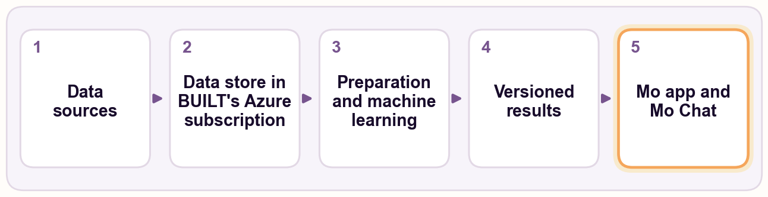
1 | Data sources. SPINS weekly retail sales (the core), Circana for Costco, and BUILT's item master, including NetSuite item attributes. BUILT's shipments and trade promotion calendar are being added and evaluated.
2 | A data store in BUILT's own Azure subscription.
3 | Preparation and machine learning. Prepared feature tables and model scoring, refreshed by Aevah when new SPINS data arrives and checked before release.
4 | Versioned results, stored back in the data store with their date and model version.
5 | The Mo app and Mo Chat, which read results only through fixed, predefined data requests.

Where Mo's forecasts and scores get their data
Source | What it provides | Status
SPINS weekly retail sales | Sales, prices, promotions and distribution for BUILT and the full category at more than 100 retail accounts | In use (the core)
Circana | Sales for Costco, which SPINS does not cover | Loaded into the data store
BUILT's item master | Items, product lines, pack details and NetSuite item attributes | In use
BUILT's NetSuite shipments | Shipments to retailers without store-level sales data | Being added and evaluated
BUILT's trade promotion calendar | Planned promotions by customer | Being added and evaluated

Retail sales data arrive weekly, a few weeks after the fact, so Mo's forecast views state the last week of actual sales they use.

Where Mo runs
Mo runs in BUILT's own Azure subscription, in the West US 3 region (United States), operated by Aevah.

Keeping the numbers honest
Mo's forecasts and scores are stored with the date they were produced and the model version that produced them, and forecasts are now saved as versions, so an earlier forecast can be compared with what actually sold. When Aevah finds an error in its own work, the correction is recorded in Aevah's records alongside the original result rather than quietly replaced.

Questions
Aevah · [[JASON: contact name and email]]

