Meijer Singles at Checkout
What other retailers show, what it could mean at Meijer, and how to test it
Add-on to the Meijer Account Brief v2 · Data: SPINS weekly, each retailer's own stores, through Sept 6, 2026 · Period: last 13 weeks (June 14 – Sept 6, 2026) unless a table says otherwise
Issued October 13, 2026 · prepared by Aevah (Mo) for BUILT

Summary
- Meijer is the only grocery account that carries BUILT 4-packs but no singles. Every other grocer started with singles. The only retailers that added singles to an established 4-pack set are Target and Walmart, both supercenters like Meijer.
- Both run singles as seasonal programs: in most stores for a few months, then back to a core of stores. Target put singles in roughly 70% of its stores for the 2025 holidays and in most stores again this summer.
- When Target added singles for the 2025 holidays, most of the singles bars were additional sales for BUILT. Its 4-packs sold somewhat less than expected, but the size cannot be pinned down because Target added four new 4-pack flavors at the same time. Depending on the comparison, between none and just under half of the singles bars came out of 4-packs.
- A typical grocer sells about 3.4 singles per item per store per week, a typical convenience chain about 2.0 (Wawa 4.5), and Target about 5 with singles in most stores. Singles sell for about 13% more per bar than 4-packs.
- At Meijer, 4 checkout singles in all stores could sell roughly 2,240–5,376 bars a week (scenarios below). Even if close to half came out of 4-packs, BUILT would gain bars and dollars. This is a scenario, not a forecast.
- Recommended: a 13-week test in a set of Meijer stores, compared with matched stores without singles, outside the holiday season, using Meijer's store-level sales.

1 — Who is comparable to Meijer
Every grocery account with BUILT singles (Kroger, Publix, Albertsons, Hy-Vee, Giant Eagle, Wegmans and others) carried singles before 4-packs, so none shows what happens when singles join an established 4-pack set. Target and Walmart did exactly that, and like Meijer they are supercenters.

2 — How Target and Walmart run singles
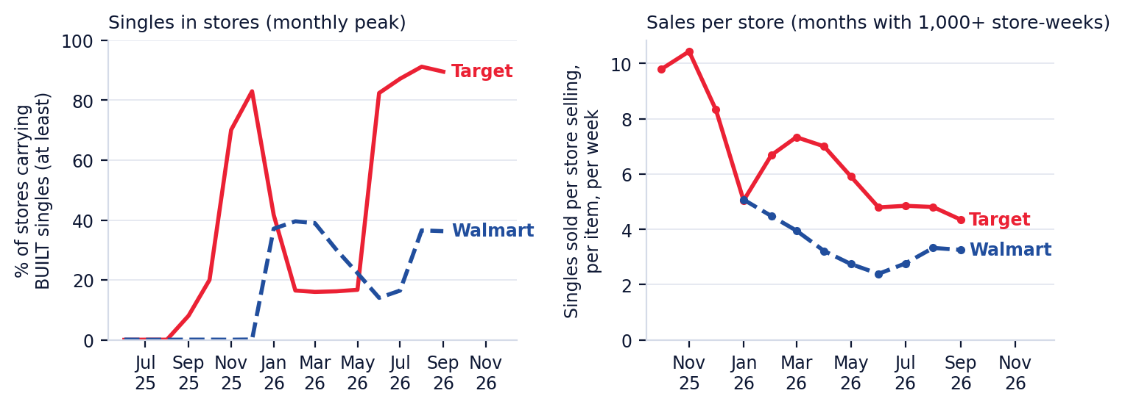
Left: share of stores carrying BUILT singles (the most widely stocked single; a floor on stores with any single). Right: singles sold per store selling, per item, per week.
- Target: singles in about 10% of stores in early October 2025, about 70% on average in November–December (53–83% week to week, including a holiday flavor), back to about 16% from January to May, then 82–91% from June to September 2026.
- Walmart: about 40% of stores in January–March 2026, fading gradually (26% in April, 9% in July), then about 37% again in August–September.
- The stores that keep singles in the off-season are self-selected strong stores, so their higher sales per store are not a benchmark for a full rollout.

3 — Did singles take sales from 4-packs?
One season can be measured: Target's 2025 holiday program, compared with the weeks just before and after it, with the same 4-pack items at grocery retailers removing BUILT-wide seasonality.
What we can say | Detail
Direction | 4-packs sold somewhat less than expected while singles were in most stores
Size | Not pinned down: between none and just under half of the singles bars came out of 4-packs, depending on which weeks are compared
Why it is uncertain | Target added four new 4-pack flavors (late Sept – mid Oct 2025) right before the program
In every version | Most singles bars were additional bars for BUILT
Walmart | Not measurable: its singles fade in and out gradually, with no clean before and after
One retailer and one holiday season. This describes what happened there, not what will happen at Meijer's checkouts; SPINS does not show where in the store the singles were placed.

4 — How much singles sell
Where | Singles sold per store selling, per item, per week
Typical grocer (middle of 16 grocery accounts) | 3.4
Typical convenience chain (middle of 15) | 2.0
Wawa | 4.5
Target (singles in most stores) | 4.8
Walmart (about a third of stores) | 3.2
Last 13 weeks. Units per store selling per item: the right unit for planning a few checkout items. Middle = median retailer, so one large chain does not set the figure.

Flavors
Top singles at convenience chains | Per store selling per week | Chains selling it
Cookie Dough Chunk | 2.85 | 14
Brownie Batter | 2.74 | 15
Salted Caramel | 2.65 | 3
Coconut | 2.54 | 13
Peanut Butter | 2.38 | 11
Cookies N Cream | 2.37 | 9
Convenience stores are the closest SPINS view of impulse buying. Cookie Dough, Brownie Batter and Coconut, three of Meijer's main 4-pack flavors, lead. At Target, Peanut Butter and Brownie Batter rank highest, but items in fewer stores show higher sales per store, so that ranking is not like-for-like.

Price
Retailer | Singles, per bar | 4-packs, per bar | Singles premium
Target | $2.50 | $2.22 | 13%
Walmart | $2.54 | $2.25 | 13%
Typical non-promoted price, last 13 weeks. Price and cannibalization are separate analyses.

5 — What it could mean at Meijer (scenarios, not a forecast)
Assumptions: 4 singles at checkout in all 280 Meijer stores; sales per store from section 4; a single at about $2.52; Meijer's 4-pack bars at about $2.28 each; Meijer's 4-packs now sell about 69 bars per store per week. The share taken from 4-packs spans the range seen at Target.
Sales per store | Share from 4-packs | Singles bars per week | Singles retail $ per week | Net new BUILT bars per week | Net new retail $ per week | Change in BUILT bars at Meijer
Low (typical convenience chain) | 0% | 2,240 | $5,644 | 2,240 | $5,644 | +12%
Low (typical convenience chain) | 25% | 2,240 | $5,644 | 1,680 | $4,365 | +9%
Low (typical convenience chain) | 45% | 2,240 | $5,644 | 1,232 | $3,341 | +6%
Mid (typical grocer) | 0% | 3,752 | $9,455 | 3,752 | $9,455 | +19%
Mid (typical grocer) | 25% | 3,752 | $9,455 | 2,814 | $7,311 | +15%
Mid (typical grocer) | 45% | 3,752 | $9,455 | 2,064 | $5,597 | +11%
High (Target, singles in most stores) | 0% | 5,376 | $13,547 | 5,376 | $13,547 | +28%
High (Target, singles in most stores) | 25% | 5,376 | $13,547 | 4,032 | $10,476 | +21%
High (Target, singles in most stores) | 45% | 5,376 | $13,547 | 2,957 | $8,019 | +15%
Retail dollars at shelf price, before Meijer's margin; BUILT's revenue is its selling price to Meijer. Estimates from other retailers' patterns; checkout placement may sell differently from where singles sit at those retailers.

6 — How to test it at Meijer
- Put 3–4 singles at the checkouts in a set of test stores (for example 40–60), and pick matched control stores with similar BUILT 4-pack sales and region.
- Run at least 13 weeks, outside November–December, so holiday traffic does not blur the result.
- Measure, test vs control: BUILT 4-pack base units per store per week (did 4-packs lose?), singles sold per store per week, and total BUILT bars and dollars per store.
- This needs Meijer's store-level sales for the test and control stores. SPINS reports Meijer as one total, so it cannot show the difference between test and control stores.
- Decide on total BUILT bars and dollars per store, not on 4-packs alone: some overlap is expected and is fine as long as the total grows.

Sources and caveats
- SPINS weekly data, each retailer's own stores (RMA), through Sept 6, 2026. Prepared by Aevah with Mo.
- SPINS does not record shelf location, so checkout and aisle placement cannot be separated anywhere in this add-on.
- Target and Walmart are the only analogs, with one measurable season (Target, holidays 2025). Results describe what happened there; they are not proof of cause and not a forecast for Meijer.
- The scenarios in section 5 multiply other retailers' sales per store by Meijer's store count; they are a sizing aid, and the store test is the way to measure Meijer itself.
- Internal to BUILT and Aevah. Not for distribution outside BUILT.

