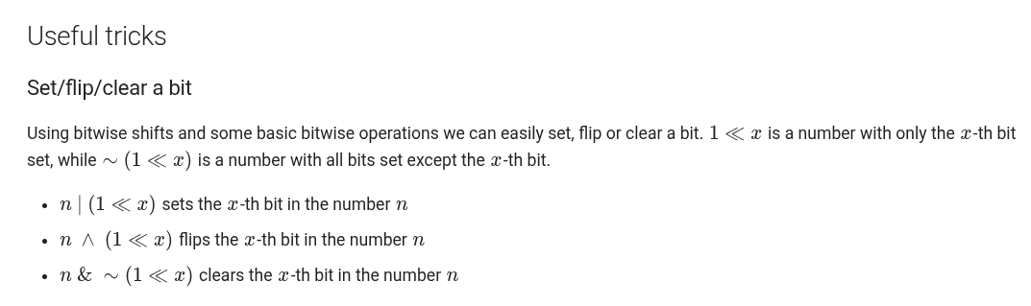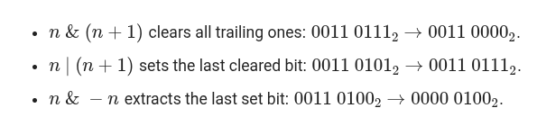
Check If x-th bit is set or not
bool is_set(unsigned int number, int x) {
return (number >> x) & 1;
}
Check even or odd
if (n & 1 == 0) cout << “even”;
else if (n & 1 == 1) cout << “odd”;
Check if a number is divisible by a power of 2
bool isDivisibleByPowerOf2(int n, int k) {
int powerOf2 = 1 << k;
return (n & (powerOf2 - 1)) == 0;
}
// if n & (2^k-1) == 0 then, n is divisible by 2^k

Count Set Bits
int countSetBits(int n)
{
int count = 0;
while (n)
{
n = n & (n - 1);
count++;
}
return count;
}
// countSetBits(5) (n = 5)
// 5 & 4 =>
101
&100
100 => 4 (now n = 4) count = 1;
// 4 & 3
100 & 011 = 000 ( now n will be 0 ) count = 2;
while loop closed (as n = 0)

