

Department Of Computer Science & Mathematics
Bangladesh Agricultural University

Lab Assignment
Course Code: CSM 3222
Course Title: Compiler

Lab No. 01
Date of Submission: 13-10-2026

SUBMITTED TO:  Raihan Kabir Rifat  Lecturer  Department of Computer Science  And Mathematics  Bangladesh Agricultural University  Mymensingh | SUBMITTED BY:  Name: Md. Asifuzzaman  ID: 2309005  Reg.: 57089  Level-3, Semester-1  Session: 2022-2023,  B.Sc. in Bioinformatics Engineering

Task 01: EASY LEVEL — Stack Machine Instructions

Re-implement the program in the following languages and test the program with each exercise of the easy_exercises.txt file:
i. C++
ii. Python

Code

/**
Easy Task
@uthor: ASIF
ID: 2309005
**/

#include <iostream>
#include <string>

using namespace std;

int main() {
string str;
int cnt = 0;

while (cin >> str) {
if (str == "^Z" || str == "^X") break;

cnt++;
cout << "Token No " << cnt << " : " << str << '\n';
} return 0;}

Exercise Outputs:
Exercise 01
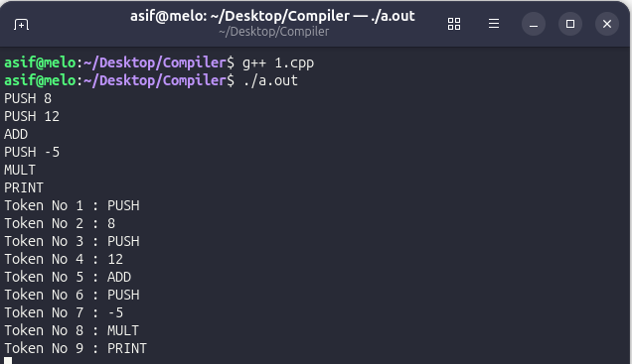

Exercise 02

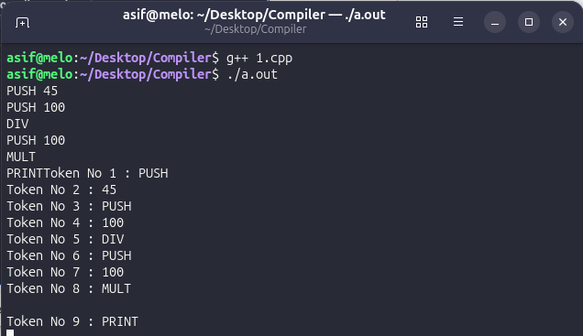

Exercise 03
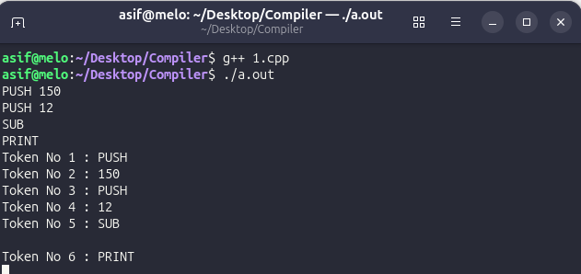

Exercise 04
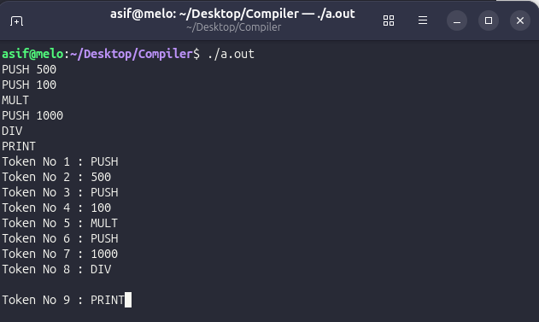

Exercise 05
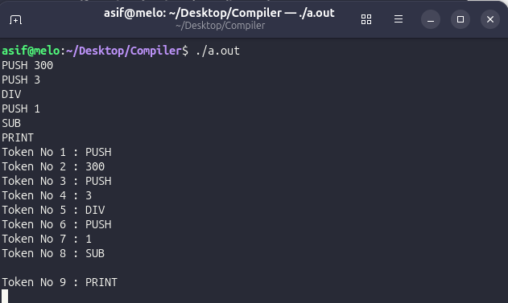

Task 02: MODERATE LEVEL — Variable Assignments & Expressions

Write a robust program that can tokenize (print word-by-word) a given input stream from the moderate_exercises.txt file.
Challenge:
i. Take input line-by-line. That is, given a 5-line input, your program can store those 5 lines into a vector (or array) of strings.
ii. Consider each punctuation character a word, i.e., "id1 *= 2" has 4 tokens: "id1", "*", "=", and "2".

Code:
/**
Moderate Task
@uthor: ASIF
ID: 2309005

**/

#include <iostream>
#include <string>
#include <vector>
#include <stack>
#include <queue>
#include <sstream>
#include <cctype>

using namespace std;

bool alphanum(const string& str) {
if (str.empty()) return false;
for (char c : str) {
if (!isalnum(c)) return false;
}
return true;
}

bool bornomala(string str) {
for (int i = 0; i < str.size(); i++) {
if ( (str[i] >= 'a' && str[i] <= 'z') ||
(str[i] >= 'A' && str[i] <= 'Z') ||
(str[i] >= '0' && str[i] <= '9')) return true;
else if (!isalpha(str[i]) || str[i] == '(' || str[i] == ')') {
return false;
}
}
return true;
}

bool ispunc(char ch) {
if (ch == '=' || ch == '+' || ch == '-'
|| ch == '/' || ch == '*' ||
ch == '(' || ch == ')'){
return true;
}
return false;
}

int main()
{
string str;
vector<string> v;
stack<string> st;
queue<string> tokens;

while (getline(cin, str)) {
v.pb(str);
}

int i = 0;
for (auto it: v) {
i++;
stringstream ss(it);
string temp;

cout << "\"" << it << "\" has ";

int j = 0;

while (ss >> temp) {
if (alphanum(temp)) {
tokens.push(temp);
} else {
string curr = "";
for (int i = 0; i < temp.size(); i++) {
if (ispunc(temp[i])) {
if (!curr.empty()) {
tokens.push(curr);
curr = "";
}
tokens.push(string(1, temp[i]));
}
else {
curr += temp[i];
}
}
if (!curr.empty()) {
tokens.push(curr);
}
}
}
cout << tokens.size() << " tokens:";

while (!tokens.empty()) {
j++;
if (tokens.size() > 1) cout << "'" << tokens.front() << "',";
else cout << " and '" << tokens.front() << "'.";
tokens.pop();
}

cout << '\n';

}
return 0;}

Exercise 01
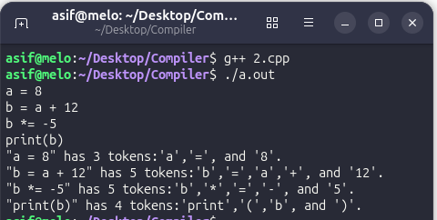

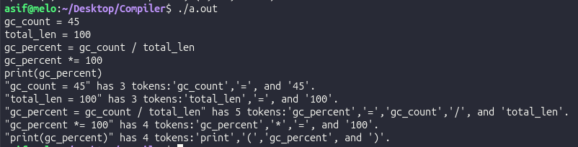
Exercise 02
Exercise 03
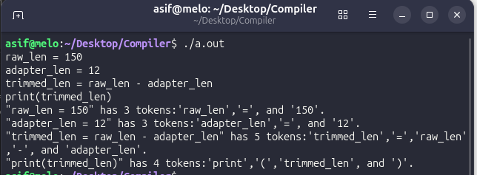Exercise 04
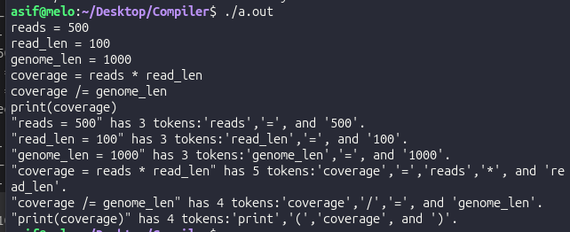

Exercise 05


