《移动平台开发-IOS》课程报告

题 目： 留言板
专 业： 软件工程
学 号： 201821122038
项目设计人： 王晓敏

集美大学 计算机工程学院

目 录

一、项目的来源及意义 1
二、项目需求分析及设计 1
三、项目实现 1
四、项目运行情况及说明 2
五、总结 2
六、附录 3

- 项目来源及意义
项目来源：由于网上交流有时缺乏实时性，产生写个留言板的想法。
项目意义：留言板就是保存每个人的说法，并能展示给未来更多人得知。解决不能同步交流的困扰。同时能将所要表达的内容更清晰的表达出来。

- 项目需求分析及设计
1.能登陆注册，为用户提供使用入口。
2.能发表留言，将留言通过持久化保存下来。
3.能删除自己发表的留言，并将持久化内容更新。
4.能回复留言。
- 项目实现
登陆成功后进入tabbar 如图一所示
tabViewController.viewControllers = [informationViewController,messageNavigationController]
let tabBar = tabViewController.tabBar
let informationItem = tabBar.items![0]
informationItem.title = " 我的"
informationItem.image = UIImage(named: "mine")
let messageItem = tabBar.items![1]
messageItem.title = "留言板"
messageItem.image = UIImage(named: "category")
tabViewController.modalPresentationStyle = UIModalPresentationStyle.fullScreen
self.present(tabViewController, animated: true, completion: nil)

添加留言 如图二所示
@objc func addMessage(){
var messageText:UITextField?
let tip = UIAlertController(
title: "添加", message: "请输入留言信息",
preferredStyle: UIAlertController.Style.alert)
let cancel = UIAlertAction(title: "取消", style: UIAlertAction.Style.default, handler: nil)
let yes = UIAlertAction(title: "添加", style: UIAlertAction.Style.default){
[self](action) -> Void in
if messageText?.text == "" {
let alter = UIAlertController(title: "提示", message: "留言为空", preferredStyle: UIAlertController.Style.alert)
let action = UIAlertAction(
title: "重新输入", style: UIAlertAction.Style.default, handler:{_ in self.present(tip, animated: true, completion: nil)
}
)
alter.addAction(action)
self.present(alter, animated: true, completion: nil)
}
else{
newMessage = Message(writer: user!, text: (messageText?.text)!, time: Date(), reverts: Array<Revert>())
updateMessage()
}
}
tip.addTextField { (message) in
messageText = message
messageText!.placeholder = "输入留言信息"
}
tip.addAction(cancel)
tip.addAction(yes)
self.present(tip, animated: true, completion: nil)
}

删除留言 如图三所示
@objc func deleteMessage(){
messages.remove(at: index!)
let messagePath:URL={
let docs = FileManager.default.urls(for: .documentDirectory, in: .userDomainMask)
let doc = docs.first!
return doc.appendingPathComponent("messages.archive")
}()
NSKeyedArchiver.archiveRootObject(messages, toFile: messagePath.path)

self.dismiss(animated: true, completion: nil)
let sender = ["flag":1,"index":index] as [String : Any]
NotificationCenter.default.post(name: NSNotification.Name("DoDelete"), object: nil, userInfo: sender)
}

@objc func deleteMessage(_ notifation:Notification){
let userInformation = notifation.userInfo!
let index = userInformation["index"] as! Int
messages.remove(at: index)
tableView.deleteRows(at: [IndexPath(row: index, section: 0)], with: UITableViewRowAnimation.left)
}
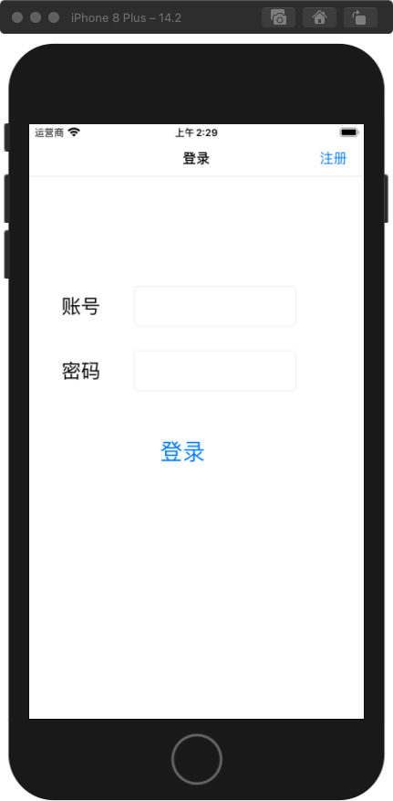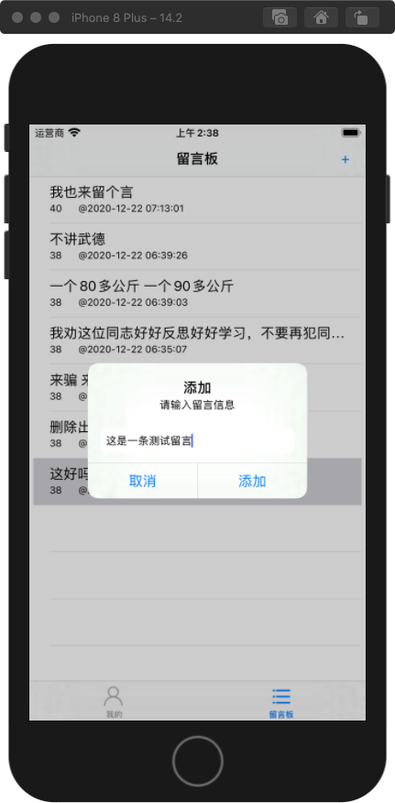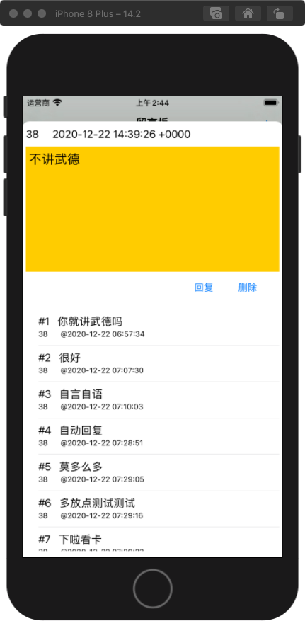
图一 登陆成功 图二 添加留言 图三 回复
- 项目运行情况及说明
主要使用了tableview展示留言和回复信息。
使用文件存储实现持久化。
- 总结
1.登陆时若不存在用户名未单独列出，可以列出提示去注册。
2.昵称及用户密码的修改还未实现。
3.忘记密码后的找回密码未实现。
4.回复无法删除，只能删除留言一起删除。
5.实现了用户只能删除自己的留言。
6.实现了用户留言时间和回复时间的持久化存储。
7.实现了用户退出登陆的操作。

附录
import UIKit
public var id:String?
class SceneDelegate: UIResponder, UIWindowSceneDelegate {
var window: UIWindow?
func scene(_ scene: UIScene, willConnectTo session: UISceneSession, options connectionOptions: UIScene.ConnectionOptions) {
self.window?.rootViewController = UINavigationController(rootViewController: LoginViewController())
guard let _ = (scene as? UIWindowScene) else { return }
}
}
// ViewController.swift
// MessageBox
// Created by 王晓敏 on 2020/12/9.
//
import UIKit
class LoginViewController: UIViewController {
let idLabel:UILabel! = UILabel(frame: CGRect(x: 40, y: 200, width: 100, height: 50))
let passwordLabel: UILabel! = UILabel(frame: CGRect(x: 40, y: 280, width: 100, height: 50))
let idText:UITextField = UITextField(frame: CGRect(x: 130, y: 200, width: 200, height: 50))
let passwordText:UITextField = UITextField(frame: CGRect(x: 130, y: 280, width: 200, height: 50))
let loginButton:UIButton = UIButton(type: .system)
var user = Dictionary<String,String>()
override func viewDidLoad() {
super.viewDidLoad()
NotificationCenter.default.addObserver(self, selector: #selector(autoFillInfo(_:)), name: NSNotification.Name(rawValue:"RegisterSubmit"), object: nil)
NotificationCenter.default.addObserver(self, selector: #selector(logout(_:)), name: NSNotification.Name(rawValue:"Logout"), object: nil)
idLabel.text = "账号"
idLabel.font = UIFont.systemFont(ofSize: 24)
idText.keyboardType = UIKeyboardType.numberPad
idText.borderStyle = UITextField.BorderStyle.roundedRect
passwordLabel.text = "密码"
passwordLabel.font = UIFont.systemFont(ofSize: 24)
passwordText.isSecureTextEntry = true
passwordText.borderStyle = UITextField.BorderStyle.roundedRect
self.view.backgroundColor = UIColor.white
self.title = "登录"
self.view.addSubview(idLabel)
self.view.addSubview(idText)
self.view.addSubview(passwordLabel)
self.view.addSubview(passwordText)
loginButton.frame = CGRect(x: 70, y: 380, width: 240, height: 50)
loginButton.setTitle("登录", for: .normal)
loginButton.titleLabel?.font = UIFont.systemFont(ofSize: 28)
self.view.addSubview(loginButton)
loginButton.addTarget(self, action: #selector(LoginViewController.login), for: .touchUpInside)
self.navigationController?.setNavigationBarHidden(false, animated: true)
self.navigationItem.rightBarButtonItem = UIBarButtonItem(title: "注册", style: UIBarButtonItem.Style.plain, target: self, action: #selector(LoginViewController.register))
}
@objc func register(){
let viewController = RegisterViewController()
self.navigationController?.pushViewController(viewController, animated: true)
}
@objc func logout(_ notifation:Notification){
passwordText.text = ""
passwordText.becomeFirstResponder()
}
@objc func autoFillInfo(_ notifation:Notification){
let userInformation = notifation.userInfo!
id = userInformation["id"] as? String
idText.text = id
passwordText.text = ""
passwordText.becomeFirstResponder()
}
@objc func login(){
//打开plist
let documentPath = NSSearchPathForDirectoriesInDomains(.documentDirectory, .userDomainMask, true).first!
let dictionaryPath = documentPath.appending("userList.plist")
let dicFromPList:NSDictionary? = NSDictionary(contentsOfFile: dictionaryPath)
if(dicFromPList != nil){
self.user = dicFromPList as! [String : String]
}
id = idText.text!
let password:String = passwordText.text!
var tip:UIAlertController!
var action:UIAlertAction!
if(id==""||password==""){
tip = UIAlertController(title: "提示", message: "账号密码为空", preferredStyle: UIAlertController.Style.alert)
action = UIAlertAction(title: "重新输入", style: UIAlertAction.Style.default, handler: nil)
tip.addAction(action)
self.present(tip, animated: true, completion: nil)
}else if(user[id!] != password){
tip = UIAlertController(title: "提示", message: "账号密码错误", preferredStyle: UIAlertController.Style.alert)
action = UIAlertAction(title: "重新输入", style: UIAlertAction.Style.default, handler: nil)
tip.addAction(action)
self.present(tip, animated: true, completion: nil)
}else{
self.view.endEditing(true)
let tabViewController = UITabBarController()
let informationViewController = InformationViewController()
let messageViewController = MessageViewController()
let messageNavigationController = UINavigationController(rootViewController: messageViewController)
tabViewController.viewControllers = [informationViewController,messageNavigationController]
let tabBar = tabViewController.tabBar
let informationItem = tabBar.items![0]
informationItem.title = " 我的"
informationItem.image = UIImage(named: "mine")
let messageItem = tabBar.items![1]
messageItem.title = "留言板"
messageItem.image = UIImage(named: "category")
tabViewController.modalPresentationStyle = UIModalPresentationStyle.fullScreen
self.present(tabViewController, animated: true, completion: nil)
}

}
override func didReceiveMemoryWarning() {
super.didReceiveMemoryWarning()
NotificationCenter.default.removeObserver(self)
}
}
// RegisterViewController.swift
// MessageBox
// Created by 王晓敏 on 2020/12/10.
//
import UIKit
class RegisterViewController: UIViewController {
let idLabel:UILabel! = UILabel(frame: CGRect(x: 40, y: 200, width: 100, height: 50))
let passwordLabel: UILabel! = UILabel(frame: CGRect(x: 40, y: 280, width: 100, height: 50))
let idText:UITextField = UITextField(frame: CGRect(x: 130, y: 200, width: 200, height: 50))
let passwordText:UITextField = UITextField(frame: CGRect(x: 130, y: 280, width: 200, height: 50))
let submitButton:UIButton = UIButton(type: .system)
override func viewDidLoad() {
super.viewDidLoad()
idLabel.text = "账号"
idLabel.font = UIFont.systemFont(ofSize: 24)
idText.keyboardType = UIKeyboardType.numberPad
idText.borderStyle = UITextField.BorderStyle.roundedRect
passwordLabel.text = "密码"
passwordLabel.font = UIFont.systemFont(ofSize: 24)
passwordText.isSecureTextEntry = true
passwordText.borderStyle = UITextField.BorderStyle.roundedRect
self.view.backgroundColor = UIColor.white
self.title = "注册"
self.view.addSubview(idLabel)
self.view.addSubview(idText)
self.view.addSubview(passwordLabel)
self.view.addSubview(passwordText)
idText.becomeFirstResponder()
submitButton.frame = CGRect(x: 70, y: 380, width: 240, height: 50)
submitButton.setTitle("提交", for: .normal)
submitButton.titleLabel?.font = UIFont.systemFont(ofSize: 28)
self.view.addSubview(submitButton)
submitButton.addTarget(self, action: #selector(RegisterViewController.submit), for: .touchUpInside)
}

@objc func submit(){
let id:String = idText.text!
let password:String = passwordText.text!
var tip:UIAlertController!
var action:UIAlertAction!
let documentPath = NSSearchPathForDirectoriesInDomains(.documentDirectory, .userDomainMask, true).first!
let dictionaryPath = documentPath.appending("userList.plist")
var dicFromPList:NSDictionary? = NSDictionary(contentsOfFile: dictionaryPath)
var users = Dictionary<String,String>()
if(dicFromPList != nil){
users = dicFromPList as! [String : String]
}
if id==""||password=="" {
tip = UIAlertController(title: "提示", message: "账号或密码为空", preferredStyle: UIAlertController.Style.alert)
action = UIAlertAction(title: "返回", style: UIAlertAction.Style.cancel, handler: nil)
tip.addAction(action)
}else if(users[id] != nil){
tip = UIAlertController(title: "提示", message: "该账号已注册", preferredStyle: UIAlertController.Style.alert)
action = UIAlertAction(title: "返回", style: UIAlertAction.Style.cancel, handler: nil)
tip.addAction(action)
}else{
var loginInfo = Dictionary<String,String>()
let documentPath = NSSearchPathForDirectoriesInDomains(.documentDirectory, .userDomainMask, true).first!
let dictionaryPath = documentPath.appending("userList.plist")
var dicFromPList:NSDictionary? = NSDictionary(contentsOfFile: dictionaryPath)
if(dicFromPList != nil){
loginInfo = dicFromPList as! [String : String]
}
loginInfo.updateValue(password, forKey: id)
dicFromPList = loginInfo as NSDictionary
let _:Bool = dicFromPList!.write(toFile: dictionaryPath, atomically:true)
self.view.endEditing(true)
var users:Array<User>
let homePath:URL={
let docs = FileManager.default.urls(for: .documentDirectory, in: .userDomainMask)
let doc = docs.first!
return doc.appendingPathComponent("users.archive")
}()
users = (NSKeyedUnarchiver.unarchiveObject(withFile: homePath.path) as? Array<User>)!//TODO:一开始为空文件
let user:User = User(id: id, nickName: id)
users.append(user)
NSKeyedArchiver.archiveRootObject(users, toFile: homePath.path)
tip = UIAlertController(title: "提示", message: "注册成功", preferredStyle: UIAlertController.Style.alert)
action = UIAlertAction(title: "返回", style: UIAlertAction.Style.default) { (alters:UIAlertAction) in
let userInformation = ["id":id,"password":password]
NotificationCenter.default.post(name: NSNotification.Name("RegisterSubmit"), object: nil, userInfo: userInformation)
self.navigationController?.popViewController(animated: true)
}
tip.addAction(action)
}
self.present(tip, animated: true, completion: nil)
}

}
// InformationViewController.swift
// MessageBox
// Created by 王晓敏 on 2020/12/14.
import UIKit
class InformationViewController: UIViewController {
let idLabel:UILabel = UILabel(frame: CGRect(x: 40, y: 100, width: 100, height: 30))
let nickNameLabel:UILabel = UILabel(frame: CGRect(x: 40, y: 150, width: 100, height: 30))
let idText:UILabel = UILabel(frame: CGRect(x: 150, y: 100, width: 100, height: 30))
let nickName:UILabel = UILabel(frame: CGRect(x: 150, y: 150, width: 100, height: 30))
let logoutBtn:UIButton = UIButton(type: .system)
override func viewDidLoad() {
super.viewDidLoad()
self.view.backgroundColor = UIColor.white
initThis()
idLabel.text="用户名"
nickNameLabel.text="昵称"
logoutBtn.frame = CGRect(x: 150, y: 250, width: 80, height: 30)
logoutBtn.setTitle("注销", for: .normal)

self.view.addSubview(idLabel)
self.view.addSubview(idText)
self.view.addSubview(nickNameLabel)
self.view.addSubview(nickName)
changeNameBtn.addTarget(self, action: #selector(InformationViewController.changeNickName), for: .touchUpInside)
self.view.addSubview(logoutBtn)
logoutBtn.addTarget(self, action: #selector(InformationViewController.logout), for: .touchUpInside)
}

func initThis(){
self.idText.text = id
var users:Array<User>
let homePath:URL={
let docs = FileManager.default.urls(for: .documentDirectory, in: .userDomainMask)
let doc = docs.first!
return doc.appendingPathComponent("users.archive")
}()
users = (NSKeyedUnarchiver.unarchiveObject(withFile: homePath.path) as? Array<User>)!
var user:User = User(id: "", nickName: "")
var flag:Bool = false
for index in 0..<users.count{
if(users[index].id == id){
user = users[index]
flag = true
}
}
if flag{
self.nickName.text = user.nickName
}
}
@objc func changeNickName(){
var users:Array<User>
let homePath:URL={
let docs = FileManager.default.urls(for: .documentDirectory, in: .userDomainMask)
let doc = docs.first!
return doc.appendingPathComponent("users.archive")
}()
users = (NSKeyedUnarchiver.unarchiveObject(withFile: homePath.path) as? Array<User>)!
var user:User = User(id: "", nickName: "")
for index in 0..<users.count{
if(users[index].id == id){
user = users[index]
}
}
}
@objc func logout(){
self.dismiss(animated: true, completion: nil)
NotificationCenter.default.post(name: NSNotification.Name("Logout"), object: nil, userInfo: nil)
self.navigationController?.popViewController(animated: true)
}
}
// MessageViewController.swift
// MessageBox
// Created by 王晓敏 on 2020/12/19.

import UIKit
class MessageViewController: UIViewController,UITableViewDataSource,UITableViewDelegate {
var users:Array<User> = []
var user:User?
var newMessage:Message?
var messages:Array<Message> = []
var tableView = UITableView()
override func viewDidLoad() {
super.viewDidLoad()
self.view.backgroundColor = UIColor.white
initThis()
self.title = "留言板"
self.navigationController?.setNavigationBarHidden(false, animated: true)
self.navigationItem.rightBarButtonItem = UIBarButtonItem(title: "+", style: UIBarButtonItem.Style.plain, target: self, action: #selector(MessageViewController.addMessage))
NotificationCenter.default.addObserver(self, selector: #selector(deleteMessage(_:)), name: NSNotification.Name(rawValue:"DoDelete"), object: nil)
}
func initThis(){
let homePath:URL={
let docs = FileManager.default.urls(for: .documentDirectory, in: .userDomainMask)
let doc = docs.first!
return doc.appendingPathComponent("users.archive")
}()
users = (NSKeyedUnarchiver.unarchiveObject(withFile: homePath.path) as? Array<User>)!
for index in 0..<users.count{
if(users[index].id == id){
user = users[index]
break
}
}
let messagePath:URL={
let docs = FileManager.default.urls(for: .documentDirectory, in: .userDomainMask)
let doc = docs.first!
return doc.appendingPathComponent("messages.archive")
}()
messages = (NSKeyedUnarchiver.unarchiveObject(withFile: messagePath.path) as? Array<Message>)!
let screenRect = UIScreen.main.bounds
let tableRect = CGRect(x: 5, y: 20, width: screenRect.size.width-10, height: screenRect.size.height-20)
tableView = UITableView(frame: tableRect)
tableView.dataSource = self
tableView.delegate = self
self.view.addSubview(tableView)
}
@objc func addMessage(){
var messageText:UITextField?
let tip = UIAlertController(
title: "添加", message: "请输入留言信息",
preferredStyle: UIAlertController.Style.alert)
let cancel = UIAlertAction(title: "取消", style: UIAlertAction.Style.default, handler: nil)
let yes = UIAlertAction(title: "添加", style: UIAlertAction.Style.default){
[self](action) -> Void in
if messageText?.text == "" {
let alter = UIAlertController(title: "提示", message: "留言为空", preferredStyle: UIAlertController.Style.alert)
let action = UIAlertAction(
title: "重新输入", style: UIAlertAction.Style.default, handler:{_ in self.present(tip, animated: true, completion: nil)
}
)
alter.addAction(action)
self.present(alter, animated: true, completion: nil)
}
else{
newMessage = Message(writer: user!, text: (messageText?.text)!, time: Date(), reverts: Array<Revert>())
updateMessage()
}
}
tip.addTextField { (message) in
messageText = message
messageText!.placeholder = "输入留言信息"
}
tip.addAction(cancel)
tip.addAction(yes)
self.present(tip, animated: true, completion: nil)
}
func updateMessage(){
messages.insert(newMessage!, at: 0)
let messagePath:URL={
let docs = FileManager.default.urls(for: .documentDirectory, in: .userDomainMask)
let doc = docs.first!
return doc.appendingPathComponent("messages.archive")
}()
NSKeyedArchiver.archiveRootObject(messages, toFile: messagePath.path)

tableView.insertRows(at: [IndexPath(row: 0, section: 0)], with: UITableViewRowAnimation.right
)
}
@objc func deleteMessage(_ notifation:Notification){
let userInformation = notifation.userInfo!
let index = userInformation["index"] as! Int
messages.remove(at: index)
tableView.deleteRows(at: [IndexPath(row: index, section: 0)], with: UITableViewRowAnimation.left)

}
func tableView(_ tableView: UITableView, numberOfRowsInSection section: Int) -> Int {
return messages.count
}

func tableView(_ tableView: UITableView, cellForRowAt indexPath: IndexPath) -> UITableViewCell {
let identifier = "messageCell"
var cell = tableView.dequeueReusableCell(withIdentifier: identifier)
if cell == nil{
cell = UITableViewCell(style: UITableViewCellStyle.subtitle, reuseIdentifier: identifier)

}
cell?.textLabel?.text = messages[indexPath.row].text
let dateFormatter = DateFormatter()
dateFormatter.dateFormat = "yyyy-MM-dd HH:mm:ss"
let date = dateFormatter.string(from: messages[indexPath.row].time)
cell?.detailTextLabel?.text = messages[indexPath.row].writer.nickName + " @" + date
return cell!
}
func tableView(_ tableView: UITableView, didSelectRowAt indexPath: IndexPath) {
let viewController = RevertViewController()
self.present(viewController, animated: true, completion: nil)
let messageIndex = ["flag":1,"index":indexPath.row]
NotificationCenter.default.post(name: NSNotification.Name("detail"), object: nil, userInfo: messageIndex)
}
// Model.swift
// MessageBox
// Created by 王晓敏 on 2020/12/20.
import Foundation
class User:NSObject,NSCoding,NSSecureCoding{
var id:String
var nickName:String
func encode(with coder: NSCoder) {
coder.encode(id,forKey: "id")
coder.encode(nickName,forKey: "nickName")
}
required init?(coder: NSCoder) {
id = coder.decodeObject(forKey: "id") as! String
nickName = coder.decodeObject(forKey: "nickName") as! String
}
static var supportsSecureCoding: Bool{
return true
}
init(id:String,nickName:String){
self.id = id
self.nickName = nickName
}
}
class Revert:NSObject,NSCoding,NSSecureCoding{
var writer:User
var text:String
var time:Date
func encode(with coder: NSCoder) {
coder.encode(writer,forKey: "writer")
coder.encode(text,forKey: "text")
coder.encode(time,forKey: "time")
}
required init?(coder: NSCoder) {
writer = coder.decodeObject(forKey: "writer") as! User
text = coder.decodeObject(forKey: "text") as! String
time = coder.decodeObject(forKey: "time") as! Date
}
static var supportsSecureCoding: Bool{
return true
}
init(writer:User,text:String,time:Date){
self.writer = writer
self.text = text
self.time = time
}
}

class Message:NSObject,NSCoding,NSSecureCoding{
var writer:User
var text:String
var time:Date
var reverts:Array<Revert>
func encode(with coder: NSCoder) {
coder.encode(writer,forKey: "writer")
coder.encode(text,forKey: "text")
coder.encode(time,forKey: "time")
coder.encode(reverts,forKey: "reverts")
}
required init?(coder: NSCoder) {
writer = coder.decodeObject(forKey: "writer") as! User
text = coder.decodeObject(forKey: "text") as! String
time = coder.decodeObject(forKey: "time") as! Date
reverts = coder.decodeObject(forKey: "reverts") as! Array<Revert>
}
static var supportsSecureCoding: Bool{
return true
}
init(writer:User,text:String,time:Date,reverts:Array<Revert>){
self.writer = writer
self.text = text
self.time = time
self.reverts = reverts
}
// RevertViewController.swift
// MessageBox
// Created by 王晓敏 on 2020/12/22.

import UIKit
class RevertViewController: UIViewController,UITableViewDataSource,UITableViewDelegate {
var messages:Array<Message> = []
var message:Message?
var index:Int?
var users:Array<User> = []
var user:User?
var writerLabel:UILabel!
var textLabel:UITextView!
var tableView = UITableView()
let deleteMessageBtn:UIButton = UIButton(type: .system)
let combackBtn:UIButton = UIButton(type: .system)
override func viewDidLoad() {
super.viewDidLoad()
self.view.backgroundColor = UIColor.white
let homePath:URL={
let docs = FileManager.default.urls(for: .documentDirectory, in: .userDomainMask)
let doc = docs.first!
return doc.appendingPathComponent("users.archive")
}()
users = (NSKeyedUnarchiver.unarchiveObject(withFile: homePath.path) as? Array<User>)!
for index in 0..<users.count{
if(users[index].id == id){
user = users[index]
break
}
}
let messagePath:URL={
let docs = FileManager.default.urls(for: .documentDirectory, in: .userDomainMask)
let doc = docs.first!
return doc.appendingPathComponent("messages.archive")
}()
messages = (NSKeyedUnarchiver.unarchiveObject(withFile: messagePath.path) as? Array<Message>)!
NotificationCenter.default.addObserver(self, selector: #selector(getIndex(_:)), name: NSNotification.Name(rawValue:"detail"), object: nil)
let screenRect = UIScreen.main.bounds
textLabel = UITextView(frame: CGRect(x: 5, y: 40, width: screenRect.size.width-10, height: 200))
textLabel.font = UIFont.systemFont(ofSize: 20)
textLabel.isEditable = false
textLabel.backgroundColor = .systemYellow
writerLabel = UILabel(frame: CGRect(x: 5, y: 5, width: screenRect.size.width-10, height: 30))
self.view.addSubview(textLabel)
self.view.addSubview(writerLabel)
deleteMessageBtn.frame = CGRect(x: screenRect.size.width-80, y: 250, width: 50, height: 30)
deleteMessageBtn.setTitle("删除", for: .normal)
deleteMessageBtn.addTarget(self, action: #selector(RevertViewController.deleteMessage), for: .touchUpInside)
combackBtn.frame = CGRect(x: screenRect.size.width-150, y: 250, width: 50, height: 30)
combackBtn.setTitle("回复", for: .normal)
combackBtn.addTarget(self, action: #selector(RevertViewController.updateComeback), for: .touchUpInside)
self.view.addSubview(combackBtn)
let tableRect = CGRect(x: 5, y: 300, width: screenRect.size.width-10, height: screenRect.size.height-350)
tableView = UITableView(frame: tableRect)
tableView.dataSource = self
tableView.delegate = self
self.view.addSubview(tableView)
}
@objc func getIndex(_ notifation:Notification){
let userInformation = notifation.userInfo!
index = userInformation["index"] as! Int
message = messages[index!]
writerLabel.text = (message?.writer.nickName)! + " " + (message?.time.description)!
textLabel.text = message?.text
if(message?.writer.id == id){
self.view.addSubview(deleteMessageBtn)
}
}
@objc func deleteMessage(){
messages.remove(at: index!)
let messagePath:URL={
let docs = FileManager.default.urls(for: .documentDirectory, in: .userDomainMask)
let doc = docs.first!
return doc.appendingPathComponent("messages.archive")
}()
NSKeyedArchiver.archiveRootObject(messages, toFile: messagePath.path)

self.dismiss(animated: true, completion: nil)
let sender = ["flag":1,"index":index] as [String : Any]
NotificationCenter.default.post(name: NSNotification.Name("DoDelete"), object: nil, userInfo: sender)
}
@objc func updateComeback(){
var messageText:UITextField?
let tip = UIAlertController(
title: "回复", message: "请输入",
preferredStyle: UIAlertController.Style.alert)
let cancel = UIAlertAction(title: "取消", style: UIAlertAction.Style.default, handler: nil)
let yes = UIAlertAction(title: "回复", style: UIAlertAction.Style.default){
[self](action) -> Void in
if messageText?.text == "" {
let alter = UIAlertController(title: "提示", message: "内容为空", preferredStyle: UIAlertController.Style.alert)
let action = UIAlertAction(
title: "重新输入", style: UIAlertAction.Style.default, handler:{_ in self.present(tip, animated: true, completion: nil)
}
)
alter.addAction(action)
self.present(alter, animated: true, completion: nil)
}
else{
message?.reverts.append(Revert(writer: user!, text: (messageText?.text)!, time: Date()))
updateMessage()
}
}
tip.addTextField { (message) in
messageText = message
messageText!.placeholder = "输入回复信息"
}
tip.addAction(cancel)
tip.addAction(yes)
self.present(tip, animated: true, completion: nil)
}
func updateMessage(){
let messagePath:URL={
let docs = FileManager.default.urls(for: .documentDirectory, in: .userDomainMask)
let doc = docs.first!
return doc.appendingPathComponent("messages.archive")
}()
NSKeyedArchiver.archiveRootObject(messages, toFile: messagePath.path)
tableView.insertRows(at: [IndexPath(row: (message?.reverts.count)!-1, section: 0)], with: UITableViewRowAnimation.right
)
}
func tableView(_ tableView: UITableView, numberOfRowsInSection section: Int) -> Int {
return (message?.reverts.count)!
}
func tableView(_ tableView: UITableView, cellForRowAt indexPath: IndexPath) -> UITableViewCell {
let identifier = "messageCell"
var cell = tableView.dequeueReusableCell(withIdentifier: identifier)
if cell == nil{
cell = UITableViewCell(style: UITableViewCellStyle.subtitle, reuseIdentifier: identifier)
}
cell?.textLabel?.text = "#" + (indexPath.row+1).description + " " + message!.reverts[indexPath.row].text
let dateFormatter = DateFormatter()
dateFormatter.dateFormat = "yyyy-MM-dd HH:mm:ss"
let date = dateFormatter.string(from: message!.reverts[indexPath.row].time)
cell?.detailTextLabel?.text = message!.reverts[indexPath.row].writer.nickName + " @" + date
return cell!
}

}

