|  |  |  |  |
| --- | --- | --- | --- |
| Department of Engineering  2020-2021 | | |  |
| ***Characteristics of synchronous machines and the effects of various loading methods*** | | | |
|  |  |  | |
| **Unisa Bangura** | 17000873 | BEng (Hons) Electrical and Electronic Engineering. | |

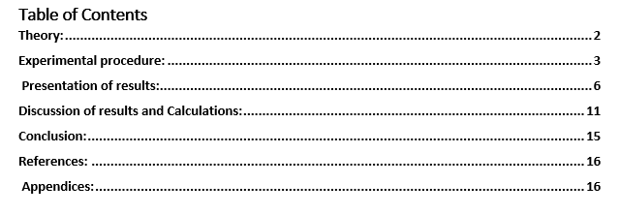



# **Theory:**

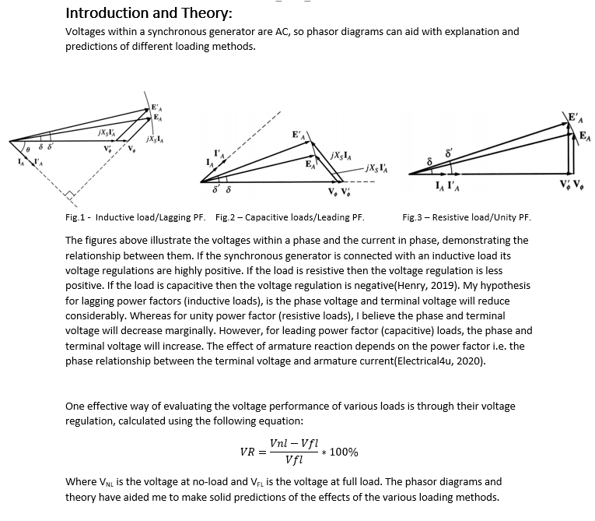

# **Experimental procedure:**

**Task 1: Open and short circuit characteristics.**

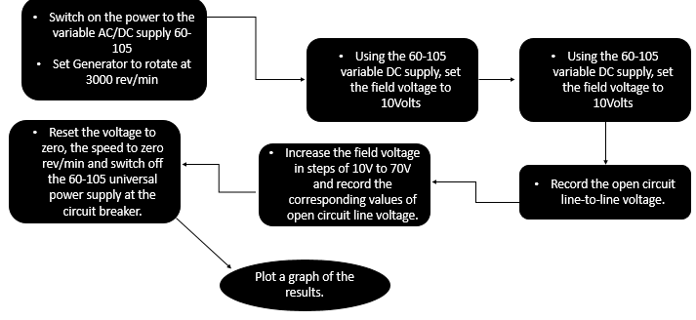**Procedure for open circuit operation experiment:**

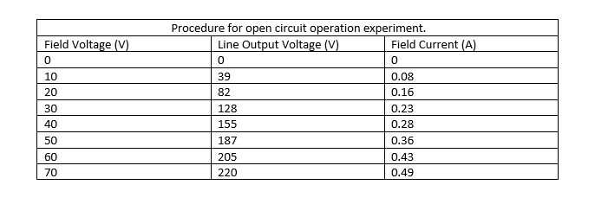

The resultant graph of this open circuit test can be found within the results section along with critical analysis within the discussion section.

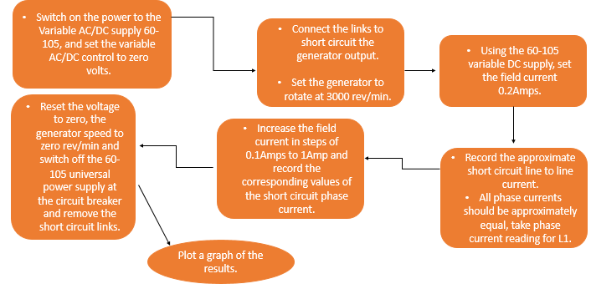**Procedure for short circuit operation experiment:**

The resultant graph of this short circuit test data can be found within the results section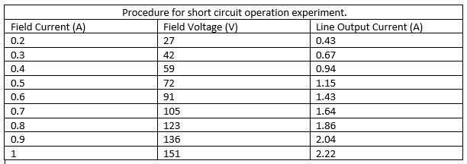.

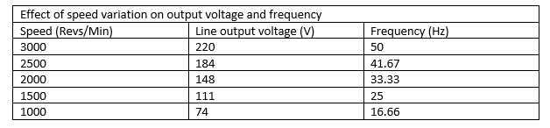**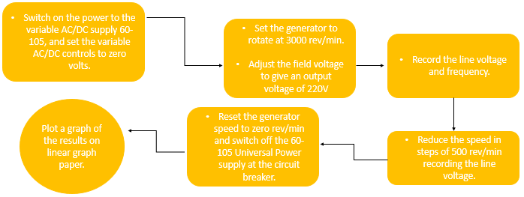Effect of speed variation on output voltage and frequency:**

The relationship between speed variation and its effect on output voltage and frequency has been plotted within the results section and theoretical analysis has been applied to support the results obtained within the discussion.

**Task 2: Voltage regulation of Synchronous Generators:**

**Procedure for voltage regulation with resistive load:**

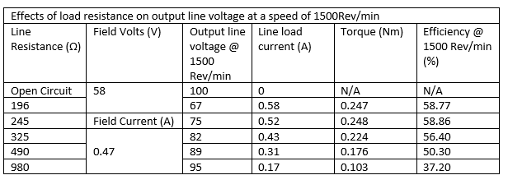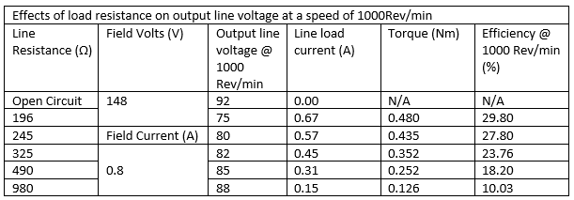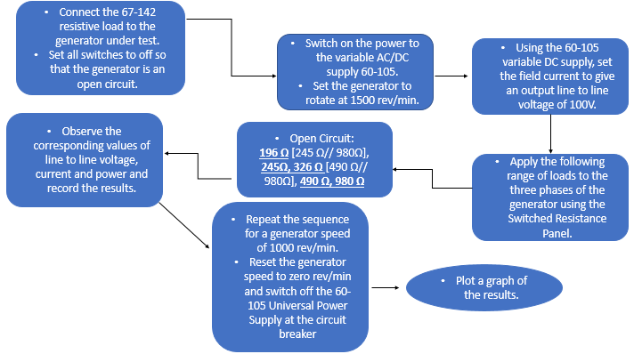

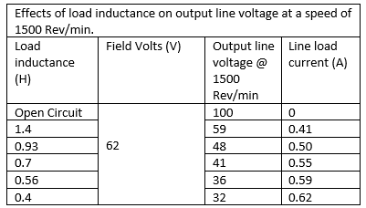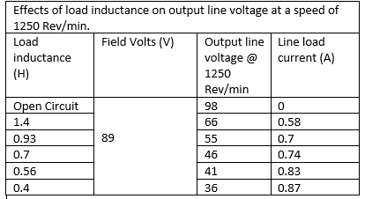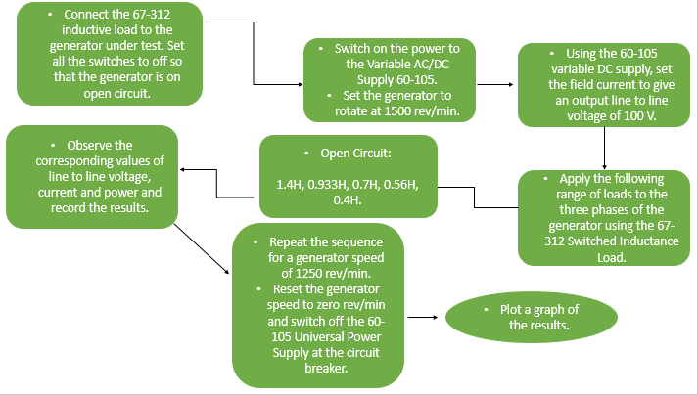**Procedure for voltage regulation with inductive load:**

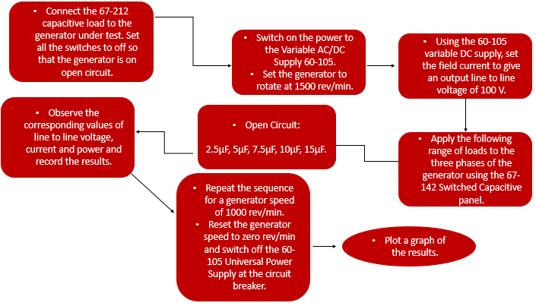**Procedure for voltage regulation with capacitive load:**

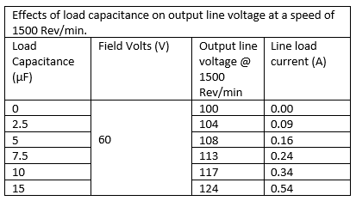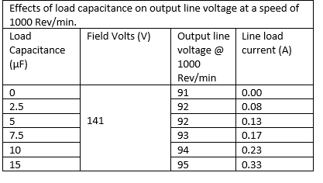

After the practical data was derived, a verification process was required to ensure the data was collected correctly. The Multisim software was used to replicate the experiment to acquire theorical data which would allow comparison and further critical analysis to be completed. The Multisim circuits utilised can be found in Appendix 1-3. The resultant data of the Multisim simulation can be found in Appendix 4-9.

# **Presentation of results:**

Fig.4 – Open Circuit analysis results.

Fig.5 – Short circuit analysis.

Fig.6 – Effect of speed variation on output voltage and frequency.

Fig.7 – Effect of various load resistances on output line voltage at 1500rpm&1000rpm.

Fig. 8 – Effect of various load resistances on load line current at 1500rpm&1000rpm

Fig . 9 – Apparent Power for various resistive loads and 1500rpm and 1000rpm.

Fig. 10 – Effect of load inductance on output load line current.

Fig.11 – Effect of load inductance on output line voltage.

Fig. 12 – Apparent power for various inductive loads at 1500rpm and 1250rpm.

Fig.13 – Effects of load capacitance of output line voltage.

Fig.14 – Effect of load capacitance of load line current.

Fig. 15 – Apparent power for various capacitive loads at 1500rpm and 1000rpm.

# **Discussion of results and Calculations:**

Fig. 4 displays a linear trend to begin with before starting to level out as the field current increases. At higher field current levels, the iron in the machine saturates and the percentage of field MMF applied to the air gap is reduced. As a result, the induced voltage falls below the air gap line (Knight, 2021). This theory is evident in Fig.4. One reason this type of analysis is so vital is because it provides us with the relationship between field current and induced voltage for all types of load conditions.

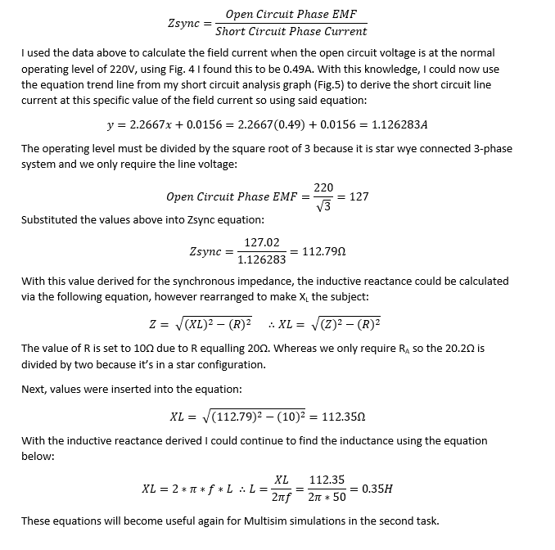From Fig.5 we can see that there is a linear relationship between the field current and line output current. The field current may be increased to get armature current up to 150% of the rated value (Electrical study notes, 2017). Both Fig.4&5 are vitally important to calculate the synchronous impedance, as the open-circuit voltage per phase divided by short circuit armature current, displayed in the equation below:

When setting up my Multisim circuit, component values had to be selected for the voltage, resistance, and inductance. As stated earlier, some of the prior calculations above can be utilised for the resistance and inductance. However, Task 2 sets the line to line voltage to 100V meaning to find that phase voltage it needs to be divided by the square root of 3, hence:

$$\frac{100V}{\sqrt{3}}=57.735V$$

This will be my Multisim input voltage for the second task.

Fig.6 illustrates the speed variation due to the voltage and frequency; it can be clearly seen from the graph that as the speed increases the frequency and line output voltage will follow suit. This relationship can be explained by the following equations:

$$V=E$$

$$E=K*Φ*f ∴ V=K* Φ*f$$

Where K is the synchronous generator constant, Φ is the flux of the SG and f is the frequency proving my analysis with theory. This equation supports my observation that as the frequency rises the voltage will increase meaning I am happy the data so far satisfies theoretical predictions.

Fig.7 displays the results derived from the various resistive loading values applied and plots them against the output line voltage. From this data, it is evident that some anomalous results have been recorded. Based on theory I would expect the 1500rpm output line voltage to be larger than 1000rpm data, however the first two data points contradict this. From the data I can conclude that the voltage increases as the resistive load increases which supports my hypothesis and theory.

There is a negative correlation between generator speed and line load current displayed on Fig.8 meaning the graph suggests that as resistive load is increased the current will also fall.

Fig.9 illustrates the relationship between the power and the various different resistive loads, the apparent power was calculated using the following equation:

$$S=V*I$$

Where: S is the apparent power, V is the output line voltage and I is the load line current.

Due to the previous anomalous results, Fig.9 implies a lower frequency (generator speed) renders a higher apparent power however I disagree with this and will prove the opposite in a Multisim simulation to support theory. Fig.9 indicates that a lower restive load allows for a higher apparent power which I will again confirm in simulations.

Fig.16 Fig.17

As stated above, Multisim circuits (Appendix 1-3) were created to allow for comparison between simulated and practical data to provide clarity on the effects of various loading techniques.

Fig.16 and 17 show the results of my Multisim simulation results, the relationships above echo the practical data proving that as the load resistance increases output line voltage increases and the load line current decreases.

The inductive load (lagging PF) was the next method applied, Fig.10 demonstrates the effect on load line current. As can be seen from the graph there is another negative correlation meaning as the inductive load is increased the current decreases. Fig.11 explores the relationship between the various inductive loads and output line voltage, clearly the graph shows a trend that the voltage increases as the inductive load increases. Another important observation from Fig.10 and 11 is that the lower generator speed (frequency) renders a higher voltage and current. Figure.12 displays the apparent power at the various inductive load values, because of the higher values for the lower generator speed in terms of voltage and current it results in the apparent power being larger for 1250rpm speed. Showing power increases along with load inductance value increasing.

Fig.18. Fig.19.

Very similar results were produced by the simulated version (Fig.18 and 19) of the inductive load experiment, supporting the conclusions drawn from the practical data and theory explored above.

Fig. 13 signifies the resultant graph of the capacitive loading effects; from this test I expected the output line voltage to increase as the capacitive load values rises. This was exactly evident on the graph along with another relationship that a higher frequency or generating speed will render greater values for the voltage. Fig.14 proves that both these trends are identical in terms of load line current as it increases with load capacitance. Fig.15 demonstrates the apparent power as the load capacitor varies in value, this figure illustrates the power increasing as does the load capacitance. Moreover, the higher generator speed resulted in a larger apparent power.

Again, these results had to be verified using a Multisim simulation for complete accuracy. All above conclusions drawn regarding the load capacitance were corroborated and validated by Fig.20 and 21 below:

Fig. 20. Fig.21.

Fig.22-24 represent the simulated output power for the various loading methods applied to the Multisim equivalent circuit. The results consolidate the practical findings, as relationships are echoed. As the resistive load increases the power decreases, as the inductive load increase the power increase and as the capacitive load increase the power rises also.

After analysis of practical and theoretical data it is clear that the resistive load causes a unity power factor, resulting in the EMF, field flux and armature current to be in phase. The voltage regulation at a resistive load of 980Ω (Appendix 4/5) is 1.8% for the 1002rpm generator speed (16.7Hz) and 1.09% for the 1500rpm (25Hz) . This is a result of the armature flux lagging the field flux by 90°, causing cross magnetizing flux meaning similar values of full-load and no-load voltages hence the low percentage for voltage regulation.

In regard to the inductive load, the results confirm a lagging power factor occurs thus the armature current is lagging the field flux and electromotive force. Armature flux is also lagging the current resulting in a 180° phase difference between the armature flux and field flux. The demagnetizing effect occurs consequently. When the field gets distorted, it is known as a cross magnetizing effect. And when the field flux gets reduced, it is known as the demagnetizing effect. (Electrical4U, 2020) The voltage regulation at an inductive load of 1.4H, at a rotation speed of 1500rpm is 25.6% but with a load of 0.4H it was 84%, hence proving prior theory. Remaining results for voltage regulations can be found in appendix 6 and 7.

Finally, the last loading method simulated and analysed was capacitive. The practical results were common of a leading power factor and simulation confirmed this. From theory I know this means the armature current will lead the EMF, but armature flux this time will be lagging the current by a 90° phase difference. Opposite to the previous methods this causes the magnetizing effect because the armature flux and field flux are now in phase. The voltage regulation at a capacitive load of 15µF with a generator speed of 1500rpm is -13.3% yet at 1000rpm is was only -5.95% synonymous to predictions. Remaining results for voltage regulations can be found in appendix 8 and 9.

# **Conclusion:**

# **References:**



# **Appendices:**

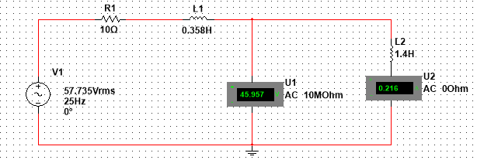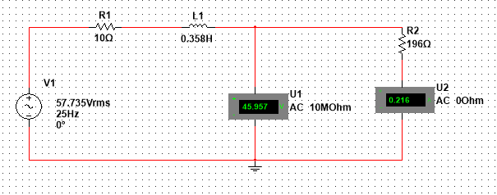

Appendix 1.

Appendix 2.

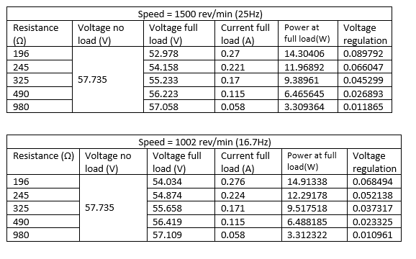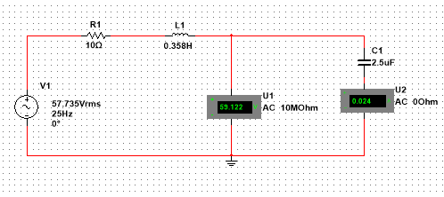Appendix 3.

Appendix 4&5.

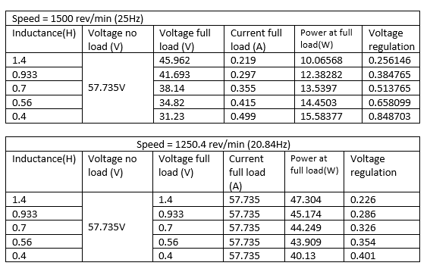Appendix 6&7.

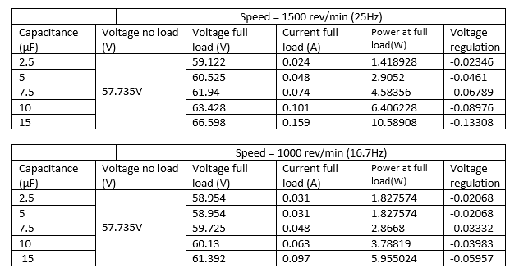

Appendix 8&9.