Nautical Autonomous System with Task Integration
Final Report

Terry Max Christy & Jeremy Borgman
Dr. Gary Dempsey & Nick Schmidt
April 10, 2012

Contents
Project Summary: 2
System Overview: 2
Motor Interfacing Module 3
Thruster Circuitry 3
Differential Drive Circuitry 4
Bidirectional Relay Circuitry 4
communication 5
Remote control 5
Beagleboard & os 6
High level Control scheme 6
Buoy Detection 7
Channel navigation 7
Obsticle avoidance 7

Project Summary:
The student members of Team NASTI propose the Nautical Autonomous System with Task Integration (NASTI), an autonomous system based around a catamaran platform, as the basis for the senior project. The platform will be designed in such a way that it can autonomously navigate a channel of water buoys. Ultimately, the robotic platform is intended to compete in the AUVSI (Association for Unmanned Vehicle Systems International) Foundation and ONR's(Office of Naval Research) 5th International RoboBoat Competition. This competition is based around the main goal of navigating an unknown path of water buoys, and running through a speed test straightaway. If a vehicle can complete this, then there are sub tasks that can be completed for extra points. This project will focus on completion of the main navigational task based on image processing for the senior project, and the rest of the competition will be taken as secondary goals for the team. The goals, both the navigational and the competition goals can be seen in .
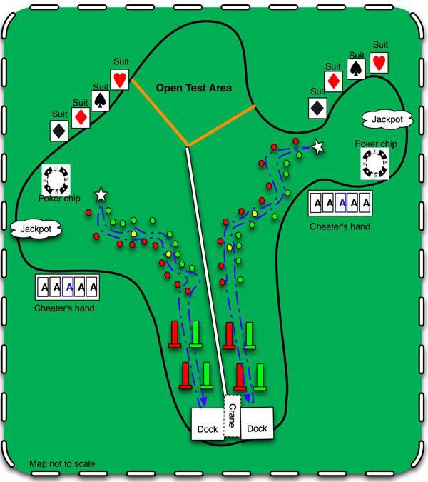

Figure 1. Competition Layout

System Overview:
Shown below in Figure 2 is a detailed overview of the autonomous boat. The figure shows the flow of information. There are seven major sub-systems each of which will be discussed below.
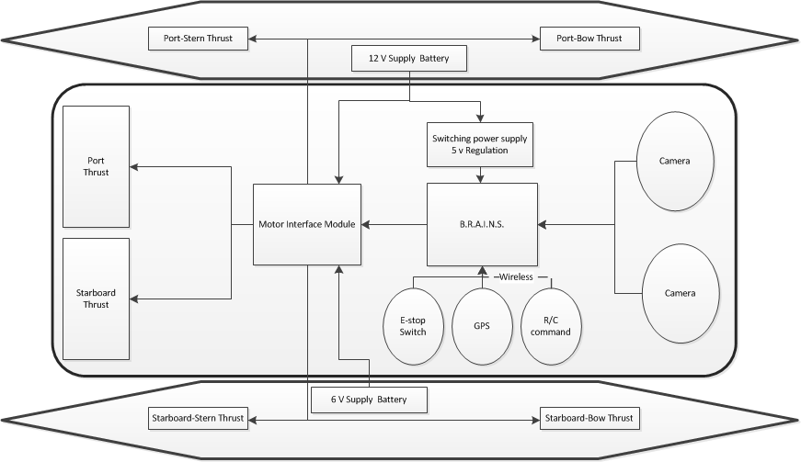
Figure 2. System Overview

Motor Interfacing Module
The purpose of the motor interfacing module is to decode the output of the BeagleBoard and Remote Acquisition for Interfacing Navigational Systems (BRAINS) box. Figure 3 shows the layout of the Module.
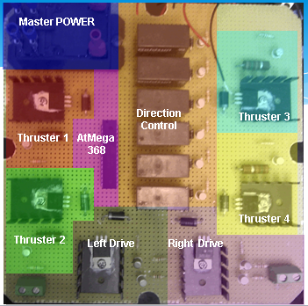
Figure 3. Motor Interfacing Module

Thruster Circuitry
As can be seen in Figure 2 there are four side thrusters to help pivot the boat and move it laterally. The thrusters require twelve volts and an estimated peak current of 3A. To accommodate these requirements, the circuit in Figure 4 was created. The microcontroller can source a maximum of 40mA so two transistors stages were need to boost the current to the 3A maximum. Diode D1 was added as a freewheeling diode to prevent the reverse voltage generated by the motor from overloading transistor Q2.
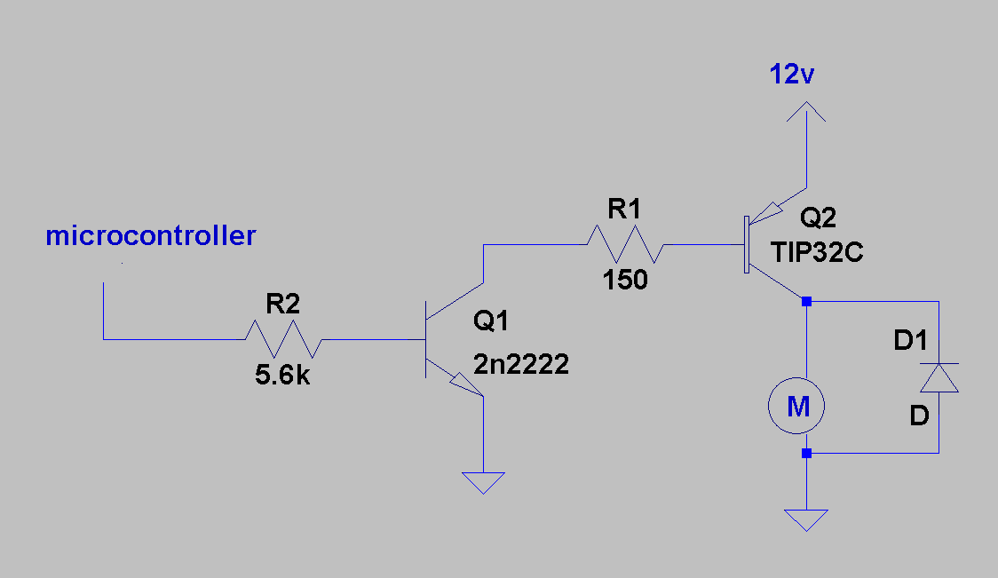
Figure 4. Thruster Circuitry

Differential Drive Circuitry
The circuitry for the differential drive motor is shown below in Figure 5. As can be seen, the general layout is the same with different discrete components. The motors run at 6 volts with an estimated peak current of 8 amps. To satisfy these conditions the circuit in Figure 5 was created.
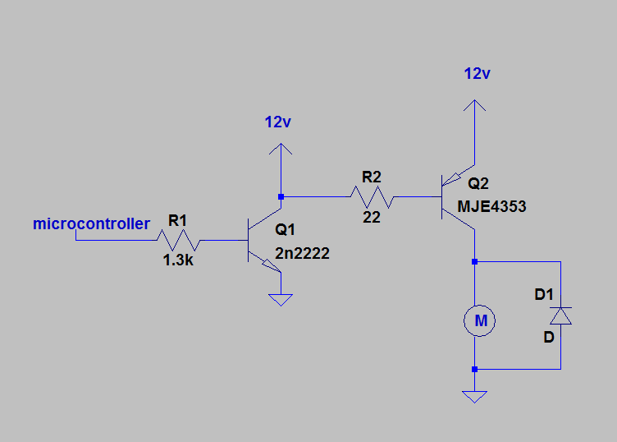
Figure 5. Differential Drive Circuitry

Bidirectional Relay Circuitry
All of the motors needed to be run in either direction which necessitated bi-directionality circuitry. The high current specifications combined with the goal for a low cost solution ruled out most of the typical methods to achieve bi-directionality. A double pull double throw relay connected to a switching transistor was ultimately utilized. EXPLAIN FIGURE TO BE CREATED.

communication
As can be seen in Figure 1, there are two microcontrollers, a BeagleBoard, the RC control receiver, and the interfacing circuitry that all must communicate. This section will describe the communication protocols. Figure 6 (below) shows the protocols used to facilitate the communication between the different boards.
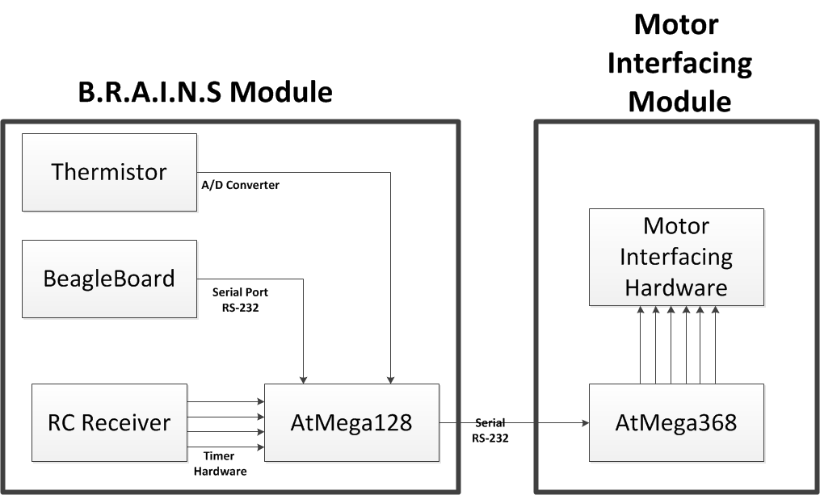
Figure 6. Communication Overview
The output of the RC receiver is a 0-5v 50 Hz servo control signal. The length of the pulse corresponds to how far the lever is pulled. The AtMega128 records the length of the pulses and decodes them into a signal to be sent to the motors. This value is temporarily saved.
In the case of autonomous mode, the AtMega128 receives the decoded motor packet over the serial port. This value is also temporarily saved.
A decoded motor packet consists of nine bytes. The first three bytes are *** which indicates to the AtMega368 that new motor instructions are coming. The next six bytes correspond to each of the six motors. The first seven bits of each byte represent a PWM value from 0-99%. The last bit corresponds to the directionality of the motor. This coding scheme allows for a minimal amount of data to be transmitted.
When the AtMega368 receives a new motor packet it first checks to see if any motor has changed direction. If a motor has indeed changed direction, the motor is turned off for 250ms. This is to prevent large current spikes from destroying the motor circuitry. After a directionality check has been performed the PWM for each motor is updated.

Remote control
Using the Futaba T6EX R/C transmitter (shown below) with the Futaba R617FS receiver and the communication protocol described above a remote control scheme has been developed for emergency control of the boat. In this control scheme, the platform is allowed 3 degrees of freedom that can be controlled from 3 axis of the transmitter joysticks. To enter this emergency control mode, the right shoulder switch has to be flipped in the downward position to force the master Atmega to send motor control bytes based on the r/c commands rather than the BeagleBoard control signal. This is exemplified in Figure 7 below.
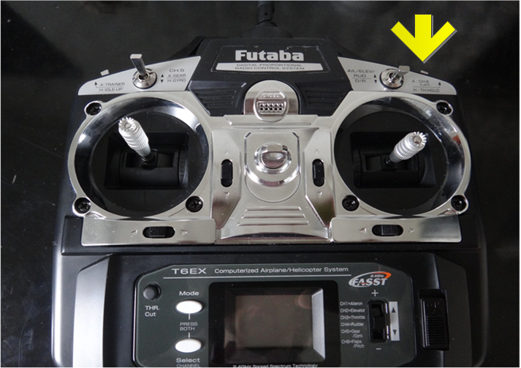
Figure 7. R/C Transmitter
In Figure 7 the yellow arrow is pointing to the control switch, and the direction control is shown by the red arrows. The left joystick ratchets in the vertical directions. This axis is then used for throttle control of the main drive motors. The horizontal motion of the left joysticks provides a strafing thrust from the pontoon mounted side thrusters. The final degree of freedom is controlled by the right joysticks horizontal motion. This signal will rotate the boat in place using the side mount thrusters.

Beagleboard & os
All the image processing and path planning code is executed on a BeagleBoard-XM. This board runs and embedded linux distribution on an SD card and a TI ARM Cortex–A8 processor. It shipped with a distribution called Angstrom and many software packages and kernel modules. Many of these modules were not needed. To allow for a faster boot time and less overhead on computations a new image was generated using the Narcissus online image builder. Other distributions were benchmarked, including Ubuntu 10.10 for ARM. However, a comparison of the BogoMIPS reveals the fastest OS to be Angstrom. BogoMIPS is an estimated measurement
After this new image was installed, the serial port on the BeagleBoard was configured to allow for programming without a monitor. Since the image is completely bare bones, no kernel modules were installed. The only modules that were subsequently installed were a wireless, webcam, and serial-usb driver.
As explained in the next section of this paper, our vision system is implemented using the open source image processing library, OpenCV. This library has already been ported for an ARM processor. The Angstrom package manager was used to install and configure the library. As a benchmark, the library was natively compiled on the BeagleBoard but no significant improvement to the frames per second was noticed.
The final task in readying the BeagleBoard was creating MakeFile for multi-file compiling. Since the BeagleBoard is an embedded system it is not practical to install an IDE to facilitate managing multi file projects. This is done through the use of MakeFiles. Essentially the make utility takes a makefile which explains all the interdependencies, links them, compiles them into objects, and then creates an executable.

High level Control scheme
The high level control code for the autonomous system has been written in an object oriented C++ coding style. Using this method the project is able to use classes, structures, and vectors to define the information in the autonomous system. This partially removes the concern with the hardware limitations of the control device so that the software can be designed at a higher level.
Ultimately, the control scheme is based around a vision system. The code reads in an image from a web camera that is mounted to the top of the motor mount bar on the stern of the boat. The system requires only one camera to reduce complexity and processor computation time. Thus, the system does not rely on stereoscopic vision, but rather uses the fact that the boat will be facing the buoy channel entrance at the time that the image processing becomes useful and the reasonable assumption that the channel is mostly straight. With these assumptions in mind, the code can then begin to process the images using a set of libraries known as OpenCV. These libraries allow the use of high level functions to perform image processing in a relatively optimized manner.
The first step in this process is to determine a horizon level. This would ideally be the location where the edge of the pond meets the ground and sky in the image. However, for the sake of simplicity and reduced computation, it is assumed that the horizon is roughly one third of the way down the image. With this information, the algorithm determines a region of interest to be the bottom two thirds of the image and performs all further processing on that part of the image. This both reduces the computation time on the image, and reduces the false buoys that can be found by objects that are not in the pond or pool. After this step has been performed, the algorithm can search for the red, green, yellow, and blue buoys.

Buoy Detection
After the code has determined the region of interest (ROI) in an image from the camera, it is stored into an OpenCV variable called an IplImage. This image is then converted from the RGB (Red Green Blue) color space into the HSV (Hue Saturation Value) color space. This step is performed because the autonomous system is expected to perform under various lighting conditions. When the buoys are under different light, the RGB values can range wildly while the HSV values change only slightly. The saturation is the most likely to change as the buoy is a somewhat reflective surface and thus direct sunlight almost completely floods that part of the buoy in white color.
With this knowledge, a set of constant threshold values can be set for each of the three color channels, and this can be repeated for each color of buoy that the program wishes to detect. Using these bounds, the areas that contain the buoy colors can be determined using an optimized search algorithm that creates a second image that is a binary image that is the same size as the input image where the pixels that fall into the defined color thresholds are set to the maximum value of 255 and the pixels that do not contain the buoy are set to 0. This leaves the buoys clearly defined in the image, but the locations and sizes still needs to be determined relative to the image.
To determine this information, another C++ library is used that is optimized to quickly search through an image and determine ‘blobs’ of color in that image, and since the only patches of color are the buoys this is desirable. The library is called cvblobslib and idea behind these functions is that a blob is an area of connected color pixels given some variance and threshold. CBlobResult, the function that returns the blob information, requires a binary or grayscale input image. It can determine a blob by scanning through the images and build a blob object around locations of pixels that are above a provided threshold given a provided variance. It then determines each connected area of pixels to be a blob, and returns the results into an array of blobs.

The blob object then contains several parameters that provide information about that blob. The most important to the code is the min and max x and y locations of the blob. From this information, as can be seen in appendix blah, the center and radius of the buoy can be estimated in terms of pixels. Also shown in appendix blah, the buoys are then stored into a vector, where they are sorted from the lowest buoy of that color in the image to the highest. The driver for the camera that is used returns the xy axis in reference to the top left most pixel as the origin, and the positive y values count down as in Figure 8.

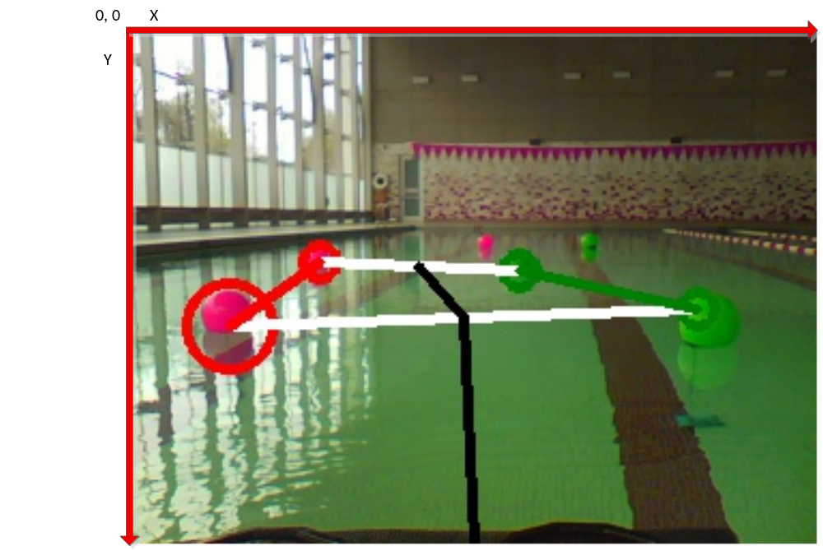
Figure 8. XY plot description
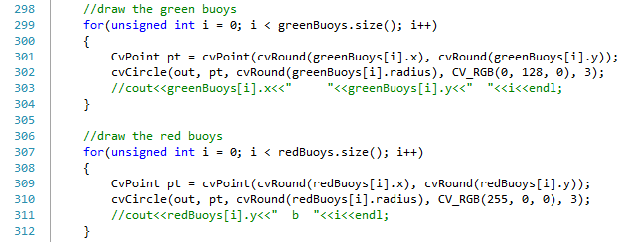
Figure 9. Opencv draw circle code

Also in Figure 8, the vectors of red and green buoys have been drawn on the image using OpenCV drawing functions in Figure 9. This function uses the location of each buoy as well as the determined radius. From this image it can be seen that the algorithm sometimes considers the reflection on the water to be part of the buoy blob and, as in the first green buoy, only sees the well let portion. Both of these cases are ok as the relative location is still usable and considering the speed of the system it is not important for it to be extremely accurate. The figure also shows the gates (white) and path (black) which will be described below.

Channel navigation
Once the buoy color and location is known, then the red and green buoys can be paired into ‘gates’ using the code in appendix blah and shown as white lines in Figure 8. Using the gate information a desired path can be determined. The algorithm is designed to move from one gate to the next moving through the center of each one. With all of the information that is available, an overall desired path can be determined, and is shown by the black line in Figure 8 however the most important section of the path is the first one at the bottom.
This section is determined by imposing a line from the bottom center of the image to the middle of the first gate. This method relies on the fact that the camera is centered and that the bottom of the image can be assumed to be level with the front of the boat. These assumptions allow the line to be the path that the boat should follow to make it through the immediate goal. Then using the slope and length of the line that is gathered in appendix blah a set of control signals can be constructed to correct the current motion of the boat to match the desired path. The algorithm used to determine the control signals can be seen in appendix blah. This algorithm simply uses a proportional controller that determines the desired turn strength based on the slope of the path line and the desired thrust speed based on the length. The current algorithm uses both the side thrusters in a pivotal motion as in figure blah below and the differential drive of the main thrust to turn the boat as it moves through the water. This algorithm can be reviewed in appendix blah.
Upon completion of the channel navigation, there will be a blue buoy to mark the end of the channel (or the beginning when returning to port). At this point another control algorithm would take over in order to locate and travel to one or more of the challenge stations of the competition, however that is not part of the senior design so will be omitted from this report. After attempting the tasks and returning to the buoy channel the channel navigation algorithm can take control again with a red right return mantra to port navigation. In this scheme, the red buoy will be on the right of the boat as it returns to port where it will need to dock (also not part of senior design).

Obstacle avoidance
Scattered through the buoy channel there are a few yellow buoys that are to be considered as obstacles and avoided in the navigation algorithm. The program first identifies the yellow buoys by the color as described above, then determines a threat level based on its vertical positioning in the image. If there is a yellow buoy that is closer to the boat then the first gate, it moves into the extremely hazardous mode in which the yellow buoy must be avoided at all costs. To achieve this, the desired path then becomes a line from the bottom of the image to the yellow buoy and becomes a peak in an avoidance gradient. This gradient plane can be seen in figure blah and can be described as two valleys on either side of the path. The slope of the path line will then determine how hard the boat needs to turn. If the slope indicates that the buoy is far enough to the side of the boat, but not so far that the boat maybe veering off course, then the boat can remain traveling in the direction it is heading. If the slope indicates that the boat is going to hit the buoy, or that it is moving too far off course, then the control algorithm needs to correct for this discrepancy. Once again, a proportional control is used to accomplish this task.
The main concern with this method becomes remaining on course. If the boat attempts to turn too hard away from the obstacle it may lose sight of the yellow buoy, the next gate, or all of the buoys. If it does lose sight of all of the buoys, a search algorithm will take control and the boat will rotate in place to search for a new gate to head to. The program will know if it is the correct gate to head through to advance through the channel if it follows the three R’s mantra. If the only gate that can be found is in the wrong direction, it can at least travel to it and try to start over.

Sources
[1] “The Four Elements" 4th International RoboBoat Competition Final Rules. Arlington, VA: AUVSIfoundation. PDF.
[2] Bradski, Gary Rost., and Adrian Kaehler. Learning OpenCV. Beijing: O'Reilly, 2008. Print.

Appendix A Proposed Schedule of Remaining Work
Weeks | Major Deliverable
13-Nov
 | Finalize BeagleBoard environment
 | Have a prototype buoy detection program
 | Begin design of communication channel between uC and BeagleBoard
 | Perform mechanical testing on Mark 1 prototype (drag, acceleration, weight restrictions)
20-Nov
 | Gyroscopes and accelerometer communication channel development
 | Begin construction of communication channel between uC and BeagleBoard
 | Continue to evaluate Mark 1 prototype
Weeks | Major Deliverable
27-Nov
 | Decide whether to improve hovercraft platform or switch to a catameran platform
 | Begin developing PID stabilization for craft
 | Begin developing path planning algorithm using buoy/horizon detection
Dec-Jan
 | Continually tune and develop path planning/stabilization controls. Finish high level command system.
Weeks | Major Deliverable
Feb
 | Begin actual testing of fully integrated platform.
March
 | All high level designs will be done at this point. The controls and vision algorithms will be continually improved. Begin developing designs for bonus tasks.
April
 | Complete the design for any bonus tasks and begin the testing of these systems
May
 | Be able to demonstrate path planning and stable navigation for final presentation

