1. What is LAN Card?
To connect to a network, a device needs an interface to translate the information into the packets of information that can be transmitted on the network. When a network is primarily in one area, it is referred to as a Local Area Network or LAN.
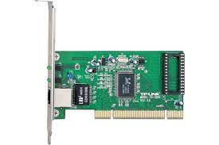

2. What is RJ-45 connectors?
A registered jack (RJ) is a standardized physical network interface for connecting telecommunications or data equipment. The physical connectors that registered jacks use are mainly of the modular connector and 50-pin miniature ribbon connector types.
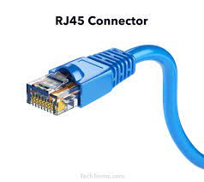

3. What are SWITCH?
Switches are networking devices operating at layer 2 or a data link layer of the OSI model. They connect devices in a network and use packet switching to send, receive or forward data packets or data frames over the network. A network switch connects devices (such as computers, printers, wireless access points) in a network to each other, and allows them to 'talk' by exchanging data packets.

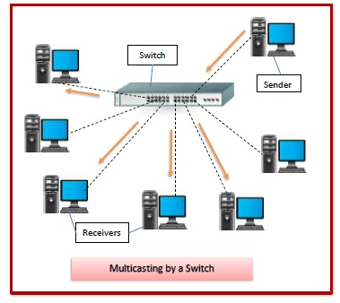

4. What is CAT-5 cable?
Alternatively known as an Ethernet cable or LAN cable, a Cat 5 or category 5 is a network cable that consists of four twisted pairs of copper wire terminated by an RJ-45 connector.
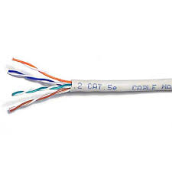

5. What is Cable-Tester?
A network cable tester is an electronic device that measures the conductive between two ends of a cable. It also checks and measures signal for correct wiring. There are two most common ways of testing the connection: Tester sends a current down the wire and measures its level.
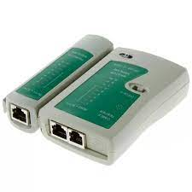

6. What is Crimping Tool?
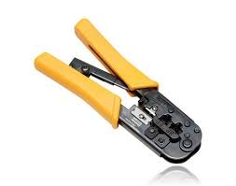
A crimping tool is the tool used to deform the material and create the connection. Crimping is commonly used in electrical work, to attach wires together or wire to other connectors. Crimping is a way of joining pieces of metal or other ductile material by deforming one or both of the pieces to hold the other, and this deformity is known as the ‘crimp’.

7. Types of Hub.
1. Passive Hub: Passive hubs do not include any computerized elements, and they do not procedure the data signal at all. The main goal of a passive hub is to connect the signals from various network cable segments. All devices connected to a passive hub take all the packets that develop through the hub.

2. Active Hub: The hubs that contain repeating capabilities to strengthen the signals in a network are called active hubs. The limitation of active hubs is that they magnify noise along with the signals. They are a little brighter than passive hubs because they boost the signals before passing them between nodes to the node. They are also called concentrators and can accommodate more one than one set of network connections.

3. Intelligent Hub: These hubs are also called smart hubs. They have a special kind of software in them to perform management functions in the network. The software offers them the capability to find and separate network issues. Thus they have both monitoring and management capabilities.

8. How to crimp CAT-5 cable with RJ-45 connector?
Step-1: Strip the cable back 1 inch (25 mm) from the end. Insert the cable into the stripper section of the tool and squeeze it tight. Then, rotate the crimping tool around the cable in a smooth and even motion to create a clean cut. Keep the tool clamped and pull away towards the end of the wire to remove the sheathing.

Step-2: Untwist and straighten the wires inside of the cable. Inside of the cable you’ll see a bunch of smaller wires twisted together. Separate the twisted wires and straighten them out so they’re easier to sort into the right order.

Step-3: Arrange the wires into the right order. Use your fingers to put the wires in the correct order so they can be properly crimped. The proper sequence is as follows from left to right: Orange/White, Orange, Green/White, Blue, Blue/White, Green, Brown/White, Brown.

Step-4: Cut the wires into an even line 1⁄2 inch (13mm) from sheathing. Hold the wires with your thumb and index finger to keep them in order. Then, use the cutting section of the crimping tool to cut them into an even line.
Step-5: Insert the wires into the RJ-45 connector. Hold the RJ-45 connector so the clip is on the underside and the small metal pins are facing up. Insert the cable into the connector so that each of the small wires fits into the small grooves in the connector.

Step-6: Stick the connector into the crimping part of the tool and squeeze twice. Insert the connector in the crimping section of the tool until it can’t fit any further. Squeeze the handles to crimp the connector and secure the wires. Release the handles, then squeeze the tool again to make sure all of the pins are pushed down.

Step-7: Remove the cable from the tool and check that all of the pins are down. Take the connector out of the tool and look at the pins to see that they’re all pushed down in an even line. Lightly tug at the connector to make sure it’s attached to the cable.

9. Write note on Hub.
Hub: A network hub is a node that broadcasts data to every computer or Ethernet-based device connected to it. A hub is less sophisticated than a switch, the latter of which can isolate data transmissions to specific devices. Network hubs are best suited for small, simple local area network (LAN) environments. A hub has many ports in it. A computer which intends to be connected to the network is plugged in to one of these ports. When a data frame arrives at a port, it is broadcast to every other port, without considering whether it is destined for a particular destination device or not.

10. Study of Topology.
A Network Topology is the arrangement with which computer systems or network devices are connected to each other. Topologies may define both physical and logical aspect of the network. Both logical and physical topologies could be same or different in a same network. Network topology plays a major role in how a network functions. Namely, the topology has a direct effect on network functionality. Choosing the right topology can help increase performance, as a properly chosen and maintained network topology increases energy efficiency and data transfer rate.

11. Different types of Topologies.
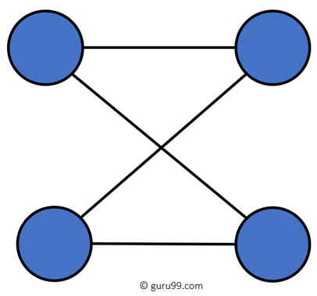
1. Point to Point (P2P): Point-to-point topology is the easiest of all the network topologies. In this method, the network consists of a direct link between two computers.

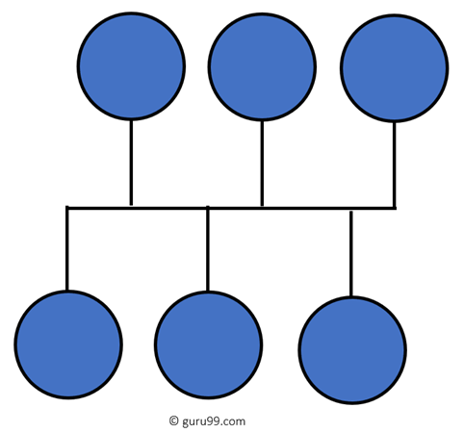
2. Bus Topology: Bus topology uses a single cable which connects all the included nodes. The main cable acts as a spine for the entire network. One of the computers in the network acts as the computer server. When it has two endpoints, it is known as a linear bus topology.

3. Ring Topology: In a ring network, every device has exactly two neighboring devices for communication purpose. It is called a ring topology as its formation is like a ring. In this topology, every computer is connected to another computer. Here, the last node is combined with a first one.
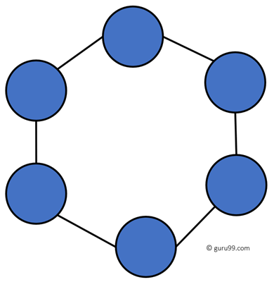

4. Star Topology: In the star topology, all the computers connect with the help of a hub. This cable is called a central node, and all other nodes are connected using this central node. It is most popular on LAN networks as they are inexpensive and easy to install.
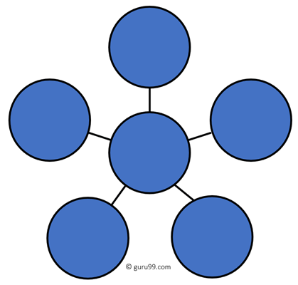

5. Mesh Topology: The mesh topology has a unique network design in which each computer on the network connects to every other. It is develops a P2P (point-to-point) connection between all the devices of the network. It offers a high level of redundancy, so even if one network cable fails, still data has an alternative path to reach its destination.

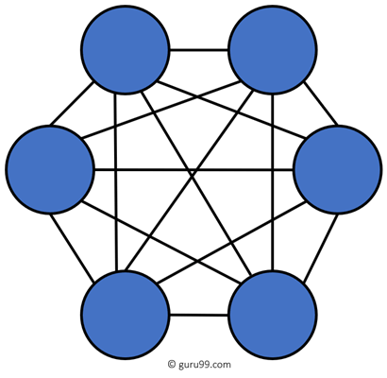

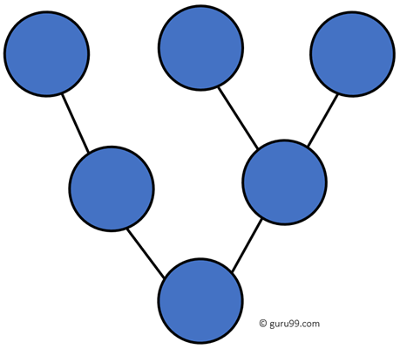
6. Tree Topology: Tree topologies have a root node, and all other nodes are connected which form a hierarchy. So it is also known as hierarchical topology. This topology integrates various star topologies together in a single bus, so it is known as a Star Bus topology.

7. Hybrid Topology: Hybrid topology combines two or more topologies. You can see in the above architecture in such a manner that the resulting network does not exhibit one of the standard topologies.
