first_idea (discontinue)
is be
is

use sural instead of capitals

a u

as

even small are hard
Tuesday, 3 March, 2026
10:43
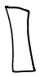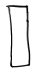
At
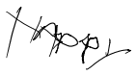
-Hear

-
o
o
x

a G A
. b m B [confusingaith8) D b

Ct [
d -D or .

e -for R

. f 7 F or F
•r get-confusing with g nine/ grid rescaling required
h m M or h
i -7 I or it dot not compulsory.
j G F or jet grid rescaling required
KJK or k
^ a L or k contusing with Lone
ah-dot asperse


Hoarse w

c.
- .
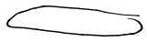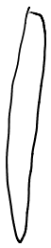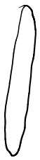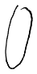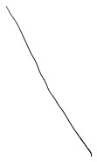
.
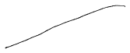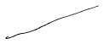
-on.
.
.
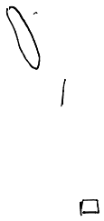
a
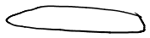

a .

. °
8o

00
,

. , so.
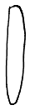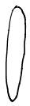
o
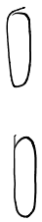

.
&
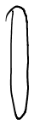
o


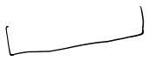

final_grid
Tuesday, 3 March, 2026
11:23
}
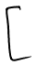
Stand =
F .
-_ - - -
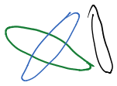
upper

.
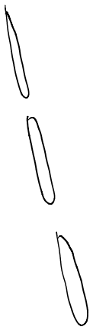

sleep = [ -- --

saint Y -- - -
. --- - - -
core

. -- --
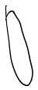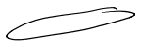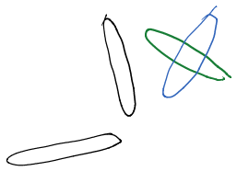
cross-slant's [ -- _ -- ]
lower
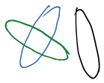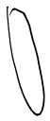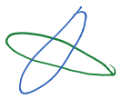
a .
.
set
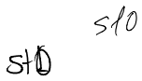
do, do stay died 5+6
$3
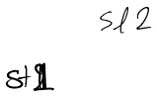
dried 2 sits. dried]
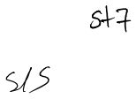
sly
81-32 dr. dh sits ds, cds 518 516 $7

class sg
in
parents = canvas Marr

abstract turn ONC)

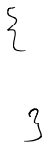
see
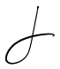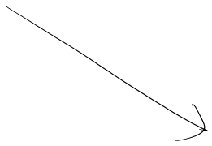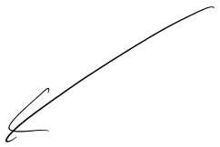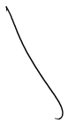
Stand sleep stray
cross Diary

OR
Silent

parent

se-start
n-end

y-start

Y-end
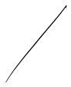
3
parent parent Se
parent

N-start

U-end

y-start

Y-end
n-range

n-start

n-end

tum ON
y-range

N-start

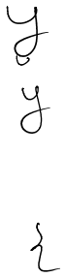
-end

tam OM
turnon .
turn ON
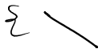
is
:
3 .
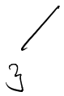
-

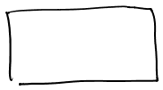
Object_oriented_perspective (discontinue)
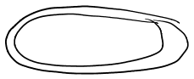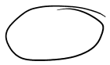
interrace
ab-class
class
Tuesday, 3 March, 2026
11:41

.

say
but then parent cannot be charged dynamically
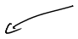
parent

turnon

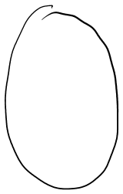
See
@ abstract tumor NC)
,
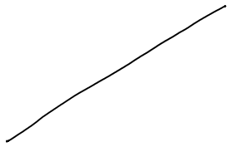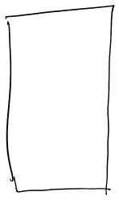
grant
.
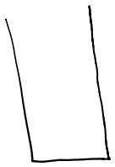
but Rou bodies cannot be
modified Ror tern ONC) if interfaces are used
APP .
strain

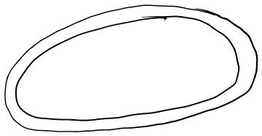
das say
parent
ab tum ON
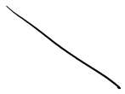
l
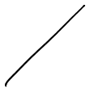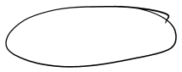
scant
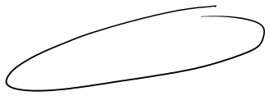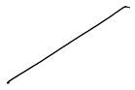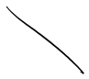
straight
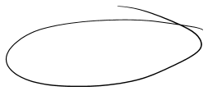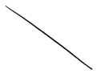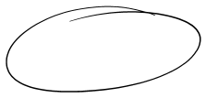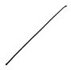
cross dray
day
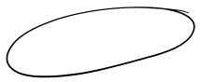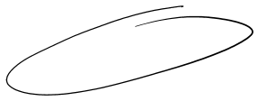
sleep
stars

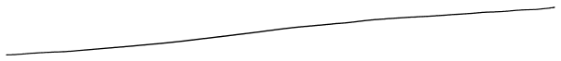
what if are add a method condition Israel)
•gets charged (implemented wrt child requirement

•turn ON stays save

void turn ONC)
↳K = start
Roar ( kind)
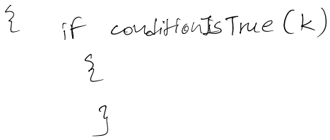

n-and (K) For merging 4 different loop states as single variable with u states
parent (n-cord (K)) Cy-cord (K)) = L

m
~

y-cord CK)

Maths_required
Tuesday, 3 March, 2026
11:51
ja-Mari-start
while (Assign-end, jet
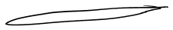
•J n y

-- in
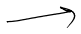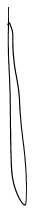
i = n-start
while (in-end) it

1-us) C; -ye) = Ci-nelly-yes)

is ns = is The it (need us)
-_
&Ys Jaye jet eyes Ys)
In
?
n-y-yes 2
. -
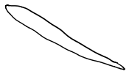
.
very u
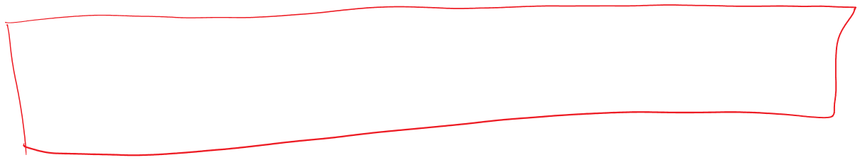
-- (weans)
i -Us = i-see
jo-ye 8-9-5
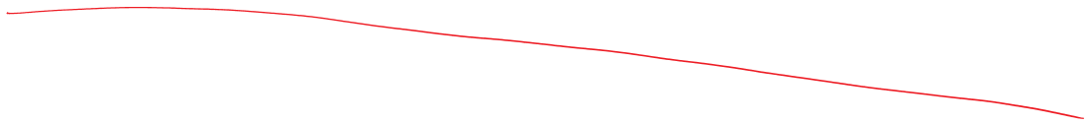
- U-a, y -s
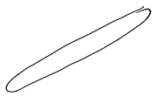
x

•-
U-soy -e

@ NS, y -e
2 (use ne)

--
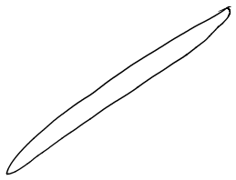
. . . .
.
is ns = i-ne
j-ye joys

↳Ci-ns) (joys) = (i-ne) C; -ye)

since i and j are moringas save unit distance
from their previous values,
nested igloo p can be replaced with single "k" loop
. 4 s
in d

•
Nery s

it : k = start
term: k = end
ones
→air CKDC col] = L 15
in oap
m pined
instead of (n-sigs), (n-age),

ten can be used to reduce variables required
- y are Crow} CK] = L

rest yst
→arr [k] [12] = L
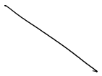

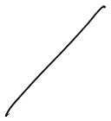
→are Castle] (ye-k] 12=0 Kaye-yes

reg:
U's (no improvement since
art CK] [col] Z ten ten and use are one)
Kat

→k to
ahilelk clear)

are tow] [k] =|

→K to
while (Kalen)
are us + k] Cyst] H yes Kott

→Koo
anile (katan)
arrest k] CY c -k]

Kat

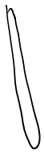
→k to
while (kala)
col
n-St

reg:
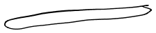
y -s
too
Ten
Ys
Kit

reg:
ten
US
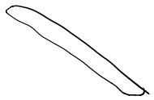

regs.
Len

US
ye
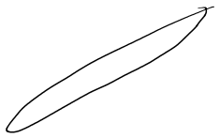
.

-

-

Object_oriented_perspective
Tuesday, 3 March, 2026
12:41
sayer

parent, ten
abstract turn ONC)
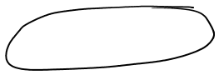
DRY principle
}
"t.
1
l
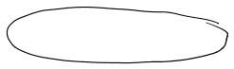
slanting
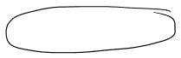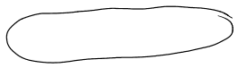
Drag sag
sleeping say
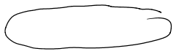
standing Leg
Us
Fe
2-5
g-s
so
•NS cool

