AWS

What is cloud computing:

Its an on-demand delivery of IT infrastructure(servers,dbases,compute nodes etc) via the internet, with pay as you go pricing model, So no more hosting of physical servers in house any more, rather out-source to cloud service provider like Amazon(AWS) Google Cloud, MS(azure)

<https://www.youtube.com/watch?v=dH0yz-Osy54>

AWS architecture

Region and Availability zones(AZ) & edge locations

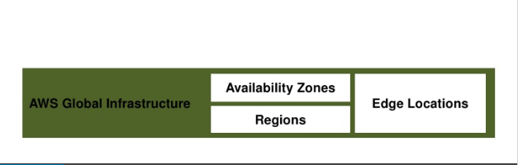

Edge Locations: Apart from Regions and AZ, amazon has more points of presences through edge locations these are smaller locations that cache the data and use through Amazon Cloud Front service.

They are independent of Regions and AZ, and generally used for frequently used customer data

Domains of AWS: aws offers plenty for services offered under different domains

* Compute e.g. EC2
* Migration
* Security
* Storage
* Networking
* Messaging
* Database
* Management Tools
* Analytics

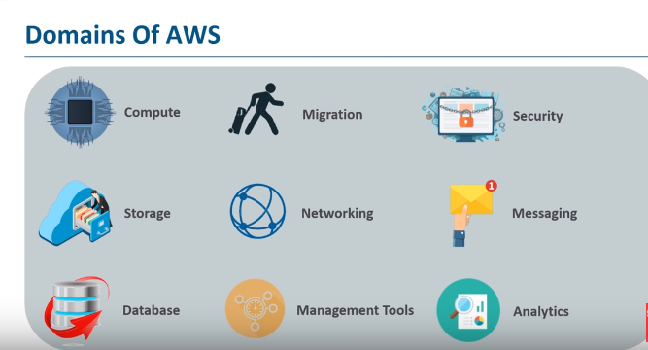

* Cloud security
* Cloudwatch: complete suite of monitoring dash-board, so you can monitor each and every cloud service, also set alarms
* CloudTrail: this is loggin service for all your cloud processes
* IAM: its an aws process, that allows you to setup roles and responsibility for various level of user access, it stands for Identification and Access Management
* EC2: Elastic Compute Cloud

<https://www.youtube.com/watch?v=8TlukLu11Yo>

* It’s a web-service which provides secure and reliable compute capacity in the cloud
* Easy to scale up and down
* Can be integrated with several other services
* Again, pay only for what you use
* Steps to use and EC2

1. Chose an AMI(amazon machine image): basically its the software and applications that we would need to run our application on.

AMI is a template used to create a new machine, major composes of the OS, permissions,the other software used to run the applications in this EC2

AMI is of 2 types a) pre-defined by Amazon, b) custom built

See the amazon AMI market place for more options

1. Chose the hardware or the Instance Type: these are fixed and cannot be altered

They are of 5 main types or **Families as termed**

1. Compute optimized: gives to lots of compute power, or processor power
2. Memory optimized: suitable for applications requiring in-memory caching
3. GUP Optimized: used for graphic centric applications
4. Storage Optimized: ideal for storage servers, dbase etc
5. General Purpose: everything is equally optimized
6. Configure the instance: this includes the config details like

* Purchase/billing config: wether on-demand instance, or spot instance, reserve instance etc
* Type of IP to be assigned, public private
* IAM role for authorization
* Shut-down behaviours:
* You can also provide boot-strap options where-in provide scripts to be executed when the instance is booting up

1. Add storage

* Options can be s3, EBS, EFS etc

1. Add tags/(optioinal) but vital: this describs the prupose of this EC2 instance, because in practicality there are thousands of EC2 instance running, and amoung them tagging makes it very esasy to identify it.
2. Configure fire-wall also called as security group, this is where we allow or deny connections to the EC2 instance from the outside word, can also with-in the network

* How to connect to your EC2 instance from remote m/c.
* Via putty using a public/private key SSH
* Storage options in AWS

Block level storage vs Object level

In block level storage the unit of storage is a block, i.e. if you have a 100 mb excel file and lets say it occupies 2 blocks(asuume block size is 60mb), then if suppose you changed only 1 or 2 cells in that excel file, then after the change when you try to save the file back to disk, only those blocks having the update data need to be written back, and not the whole file.

In object level storage the whole file needs to be written back to disk. So this means object level storage will take more time.

* When to use what: if you want to do very fast read/write concurrently that block storage is the right option. WORM is ideal for Object storage
* S3 Simple Storage Service
* is object level storage, best used for WORM applications, size is auto scalable
* Glacier, can be used as a standalone service
* EBS: elastic block storage
* elastic block storage, good for server disks,
* Persistent is terms for read and write
* Bounded by size
* High in performance
* Its by default replicate 2 times within the same AZ, where this EBS is procured and not across AZ
* Could be mounted on 1 EC2 within the same AZ

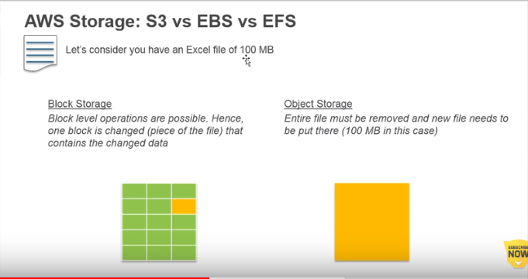

* EFS: similar to a NAS mount, i.e. a shared file system/storage where multiple users can write to it at the same time. <https://www.youtube.com/watch?v=6ZIPBC78U0s&t=42s>
* SNS: Simple Notification Serivce of aws, helps us set up a topic and add subscribers to it, thus we can send notifications and subscribes will receive it.

We can cereate an event in the storage we have opted for eg. S3-bucket, or EBS

* S3
* vpc