The status of academic research on salmon farming: a living evidence map

Results

Review process
The review process is outlined in the flow diagram in Figure 1. Across the 21 databases searched, a total of 169,373 search results was obtained. Following deduplication, 79,554 unique candidate records remained. Title and abstract repair and enrichment supplemented 6,046 records, whilst a sweep for retractions identified 27 records that were excluded from further analysis.
Following screening of titles and abstracts, 27,726 were included in the map, and passed on to annotation. Species annotations were obtained for all 27,726 records, geography for 9,986 records, and topic classifications for 27,412 records.
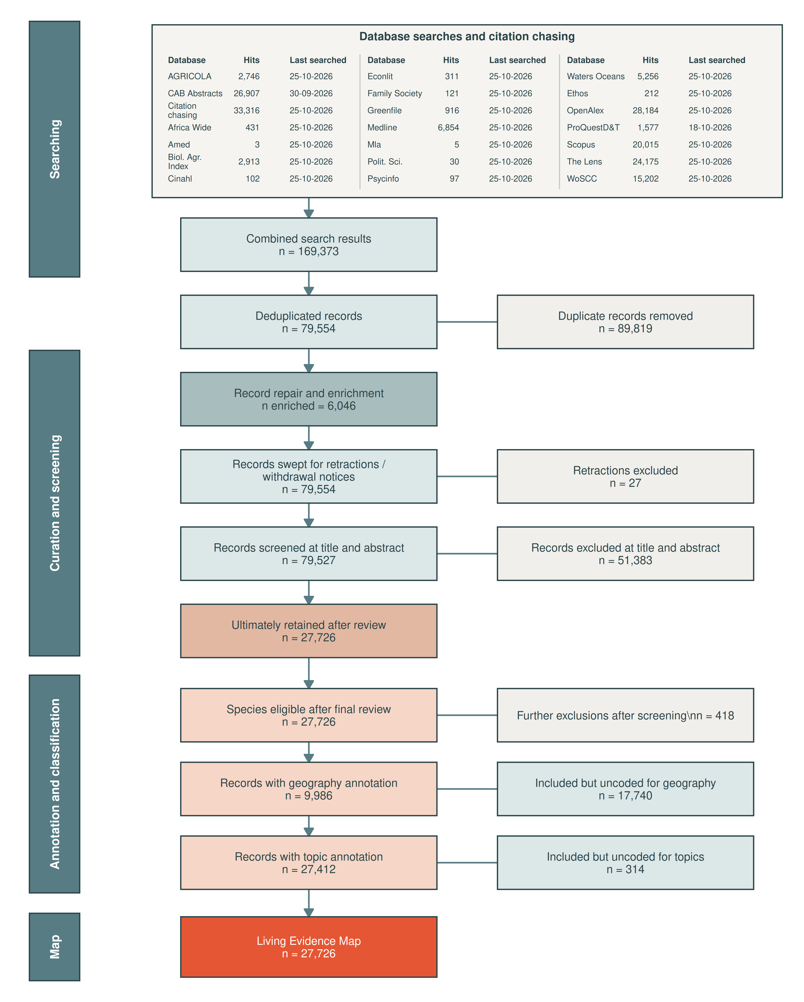
Figure 1. Flow of records through database searching, deduplication, record repair and enrichment, retraction screening, title-and-abstract screening, annotation and inclusion in the Living Evidence Map.

Screening validation and reviewer consistency
Across the saved human–model validation history, 21,950 substantive screening comparisons were available. The cumulative raw agreement was 96.79% and cumulative Cohen’s kappa was 0.922.
Model validation history
Date | Records | Substantive comparisons | Raw agreement | Cohen’s κ
26-09-2026 | 22,198 | 21,950 | 96.8% | 0.922
Cumulative | 22,198 | 21,950 | 96.8% | 0.922
Database provenance was retained through deduplication, allowing the contribution and overlap of the 21 bibliographic sources to be compared for the deduplicated corpus and the definitive final included corpus. Figure 2 shows records contributed uniquely by each database, while Figure 3 shows only multi-database overlaps.
Figure 2. Unique contribution of each bibliographic database. Records are counted as unique when they were retrieved from that database and no other searched database. Black bars show unique records in the deduplicated corpus; salmon-pink bars show the subset retained in the definitive final included corpus.
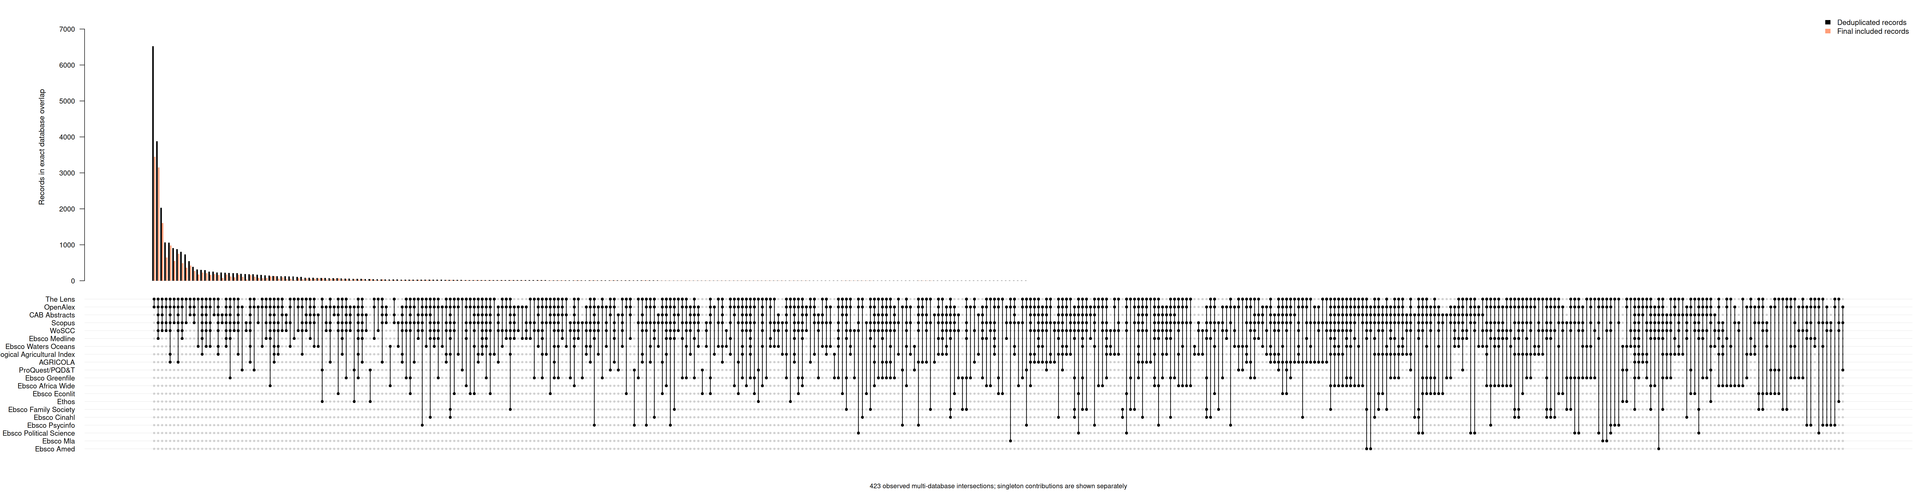
Figure 3. Overlap among bibliographic databases. Only records retrieved from two or more databases are shown; single-database records are presented in Figure 2. Black bars show exact database intersections in the deduplicated corpus and salmon-pink bars show the corresponding records retained in the definitive final included corpus. The matrix indicates the databases represented in each intersection.

Publication year
The volume of academic evidence on salmon farming increased markedly over time. There were 1,362 included records published in 2025, the highest complete publication year in the current corpus, compared with just 665 in 2010.
The three largest focal species categories were Rainbow trout (12,186 records; 44.0%), Atlantic salmon (9,910; 35.7%) and Unspecified species (5,301; 19.1%). Species categories are not mutually exclusive because individual records can refer to more than one eligible farmed species.
Figure 4. Records by publication year and focal farmed species.
The thematic composition of the literature also expanded through time. The largest high-level topic was Production, followed by Environment. Because records can receive more than one high-level topic, annual stacked totals represent topic-record assignments rather than mutually exclusive studies.
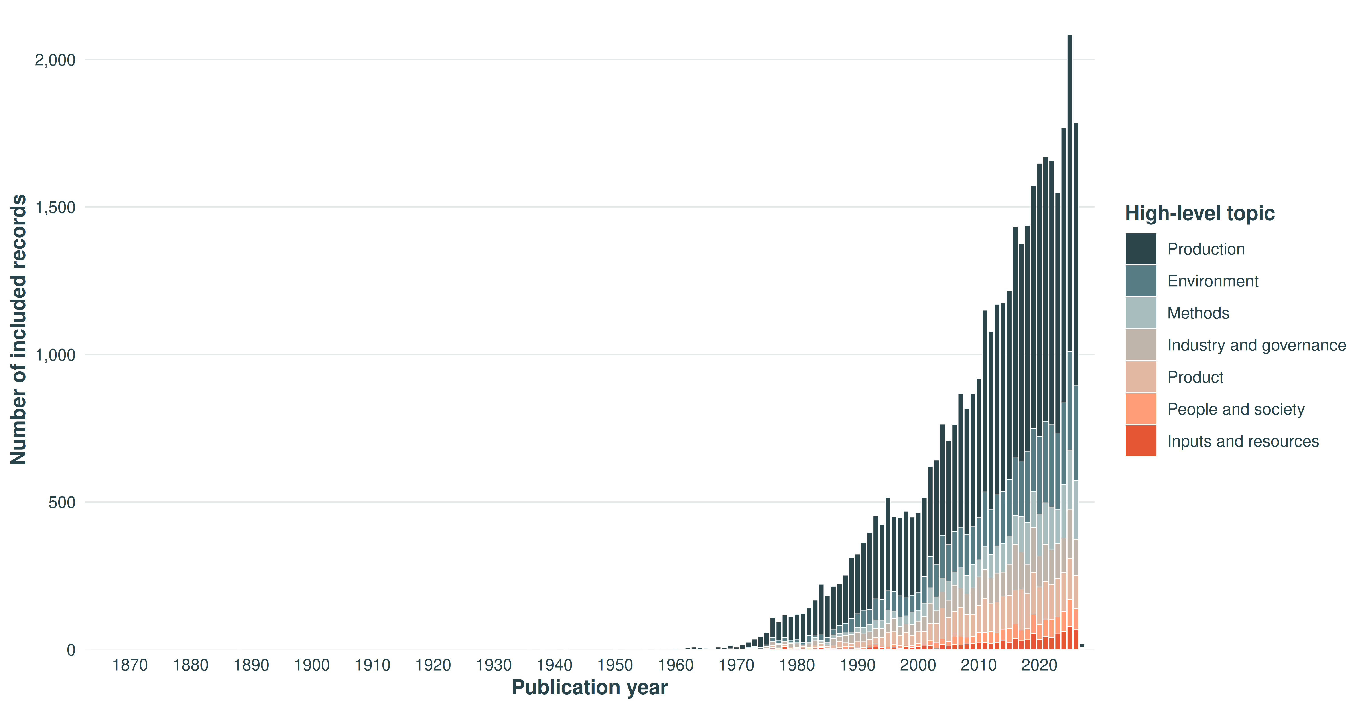
Figure 5. Topic-assignment frequency for high-level topics by publication year.

Geography
A substantive study country could be resolved for 9,986 records (36.0%), while 17,740 included records (64.0%) did not contain sufficient evidence for a defensible country-level assignment. Among records with assigned geography (Figure 6), the largest country evidence bases were Norway (2,117 records), Canada (1,319), United Kingdom (1,172), Chile (1,159), United States (831), Turkey (554). Countries demonstrated strong species-specificity, as expected (Figure 7), with the major Atlantic salmon producing countries contributing most to the evidence base, and a large number of other countries contributing collectively to rainbow trout research (e.g. Turkey). Records may be assigned to more than one country where the substantive study spans multiple countries.
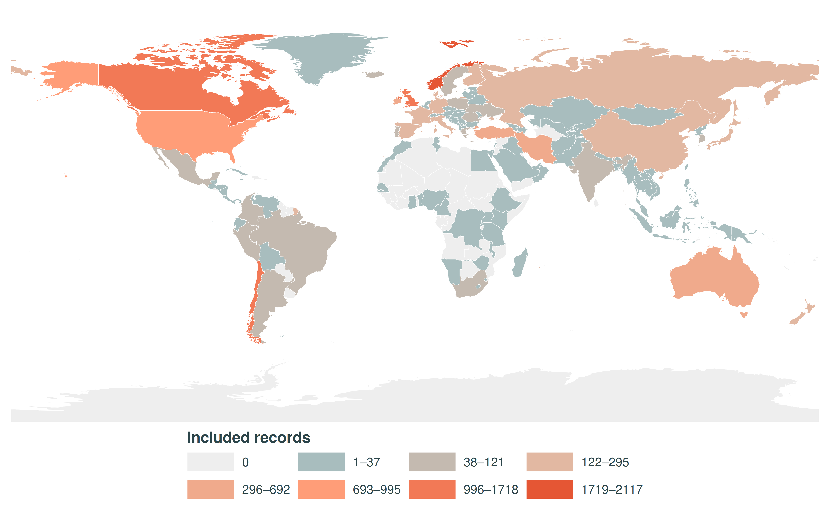
Figure 6. Global distribution of included records by substantive study country.
Figure 7. Records per country for the 20 most frequently represented study countries, by focal farmed species.

Topics
At least one topic was assigned to 27,412 of the 27,726 included records; 314 records (1.1%) remained uncoded for topic. Across coded records, the final ontology contained 77,550 distinct record-topic assignments.
The evidence base was strongly oriented towards Production, represented in 21,291 records (76.8%). Environment was the second-largest theme (5,987; 21.6%), followed by Product (3,207; 11.6%), Industry and governance (3,133; 11.3%) and Methods (3,034; 10.9%). People and society (1,152; 4.2%) and Inputs and resources (950; 3.4%) were substantially smaller. Theme percentages are not mutually exclusive because a record can be assigned to more than one theme.
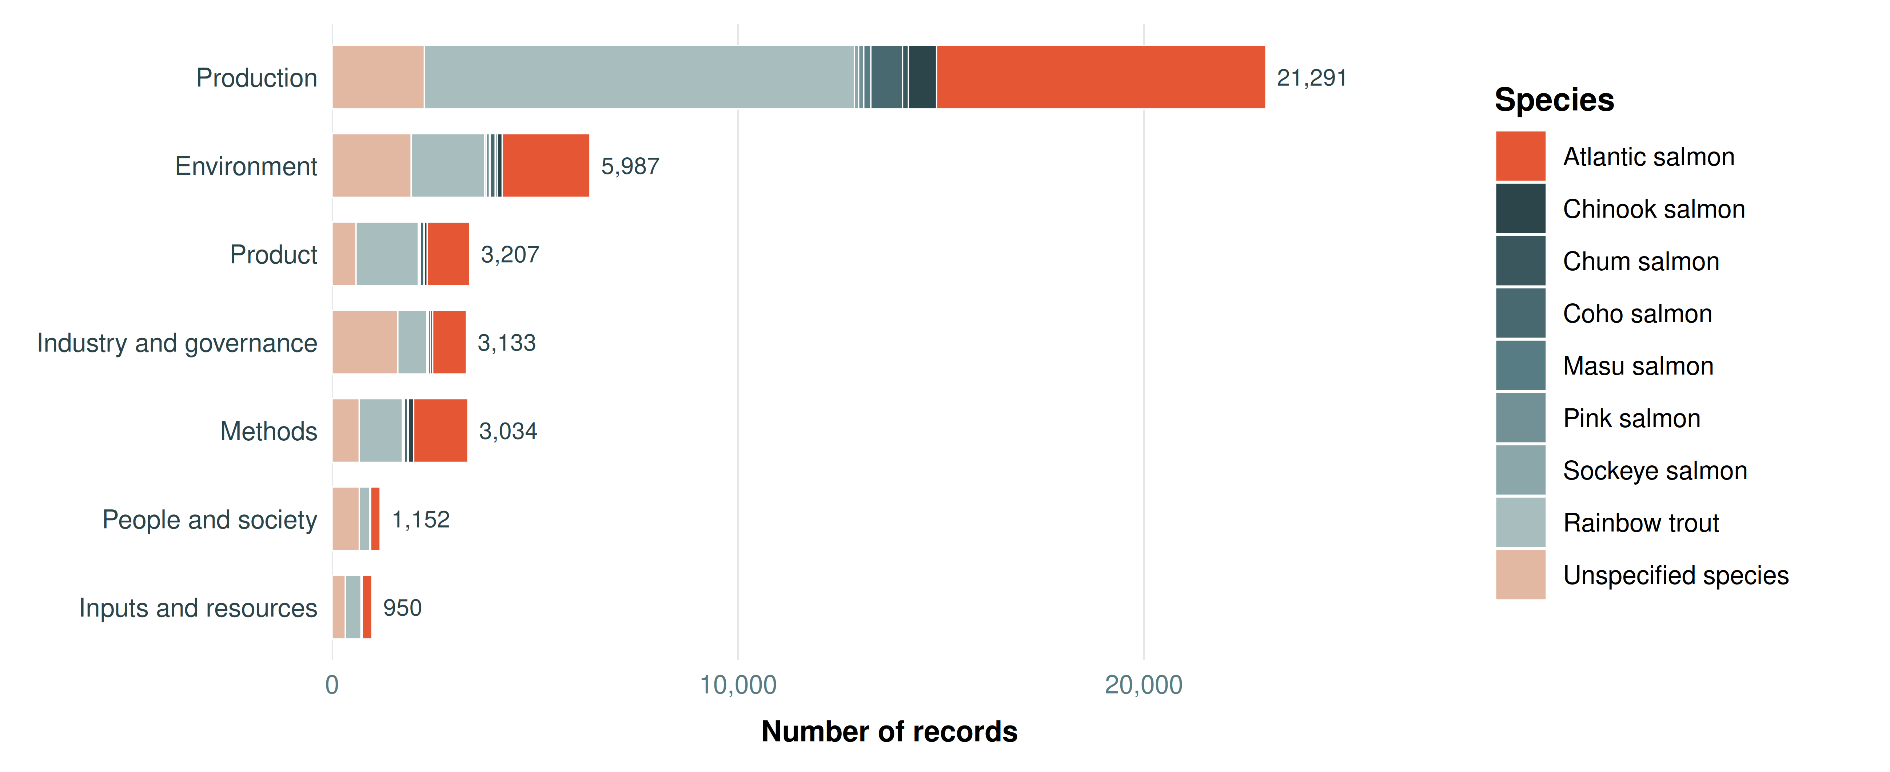
Figure 8. High-level topic frequency by focal farmed species. Numbers at bar ends are unique records assigned to each high-level theme; stacked species segments may sum above the unique-record total for multi-species records.

Production
Production research was centred on fish performance and biology, fish health, feed and nutrition, breeding and reproduction, and stress and mortality. The most frequently assigned terminal topic was Physiology, metabolism and biological responses (7,477 records; 27.0%), followed by Growth and development (4,839; 17.5%). Other major concentrations included Alternative feed ingredients (2,532; 9.1%), Feed additives and supplements (2,515; 9.1%), Other diseases - Prevention and treatment (2,478; 8.9%) and Anatomy and tissues (2,008; 7.2%). Sea lice remained a substantial research cluster, including 850 records on Sea lice control and treatment and 598 on Sea lice epidemiology.
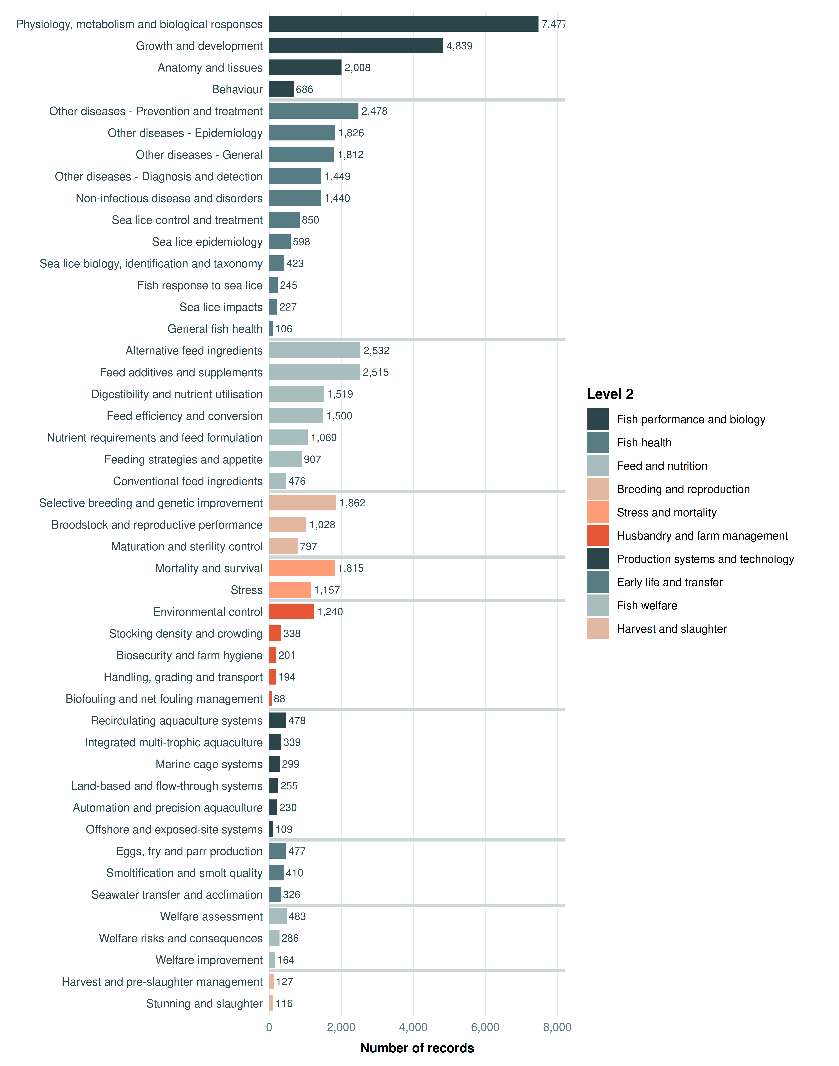
Figure 9. Topic-assignment frequency within the Production theme.

Environment
Environmental research was concentrated in Physiology, metabolism and biological responses (7,477; 27.0%), Growth and development (4,839; 17.5%), Alternative feed ingredients (2,532; 9.1%) and Feed additives and supplements (2,515; 9.1%).
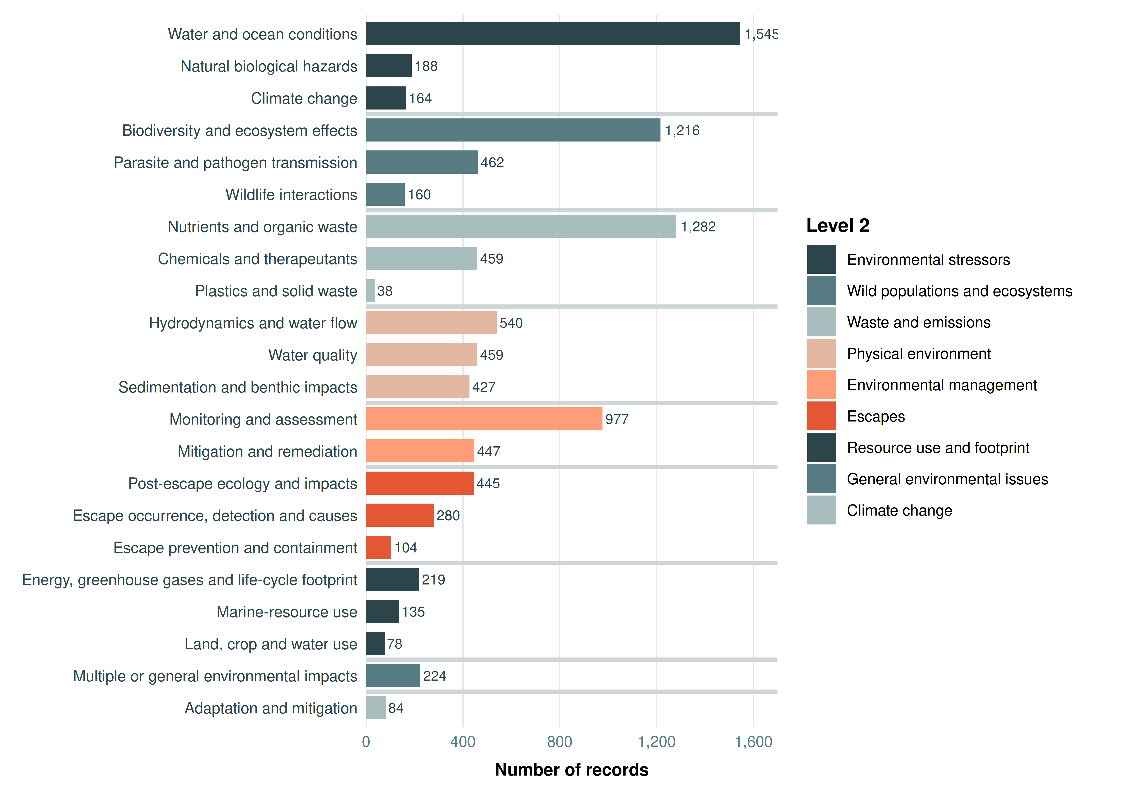
Figure 10. Topic-assignment frequency within the Environment theme.

Methods
Methods research was dominated by Physiology, metabolism and biological responses (7,477; 27.0%), followed by Growth and development (4,839; 17.5%), Alternative feed ingredients (2,532; 9.1%) and Feed additives and supplements (2,515; 9.1%).
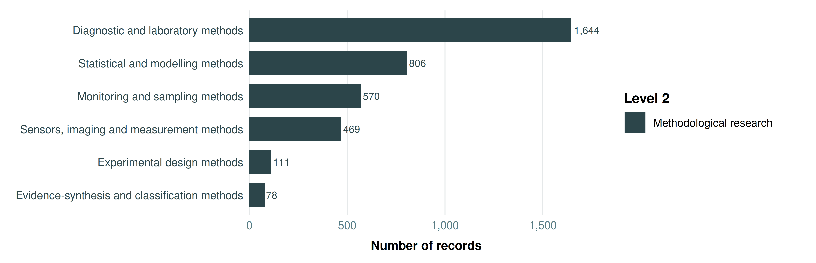
Figure 11. Topic-assignment frequency within the Methods theme.

Industry and governance
Within Industry and governance, Physiology, metabolism and biological responses was the largest terminal topic (7,477; 27.0%), followed by Growth and development (4,839; 17.5%), Alternative feed ingredients (2,532; 9.1%), Feed additives and supplements (2,515; 9.1%) and Other diseases - Prevention and treatment (2,478; 8.9%).
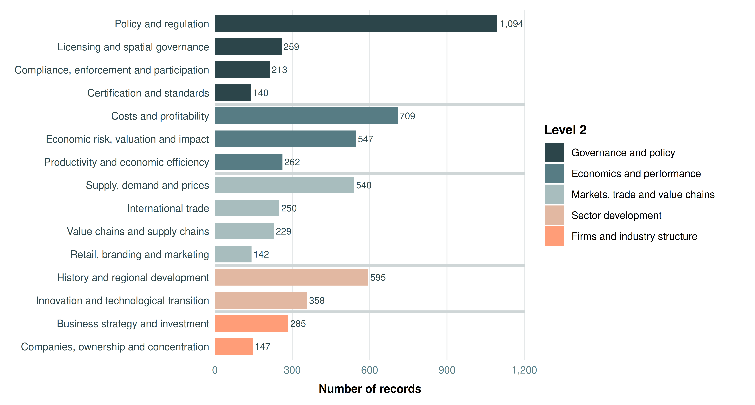
Figure 12. Topic-assignment frequency within the Industry and governance theme.

Product
Product research was led by Physiology, metabolism and biological responses (7,477; 27.0%), Growth and development (4,839; 17.5%) and Alternative feed ingredients (2,532; 9.1%). Feed additives and supplements and Other diseases - Prevention and treatment were also prominent.
Figure 13. Topic-assignment frequency within the Product theme.

People and society
People and society was much smaller than the Production and Environment evidence bases. The largest terminal topics were Physiology, metabolism and biological responses (7,477; 27.0%), Growth and development (4,839; 17.5%) and Alternative feed ingredients (2,532; 9.1%). Topics relating to Employment and job creation, Local and rural development, Livelihoods and income, Indigenous peoples and rights, Food availability and nutritional security, Culture, identity and traditions, Working conditions and occupational health, Distribution of benefits and harms, Local and Indigenous knowledge, Displacement, disruption and wellbeing, Multiple or general social impacts, Environmental justice and human rights, Health impacts of aquaculture, Competition with other food uses, Labour rights, exploitation and migration, and Affordability and access each represented under 0.5% of the full evidence map.
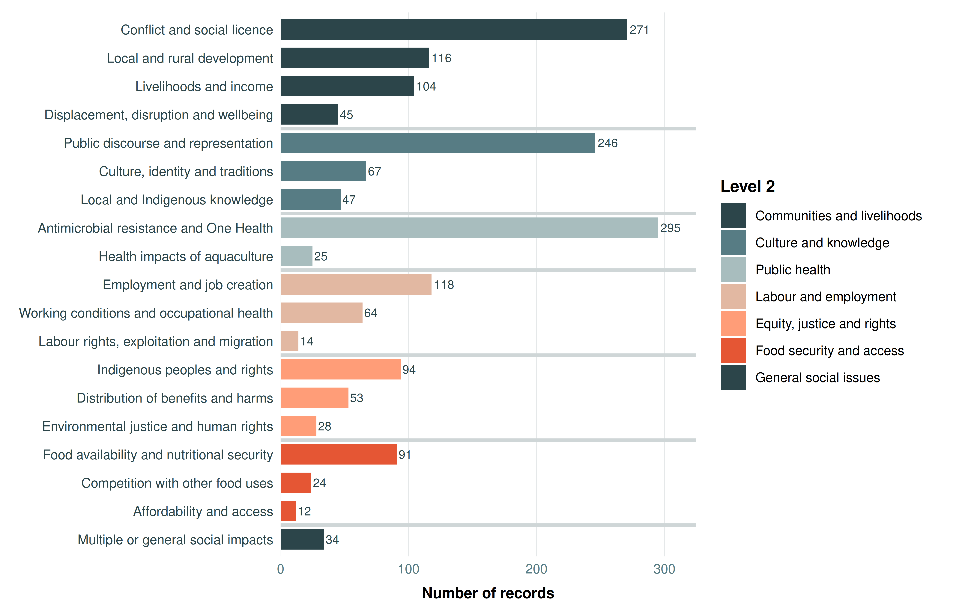
Figure 14. Topic-assignment frequency within the People and society theme.

Inputs and resources
Inputs and resources was the smallest high-level theme. Physiology, metabolism and biological responses accounted for 7,477 records (27.0%) and was more common than Growth and development (4,839; 17.5%), and Alternative feed ingredients (2,532; 9.1%). Affordability and access and Therapeutants and chemicals were represented in only 12 (<0.1%) and 9 (<0.1%) records, respectively.
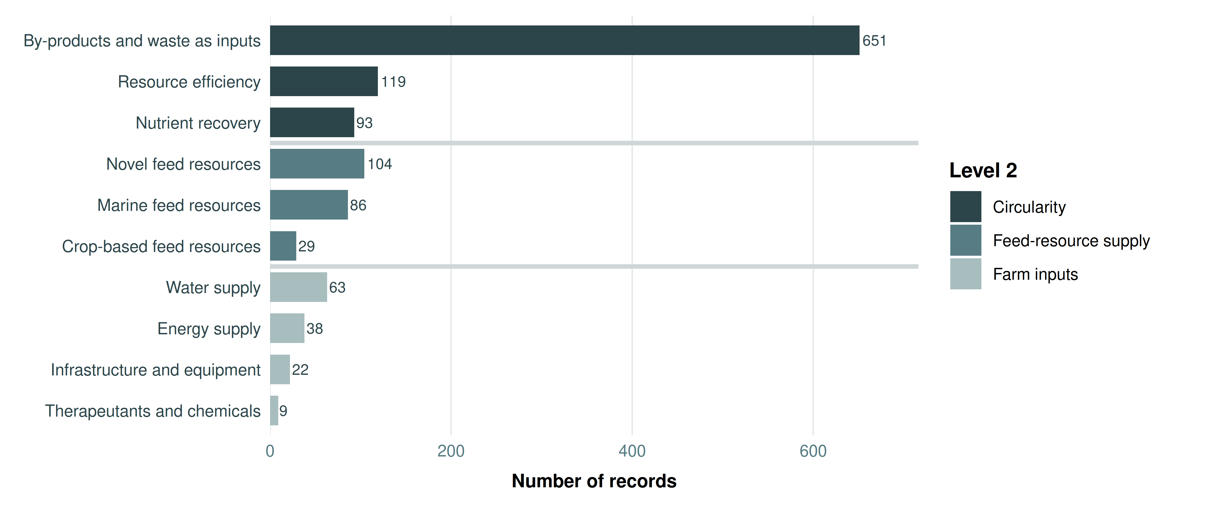
Figure 15. Topic-assignment frequency within the Inputs and resources theme.

Comparison with secondary research
We compare these results with a recent umbrella review of 37 systematic reviews across salmon aquaculture (Haddaway et al. 2026). This comparison shows substantial differences between the distribution of primary research and systematic-review coverage. Sea lice control and treatment occurs in 850 mapped records (3.1%), compared with 8 of 37 systematic reviews (21.6%) in the umbrella-review dataset. By contrast, several of the largest areas in the mapped literature have comparatively little systematic-review coverage, including Physiology, metabolism and biological responses (27.0% of mapped records), Growth and development (17.5%), and major disease, environmental and methodological topics.
Social research was particularly weakly represented in the systematic-review literature. In the final canonical map, Antimicrobial resistance and One Health accounts for 27.0% of records, Conflict and social licence for 17.5%, and Public discourse and representation for 9.1%; the umbrella review includes one review on antimicrobial resistance/One Health and none in most of the other social categories. Overall, the comparison continues to indicate that the systematic-review evidence covers a narrower subset of the topics represented across the mapped literature, with particularly strong representation of sea lice and limited coverage of several major physiological, environmental, methodological, governance and social research areas.
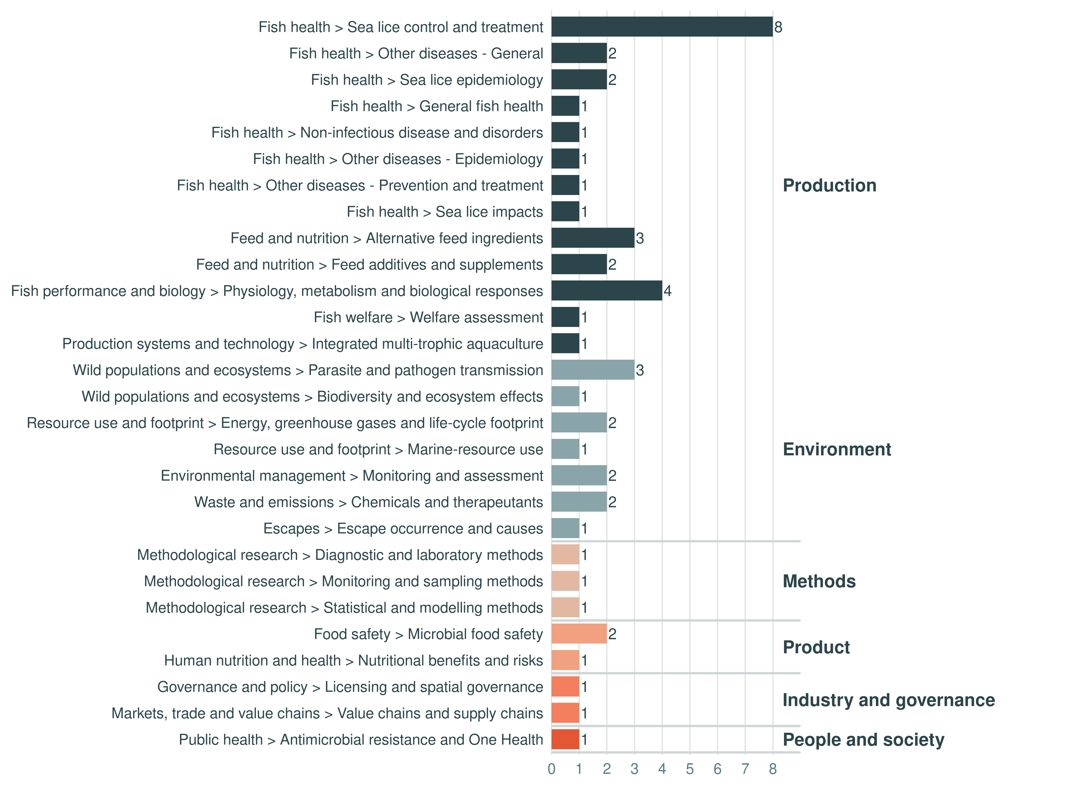
Figure 16. Topic-assignment frequency among the 37 systematic reviews included in the umbrella review (Haddaway et al. 2026).

References
Haddaway, Neal, María D. López Rodríguez, Heather Cooley, et al. 2026. “What Evidence Exists on Salmon Farming? An Overview of Reviews.” Environmental Evidence. https://doi.org/10.1186/s13750-026-00391-y.

