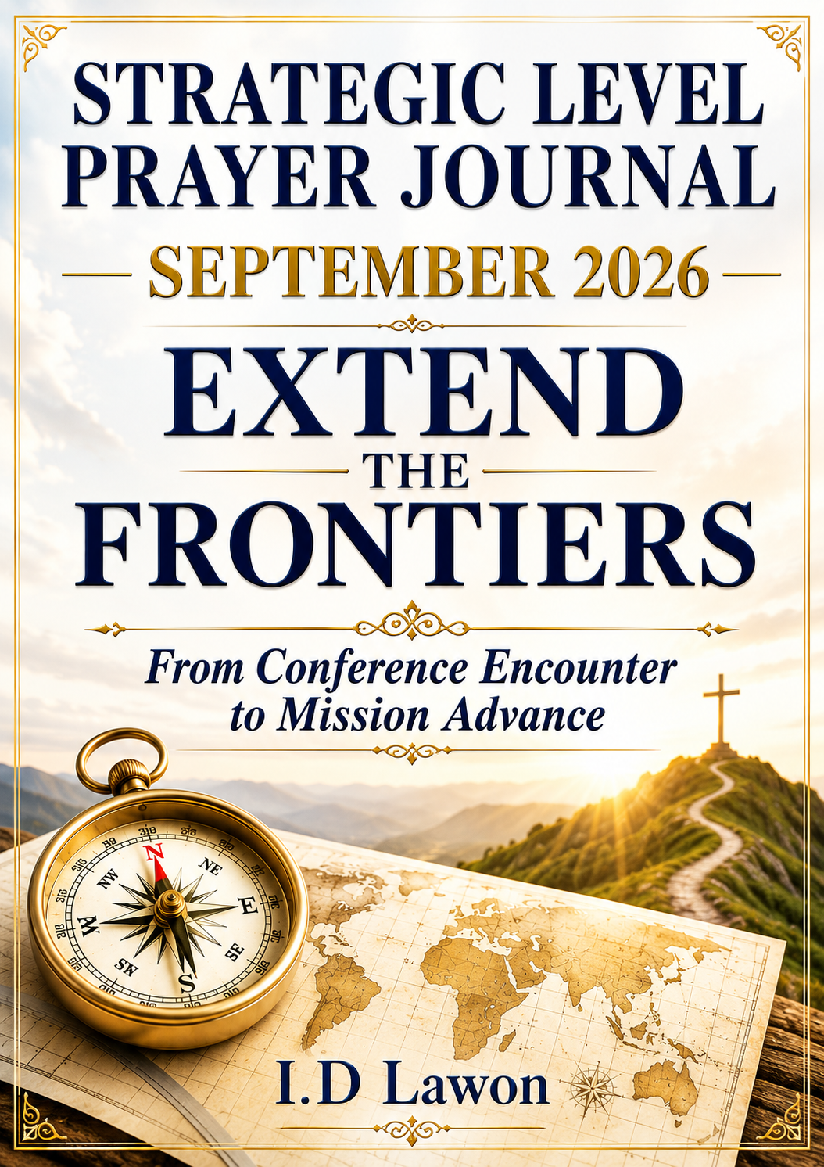

CONTENTS

How to access a particular item of interest

Content and Acknowledgements | 2
A Guide to understanding of the Strategic Level Prayer Journal | 3-4
EXTEND THE FRONTIERS:  From Conference Encounter to Mission Advance | 4-20
Adopt a People Strategy | 20-24
Opportunity to Support this Journal | 24
Is this the month of your Birth? | 24-25
September Daily Devotion - From Conference Encounter to Mission Advance | 25-52
Evangelism Comic Content – Jack Chick | 52-60
Fullstature College Of The Bible And Missions & Reaching the Nations | 60-64
World Map | 65
The Generosity Test | 66

ACKNOWLEDGEMENTS

- Late Rev. Mrs C.O. Lawon
- I.D. LAWON
https.//www.fullstature.net/adopt-a-missionar
- https://www.moongiant.com/moonphases/september/2026/
- https://www.chick.com/products/tract?stk=1188

May the Lord grant you understanding of this prayer journal as you pray, consequent upon which there will be changes in your life or your prayer group or Family, Church, Nation, and Continent. What is presented are not Jewish Dates or the Jewish calendar but what the LORD instituted which we all see manifested in the movement of the Moon every month. The enemy has always manipulated these bodies for which believers are just becoming aware. This season is also a special edition of revelation which brings a new breath of fresh air without adding to the word of God but confirms it and makes our faith stronger.
You may wish to pray in two ways:-
- You can pray using the whole journal to pray into the womb of time according to the authority level granted to you by your appointment in the Lord. Expect the prophetic germination [as you saturate the ground and the womb of time with God’s ordination] to happen. In any case ensure your seed remains in the ground as investment for the coming year. Determine, and command what this month should deliver to you and what it should not and must Not.
- You can also use this daily for your prayers AND DEVOTION to prevail at the gate of each day, especially on critical days of intense warfare in the heavens. Remember that the day starts from 6pm for the next 24 hours. If you are in Britain for instance the time will be early hours of the next day in Hong Kong @ your 6pm.
- This document may seem lengthy, but it shows the effort that was generated in prayer. You can keep it and save it for use in a good way.
Pray that your prophetic faculties will be on the rise and be enlarged and sharp…visions; dreams; interpreting symbols; applying parables; riddles; revelation and predictions; accurate delivery of words of wisdom and words of knowledge; intercessions; interaction with heaven etc.. Divine decrees to cause the future and many other such faculties
SHAPE YOUR DAY, MONTH AND CONSEQUENTLY YOUR YEARS
Ignorance of what every month holds for you, your family, community, nation, the church and the continent at large has caused many to perish, miss out or not fully access what God has in store for them.
Understanding the heavens and what they signify every month is another very key aspect as we enter this new level of our assignments among the nations. While the kingdom of darkness has used astrology, prognostications, and all manner of demonic methods to control the activities on earth using the heavens, the church continues in ignorance. They have even employed materialism to blind believers in Jesus Christ, whereas all things are yours
We thank God for the many people whom He is raising in different parts of the world to understand what the heavens hold for us every month. As you seek deeper understanding, the Holy Spirit will guide you into greater revelations. Amen

EXTEND THE FRONTIERS:
From Conference Encounter to Mission Advance

AWMC Ibadan 2026 Post-Conference Prayer and Action Journey
“But ye shall receive power, after that the Holy Ghost is come upon you: and ye shall be witnesses unto me…”
— Acts 1:8
“Behold, I send you forth as sheep in the midst of wolves: be ye therefore wise as serpents, and harmless as doves.”
— Matthew 10:16
“Therefore, my beloved brethren, be ye stedfast, unmoveable, always abounding in the work of the Lord…”
— 1 Corinthians 15:58

THE CONFERENCE HAS ENDED, BUT THE ASSIGNMENT HAS NOT
AWMC Ibadan 2026 has concluded. The meetings are over. The messages have been preached. The prayers have been offered. The appeals have been made. People have returned to their churches, ministries, professions, families, and communities.
But heaven’s purpose for the conference did not end when the final meeting closed.
In many ways, the real test of AWMC begins after AWMC.
A conference may gather people, awaken hearts, communicate vision, impart spiritual burden, and expose believers to the unfinished task of world evangelization. But the ultimate measure of such a gathering is not merely what happened in the auditorium. It is what happens afterwards in the lives of those who heard God.
What decisions will survive the excitement of the conference?
What burdens will become assignments?
What prayers will become actions?
What commitments will become obedience?
What relationships will become partnerships?
What resources will be redirected toward God’s mission?
What workers will emerge?
What new initiatives will be born?
And ultimately, what frontiers will actually be extended?
This is the burden of our September 2026 Strategic Prayer Journey.
During AWMC, we called participants to respond within 7-, 30-, and 90-day windows. This was deliberate. Spiritual encounters must be given practical pathways. Without intentional follow-through, conviction can gradually become memory, and memory can eventually become another story about what God once said to us.
September therefore becomes a crucial bridge between conference encounter and sustained mission obedience.
For these 30 days, we are asking every participant, every church, every ministry leader, every intercessor, every professional, every young person, and every friend of the missionary enterprise to bring one question continually before the Lord:
What am I actually doing with what God said to me at AWMC?

FROM INSPIRATION TO OBEDIENCE
Scripture repeatedly shows that divine revelation demands human response.
When God called Abraham, Abraham went.
When God confronted Moses at the burning bush, Moses eventually returned to Egypt.
When Isaiah saw the Lord, heard the question, “Whom shall I send, and who will go for us?” his response was:
“Here am I; send me.”
— Isaiah 6:8
When Jesus called His first disciples, they left their nets and followed Him.
When the Holy Spirit spoke at Antioch—“Separate me Barnabas and Saul for the work whereunto I have called them”—the church fasted, prayed, laid hands upon them, and sent them forth (Acts 13:1–4).
The book of Acts is not merely the record of people who received revelation. It is the history of people who acted upon revelation.
That must become our posture after AWMC.
We cannot measure the success of a mission conference only by attendance, offerings, excitement, powerful preaching, prophetic utterances, or the number of people who responded publicly. These things have their place. But the deeper question is whether the people of God move from hearing to doing.
James warns us:
“But be ye doers of the word, and not hearers only…”
— James 1:22
September is therefore not merely another month of prayer.
It is a month of strategic prayer, preservation, discernment, obedience, and mission advance.

POWER FOR THE FRONTIERS
The mandate of Acts 1:8 remains central:
“But ye shall receive power, after that the Holy Ghost is come upon you: and ye shall be witnesses unto me…”
Jesus connected the coming of the Holy Spirit with the expansion of witness.
Jerusalem.
Judaea.
Samaria.
The uttermost part of the earth.
The Holy Spirit was not given merely to make the Church comfortable within its existing boundaries. He empowers the people of God to move beyond them.
Every generation therefore inherits a frontier.
There are places where Christ is scarcely known.
There are peoples among whom there is little gospel witness.
There are languages without adequate biblical resources.
There are cities containing vast migrant and diaspora populations.
There are professions and institutions requiring credible Christian witness.
There are younger generations waiting to be discipled.
There are churches that must rediscover their missionary identity.
There are workers waiting to be equipped.
There are indigenous believers who can reach communities outsiders may find difficult or dangerous to enter.
And there are believers sitting in our congregations whose professions, resources, relationships, technology, influence, and spiritual gifts have not yet been intentionally connected to the Great Commission.
These are all frontiers.
The command therefore remains:
Extend the frontiers.

ADVANCE, BUT DO NOT PRESUME

We must, however, confront one important reality.
The Great Commission has never been a command to abandon wisdom.
Nigeria presently faces serious security challenges. Some communities are affected by kidnapping, banditry, terrorism, communal violence, criminal activity, or the near absence of effective security infrastructure.
This affects missionary strategy.
There are places where a careless journey can unnecessarily expose missionaries, pastors, young volunteers, or church members to grave danger.
We therefore refuse two opposite errors.
Fear must not paralyze the Great Commission.
But equally,
Presumption must not masquerade as faith.
Jesus Himself said:
“Behold, I send you forth as sheep in the midst of wolves: be ye therefore wise as serpents, and harmless as doves.” — Matthew 10:16
Wisdom and mission are not enemies.
Prayer and planning are not enemies.
Faith and security assessment are not enemies.
The leading of the Holy Spirit and careful intelligence are not enemies.
There were occasions when Paul escaped danger. At Damascus, believers lowered him through the city wall in a basket (Acts 9:23–25). At other times, believers warned him of plots against his life. Missionary courage did not require unnecessary exposure to avoidable danger.
Therefore, when direct access is temporarily unsafe, the mission does not stop; the strategy changes.
We can pray.
We can research.
We can identify indigenous workers.
We can train believers already near the people.
We can strengthen churches within accessible areas.
We can support trustworthy frontline workers.
We can use radio, audio Scripture, digital platforms, media, telephone communication, and other appropriate technologies.
We can reach members of an unreached people group who have migrated to safer cities.
We can develop language and cultural understanding.
We can build relationships and prepare teams.
We can wait for a safer access window without abandoning the burden.
The question is not simply:
“Can I travel there now?”
The larger question is:
“Lord, what is the wisest and most obedient pathway for advancing Your purpose among these people?”

FOUR FRONTIERS BEFORE US
During these 30 days, we will repeatedly return to four interconnected mission frontiers:
Geographical. People. Functional. Multiplication.
Together they help us move from a general desire to “do missions” toward identifiable, responsible action.

1. THE GEOGRAPHICAL FRONTIER — WHERE?
God’s mission has geographical dimensions.
Jesus spoke about Jerusalem, Judaea, Samaria, and the uttermost parts of the earth.
Paul desired to preach Christ where He had not been named (Romans 15:20).
The question “Where?” therefore remains legitimate.
Where is gospel witness weak?
Where are churches scarce?
Where are missionary workers few?
Where has God given us relationships or unusual access?
Where are communities changing because of migration, conflict, education, urbanization, or economic movement?
Yet geographical burden must not automatically be interpreted as an instruction to travel immediately.
Sometimes God’s first instruction concerning a territory may be:
Pray for it.
Study it.
Understand it.
Identify workers there.
Build relationships.
Support someone already there.
Prepare yourself.
Mobilize a church.
Develop a team.
Wait.
The geographical frontier therefore requires both apostolic urgency and strategic patience.
During September, ask:
Lord, what place are You asking me to carry in my heart?

2. THE PEOPLE FRONTIER — WHO?
Maps are important, but mission is ultimately about people.
God did not merely love territories.
“For God so loved the world, that he gave his only begotten Son…”
— John 3:16
The missionary question must therefore move beyond Where? to Who?
Who are the people?
What language do they speak?
What do they believe?
What prevents them from hearing or understanding the gospel?
Who already has relational access to them?
Where else can they be found?
This final question has become increasingly important.
A people group that may be difficult to reach in its traditional homeland may have members living in Ibadan, Lagos, Abuja, Accra, London, New York, Johannesburg, or another major city.
Students move.
Businesspeople move.
Refugees move.
Professionals migrate.
Families relocate.
Diaspora communities emerge.
God can therefore bring the nations to our doorstep even while He continues calling workers to the nations.
September should awaken us to look again.
Perhaps the “unreached” person is already our neighbour, colleague, student, customer, patient, tenant, employee, employer, or business associate.
Ask:
Lord, who are the people You want me to see?

3. THE FUNCTIONAL FRONTIER — WHAT IS IN MY HAND?
One of the greatest mistakes in missions mobilization is to create the impression that meaningful participation begins only when someone becomes a full-time cross-cultural missionary.
Scripture presents a much larger picture.
The mission of God requires the whole Body of Christ.
Some will go.
Some will send.
Some will pray.
Some will give.
Some will teach.
Some will research.
Some will translate.
Some will administer.
Some will mobilize.
Some will provide professional skills.
Some will develop technology.
Some will care for missionary families.
Some will strengthen local churches.
Some will create businesses that generate kingdom resources.
Some will train emerging leaders.
Some will communicate through media.
Some will help provide medical, educational, logistical, technical, or humanitarian platforms through which Christian witness can be strengthened.
The functional frontier asks:
What has God already placed in my hand that can advance His mission?
Moses had a rod.
David had a sling.
Dorcas had a needle and garments.
Lydia had a home and commercial resources.
Priscilla and Aquila had a profession, a home, mobility, biblical understanding, and a willingness to disciple others.
The question is not merely, “What don’t I have?”
The question is:
What do I already have that has not yet been surrendered to the mission of God?
Your profession may be part of your missionary equipment.
Your business may become a sending platform.
Your computer may become a mission tool.
Your writing ability may become a mobilization instrument.
Your retirement years may become years of intercession and mentoring.
Your home may host missionaries.
Your relationships may open doors.
Your resources may keep another worker on the field.
Your administrative ability may strengthen an entire mission structure.
September must help us discover that mission is not the assignment of a missionary elite.
The whole Church must participate in taking the whole gospel to the whole world.

4. THE MULTIPLICATION FRONTIER — WHO WILL CONTINUE AFTER ME?
Perhaps the greatest frontier is multiplication.
Mission that depends permanently upon one charismatic leader remains fragile.
Jesus did not merely gather followers. He formed disciples who could carry the mission after His ascension.
Paul told Timothy:
“And the things that thou hast heard of me among many witnesses, the same commit thou to faithful men, who shall be able to teach others also.”
— 2 Timothy 2:2
Paul.
Timothy.
Faithful people.
Others also.
Four generations appear within one verse.
That is multiplication.
We must therefore ask harder questions.
Who am I discipling?
Who am I mentoring?
Who am I preparing?
Who am I giving responsibility to?
Who am I helping discover his or her calling?
If God gives me a mission burden, how will that burden survive me?
If God gives us a church, how will that church reproduce?
If God raises one missionary, how will that missionary help raise others?
If God raises a giver, can that giver inspire other kingdom financiers?
If God raises an intercessor, can that intercessor build an intercessory company?
If God raises one mission-minded pastor, can that pastor help awaken ten other congregations?
The frontier is not fully extended merely because I went.
The frontier is extended more sustainably when others arise because I obeyed.

PRESERVATION IS PART OF THE MISSION
There is another burden we must carry seriously throughout September: the preservation of God’s people and God’s work.
Mission advance takes place in a world marked by suffering, sickness, opposition, disappointment, bereavement, spiritual conflict, and human vulnerability.
We must therefore pray deliberately for missionaries, leaders, families, churches, conference participants, mission partners, and those carrying new assignments.
We pray for preservation of life.
Preservation of health.
Preservation of marriages and families.
Preservation of faith.
Preservation of calling.
Preservation of workers from discouragement.
Preservation from avoidable danger.
Preservation from moral failure.
Preservation from financial collapse.
Preservation from wrong decisions.
Preservation from spiritual attack.
Preservation of the fruit already gained.
But our theology of preservation must remain rooted in Christ rather than in fear. We do not build doctrine merely from painful events, nor do we allow bereavement to drive us into superstition. Neither do we become spiritually careless.
We pray.
We watch.
We stand together.
We strengthen the weak.
We care for the sick.
We encourage the discouraged.
We support grieving families.
We exercise practical wisdom.
And we continue the assignment.
The enemy must not be allowed to use sorrow to terminate obedience.
Paul could say:
“We are troubled on every side, yet not distressed; we are perplexed, but not in despair…”
— 2 Corinthians 4:8
The Church advances not because God’s servants never experience adversity, but because Christ remains Lord in the midst of adversity.

SEPTEMBER MUST PRODUCE EVIDENCE
Thirty days from now, something should be different.
Someone should have begun praying consistently for a people group.
Someone should have researched an unreached community.
Someone should have contacted a missionary.
Someone should have joined an intercessory team.
Someone should have redirected part of his or her resources toward missions.
Someone should have begun mentoring another believer.
Someone should have offered a professional skill.
Someone should have started learning about a people or language.
Someone should have initiated a safe local evangelistic outreach.
Someone should have begun reaching diaspora members of a difficult-access people.
Someone should have called a pastor and said, “How can our church become more intentionally involved?”
Someone should have moved from interest to involvement.
This is why our 7-, 30-, and 90-day windows matter.

Within 7 days — RESPOND.
Write down what God said.
Identify your frontier.
Take the first small step.

Within 30 days — ENGAGE.
Move from intention to identifiable participation.
Make the call.
Join the prayer team.
Begin the research.
Make the contribution.
Offer the skill.
Start the relationship.
Begin the training.

Within 90 days — ESTABLISH.
Turn an isolated action into a sustainable pattern.
Build the partnership.
Develop the ministry pathway.
Form the team.
Strengthen the worker.
Create accountability.
Measure progress.
Begin multiplying what God has entrusted to you.

LORD, SHOW ME MY FRONTIER
This September journey is therefore intensely personal.
It is possible to celebrate missionaries without becoming missional.
It is possible to attend mission conferences without changing our priorities.
It is possible to pray passionately during a meeting and return immediately to business as usual.
We must resist that possibility.
For the next 30 days, place your life before God again.
Your time.
Your profession.
Your money.
Your relationships.
Your church.
Your influence.
Your experience.
Your education.
Your technology.
Your spiritual gifts.
Your future.
And ask:
Lord, where is my frontier?
Is it geographical?
Is it a particular people?
Is it functional—something already in your hand?
Is it multiplication—someone you must raise?
Perhaps it is more than one.
Then ask a second question:
What is my next act of obedience?
Not next year’s act.
Not what somebody else should do.
Not what you would do if you had more money.
Not what you might do if Nigeria became perfectly secure.
What can you responsibly obey now?
Then ask one final question:
Who will be affected by my obedience?
That question takes us beyond ourselves.

THE FRONTIER IS STILL BEFORE US
AWMC Ibadan 2026 is now history.
But the Great Commission is not history.
The nations are still before us.
The unreached are still before us.
The next generation is still before us.
The unfinished task is still before us.
And the Holy Spirit is still empowering the Church.
We therefore enter September neither carelessly nor fearfully.
We enter prayerfully.
We enter watchfully.
We enter strategically.
We enter compassionately.
We enter courageously.
We will pray before we move.
We will discern before we presume.
We will research where we do not understand.
We will partner where others have better access.
We will strengthen indigenous workers.
We will use every legitimate skill and technology God has placed in our hands.
We will protect people without surrendering the mission.
We will mourn when there is sorrow without abandoning our calling.
We will raise others rather than build everything around ourselves.
And when one door is closed, we will ask the Holy Spirit to show us another pathway to the people.
For thirty days our prayer will therefore be:
Lord, preserve Your people. Awaken Your Church.
Clarify our assignments. Break the power of fear and complacency.
Give us wisdom for dangerous and difficult frontiers.
Show us the peoples You are calling us to reach.
Reveal how our gifts, professions, resources, and relationships can serve Your mission.
Raise workers from among us.
Strengthen those already on the field.
Turn conference commitments into concrete obedience.
Make disciples who will make disciples.
Raise workers who will raise workers.
Raise churches that will send and reproduce.
And by the power of the Holy Spirit, EXTEND THE FRONTIERS through us.
The conference has ended.
The assignment has begun.
September 2026 must become our month of Strategic Prayer, Preservation, Obedience and Mission Advance.
PRAY. DISCERN. PRESERVE. OBEY. ENGAGE. MULTIPLY. EXTEND.
The frontier is waiting.
I D Lawon
25/08/2026

Adopt-A-Missionary- A Missions’ Strategy
https://fullstature.net/25-get-involved/25-adopt-a-missionary/
...a strategy for loving the missionary family as well as the people groups, they serve
Adopt-A-Missionary is a mission strategy that has gained momentum in missions over the years. What makes this strategy different is its focus. Historically, churches have focused on countries, and mission agencies have focused their attention on people groups. Adopt-A- Missionary focuses on missionary families, or what we can call message bearers.
For 5 years, my wife (of blessed memory) and I served as missionary representatives to the Kenyan peoples of East Africa. We divided the nation of Kenya into 6. Working with the missionary on ground we had a plan to evangelise the nation. We raised teams of two by two from Nigeria and travelled from Nigeria to the different regions of Kenya. We planted 6 churches throughout the country. In the last 29 years + the FMI missionary teams have been helped by God to open the gospel among 40 unreached people groups. Our FMC churches faithfully prayed and the missionaries that we served with, and the church has supported them financially.
In 1990 for example, we were relocated to Kano, Nigeria, Northwest, with two major tribes- the Kanawas and Magusawas. We were led of the Lord to pay more attention to tribal missions in 1993, where the gospel has never been heard while maintaining a church base. Thankfully, our churches have continued to pray for and support the mission’s effort with this strategic ministry.
ADOPT-A-Missionary Defined
What then does it mean to Adopt-A-missionary? It means committing yourself as an individual, fellowship group, local congregation, denomination, or mission agency to pray for and commit resources to win souls, establish believers, administrate the work within a specific people group through a missionary family or families. This commitment is continued until the believers in that people group can reach the rest of their people without outside (cross-cultural) assistance.
We are agents of God praying, giving, and serving to see an adopted family reach out to bring sinners into God’s family. This is the true meaning of Adopting a missionary family. One day this will be accomplished, and every tribe, tongue, people, and nation will give glory to God around His throne (Rev. 5:9).
Adopt a Missionary Family
Fullstature Missions International is committed to the work of missions and has developed a ministry to bring into focus the Great Commission (Matt 28:19-20) set forth by Christ and to support missionary families need. We ask that your family prayerfully consider adopting a missionary family to be a blessing and to be blessed. After you have made an adoption, we encourage you can send your missionary family an email to share about your family and to ask them to share with you. The FMI becomes a bridge to help people you may never know or meet. You can reach out to the missionary during Holidays, birthdays, or anniversaries or just at any time. Commit to lift your missionary up in prayer. (Phil 6)
It is also our desire to support more missionaries through our ministry budget than we currently can do. The missionaries we support currently are under-supported. In other words, the support we grant is not adequate. In most cases, we are nearly able (with Naira) to provide what will keep body and soul together leaving projects in the field undone. This is where you pause and do something.
It is our goal to ensure that every Missionary, supported through, (what we call) the General Fund which includes the “Faith Promise Offering” (FPO), are missionaries we, as a ministry want to support.
The money these Missionaries receive is totally dependent on what is given by the individual or families who have adopted them.
Example: Missionary “Felix” may have two families in First Baptist Church which chose to adopt him. They do so for a combined support of $200 per month, one for $75 per month and one for $125 per month. Should the family who chose to support Missionary “Felix” for $125 per month be unable to do so for any reason, Missionary “Felix” would only receive $75 for that month. There will be a “shortfall” and the family who was unable to give what they had purposed to give would not be contacted and asked, “Where is your contribution”.
If you have a desire to support a Missionary, please feel free to fill out a “Adopt-A-Missionary Request Form” and return it to our ministry office.
Build a Relationship
Develop a relationship with your adopted missionary family. Learn about their ministry and their ups and downs so that you know when to Praise God with them and when to lift them up in prayer. Being a missionary can have very hard times and there is great comfort when a missionary knows that God is always there and that there are people supporting them at every step.
Faith Promise
In addition to your commitment to get to know and pray for your adopted missionary, you may consider supporting your missionary financially. Among some of the greatest difficulties that missionaries face is having their financial needs met. Missionaries typically spend a significant amount of time raising monies to support their ministries which in turn reduces the amount of time out in the field.
Would you prayerfully consider financially committing to a missionary? If you agree please fill out the form below and send separately.
Thank you.

Missionary Adoption Promise Form
Fullstature Missions International Conference Centre for the Nations, 4 Parliament Highway, Secretariat
Donor Information (please print or type)
Click this link to complete online-
https.//www.fullstature.net/adopt-a-missionary
Name______________________________________________________________________ Billing address____________________________________________________________________ ___________________________________________________________________________
City _____________ _________________ Zip Code _____________________
Phone __________________________ ____________________________
WhatsApp _______________________________ Email __________________________
Type Donor ☐ individual ☐church group ☐church ☐other: ___________________________________________________________________________
Promise Information: I want to ☐donate to General Fund ☐ Adopt a Missionary I (we) promise by faith a total of $____________________ to be paid: ☐one time ☐monthly
☐quarterly ☐yearly for a length of: ☐three years ☐four years ☐five years.
This gift will start ____________________ (date) and end ____________________ (date), with an option to continue. I (we) plan to make this contribution in the form of: ☐cash ☐check ☐credit card ☐other.
If you have already been given a missionary name list here: ____________________________________________________ Please contact me by ☐phone ☐email if my missionary leaves the field
I am also interested in: ☐ Praying for MAP ☐ Receiving more information ☐ Going on a Mission Trip
Contact Information:
☐Giving toward MAP
☐ Representative visiting my church
☐ Becoming a MAP Missionary Mobilizer
Please send all MAP information to (list name and email):___________________________________________________________________________________________________________________________________________________________________________________________________________________________
Please communicate all MAP financial information with (list name and email):
Name (Print) _______________________________________________________________
Position: ___________________________________________________________________
Signature(s) _________________________________Date ___________________________
Online Giving
Donation Instructions
You can give a general gift or toward your specific missionary for a tax-deductible contribution. If you have filled out this faith promise form, you will receive a missionary’s name and account to give toward, and/or you can give a general gift to be used by MAP
https.//www.fullstature.net/adopt-a-missionary.
$$$$$$$$$$$$$$$$$$$$$$$$$$$$$$$$$$$$$$$$$$$$$$$$$$$$$$$$$$$$$$$$$$$$$$$$$$$

YOU HAVE AN OPPORTUNITY TO SUPPORT THIS JOURNAL
The Strategic Level Prayer Journal is a daily devotional with God’s timing (Kairos) attached. It is published monthly by faith and support of the brethren.
Please support the continued publication of this journal.
Send your donations to: -
Bank: - Zenith Bank Plc.
Account Name: - Fullstature Missions International
Account Number: - 1011822382
Please send SMS or WhatsApp to +234-802 333 9638 or email: fmi@fullstature.net to notify us of your donation. The Lord blesses us. Amen.

IS THIS THE MONTH OF YOUR BIRTH?
USE REVELATION KNOWLEDGE WELL
(AND AGAIN)!!
Even if this is not your month of birth, pray into the day of your birth on a weekly basis (that is the weekday in which you were born). Take time at regular basis to be praying for yourself and prophesying over your own life. Speak into the foundations of your life and prophesy good things.
Thank Him for your specific day of birth. Declare that day blessed.

• Thank Him that He ordained that you will be made manifest on earth on a specific day in that month at a specific hour and minute.
• Thank Him that He has a purpose for your life, and it will be fulfilled.
• Ask Jehovah to forgive you where you have for one reason or another, ignored or rejected to recognize your day of birth.
• Thank Jehovah for the day of your conception. (Psa 139:13)
• Thank Jehovah that when He thought of you, he already thought of your entire life. Thank Him that He did not leave anything to chance. (Isa 49:1)
• Thank Him that he knew exactly what your redemptive purpose was going to be. (Psa. 139:16)
• Pray that He will reveal the original you more and more as you enter another year of your life. (Psa 139:13-15)
• Pray that He will restore the heavenly label, and the heavenly name He gave you before you were conceived. (Jer 1:5).
• Speak into the foundations of your life and prophesy good things.
• Prophesy that you will live and not die prematurely in any area of your life. Your family will live, the work of your hand will live and grow from strength to strength. Deut. 33:6, Psa. 27:13, 118:17
• Prophesy and proclaim the blessing of Levi upon your life as a priest unto Jehovah (2 Pet 2:9, Deut 33:8-11)
• Prophesy and proclaim the blessing of Benjamin upon your life Deut. 33:12
• Prophesy the blessing of the wisdom of Issachar in every area of life. Wisdom to establish the work of your hands, your family, as you grow a year older 1 Chron 12:32, Deut.33:18b-19, Pro 24:3-4
• Prophesy the blessing of Dan concerning your role as a leader. Prophesy over your inheritance that Jehovah will indeed ensure you leave an inheritance for your descendants. Deut 33:20-21, Psa 16:5-6.
• Prophesy the blessing of Joseph. Speak to the earth and declare that the earth will bring forth its best for you in this New Year. Prophesy to the heavens to declare the glory of Jehovah over your life every day of this New Year. Deut 33:13-17, Lev 26:4-5, Hos 2:21-22, Psalm 19:1-2, Isa 55:12
• Prophesy that you will grow in your spirit man into a matured son so you can receive your inheritance. Wherever you go in this New Year, creation will experience release from frustration. Rom 8:19-20, Gal 4:1-2
• Praise Jehovah that your birthday marks the entry into another season of Jubilee. Thank Jehovah that immediately you were born, you cried out prophetically blowing your own jubilee cornet, and prophetically rejoiced in yourself. Ask Him to give you joy no matter your circumstance, to rejoice on this day. Amen.

The days and times highlighted in the month of September {below} are referred to as High Days on which to intensify intercession for yourself, family members, community, church and Nation. Men draw power from the celestial bodies and desire to invoke such powers against their fellow humans. You can disannul such powers by intensive intercession on these high days wherever you may be in the earth.

Full Moon and New Moon for September 2026.
  Last Quarter  September 4  07:51 UTC |   New Moon  September 11  03:27 UTC |   First Quarter  September 18  20:43 UTC |   Full Moon  September 26  16:48 UTC | ⟩

DAYS 1–6 — EVANGELIZE
AWAKEN AGAIN TO THE HARVEST

 TUESDAY, SEPTEMBER 1, 2026

REMEMBER WHAT GOD SAID
Topic: Recovering the Divine Impression
Frontier Focus: All Four Frontiers

Scripture Reflection
Habakkuk 2:2–3; John 14:26
God told Habakkuk to write the vision. Jesus promised that the Holy Spirit would bring His words back to remembrance. Spiritual impressions must not be allowed to disappear beneath ordinary life after AWMC. What God emphasized may contain the seed of future obedience.

Biblical Examples and Ancient Literature
Nehemiah carried Jerusalem in his heart before rebuilding its walls (Neh. 1:3–4; 2:11–18). Paul repeatedly remembered and obeyed his heavenly calling (Acts 26:19).

Five Reference Scriptures
Habakkuk 2:2–3; John 14:26; Nehemiah 2:12; Acts 26:19; 1 Timothy 4:14.

Testimonies
Many significant missionary movements began when individuals refused to forget a burden God had placed upon them. A remembered burden became prayer; prayer became obedience; obedience became movement.

Strategic Prayers
- Holy Spirit, bring back every genuine word, burden, conviction, and instruction.
- Separate divine direction from temporary emotion.
- Show me where, who, what I can contribute, and whom I can help multiply.
- Connect me with people necessary for obedience.
- Turn AWMC inspiration into measurable action.

Personal Prayer
Lord, show me what You specifically require of me within the next 7 days, 30 days, and 90 days.

Proclamation
I will not lose what God awakened in me. I will write the vision, discern my assignment, and move from inspiration into obedient action.

WEDNESDAY, SEPTEMBER 2, 2026

RECOVER GOD’S HEART FOR THE LOST
Topic: Let Me See People as God Sees Them
Frontier Focus: PEOPLE

Scripture Reflection
Matthew 9:36–38; Romans 9:1–3
Jesus did not see crowds merely as numbers. He saw people who were distressed and scattered. Paul similarly carried deep anguish for those separated from Christ. Authentic mission grows from the heart of God.

Biblical Examples and Ancient Literature
Moses pleaded for Israel even after their rebellion (Exod. 32:30–32). Jonah illustrates the opposite danger: possessing God’s message without sharing God’s compassion (Jonah 4:1–11).

Five Reference Scriptures
Matthew 9:36–38; Romans 9:1–3; Luke 19:10; Ezekiel 34:11–12; 2 Corinthians 5:14.

Testimonies
Mission history repeatedly demonstrates that sustained engagement often begins when distant populations cease being statistics and become people with names, stories, families, hopes, and eternal significance.

Strategic Prayers
- Father, give me Your compassion for people.
- Deliver me from indifference toward those without Christ.
- Put specific people and communities upon my heart.
- Raise laborers for neglected harvest fields.
- Make our churches compassionate sending communities.

Personal Prayer
Lord, identify people I should begin praying for by name. Give me courage to listen, love, serve, witness, and remain engaged.

Proclamation
The harvest will not remain a statistic before me. I receive the compassion of Christ. I will see people, pray for people, love people, and participate in God’s mission to people.

THURSDAY, SEPTEMBER 3, 2026

SEE THE UNFINISHED GEOGRAPHICAL TASK
Topic: Looking Beyond Familiar Territory
Frontier Focus: GEOGRAPHICAL

Scripture Reflection
Romans 15:20–21; Acts 1:8
Paul deliberately looked toward places where Christ had not been adequately proclaimed. Jesus expanded the disciples’ vision from Jerusalem to the ends of the earth. Geography still matters where gospel access remains weak.

Biblical Examples and Ancient Literature
Abraham obeyed God’s geographical summons without knowing every detail beforehand (Gen. 12:1–4). Paul’s Macedonian call redirected missionary movement toward a new region (Acts 16:6–10).

Five Reference Scriptures
Genesis 12:1–3; Acts 1:8; Acts 16:9–10; Romans 15:20–21; Isaiah 49:6.

Testimonies
The expansion of the gospel across generations has often occurred because believers became concerned about places beyond their immediate communities and developed sustained prayer, sending, translation, training, and missionary presence.

Strategic Prayers
- Lord, reveal places where gospel access remains weak.
- Give Your Church accurate knowledge of unfinished fields.
- Raise indigenous workers within those regions.
- Open legitimate doors for cross-cultural engagement.
- Give me wisdom concerning my own role.

Personal Prayer
Lord, place one location before me for informed, sustained prayer. Show me whether my role is to go, give, pray, connect, train, advocate, or send.

Proclamation
I will look beyond familiar territory. I will pray intelligently for unfinished fields without confusing burden with premature deployment. God will clarify my part in His global purpose.

Last Quarter  September 4  07:51 UTC | New Moon  September 11  03:27 UTC | First Quarter  September 18  20:43 UTC | Full Moon  September 26  16:48 UTC | ⟩

FRIDAY, SEPTEMBER 4, 2026

SEE THE PEOPLE BEYOND THE MAP
Topic: Every Tribe, Language, People, and Nation
Frontier Focus: PEOPLE

Scripture Reflection
Revelation 7:9–10; Matthew 28:19
Nations in Scripture are more than political boundaries. Within one country may live many languages, ethnic communities, migrant populations, cultural networks, and groups with very different levels of gospel access.

Biblical Examples and Ancient Literature
At Pentecost, people from many nations heard the mighty works of God in their own languages (Acts 2:5–11). Philip crossed a cultural boundary to proclaim Christ to the Ethiopian official (Acts 8:26–39).

Five Reference Scriptures
Genesis 12:3; Matthew 28:19; Acts 2:5–11; Acts 8:26–39; Revelation 7:9–10.

Testimonies
Missionary advance has frequently accelerated when Christians learned to distinguish between reaching a country and making disciples among the diverse peoples living within it.

Strategic Prayers
- Lord, open my eyes to overlooked peoples.
- Reveal communities near me that remain culturally distant from the gospel.
- Raise witnesses who understand their languages and cultures.
- Destroy prejudice and unhealthy cultural superiority.
- Establish sustained relationships rather than occasional contact.

Personal Prayer
Father, identify one people or community for whom I can pray consistently. Show me how to learn before attempting to act.

Proclamation
I will see beyond borders to people. Every tribe and tongue matters to God. I receive grace to pray intelligently, engage respectfully, and participate faithfully until Christ is known among the peoples.

SATURDAY, SEPTEMBER 5, 2026

DISCOVER WHAT IS ALREADY IN YOUR HAND
Topic: Turning Present Resources into Missionary Capacity
Frontier Focus: FUNCTIONAL

Scripture Reflection
Exodus 4:2; Romans 12:6–8
God asked Moses, “What is that in your hand?” What appeared ordinary became useful in divine assignment. Mission does not begin only with what we lack. God can mobilize what He has already entrusted to us.

Biblical Examples and Ancient Literature
Dorcas used practical skills to serve others (Acts 9:36–39). Lydia placed her home and resources at the service of the emerging church (Acts 16:14–15, 40). Priscilla and Aquila combined work, hospitality, discipleship, and ministry.

Five Reference Scriptures
Exodus 4:2; Romans 12:6–8; Acts 9:36; Acts 16:14–15; 1 Peter 4:10.

Testimonies
Mission has advanced through far more than preaching alone: teachers, doctors, administrators, businesspeople, translators, technicians, intercessors, writers, donors, hosts, media workers, and professionals have all contributed strategically.

Strategic Prayers
- Lord, reveal the missionary potential of what I already possess.
- Consecrate my profession and abilities.
- Show me resources I have underestimated.
- Connect my abilities to genuine missionary needs.
- Give me discipline to develop what You have entrusted to me.

Personal Prayer
Lord, examine my skills, profession, relationships, finances, technology, experience, knowledge, and influence. What can enter Your service now?

Proclamation
What God has placed in my hand has Kingdom potential. My gifts, resources, profession, relationships, and experience are available to Christ for the advance of His mission.

SUNDAY, SEPTEMBER 6, 2026

LORD, SHOW ME MY PART
Topic: From General Burden to Personal Assignment
Frontier Focus: ALL FOUR FRONTIERS

Scripture Reflection
Isaiah 6:8; 1 Corinthians 12:4–7
Isaiah responded, “Here am I; send me.” Yet Scripture also teaches diversity of gifts and assignments. Availability does not mean everyone performs the same function. Mission requires obedient people occupying their God-appointed places.

Biblical Examples and Ancient Literature
Paul planted, Apollos watered, and God gave the increase (1 Cor. 3:6). Some went, others sent, churches prayed, households hosted, leaders trained, and believers gave. The mission advanced through coordinated obedience.

Five Reference Scriptures
Isaiah 6:8; 1 Corinthians 3:6–9; 1 Corinthians 12:4–7; Romans 10:14–15; Philippians 4:15–17.

Testimonies
Healthy missionary movements emerge when believers stop asking whether everyone must become the same kind of missionary and begin asking how every believer can participate responsibly in God’s mission.

Strategic Prayers
- Lord, define my present assignment.
- Deliver me from comparison and imitation.
- Give me courage to obey what You reveal.
- Join me to others whose gifts complement mine.
- Let my obedience eventually produce other obedient disciples.

Personal Prayer
Complete prayerfully:
“Within my 7:30:90 window, I believe my present mission responsibility is ______________________________.”
Within 7 days I will: __________
Within 30 days I will: _________
Within 90 days I will: _________

Proclamation
Here I am, Lord. My life, gifts, resources, relationships, and opportunities belong to You. I will discover my part, take my place, fulfill my assignment, and help others enter theirs.

DAYS 7–12 — ESTABLISH

PRESERVE THE LABORERS AND SECURE THE GROUND
- MONDAY, SEPTEMBER 7, 2026

STRENGTHEN WHAT REMAINS
Topic: Guarding the Fire After the Gathering
Scripture Reflection — Revelation 3:2; Isaiah 35:3–4
God calls His people to strengthen what remains before it dies. AWMC must not become merely a powerful memory. Spiritual awakening must mature into obedience, discipline, relationships, and multiplication. Strengthen tired hands; steady weak knees; awaken those becoming spiritually passive.
Biblical Examples & Ancient Literature:
Elijah experienced exhaustion after Carmel, yet God restored him for continuing assignment (1 Kings 19:4–18). Paul repeatedly revisited believers to strengthen them after initial evangelistic breakthroughs (Acts 14:21–23). The early church likewise understood perseverance as essential to preserving gospel fruit.
5 Reference Scriptures:
Revelation 3:2; Isaiah 35:3–4; Acts 14:21–23; Galatians 6:9; Hebrews 10:23–25.
Testimonies:
Recall specific commitments, renewed convictions, missionary responses, and relationships produced through AWMC. Thank God that these are seeds capable of multiplication.
Strategic Prayers:
- Father, preserve every genuine seed planted through AWMC.
- Break discouragement, distraction, weariness, and spiritual lethargy.
- Strengthen every participant to fulfil commitments made before You.
- Reconnect people who need encouragement and accountability.
- Turn conference inspiration into multiplying disciples and ministries.
Personal Prayer:
Lord, revive me wherever my own fire has diminished. Give me strength to strengthen others.
Proclamation:
What God awakened shall not die. We strengthen what remains, preserve the fire, and advance into multiplication in Jesus’ name. Amen.

TUESDAY, SEPTEMBER 8, 2026

NUMBER OUR DAYS
Topic: Living Wisely in the Light of Eternity
Scripture Reflection — Psalm 90:12–17
Life is limited; therefore time is sacred. Moses does not ask merely for longer life but for wisdom to use life purposefully. Mission urgency is not panic—it is stewardship. We must invest our remaining days in what carries eternal significance.
Biblical Examples & Ancient Literature:
Moses completed his assignment knowing his earthly journey was ending (Deuteronomy 31:1–8). Paul approached death conscious that he had fought, finished, and kept the faith (2 Timothy 4:6–8). Scripture’s wisdom tradition repeatedly contrasts fleeting human life with God’s enduring purposes.
5 Reference Scriptures:
Psalm 90:12–17; Ecclesiastes 3:1–11; John 9:4; Ephesians 5:15–17; 2 Timothy 4:6–8.
Testimonies:
Remember laborers who faithfully used their years for Christ. Their lives remind us that longevity is valuable when surrendered to divine purpose.
Strategic Prayers:
- Lord, teach us to number our days.
- Deliver us from wasted years and misplaced priorities.
- Give aging laborers strength to finish well.
- Raise younger laborers to receive responsibility.
- Give FMI/AWMC wisdom for generational continuity.
Personal Prayer:
Father, show me what deserves my remaining time, strength, relationships, and resources.
Proclamation:
My days belong to God. I shall live wisely, serve purposefully, finish faithfully, and invest my life in what outlives me.

WEDNESDAY, SEPTEMBER 9, 2026

GRIEVE WITH HOPE
Topic: Sorrow Without Surrendering the Mission
Scripture Reflection — John 11:33–36; 1 Thessalonians 4:13–18
Jesus wept. Christianity does not demand emotional denial. Yet Christian grief is transformed by resurrection hope. We honor those who have departed, comfort their families, and refuse to allow bereavement to terminate the assignment of Christ.
Biblical Examples & Ancient Literature:
Israel mourned Moses for thirty days, but afterward Joshua arose and the journey continued (Deuteronomy 34:7–9; Joshua 1:1–9). Stephen was deeply mourned, yet persecution scattered believers who continued preaching Christ (Acts 8:1–4).
5 Reference Scriptures:
John 11:33–36; 1 Thessalonians 4:13–18; Deuteronomy 34:7–9; Joshua 1:1–9; Acts 8:1–4.
Testimonies:
Remember departed missionaries, pastors, supporters, parents, spouses, and intercessors whose faithfulness contributed to today’s harvest.
Strategic Prayers:
- Comfort every grieving family.
- Heal hearts without erasing precious memories.
- Preserve ministries affected by bereavement.
- Raise successors where laborers have departed.
- Let one generation faithfully transmit the gospel to another.
Personal Prayer:
Lord, teach me to honor those who have gone while faithfully carrying forward what You have entrusted to me.
Proclamation:
We grieve, but not without hope. Christ is risen! Generations may pass, but the gospel shall continue until the nations worship the Lamb.

THURSDAY, SEPTEMBER 10, 2026

PRESERVE THE LABORERS
Topic: Divine Preservation for Those Who Carry the Gospel
Scripture Reflection — Psalm 91; Psalm 121; 2 Thessalonians 3:1–3
The harvest requires laborers, and laborers require preservation. We therefore pray deliberately for missionaries, pastors, leaders, volunteers, participants, spouses, children, and supporting families. Preservation includes physical safety, health, emotional resilience, wisdom, spiritual vigilance, and sustainable rhythms of service.
Biblical Examples & Ancient Literature:
God preserved Paul through persecution, imprisonment, shipwreck, opposition, and danger until his assignment was fulfilled (2 Corinthians 11:23–28; Acts 27). Elijah was sustained during famine, demonstrating God’s ability to preserve His servant amid hostile conditions.
5 Reference Scriptures:
Psalm 91:1–16; Psalm 121:1–8; 2 Thessalonians 3:1–3; Isaiah 40:29–31; 2 Corinthians 4:7–9.
Testimonies:
Thank God for laborers preserved through years of ministry, difficult fields, sickness, financial pressure, insecurity, and spiritual opposition.
Strategic Prayers:
- Preserve every FMI/AWMC laborer and family.
- Strengthen bodies, minds, marriages, and households.
- Grant wisdom concerning travel and ministry decisions.
- Protect workers from burnout and isolation.
- Give laborers grace for fruitful longevity.
Personal Prayer:
Lord, preserve me for Your purpose and teach me to steward my body, soul, relationships, and calling responsibly.
Proclamation:
The Keeper of Israel watches over His laborers. We shall be preserved, strengthened, and sustained to complete our assignments.

Last Quarter  September 4  07:51 UTC | New Moon  September 11  03:27 UTC | First Quarter  September 18  20:43 UTC | Full Moon  September 26  16:48 UTC | ⟩

FRIDAY, SEPTEMBER 11, 2026

RESIST OPPOSITION TO GOSPEL ADVANCE
Topic: Standing Firm While the Word Runs
Scripture Reflection — Ephesians 6:10–20; 1 Thessalonians 2:18:
Scripture recognizes real opposition to gospel advance. Yet spiritual warfare is not fear-driven obsession with darkness. Christ has triumphed. We stand in His strength, clothed with truth, righteousness, faith, salvation, God’s Word, and persevering prayer.
Biblical Examples & Ancient Literature:
Nehemiah’s builders faced intimidation and conspiracy but continued building with vigilance (Nehemiah 4). Paul encountered opposition repeatedly yet testified that the Lord stood with him so the message could be fully proclaimed (2 Timothy 4:16–18).
5 Reference Scriptures:
Ephesians 6:10–20; 1 Thessalonians 2:18; Colossians 2:13–15; Acts 4:29–31; 2 Timothy 4:16–18.
Testimonies:
Remember occasions when closed doors opened, hostility subsided, resources appeared, workers persevered, and the gospel advanced despite resistance.
Strategic Prayers:
- Let every legitimate barrier against gospel advance yield to God’s purpose.
- Give missionaries courage without recklessness.
- Open geographical and people-group access.
- Frustrate deception, intimidation, division, and discouragement.
- Let God’s Word run swiftly and be glorified.
Personal Prayer:
Lord, make me courageous, discerning, truthful, prayerful, and steadfast.
Proclamation:
Jesus Christ is Lord. We stand in His victory. Every God-appointed door shall be pursued faithfully, and the Word of the Lord shall run and be glorified.

SATURDAY, SEPTEMBER 12, 2026

ESTABLISH THE WORK OF OUR HANDS
Topic: From Conference Inspiration to Sustainable Kingdom Work
Scripture Reflection — Psalm 90:17; 1 Corinthians 15:58
We do not merely ask God to bless activity; we ask Him to establish work aligned with His purposes. AWMC must produce enduring fruit—disciples, laborers, partnerships, prayer movements, sending structures, resources, and multiplying initiatives.
Biblical Examples & Ancient Literature:
The Antioch church moved from worship and prayer to Spirit-directed sending (Acts 13:1–3). Paul later strengthened the churches already planted (Acts 15:36, 41). Gospel advance therefore included both pioneering and establishment.
5 Reference Scriptures:
Psalm 90:17; 1 Corinthians 15:58; Acts 13:1–3; Acts 14:21–23; Philippians 1:3–6.
Testimonies:
Identify AWMC relationships and commitments already becoming concrete actions. Record them as evidence of God’s continuing work rather than merely conference memories.
Strategic Prayers:
- Establish every assignment genuinely born of God.
- Convert commitments into measurable action.
- Build sustainable follow-up and accountability.
- Connect people, resources, churches, and opportunities strategically.
- Cause established work to reproduce beyond its founders.
Personal Prayer:
Father, establish the work of my hands. Show me the specific responsibility I must now carry forward.
Proclamation:
We shall not live from conference to conference. By God’s grace, awakening shall become establishment, establishment shall produce obedience, and obedience shall multiply into enduring kingdom fruit. Amen.

SEPTEMBER 13–18 — EQUIP

PREPARE FOR RESPONSIBLE MISSION

SEPTEMBER 13 — EMPOWERED BY THE HOLY SPIRIT

Scripture References
Acts 1:8; Zechariah 4:6
Jesus declared, “But ye shall receive power, after that the Holy Ghost is come upon you: and ye shall be witnesses unto me” (Acts 1:8).
God also reminded Zerubbabel, “Not by might, nor by power, but by my spirit, saith the LORD of hosts” (Zechariah 4:6).
Mission is God’s work, and it cannot be accomplished merely through human organization, intelligence, money, technology, or enthusiasm. These have their proper place, but none can substitute for the empowering presence of the Holy Spirit.
The early disciples had walked with Jesus and received His teaching, yet He commanded them to wait until they were clothed with power from above. The task before them required more than knowledge. They needed divine enablement.
As we move from awakening and establishment into equipping, we must begin here. Missionaries, pastors, mobilizers, professionals, intercessors, senders, and administrators all need the Holy Spirit. He gives courage, wisdom, discernment, spiritual gifts, direction, endurance, and power for witness.

Frontier Focus: ALL FOUR
Today, surrender your abilities to God afresh. Ask the Holy Spirit to take what you have and empower it for His mission.

Pray
Holy Spirit, fill me afresh. Deliver me from dependence upon human strength alone. Empower my life, gifts, profession, resources, and relationships for the advance of Christ’s mission. Make me an effective witness wherever You place me. Amen.

Mission Response
Where am I depending on my own strength rather than the Holy Spirit?

SEPTEMBER 14 — EQUIPPED WITH THE WORD

Scripture References
2 Timothy 2:15; Acts 17:11
Paul instructed Timothy, “Study to shew thyself approved unto God… rightly dividing the word of truth” (2 Timothy 2:15).
The Bereans were commended because “they received the word with all readiness of mind, and searched the scriptures daily” (Acts 17:11).
Passion for mission must be accompanied by truth.
A worker may be sincere, energetic, and sacrificial, yet cause damage if he or she does not understand the message being proclaimed. We are not commissioned merely to travel, organize meetings, or undertake humanitarian activities. We are entrusted with the gospel of Jesus Christ.
Therefore, equipping requires serious engagement with Scripture.
We must know what the Bible teaches about God, humanity, sin, salvation, Christ, the Holy Spirit, the Church, discipleship, mission, holiness, suffering, and eternal hope.
Missionaries must also learn to distinguish biblical truth from cultural assumptions, personal opinions, traditions, and popular teachings.

Frontier Focus: FUNCTIONAL
Whatever your function in mission, become a person of the Word. Those who go need Scripture. Those who pray must pray biblically. Those who teach must handle truth faithfully. Those who lead must lead according to God’s revelation.

Pray
Lord, give me hunger for Your Word. Correct my errors, deepen my understanding, and teach me to handle Scripture faithfully. Equip me to communicate Your truth accurately and graciously. Amen.

Mission Response
What area of biblical knowledge must I strengthen for the assignment God is giving me?

SEPTEMBER 15 — CHARACTER BEFORE ASSIGNMENT

Scripture References
2 Timothy 2:20–22; 1 Timothy 3:1–13
Paul teaches that anyone who cleanses himself from dishonorable things becomes “a vessel unto honour, sanctified, and meet for the master’s use, and prepared unto every good work” (2 Timothy 2:21).
In 1 Timothy 3:1–13, qualifications for spiritual responsibility emphasize character: blamelessness, faithfulness, self-control, maturity, integrity, good family leadership, and a trustworthy reputation.
God is concerned not only about what we can do, but also about who we are becoming.
Giftedness cannot replace godliness.
Mission places people in situations involving money, relationships, authority, cultural differences, loneliness, pressure, opposition, and sometimes public recognition. Unformed character can turn genuine gifting into destructive leadership.
Therefore, God equips the worker internally before and while He uses the worker externally.

Frontier Focus: MULTIPLICATION
We must reproduce healthy workers, not merely active workers.
If unhealthy leadership multiplies, its weaknesses multiply with it. But when integrity, humility, holiness, accountability, and servant leadership are reproduced, the mission becomes stronger across generations.

Pray
Lord, search me. Purify my motives and strengthen my character. Deliver me from hidden compromise, pride, greed, immorality, bitterness, and the desire for recognition. Make me a vessel fit for Your use and worthy of the trust You place in me. Amen.

Mission Response
What character issue must God address in me before greater responsibility comes?

SEPTEMBER 16 — DISCOVER YOUR MISSION FUNCTION

Scripture References
Romans 12:4–8; 1 Peter 4:10
Romans 12 teaches that although believers are many members, “all members have not the same office” (Romans 12:4).
Peter likewise commands, “As every man hath received the gift, even so minister the same one to another” (1 Peter 4:10).
Not everyone is called to perform the same function in mission.
The Great Commission requires the whole Body of Christ, but the members contribute differently.
Some will go. Others will pray. Some will give or send. Others will train, research, mobilize, translate, create, heal, teach, administrate, communicate, counsel, build, organize, or develop technology.
The question is not simply, “Am I called to mission?”
Every Christian participates in God’s mission.
The more practical question is:
“What part has God equipped me to play?”

Frontier Focus: FUNCTIONAL
Your profession, experience, relationships, spiritual gifts, resources, education, creativity, and even problems you have learned to solve may provide clues to your mission function.
Do not despise your contribution because it does not look like someone else’s.

Pray
Father, show me my place in Your mission. Reveal the gifts, abilities, experiences, and resources You have entrusted to me. Connect me with people and opportunities where these can serve Your Kingdom effectively. Amen.

Mission Response
Circle or write your present mission function:
Go | Pray | Give | Send | Train | Research | Mobilize | Translate | Create | Heal | Teach | Administrate | Communicate | Other: ________

SEPTEMBER 17 — PROFESSIONS, TECHNOLOGY AND RESOURCES FOR MISSION

Scripture References
Exodus 35:30–35; Acts 18:1–3
In Exodus 35, God filled Bezalel with wisdom, understanding, knowledge, and craftsmanship for the work He had appointed.
In Acts 18:1–3, Paul worked alongside Aquila and Priscilla because they shared the trade of tent making.
God can use professional competence and practical skill for Kingdom purposes.
The missionary workforce therefore extends beyond pastors and traditional missionaries.
Doctors and nurses can bring healing and create access to communities. Educators can develop people. Engineers can solve infrastructure problems. Businesspeople can create employment and sustain Kingdom initiatives. Media practitioners can communicate the gospel across boundaries. IT professionals can develop digital tools. Researchers can identify unreached populations and evaluate ministry effectiveness. Administrators can build systems that enable others to serve effectively.
Your profession may not be separate from your mission calling. It may become one of the instruments through which that calling is expressed.

Frontier Focus: FUNCTIONAL
Today, place your training, profession, technology, finances, experience, networks, and creativity before God.
Ask not only, “What can I give?”
Ask also, “What has God already placed in my hands that can advance His mission?”

Pray
Lord, consecrate my profession, skills, technology, resources, and experience for Your purposes. Give me creativity to see possibilities I have previously overlooked. Use what is in my hands to serve people and advance the gospel. Amen.

Mission Response
Name one professional skill or resource you can intentionally place into mission during the coming year.

Last Quarter  September 4  07:51 UTC | New Moon  September 11  03:27 UTC | First Quarter  September 18  20:43 UTC | Full Moon  September 26  16:48 UTC | ⟩

SEPTEMBER 18 — WISDOM, SECURITY AND STRATEGIC PREPARATION

Scripture References
Matthew 10:16, 23; Proverbs 22:3; Luke 14:28–32
Jesus told His disciples, “Behold, I send you forth as sheep in the midst of wolves: be ye therefore wise as serpents, and harmless as doves” (Matthew 10:16).
He also instructed them that when persecuted in one place, they could flee to another (Matthew 10:23).
Proverbs 22:3 teaches that the prudent person foresees danger and takes appropriate precautions. In Luke 14:28–32, Jesus uses the illustrations of calculating the cost of a building project and assessing resources before battle.
Missionary courage is not carelessness.
Faith does not eliminate planning. Spiritual boldness does not excuse avoidable recklessness.
Before entering difficult environments, responsible workers should assess security, local relationships, transportation, communication, health, cultural understanding, legal requirements, team support, emergency procedures, and contingency planning.
Some fields require confidentiality and careful communication. Others require experienced local partners. Still others may require specialized health or security preparation.

Frontier Focus: GEOGRAPHICAL
The unfinished geographical task sometimes takes us toward difficult places. We will not allow fear to stop us, but neither will we send God’s people carelessly into avoidable danger.
Wisdom and courage must travel together.

Pray
Lord, give us courage without presumption and wisdom without fear. Protect missionaries and their families. Give mission leaders discernment to prepare, send, support, and respond responsibly. Open difficult territories to the gospel and establish trustworthy relationships within them. Amen.

Mission Response
What preparation would be necessary before you or someone you support enters a difficult mission environment?

EQUIP — SEPTEMBER 13–18
September 13 — Empowered by the Holy Spirit
September 14 — Equipped with the Word
September 15 — Character Before Assignment
September 16 — Discover Your Mission Function
September 17 — Professions, Technology and Resources for Mission
September 18 — Wisdom, Security and Strategic Preparation
EQUIP asks not merely, “Are we willing to serve?” but also, “Are we spiritually, biblically, morally, functionally, and strategically prepared to serve well?”

SEPTEMBER 19–24 — ENGAGE

TURN PRAYER INTO ACTION
ENGAGE moves us from conviction and preparation into responsible participation. Prayer must produce obedience; knowledge must become action; and calling must find practical expression.

SEPTEMBER 19 — OBEDIENCE BEGINS NOW

Scripture References
James 1:22; Acts 8:26–30; Luke 11:28; John 14:15
“But be ye doers of the word, and not hearers only…” — James 1:22
God does not reveal His will merely to increase our knowledge. He speaks so that we may obey.
Philip demonstrates this principle in Acts 8. When the angel directed him toward the road from Jerusalem to Gaza, Philip did not demand to know the entire plan. He arose and went. Only after he obeyed the first instruction did God reveal the next step—approaching the Ethiopian official.
Mission often advances this way.
You may not presently be able to relocate to another nation, become a full-time missionary, or undertake a major project. But there is usually something you can legitimately begin now.
You can pray. You can learn. You can contact a missionary. You can begin supporting a worker. You can speak to someone about Christ. You can develop a skill God may use. You can mobilize another believer.

Frontier Focus: ALL FOUR

Reflection
Ask yourself:
What has God already shown me that I have not yet acted upon?
What can I legitimately begin today?
Do not allow what you cannot yet do to prevent you from doing what you can do.

Prayer
Lord, deliver me from passive Christianity. Give me courage to obey what You have already made clear. Show me the first responsible step I can take today, and give me grace to take it without delay. Amen.

Mission Action
Write down one concrete act of mission obedience and begin it today.

SEPTEMBER 20 — PRAY: ADOPT A FRONTIER

Scripture References
Colossians 4:2–4; Matthew 9:37–38; Romans 10:1; 2 Thessalonians 3:1–2
“Pray ye therefore the Lord of the harvest, that he will send forth labourers into his harvest.” — Matthew 9:38
Prayer is not a substitute for mission. Prayer is one of the forces through which mission advances.
Paul repeatedly asked believers to pray that doors would open for the Word. Jesus commanded His disciples to pray for laborers. Missionary prayer therefore becomes stronger when it moves from general concern to sustained, informed intercession.
Today, adopt a frontier.
It may be a people group, geographical location, missionary family, indigenous church, ministry, unreached community, translation project, or mission initiative.
Learn their names. Understand their circumstances. Discover their challenges. Find trustworthy information. Pray intelligently and consistently.
Instead of merely saying, “Lord, bless the missionaries,” begin praying specifically.

Frontier Focus: GEOGRAPHICAL + PEOPLE

Reflection
Who or what is God placing before me for sustained prayer?
What information do I need in order to pray more intelligently?

Prayer
Father, enlarge my heart beyond my immediate environment. Place a people, place, worker, or mission burden upon my heart. Teach me to watch faithfully in prayer until doors open, laborers arise, Christ is proclaimed, and Your kingdom advances. Amen.

Mission Action
Choose one mission frontier today and begin a written prayer record for it.

SEPTEMBER 21 — CONNECT: FIND THOSE ALREADY THERE

Scripture References
Philippians 1:3–5; Romans 16:3–4; Acts 18:24–27; Proverbs 15:22
“For your fellowship in the gospel from the first day until now.” — Philippians 1:5
Mission is not an individual adventure. God has already been working in many places long before we become aware of them.
Before launching something new, ask:
Who is already there?
Look for trustworthy indigenous believers, churches, missionaries, mission agencies, training institutions, Christian professionals, researchers, and experienced field workers.
Paul’s ministry itself depended upon networks of partners. Romans 16 reveals men and women who hosted, served, traveled, labored, protected, and partnered with him.
Responsible mission therefore requires humility.
We do not enter communities assuming that we are the first people God has sent. We listen. We learn. We honor faithful workers. We strengthen what already exists where appropriate.

Frontier Focus: PEOPLE + MULTIPLICATION
Healthy relationships can prevent unnecessary duplication, costly mistakes, cultural misunderstanding, and isolated ministry.

Reflection
Who already understands the frontier God is placing on my heart?
Whom should I listen to before deciding what to do?

Prayer
Lord, connect me with trustworthy people who understand the fields You are placing before me. Deliver me from pride and unnecessary independence. Give me discernment to recognize faithful partners and humility to learn from those who have labored before me. Amen.

Mission Action
Identify one credible person, church, missionary, or organization connected with your adopted frontier and initiate contact.

SEPTEMBER 22 — GIVE AND SEND

Scripture References
Philippians 4:15–18; 3 John 5–8; Romans 10:14–15; 2 Corinthians 9:6–8
“We therefore ought to receive such, that we might be fellow helpers to the truth.” — 3 John 8
Not everyone crosses a geographical frontier personally, but every believer can participate in advancing the gospel.
Some go. Others make their going possible.
Paul described the Philippians’ financial partnership as both practical support and spiritual fruit. Their giving entered directly into the work of the gospel.
Resources can cross frontiers even when circumstances prevent people from doing so.
Money can support missionaries. Technology can carry Scripture. Professional expertise can strengthen indigenous ministries. Vehicles can transport workers. Scholarships can train emerging leaders. Resources can support Bible translation, evangelism, humanitarian engagement, discipleship, communication, and mission infrastructure.

Frontier Focus: FUNCTIONAL
Mission giving, however, should be responsible. Generosity requires stewardship.
Ask whether workers and ministries are trustworthy, accountable, effective, and genuinely connected to the work they claim to undertake.

Reflection
What has God placed in my hands that could strengthen someone already serving?

Prayer
Father, everything I possess ultimately belongs to You. Deliver me from selfishness and careless giving. Give me wisdom to recognize trustworthy kingdom opportunities and generosity to strengthen those faithfully advancing the gospel. Amen.

Mission Action
Choose one credible mission worker or initiative and determine one practical way you can strengthen the work.

SEPTEMBER 23 — ADVANCE THE FRONTIER

SEVEN PATHWAYS OF RESPONSIBLE MISSION OBEDIENCE

Scripture References
Matthew 10:16, 23; Romans 10:13–15; Proverbs 22:3; 1 Corinthians 12:4–7; Acts 13:1–4
God’s mission requires courage, but biblical courage is not recklessness.
Today, choose one or more pathways of responsible mission obedience:
- PRAY — Adopt a people, worker, or location for sustained, informed intercession.
- LEARN — Research their worldview, language, religion, history, needs, existing Christian witness, and security environment.
- CONNECT — Find trustworthy people already serving there.
- GIVE — Support vetted workers, indigenous ministries, Bible translation, training, evangelism, and credible mission initiatives.
- MOBILIZE — Awaken somebody else. Form a prayer group, speak to your congregation, mobilize young people, or introduce professionals to mission opportunities.
- REACH NEARBY — Look for people from distant or difficult-access communities already living in accessible cities, universities, markets, workplaces, and diaspora communities.
- PREPARE TO GO — If genuinely called to physical field engagement, prepare through training, team formation, security assessment, cultural orientation, local contacts, health preparation, funding, communication, organizational accountability, and appropriate timing.

Declaration
We reject fear, but we reject presumption. We will not abandon difficult frontiers, and we will not send God’s people carelessly into avoidable danger. By prayer, wisdom, partnership, preparation, and the power of the Holy Spirit, we will find responsible pathways for the gospel to advance.

Mission Action
Circle the pathway—or pathways—you will begin pursuing now.

SEPTEMBER 24 — PARTNER FOR GREATER IMPACT

Scripture References
Ecclesiastes 4:9–12; Philippians 1:5; 1 Corinthians 3:6–9; Romans 12:4–8; Acts 13:1–3
“For we are labourers together with God…” — 1 Corinthians 3:9
The Great Commission is greater than any individual, congregation, denomination, agency, or ministry.
No single ministry possesses every gift necessary for the task.
One church may possess passionate intercessors. Another may have trained workers. A mission agency may understand deployment. A theological institution may provide training. Professionals may contribute medicine, technology, education, research, administration, media, engineering, finance, or logistics. Indigenous believers bring language, cultural understanding, relationships, and local credibility.
Partnership brings these strengths together.

Frontier Focus: FUNCTIONAL + MULTIPLICATION
Partnership does not require organizations to lose their identity. It requires us to recognize that the mission belongs to Christ, not to us.
Competition weakens mission. Kingdom partnership strengthens it.

Reflection
Who possesses strengths that complement what God has placed in my hands?
Where am I trying to accomplish alone what could be accomplished better together?

Prayer
Lord Jesus, You are the Lord of the harvest. Deliver Your Church from rivalry, territorialism, and unnecessary competition. Connect churches, agencies, training institutions, professionals, indigenous workers, intercessors, and resource partners for the advance of Your kingdom. Make me a trustworthy partner in Your mission. Amen.

Mission Action
Identify one person, church, agency, institution, or ministry with whom responsible partnership could increase mission impact.
Today, make the connection.

SEPTEMBER 25–30 — EXTEND

FROM PARTICIPATION TO MULTIPLICATION

SEPTEMBER 25 — DISCIPLES WHO MAKE DISCIPLES

Scripture References
Matthew 28:18–20; John 15:8, 16; Acts 14:21–22
Jesus did not command us merely to gather converts but to make disciples. A disciple learns Christ, follows Christ, obeys Christ, and increasingly helps others follow Christ.
The Great Commission therefore contains multiplication within it. Jesus said, “Teaching them to observe all things whatsoever I have commanded you” (Matthew 28:20). What Christ taught the first disciples was to be transmitted to others.
Mission becomes sustainable when those reached become those who reach others.
Today, examine your understanding of fruitfulness. Attendance, responses, decisions, and professions of faith matter, but they are beginnings rather than the final goal. We must ask: Are people becoming established followers of Jesus? Are they learning Scripture? Are they growing in obedience? Are they becoming capable of helping someone else follow Christ?

Frontier Focus: MULTIPLICATION

Reflect
Who is presently growing spiritually because I am intentionally investing in them?
Have I been satisfied with reaching people without helping them mature?

Pray
Lord Jesus, deliver me from measuring success only by immediate results. Give me patience to nurture people until Christ is formed in them. Show me someone I can intentionally disciple. Help me teach by Scripture, character, example, encouragement, and correction. May those I disciple become disciple-makers themselves.

Act
Write the name of one person you will intentionally strengthen over the next 90 days.
My person: __________________________
My first step: _______________________
Last Quarter  September 4  07:51 UTC | New Moon  September 11  03:27 UTC | First Quarter  September 18  20:43 UTC | Full Moon  September 26  16:48 UTC | ⟩

SEPTEMBER 26 — WORKERS WHO RAISE WORKERS

Scripture References
2 Timothy 2:1–2; Luke 10:1–2; Ephesians 4:11–12
Paul gave Timothy a multiplication strategy:
What you have heard from me, entrust to faithful people who will be able to teach others also.
Four generations appear in one verse: Paul → Timothy → faithful people → others also.
This is more than succession. It is multiplication.
Every mature worker should eventually become a raiser of workers. Pastors should raise pastors. Missionaries should develop missionaries. Teachers should prepare teachers. Intercessors should train intercessors. Mobilizers should reproduce mobilizers.
Jesus Himself confronted the shortage of workers: “The harvest truly is great, but the labourers are few” (Luke 10:2).
One answer to the shortage is not simply that existing workers work harder. We must raise more workers.

Frontier Focus: MULTIPLICATION

Ask
Who am I preparing to continue what God has entrusted to me?
If I became unavailable tomorrow, who understands enough of what I do to continue responsibly?

Pray
Father, make me more than a worker; make me a raiser of workers. Give me eyes to recognize faithful people. Deliver me from insecurity that refuses to release responsibility. Teach me to instruct, demonstrate, supervise, correct, encourage, and entrust responsibility to others.

Act
Identify one person you can begin preparing.
Name: _______________________________
What can I begin transferring?
SEPTEMBER 27 — CHURCHES THAT BECOME SENDING CHURCHES

Scripture References
Acts 13:1–4; Philippians 4:15–18; 3 John 5–8
Antioch was not merely a church where people worshipped. It became a church from which people were sent.
While the believers ministered to the Lord and fasted, the Holy Spirit said:
“Separate me Barnabas and Saul for the work whereunto I have called them.” — Acts 13:2
The church prayed, fasted, laid hands upon them, and released them.
This is a crucial transition: from attending mission events to becoming a missionary people.
AWMC should therefore never become merely an annual conference in the calendar. Its burden must enter the continuing life of local churches.
A sending church prays for the nations, teaches mission, identifies potential workers, develops them, gives sacrificially, supports credible ministries, receives reports from the field, cares for missionaries, and releases people when God calls.

Frontier Focus: FUNCTIONAL + MULTIPLICATION

Reflect
Does my church merely support missions occasionally, or is participation in God’s mission becoming part of our identity?

Pray
Holy Spirit, awaken our churches. Raise praying churches, giving churches, training churches, sending churches, and churches that care for those they send. Give pastors wisdom to develop mission without neglecting the local flock.

Act
Choose one practical mission action your church or fellowship could begin within 90 days.
Our action: __________________________
Who should I speak with? __________________

SEPTEMBER 28 — STRENGTHEN INDIGENOUS AND NEAR-CULTURE WORKERS

Scripture References
Acts 18:24–28; Romans 16:3–4; Philippians 1:3–5; 3 John 5–8
Going personally is not the only legitimate form of mission participation.
Sometimes geographical access is restricted by distance, government policy, insecurity, language, health, finances, or other circumstances. Wisdom asks another question:
Who is already there whom we can responsibly strengthen?
Priscilla and Aquila encountered Apollos, recognized both his strength and what was lacking, and helped him understand the way of God more accurately. Their contribution strengthened a worker who subsequently strengthened many others.
Indigenous and near-culture believers often possess advantages outsiders must spend years acquiring: language, cultural understanding, relationships, local credibility, and knowledge of the environment.
Partnership, however, requires discernment. We must not send resources indiscriminately. Credibility, doctrine, character, accountability, competence, and local relationships matter.

Frontier Focus: GEOGRAPHICAL + PEOPLE + MULTIPLICATION

Ask
Where can I not presently go but still help advance the gospel?
Who is already faithfully serving there?

Pray
Lord, connect us with trustworthy indigenous and near-culture workers. Give us discernment to distinguish genuine laborers from opportunists. Show us where prayer, training, encouragement, technology, resources, or strategic partnership can strengthen those already positioned near the harvest.

Act
Research one credible worker, church, agency, or indigenous ministry connected with a frontier that concerns you.
Frontier: ____________________________
Possible partner: _____________________
Next step: ___________________________

SEPTEMBER 29 — THE 30-DAY REVIEW: WHAT HAVE I DONE?

Scripture References
Habakkuk 2:2–3; Luke 14:28; James 1:22–25; 2 Corinthians 13:5
Thirty days ago we began by asking what God impressed upon us through AWMC.
Now comes an important spiritual discipline: review.
Reflection without obedience can produce inspiration without transformation. James warns us not merely to hear the Word but to do it.
Therefore, today is not primarily about receiving another assignment. It is about examining our response to what we have already received.

Frontier Focus: ALL FOUR
Prayerfully answer:
1. What did God impress upon me?

2. What did I commit myself to do?

3. What have I actually done during these 30 days?

4. Which frontier am I presently engaging?
Geographical / People / Functional / Multiplication
5. Who am I now working with?

6. What remains undone?

7. What specific action will I complete before Day 90?

Pray
Father, search my heart. Show me where I have obeyed and where I have delayed. Protect me from condemnation, excuses, and self-deception. Give me grace to complete what You have genuinely entrusted to me.

Act
Write one measurable Day-90 commitment, give it a completion date, and share it with someone who can hold you accountable.

SEPTEMBER 30 — WE WILL NOT RETURN TO BUSINESS AS USUAL

Scripture References
Acts 20:24; 1 Corinthians 15:58; Isaiah 6:8; Acts 1:8
September ends. The assignment does not.
These thirty days were never intended to create another devotional experience. They were designed to move us from awakening to sustained participation.
We therefore recommit ourselves to the four mission frontiers:
GEOGRAPHICAL — Where must gospel access increase?
PEOPLE — Who still needs intentional witness?
FUNCTIONAL — What has God placed in our hands?
MULTIPLICATION — Who will continue and reproduce the work?

Our Declaration
We will pray.
We will prepare.
We will partner.
We will give.
We will send.
We will reach those God brings near.
We will go when God opens responsible pathways.
We will raise others.
We will preserve the laborers.
And by the power of the Holy Spirit, we will extend the mission frontiers.

THE 7:30:90 AWMC ACTION COVENANT
WITHIN 7 DAYS — RESPOND
Write what God has asked you to begin. Pray over it. Tell someone who can hold you accountable.
WITHIN 30 DAYS — ACT
Take at least one measurable step in one or more frontiers.
WITHIN 90 DAYS — ESTABLISH
Move from an isolated action toward a sustainable pattern.
The ultimate question is not:
“Did I attend AWMC?”
It is:
“What has changed in my participation in God’s mission because I attended AWMC?”

SEPTEMBER WATCHWORD
THE FRONTIER MUST BE REACHED—BUT WISDOM MUST DETERMINE HOW, WHEN, BY WHOM, AND THROUGH WHAT PATHWAY.
Pray strategically. Preserve the laborers. Act obediently. Advance wisely. Multiply the mission.

Share your testimony@ fmi@fullstature.net


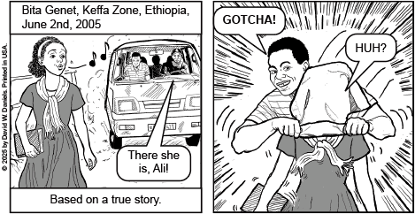
Page 2

Page 3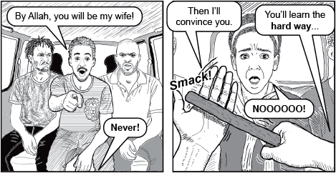
Page 4
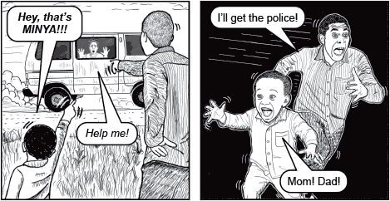
Page 5
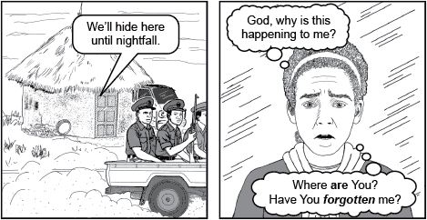
Page 6
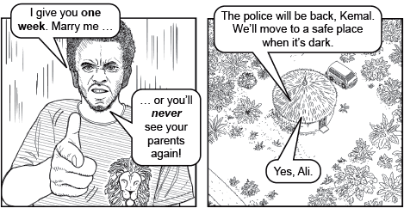
Page 7
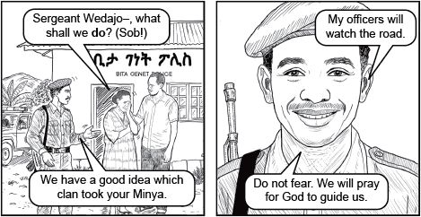
Page 8
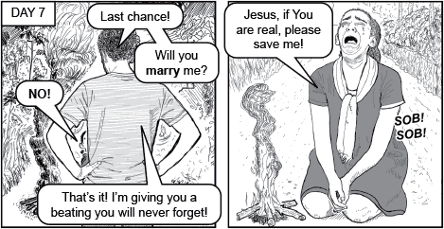
Page 9
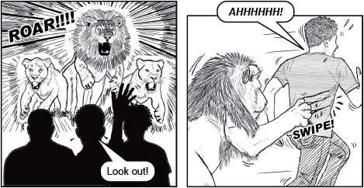
Page 10
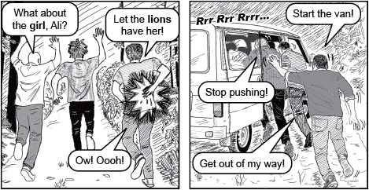
Page 11
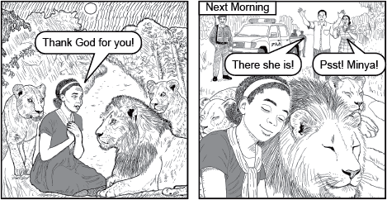
Page 12
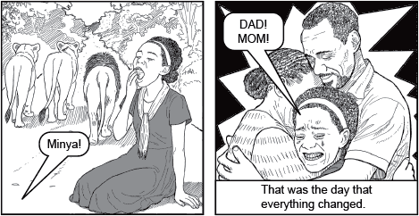
Page 13
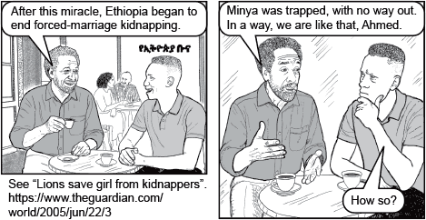
Page 14
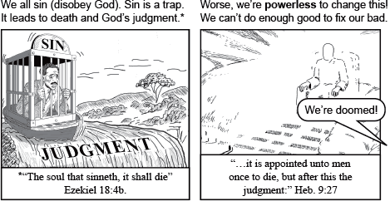
Page 15
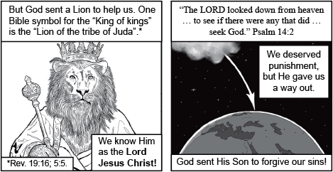
Page 16
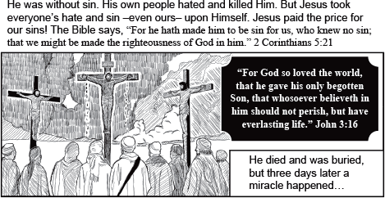
Page 17
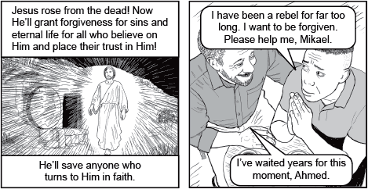
Page 18
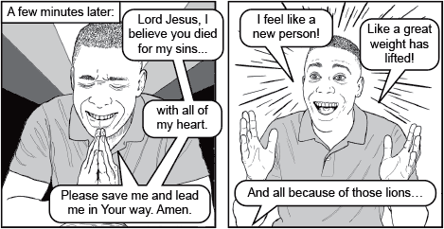
Page 19
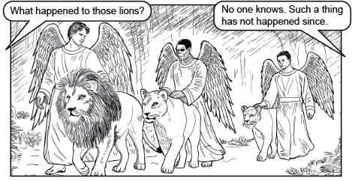
Page 20
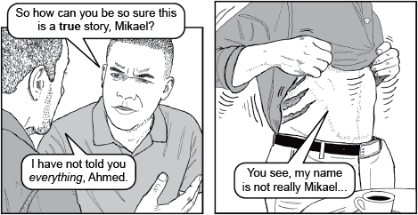
Page 21
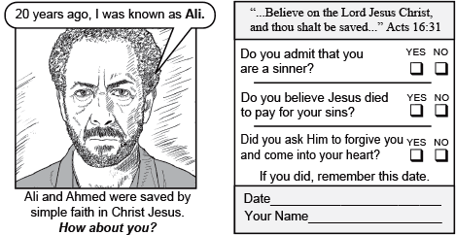
Page 22
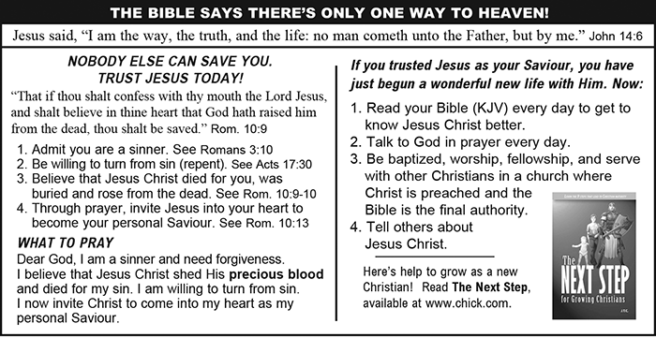
Page 23

FULLSTATURE COLLEGE OF THE BIBLE AND MISSIONS
WISDOM TO PREPARE for the Work with Eternal Benefits for all.
We must think deeply about making Jesus known. He has given us the Holy Spirit, the Bible and many preachers but we need to be trained in our minds on how to be effective for the Lord.
Experience has shown that if we just count on our love and passion to make inroads in the mission field or as pastors or in ministry, we’d likely become burnt out and quit very soon. Instead, God gave us the wisdom to prepare. The interest you expressed at the AWMC24, must remain burning and you have opportunity to be trained.
If you just show up in ministry, hearts full of love for God and eager to make big changes for His Kingdom, you will likely be back home early, burnt out and disappointed.
Instead, God gives us the wisdom to slow down and discover how we could effectively work on His behalf, using the talents, skills, and education He blessed us with.
God cut us out for this work, but we are presently rough and unpolished. Fullstature College of the Bible and Missions (FCBM) will help take out the raw edges, sand out the splinters and prepared you for God to add the varnish, readying us to begin your work. Don’t get us wrong we have always been a little unfinished, but God has helped us to help others since 1994. In this work, we will always need to be learning, growing, and adapting.

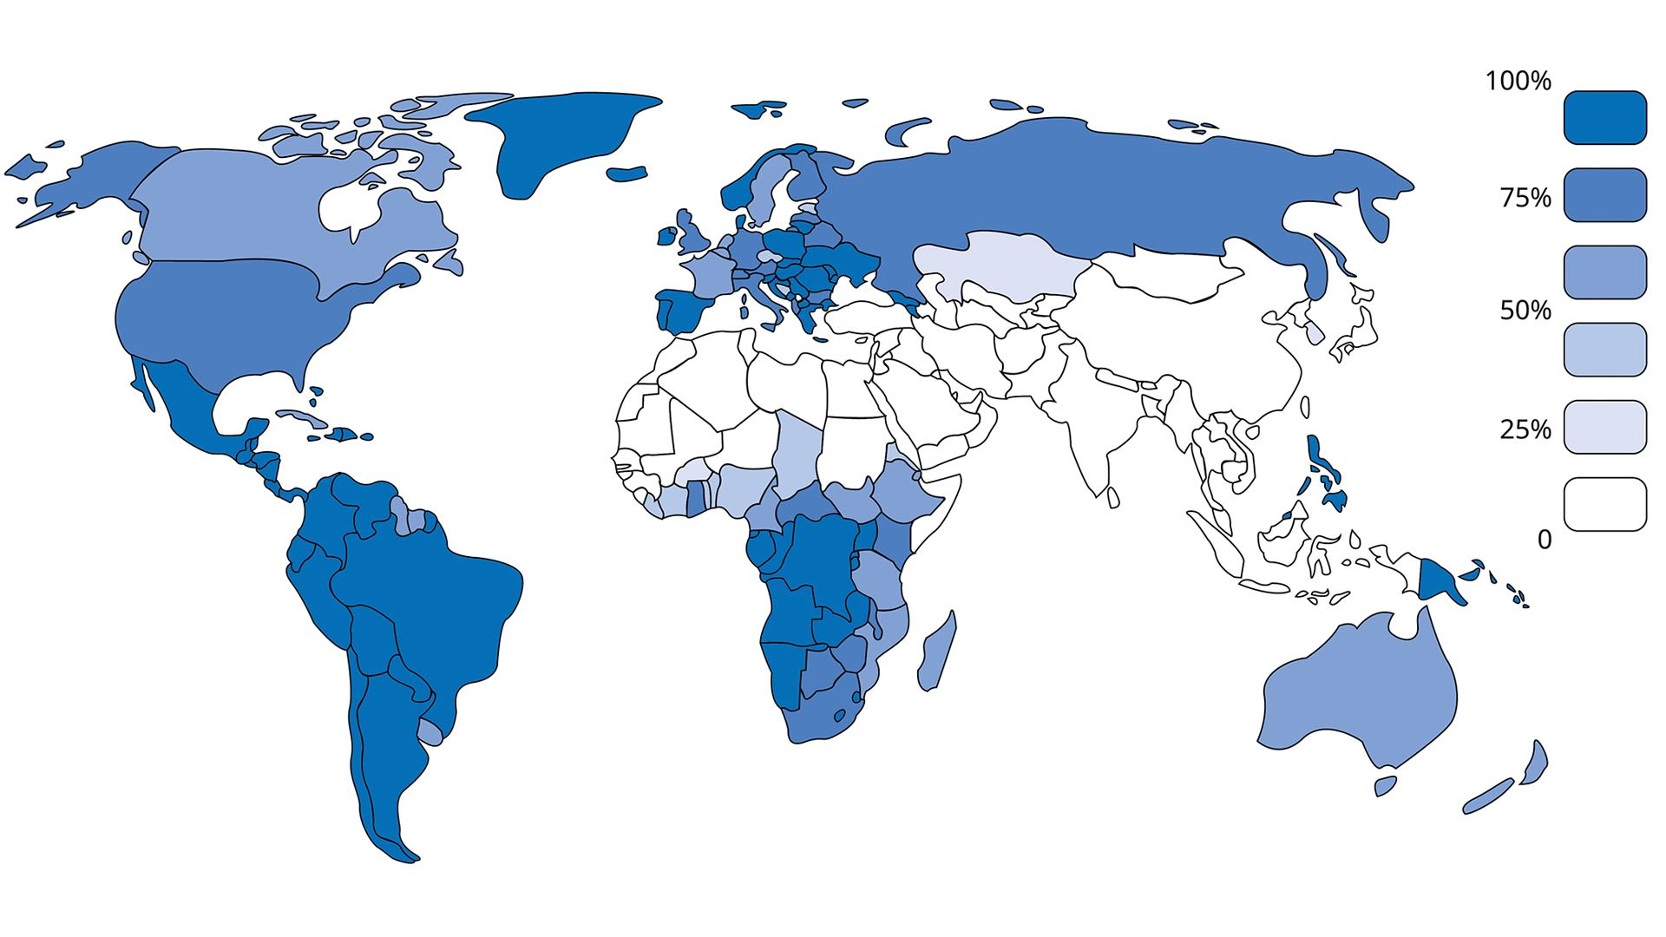
Source: World Christian Database, Accessed May 2023; *Graph reports Christian affiliation, or membership, not belief, practice, or theological beliefs.
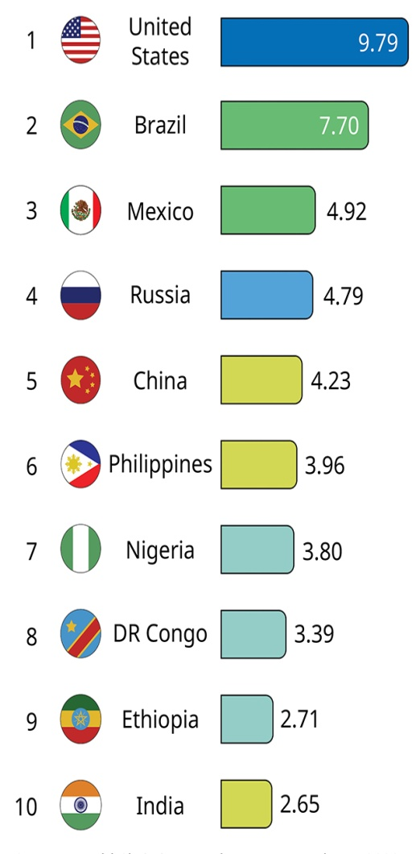

% of Global Christianity
Ranking of Countries

Growth and Decline
Over the past century, Christianity witnessed its most marked growth in Sub-Saharan Africa and its most marked decline in the Middle East, North Africa, and Western Europe.

Lowest % Christian

Countries with Lowest % Christian
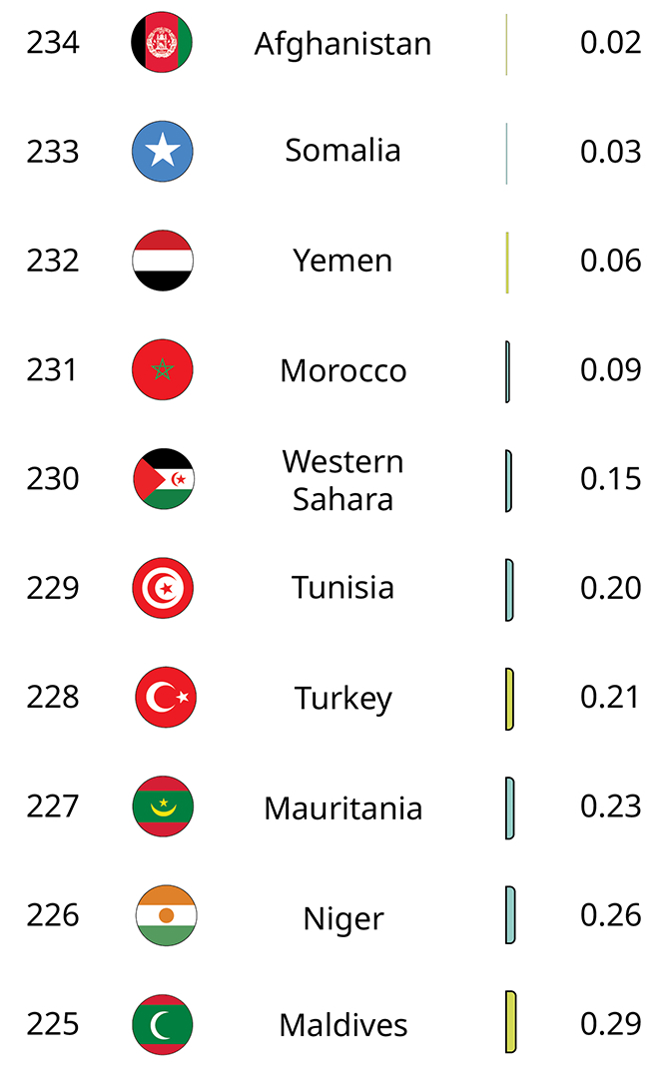
Source: World Christian Database, Accessed May 2023
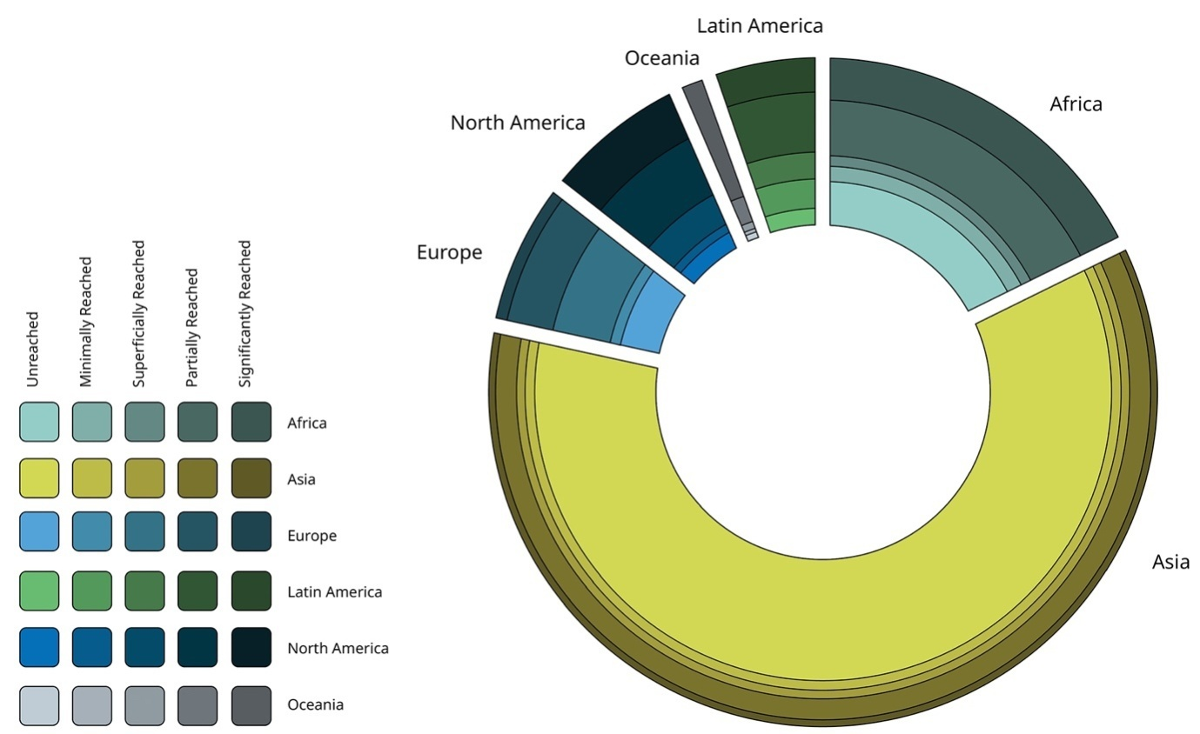

Unreached People by Region- Source: The Joshua Project, 2023

Definition
Unreached people groups are those who lack an indigenous church capable of evangelizing their own people. People groups are distinct social groups where shared language and cultural practices create communal belonging.

Missionary Challenge
The countries that have received the greatest amount of Western missionary attention over two centuries contain the greatest number of unreached and unreached people groups: China and India (which once included Pakistan and Bangladesh).
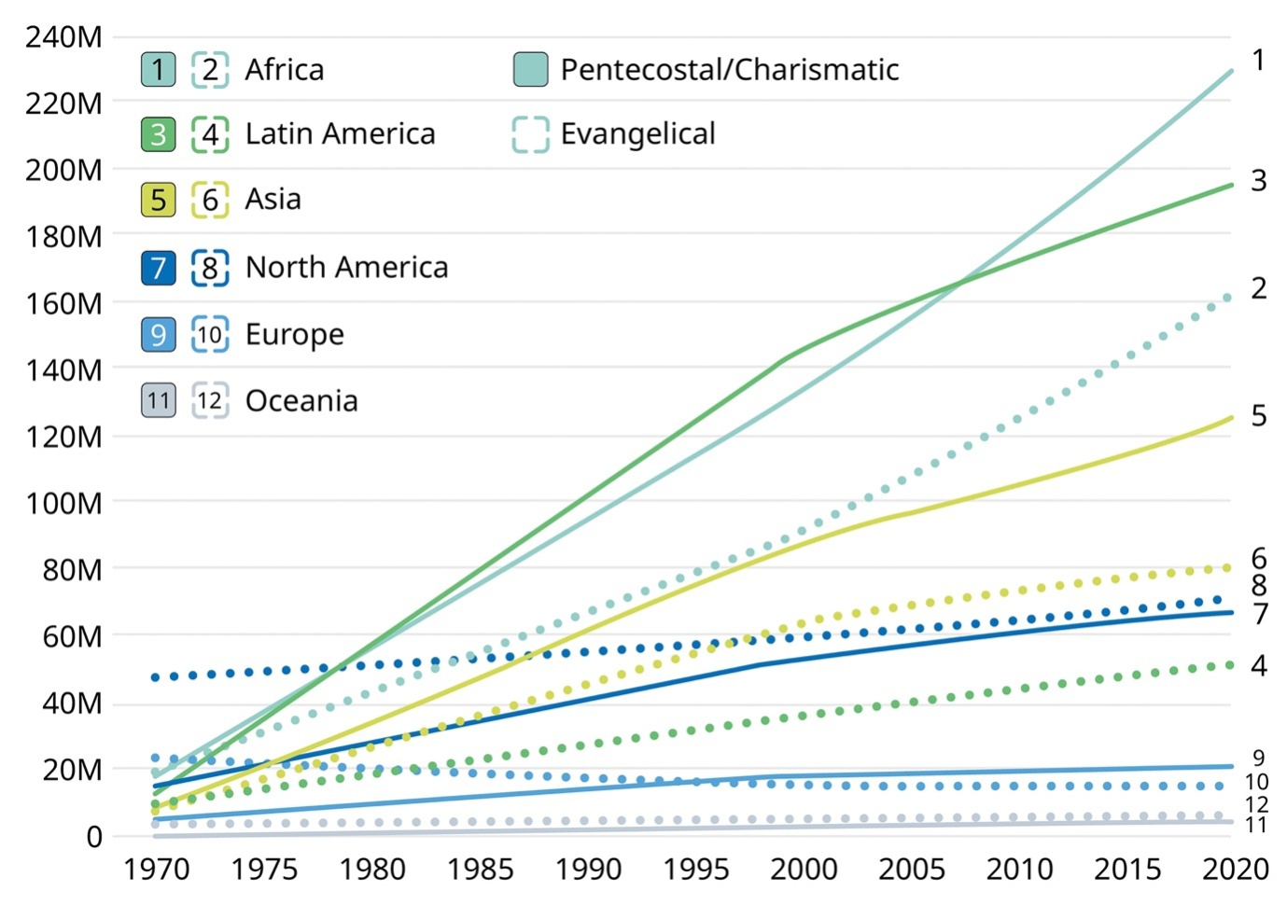

Rise of Evangelicals and Pentecostals- Source: World Christian Encyclopaedia pgs. 25-26, 2020; M = Millions

Global Evangelicals- Source: World Christian Encyclopaedia, pg. 25, 2020

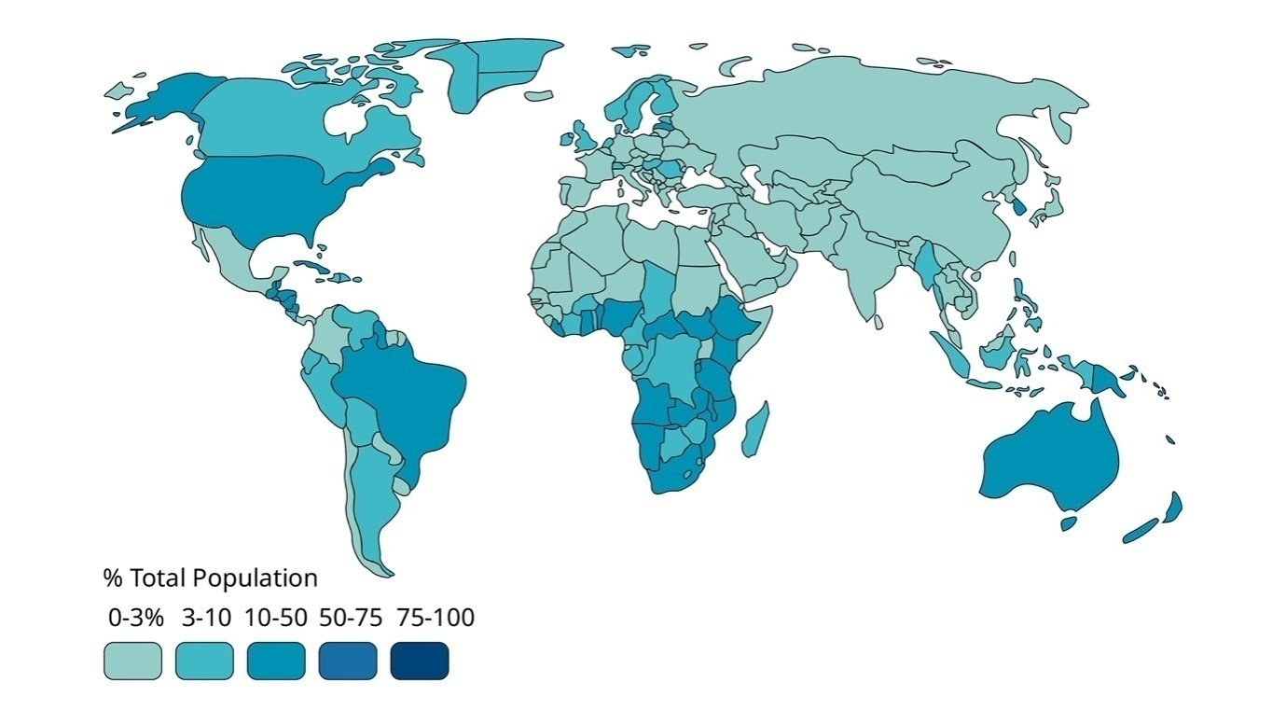Global Pentecostals/ Charismatics-Source: World Christian Encyclopaedia, pg. 25, 2020

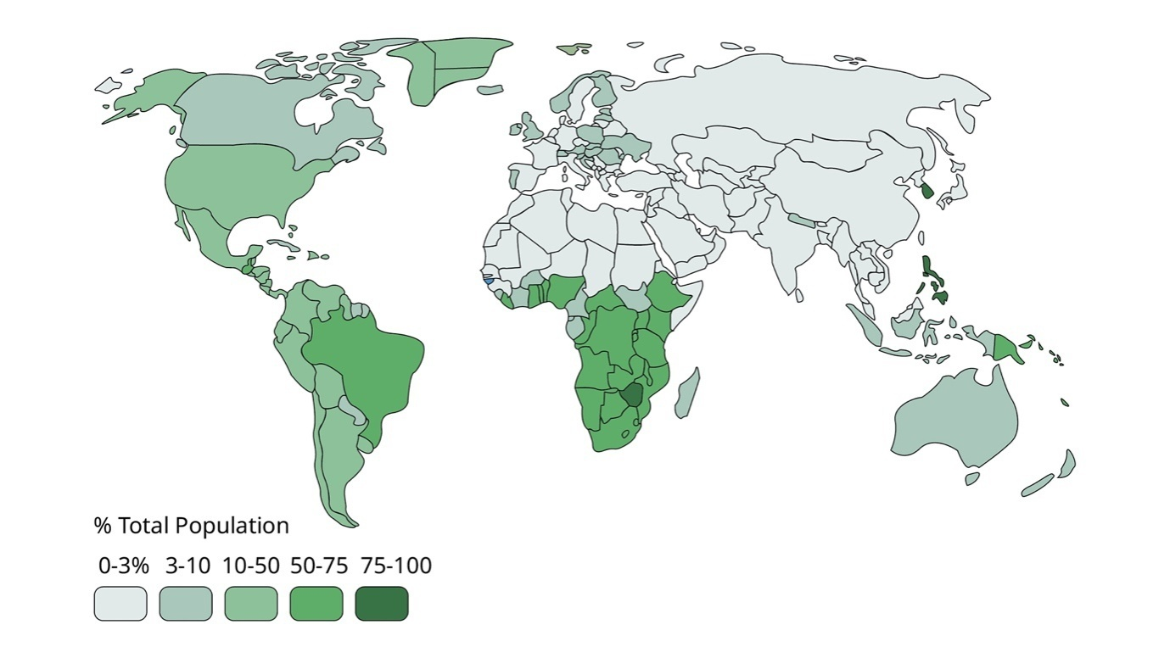

STRATEGIC LEVEL PRAYER JOURNAL-AUGUST 2018

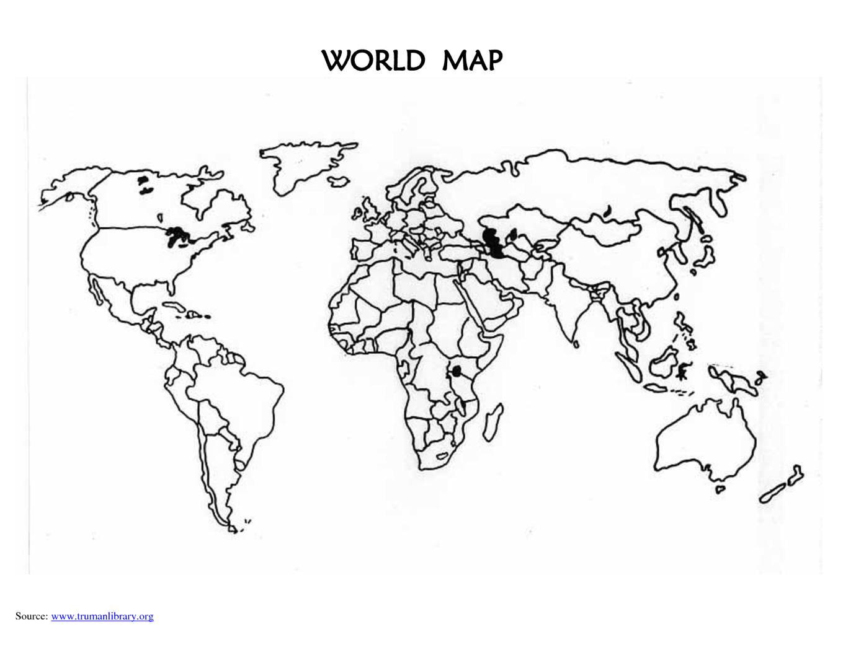

FMI Celebrates

25 years of Missionary Ministry-1993-2018

Reaching out to 40 tribes and peoples

Benin-Burundi- Ghana- Guinea Bissau- Nigeria- Tanzania- Togo|

United Kingdom| USA

Congo Dem. Republic| Malaysia| South Africa| Turkey| UAE| Zimbabwe

