

CONTENTS

How to access a particular item of interest

Content and Acknowledgements | 2
A Guide to understanding of the Strategic Level Prayer Journal | 3-4
THE YEAR OF THE CROWN AND THE SWORD  5787/2027: Authority, Warfare, Recovery and Kingdom Advance | 4-14
Adopt a People Strategy | 14-17
Opportunity to Support this Journal | 18
Is this the month of your Birth? | 18-19
October Daily Devotion | 19-41
Evangelism Comic Content – Jack Chick | 41-49
Fullstature College Of The Bible And Missions & Reaching the Nations | 49-53
World Map | 54
The Generosity Test | 55

ACKNOWLEDGEMENTS

- Late Rev. Mrs C.O. Lawon
- I.D. LAWON
- https.//www.fullstature.net/adopt-a-missionar
- https://www.moongiant.com/moonphases/march/2026/
- https://www.chick.com/products/tract?stk=295&_gl=1*hdxing*_up*MQ..*_ga*MjAzMDQ1OTgyMi4xNzc0MTM0ODEy*_ga_4S12FGH845*czE3NzQxMzQ4MTAkbzEkZzEkdDE3NzQxMzQ4NjIkajgkbDAkaDA.

May the Lord grant you understanding of this prayer journal as you pray, consequent upon which there will be changes in your life or your prayer group or Family, Church, Nation, and Continent. What is presented are not Jewish Dates or the Jewish calendar but what the LORD instituted which we all see manifested in the movement of the Moon every month. The enemy has always manipulated these bodies for which believers are just becoming aware. This season is also a special edition of revelation which brings a new breath of fresh air without adding to the word of God but confirms it and makes our faith stronger.
You may wish to pray in two ways:-
- You can pray using the whole journal to pray into the womb of time according to the authority level granted to you by your appointment in the Lord. Expect the prophetic germination [as you saturate the ground and the womb of time with God’s ordination] to happen. In any case ensure your seed remains in the ground as investment for the coming year. Determine, and command what this month should deliver to you and what it should not and must Not.
- You can also use this daily for your prayers AND DEVOTION to prevail at the gate of each day, especially on critical days of intense warfare in the heavens. Remember that the day starts from 6pm for the next 24 hours. If you are in Britain for instance the time will be early hours of the next day in Hong Kong @ your 6pm.
- This document may seem lengthy, but it shows the effort that was generated in prayer. You can keep it and save it for use in a good way.
Pray that your prophetic faculties will be on the rise and be enlarged and sharp…visions; dreams; interpreting symbols; applying parables; riddles; revelation and predictions; accurate delivery of words of wisdom and words of knowledge; intercessions; interaction with heaven etc.. Divine decrees to cause the future and many other such faculties
SHAPE YOUR DAY, MONTH AND CONSEQUENTLY YOUR YEARS
Ignorance of what every month holds for you, your family, community, nation, the church and the continent at large has caused many to perish, miss out or not fully access what God has in store for them.
Understanding the heavens and what they signify every month is another very key aspect as we enter this new level of our assignments among the nations. While the kingdom of darkness has used astrology, prognostications, and all manner of demonic methods to control the activities on earth using the heavens, the church continues in ignorance. They have even employed materialism to blind believers in Jesus Christ, whereas all things are yours
We thank God for the many people whom He is raising in different parts of the world to understand what the heavens hold for us every month. As you seek deeper understanding, the Holy Spirit will guide you into greater revelations. Amen

THE YEAR OF THE CROWN AND THE SWORD

5787/2027: Authority, Warfare, Recovery and Kingdom Advance
There are seasons when God awakens His people to truths that have always been in Scripture but have not been sufficiently active in their consciousness. The transition into the Hebrew year 5787 is interpreted as a new season.
Two images are indicated:-THE CROWN AND THE SWORD.
The Hebrew letter zayin, associated with the number seven, with being equipped for conflict. “CROWNED and ANOINTED” for the conflict ahead. The crown is joined with the sword, commissioning, movement, recovery, prepared ground and harvest.
The Bible is filled with crowns, swords, battles, authority, inheritance, recovery, fruitfulness and harvest.
Therefore, the question is not merely:
“What is the prophetic implication of the year 5787?”
The deeper question is:

What is the present truth for the Church that the Lord is seeking to underline at this time?
And what must we actually do about it?

1. THE CROWN: KNOW WHO YOU ARE BEFORE YOU ENTER THE BATTLE
A crown represents authority, government, responsibility and delegated rule.
Revelation 5:10 declares:
“And hast made us unto our God kings and priests: and we shall reign on the earth.”
Peter similarly describes God’s people as:
“a royal priesthood.”
— 1 Peter 2:9
Notice the combination.
We are not merely kings.
We are kings and priests.
The crown without priesthood produces arrogance.
Priesthood without authority can produce passivity.
But biblical maturity joins the two.

The priest stands before God.
. The priest worships.
The priest hears.
The king exercises delegated authority
The king governs what has been entrusted to him.

This is why one of the most important revelations for this season is not simply:
“I have authority.”
It is:

“I am under authority, therefore I can exercise authority.”
Jesus demonstrated this perfectly.
He said:
“I can of mine own self do nothing.”
— John 5:30
Yet the same Jesus commanded storms, rebuked demons, healed diseases, multiplied food and raised the dead.
Submission to the Father gave Him authority.
Submission was the foundation of His authority. For strategic-level intercessors, this is critical.
The Crown means:

Know your jurisdiction.

2. THE SWORD: GET THE WORD BACK INTO YOUR MOUTH
Paul leaves no ambiguity about the believer’s primary offensive weapon:
“And take…the sword of the Spirit, which is the word of God.”
— Ephesians 6:17
The Sword is not anger. The Sword is not volume.
The Sword is not personality. The Sword is the Word of God activated by the Spirit of God.
This makes the 5787 imagery of Pey—mouth—and Zayin—sword—particularly striking as a prophetic picture.
…and out of his mouth went a sharp two-edged sword: and his countenance was as the sun shineth in his strength. Rev 1:16‬‬‬‬‬‬‬‬‬‬‬‬‬‬‬‬‬‬‬‬‬‬‬‬‬‬‬‬‬‬‬‬‬‬‬‬‬‬‬‬‬‬‬‬‬‬‬‬‬‬‬‬‬‬‬‬‬‬‬‬‬‬‬‬‬‬
And out of his mouth goeth a sharp sword, that with it he should smite the nations Rev. 19:6. And the remnant were slain with the sword of him that sat upon the horse, which sword proceeded out of his mouth: “The sword is your mouth! “He connected the mouth with praise and prayer against walls that had contained and restricted God’s people.‬‬‬‬‬‬‬‬‬‬‬‬‬‬‬‬‬‬‬‬‬‬‬‬‬‬‬‬‬‬‬‬‬‬‬‬‬‬‬‬‬‬‬‬‬‬‬‬‬‬‬‬‬‬‬‬‬‬‬‬‬‬‬‬‬‬‬‬‬‬‬‬‬‬‬‬‬‬‬‬‬‬‬‬‬‬‬‬‬‬‬‬‬‬‬‬
That imagery immediately recalls Jesus’ the book of Revelation and God’s fierceness and anger against every spirit of the antichrist.
Jesus was battle ready in the wilderness and when the enemy attacked him, three times Jesus answered:

“It is written.”
Jesus did not defeat temptation through emotional intensity.
He wielded revealed truth.
The lesson for strategic prayer is enormous.

**A Bible on your shelf is a stored sword.
A Word believed in your heart and released in obedience is a wielded sword. **
Jesus said: “If ye abide in me, and my words abide in you…” — John 15:7. The Word must abide before it can be wielded properly.
Therefore:
Hear the Word. Understand the Word. Believe the Word. Obey the Word. Then speak the Word.

3. DON’T JUST SHOUT—HEAR GOD’S STRATEGY
One of the powerful prophetic pictures emerging from 5787 has been Jericho.
Israel marched around Jericho for six days. On the seventh day they marched seven times. The priests sounded the trumpets. The people shouted.
And the wall fell.
Joshua 6:20 records:
“The people shouted with a great shout, that the wall fell down flat.”
This is certainly a biblical precedent for the relationship between sound, obedience, warfare and breakthrough.
But we must notice something. Israel did not invent the strategy.

God gave the strategy.
Joshua did not gather the elders and say “Walls respond to noise. Everybody shout.” The shouting worked within specific divine instruction.
This gives us a major principle for 5787:

DON’T JUST SHOUT LOUDER. HEAR GOD MORE CLEARLY.
Some walls require prayer. Some require repentance. Some require confrontation. Some require perseverance. Some require legal action. Some require reconciliation. Some require changing strategy. Some require walking away.
And some require standing still and watching God work. The mature warrior does not merely know how to use a sword.

He knows when God has told him to draw it.

4. HUMAN BEINGS CAN BECOME REAL OBSTACLES
This point must be addressed because we can fail in spiritual warfare.
Paul says:
“For we wrestle not against flesh and blood…”
— Ephesians 6:12
That does not mean flesh and blood can never obstruct God’s purposes.
Pharaoh obstructed Moses. Haman plotted against the Jews. Sanballat and Tobiah deliberately opposed Nehemiah. Herod imprisoned Peter and killed James. Elymas attempted to prevent Sergius Paulus from believing the gospel.
Paul himself wrote:
“For a great door and effectual is opened unto me, and there are many adversaries.”
— 1 Corinthians 16:9
Notice this carefully:

OPEN DOOR AND ADVERSARIES EXISTED AT THE SAME TIME.
The presence of an adversary did not prove the absence of God’s open door.
Nehemiah prayed.
But Nehemiah also posted guards. He trusted God.
But he also refused Sanballat’s invitations. He discerned spiritual opposition. But he also established practical boundaries.
Paul prayed. But Paul also used his Roman citizenship. He appealed to lawful authority.
Jesus loved Peter. But when Peter voiced something contrary to His assignment, Jesus confronted the thought immediately:
“Get thee behind me, Satan.”
— Matthew 16:23 Our response must therefore operate at several levels.
Pray against spiritual resistance. Confront deception with truth. Establish boundaries against manipulation. Use legitimate authority against injustice. Forgive people without surrendering your assignment to them. Refuse personal vengeance. Continue moving through the door God opened.
Faith refuses to allow every accusation, rumor, threat, disappointment or hostile word to penetrate the inner man.
Psalm 3:3 says: “But thou, O LORD, art a shield for me; my glory, and the lifter up of mine head.”
The shield protects something precious:
your ability to keep your head up.
Strategic warfare therefore includes refusing intimidation. You cannot advance while continually looking backward to see who dislikes you.

5. RECOVERY IS PART OF THE MESSAGE
“Proclaim liberty throughout all the land unto all the inhabitants thereof.”
— Leviticus 25:10
Inheritance was restored.
Liberty was proclaimed.
Debts and economic relationships were reset according to God’s covenant order.
This gives us another powerful prayer direction:

RECOVER WHAT CORRUPTION HAS PREVENTED FROM FULFILLING ITS PURPOSE.
Joel 2:25 declares:
“I will restore to you the years that the locust hath eaten.”
Recovery may involve finances.
But it is much larger than money.
Recover:
vision. calling. relationships. credibility. institutional strength. missional territory. Lost opportunities. generational inheritance. spiritual disciplines. the Church’s prophetic voice.
God does not restore yesterday merely so we can recreate yesterday.

RESTORATION MUST BECOME ADVANCEMENT.

6. THE GATE AND THE TERRITORY: KNOW YOUR ASSIGNED GROUND
GOD IS SPEAKING about gates, prepared ground, nations and enlargement.
Scripture certainly contains this imagery.
God promised Abraham:
“thy seed shall possess the gate of his enemies.”
— Genesis 22:17
Jesus declared:
“the gates of hell shall not prevail against it.”
— Matthew 16:18
Paul understood that God assigned spheres of responsibility: “according to the measure of the rule which God hath distributed to us.”
— 2 Corinthians 10:13
Strategic intercessors must therefore ask:

WHAT GROUND HAS GOD ACTUALLY ASSIGNED US?
Your territory may be:
a family,
a congregation,
a profession,
a university,
a city,
a mission field,
a business,
a government responsibility,
a people group,
a media platform,
or a generation you are called to disciple.
Find the assignment.
Then occupy it faithfully.

7. PROVISION: GOD KNOWS WHAT THE ASSIGNMENT REQUIRES
“God is able to make all grace abound toward you; that ye…may abound to every good work.”
— 2 Corinthians 9:8. Notice the purpose of abundance:

EVERY GOOD WORK.
God’s abundance is not merely accumulation.
It is supply for assignment.
Jesus repeatedly demonstrated this.
When taxes were required, He knew where provision would be found (Matthew 17:27).
When thousands needed feeding, He knew what to do with five loaves and two fishes.
When Peter’s nets were empty, Jesus knew where the fish were. The revelation is not:
“Christians should chase money.”
It is:

GOD’S ASSIGNMENTS ARE NOT LIMITED TO THE RESOURCES YOU CAN CURRENTLY SEE.
Ask:
What has God already placed nearby? What resource have we overlooked? What contacts needs activation? What knowledge do we need? What instruction has God already given?
Provision often follows divine instruction plus obedient action for a given assignment.

8. THE HARVEST IS PLENTIOUS
Jesus said:
“The harvest truly is plenteous, but the labourers are few.”
— Matthew 9:37
And:
“Herein is my Father glorified, that ye bear much fruit.”
— John 15:8
Why recover territory? SO IT CAN PRODUCE.
Why break the wall?
So you can enter the assignment.
Why enter the assignment?
So God’s purpose can become fruitful.
Why wield the Sword?
Because resistance must not be allowed to cancel harvest.
If we spend the entire year fighting but produce no disciples, establish no churches, heal no families, strengthen no institutions, develop no leaders, help no poor, influence no communities and extend no Kingdom witness, something has gone wrong.

The objective of warfare is not warfare.
The objective is the unhindered fulfillment of God’s purpose.

9. WEAR THE CROWN. TAKE THE SWORD. ENTER THE ASSIGNMENT.
What, then, should strategic intercessors do in 5787/2027? Begin with consecration.
Do not rush into warfare. Stand before God. Ask Him to expose fear, pride, bitterness, distraction and false agreements.
Then recover your identity. You belong to Christ.
Receive again the authority He has delegated.
Sharpen the Sword. Return to Scripture.
Put God’s Word back into your prayer language.
Strengthen the shield. Stop allowing every arrow to determine your emotional condition.
Discern your gate.
Do not waste energy fighting battles outside your assignment.
Recognize human obstacles without hating human beings. Use prayer, wisdom, boundaries, lawful authority, reconciliation and courageous action appropriately.
Ask for recovery.
But do not stop at recovery.
Ask for fruitfulness.
And above everything:

KEEP THE HARVEST BEFORE YOU.
The Crown says:
KNOW YOUR AUTHORITY.
The Sword says:
GET YOUR EDGE BACK.
The Shield says:
DON’T LET THE ARROWS STOP YOU.
The Gate says:
DISCERN YOUR ACCESS POINT.
The Territory says:
KNOW YOUR ASSIGNMENT and RECOVER WHAT WAS LOST.
Provision says:
EXPECT GOD TO SUPPLY FOR HIS PURPOSE.
The Harvest says:

MAKE THE RECOVERED GROUND PRODUCE.

10. A STRATEGIC PRAYER ACTIVATION FOR 5787/2027
Father, in the name of Jesus Christ, bring us into complete alignment with Your purpose for this season.
Crown us with the consciousness of delegated authority, but keep us humble under the lordship of Jesus Christ.
Sharpen the Sword of Your Word in our hearts and mouths. Deliver us from empty words, fearful words, careless words and words that agree with the enemy’s interpretation of our circumstances.
Teach our hands to war and our fingers to fight, but also teach us which battles belong to us and which battles we must leave in Your hands.
Strengthen the shield of faith around our families, churches, ministries, institutions, businesses, nations and assignments. Let the fiery arrows of intimidation, accusation and discouragement lose their power.
Where human beings have constituted themselves as obstacles to righteous purposes, give us wisdom. Show us when to pray, when to speak, when to confront, when to establish boundaries, when to appeal to legitimate authority, when to forgive, and when simply to keep moving. Keep hatred and vengeance out of our hearts.
Restore what corruption has consumed. Restore years, opportunities, relationships, resources, institutions, credibility and inheritance that still belong to Your purpose.
Show us the gates You have appointed. Keep us from wasting strength at gates You never assigned us.
Open our eyes to provision already prepared. Show us the fish with the coin, the nets that must be cast again, the loaves already in our hands, and the contacts and resources You have positioned around the assignment.
Make recovered territory fruitful.
Let our families become fruitful. Let our churches become fruitful. Let our mission fields become fruitful. Let our businesses become fruitful. Let our institutions become fruitful. Let the nations become fields of harvest.
And when resistance appears, remind us:

AN ADVERSARY AT THE DOOR DOES NOT NECESSARILY MEAN GOD DID NOT OPEN THE DOOR.
We will not retreat merely because there are adversaries.
We will hear God.
We will obey God.
We will worship.
We will stand.
We will speak His Word.
We will advance through the gates He opens.
And we will turn recovered ground into harvest.

THIS IS THE CALL OF THE CROWN AND THE SWORD.
Know your authority. Get your edge back. Speak the Word. Choose your battles. Guard your heart. Recover lost ground. Trust God’s provision. Fight from rest. Enter your assignment. Release fruitfulness. Extend the blessing. Bring in the harvest.
Amen.
I D. Lawon,
September 29th, 2026.

Adopt-A-Missionary- A Missions’ Strategy
https://fullstature.net/25-get-involved/25-adopt-a-missionary/
...a strategy for loving the missionary family as well as the people groups, they serve
Adopt-A-Missionary is a mission strategy that has gained momentum in missions over the years. What makes this strategy different is its focus. Historically, churches have focused on countries, and mission agencies have focused their attention on people groups. Adopt-A- Missionary focuses on missionary families, or what we can call message bearers.
For 5 years, my wife (of blessed memory) and I served as missionary representatives to the Kenyan peoples of East Africa. We divided the nation of Kenya into 6. Working with the missionary on ground we had a plan to evangelise the nation. We raised teams of two by two from Nigeria and travelled from Nigeria to the different regions of Kenya. We planted 6 churches throughout the country. In the last 29 years + the FMI missionary teams have been helped by God to open the gospel among 40 unreached people groups. Our FMC churches faithfully prayed and the missionaries that we served with, and the church has supported them financially.
In 1990 for example, we were relocated to Kano, Nigeria, Northwest, with two major tribes- the Kanawas and Magusawas. We were led of the Lord to pay more attention to tribal missions in 1993, where the gospel has never been heard while maintaining a church base. Thankfully, our churches have continued to pray for and support the mission’s effort with this strategic ministry.
ADOPT-A-Missionary Defined
What then does it mean to Adopt-A-missionary? It means committing yourself as an individual, fellowship group, local congregation, denomination, or mission agency to pray for and commit resources to win souls, establish believers, administrate the work within a specific people group through a missionary family or families. This commitment is continued until the believers in that people group can reach the rest of their people without outside (cross-cultural) assistance.
We are agents of God praying, giving, and serving to see an adopted family reach out to bring sinners into God’s family. This is the true meaning of Adopting a missionary family. One day this will be accomplished, and every tribe, tongue, people, and nation will give glory to God around His throne (Rev. 5:9).
Adopt a Missionary Family
Fullstature Missions International is committed to the work of missions and has developed a ministry to bring into focus the Great Commission (Matt 28:19-20) set forth by Christ and to support missionary families need. We ask that your family prayerfully consider adopting a missionary family to be a blessing and to be blessed. After you have made an adoption, we encourage you can send your missionary family an email to share about your family and to ask them to share with you. The FMI becomes a bridge to help people you may never know or meet. You can reach out to the missionary during Holidays, birthdays, or anniversaries or just at any time. Commit to lift your missionary up in prayer. (Phil 6)
It is also our desire to support more missionaries through our ministry budget than we currently can do. The missionaries we support currently are under-supported. In other words, the support we grant is not adequate. In most cases, we are nearly able (with Naira) to provide what will keep body and soul together leaving projects in the field undone. This is where you pause and do something.
It is our goal to ensure that every Missionary, supported through, (what we call) the General Fund which includes the “Faith Promise Offering” (FPO), are missionaries we, as a ministry want to support.
The money these Missionaries receive is totally dependent on what is given by the individual or families who have adopted them.
Example: Missionary “Felix” may have two families in First Baptist Church which chose to adopt him. They do so for a combined support of $200 per month, one for $75 per month and one for $125 per month. Should the family who chose to support Missionary “Felix” for $125 per month be unable to do so for any reason, Missionary “Felix” would only receive $75 for that month. There will be a “shortfall” and the family who was unable to give what they had purposed to give would not be contacted and asked, “Where is your contribution”.
If you have a desire to support a Missionary, please feel free to fill out a “Adopt-A-Missionary Request Form” and return it to our ministry office.
Build a Relationship
Develop a relationship with your adopted missionary family. Learn about their ministry and their ups and downs so that you know when to Praise God with them and when to lift them up in prayer. Being a missionary can have very hard times and there is great comfort when a missionary knows that God is always there and that there are people supporting them at every step.
Faith Promise
In addition to your commitment to get to know and pray for your adopted missionary, you may consider supporting your missionary financially. Among some of the greatest difficulties that missionaries face is having their financial needs met. Missionaries typically spend a significant amount of time raising monies to support their ministries which in turn reduces the amount of time out in the field.
Would you prayerfully consider financially committing to a missionary? If you agree please fill out the form below and send separately.

Thank you.

Missionary Adoption Promise Form
Fullstature Missions International Conference Centre for the Nations, 4 Parliament Highway, Secretariat Donor Information (please print or type)
Click this link to complete online- https.//www.fullstature.net/adopt-a-missionary
Name______________________________________________________________________
Billing
address____________________________________________________________________ _____________________________________________________________
City, _____________ _________________ Zip Code _____________________
Phone __________________________ ____________________________
WhatsApp _______________________________ Email __________________________
Type Donor ☐ individual ☐church group ☐church ☐other:
____________________________________
Promise Information: I want to ☐donate to General Fund ☐ Adopt a Missionary I (we) promise by faith a total of $____________________ to be paid: ☐one time ☐monthly ☐quarterly ☐yearly for a length of: ☐three years ☐four years ☐five years.
This gift will start ____________________ (date) and end ____________________ (date), with an option to continue. I (we) plan to make this contribution in the form of: ☐cash ☐check ☐credit card ☐other.
If you have already been given a missionary name list here:
____________________________________________________ Please contact me by ☐phone ☐email if my missionary leaves the field
I am also interested in: ☐ Praying for MAP ☐ Receiving more information ☐ Going on a Mission Trip
Contact Information:
☐Giving toward MAP
☐ Representative visiting my church
☐ Becoming a MAP Missionary Mobilizer
Please send all MAP information to (list name and
email):________________________________________________________________________ ______________________________________________________________________________ _____________________________________________________________________
Please communicate all MAP financial information with (list name and email):
Name (Print) ______________________________________________
Position: _______________________________________________
Signature(s) __________________________Date _______________________
Online Giving
Donation Instructions
You can give a general gift or toward your specific missionary for a tax-deductible contribution. If you have filled out this faith promise form, you will receive a missionary’s name and account to give toward, and/or you can give a general gift to be used by MAP
https.//www.fullstature.net/adopt-a-missionary.
$$$$$$$$$$$$$$$$$$$$$$$$$$$$$$$$$$$$$$$$$$$$$$$$$$$$$$$$$$$$$$$$$$$$$$$$$$$

YOU HAVE AN OPPORTUNITY TO SUPPORT THIS JOURNAL
The Strategic Level Prayer Journal is a daily devotional with God’s timing (Kairos) attached. It is published monthly by faith and support of the brethren.
Please support the continued publication of this journal.
Send your donations to: -
Bank: - Zenith Bank Plc.
Account Name: - Fullstature Missions International
Account Number: - 1011822382
Please send SMS or WhatsApp to +234-802 333 9638 or email: fmi@fullstature.net to notify us of your donation. The Lord blesses us. Amen.

IS THIS THE MONTH OF YOUR BIRTH?
USE REVELATION KNOWLEDGE WELL (AND AGAIN)!!
Even if this is not your month of birth, pray into the day of your birth on a weekly basis (that is the weekday in which you were born). Take time at regular basis to be praying for yourself and prophesying over your own life. Speak into the foundations of your life and prophesy good things.
Thank Him for your specific day of birth. Declare that day blessed.

- Thank Him that He ordained that you will be made manifest on earth on a specific day in that month at a specific hour and minute.
- Thank Him that He has a purpose for your life, and it will be fulfilled.
- Ask Jehovah to forgive you where you have for one reason or another, ignored or rejected to recognize your day of birth.
- Thank Jehovah for the day of your conception. (Psa 139:13)
- Thank Jehovah that when He thought of you, he already thought of your entire life. Thank Him that He did not leave anything to chance. (Isa 49:1)
- Thank Him that he knew exactly what your redemptive purpose was going to be. (Psa. 139:16)
- Pray that He will reveal the original you more and more as you enter another year of your life. (Psa 139:13-15)
- Pray that He will restore the heavenly label, and the heavenly name He gave you before you were conceived. (Jer 1:5).
- Speak into the foundations of your life and prophesy good things.
- Prophesy that you will live and not die prematurely in any area of your life. Your family will live, the work of your hand will live and grow from strength to strength. Deut. 33:6, Psa. 27:13, 118:17
- Prophesy and proclaim the blessing of Levi upon your life as a priest unto Jehovah (2 Pet 2:9, Deut 33:8-11)
- Prophesy and proclaim the blessing of Benjamin upon your life Deut. 33:12
- Prophesy the blessing of the wisdom of Issachar in every area of life. Wisdom to establish the work of your hands, your family, as you grow a year older 1 Chron 12:32, Deut.33:18b-19, Pro 24:3-4
- Prophesy the blessing of Dan concerning your role as a leader. Prophesy over your inheritance that Jehovah will indeed ensure you leave an inheritance for your descendants. Deut 33:20-21, Psa 16:5-6.
- Prophesy the blessing of Joseph. Speak to the earth and declare that the earth will bring forth its best for you in this New Year. Prophesy to the heavens to declare the glory of Jehovah over your life every day of this New Year. Deut 33:13-17, Lev 26:4-5, Hos 2:21-22, Psalm 19:1-2, Isa 55:12 • Prophesy that you will grow in your spirit man into a matured son so you can receive your inheritance. Wherever you go in this New Year, creation will experience release from frustration. Rom 8:19-20, Gal 4:1-2
- Praise Jehovah that your birthday marks the entry into another season of Jubilee. Thank Jehovah that immediately you were born, you cried out prophetically blowing your own jubilee cornet, and prophetically rejoiced in yourself. Ask Him to give you joy no matter your circumstance, to rejoice on this day. Amen.

The days and times highlighted in the month of OCTOBER {below} are referred to as High Days on which to intensify intercession for yourself, family members, community, church and Nation. Men draw power from the celestial bodies and desire to invoke such powers against their fellow humans. You can disannul such powers by intensive intercession on these high days wherever you may be in the earth.

Full Moon and New Moon for October 2026.
⟨ |   Last Quarter  October 3  13:25 UTC |   New Moon  October 10  15:50 UTC |   First Quarter  October 18  16:12 UTC |   Full Moon  October 26  04:11 UTC | ⟩

EVANGELISE — REVISED DEVOTIONS, DAYS 1–3

 THURSDAY, 1 OCTOBER 2026

CROWNED TO BEAR WITNESS
Five Scripture References: 1 Peter 2:9; Revelation 5:10; John 5:30; Matthew 28:18–20; Acts 1:8.
Biblical Reflection: The crown in your article speaks of delegated authority and responsibility. Peter calls believers a royal priesthood so that they may proclaim God’s excellencies. We first stand before God in worship, then go among people as witnesses. Our authority does not come from status or force of personality. Jesus, who possessed all authority, lived in submission to the Father. As we begin this month, let our first act of warfare be to recover our identity in Christ and our readiness to share His gospel. People need to hear what He has done, not merely see how strongly we can confront opposition.
Ancient Examples: Peter denied Jesus in fear, but after receiving the Holy Spirit, he proclaimed the risen Christ at Pentecost. His courage served the message entrusted to him.
Strategic Prayer: Father, remove pride, fear and silence. Fill our churches with the Spirit and open our mouths to speak of Jesus to those You place before us.
Proclamations: We belong to Christ. We bear witness under His authority. The gospel will reach our assigned fields.

FRIDAY, 2 OCTOBER 2026

PUT THE WORD BACK IN YOUR MOUTH
Five Scripture References: Ephesians 6:17; Matthew 4:1–11; John 15:7; Romans 10:14–17; Isaiah 55:10–11.
Biblical Reflection: The sword of the Spirit is the Word of God. Jesus answered temptation with “It is written,” showing us the strength of truth received and rightly spoken. Your article gives us an order to follow: hear the Word, understand it, believe it, obey it, then speak it. That order matters in evangelism. We cannot replace the good news of Christ with loud declarations about our own power. People must hear of His life, death and resurrection, and be called to respond to Him. Let Scripture fill our prayers and shape our conversations. A sharpened sword serves the mission when God’s truth reaches another person with clarity and love.
Ancient Examples: Philip heard the Ethiopian traveller reading Isaiah. He began with that Scripture and explained the good news about Jesus, meeting the man at the point of his question.
Strategic Prayer: Lord, give us understanding, timely words and attentive hearts. Lead us to people who are ready to hear.
Proclamations: God’s Word abides in us. We will speak Christ clearly. His Word will accomplish His purpose.
⟨ | Last Quarter  October 3  13:25 UTC | New Moon  October 10  15:50 UTC | First Quarter  October 18  16:12 UTC | Full Moon  October 26  04:11 UTC

SATURDAY, 3 OCTOBER 2026

HEAR THE STRATEGY FOR THE HARVEST
Five Scripture References: Joshua 6:2–5; Joshua 6:20; Luke 5:4–6; Acts 16:6–10; Matthew 9:37–38.
Biblical Reflection: Israel’s shout at Jericho followed an instruction God had already given. The shout was an act of obedience within His strategy. In the same way, Jesus directed Peter to cast his net after a fruitless night, and the catch followed Peter’s response. For evangelism, we must ask the Lord of the harvest where He is sending us, whom He wants us to approach and what faithful action is needed now. A family conversation, a visit, a new language or a journey into another community may become the opening. Prayer prepares us to recognise the instruction; obedience puts us in the field.
Ancient Examples: Paul intended to travel in one direction, but after the Macedonian vision he went where the call led him. Joshua followed God’s unusual directions around Jericho.
Strategic Prayer: Lord, give us ears to hear and courage to act. Send labourers into overlooked communities and guide every step of our witness.
Proclamations: We will hear God, obey His direction and carry the gospel through the doors He opens.

EVANGELISE — DAYS 4–6

SUNDAY, 4 OCTOBER 2026

AN OPEN DOOR MAY HAVE ADVERSARIES
Five Scripture References: 1 Corinthians 16:9; Ephesians 6:12; Acts 13:6–12; Nehemiah 4:7–9; Matthew 5:44.
Biblical Reflection: Paul described a great, effective door alongside many adversaries. Opposition did not cancel the opportunity God had given him. As we evangelise, resistance may come through intimidation, misleading claims, hostile decisions or our own fear. We must discern what is happening without treating people as enemies to be hated. Your article calls us to pray against spiritual resistance, answer deception with truth, establish wise boundaries and continue through the door God opens. The person opposing the gospel today may yet become someone Christ saves. We therefore refuse vengeance while remaining firm in our assignment.
Ancient Examples: Elymas tried to turn a governor away from the faith, but Paul confronted his deception and the governor believed. Nehemiah prayed and posted guards when opponents threatened the work.
Strategic Prayer: Father, protect those sharing the gospel in resistant places. Give us discernment, lawful courage and love for those who oppose us. Keep fear and bitterness from governing our response.
Proclamations: We will walk through God’s open doors. Adversaries will not silence our witness. We will speak truth, guard our hearts and leave room for Your mercy.

MONDAY, 5 OCTOBER 2026

RECOVER THE VOICE OF WITNESS
Five Scripture References: Joel 2:25–27; Luke 15:20–24; John 21:15–17; Acts 4:29–31; Psalm 51:12–13.
Biblical Reflection: Your article calls us to recover more than money: vision, calling, credibility, relationships and the Church’s prophetic voice. Within the frontier of Evangelise, we ask what has weakened our witness. Some have stopped speaking after rejection. Others carry regret over opportunities missed or relationships damaged. God’s restoration can renew courage and obedience, even when lost time cannot simply be relived. Recovery has a purpose: that we may serve again and bring others to Him. We should seek reconciliation where possible, repent where necessary and ask the Spirit to restore our willingness to speak of Christ.
Ancient Examples: Peter denied Jesus, yet the risen Lord restored him and entrusted him with care for His people. David prayed for restored joy and promised to teach transgressors God’s ways. Neither treated restoration as an end in itself.
Strategic Prayer: Lord, heal the wounds that have silenced our witness. Restore strained relationships where reconciliation is possible. Give fresh boldness to believers who have withdrawn from their calling.
Proclamations: Shame will not have the final word. Christ restores His servants. Our renewed voice will proclaim His mercy and call people to Him.

TUESDAY, 6 OCTOBER 2026

DISCERN YOUR GATE; BRING IN THE HARVEST
Five Scripture References: Genesis 22:17–18; Matthew 16:18; 2 Corinthians 10:13–16; Matthew 9:37–38; John 15:8.
Biblical Reflection: Your article asks a vital question: What ground has God actually assigned us? An evangelistic gate may be a household, neighbourhood, profession, campus, media platform or people group. We need not claim every territory to be faithful in the one entrusted to us. Ask where relationships already exist, where people are asking questions and where workers are needed. Then pray, prepare and go. The aim of entering a gate is fruit: people hearing the gospel, becoming disciples and growing within a community of faith. Strategic prayer should move us toward that harvest, with practical steps to welcome and teach those who respond.
Ancient Examples: Paul recognised a measure of responsibility assigned to his ministry and sought to preach beyond the places already reached. Jesus saw the crowds with compassion and told His disciples to ask the Lord of the harvest for labourers.
Strategic Prayer: Lord, identify our appointed fields. Raise and send workers; provide what the work requires. Make our witness fruitful and help us care faithfully for new believers.
Proclamations: We will occupy our assigned ground. We will sow the gospel and gather the harvest God gives.

ESTABLISH — DAYS 7–9

WEDNESDAY, 7 OCTOBER 2026 — DAY 7

ESTABLISH BELIEVERS UNDER CHRIST’S AUTHORITY
Five Scripture References: Colossians 2:6–7; 1 Peter 2:9; John 5:30; Luke 6:46–49; Ephesians 2:19–22.
Biblical Reflection: Evangelism calls people to Christ; establishment teaches them to walk with Him. Your article joins the crown with priesthood: we exercise delegated authority while remaining submitted to God. A new believer needs this foundation early. Authority does not mean acting independently or commanding every difficulty to disappear. It means belonging to Jesus, hearing His words and doing what He says. The house in Jesus’ parable stood because its builder dug deep and laid a foundation. Let our churches give people more than an invitation to attend. Let us help them pray, learn Scripture, obey Christ and belong to His household.
Ancient Examples: Jesus trained His disciples while they travelled with Him. They watched Him minister, heard His teaching and learned that even their authority over demons was cause to rejoice chiefly because their names were written in heaven.
Strategic Prayer: Father, establish every new believer in Christ. Give pastors and disciplers patience to build strong foundations. Expose pride and strengthen humble obedience among us.
Proclamations: We are rooted in Christ. Our authority remains under His lordship. Those gathered through the gospel will grow into steadfast disciples.

THURSDAY, 8 OCTOBER 2026

ESTABLISH THE WORD IN THE HEART
Five Scripture References: John 15:7; Acts 2:42; Psalm 119:11; James 1:22–25; Ephesians 6:17.
Biblical Reflection: Your article says that the Word must abide before it can be wielded properly. A believer may learn to make strong declarations while still lacking the daily habit of listening to Scripture. Establishment closes that gap. We read to know God’s character, understand His commands and bring our lives into agreement with His truth. Then our prayers and proclamations have substance. Scripture also corrects us: the sword searches our own motives before we use it in spiritual warfare. Encourage new disciples to ask what a passage means, how it reveals Christ and what obedience it requires today. A church established in the Word can endure beyond one inspiring meeting.
Ancient Examples: The first believers devoted themselves to the apostles’ teaching, fellowship, breaking of bread and prayers. Their shared life gave practical shape to what they had received.
Strategic Prayer: Lord, place a hunger for Scripture in our homes and congregations. Raise faithful teachers and give us grace to practise what we hear.
Proclamations: God’s Word will dwell in us. We will receive correction, obey truth and speak His promises with understanding.

FRIDAY, 9 OCTOBER 2026

BUILD A COMMUNITY THAT CAN STAND
Five Scripture References: Acts 2:42–47; Ephesians 4:11–16; Hebrews 10:24–25; Nehemiah 4:9–14; Galatians 6:2.
Biblical Reflection: An isolated believer is more vulnerable to discouragement, accusation and fear. Your article speaks of strengthening the shield and refusing to let every arrow determine our condition. One way God strengthens us is through a faithful community. Establishment requires people who pray together, teach truth, carry burdens and notice when someone is slipping away. It also requires wise boundaries. Nehemiah’s workers prayed and kept watch; they remained connected to one another while continuing the work. Our congregations should make room for honest questions and practical care, so that newly gathered believers learn to stand with others as they grow in Christ.
Ancient Examples: The Jerusalem believers shared meals, teaching and prayers as their number increased. When opposition threatened Jerusalem’s rebuilding, Nehemiah stationed families together and called them to remember the Lord.
Strategic Prayer: Father, establish our churches in truth and mutual care. Heal distrust, strengthen responsible leaders and help us recognise those who need support before they withdraw.
Proclamations: We will stand together in Christ. Intimidation will not scatter us. Our fellowship will strengthen disciples for the work ahead.
⟨ | Last Quarter  October 3  13:25 UTC | New Moon  October 10  15:50 UTC | First Quarter  October 18  16:12 UTC | Full Moon  October 26  04:11 UTC

ESTABLISH — DAYS 10–12

SATURDAY, 10 OCTOBER 2026

GUARD THE PEOPLE GOD IS ESTABLISHING
Five Scripture References: 1 Corinthians 16:9; Ephesians 6:12; Nehemiah 4:9–14; Acts 20:28–31; 1 Peter 5:2–3.
Biblical Reflection: An open door can have adversaries. When people begin following Christ, discouragement, false teaching and manipulation may threaten their growth. Your article calls us to discern spiritual opposition while dealing wisely with human conduct. Establishing believers therefore includes prayer, sound teaching and leaders who pay attention to those entrusted to them. We must neither ignore harmful behaviour nor become suspicious of everyone. Shepherds protect the flock by speaking truth, setting appropriate boundaries and caring for people without dominating them. New disciples should know whom to approach with questions and how to seek help when pressure comes.
Ancient Examples: Nehemiah prayed, posted guards and kept building amid threats. Paul warned the Ephesian elders to watch over themselves and the flock because damaging teaching could arise even from within their community.
Strategic Prayers:
- Father, protect new believers from deception and intimidation.
- Give leaders discernment without suspicion or pride.
- Expose harmful conduct and grant courage to address it fairly.
- Strengthen every discouraged disciple through truth and fellowship.
- Keep our churches faithful to Christ as we continue building.
Proclamations: Christ is the Shepherd of His people. We will pray, watch and care for those entrusted to us. Opposition will not determine the future of this work.

SUNDAY, 11 OCTOBER 2026

LET RECOVERY BECOME GROWTH
Five Scripture References: Joel 2:25–27; John 21:15–17; Isaiah 61:3–4; Philippians 3:12–14; Ephesians 4:15–16.
Biblical Reflection: Your article calls for the recovery of relationships, credibility, spiritual disciplines and institutional strength. Establishment gives that recovery a lasting direction. A restored person needs more than one moment of relief; a restored ministry needs more than the return of its former reputation. Both need truthful relationships, accountable service and steady growth in Christ. We cannot retrieve every missed opportunity exactly as it was. We can, however, receive God’s mercy and attend faithfully to what He places before us now. Where trust has been damaged, let repentance be joined to patient, observable change. Where prayer or study has been neglected, let us rebuild daily habits.
Ancient Examples: After Peter’s denial, Jesus restored him and gave him a charge: “Feed my sheep.” Peter’s recovery led into responsibility for others. The returned exiles rebuilt ruined places through sustained work, one section at a time.
Strategic Prayers:
- Lord, restore joy and steadfastness to wounded believers.
- Heal relationships where repentance and reconciliation are possible.
- Rebuild trustworthy leadership through humility and faithful conduct.
- Renew prayer, Scripture and fellowship in our daily lives.
- Turn every genuine recovery toward service and growth.
Proclamations: God’s mercy gives us a way forward. We will rebuild faithfully. Recovered lives and institutions will serve His purpose.

MONDAY, 12 OCTOBER 2026

ESTABLISH PROVISION FOR THE WORK
Five Scripture References: 2 Corinthians 9:8; Matthew 17:24–27; Mark 6:35–44; Acts 6:1–7; Philippians 4:19.
Biblical Reflection: God’s abundance, as your article emphasises, is supply for every good work. Establishing disciples requires practical provision: people who teach, places to gather, time for mentoring and care for those in need. Jesus directed Peter concerning the tax payment and multiplied the loaves placed before Him. His provision called for listening and obedient action. We should therefore pray expectantly while examining what God has already entrusted to us. Who can teach a small group? What space can be shared? Which overlooked need is preventing people from participating fully? Clear stewardship helps provision reach the assignment it was given to support.
Ancient Examples: When some widows were being overlooked in the daily distribution, the early church appointed trustworthy people to address the need. The apostles remained devoted to prayer and the ministry of the Word, and the number of disciples increased.
Strategic Prayers:
- Father, supply what our discipleship work truly requires.
- Open our eyes to resources and willing workers already nearby.
- Give us wisdom to distribute help fairly.
- Provide teachers, mentors and places of fellowship.
- Make every gift serve the growth of Your people.
Proclamations: God is able to supply for His work. We will steward what He provides. Established disciples will become ready to serve others.

EQUIP — DAYS 13–15

TUESDAY, 13 OCTOBER 2026

SHARPEN THE SWORD THROUGH PRACTICE
Five Scripture References: Ephesians 6:17; 2 Timothy 2:15; Hebrews 5:12–14; Matthew 4:1–11; James 1:22.
Biblical Reflection: Your article calls us to put the Word back into our mouths. Equipping goes beyond learning verses to repeat. We must study their meaning, receive their correction and practise obedience. A sword is handled well through training. Likewise, believers grow in discernment as they apply Scripture to real choices: whether to speak, wait, forgive, confront or change course. Jesus’ answers in the wilderness came from the written Word. He used it faithfully, without accepting the enemy’s misuse of Scripture. Our training should help people recognise that difference.
Ancient Examples: Jesus answered each temptation with Scripture. Timothy was instructed to handle the word of truth rightly and pass on sound teaching.
Strategic Prayers:
- Lord, give us hunger for Your Word.
- Teach us to understand Scripture in its context.
- Correct our careless use of biblical promises.
- Train us to obey what we learn.
- Raise teachers who equip others with patience and truth.
Proclamations: The Word of God will dwell richly in us. Our discernment will grow through practice. We will speak His truth with wisdom and courage.

WEDNESDAY, 14 OCTOBER 2026

TRAIN OUR EARS FOR GOD’S STRATEGY
Five Scripture References: Joshua 6:2–5; Proverbs 3:5–6; Luke 5:4–6; Acts 16:6–10; James 1:5.
Biblical Reflection: Jericho teaches us that the shout followed God’s instruction. Peter’s full net followed Jesus’ direction to cast it again. Equipping strategic intercessors therefore includes learning to listen before acting. We bring a situation before God, examine Scripture, seek wisdom and test our proposed action. The next step may be prayer, a conversation, careful planning or patient waiting. We should not turn one biblical strategy into a rule for every circumstance. God’s direction calls for discernment, and discernment must lead to obedience.
Ancient Examples: Joshua followed the particular instructions given for Jericho. Paul adjusted his journey after receiving the Macedonian vision and then entered a new field of ministry.
Strategic Prayers:
- Father, quiet the fear that makes us rush.
- Give us wisdom for decisions before us.
- Help us test impressions by Your Word.
- Unite our teams around sound direction.
- Give us courage to obey when the next step is clear.
Proclamations: We will listen and respond. We will choose our battles wisely. God will guide us in the assignments He has given.

THURSDAY, 15 OCTOBER 2026

EQUIP WORKERS TO STAND AND SERVE
Five Scripture References: Ephesians 6:10–18; Nehemiah 4:16–18; 2 Timothy 2:2; 1 Peter 5:8–9; Galatians 6:9.
Biblical Reflection: Your article urges us to strengthen the shield so that intimidation and accusation do not halt our assignment. Workers need preparation for pressure as well as enthusiasm for service. Equip them to pray, recognise discouragement, seek help, set wise boundaries and continue doing good. They should also know how to use legitimate authority when conduct causes harm. Spiritual strength does not require carrying every burden alone. Paul’s picture of armour addresses believers together; Nehemiah’s builders stayed alert together. Training is stronger when experienced workers walk beside those still learning.
Ancient Examples: Nehemiah organised the builders to work while remaining prepared against threats. Paul instructed Timothy to entrust what he had learned to faithful people who could teach others.
Strategic Prayers:
- Lord, strengthen workers facing intimidation.
- Surround them with wise companions and mentors.
- Teach us to confront wrongdoing without vengeance.
- Restore those exhausted by prolonged resistance.
- Raise dependable workers who will equip others.
Proclamations: We will stand firm in the Lord. We will serve with courage and wisdom. Resistance will not stop the work entrusted to us.

EQUIP — DAYS 16–18

FRIDAY, 16 OCTOBER 2026

EQUIPPED FOR APOSTOLIC AUTHORITY
Five Scripture References: John 20:21; Mark 3:14–15; Acts 1:8; 2 Corinthians 10:8; Ephesians 4:11–13.
Biblical Reflection: Apostolic authority begins with being sent by Christ. The lead article joins the crown to priesthood: we stand before God, hear Him and then act under His authority. Jesus appointed the Twelve to be with Him before sending them to preach. Paul described authority given for building people up. We must therefore equip workers to serve Christ’s mission, confront resistance and strengthen the Church, while remaining accountable for how they exercise authority. A title cannot replace obedience, character or fruit.
Ancient Examples: Jesus sent the Twelve to preach and minister. Paul used his authority to establish churches and strengthen believers through teaching.
Strategic Prayers:
- Lord Jesus, keep us under Your authority.
- Purify our motives as You send us.
- Give workers courage to preach and serve.
- Restrain every misuse of spiritual authority.
- Build Your Church through faithful ministry.
Proclamations: Christ sends us. We will exercise authority for His purpose and for the building up of His people.

SATURDAY, 17 OCTOBER 2026

EQUIP WORKERS TO RECOGNISE PROVISION
Five Scripture References: Matthew 17:24–27; Mark 6:35–44; Luke 5:4–6; 2 Corinthians 9:8; Acts 3:6.
Biblical Reflection: The lead article says that God’s assignments are not limited to the resources we can currently see. Jesus knew where Peter would find the tax payment, directed a fruitful catch and multiplied the loaves already in the disciples’ hands. These accounts train us to ask what the assignment requires and what instruction God is giving. Provision may involve money, but it may also involve people, knowledge, time or a gift already present. Apostolic workers must learn to recognise resources, steward them honestly and keep them directed toward the work rather than personal display.
Ancient Examples: The disciples distributed the loaves Jesus blessed. At the temple gate, Peter offered the lame man what he had received in Christ’s name.
Strategic Prayers:
- Father, supply what each assignment requires.
- Open our eyes to resources already entrusted to us.
- Give us skill to steward every gift.
- Connect workers with willing partners.
- Let provision reach those it is meant to serve.
Proclamations: God is able to supply for every good work. We will obey His direction and use His provision faithfully.
⟨ | Last Quarter  October 3  13:25 UTC | New Moon  October 10  15:50 UTC | First Quarter  October 18  16:12 UTC | Full Moon  October 26  04:11 UTC

SUNDAY, 18 OCTOBER 2026

EQUIP OTHERS TO CARRY THE MISSION
Five Scripture References: Ephesians 4:11–16; 2 Timothy 2:2; Acts 14:21–23; Matthew 9:37–38; John 15:8.
Biblical Reflection: Apostolic authority should produce equipped people and growing churches. The lead article keeps the harvest before us: resistance must not consume all our attention while disciples remain untaught and workers remain unprepared. Equipping means recognising gifts, teaching sound doctrine, mentoring emerging leaders and entrusting them with real responsibility. It also means returning to strengthen those already reached. The work advances when believers mature enough to serve others and carry the gospel beyond their first teachers.
Ancient Examples: Paul and Barnabas returned to strengthen new disciples and appoint elders. Paul instructed Timothy to entrust sound teaching to faithful people who could teach others.
Strategic Prayers:
- Lord of the harvest, raise more workers.
- Reveal gifts within our congregations.
- Give mentors patience and integrity.
- Prepare emerging leaders for faithful responsibility.
- Make our training fruitful beyond our own generation.
Proclamations: We will equip the saints for ministry. New leaders will grow in Christ. The harvest will lead to enduring disciples and strengthened churches.

ENGAGE — DAYS 19–21

MONDAY, 19 OCTOBER 2026

ENTER THE GATE GOD HAS ASSIGNED
Five Scripture References: Genesis 22:17–18; 2 Corinthians 10:13–16; Acts 17:16–34; Matthew 5:13–16; Jeremiah 29:7.
Biblical Reflection: The lead article asks, “What ground has God actually assigned us?” Engagement begins by answering that question. Our gate may be a profession, university, neighbourhood, public responsibility or media platform. Apostolic authority gives us courage to enter such places as Christ’s witnesses; it does not excuse neglecting the people and duties already entrusted to us. Learn the needs of your community, speak truth and do the good work within your reach. A gate is an access point for service and witness.
Ancient Examples: In Athens, Paul observed the city, spoke with its people and proclaimed the God they did not know. Jeremiah urged the exiles to seek the welfare of the city where they lived.
Strategic Prayers:
- Lord, show us our assigned gates.
- Give us understanding of the people there.
- Open relationships for truthful witness.
- Make our work beneficial to the community.
- Keep us faithful within the responsibility You give.
Proclamations: We will enter our assigned ground. We will serve with wisdom, speak of Christ and seek fruit that honours God.

TUESDAY, 20 OCTOBER 2026

CONFRONT OBSTACLES EVERY OBSTACLE
Five Scripture References: 1 Corinthians 16:9; Ephesians 6:12; Nehemiah 4:7–9; Acts 16:37–39; Romans 12:18–21.
Biblical Reflection: The lead article recognises that human beings can obstruct a righteous assignment. Paul found adversaries beside an open door. We should respond with both spiritual discernment and practical wisdom: pray, establish boundaries, answer falsehood, seek reconciliation where possible and use legitimate authority when needed.
We must protect the work without surrendering our love for people. When a threat requires action, careful records, trustworthy counsel and lawful remedies may be part of faithful stewardship.
Ancient Examples: Nehemiah prayed and posted guards when opponents threatened the builders. After being unlawfully beaten, Paul required the magistrates to acknowledge what had happened.
Strategic Prayers:
- Father, expose deception surrounding righteous work.
- Give us courage to set necessary boundaries.
- Guide us toward fair and lawful remedies.
- Guard our hearts from revenge.
- Keep open doors fruitful amid opposition.
Proclamations: Adversaries will not define our assignment. We will stand firm, act wisely and overcome evil with good.

WEDNESDAY, 21 OCTOBER 2026

RECOVER WHAT CORRUPTION HAS WITHHELD
Five Scripture References: Leviticus 25:10; Joel 2:25–27; Luke 19:1–10; Isaiah 58:6–12; Ephesians 2:10.
Biblical Reflection: The lead article calls us to recover what corruption has prevented from fulfilling its purpose: opportunity, credibility, contacts, institutions and inheritance. Engagement brings that prayer into public life. We should ask where dishonest practices, neglect or unjust arrangements have harmed people, then pursue truthful and practical repair. Recovery may require confession, restitution, advocacy, better systems or sustained service. Apostolic authority calls us to confront bondage while building what helps people flourish. The goal is not merely to regain what was lost; recovered ground must bear fruit.
Ancient Examples: Zacchaeus responded to Jesus by offering restitution to those he had defrauded. Isaiah described worship joined to freeing the oppressed, sharing bread and rebuilding ruined places.
Strategic Prayers:
- Lord, reveal what corruption has damaged.
- Give wrongdoers grace to repent and make restitution.
- Strengthen those seeking just remedies.
- Help us rebuild trustworthy institutions.
- Turn recovered opportunities into blessing for others.
Proclamations: God calls us to truth and restoration. We will confront corruption without becoming corrupt. Recovered ground will serve His good purpose.

Engage — Days 22–24

THURSDAY, 22 OCTOBER 2026

KEEP YOUR HEAD UP UNDER FIRE
Five Scripture References: Psalm 3:3; Ephesians 6:16; Nehemiah 6:1–9; 2 Timothy 1:7; Acts 4:29–31.
Biblical Reflection: The lead article calls the Lord our shield and the lifter of our head. Those engaging their communities may face accusation, threats or persistent criticism. The shield of faith helps us refuse the lie that such pressure must end our assignment. Faith does not forbid us from examining a fair concern or correcting a mistake. It gives us steadiness to distinguish correction from intimidation. Apostolic authority is exercised with a guarded heart: we remain answerable for our conduct while refusing to let fear govern our witness.
Ancient Examples: Nehemiah recognised an invitation designed to draw him away from the work and declined it. When the early believers were threatened, they prayed for boldness and continued speaking God’s Word.
Strategic Prayers:
- Lord, shield workers facing intimidation.
- Help us receive correction where it is due.
- Expose threats meant to distract us.
- Restore courage to those who have drawn back.
- Keep our hearts steady and our speech truthful.
Proclamations: The Lord is our shield. Fear will not direct our steps. We will continue the work He has entrusted to us.

FRIDAY, 23 OCTOBER 2026

FIND PROVISION FOR THE PEOPLE YOU SERVE
Five Scripture References: 2 Corinthians 9:8; Matthew 17:24–27; Mark 6:35–44; Acts 6:1–7; Proverbs 11:25.
Biblical Reflection: The lead article asks us to look for the provision an assignment requires: the fish with the coin, the nets cast again and the loaves already in our hands. As we engage a community, prayer should sharpen our attention to actual needs. Who lacks food, care, teaching or a fair opportunity to participate? What people, skills and resources has God placed nearby? Apostolic authority calls workers to organise service as well as proclaim truth. We ask God to supply, then steward what He provides so help reaches those for whom it is intended.
Ancient Examples: Jesus received the loaves, blessed them and had the disciples distribute food to the crowd. The early church appointed trusted workers when widows were being overlooked in the daily provision.
Strategic Prayers:
- Father, show us the needs we are assigned to address.
- Reveal resources already within reach.
- Raise generous and trustworthy partners.
- Give us wisdom to distribute help fairly.
- Let Your provision strengthen our witness.
Proclamations: God is able to supply for every good work. We will use His provision faithfully and serve people with dignity.

SATURDAY, 24 OCTOBER 2026

MAKE THE ENGAGED GROUND FRUITFUL
Five Scripture References: John 15:8; Ephesians 2:10; Acts 10:38; Matthew 5:14–16; Galatians 6:9–10.
Biblical Reflection: The lead article keeps the harvest before us. Entering a gate or overcoming resistance is valuable because God intends good work to follow. Ask what fruit is growing where we serve. Are people receiving care? Are relationships being repaired? Are disciples being formed? Are unjust practices being challenged with truthful alternatives? We cannot force every outcome, but we can remain faithful in the work Christ gives us. Apostolic authority sends the Church outward to bear witness through both proclamation and action. Let us measure progress by lives served and obedience sustained, as well as by doors opened.
Ancient Examples: Jesus went about doing good and healing those oppressed by the devil. His ministry showed compassion in action. Paul urged believers not to grow weary in doing good, especially toward the household of faith.
Strategic Prayers:
- Lord, make our service fruitful.
- Keep people’s needs before our programmes.
- Strengthen workers who have grown weary.
- Bring healing and justice where harm has endured.
- Let our good works direct attention to You.
Proclamations: We will not stop at entering the gate. In Christ, we will serve faithfully and seek a harvest that blesses people and glorifies God.

Extend — Days 25–27

SUNDAY, 25 OCTOBER 2026

CARRY THE WITNESS BEYOND FAMILIAR GROUND
Five Scripture References: Genesis 12:2–3; Matthew 28:18–20; Acts 1:8; Acts 13:1–3; Revelation 7:9–10.
Biblical Reflection: The lead article calls us to know our assigned territory and then turn recovered ground into harvest. The frontier of Extend asks where Christ is sending us next. Apostolic authority carries the gospel across familiar boundaries: into another community, language or nation. We must listen carefully before going, prepare workers and honour the people we seek to reach. The promise to Abraham looked toward blessing for all families of the earth. Jesus’ commission sends His disciples to all nations. Extension begins with obedience to that purpose, whether we go ourselves or strengthen those whom God sends.
Ancient Examples: The church at Antioch worshipped and fasted before sending Barnabas and Saul. They did not keep every gifted worker within their own congregation.
Strategic Prayers:
- Lord, show us the fields beyond our present reach.
- Call and prepare workers for those fields.
- Give us understanding across languages and cultures.
- Strengthen churches that send and support them.
- Gather disciples from every people You lead us to serve.
Proclamations: Christ sends His people beyond familiar ground. We will hear, prepare and go. His gospel is good news for the nations.
⟨ | Last Quarter  October 3  13:25 UTC | New Moon  October 10  15:50 UTC | First Quarter  October 18  16:12 UTC | Full Moon  October 26  04:11 UTC

MONDAY, 26 OCTOBER 2026

MULTIPLY WORKERS, NOT DEPENDENCE
Five Scripture References: 2 Timothy 2:2; Acts 14:21–23; Ephesians 4:11–16; Titus 1:5; Matthew 9:37–38.
Biblical Reflection: A mission does not truly extend if every decision and ministry task must return to its first worker. The lead article calls for stronger institutions and developed leaders as part of recovery. Apostolic authority should equip trustworthy people to serve, teach and lead under Christ. This takes more than appointing someone to a position. Workers need sound teaching, mentored practice, honest feedback and responsibility they can carry. As local leaders grow, the Church gains strength to care for its people and reach the next field. Multiplication requires us to make room for others to mature.
Ancient Examples: Paul and Barnabas returned to strengthen new disciples and appoint elders. Paul instructed Timothy to entrust what he had learned to faithful people able to teach others.
Strategic Prayers:
- Lord, reveal emerging workers among us.
- Give mentors generosity and patience.
- Establish leaders with character and sound doctrine.
- Heal structures that keep capable people from serving.
- Multiply faithful teams for unreached fields.
Proclamations: We will train and entrust others. Christ will strengthen His Church through many faithful workers. The mission will extend beyond our own hands.

TUESDAY, 27 OCTOBER 2026

ASK FOR PROVISION ACROSS THE FRONTIER
Five Scripture References: 2 Corinthians 9:8; Matthew 17:24–27; Luke 5:4–6; Philippians 4:15–19; Acts 18:1–5.
Biblical Reflection: Extension brings practical needs: travel, language learning, training, communication and care for workers’ families. The lead article teaches us to expect God’s supply for the assignment and to notice provision we have overlooked. Jesus directed Peter to the fish with the coin; He also told him where to cast an empty net. We should pray for clear instruction, take responsible action and account faithfully for what is received. Apostolic authority does not remove the need for planning. It gives us courage to move as God opens the way, drawing on gifts and partnerships suited to the field.
Ancient Examples: The Philippian church shared materially in Paul’s work. In Corinth, Paul worked alongside Aquila and Priscilla while continuing his ministry.
Strategic Prayers:
- Father, supply what each mission field requires.
- Reveal resources and partners already prepared.
- Give sending churches wisdom in their commitments.
- Protect workers and their families from needless strain.
- Teach us faithful stewardship of every gift.
Proclamations: God is able to supply for His purpose. We will recognize His provision, steward it well and carry the gospel forward.

EXTEND — DAYS 28–30

WEDNESDAY, 28 OCTOBER 2026

CROSS THE GATE WITH THE GOSPEL
Five Scripture References: Matthew 16:18; Acts 10:34–48; Acts 16:9–15; 2 Corinthians 10:13–16; Colossians 4:3–4.
Biblical Reflection: The lead article urges us to discern the gates God has appointed. Some gates lead across cultural, social or national boundaries we have never crossed. Apostolic authority gives us courage to carry Christ’s message there, while humility requires us to listen and learn. We must not mistake unfamiliar customs for resistance to the gospel. Pray for an open door, explain Christ clearly and welcome those who respond as fellow members of His Church. When God opens a gate, our task is to enter faithfully and help establish what He begins.
Ancient Examples: Peter entered Cornelius’s home and recognised God’s work among Gentiles. Paul crossed into Macedonia, where Lydia received his message and opened her home.
Strategic Prayers:
- Lord, open the gates You have appointed.
- Remove prejudice from our hearts.
- Give us clear speech across cultural boundaries.
- Prepare people to receive the gospel.
- Establish lasting fellowship wherever You open a door.
Proclamations: The gates of hell will not prevail against Christ’s Church. We will follow Him across every boundary He calls us to cross.

THURSDAY, 29 OCTOBER 2026

TURN RECOVERED GROUND INTO HARVEST
Five Scripture References: Joel 2:25–27; Isaiah 58:11–12; John 15:8; Acts 11:19–26; Revelation 5:9–10.
Biblical Reflection: Recovery is part of the lead article’s message, but restoration must become advancement. We may ask God to restore lost years, weakened churches, neglected mission fields and damaged institutions. Then we must ask what those restored places are meant to produce. A rebuilt training centre should prepare workers. A renewed church should make disciples. Repaired relationships should strengthen shared service. Apostolic authority calls us to build toward lasting fruit, rather than celebrate the return of what once existed. Let each testimony of recovery become a fresh responsibility before God.
Ancient Examples: Believers scattered by persecution carried the gospel to Antioch. Barnabas and Saul taught the growing church there, and that community later became a sending church.
Strategic Prayers:
- Father, restore what corruption and neglect have damaged.
- Heal weakened churches and mission partnerships.
- Give us wisdom to rebuild stronger foundations.
- Make restored ministries fruitful for others.
- Raise new workers from every recovered field.
Proclamations: Restored ground will not lie idle. By God’s grace, it will produce disciples, strengthen churches and extend the blessing.

FRIDAY, 30 OCTOBER 2026

CROWN, SWORD AND HARVEST
Five Scripture References: 1 Peter 2:9; Ephesians 6:17; Psalm 3:3; 2 Corinthians 9:8; Matthew 9:37–38.
Biblical Reflection: The lead article brings the crown, sword, shield, provision and harvest together. The crown reminds us that we belong to Christ and serve under His authority. The sword calls us to keep His Word in our hearts and mouths. The shield helps us stand when intimidation comes. Provision enables the assignment, and the harvest keeps its purpose before us. Apostolic authority should bring all these into action: people sent with the gospel, disciples established, workers equipped, communities served and the witness extended. As this month draws to a close, examine what God has shown you and identify the next act of obedience.
Ancient Examples: The believers at Antioch worshipped, fasted and sent workers. Their prayer led to movement, and their movement carried the Word into new places.
Strategic Prayers:
- Lord, keep us humble beneath Your crown.
- Sharpen Your Word in our hearts and speech.
- Shield us from fear and distraction.
- Supply the work You have assigned.
- Send labourers and bring in the harvest.
Proclamations: We will know our authority, speak the Word and obey God’s direction. We will turn recovered ground into harvest.

FINAL DAY — THANKSGIVING AND COMMISSIONING

SATURDAY, 31 OCTOBER 2026

GIVE THANKS, TAKE YOUR PLACE, EXTEND THE BLESSING
Five Scripture References: Psalm 103:1–5; 1 Peter 2:9; John 20:21; Ephesians 6:17–18; Matthew 28:18–20.
Biblical Reflection: We end this month with thanksgiving and a fresh commitment to obey Christ. The lead article has called us to know our authority, recover the Word in our mouths, choose our battles, guard our hearts and turn recovered ground into harvest. Across the five frontiers, the purpose remains clear: Evangelise, Establish, Equip, Engage and Extend. Apostolic authority is a call to be sent under Christ’s lordship, for the good of people and the advance of His gospel. Thank God for every door He opened and every lesson He taught. Then name the assignment before you and take its next faithful step.
Ancient Examples: After the risen Jesus commissioned His disciples, they waited for the Spirit and carried His witness outward. Paul and Barnabas later returned to report what God had done through their mission.
Strategic Prayers:
- Father, we thank You for Your mercy and faithfulness.
- Consecrate us afresh to the lordship of Jesus Christ.
- Establish every new disciple and equip every willing worker.
- Restore damaged ground and make it fruitful.
- Send us through Your appointed gates with courage, provision and love.
Proclamations: We receive our assignment under Christ. We will speak His Word, stand firm, serve His people and carry the blessing forward. The harvest belongs to the Lord. Amen.





Page 2
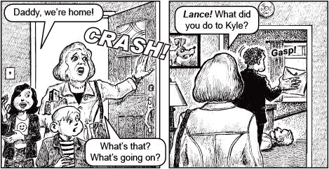
Page 3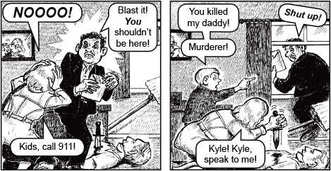
Page 4

Page 5
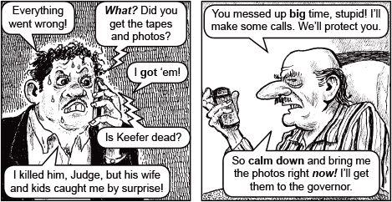
Page 6
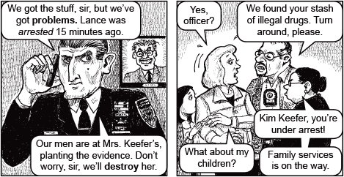
Page 7
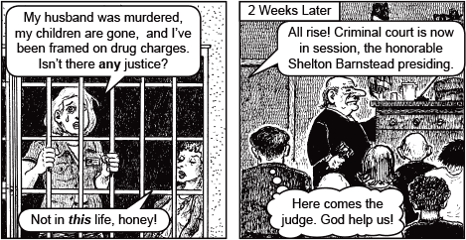
Page 8
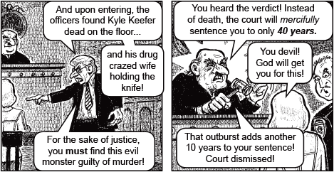
Page 9
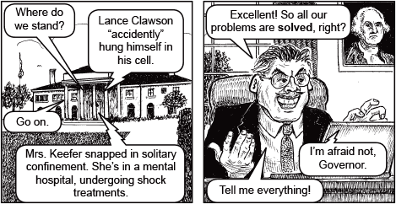
Page 10
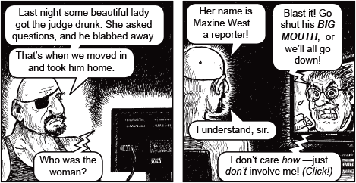
Page 11
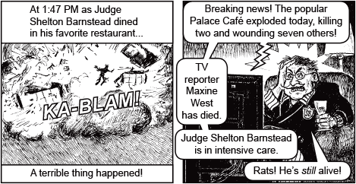
Page 12
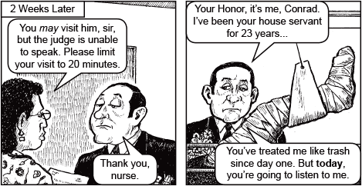
Page 13
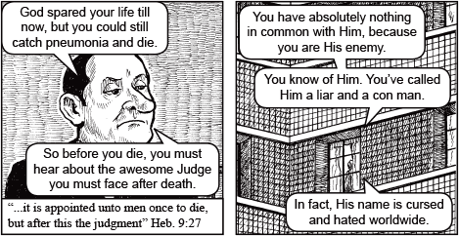
Page 14
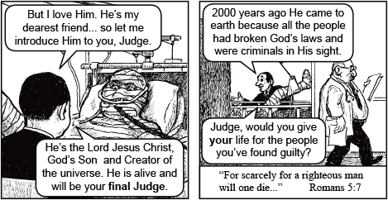
Page 15
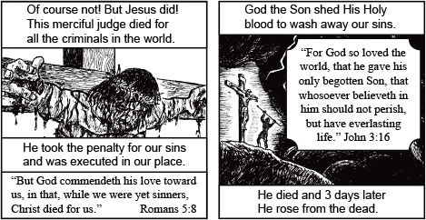
Page 16
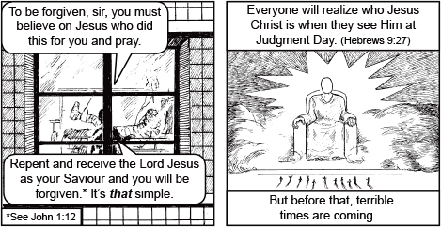
Page 17
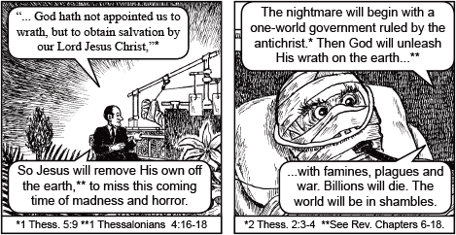
Page 18
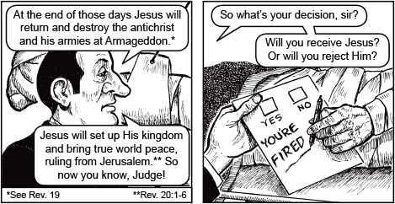
Page 19
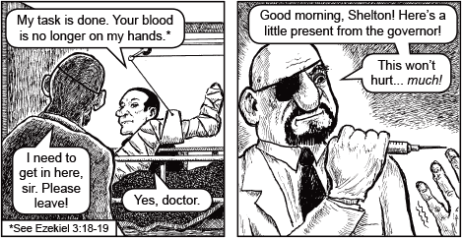
Page 20
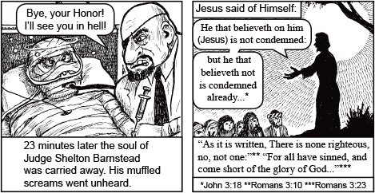
Page 21
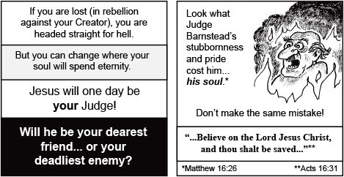
Page 22
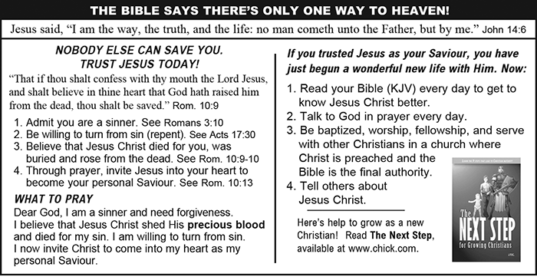
Page 23

FULLSTATURE COLLEGE OF THE BIBLE AND MISSIONS
WISDOM TO PREPARE for the Work with Eternal Benefits for all.
We must think deeply about making Jesus known. He has given us the Holy Spirit, the Bible and many preachers but we need to be trained in our minds on how to be effective for the Lord.
Experience has shown that if we just count on our love and passion to make inroads in the mission field or as pastors or in ministry, we’d likely become burnt out and quit very soon. Instead, God gave us the wisdom to prepare. The interest you expressed at the AWMC24, must remain burning and you have opportunity to be trained.
If you just show up in ministry, hearts full of love for God and eager to make big changes for His Kingdom, you will likely be back home early, burnt out and disappointed.
Instead, God gives us the wisdom to slow down and discover how we could effectively work on His behalf, using the talents, skills, and education He blessed us with.
God cut us out for this work, but we are presently rough and unpolished. Fullstature College of the Bible and Missions (FCBM) will help take out the raw edges, sand out the splinters and prepared you for God to add the varnish, readying us to begin your work. Don’t get us wrong we have always been a little unfinished, but God has helped us to help others since 1994. In this work, we will always need to be learning, growing, and adapting.

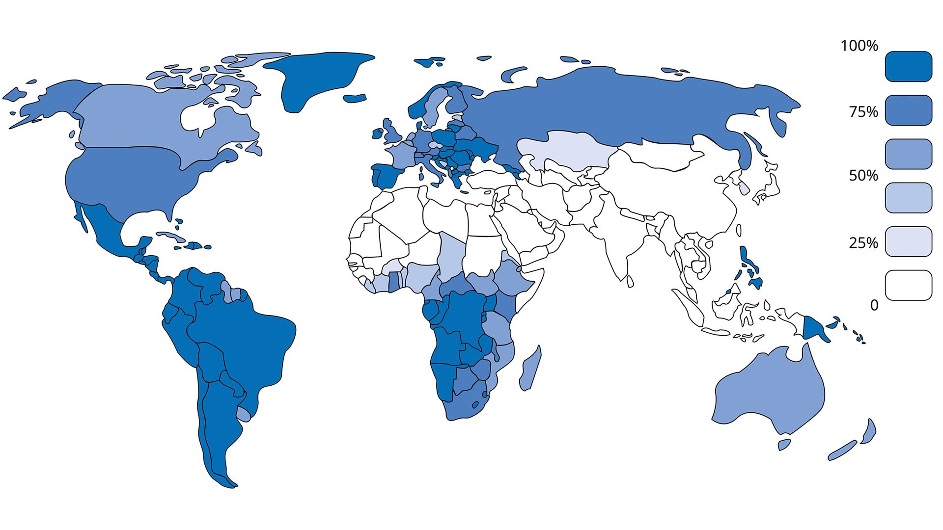
Source: World Christian Database, Accessed May 2023; *Graph reports Christian affiliation, or membership, not belief, practice, or theological beliefs.
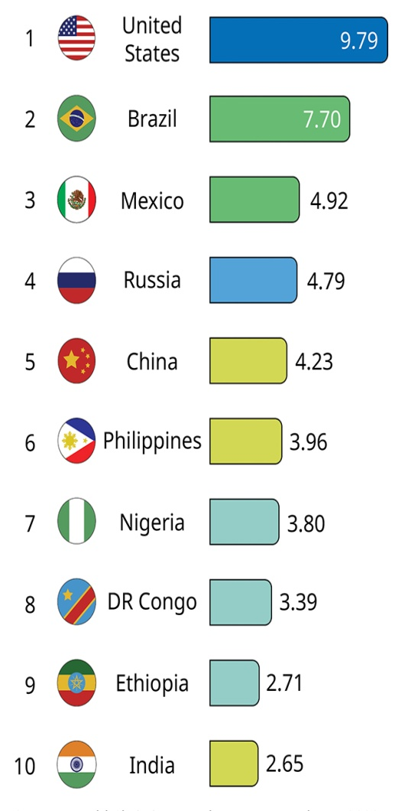

% of Global Christianity
Ranking of Countries

Growth and Decline
Over the past century, Christianity witnessed its most marked growth in Sub-Saharan Africa and its most marked decline in the Middle East, North Africa, and Western Europe.

Lowest % Christian

Countries with Lowest % Christian
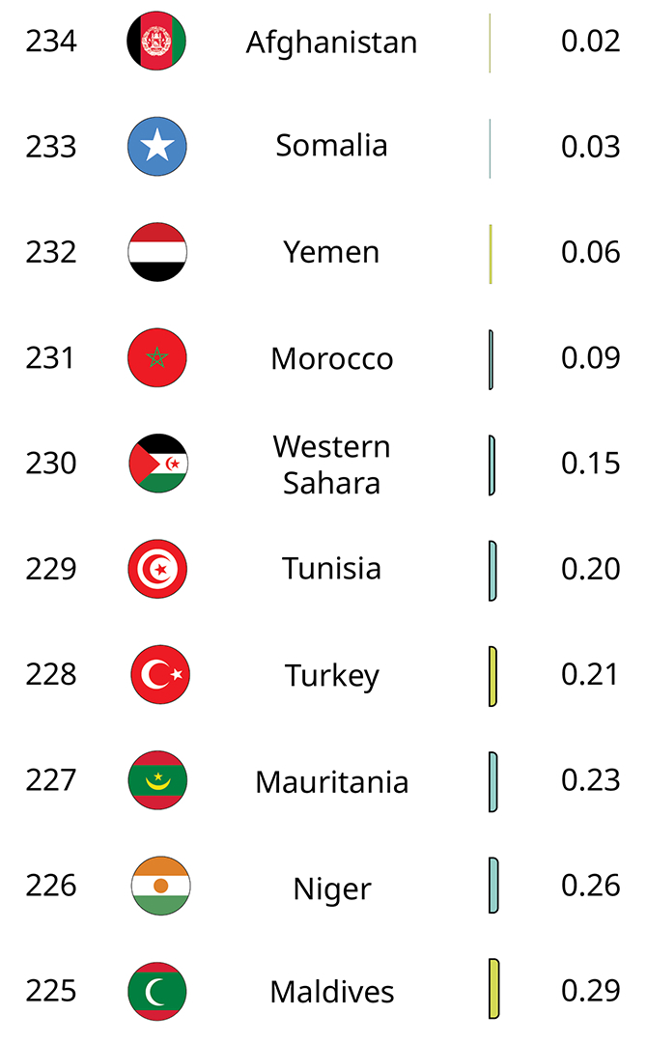
Source: World Christian Database, Accessed May 2023
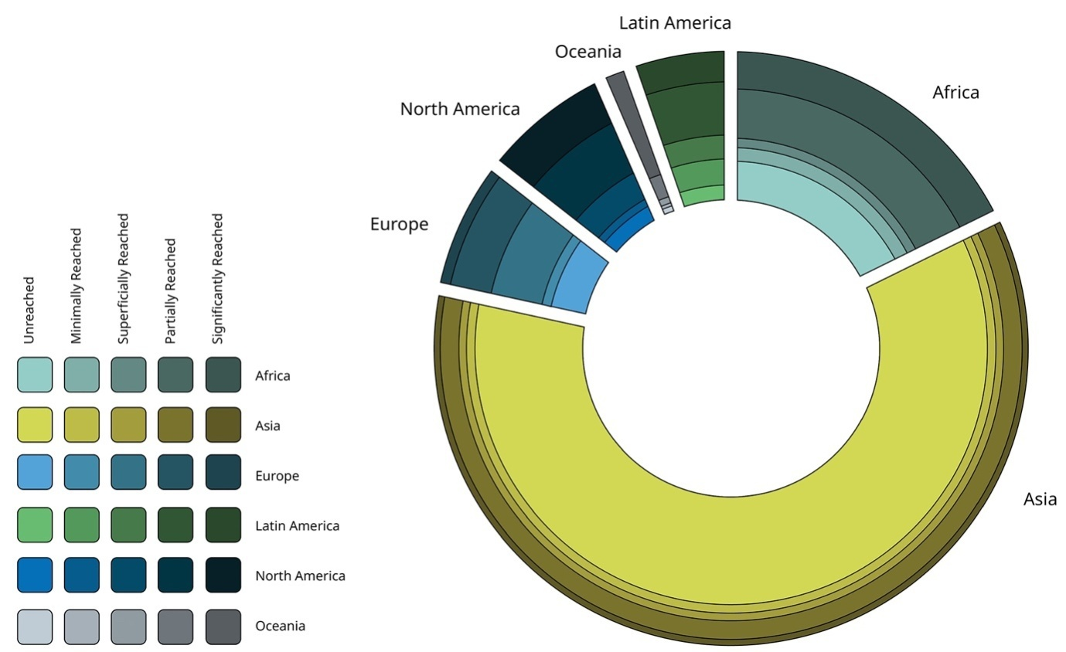

Unreached People by Region- Source: The Joshua Project, 2023

Definition
Unreached people groups are those who lack an indigenous church capable of evangelizing their own people. People groups are distinct social groups where shared language and cultural practices create communal belonging.

Missionary Challenge
The countries that have received the greatest amount of Western missionary attention over two centuries contain the greatest number of unreached and unreached people groups: China and India (which once included Pakistan and Bangladesh).
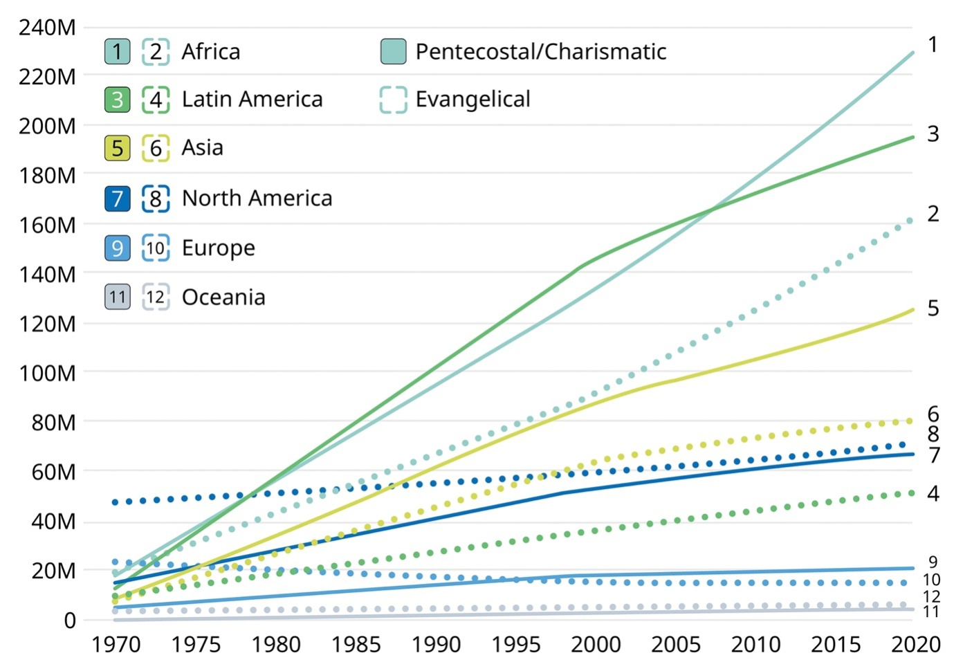

Rise of Evangelicals and Pentecostals- Source: World Christian Encyclopaedia pgs. 25-26, 2020; M = Millions

Global Evangelicals- Source: World Christian Encyclopaedia, pg. 25, 2020

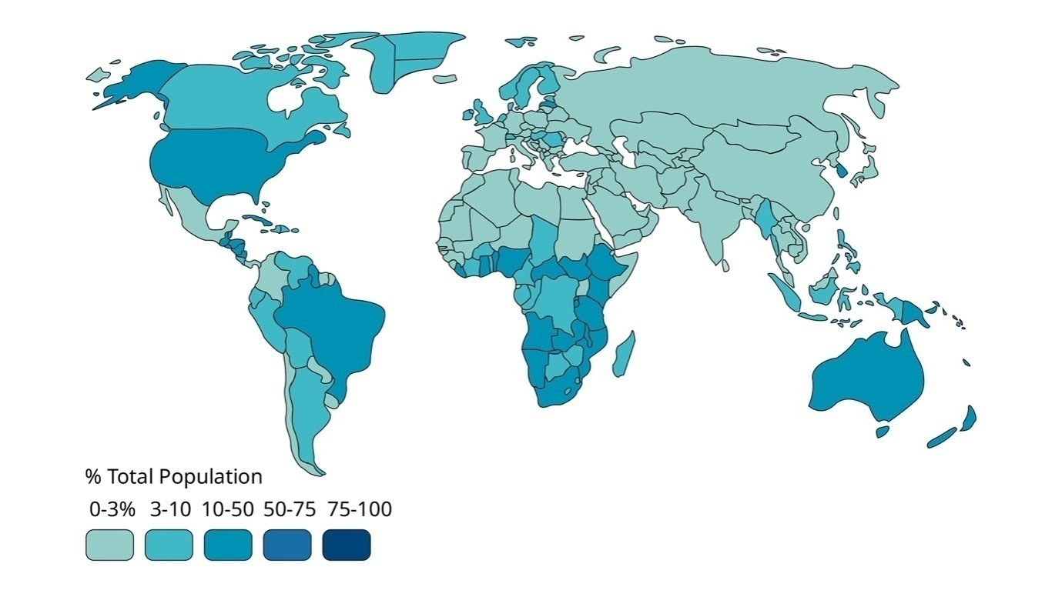Global Pentecostals/ Charismatics-Source: World Christian Encyclopaedia, pg. 25, 2020

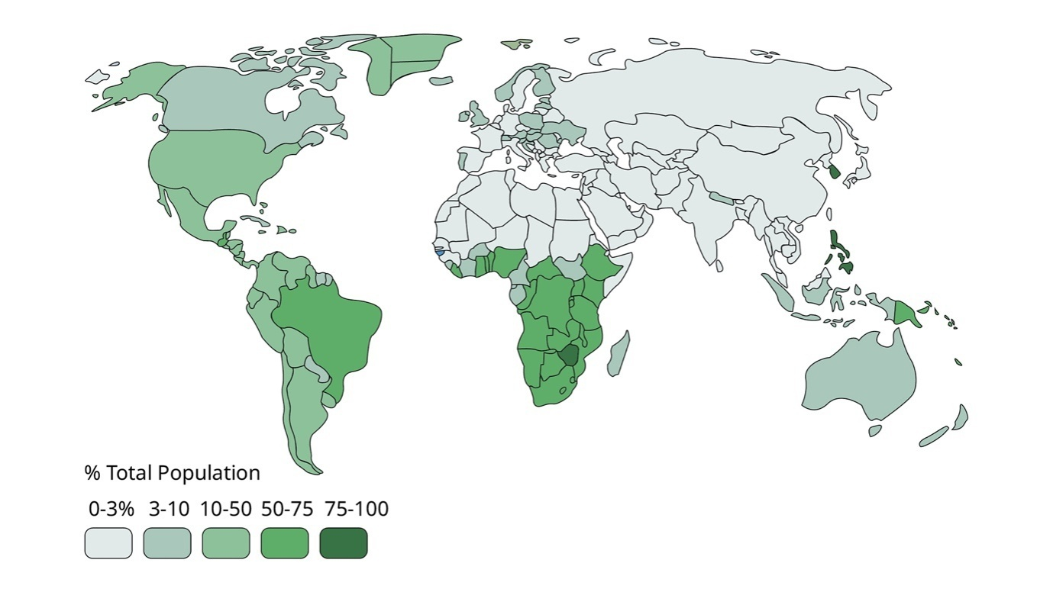

STRATEGIC LEVEL PRAYER JOURNAL-AUGUST 2018

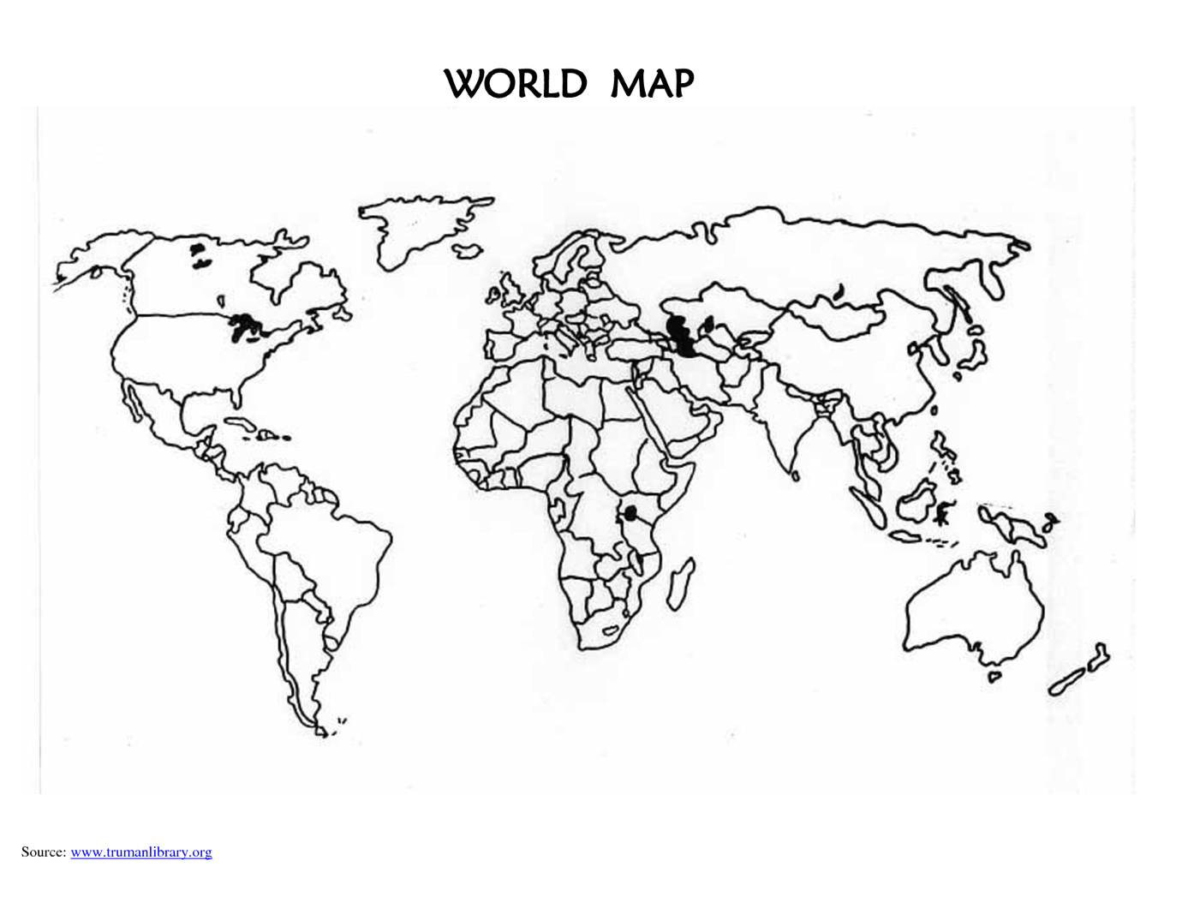

FMI Celebrates

25 years of Missionary Ministry-1993-2018

Reaching out to 40 tribes and peoples

Benin-Burundi- Ghana- Guinea Bissau- Nigeria- Tanzania- Togo|

United Kingdom| USA

Congo Dem. Republic| Malaysia| South Africa| Turkey| UAE| Zimbabwe
