
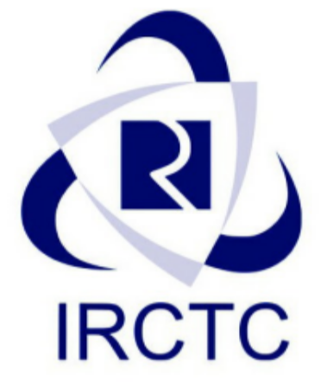
AUTHORISED RAIL E-TICKETING CENTRE

Of

KAFILA HOSPITALITY AND TRAVELS PRIVATE LIMITED

IRCTC Certificate No: KAF0046 Date of Issue: 09-08-2021

Scheme under: B2B
This is to certify that
M/s GURU NANAK INFOTECH, owned by BUTA SINGH located at MEHAL KALAN BUTA SINGH KHIALI ROAD, MAHAL KALAN, BARNALA PUNJAB 148104
Contact No. 9815572199 Email: gurunanakinfotech9@gmail.com
is a retailer of KAFILA HOSPITALITY AND TRAVELS PRIVATE LIMITED and is hereby authorized to book Railway E-tickets as per Rail E-Ticketing terms & conditions using WKAFILA00043 on the www.kafilaholidays.in Franchise System Terminal connected to IRCTC system for the general public till (08-08-2022).
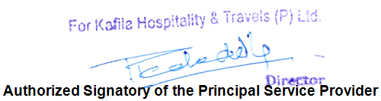

Statutory Warning:

In case any of the agent is found VIOLATING IRCTC terms and condition both the GURU NANAK INFOTECH and Kafila Hospitality and Travels Pvt Ltd shall be subjected to permanent deactivation and Punitive or any other action as per Railways Act 143 and relevant guidelines issued by IRCTC in this regards.
Registered Office: 10185-C, Arya Samaj Road, Karol Bagh, (New Delhi) - 110005
Call: +91 8587855513, 011-45022231, 9818406139 | Email: rail@kafilatravel.in
Website: http://kafilaholidays.in/

