# Predictive Pulse: Harnessing Machine Learning for Blood Pressure Analysis

# Abstract

Blood pressure is a vital indicator of cardiovascular health. Detecting irregular blood pressure patterns early can prevent severe medical conditions such as hypertension, heart disease, and stroke. This project, Predictive Pulse, utilizes machine learning to predict and monitor blood pressure levels based on easily measurable physiological and lifestyle factors. The goal is to provide a scalable, data-driven solution that enhances preventive healthcare and real-time monitoring capabilities.

# Table of Contents

Abstract

Scenario

Technical Architecture

Milestone 1: Define Problem

Milestone 2: Data Collection & Preparation

Milestone 3: Exploratory Data Analysis

Milestone 4: Model Building

Milestone 5: Evaluation & Tuning

Milestone 6: Deployment

Milestone 7: Testing & Demonstration

Conclusion and Future Enhancements

References

# Scenario:

**Scenario 1**: A patient managing hypertension wears a compatible wearable device featuring Predictive Pulse technology. Throughout the day, the device monitors their vital signs and transmits data securely. If the machine learning model identifies a potential spike in blood pressure based on observed patterns, it promptly alerts the patient and their healthcare providers. This real-time notification enables swift intervention or medication adjustments, preventing potential complications.

**Scenario 2:** A fitness enthusiast relies on a smartwatch equipped with Predictive Pulse capabilities to track their health and performance. The machine learning model analyzes their blood pressure trends over time, offering personalized insights and recommendations. These insights help optimize their workouts and lifestyle choices, promoting cardiovascular health and minimizing potential health risks.

**Scenario 3:** A healthcare provider oversees a population health initiative focused on preventing cardiovascular diseases among at-risk individuals. Leveraging Predictive Pulse technology, they remotely monitor patients and identify those at higher risk of developing hypertension or experiencing blood pressure fluctuations. This data-driven approach enables targeted interventions such as lifestyle modifications, medication adherence reminders, or telehealth consultations, effectively managing and preventing complications.

# Technical Architecture:

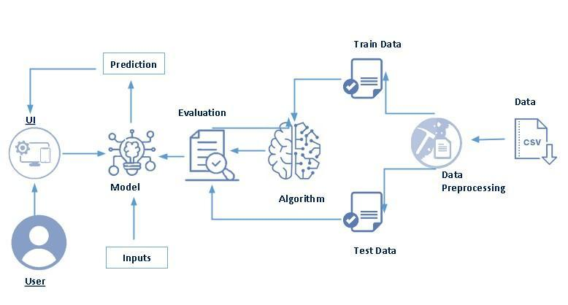

# Milestone 1: Define Problem / Problem Understanding

## Activity 1: Problem Statement & Medical Background

Hypertension (high blood pressure) is a critical risk factor for cardiovascular disease. Blood pressure is expressed as systolic/diastolic values (mmHg). Normal, elevated, and hypertension stages (Stage 1/Stage 2) classification allows early interventions. This system aims to help users self-screen and understand possible risks.

Medical context:  
- Systolic Pressure: pressure during heart contraction.  
- Diastolic Pressure: pressure during relaxation.  
- Mean Arterial Pressure (MAP) and Pulse Pressure (PP) are derived measures used in clinical evaluation.

Figure: Problem to Solution overview:

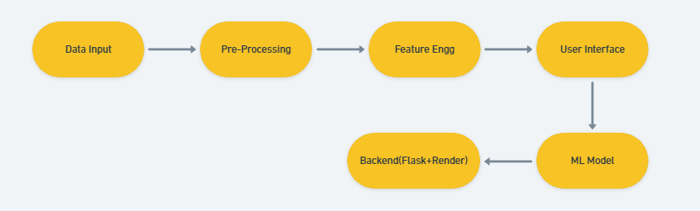

## Activity 2: Business Requirements & Stakeholders

Requirements:  
- Accurate classification of blood pressure category.  
- Low-latency inference for responsive UI.  
- Secure handling and optional logging of user inputs.  
- Clear result interpretation and recommended next steps.  
  
Stakeholders include: end-users, healthcare professionals, and potential partnering telemedicine services.

# Milestone 2: Data Collection & Preparation

Data sources: The model is trained on curated datasets combining clinical blood pressure records and demographic/lifestyle features. When assembling datasets, ethical considerations (consent, anonymization) and data quality checks are essential.

Key attributes often used:  
- Age, Gender, Weight/BMI  
- Resting Heart Rate  
- Systolic & Diastolic blood pressure  
- Smoking status, physical activity, medical history

Data Preprocessing steps:

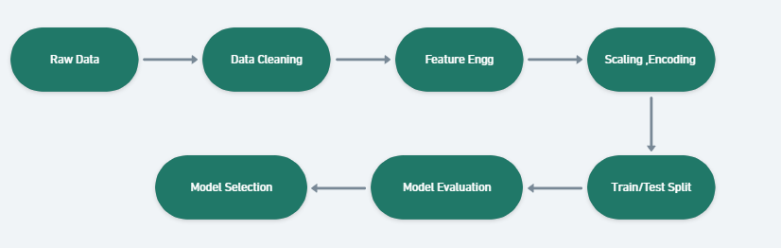

- Missing value strategies: mean/median imputation, KNN imputation for correlated features.  
- Outlier detection: IQR or Z-score for continuous variables. Apply winsorization or removal where clinically implausible.  
- Feature engineering: computing MAP, PP, categorical bucketing of age, interaction terms.  
- Scaling & encoding: StandardScaler or MinMaxScaler for numeric, one-hot/ordinal encoding for categorical.

# Milestone 3: Exploratory Data Analysis (EDA)

EDA helps understand distributions, detect data quality issues, and informs feature selection. Typical analyses include univariate histograms, boxplots for outliers, correlation heatmaps for multicollinearity, and bivariate plots.

Common findings and remediation:  
- Highly skewed measures benefit from transformation (log/Box-Cox).  
- Multicollinearity between features such as systolic & pulse pressure may require dimensionality reducion or feature selection.

# Milestone 4: Model Building

Algorithms evaluated:  
- Decision Tree: interpretable, prone to overfitting without pruning.  
- Random Forest: ensemble method reducing variance and often high-performing for tabular data.  
- Logistic Regression: baseline linear model with probabilistic outputs.  
- Support Vector Machine (SVM): effective for some decision boundaries with kernels.  
  
Selection rationale: Random Forest is often chosen for tabular health datasets due to robustness and balance between bias/variance.

Model interpretability: Feature importance from tree-based models and SHAP values can provide explanations for individual predictions.

# Milestone 5: Evaluation & Hyperparameter Tuning

Evaluation metrics for imbalanced or critical-health tasks must include precision and recall alongside accuracy. F1-score balances precision and recall. Cross-validation (k-fold) offers robust performance estimates.

Hyperparameter tuning: GridSearchCV or RandomizedSearchCV across parameters (n_estimators, max_depth, min_samples_split, etc.) with stratified folds.

# Milestone 6: Deployment

The trained model is serialized (pickle/joblib) and loaded by the Flask application on server start. REST endpoints accept form or JSON payloads, apply preprocessing pipelines, and return predictions. Deployment optimizations include caching models in memory, using gunicorn for concurrency, and containerization.

Security & Privacy: Use HTTPS, avoid logging PII, and implement user consent and data retention policies.

# Milestone 7: Testing, Demonstration & UX

Testing includes unit tests for preprocessing functions, model inference tests, and end-to-end UI tests. User testing assesses usability and interpretability of the results.

Application screenshots with captions:

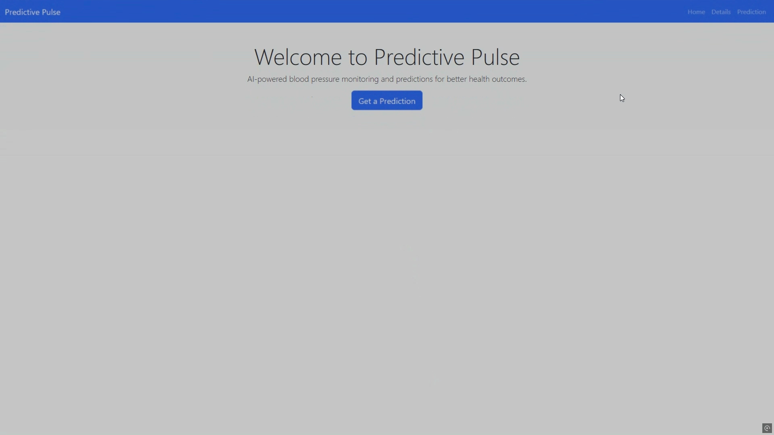

**Home Page**

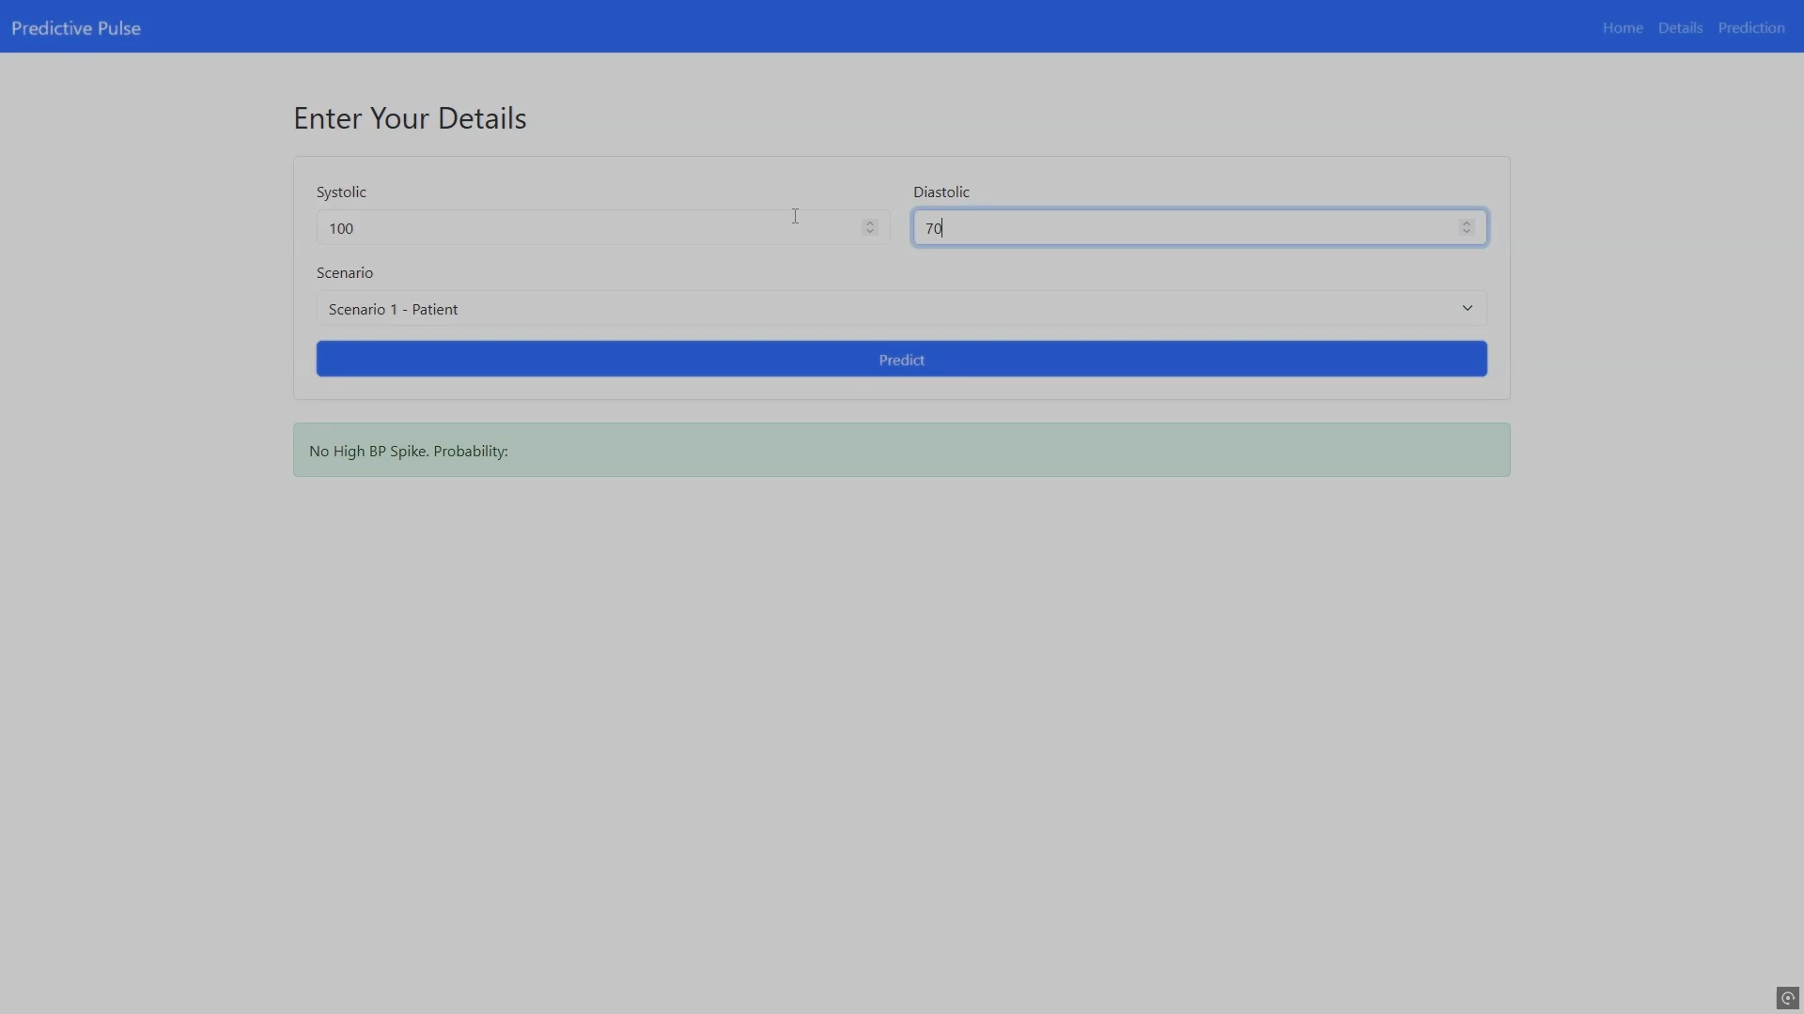

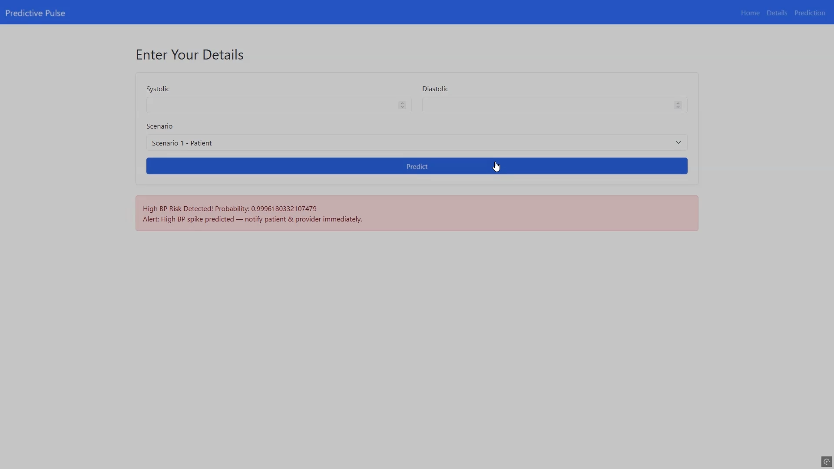

**Scenario 1**

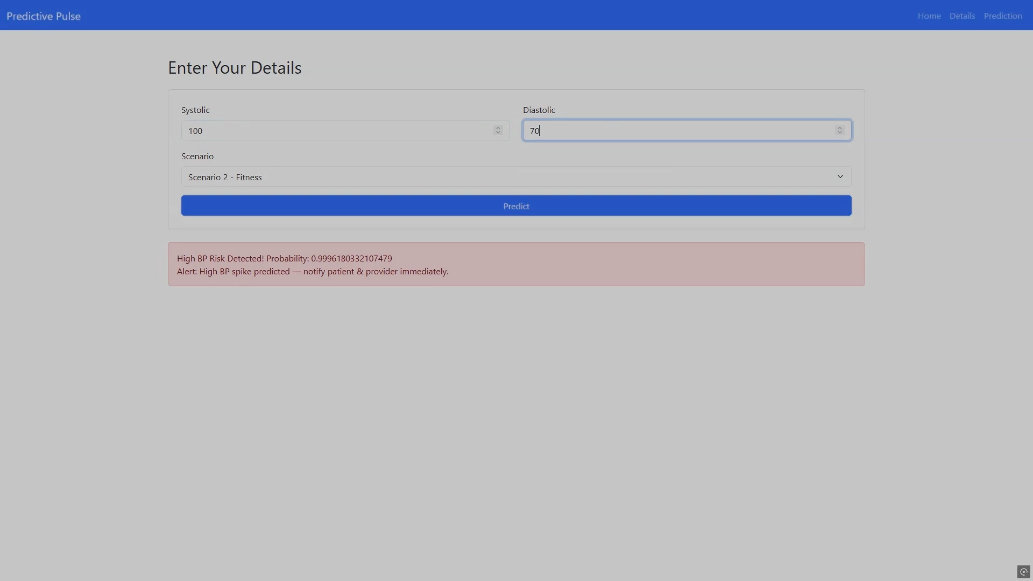

**Scenario 2**

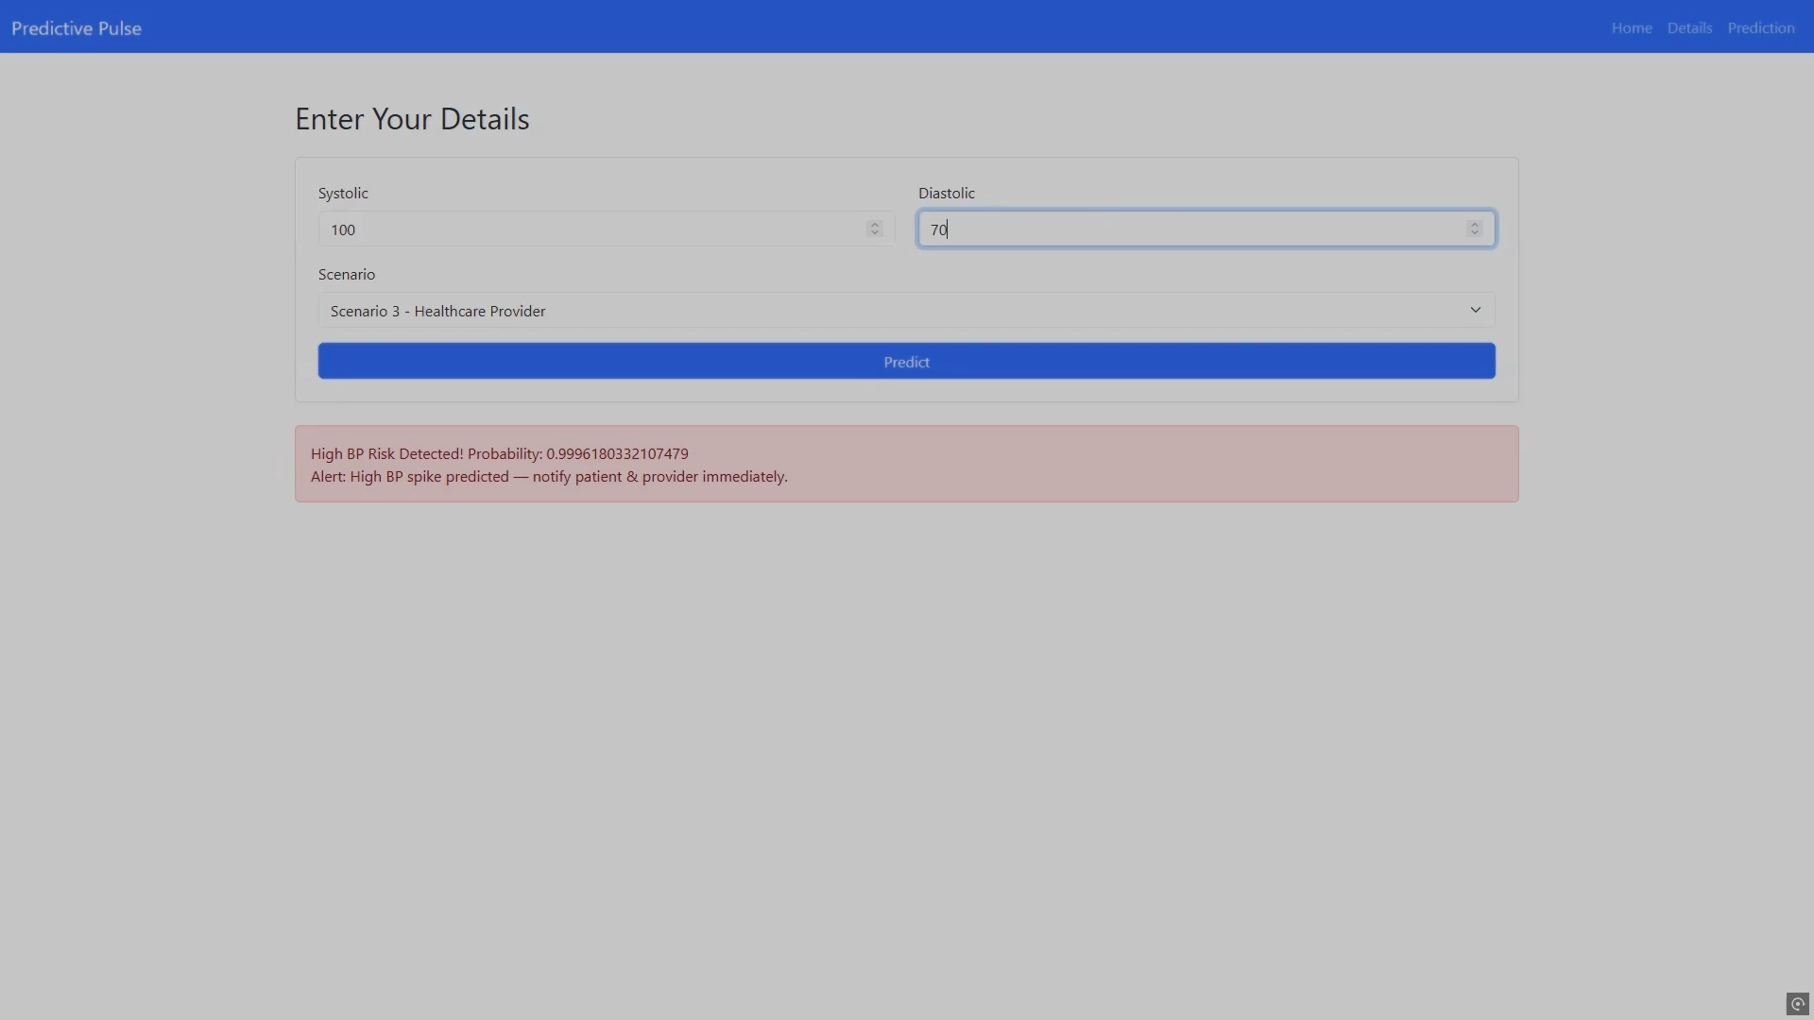

**Scenario 3**

# Conclusion and Future Enhancements

**Conclusion:**

The Predictive Pulse project successfully demonstrates how machine learning can revolutionize healthcare by offering continuous, intelligent blood pressure monitoring.

Through careful data collection, model development, and deployment, this system bridges the gap between medical precision and everyday accessibility.

The project proves that predictive analytics can help detect early signs of hypertension, enabling timely medical intervention and personalized health management.

By integrating Predictive Pulse into wearable devices and healthcare systems, patients gain autonomy over their health, while doctors receive valuable insights for better clinical decisions. This represents a significant step toward proactive and preventive healthcare solutions powered by artificial intelligence.

**Future Enhancements:**

1. Integration with Real-Time IoT Devices:

Connecting directly to smartwatches and medical sensors for live blood pressure monitoring and cloud-based data updates.

1. Deep Learning Implementation:

Leveraging recurrent neural networks (RNNs) or LSTMs to analyze sequential patterns in time-series health data for more accurate predictions.

1. Personalized Health Profiling:

Creating adaptive models that adjust predictions based on individual user data and lifestyle over time.

1. Mobile Application Development:

Launching a user-friendly mobile app that provides insights, daily health tracking, and AI-driven recommendations.

1. Data Privacy and Security Enhancements:

Employing blockchain or advanced encryption methods to protect sensitive medical data from unauthorized access.

1. Integration with Telemedicine:

Allowing seamless sharing of health data with doctors for virtual consultations and continuous monitoring**.**

# References

American Heart Association — Understanding Blood Pressure

Scikit-learn documentation — Model selection & evaluation

Research articles on ML for cardiovascular risk prediction