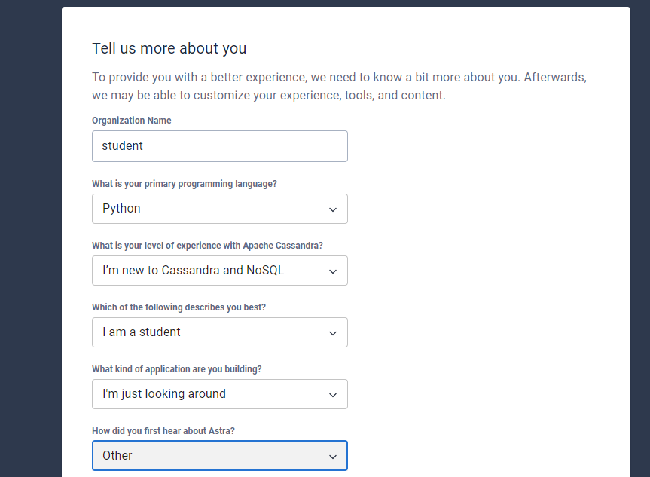
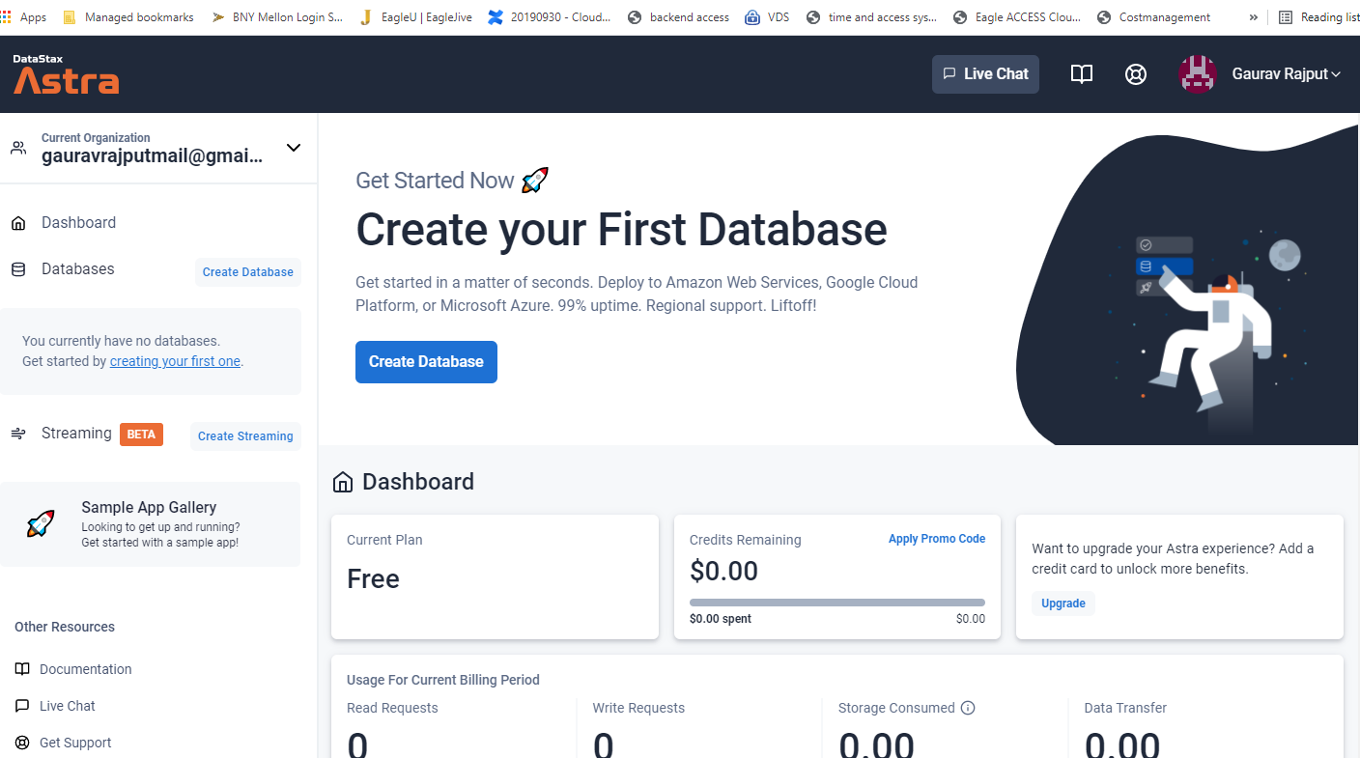
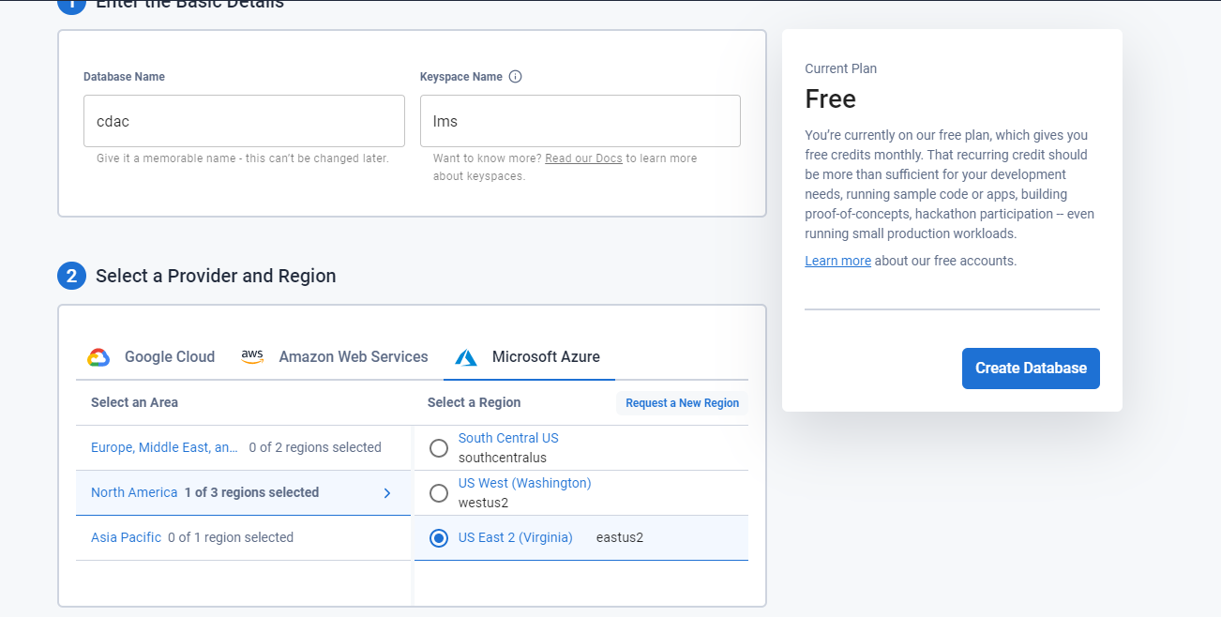
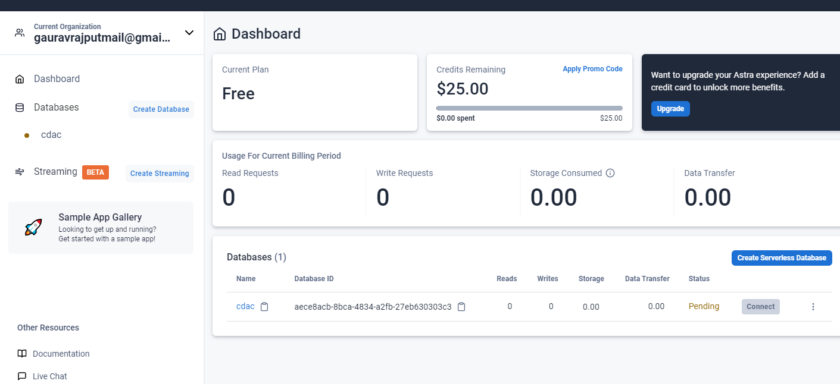
https://astra.datastax.com/org/d74aa866-ed19-426f-8db5-e8d921bfc3b9/database/aece8acb-8bca-4834-a2fb-27eb630303c3/console

CHOOSE GOOGLE CLOUD AS SERVICE PROVIDER to avoid using your card details requirement in the below step
