VK REALTY COMMAND CENTER
AI Voice Telephony & Lead Operations Platform
CLIENT USER MANUAL & FULL FEATURE DIRECTORY

Prepared For: VK Realty Management & Sales Team
Platform Engine: Arjun (VK Realty's AI Property Consultant)
Prepared By: OUTPERO Operations Team
Date of Delivery: July 2026 (Version 1.0 - Production ready)

Executive Introduction
Welcome to the VK Realty Command Center. This dashboard is a premium, white-labeled call management and artificial intelligence operations console, designed specifically for modern, non-technical real estate teams.
At the core of the platform is Arjun, your Senior AI Real Estate Consultant. Arjun operates 24/7/365 to manage every single inbound phone inquiry coming from your listings. He speaks natural, localized Spoken Hinglish/Telugish, qualifications are made live in less than 400 milliseconds, and site visits are booked and logged automatically into the CRM.
This guide walks you through every tab, dashboard module, and operational control available to you in the Command Center. For each tab, we explain exactly what it does, what business role it serves (Broker, Sales Manager, or Coordinator), and the tangible business impact it drives.
⚡ DESIGN PHILOSOPHY: The Command Center is designed so you never need to look at code, server terminals, or configuration scripts. Everything you need to manage your leads, listen to recordings, adjust Arjun's instructions, or launch outbound calling campaigns is accessible via a simple, interactive client interface.

01. Today's Overview (Morning Briefing)
A single-screen summary displaying your agency's performance in real time. It acts as the daily 'Morning Briefing' for sales teams, replacing complex charts with clean, actionable counts.
Target User Role: | Sales Managers & Broker Owners
Key Metrics Tracked: | Total Inbound Calls, Newly Qualified Leads, Site Visits Booked, Priority 'Hot' Leads.
Non-Technical Benefit: | Eliminates lead leakage entirely. Managers can check the system first thing in the morning and immediately assign the highest-value inquiries to the sales team.

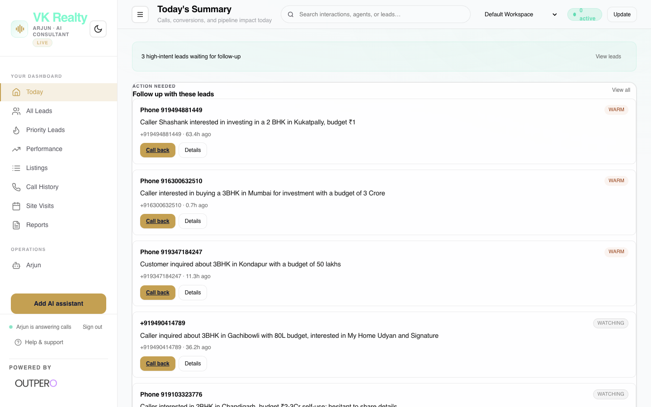
Figure 01: Interface screenshot of the Today's Overview (Morning Briefing) dashboard tab.
Key Capabilities:
- Real-time counter cards showing active phone leads and scheduled visits.
- Action items list of hot prospects who require immediate human callback or WhatsApp outreach.
- Instant quick-actions: single-click options to 'Call back', 'Open in WhatsApp', or 'Listen' to the conversation.

⚡ BUSINESS VALUE: Eliminates lead leakage entirely. Managers can check the system first thing in the morning and immediately assign the highest-value inquiries to the sales team.

02. All Leads Directory
A centralized, searchable contact book containing every prospect who has interacted with your project lines. It logs the full customer profile captured by Arjun.
Target User Role: | Sales Representatives & Site-Visit Coordinators
Key Metrics Tracked: | Prospect Name, Verified Phone Number, Target Budget, Project/Location Interest, Date Contacted.
Non-Technical Benefit: | Saves hours of manual CRM logging. Your sales team receives warm, qualified contacts with exact budgets and requirements, making sales calls highly targeted.

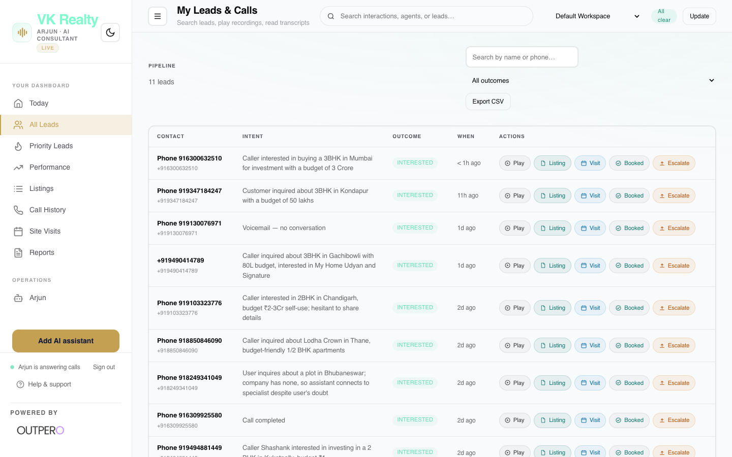
Figure 02: Interface screenshot of the All Leads Directory dashboard tab.
Key Capabilities:
- Unified search bar to filter leads by location (e.g. Kokapet, Thane), budget, or name.
- Lead cards showing detailed conversation outcomes and qualification tags.
- Timeline log of call sessions, summaries, and scheduling statuses.

⚡ BUSINESS VALUE: Saves hours of manual CRM logging. Your sales team receives warm, qualified contacts with exact budgets and requirements, making sales calls highly targeted.

03. Priority Leads (Hot Leads)
A filtered view showing only high-intent buyers who meet your primary qualification threshold (e.g. high budget, ready to visit, immediate buying timeline).
Target User Role: | Broker Owners & Senior Closers
Key Metrics Tracked: | Premium Project Interest, High-Budget Filter, Immediate Site-Visit Intent.
Non-Technical Benefit: | Optimizes sales efficiency. Directly channels your premium closers' time to the top 20% of qualified leads that represent 80% of your potential revenue.

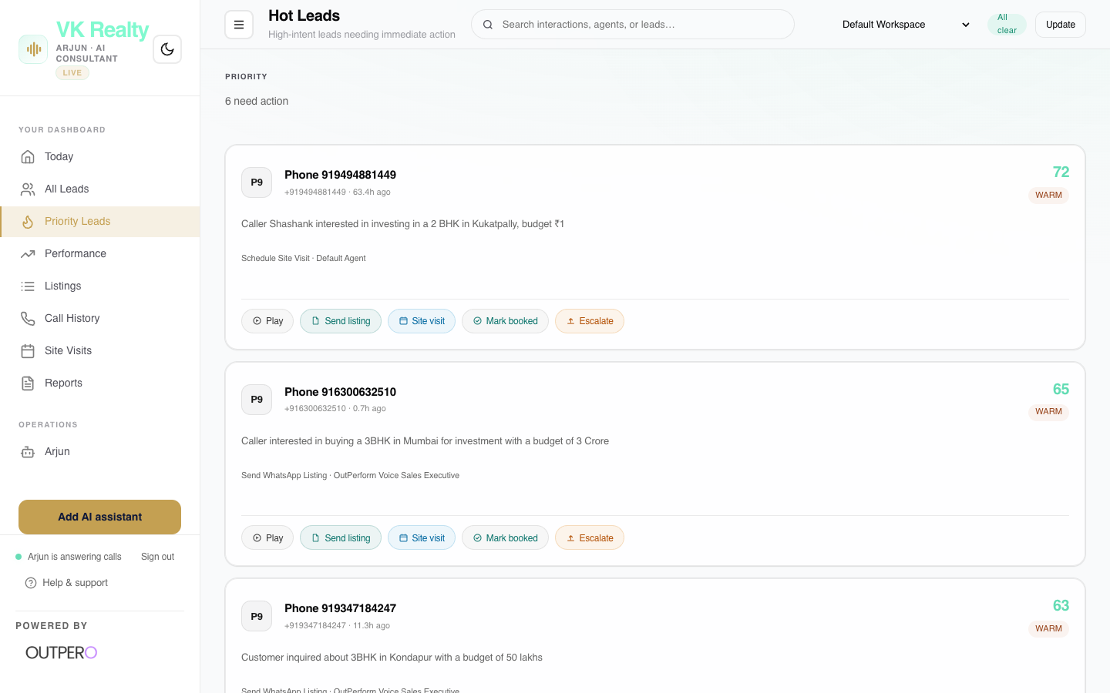
Figure 03: Interface screenshot of the Priority Leads (Hot Leads) dashboard tab.
Key Capabilities:
- Automatic tagging of callers who match high-value buyer profiles.
- Direct pipeline of customers who requested site tours on the call.
- Fast-track assignment to your closing team.

⚡ BUSINESS VALUE: Optimizes sales efficiency. Directly channels your premium closers' time to the top 20% of qualified leads that represent 80% of your potential revenue.

04. Resolution & Performance
Analytics detailing how efficiently Arjun resolves customer inquiries, showing metrics related to call success, durations, and system performance.
Target User Role: | Operations Managers & Broker Owners
Key Metrics Tracked: | Resolution Success Rate, Avg Call Duration, Inbound vs. Transferred Calls.
Non-Technical Benefit: | Provides clear proof of AI return on investment. Enables you to monitor customer experience metrics and ensure Arjun meets company service standards.

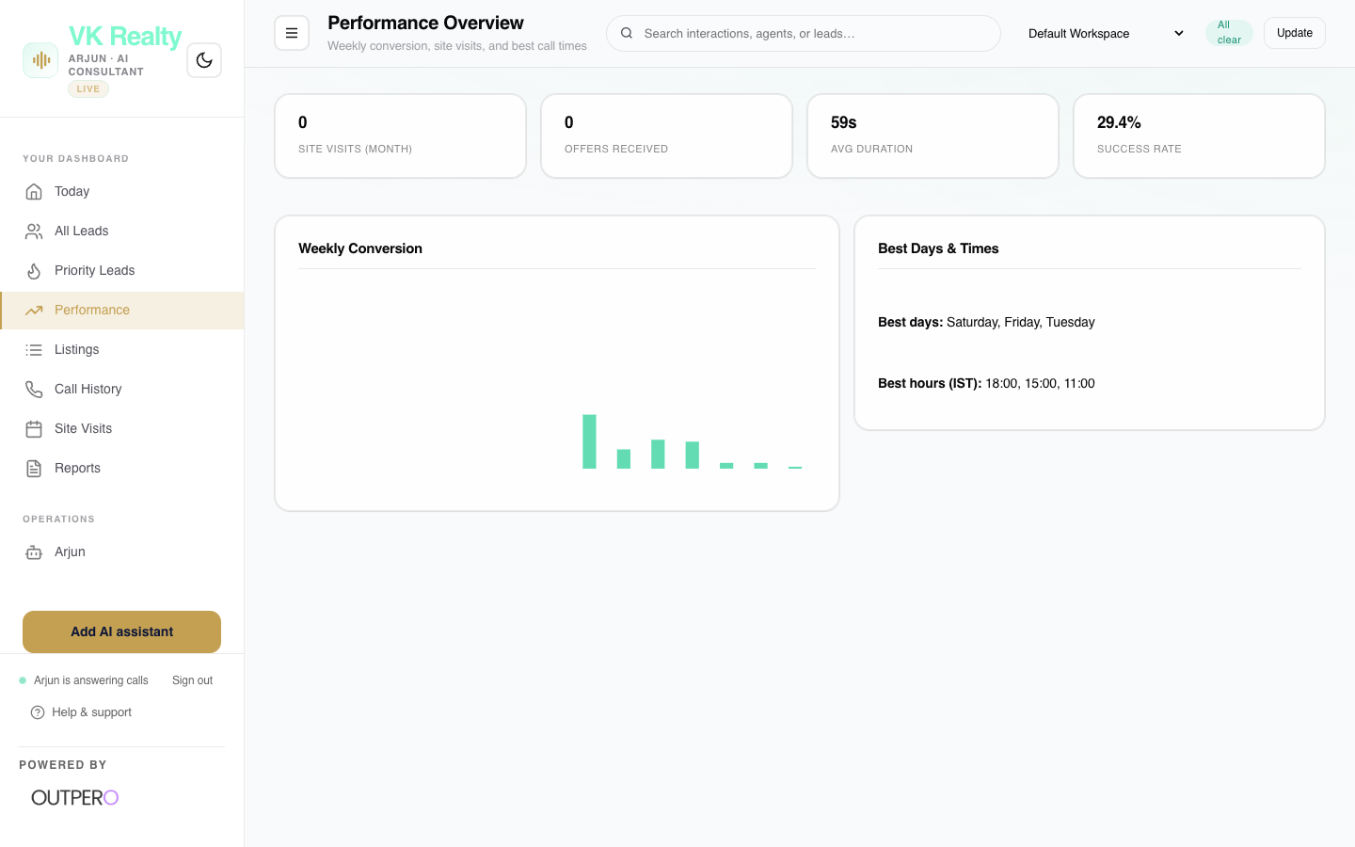
Figure 04: Interface screenshot of the Resolution & Performance dashboard tab.
Key Capabilities:
- Line graphs showing peak hours of resolution.
- Breakdown of why calls ended (e.g. site visit booked, follow-up scheduled, transferred to human rep).
- Performance comparison trends over time.

⚡ BUSINESS VALUE: Provides clear proof of AI return on investment. Enables you to monitor customer experience metrics and ensure Arjun meets company service standards.

05. Property Listing Performance
Track call volume and lead interest across different online real estate listings and portals, mapping out which projects generate the highest phone traffic.
Target User Role: | Marketing Directors & Broker Owners
Key Metrics Tracked: | Call Volume per Listing, Top-Performing Advertisements, Portal Inbound Split.
Non-Technical Benefit: | Enables data-driven advertising spend. Instantly reallocate marketing budget from poor-performing listings to the hotspots driving the most calls.

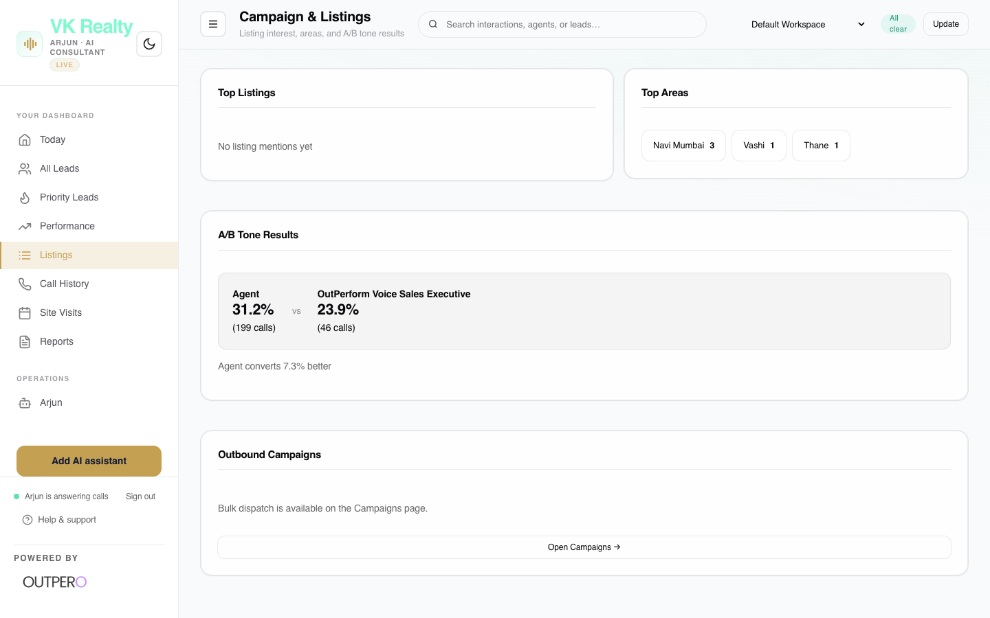
Figure 05: Interface screenshot of the Property Listing Performance dashboard tab.
Key Capabilities:
- Compare campaign performance across different landing pages and real estate platforms.
- Identify listing sources that generate low-quality or unqualified calls.
- See listing-specific budgets reported by buyers.

⚡ BUSINESS VALUE: Enables data-driven advertising spend. Instantly reallocate marketing budget from poor-performing listings to the hotspots driving the most calls.

06. Call History & Transcripts
A complete, transparent log of every call. It provides full audio recording playbacks and word-for-word transcripts, showing how Arjun communicates.
Target User Role: | Quality Assurance Managers & Sales Trainers
Key Metrics Tracked: | Call Timestamp, Talk Duration, Customer Sentiment Score, Telephony Cost.
Non-Technical Benefit: | Guarantees absolute quality control. Managers can audit Arjun's performance, hear client reactions in real-time, and refine the sales strategy based on actual call recordings.

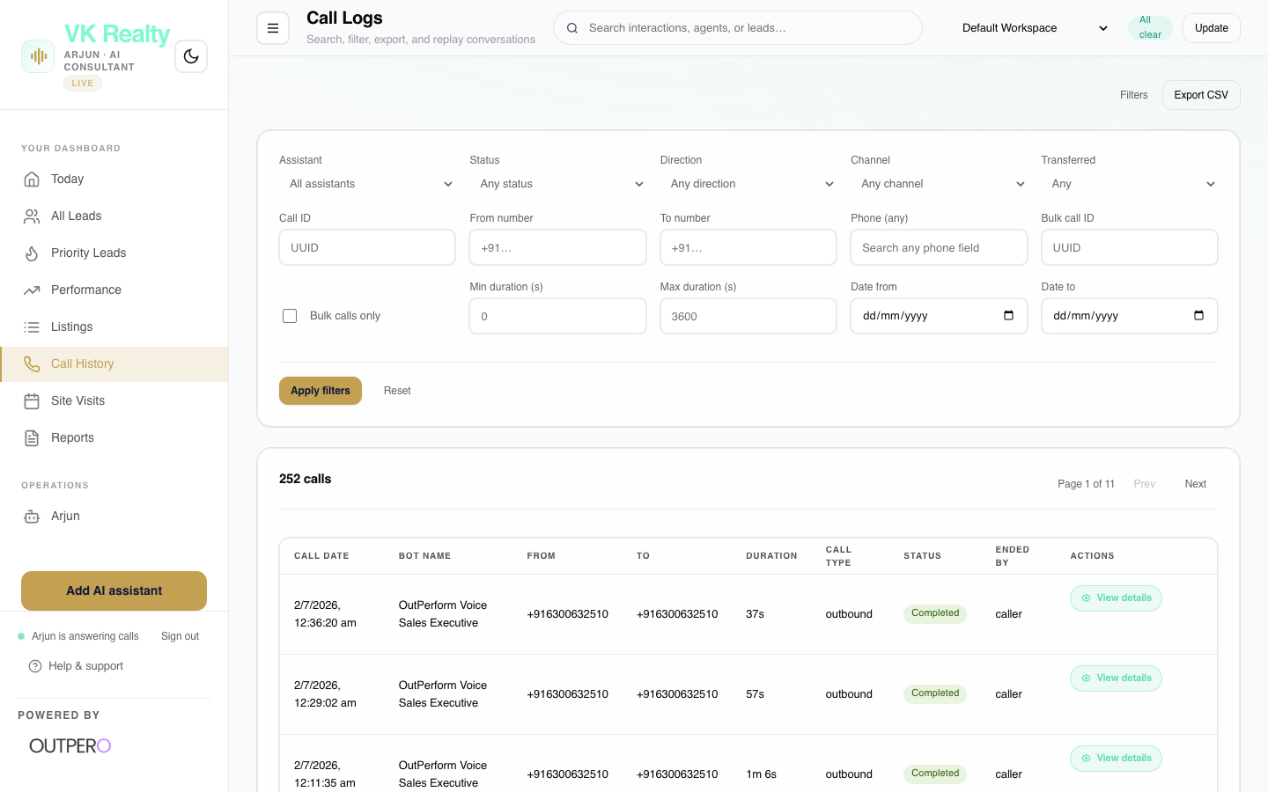
Figure 06: Interface screenshot of the Call History & Transcripts dashboard tab.
Key Capabilities:
- Embedded media player to listen to recordings directly inside the browser.
- Multilingual chat bubble transcript view showing Arjun and the buyer side-by-side.
- Search transcripts for specific customer questions or concerns.

⚡ BUSINESS VALUE: Guarantees absolute quality control. Managers can audit Arjun's performance, hear client reactions in real-time, and refine the sales strategy based on actual call recordings.

07. Site Visit Calendar
A visual schedule of all site visits booked by Arjun on the phone. It syncs bookings with team calendars to ensure site coordinators are ready.
Target User Role: | Site-Visit Coordinators & Sales Reps
Key Metrics Tracked: | Total Bookings, Host Assignments, Schedule Dates, Lead Budget.
Non-Technical Benefit: | Increases show-up rates. Organizes your on-site team, ensures reps are assigned before the customer arrives, and minimizes scheduling conflicts.

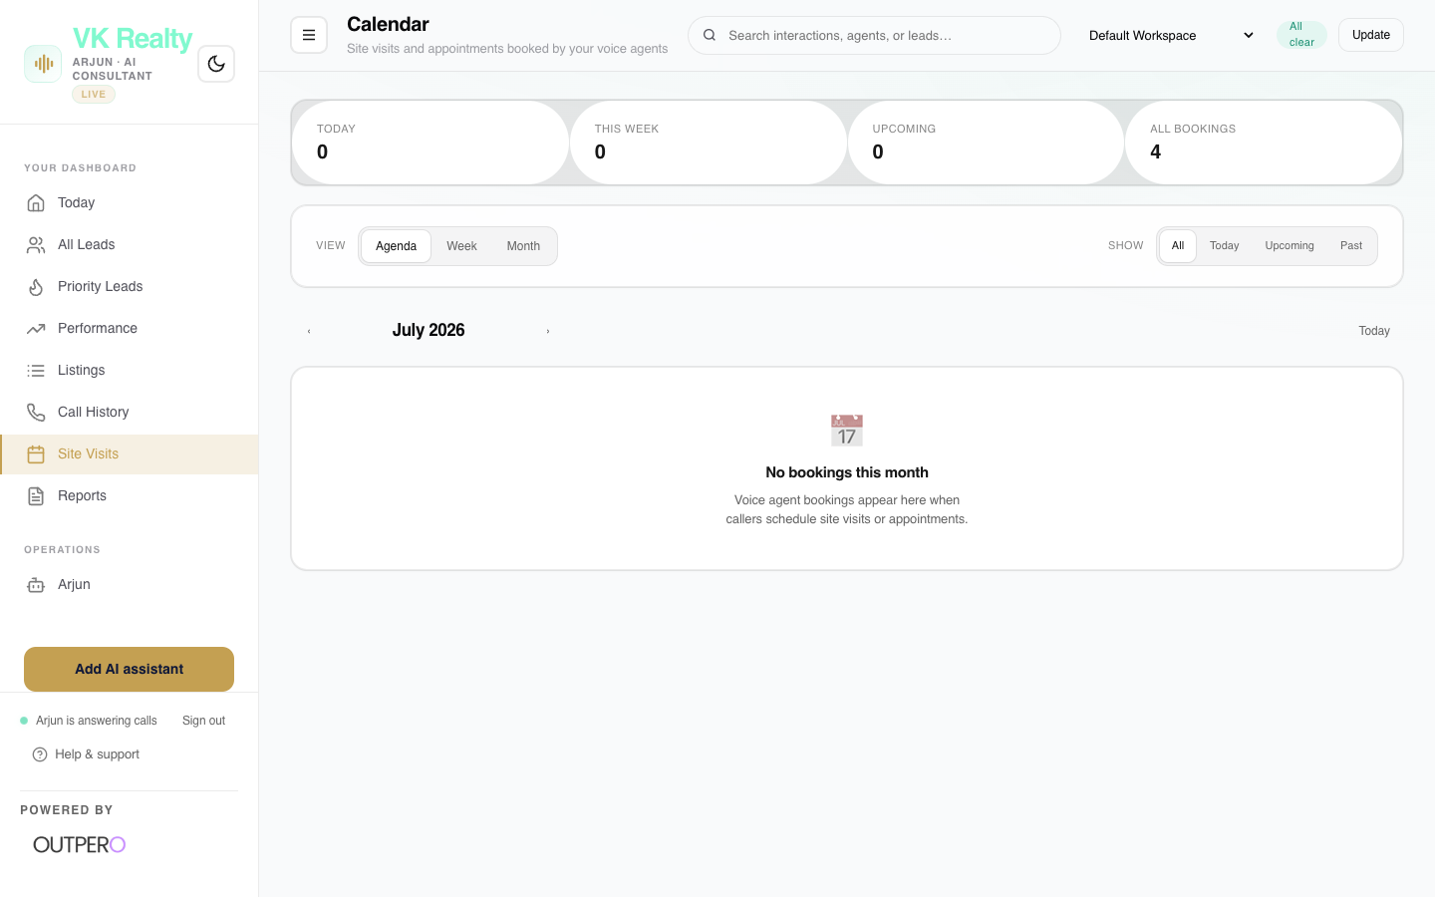
Figure 07: Interface screenshot of the Site Visit Calendar dashboard tab.
Key Capabilities:
- Calendar layout displaying visits by Day, Week, or Month.
- One-click assignment: allocate sales reps to host specific site tours.
- Automatic email/SMS integration to confirm dates with leads.

⚡ BUSINESS VALUE: Increases show-up rates. Organizes your on-site team, ensures reps are assigned before the customer arrives, and minimizes scheduling conflicts.

08. Executive Reports
The reports center compiles telemetry and conversion summaries, allowing you to generate and download performance reports for leadership meetings.
Target User Role: | Broker Owners & Executives
Key Metrics Tracked: | Lead Conversion %, Total Call Cost, Telephony Cost, Cost per Qualified Lead.
Non-Technical Benefit: | Provides boardroom-ready reports. Gives management immediate, transparent proof of cost-savings and system efficiency.

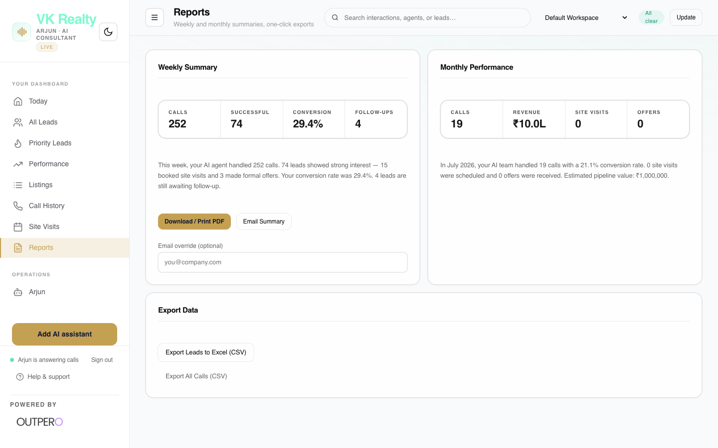
Figure 08: Interface screenshot of the Executive Reports dashboard tab.
Key Capabilities:
- Export clean CSV files of call records and qualified leads.
- Generate executive PDF summaries of weekly/monthly voice platform performance.
- Custom date range selections for comparative data analysis.

⚡ BUSINESS VALUE: Provides boardroom-ready reports. Gives management immediate, transparent proof of cost-savings and system efficiency.

09. Arjun AI Consultant Configuration
The primary settings panel for the main voice assistant. Here you can tweak Arjun's core instructions, first greeting line, and operational constraints.
Target User Role: | Sales Directors & OUTPERO Support
Key Metrics Tracked: | System Prompt Content, Greeting Language, Answer Length Limits.
Non-Technical Benefit: | Keeps your AI assistant dynamic. Quickly update project information, pricing revisions, or greeting protocols without waiting for developers to deploy code.

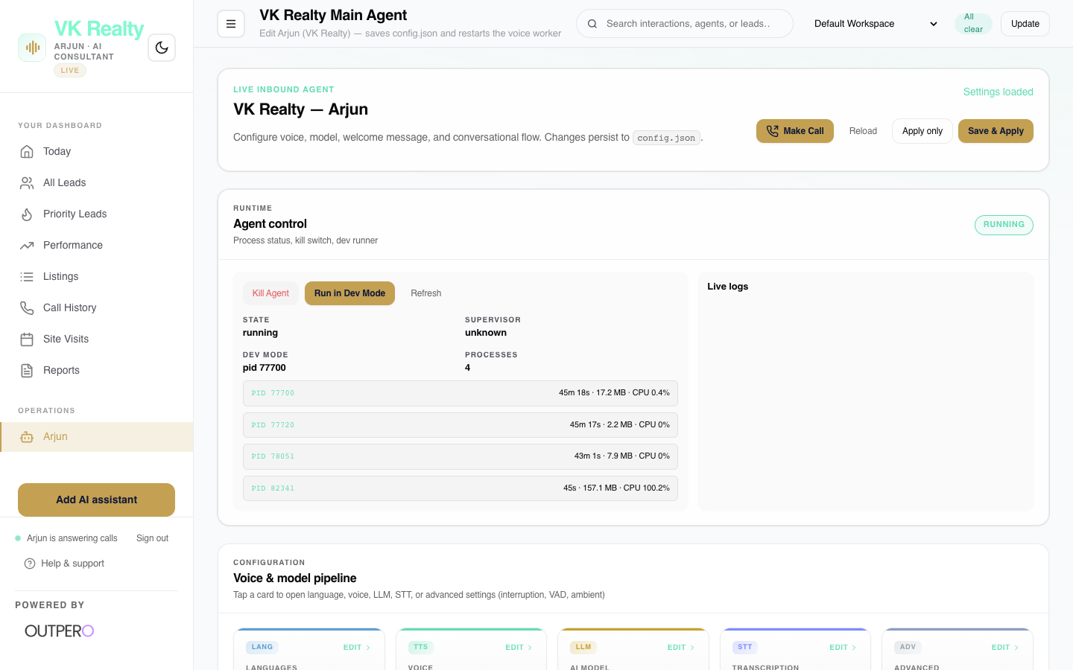
Figure 09: Interface screenshot of the Arjun AI Consultant Configuration dashboard tab.
Key Capabilities:
- Edit the system prompt: update details on property pricing, amenities, or sales tactics.
- Modify the first line (e.g. changing the greeting language or agent's name).
- Fine-tune temperature (how creative Arjun is) and token counts (how long his answers are).

⚡ BUSINESS VALUE: Keeps your AI assistant dynamic. Quickly update project information, pricing revisions, or greeting protocols without waiting for developers to deploy code.

10. Voice & Language Presets
Control how Arjun sounds, adjusting accents, voice templates, and the mixing ratio of English with regional languages (Hindi, Telugu, Marathi).
Target User Role: | Operations Managers & Quality Analysts
Key Metrics Tracked: | Voice Presets, Accent Selection, Hinglish/Telugish Balance.
Non-Technical Benefit: | Builds instant trust. By matching the regional accents and linguistic flow (Tinglish, Hinglish) of your customer, Arjun sounds warm, local, and professional.

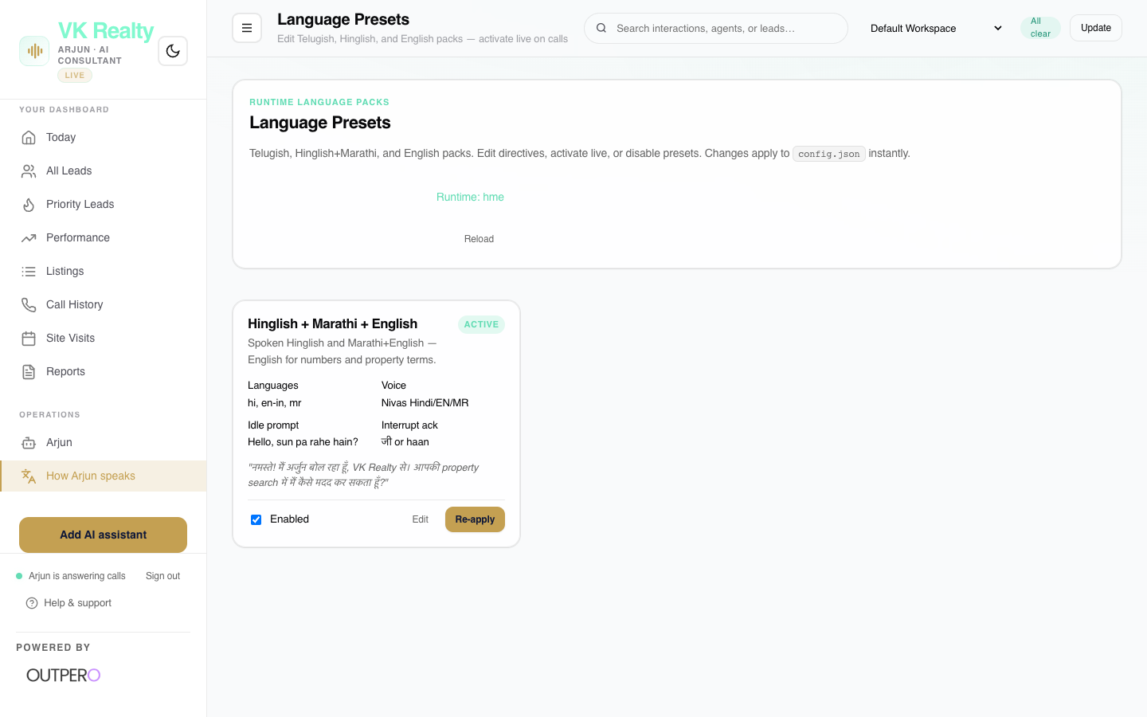
Figure 10: Interface screenshot of the Voice & Language Presets dashboard tab.
Key Capabilities:
- Select different human-like voice models (Male/Female, recommended presets).
- Control language preset templates tailored for specific customer bases.
- Test voice output live inside the dashboard.

⚡ BUSINESS VALUE: Builds instant trust. By matching the regional accents and linguistic flow (Tinglish, Hinglish) of your customer, Arjun sounds warm, local, and professional.

11. AI Assistants Directory
A directory listing all active voice agents in your organization. This allows you to manage multiple assistants deployed for different projects or channels.
Target User Role: | Broker Owners & Tech Coordinators
Key Metrics Tracked: | Total Assistants Deployed, Host Numbers, Active Status.
Non-Technical Benefit: | Enables multi-project scaling. Seamlessly run separate, specialized virtual agents for different housing projects (e.g. premium villas vs. mid-range apartments).

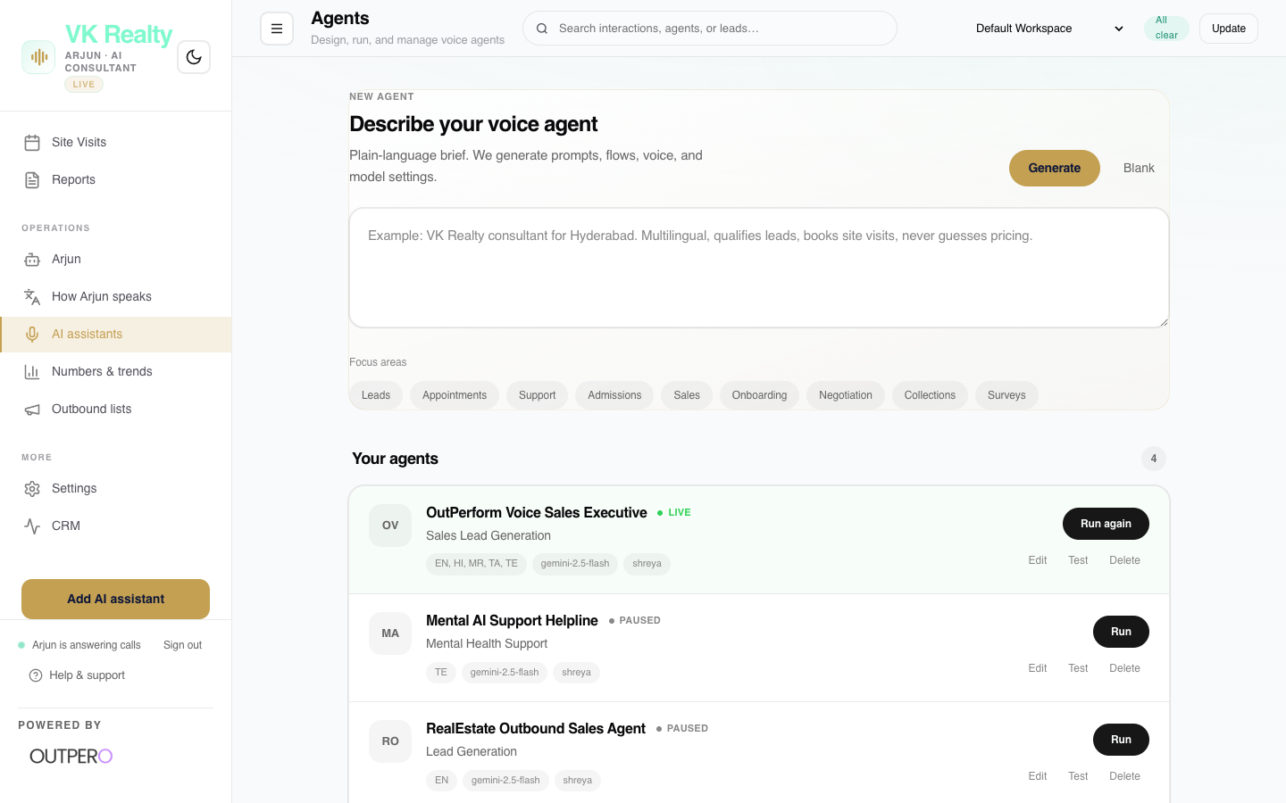
Figure 11: Interface screenshot of the AI Assistants Directory dashboard tab.
Key Capabilities:
- Deploy new virtual assistants using pre-built real estate templates.
- Clone configurations: duplicate prompts and settings from Arjun to deploy assistants for other properties.
- Toggle assistants online/offline instantly.

⚡ BUSINESS VALUE: Enables multi-project scaling. Seamlessly run separate, specialized virtual agents for different housing projects (e.g. premium villas vs. mid-range apartments).

12. Numbers & Trends (Deep Analytics)
A dashboard packed with deep telemetry graphs showing call volumes, hourly trends, connection rates, and cost breakdowns.
Target User Role: | Operations Analysts & Broker Owners
Key Metrics Tracked: | Hourly Call Distribution, Call Duration Spread, Cost per Call Trend.
Non-Technical Benefit: | Optimizes operations. For example, if graphs show 30% of calls come after 9 PM, you know exactly how many leads are saved by Arjun when human staff is off.

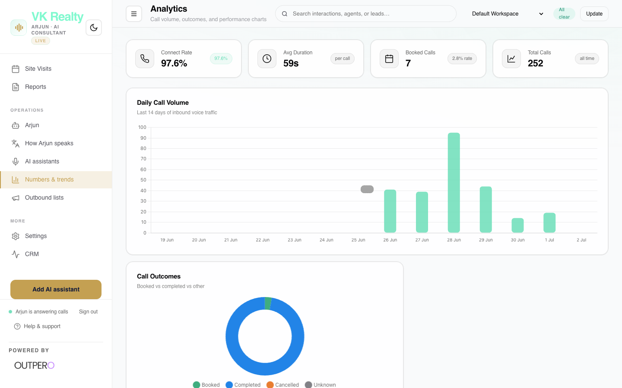
Figure 12: Interface screenshot of the Numbers & Trends (Deep Analytics) dashboard tab.
Key Capabilities:
- Visual charts detailing when customers call the most (morning vs. night).
- Telemetry on connection speeds and latency bottlenecks.
- In-depth analysis of call length distribution.

⚡ BUSINESS VALUE: Optimizes operations. For example, if graphs show 30% of calls come after 9 PM, you know exactly how many leads are saved by Arjun when human staff is off.

13. Outbound Campaigns
Manage list-based calling where Arjun dials out to CSV contact lists to announce launches, follow-up, or qualify legacy databases.
Target User Role: | Marketing Teams & Sales Managers
Key Metrics Tracked: | Campaign Completion %, Connected Calls, Interested Leads, Cost.
Non-Technical Benefit: | Multiplies sales outreach by 10x. Arjun filters out busy lines, bad numbers, and uninterested contacts, delivering only hot, interested prospects to your reps.

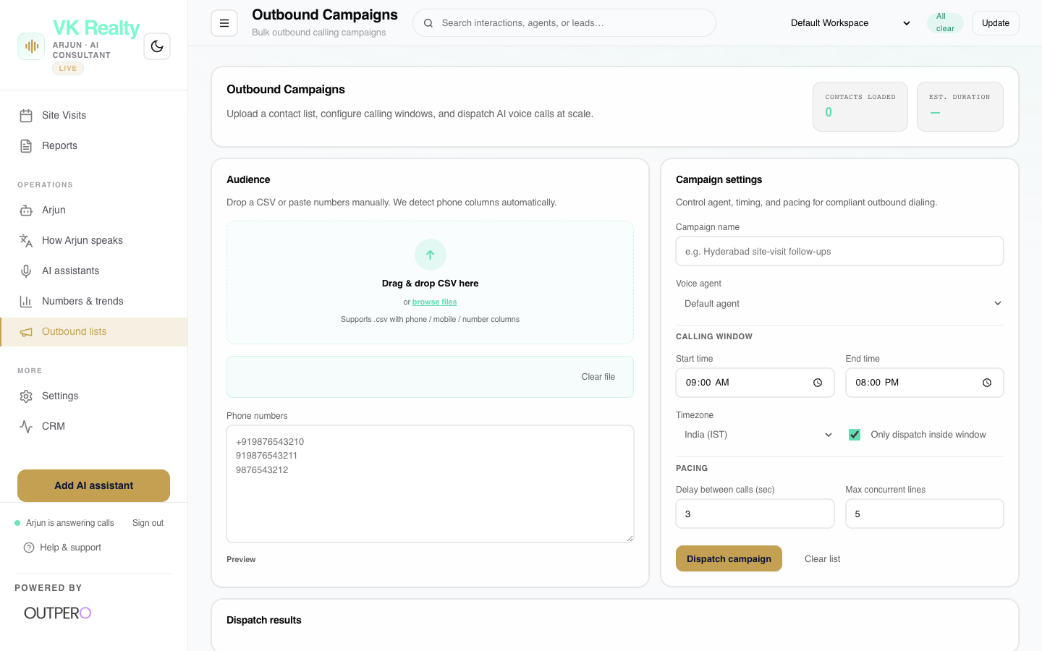
Figure 13: Interface screenshot of the Outbound Campaigns dashboard tab.
Key Capabilities:
- Upload customer databases directly via clean CSV file upload.
- Schedule campaigns: set calendar timings for when Arjun starts outbound dials.
- Live campaign progress bar showing exactly how many calls succeeded and who showed interest.

⚡ BUSINESS VALUE: Multiplies sales outreach by 10x. Arjun filters out busy lines, bad numbers, and uninterested contacts, delivering only hot, interested prospects to your reps.

14. Dashboard Settings (The Control Room)
The primary settings panel of the platform. Serves as the master configuration control for phone numbers, templates, and integration mappings.
Target User Role: | Broker Owners & Tech Managers
Key Metrics Tracked: | Core Platform Status, Setup Profiles.
Non-Technical Benefit: | Serves as the central navigation point to manage all backend resources.

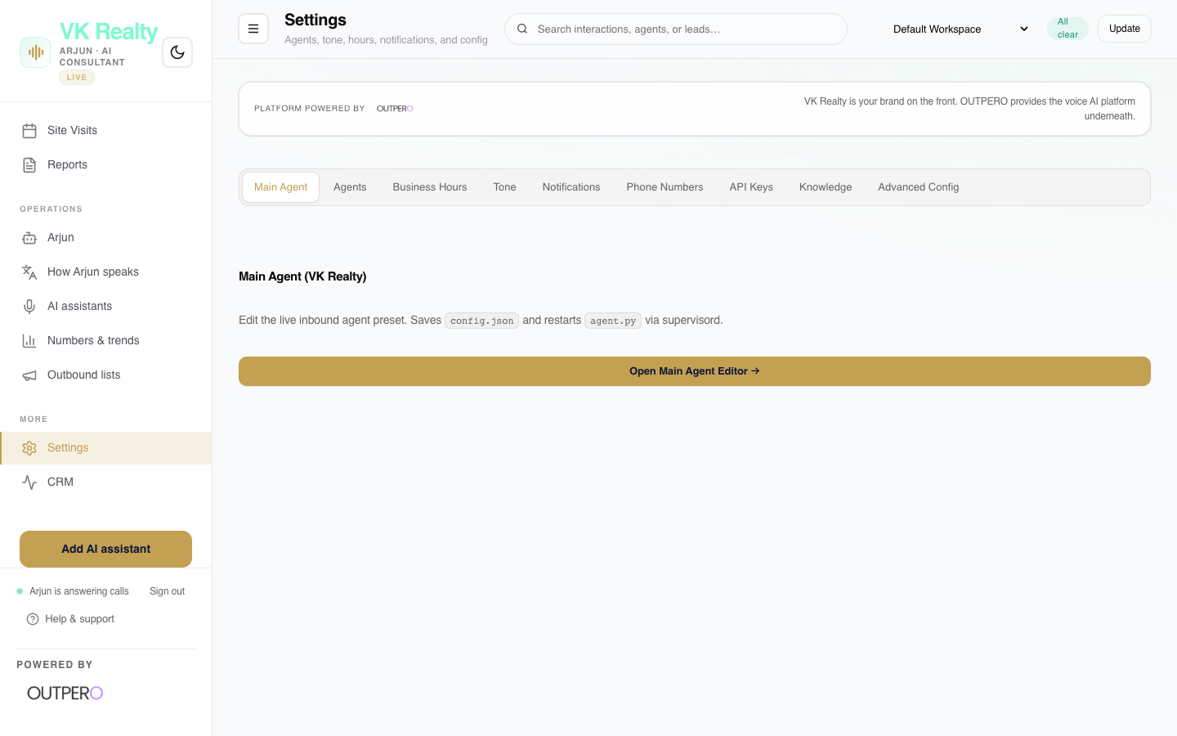
Figure 14: Interface screenshot of the Dashboard Settings (The Control Room) dashboard tab.
Key Capabilities:
- Access primary global configuration settings.
- Switch dashboard branding and visual theme elements.
- Overview of current operational thresholds.

⚡ BUSINESS VALUE: Serves as the central navigation point to manage all backend resources.

15. CRM Center
Configure the connection between your AI voice system and your CRM software (Twenty CRM, HubSpot, Salesforce, or Zoho).
Target User Role: | Operations & Tech Managers
Key Metrics Tracked: | API Connection Status, Sync Success Rate, Mapped Fields.
Non-Technical Benefit: | Eliminates administrative overhead. Ensures data captured on the phone is immediately available to human reps in the CRM, without copy-paste delays.

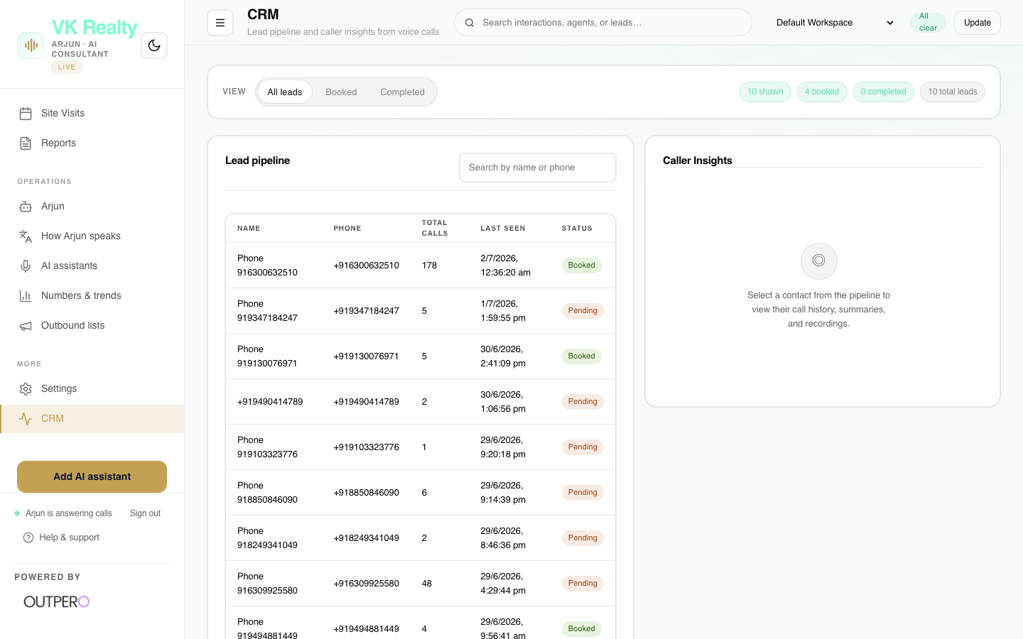
Figure 15: Interface screenshot of the CRM Center dashboard tab.
Key Capabilities:
- Map database fields (name, phone, budget) from call records to CRM pipelines.
- View logs of leads automatically synced to your sales CRM.
- Trigger manual syncs of legacy lead records.

⚡ BUSINESS VALUE: Eliminates administrative overhead. Ensures data captured on the phone is immediately available to human reps in the CRM, without copy-paste delays.

16. Property Knowledge Base
The document storage system where you upload pricing sheets, brochures, floor plans, and FAQs. Arjun references this live on calls.
Target User Role: | Marketing Teams & Project Coordinators
Key Metrics Tracked: | Active Knowledge Packs, File Sizes, Revision Dates.
Non-Technical Benefit: | Eliminates AI hallucinations. Arjun will only quote prices, availability, and amenities that are officially uploaded by your marketing team, building trusted, compliant buyer relations.

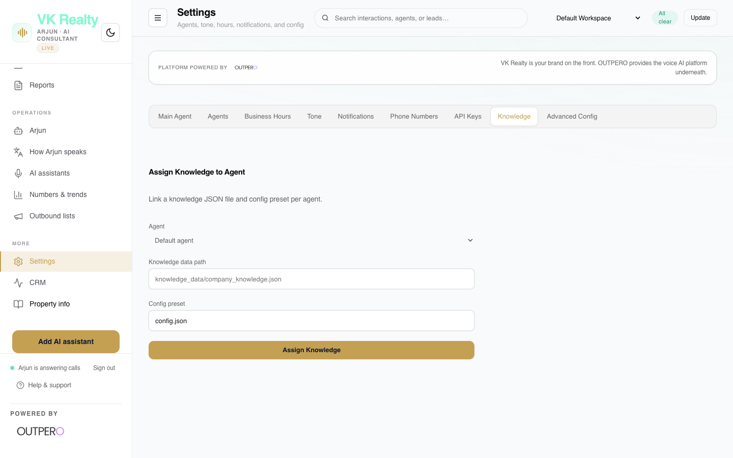
Figure 16: Interface screenshot of the Property Knowledge Base dashboard tab.
Key Capabilities:
- Upload property PDFs, brochures, and text files directly to the agent's brain.
- Review knowledge packs and assign them to specific virtual agents.
- Update prices, floor availability, and unit counts instantly.

⚡ BUSINESS VALUE: Eliminates AI hallucinations. Arjun will only quote prices, availability, and amenities that are officially uploaded by your marketing team, building trusted, compliant buyer relations.

17. Connections & Integrations
Connect the voice engine to external communication channels, such as WhatsApp messaging APIs, email alerts, and SMS systems.
Target User Role: | Operations Managers & Tech Coordinators
Key Metrics Tracked: | API Connections, Outbound Message Logs.
Non-Technical Benefit: | Engages leads instantly. Buyers immediately receive a high-quality WhatsApp message containing the project brochure, capturing their attention while interest is hot.

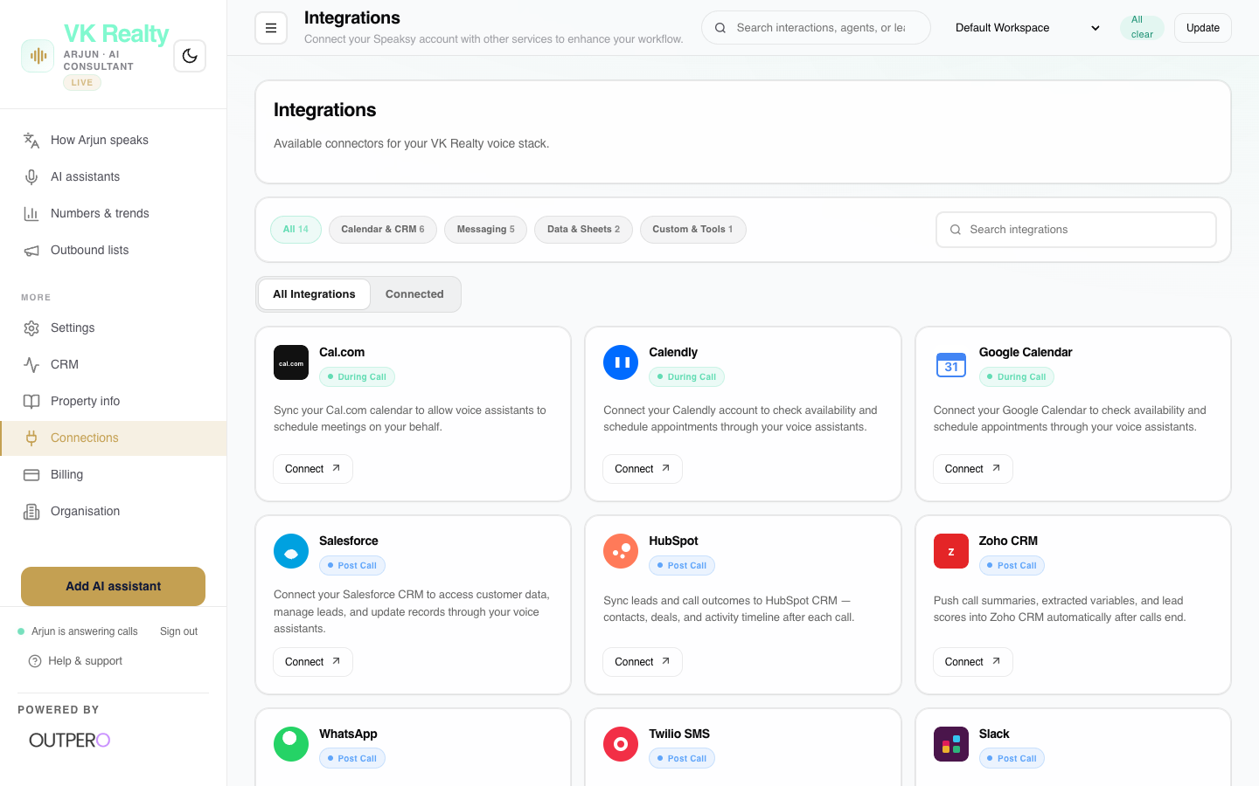
Figure 17: Interface screenshot of the Connections & Integrations dashboard tab.
Key Capabilities:
- Connect WhatsApp template APIs: trigger brochures to send automatically once a call ends.
- Configure email alerts: set up instant manager notifications when a hot lead calls.
- Manage twilio/telephony carrier configurations.

⚡ BUSINESS VALUE: Engages leads instantly. Buyers immediately receive a high-quality WhatsApp message containing the project brochure, capturing their attention while interest is hot.

18. Billing & Usage
A transparent overview of system charges, keeping track of active calling minutes, API usage rates, and invoice statements.
Target User Role: | Finance Department & Broker Owners
Key Metrics Tracked: | Total Minute Balance, Incurred Telephony Charges, Active Subscription Plan.
Non-Technical Benefit: | Ensures complete cost control. You only pay for active conversational minutes, providing massive cost savings compared to setting up a traditional call center.

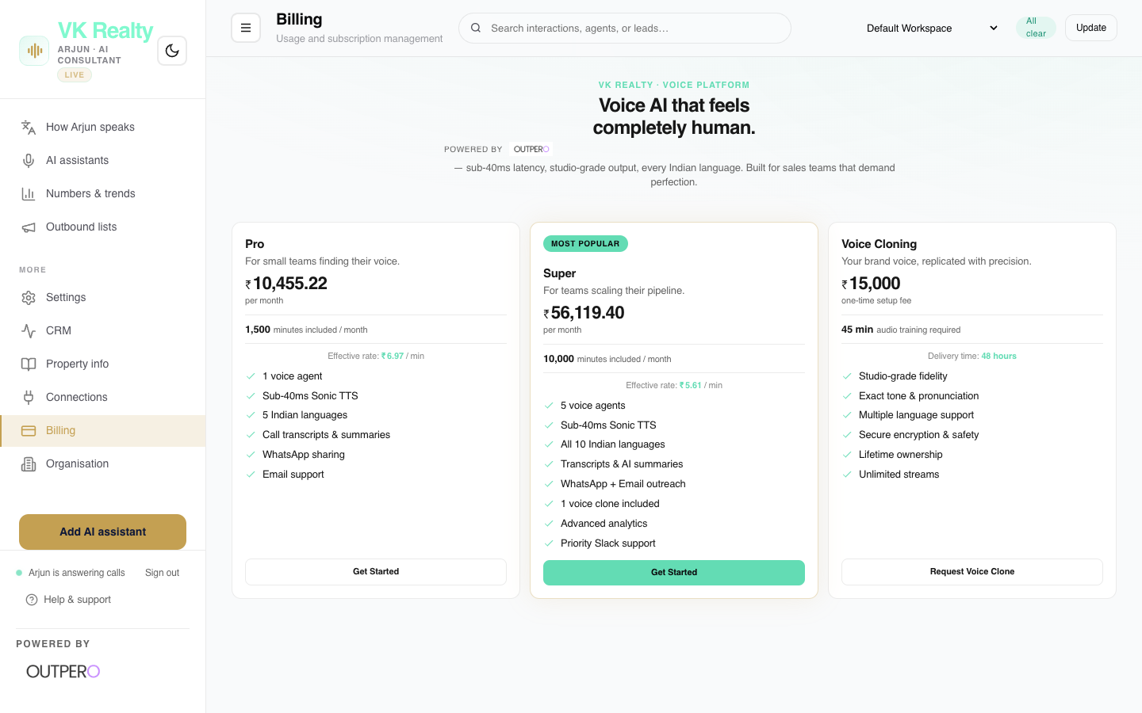
Figure 18: Interface screenshot of the Billing & Usage dashboard tab.
Key Capabilities:
- Review minute usage logs showing billing charges down to the second.
- Download monthly statements and billing invoices.
- Configure payment methods and set auto-recharge thresholds.

⚡ BUSINESS VALUE: Ensures complete cost control. You only pay for active conversational minutes, providing massive cost savings compared to setting up a traditional call center.

19. Organisation Profile
Manage your agency's account profiles, set system preferences, and handle team workspaces.
Target User Role: | Broker Owners & Admins
Key Metrics Tracked: | Workspace Members, Active Roles.
Non-Technical Benefit: | Maintains general platform settings and defines the high-level identity of the VK Realty Command Center.

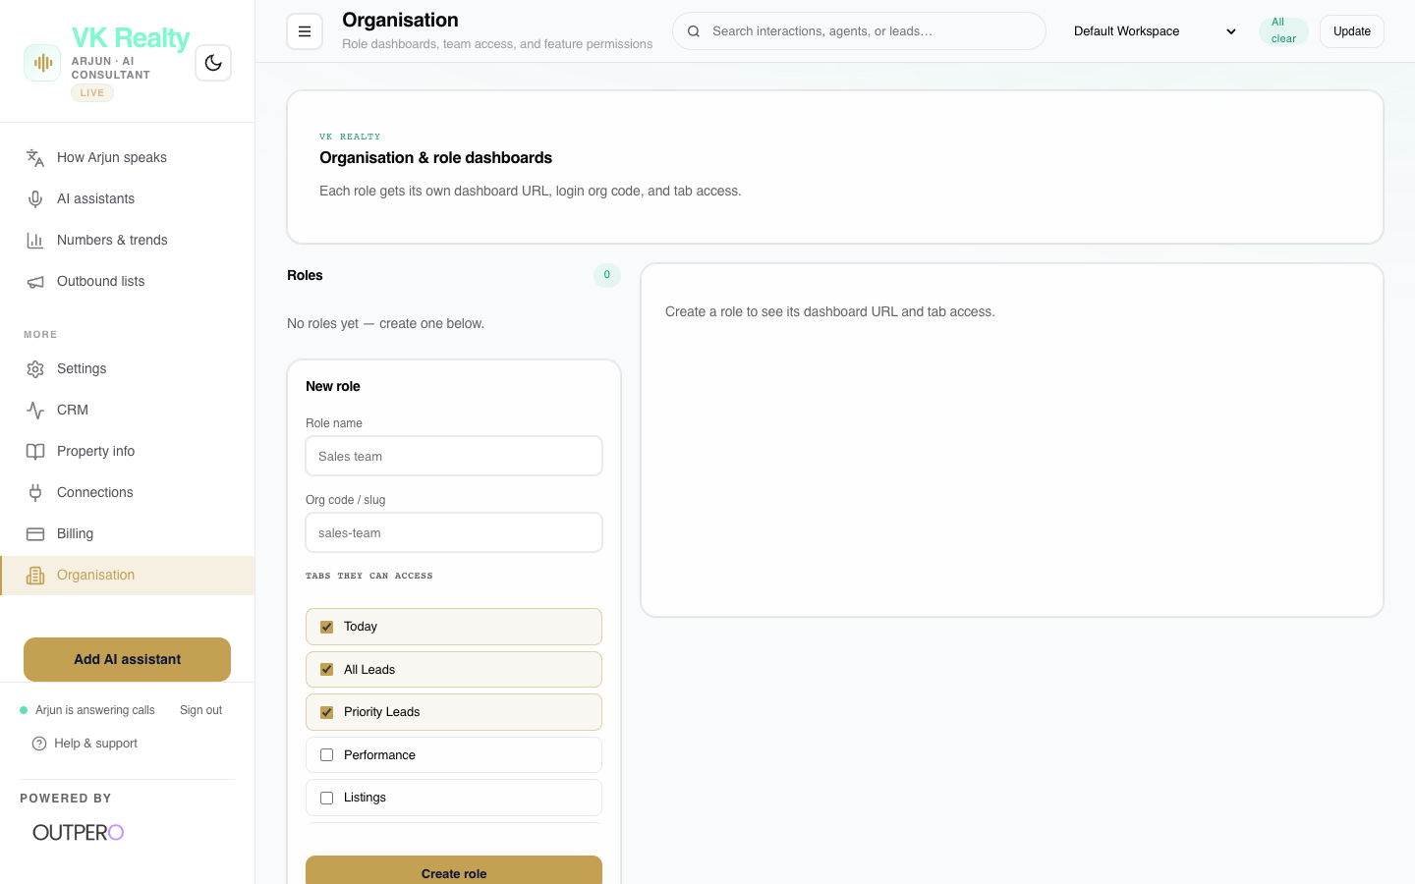
Figure 19: Interface screenshot of the Organisation Profile dashboard tab.
Key Capabilities:
- Edit organization name and configure portal subdomains.
- Review general platform metadata and parameters.
- Configure baseline regional preferences.

⚡ BUSINESS VALUE: Maintains general platform settings and defines the high-level identity of the VK Realty Command Center.

14. Settings Sub-Tabs Directory
The Settings tab acts as the master administrative panel. To keep it organized and secure, it is split into 8 focused sub-panels. Managers can toggle operational hours, edit voice tones, and view system integrations without needing access to backend servers.
Settings: AI Assistants List
Manage permissions, prompts, and status for individual assistant profiles deployed across the organization.
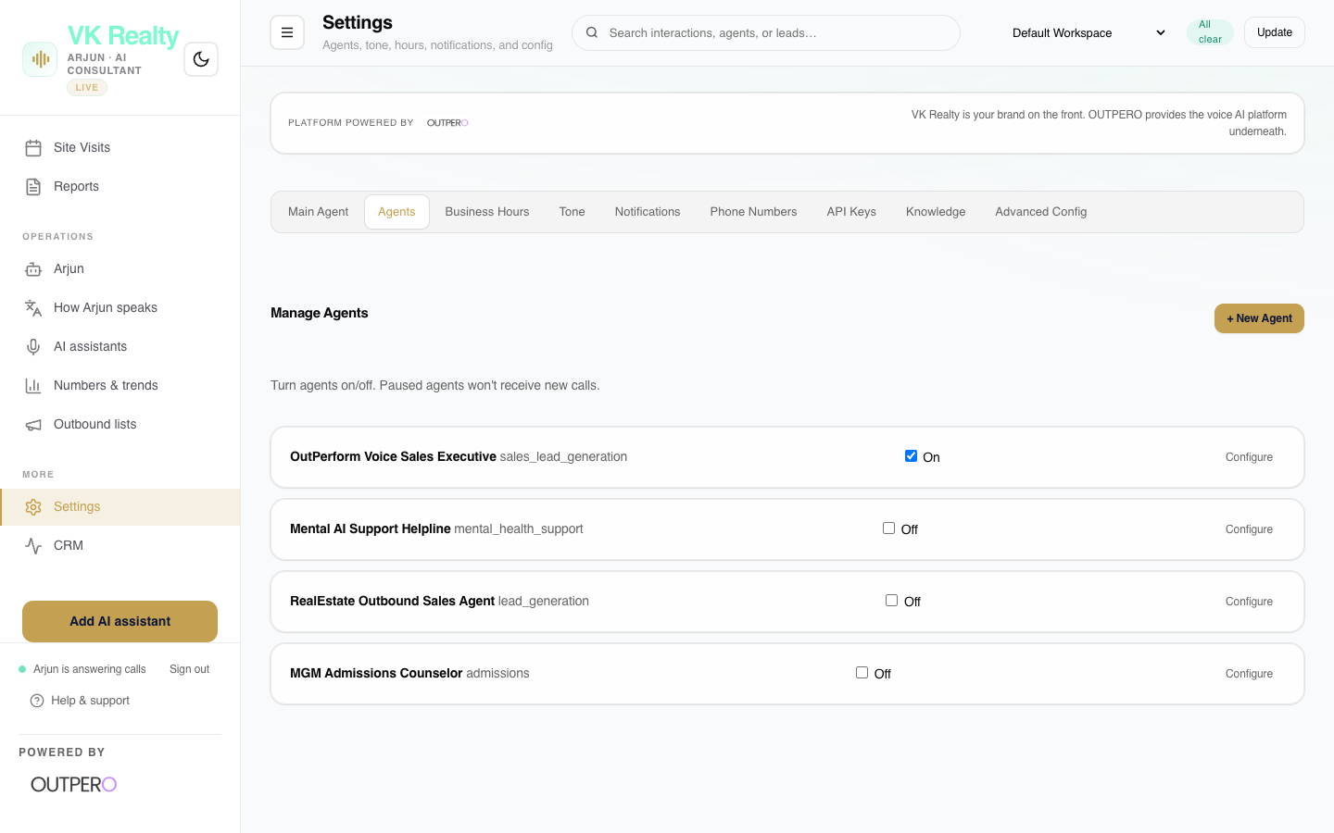
Figure: Settings: AI Assistants List panel view.
Settings: Business Hours
Define when Arjun answers calls (e.g. 24/7 or night-shift only) and setup forward routes for human reps during working hours.
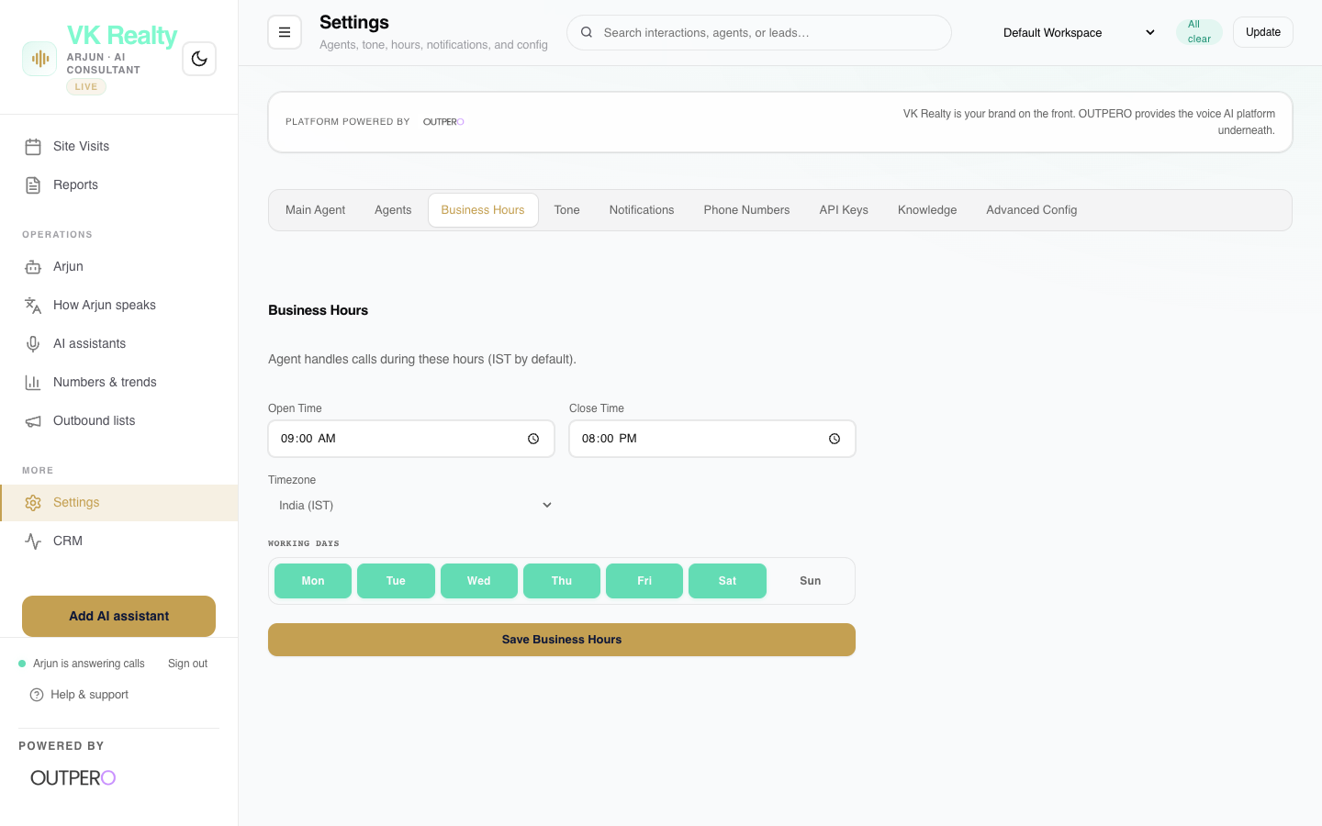
Figure: Settings: Business Hours panel view.
Settings: Agent Tone Configuration
Toggle Arjun's baseline tone styles (Professional, Casual, Warm) and select localized language Presets.
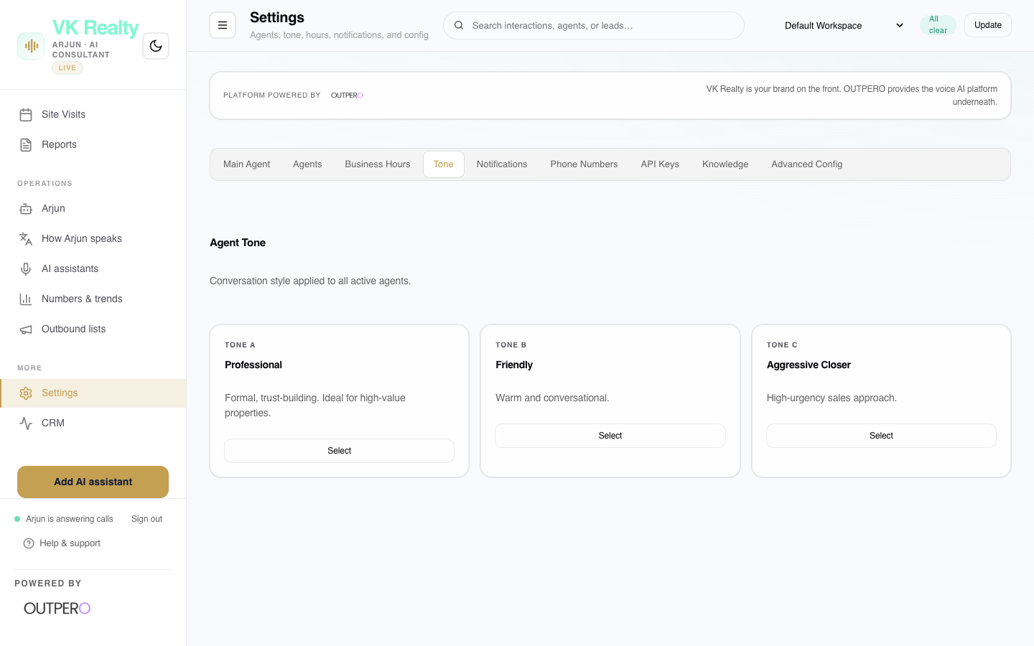
Figure: Settings: Agent Tone Configuration panel view.
Settings: Notifications Setup
Configure instant notification destinations for hot leads. Sets emails and numbers to receive SMS alerts.
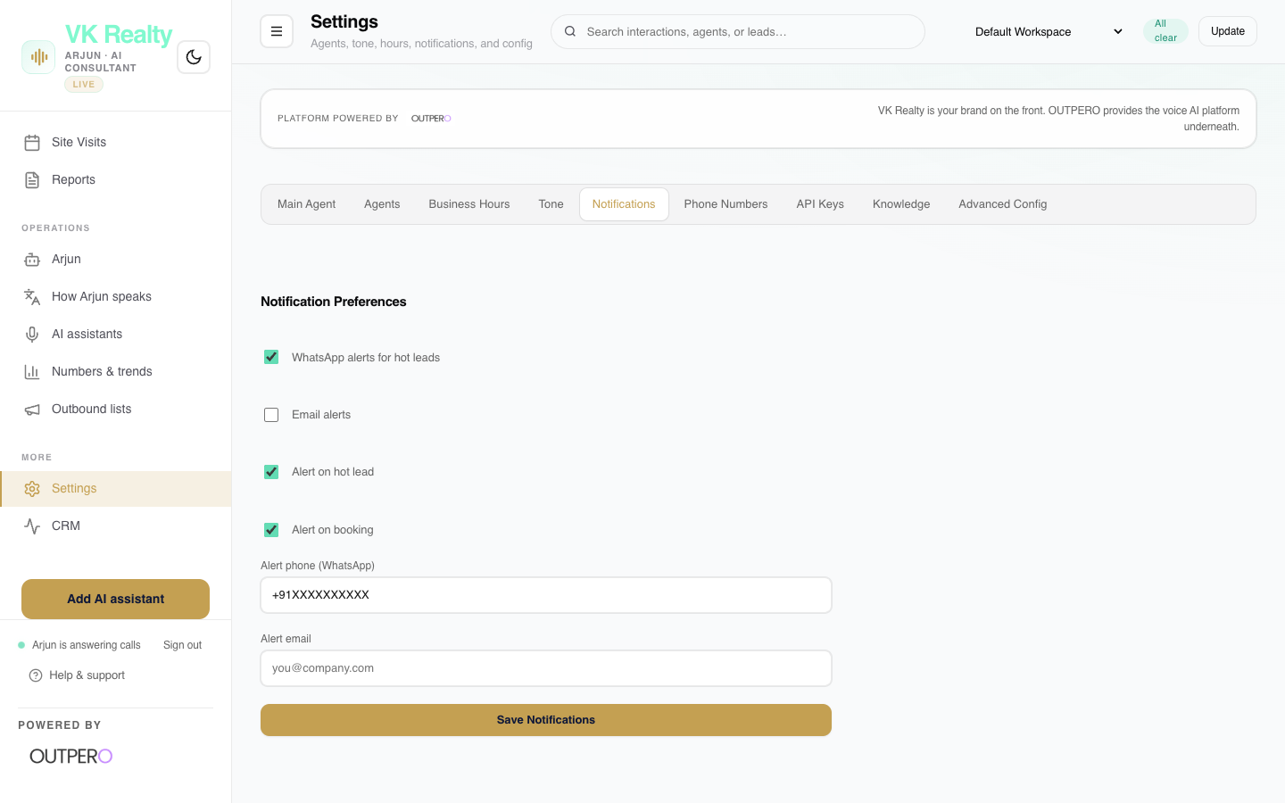
Figure: Settings: Notifications Setup panel view.
Settings: Phone Numbers Management
Link and allocate virtual numbers, setup SIP trunks, and map specific phone lines to active voice agents.
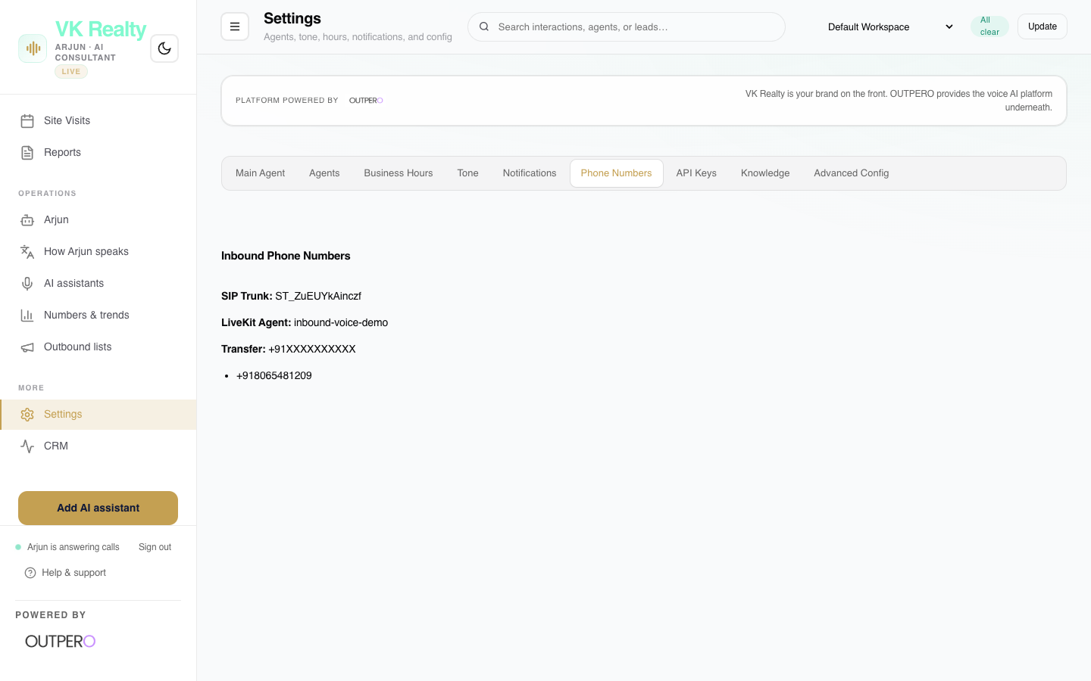
Figure: Settings: Phone Numbers Management panel view.
Settings: Secure API Keys
Displays API credentials for LLM, TTS, STT and databases, protected behind an administrative passcode unlock.
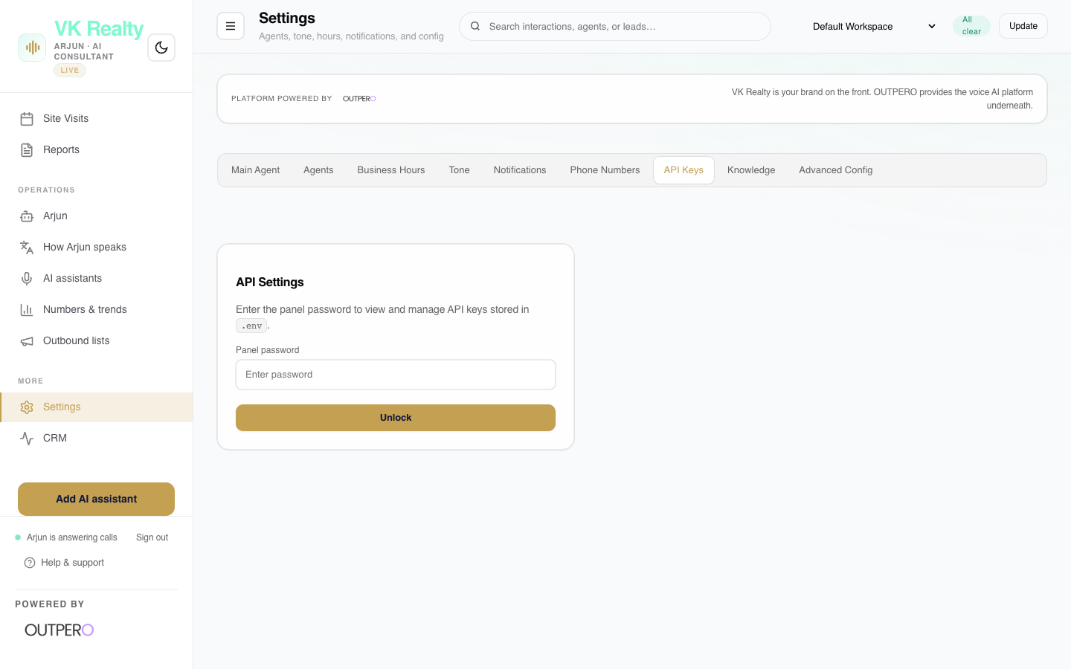
Figure: Settings: Secure API Keys panel view.
Settings: Knowledge Map
Map brochure directories and RAG configurations to specific virtual assistant personas.
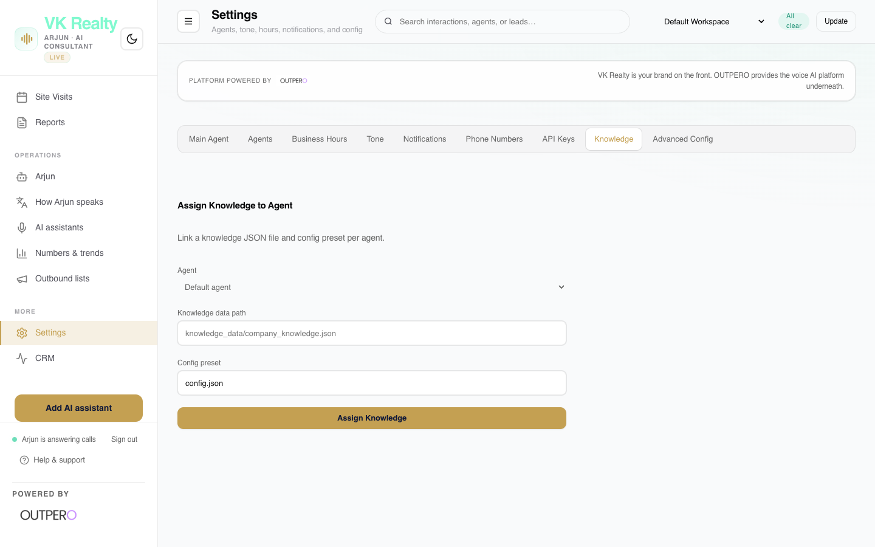
Figure: Settings: Knowledge Map panel view.
Settings: Advanced System Config
Tweak technical audio thresholds: Voice Activity Detection (VAD) delays, ambient background sound volumes, and interruption sensitivities.
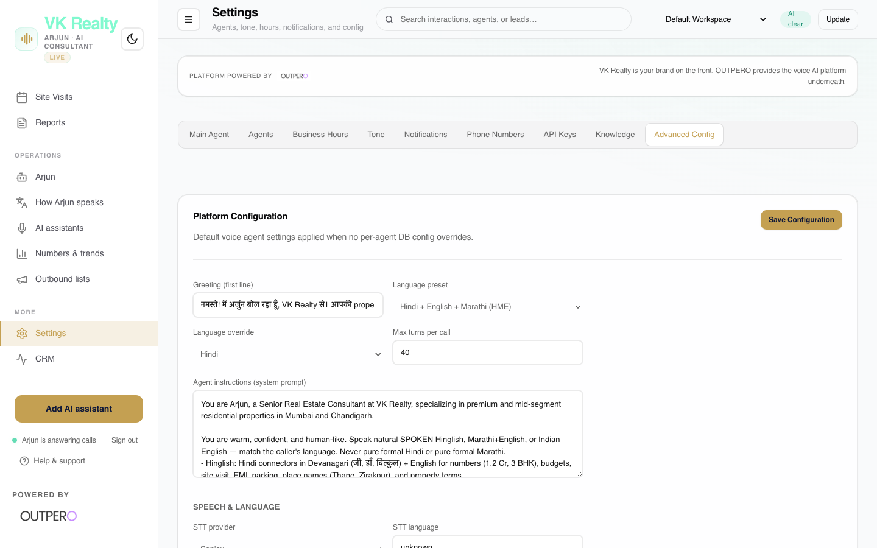
Figure: Settings: Advanced System Config panel view.

VK Realty Client Deliverables Summary
As part of the deployment, VK Realty receives the following operational assets, fully configured and integrated into their sales workflow:
- Arjun: Premium Voice Persona: A custom-trained, low-latency (under 400ms) voice agent acting as a Senior Consultant. Fully optimized for spoken Telugish, Hinglish, and Indian English, handling up to 100 parallel calls.
- VK Realty Custom Dashboard: A white-labeled, branded Command Center (serving at /vk-realty-hme/dashboard) enabling non-technical teams to oversee sales funnels, calendars, and call transcripts.
- Lead Sync & CRM Integrations: Two-way API sync mapping prospect contact data, budgets, and call summaries directly to the client's internal sales CRM.
- Automated Follow-up Telephony: A pre-configured integrations engine linked to Twilio and WhatsApp APIs, triggering immediate WhatsApp brochures and SMS confirmations once a buyer hangs up.
- RAG Knowledge Base Engine: A secure property knowledge base storage system allowing marketers to upload PDFs and Excel sheets, which Arjun references live on calls with zero hallucinations.
- Telephony Infrastructure Setup: A dedicated SIP trunk and VoBiz trunk connection, allowing VK Realty to run inbound and campaign-based outbound calling via secure corporate phone numbers.

⚡ MAINTENANCE & SUPPORT: All components are deployed and monitored by the OUTPERO Operations team. Monthly maintenance covers voice quality checks, custom vocabulary expansion, and RAG search tuning.

