1. Bài tập 1: Sử dụng Animation từ file XML
2. Mô tả ứng dụng

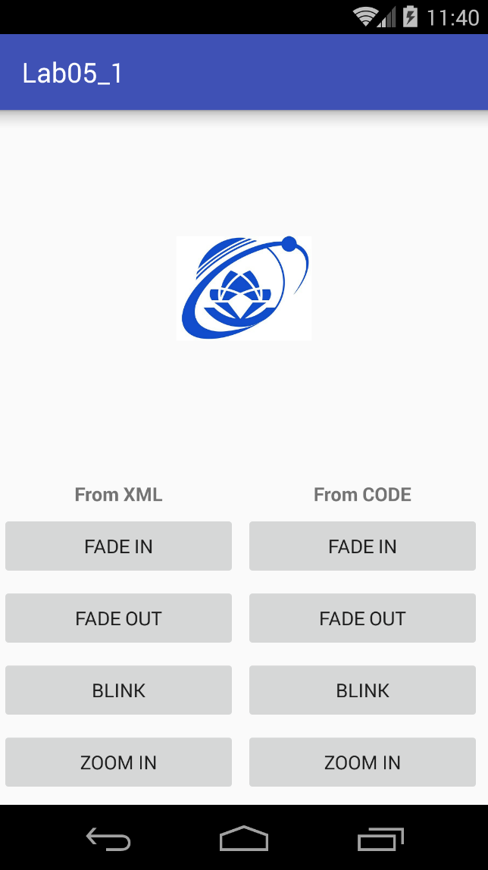Định nghĩa các animation fade in/out, rotate, zoom in/out, move, blink, slide up, bounce, combine… bằng xml từ các animation cơ bản của Android gồm: ScaleAnimation, TranslateAnimation, RotateAnimation, AlphaAnimation để tạo hiệu ứng hiển thị ImageView.

1. Các bước thực hiện

* Xây dựng các file dimens.xml

|  |  |
| --- | --- |
| **Name** | **Value** |
| margin_base | 5dp |
| margin_basex2 | 10dp |
| text_medium | 16sp |
| image_base | 100dp |

* Xây dựng file strings.xml

|  |  |
| --- | --- |
| **Name** | **Value** |
| **from_xml** | From XML |
| **from_code** | From CODE |
| **fade_in** | Fade In |
| **fade_out** | Fade Out |
| **blink** | Blink |
| **zoom_in** | Zoom In |
| **zoom_out** | Zoom Out |
| **rotate** | Rotate |
| **move** | Move |
| **slide_up** | Slide Up |
| **bounce** | Bounce |
| **combine** | Combine |

* Xây dựng giao diện

|  |
| --- |
| *<?***xml version="1.0" encoding="utf-8"***?>* <**LinearLayout xmlns:android="http://schemas.android.com/apk/res/android"  xmlns:tools="http://schemas.android.com/tools"  android:layout_width="match_parent"  android:layout_height="match_parent"  android:orientation="vertical"  tools:context="uit.edu.vn.lab05_1.MainActivity"**>  <**FrameLayout  android:layout_width="match_parent"  android:layout_height="0dp"  android:layout_weight="6"**>  <**ImageView  android:id="@+id/iv_uit_logo"  android:layout_width="@dimen/image_base"  android:layout_height="@dimen/image_base"  android:layout_gravity="center"  android:scaleType="fitCenter"  android:src="@drawable/uit_logo"**/>  </**FrameLayout**>  <**LinearLayout  android:layout_marginTop="@dimen/margin_basex2"  android:layout_width="match_parent"  android:layout_height="wrap_content"  android:orientation="horizontal"**>  <**TextView  android:layout_width="0dp"  android:layout_height="wrap_content"  android:layout_weight="1"  android:text="@string/from_xml"  android:gravity="center"  android:textStyle="bold"  android:layout_marginRight="@dimen/margin_base"**/>  <**TextView  android:layout_width="0dp"  android:layout_height="wrap_content"  android:layout_weight="1"  android:text="@string/from_code"  android:textStyle="bold"  android:gravity="center"  android:layout_marginRight="@dimen/margin_base"**/>  </**LinearLayout**>  <**ScrollView  android:layout_width="match_parent"  android:layout_height="0dp"  android:layout_weight="5"**>  <**LinearLayout  android:layout_width="match_parent"  android:layout_height="wrap_content"  android:orientation="vertical"**>  <**LinearLayout  android:layout_marginTop="@dimen/margin_base"  android:layout_width="match_parent"  android:layout_height="wrap_content"  android:orientation="horizontal"**>  <**Button  android:id="@+id/btn_fade_in_xml"  android:layout_width="0dp"  android:layout_height="wrap_content"  android:layout_weight="1"  android:text="@string/fade_in"  android:gravity="center"  android:layout_marginRight="@dimen/margin_base"**/>  <**Button  android:id="@+id/btn_fade_in_code"  android:layout_width="0dp"  android:layout_height="wrap_content"  android:layout_weight="1"  android:text="@string/fade_in"  android:gravity="center"  android:layout_marginRight="@dimen/margin_base"**/>  </**LinearLayout**>  <**LinearLayout  android:layout_marginTop="@dimen/margin_base"  android:layout_width="match_parent"  android:layout_height="wrap_content"  android:orientation="horizontal"**>  <**Button  android:id="@+id/btn_fade_out_xml"  android:layout_width="0dp"  android:layout_height="wrap_content"  android:layout_weight="1"  android:text="@string/fade_out"  android:gravity="center"  android:layout_marginRight="@dimen/margin_base"**/>  <**Button  android:id="@+id/btn_fade_out_code"  android:layout_width="0dp"  android:layout_height="wrap_content"  android:layout_weight="1"  android:text="@string/fade_out"  android:gravity="center"  android:layout_marginRight="@dimen/margin_base"**/>  </**LinearLayout**>  <**LinearLayout  android:layout_marginTop="@dimen/margin_base"  android:layout_width="match_parent"  android:layout_height="wrap_content"  android:orientation="horizontal"**>  <**Button  android:id="@+id/btn_blink_xml"  android:layout_width="0dp"  android:layout_height="wrap_content"  android:layout_weight="1"  android:text="@string/blink"  android:gravity="center"  android:layout_marginRight="@dimen/margin_base"**/>  <**Button  android:id="@+id/btn_blink_code"  android:layout_width="0dp"  android:layout_height="wrap_content"  android:layout_weight="1"  android:text="@string/blink"  android:gravity="center"  android:layout_marginRight="@dimen/margin_base"**/>  </**LinearLayout**>  <**LinearLayout  android:layout_marginTop="@dimen/margin_base"  android:layout_width="match_parent"  android:layout_height="wrap_content"  android:orientation="horizontal"**>  <**Button  android:id="@+id/btn_zoom_in_xml"  android:layout_width="0dp"  android:layout_height="wrap_content"  android:layout_weight="1"  android:text="@string/zoom_in"  android:gravity="center"  android:layout_marginRight="@dimen/margin_base"**/>  <**Button  android:id="@+id/btn_zoom_in_code"  android:layout_width="0dp"  android:layout_height="wrap_content"  android:layout_weight="1"  android:text="@string/zoom_in"  android:gravity="center"  android:layout_marginRight="@dimen/margin_base"**/>  </**LinearLayout**>  <**LinearLayout  android:layout_marginTop="@dimen/margin_base"  android:layout_width="match_parent"  android:layout_height="wrap_content"  android:orientation="horizontal"**>  <**Button  android:id="@+id/btn_zoom_out_xml"  android:layout_width="0dp"  android:layout_height="wrap_content"  android:layout_weight="1"  android:text="@string/zoom_out"  android:gravity="center"  android:layout_marginRight="@dimen/margin_base"**/>  <**Button  android:id="@+id/btn_zoom_out_code"  android:layout_width="0dp"  android:layout_height="wrap_content"  android:layout_weight="1"  android:text="@string/zoom_out"  android:gravity="center"  android:layout_marginRight="@dimen/margin_base"**/>  </**LinearLayout**>  <**LinearLayout  android:layout_marginTop="@dimen/margin_base"  android:layout_width="match_parent"  android:layout_height="wrap_content"  android:orientation="horizontal"**>  <**Button  android:id="@+id/btn_rotate_xml"  android:layout_width="0dp"  android:layout_height="wrap_content"  android:layout_weight="1"  android:text="@string/rotate"  android:gravity="center"  android:layout_marginRight="@dimen/margin_base"**/>  <**Button  android:id="@+id/btn_rotate_code"  android:layout_width="0dp"  android:layout_height="wrap_content"  android:layout_weight="1"  android:text="@string/rotate"  android:gravity="center"  android:layout_marginRight="@dimen/margin_base"**/>  </**LinearLayout**>  <**LinearLayout  android:layout_marginTop="@dimen/margin_base"  android:layout_width="match_parent"  android:layout_height="wrap_content"  android:orientation="horizontal"**>  <**Button  android:id="@+id/btn_move_xml"  android:layout_width="0dp"  android:layout_height="wrap_content"  android:layout_weight="1"  android:text="@string/move"  android:gravity="center"  android:layout_marginRight="@dimen/margin_base"**/>  <**Button  android:id="@+id/btn_move_code"  android:layout_width="0dp"  android:layout_height="wrap_content"  android:layout_weight="1"  android:text="@string/move"  android:gravity="center"  android:layout_marginRight="@dimen/margin_base"**/>  </**LinearLayout**>  <**LinearLayout  android:layout_marginTop="@dimen/margin_base"  android:layout_width="match_parent"  android:layout_height="wrap_content"  android:orientation="horizontal"**>  <**Button  android:id="@+id/btn_slide_up_xml"  android:layout_width="0dp"  android:layout_height="wrap_content"  android:layout_weight="1"  android:text="@string/slide_up"  android:gravity="center"  android:layout_marginRight="@dimen/margin_base"**/>  <**Button  android:id="@+id/btn_slide_up_code"  android:layout_width="0dp"  android:layout_height="wrap_content"  android:layout_weight="1"  android:text="@string/slide_up"  android:gravity="center"  android:layout_marginRight="@dimen/margin_base"**/>  </**LinearLayout**>  <**LinearLayout  android:layout_marginTop="@dimen/margin_base"  android:layout_width="match_parent"  android:layout_height="wrap_content"  android:orientation="horizontal"**>  <**Button  android:id="@+id/btn_bounce_xml"  android:layout_width="0dp"  android:layout_height="wrap_content"  android:layout_weight="1"  android:text="@string/bounce"  android:gravity="center"  android:layout_marginRight="@dimen/margin_base"**/>  <**Button  android:id="@+id/btn_bounce_code"  android:layout_width="0dp"  android:layout_height="wrap_content"  android:layout_weight="1"  android:text="@string/bounce"  android:gravity="center"  android:layout_marginRight="@dimen/margin_base"**/>  </**LinearLayout**>  <**LinearLayout  android:layout_marginTop="@dimen/margin_base"  android:layout_width="match_parent"  android:layout_height="wrap_content"  android:orientation="horizontal"**>  <**Button  android:id="@+id/btn_combine_xml"  android:layout_width="0dp"  android:layout_height="wrap_content"  android:layout_weight="1"  android:text="@string/combine"  android:gravity="center"  android:layout_marginRight="@dimen/margin_base"**/>  <**Button  android:id="@+id/btn_combine_code"  android:layout_width="0dp"  android:layout_height="wrap_content"  android:layout_weight="1"  android:text="@string/combine"  android:gravity="center"  android:layout_marginRight="@dimen/margin_base"**/>  </**LinearLayout**>  </**LinearLayout**>  </**ScrollView**>  </**LinearLayout**> |

* Định nghĩa animation Fade In trong file xml như sau
* Tạo folder **anim** trong folder **res**
* Tạo file **anim_fade_in.xml** trong folder **anim** với nội dung như sau

|  |
| --- |
| *<?***xml version="1.0" encoding="utf-8"***?>* <**set xmlns:android="http://schemas.android.com/apk/res/android"  android:fillAfter="true"** >   <**alpha  android:duration="1000"  android:fromAlpha="0.0"  android:toAlpha="1.0"** />  </**set**> |

* Khai báo biến và xây dựng các hàm findViewsbyIds và InitVariables

|  |
| --- |
| **private** Button **btnFadeInXml**, **btnFadeInCode**, **btnFadeOutXml**, **btnFadeOutCode**, **btnBlinkXml**,  **btnBlinkCode**, **btnZoomInXml**, **btnZoomInCode**, **btnZoomOutXml**, **btnZoomOutCode**, **btnRotateXml**,  **btnRotateCode**, **btnMoveXml**, **btnMoveCode**, **btnSlideUpXml**, **btnSlideUpCode**, **btnBounceXml**,  **btnBounceCode**, **btnCombineXml**, **btnCombineCode**; **private** ImageView **ivUitLogo**; **private** Animation.AnimationListener **animationListener**; |
| **private void** findViewsByIds() {  **ivUitLogo** = (ImageView) findViewById(R.id.***iv_uit_logo***);  **btnFadeInXml** = (Button) findViewById(R.id.***btn_fade_in_xml***);  **btnFadeInCode** = (Button) findViewById(R.id.***btn_fade_in_code***);  **btnFadeOutXml** = (Button) findViewById(R.id.***btn_fade_out_xml***);  **btnFadeOutCode** = (Button) findViewById(R.id.***btn_fade_out_code***);  **btnBlinkXml** = (Button) findViewById(R.id.***btn_blink_xml***);  **btnBlinkCode** = (Button) findViewById(R.id.***btn_blink_code***);  **btnZoomInXml** = (Button) findViewById(R.id.***btn_zoom_in_xml***);  **btnZoomInCode** = (Button) findViewById(R.id.***btn_zoom_in_code***);  **btnZoomOutXml** = (Button) findViewById(R.id.***btn_zoom_out_xml***);  **btnZoomOutCode** = (Button) findViewById(R.id.***btn_zoom_out_code***);  **btnRotateXml** = (Button) findViewById(R.id.***btn_rotate_xml***);  **btnRotateCode** = (Button) findViewById(R.id.***btn_rotate_code***);  **btnMoveXml** = (Button) findViewById(R.id.***btn_move_xml***);  **btnMoveCode** = (Button) findViewById(R.id.***btn_move_code***);  **btnSlideUpXml** = (Button) findViewById(R.id.***btn_slide_up_xml***);  **btnSlideUpCode** = (Button) findViewById(R.id.***btn_slide_up_code***);  **btnBounceXml** = (Button) findViewById(R.id.***btn_bounce_xml***);  **btnBounceCode** = (Button) findViewById(R.id.***btn_bounce_code***);  **btnCombineXml** = (Button) findViewById(R.id.***btn_combine_xml***);  **btnCombineCode** = (Button) findViewById(R.id.***btn_combine_code***); } |
| **private void** initVariables() {  **animationListener** = **new** Animation.AnimationListener() {  @Override  **public void** onAnimationStart(Animation animation) {   }   @Override  **public void** onAnimationEnd(Animation animation) {  Toast.*makeText*(getApplicationContext(), **"Animation Stopped"**,  Toast.***LENGTH_SHORT***).show();   }   @Override  **public void** onAnimationRepeat(Animation animation) {   }  }; } |

* Override hàm onCreate để load và start Animation khi user nhấn vào button tương ứng:

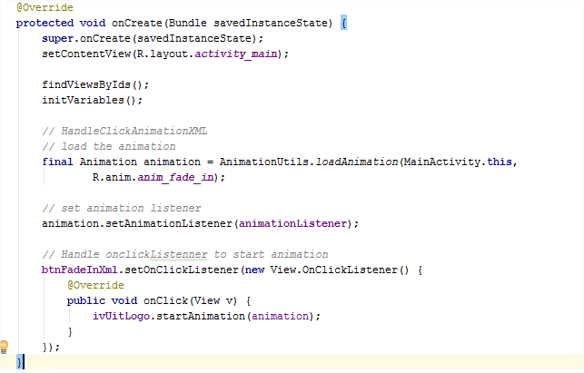

**Yêu cầu:** Hiện tại, animation Fade In đã được gắn cho ivUitLogo khi user nhấn btnFadeInXml. Sinh viên chỉnh sửa, bổ sung code để các animation hoạt động khi user nhấn vào các button (btn**Something**Xml) tương ứng.

**Hướng dẫn:** Sinh viên thực hiện các bước sau

* Định nghĩa các animation còn lại vào các file xml tương ứng

|  |  |
| --- | --- |
| Tên file | Nội dung |
| anim_blink.xml | *<?***xml version="1.0" encoding="utf-8"***?>* <**set xmlns:android="http://schemas.android.com/apk/res/android"**>  <**alpha android:fromAlpha="0.0"  android:toAlpha="1.0"  android:duration="300"  android:repeatMode="reverse"  android:repeatCount="3"**/> </**set**> |
| anim_bounce.xml | *<?***xml version="1.0" encoding="utf-8"***?>* <**set xmlns:android="http://schemas.android.com/apk/res/android"  android:fillAfter="true"  android:interpolator="@android:anim/bounce_interpolator"**>  <**scale  android:duration="500"  android:fromXScale="1.0"  android:fromYScale="0.0"  android:toXScale="1.0"  android:toYScale="1.0"** />  </**set**> |
| anim_fade_out.xml | *<?***xml version="1.0" encoding="utf-8"***?>* <**set xmlns:android="http://schemas.android.com/apk/res/android"  android:fillAfter="true"** >  <**alpha  android:duration="1000"  android:fromAlpha="1.0"  android:toAlpha="0.0"** /> </**set**> |
| anim_move.xml | *<?***xml version="1.0" encoding="utf-8"***?>* <**set  xmlns:android="http://schemas.android.com/apk/res/android"  android:interpolator="@android:anim/linear_interpolator"  android:fillAfter="true"**>   <**translate  android:fromXDelta="0%p"  android:toXDelta="75%p"  android:duration="800"** /> </**set**> |
| anim_rotate.xml | *<?***xml version="1.0" encoding="utf-8"***?>* <**set xmlns:android="http://schemas.android.com/apk/res/android"**>  <**rotate android:fromDegrees="0"  android:toDegrees="360"  android:pivotX="50%"  android:pivotY="50%"  android:duration="600"  android:repeatMode="restart"  android:repeatCount="2"  android:interpolator="@android:anim/cycle_interpolator"**/> </**set**> |
| anim_slide_up.xml | *<?***xml version="1.0" encoding="utf-8"***?>* <**set xmlns:android="http://schemas.android.com/apk/res/android"  android:fillAfter="true"** >   <**scale  android:duration="500"  android:fromXScale="1.0"  android:fromYScale="1.0"  android:toXScale="1.0"  android:toYScale="0.0"** />  </**set**> |
| anim_zoom_in.xml | *<?***xml version="1.0" encoding="utf-8"***?>* <**set xmlns:android="http://schemas.android.com/apk/res/android"  android:fillAfter="true"** >   <**scale  xmlns:android="http://schemas.android.com/apk/res/android"  android:duration="1000"  android:fromXScale="1"  android:fromYScale="1"  android:pivotX="50%"  android:pivotY="50%"  android:toXScale="3"  android:toYScale="3"** >  </**scale**> </**set**> |
| anim_zoom_out.xml | *<?***xml version="1.0" encoding="utf-8"***?>* <**set xmlns:android="http://schemas.android.com/apk/res/android"  android:fillAfter="true"** >   <**scale  xmlns:android="http://schemas.android.com/apk/res/android"  android:duration="1000"  android:fromXScale="1.0"  android:fromYScale="1.0"  android:pivotX="50%"  android:pivotY="50%"  android:toXScale="0.5"  android:toYScale="0.5"** >  </**scale**> </**set**> |
| anim_combine.xml | *<?***xml version="1.0" encoding="utf-8"***?>* <**set xmlns:android="http://schemas.android.com/apk/res/android"  android:fillAfter="true"  android:interpolator="@android:anim/linear_interpolator"** >   <**scale  xmlns:android="http://schemas.android.com/apk/res/android"  android:duration="4000"  android:fromXScale="1"  android:fromYScale="1"  android:pivotX="50%"  android:pivotY="50%"  android:toXScale="3"  android:toYScale="3"** >  </**scale**>   *<!-- Rotate 180 degrees -->* <**rotate  android:duration="500"  android:fromDegrees="0"  android:pivotX="50%"  android:pivotY="50%"  android:repeatCount="2"  android:repeatMode="restart"  android:toDegrees="360"** />  </**set**> |

* Chuyển nội dung đoạn code **load animation từ xml và bắt sự kiện onClick cho button** (trong hàm onCreate ở trên) vào 1 hàm mới:

|  |
| --- |
| **private void** handleClickAnimationXml(Button btn, **int** animId)  {  // Sinh viên tự sửa lại code cho phù hợp  } |

Trong đó: btn sẽ được truyền vào là một Button và animId là id của file Xml tương ứng với animation cần set cho button đó.

* Cuối cùng, lần lượt gọi hàm handleClickAnimationXml trong hàm onCreate() như sau:

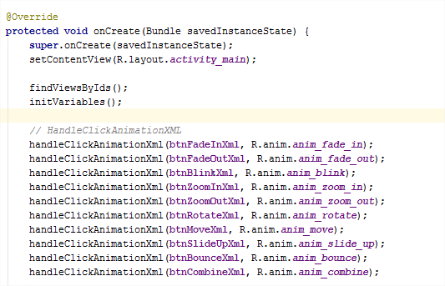

1. Bài tập 2: Sử dụng Animation từ code

Sinh viên tiếp tục sử dụng nội dung thực hành ở Bài tập 1 để thực hiện tiếp Bài tập 2.

* Xây dựng hàm handleClickAnimationCode

|  |
| --- |
| **private void** handleClickAnimationCode(Button btn, **final** Animation animation) {   *// Handle onclickListenner to start animation* btn.setOnClickListener(**new** View.OnClickListener() {  @Override  **public void** onClick(View v) {  **ivUitLogo**.startAnimation(animation);  }  });  } |

* Xây dựng hàm khởi tạo Fade In animation từ AlphaAnimation

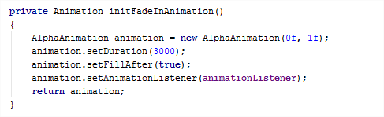

* Gọi hàm xử lý sự kiện click button tương ứng trong hàm onCreate()

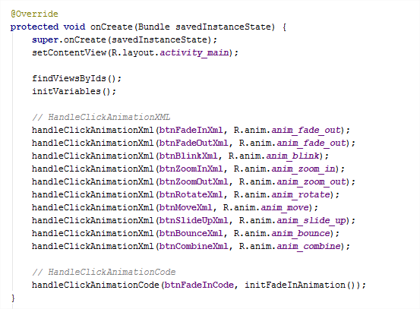

**Yêu cầu:** sinh viên tự xây dựng các hàm khởi tạo Fade Out, Blink và gắn sự kiện click cho các button btnFadeOutCode, btnBlinkCode.

1. Bài tập 3: Tạo animation khi start Activity mới

Các bước thực hiện:

* Tạo một activity mới với giao diện như hình:

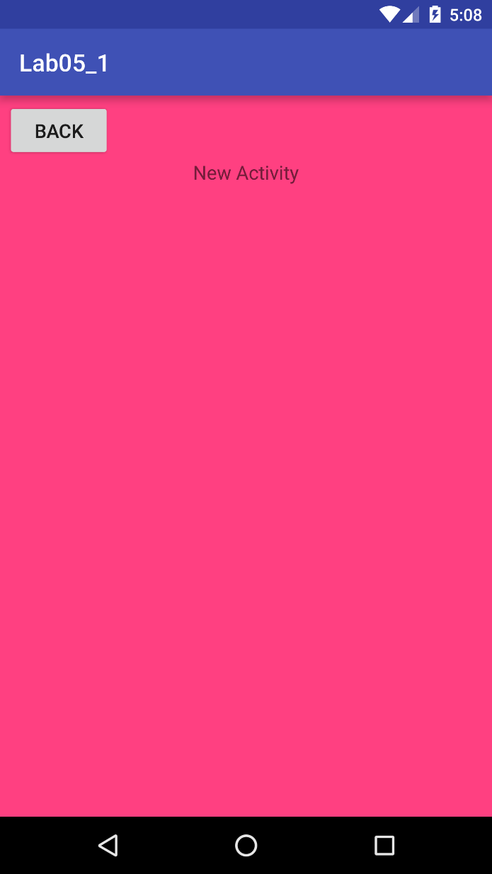

Khi user nhấn Back, ứng dụng sẽ finish activity hiện tại (new activity) để trở về MainActivity.

* Bắt sự kiện click ivUitLogo để start activity mới và set animation (fade in/out) khi chuyển đổi giữa 2 activity

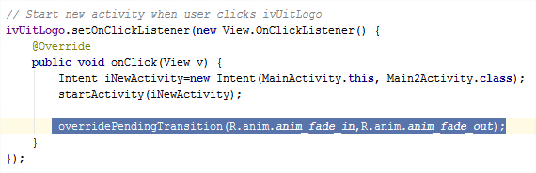

Yêu cầu: sinh viên đổi animation chuyển giữa 2 activity thành dạng new activity đẩy MainActivity từ phải qua trái như hình minh họa

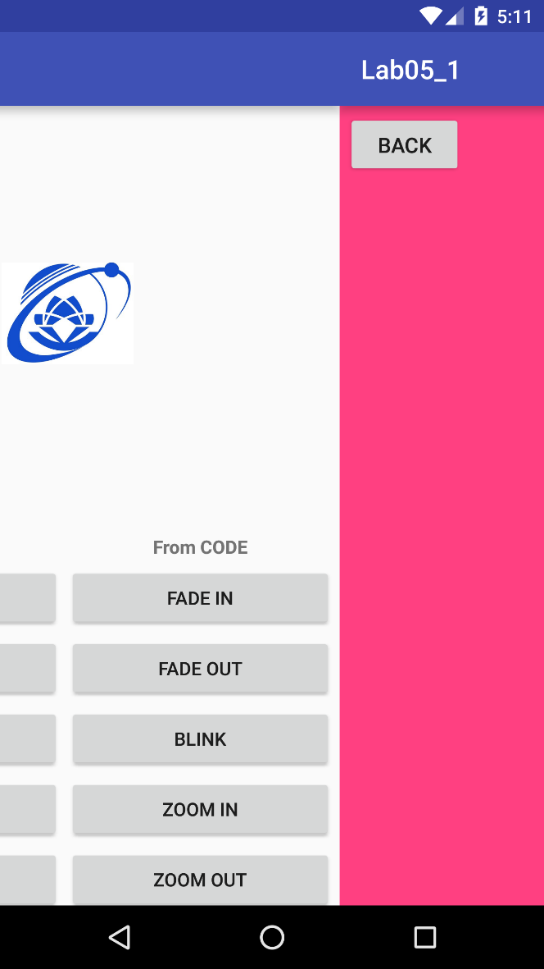

Phải qua trái

1. THAM KHẢO THÊM (Tự xem thêm)
2. **Google Cloud Message**
   * <https://duythanhcse.wordpress.com/2014/10/30/bai-50-cach-su-dung-google-cloud-message-trong-android/>
   * <https://techmaster.vn/posts/33846/google-cloud-messaging-gui-push-notifications>
3. **Google Maps APIs**
   * <https://duythanhcse.wordpress.com/2014/12/20/bai-53-google-maps-android-api-phan-1/>
   * <https://duythanhcse.wordpress.com/2014/12/21/bai-54-google-maps-android-api-phan-2/>
   * <http://t3h.vn/lap-trinh-di-dong/tin-tuc/Kham-pha-lap-trinh-di-dong/Google-Maps-Android-API-phan-1-479>
4. **Get Location**
   * <https://developer.android.com/training/location/retrieve-current.html>
   * <http://stackoverflow.com/questions/17591147/how-to-get-current-location-in-android>
5. Task thường gặp khi đi làm

Sử dụng **retrofit** gọi 1 API từ server. Sau đó, parse JSON (từ API trả về) thành list các java objects sử dụng **GSON**. Hiển thị list java object lên listview (có thể dùng **QuickAdapter** để custom). Mỗi item trong listview tương ứng một java object. Mỗi object có 1 url dẫn tới hình ảnh (icon) trên mạng. Dùng **Glide** để hiển thị hình ảnh (icon) đó cho từng object.