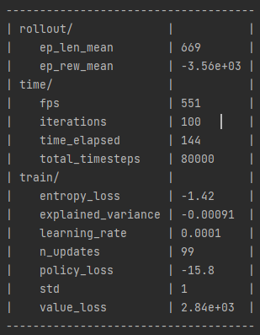

****ep_rew mean****: accumulated reward from each episode, so large  
****entropy_loss****: indicating that the probability distribution of actions is relatively even and the uncertainty is high. The closer it is to 0, the more stable it is  
****Explained variance****: It measures the accuracy of value prediction. The closer it is to 1, the better. Now that it is close to 0, it indicates that the prediction ability is relatively low.  
****Policy loss****: Gradient ascent should normally be positive, but here it is negative.  
****Value loss****: It is very large, which may indicate that there is a numerical overflow.

The performance of this model is not good enough and is also unstable.

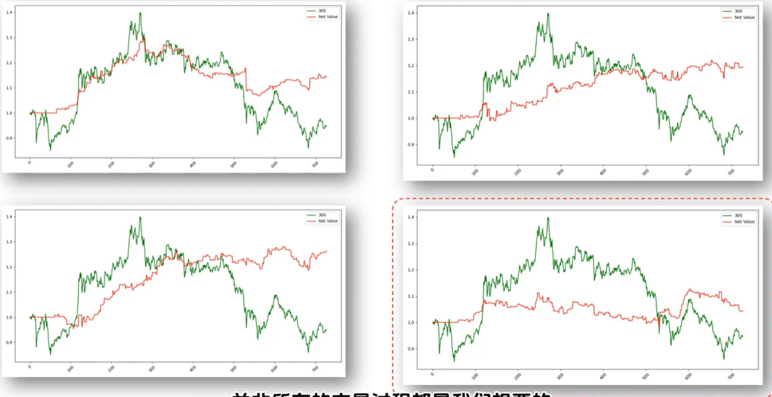

****insufficient data****: The data volume is not sufficient; at least 100,000 data points are needed.  
****data granularity****: The granularity of daily frequency data is too coarse. More detailed data, such as minute-level or order flow data, is required.  
****State design****: The market conditions and account data are simply concatenated without any processing.  
****Reward****: There is room for further optimization(****most important factor in reinforcement learning****).  
****Hyperparameter tuning****: Comparative analysis is necessary.