**Winter Semester 2022 – 2023**

**CSE4022 – Natural Language Processing**

**Task – 3**

Name: T Harshitha Deepthi Date: 13-01-23

Reg no: 20BCE2019

Slot: E1+TE1

Venue: SJT626

**Task – 1**

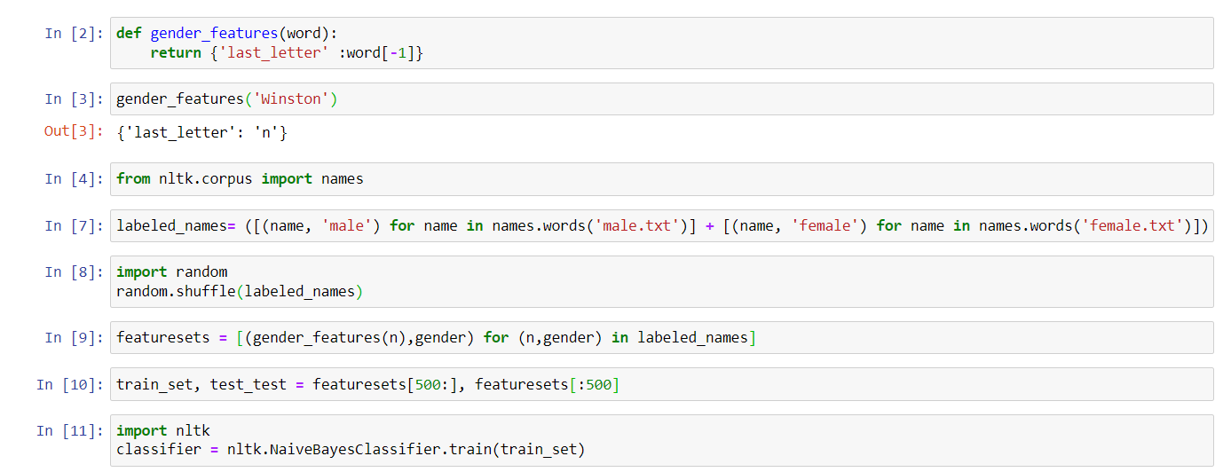

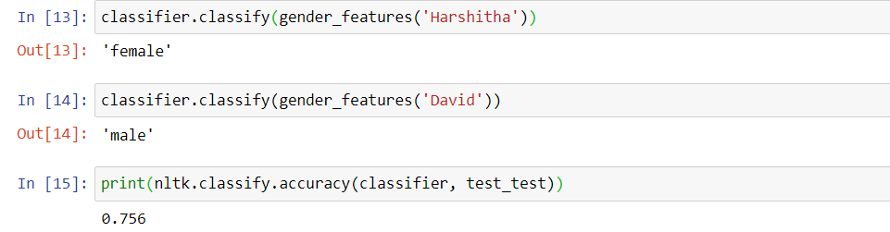

**Task -2**

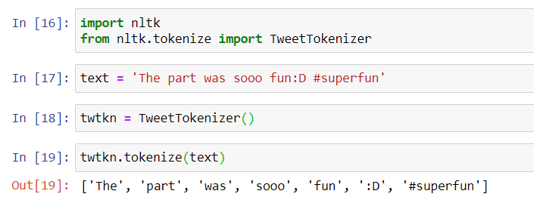

**Task – 3**

