Freight Rate Prediction — Approach & Results
Machine Learning Engineer Assessment — Spotter

1. Train / test validation approach
train_test.csv covers Jan 1 – Oct 31, 2025 (48,000 loads); the final validation.csv set to score (12,000 loads) covers Nov 1 – Dec 31, 2025 — dates the model never sees during development. A random row-wise split would let the model “see” every month during training and understate real error on genuinely future loads, so an out-of-time split was used instead:
- Train: Jan 1 – Aug 31, 2025 (38,477 rows)
- Held-out test: Sep 1 – Oct 31, 2025 (9,523 rows, never used in training or imputation)
All medians used for missing-value imputation were computed on the training rows only, so no information from the held-out period (or from validation.csv) leaks into preprocessing. Once the candidate models were compared on this held-out split, the winning model was refit on the full train_test.csv (Jan–Oct) before generating the actual validation.csv and December predictions.

2. Key findings from data exploration
- posted_rate is strongly driven by distance, but non-linearly: rate-per-mile falls as distance grows (economies of scale), so log(distance) explains log(posted_rate) far better than a linear distance term (R² ≈ 0.94 in an OLS log-log check, vs. ≈ 0.83 for a plain linear fit).
- Equipment type shifts the average rate-per-mile: Reefer > Flatbed > Dry Van (~$2.38, $2.29, $2.12 per mile on average).
- market_index and quote_signal each add a small but real amount of explanatory power on top of distance and equipment.
- There is a mild upward drift in rates across the training months (Jan → Oct), consistent with a seasonal/inflationary trend; day-of-week has almost no effect.
- 64 pickup/delivery cities appear in train_test.csv. validation.csv introduces 8 cities never seen in training (e.g. Chicago, Charlotte, San Diego) — any model relying on city identity directly (e.g. target-encoded city) would have no signal for these rows, so lane geometry (distance, lat/lon) was used instead of city identity.

3. Data-quality issues identified and how they were addressed
- Negative weight values (292 of 48,000 training rows, ~0.6%; 145 of 12,000 validation rows): magnitudes were in the normal range for the field, indicating a sign-entry error rather than bad data — corrected with abs(weight) rather than dropping the rows.
- Missing weight (300 training / 165 validation rows) and missing market_index (374 training / 249 validation rows), each under 1% of rows: both fields have very weak correlation with posted_rate (|r| < 0.04), so training-set median imputation was used, paired with a binary missing-value flag per field so the model can still distinguish imputed from observed rows.
- No duplicate load_id values, no non-positive distances or rates, and no fully duplicate rows were found.
- distance (the field used in modeling) and the great-circle distance implied by the lat/lon columns correlate at 0.9995, confirming the coordinates and distances are mutually consistent (the ~1.18x ratio between them reflects road routing vs. straight-line distance, not a data error).

4. Feature engineering
- log(distance) — primary driver, captures the economies-of-scale curve
- distance, haversine great-circle distance, and their ratio (route circuity) — cross-check / redundancy signal
- equipment (one-hot: Dry Van / Reefer / Flatbed)
- weight (cleaned), with a missing-value indicator
- market_index and quote_signal, each with a missing-value indicator where relevant
- day_of_year, month, day_of_week — captures the mild seasonal drift observed in EDA
- pickup/delivery latitude & longitude directly (not city identity) — generalizes to the unseen cities in validation.csv

5. Model selection
Three candidates were trained on the Jan–Aug split and scored on the held-out Sep–Oct split, all on log(posted_rate):
Model | MAE ($) | RMSE ($) | MAPE | R²
Ridge (chosen) | 107.93 | 633.23 | 4.77% | 0.8278
Random Forest | 133.36 | 638.17 | 5.86% | 0.8251
HistGradientBoosting | 117.32 | 636.37 | 5.09% | 0.8261

Ridge regression (with feature standardization, α selected by cross-validation) had the lowest MAE and highest R² of the three, matching the earlier EDA finding that log(rate) is close to log-linear in distance plus a handful of secondary features. Random Forest and HistGradientBoosting did not improve on this — the extra model flexibility mainly fit training-set noise rather than generalizable structure. Ridge was also preferred for a practical reason specific to this task: tree ensembles cannot extrapolate a trend past the maximum date seen in training, whereas a linear day-of-year term in Ridge extends smoothly into November/December, which is exactly the period being forecast. Ridge (log-target, α = 10, refit on all of train_test.csv) is the final model used for both validation_predictions.csv and the December forecast.

6. December 2025 forecast — Lexington → Fort Wayne, Dry Van, 360 mi, 32,000 lb
This exact lane/equipment/weight combination appears 67 times across the training months, so the December forecast is a genuine interpolation rather than an extrapolation into unfamiliar lane space. market_index and quote_signal (not provided for December) were set to their most recent (October) training-set averages as the best available proxy for prevailing market conditions.
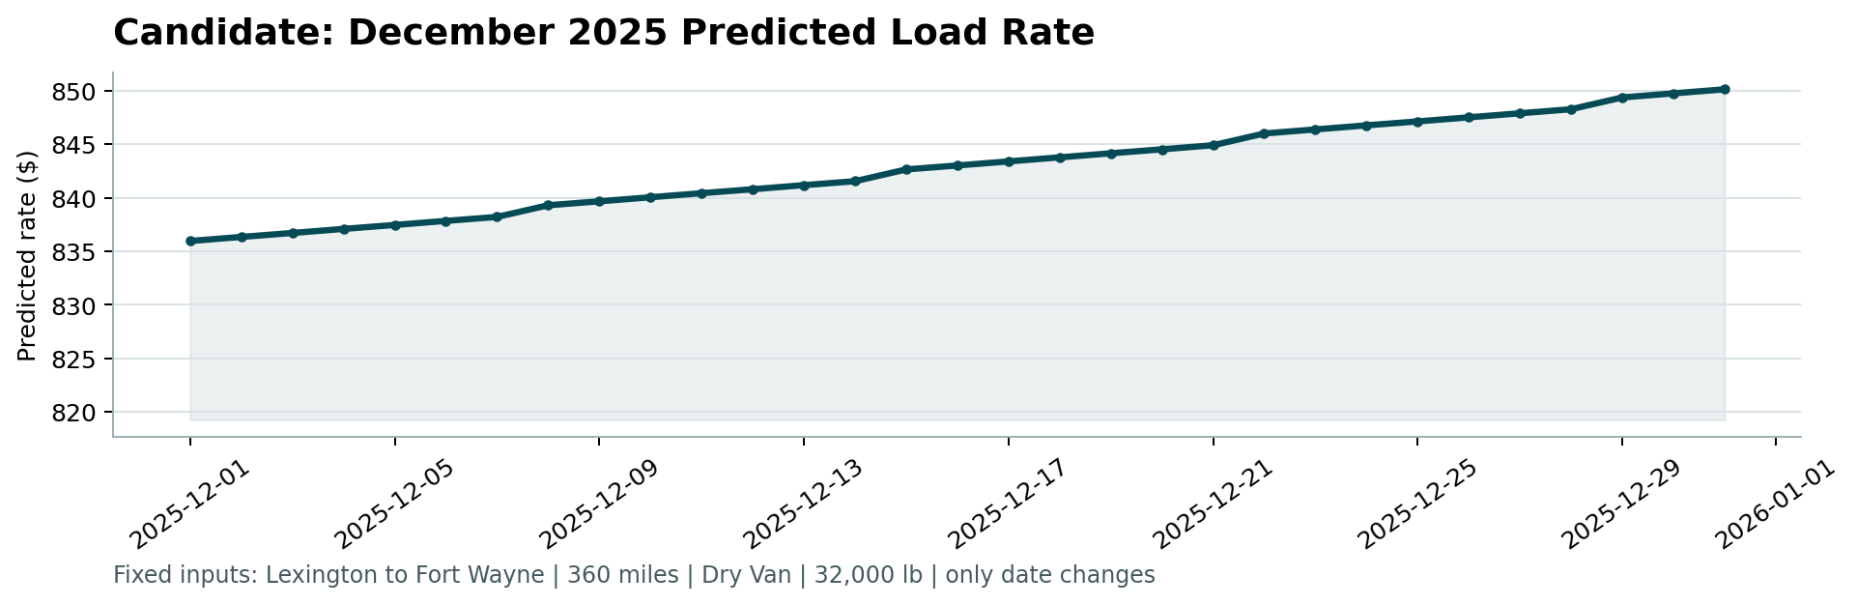
The forecast shows a gentle, steady increase across December (~$836 → ~$850, +1.7%) consistent with the mild time trend the model learned from the Jan–Oct data, plus a small day-of-week ripple.

7. Code walkthrough (see repository for full detail)
- src/features.py — shared cleaning (abs(weight)) and feature-engineering logic used identically for train, held-out test, validation, and December data, so there is no train/serve skew.
- src/train.py — loads train_test.csv, performs the Jan–Aug/Sep–Oct split, fits and compares the three candidate models, refits the chosen Ridge model on all of train_test.csv, and writes validation_predictions.csv and the completed December file.
- score.py — provided validator; confirmed both output files pass its checks and used it to generate the December chart above.

