AIVOA.AI

AI Product Engineer Challenge
Build an AI-Powered Deviation Intake Module
GOAL • Build a working Deviation Management workflow for an API pharmaceutical manufacturer.

1. What You Need to Build
Build this workflow: Deviation document / text → AI extraction → Log Deviation form → AI impact & severity assistance → user review → save.
Example scenario: An API manufacturing batch has a process parameter outside its approved range. The user should be able to report the event and use AI to structure the information.

2. Reference UI
Use the screenshot below as the UI reference. You may improve the design, but keep the workflow simple and professional.
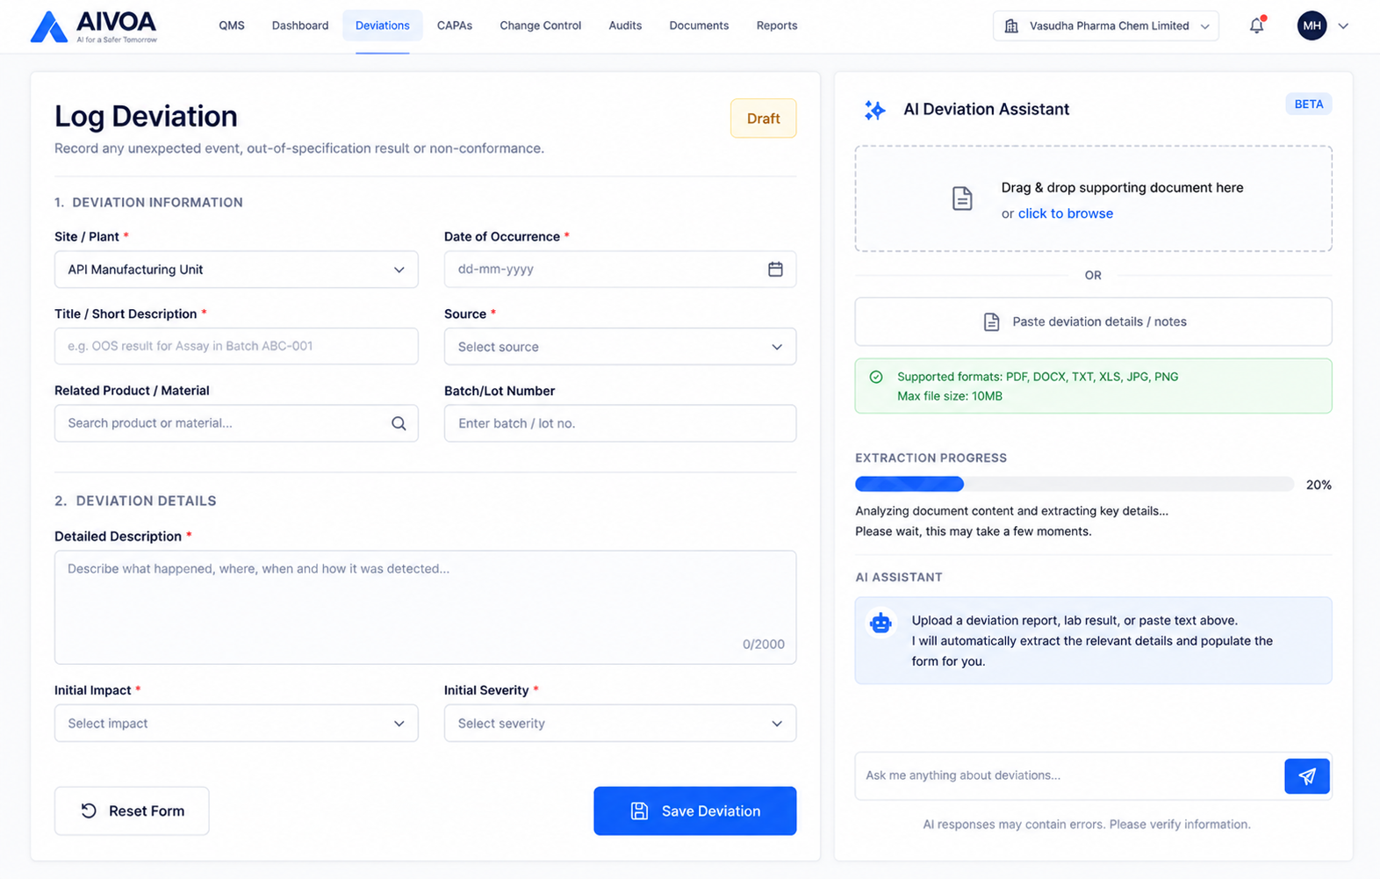
IMPORTANT • The demo video is for the Customer Complaint module. DO NOT build the Complaint module. Use the video only to understand the AI workflow and interaction pattern, then build the equivalent workflow for Deviations.

3. Reference Demo Video
https://drive.google.com/file/d/1av2lzDPx8YMSzTrIz7w51HTRWBz3_5Nj/view?usp=sharing
AIVOA- complaints module demo.mp4

4. AI Requirements
• Accept a deviation document or pasted text/email.
• Use AI to extract relevant information and populate the form.
• Provide an initial impact/severity recommendation with a short reason.
• Let the user review and edit AI-generated information before saving.
Note: You should not fill the left form manually instead utilize AI panel to fill out the left form as demonstrated in the Reference demo video

5. Technology
Frontend  React + Redux | Backend  Python + FastAPI | AI  LangGraph + Groq | Database  PostgreSQL / MySQL
Groq: gemma2-9b-it or llama-3.3-70b-versatile or any other reliable model.

6. Demo & Submission
Demo video (5–8 min): Show the working workflow first, then briefly explain the key implementation.
Show: input → AI processing → extracted form → impact/severity → review → save.
Important:
Do not upload the project, source code, demo video, assignment files, screenshots, sample documents, or any other assignment materials to GitHub or any public repository.
Submit your completed work only through the submission form below.

Deliverables
- 5–10 minutes demo video explaining:(2 video submission)
  - Working demonstration of all implemented AI tools and frontend features.
  - Demonstrate and explain the code by walking through the complete end-to-end workflow, starting from the user's input (prompt or PDF/email upload) in the frontend, showing the relevant frontend code, API endpoints, backend processing, AI/LangGraph workflow, and finally how the response populates the Log Customer Complaint form and AI Copilot Risk Assessment.
Submission Form: https://forms.gle/omEkJWxrve4ZrYbs9
Deadline: 36 hours

7. What We Look For
Take ownership. Research what you need, make sensible product decisions, and build a complete working flow without waiting for every detail to be specified.
AI coding tools are allowed and encouraged. You should understand what you build and be able to explain or modify it during the interview.

