**Weight loss**

**Is a concern for most of us and with the proper nutrition and exercise it can easily be a success story.**

Here are some weight loss products and a plan to feed your body what it needs to unlock fat stores, reset your biological terrain to get off that plateau and start reaching your ultimate goal,

**Loose weight.**

**Feel good.**

**Look good.**

**Maintain.**

**For life.**

*Cleansing*, *Foot Spa Detoxing*, *PH balanced 9.5 water* and more are aids to weight loss. Check out our links to these to see the added benefits.

**First up**, Fat Grabbers, put the *squeeze* on dietary fat.

(**RYAN** pic of fat grabbers goes here)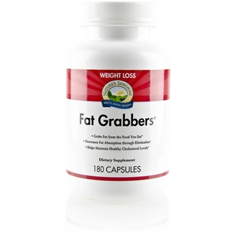 Patented FAT GRABBERS helps reduce the amount of dietary fat your body absorbs. It contains:

* **Chickweed** – *Breaks down fat in the stomach and intestines.*
* **Lecithin –** *emulsifies fat in water, breaking it into tiny globules.*
* **Psyllium hulls and guar gum –** interfere with the absorption of emulsified fat from the small intestine, grabbing a portion of fat and allowing it to be eliminated from the body before complete digestion occurs.

**Here is the game plan:**

**Choose one from each list**

**STEP 1: choose a cleanse**

**Tiao He Cleanse** 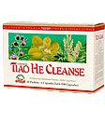

Absorbs toxins, supports the liver and gall bladder

**Clean Start** 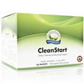

Promotes elimination of waste, soothes bowel

**STEP 2:** Choose a meal replacement

**Love & Peas** 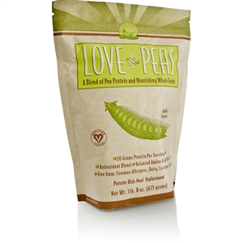

Provides essential nutrition 20g of protein per serving, supports urinary and circulatory, powerful antioxidant

**Natures Harvest**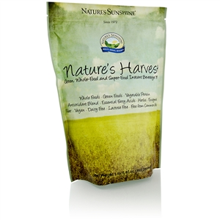

Meal replacement, green foods, antioxidants, essential fatty acids, nutritive herbs, fiber and more, allergen free

**STEP 3:** Address weight management

**Stixated** 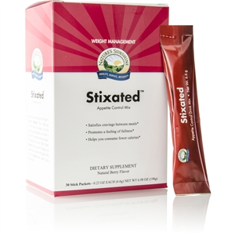

Satisfies cravings between meals promotes feeling of fullness

**Ultra Therm** 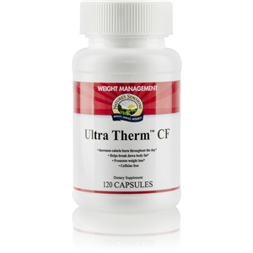

Increase calorie burn all day, helps break down body fat

**Garcinia** 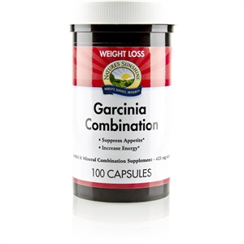

Suppresses appetite, maintains blood sugar levels

**SweetFx** 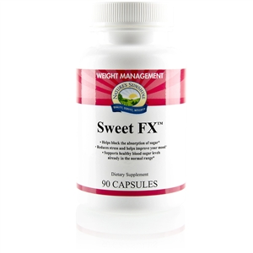

Helps block the absorption of sugar

**STEP 4:** Eat essential foods

Here are some great tips to get started:

* Choose an alkaline diet, avoid acidic foods such as soda.
* raw foods such as dark leafy greens and vegetables and when cooked, lightly steamed or blanched, this helps to keep our enzymes that digest food and reduces gas and bloating
* fruits and berries
* nuts and nut butters
* sprouted whole grains
* real butter
* good fats such as, olive oil, coconut oil, avocados, and more
* ½ your body weight in ounces of water a day
* Blending fruits and vegetables can be an excellent source of nutrients, antioxidants, fiber, energy, essential fatty acids by adding flax seeds, coconut oil, and more getting in a substantial amount in one cup for the day. Add a little fresh ginger, turmeric, parsley, chia seeds or hemp seeds for extra added benefit and energy.
* Buy organic to avoid the pesticides, herbicides, fungicides, and more that the body stores in fat in order to buffer the organs from toxicity, the goal is to burn fat not store more in it.

**STEP 5:** Exercise

Yup, there is no magic pill, exercise is essential to looking good and feeling great; however, look at the bright side, there are many great benefits in addition to loosing pounds that exercise can bestow upon us. Exercise and breathing deep keeps our lymphatic system moving keeping waste out and nutrients in, keeps our skin glowing and releases those good endorphins to keep emotional well being in check, drops pounds, tones and tightens and keeps us limber. Find a program that you are comfortable with that works for you.

GO Team look good and feel great, for life!

Lets do this!

Any questions, I am here to help, please send an email to [Shelley@HerbsforThought.com](mailto:Shelley@HerbsforThought.com)

Here’s to your health!