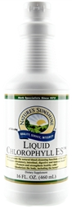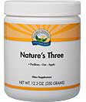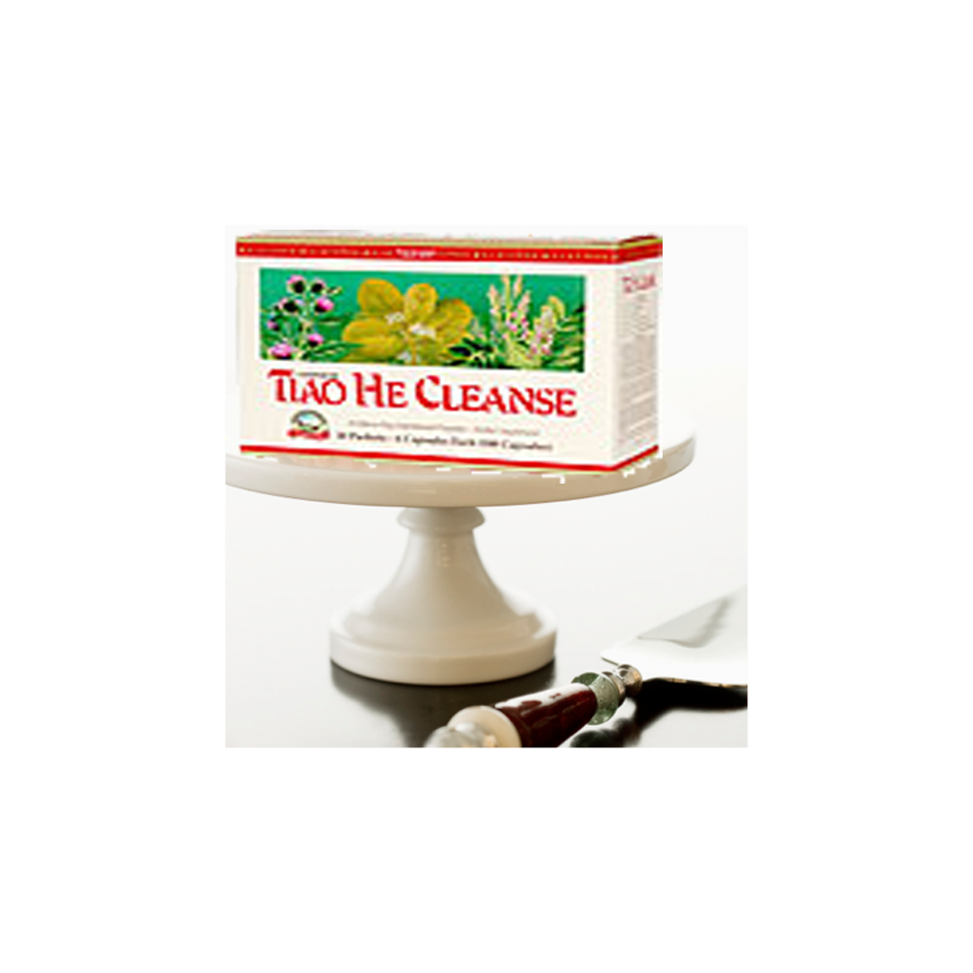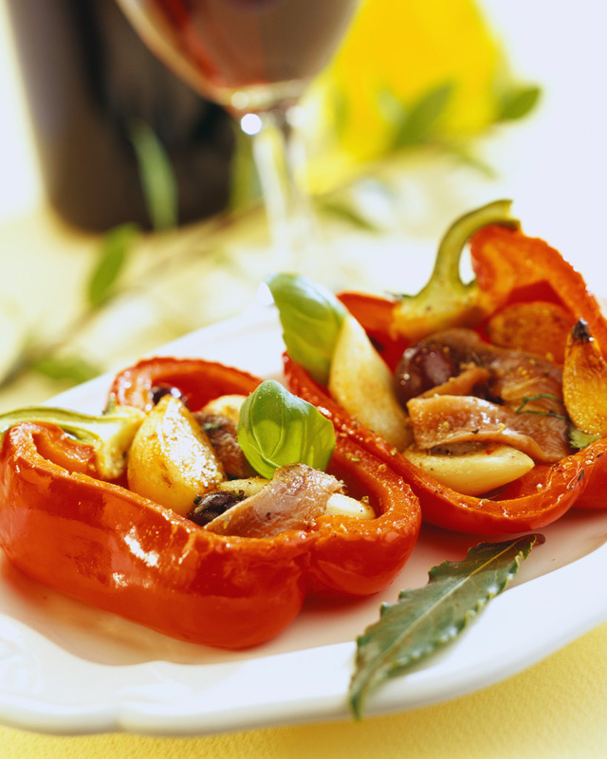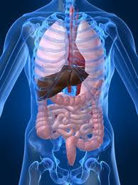[](mailto:https://www.paypal.com/cgi-bin/webscr?cmd=_s-xclick&hosted_button_id=LJ6TFNMMNCPJQ)

Four

Five

Eat a diet of fresh fruit, vegetables, especially green leafy and whole grains.

After the first morning packet, take Nature’s Three fiber to absorb the toxic waste being purged.

Drink ½ your body weight in water daily to flush out the toxins. If you Weigh 100 pnds drink 50 oz. of water. Add Chlorophyll in the water for energy, cleansing and more.

Avoid: Meat, sugary and fried foods, dairy, caffeine, soda, coffee, and alcohol.

Three

First

Second

Take 3 packages a day, one in the morning, one in the afternoon and one at night for 10 days.

“Summer time is around the corner… time to LOOK GOOD AND FEEL GREAT”

“Drop pounds, flatten tummy, gain energy, follow a simple meal plan and feel like a whole new you!”

It’s a piece of cake…really!

**IT’S TIME TO CLEANSE**

Tiao He Cleanse is a 10-day nutritional program designed to help the body achieve ***balance and harmony.*** It combines Chinese nutritional and Western herbal experience. The Tiao He Cleanse is designed to support the cleansing mechanisms of the body by targeting the intestinal, digestive and circulatory systems. So, you say, just what results can I expect from the Tiao He Cleanse? The cleanse often yields results of glowing skin, weight loss, flattened tummy, regularity in bowl movements, energy, restful sleep, mood elevation, symptomatic relief, many symptoms simply disappear after doing the Tiao He Cleanse and one feels fabulous. Here’s why…

more on 2

Here’s how it works:

## Tiao He Cleanse: Balance & Harmony

+

February, 2015

Contact me via email: Cleanse@HerbsforThought.com

*This information is not meant to diagnose, but rather to improve our health by educating ourselves.*

Hygiene isn’t only on the outside; it is taking care of the inside too

**Waste no more, Start on your road to better health now!**

**Click the “Pay Pal”** button and select “Cleanse Package” to order now

### Clean your internal house, it is important to your well being

Most of us think about hygiene as taking a shower, brushing our teeth, combing our hair, even vacuuming the rug, doing the dishes, washing our car; however, do we ever think about keeping things running efficient on the inside? Just like a well lubed car, if you don’t drain the dirty oil and put in fresh clean oil the cars engine cannot run efficiently and will lock up; our bodies will do the same over time. Our body is like a furnace that needs good fuel to burn. If garbage is put in for a period of time, it no longer runs at optimum levels and instead is bogged down and sick and tired. As we put in our bodies fats, carcinogens, anti-biotics, preservatives, additives, substances that turn into toxic waste, the body has to store it somewhere and that is in fat pockets that can eventually become cysts, boils, and tumors. Detoxing the body with the Tiao he cleanse purges toxic waste from your liver, colon and down to the cellular level freeing up the body from the waste it was swimming in to now gain energy, loose weight, eliminate bowls properly to feel GREAT. optimum levels