Mississippi River System
Dry Barge Fleet Acquisition Analysis

Market Assessment & Fleet Demographics
USACE Waterborne Commerce Data | 2013-2023

Prepared: February 2026

CONFIDENTIAL — FOR INTERNAL USE ONLY

1. Executive Summary

Fleet Snapshot (2023)
Metric | Value
Total Dry Barges (Mississippi) | 19,407
Covered Hopper Barges | 11,337
Open Hopper Barges | 8,070
Covered/Open Ratio | 1.40x
Unique Operators | 420
Average Fleet Age | 21.3 years
Median Fleet Age | 22.0 years
Oldest Active Build Year | 1934
Newest Build Year | 2023
10-Year Fleet Growth | +1,984 barges
Top-3 Operator Concentration | 45.9%
HHI (Market Concentration) | 953

Bull Case for Acquisition
The Mississippi River dry barge fleet has grown from 17,423 to 19,407 barges over the 2013-2023 period, a net increase of 1,984 units driven primarily by covered hopper expansion tied to grain export growth. The covered fleet now represents 58.4% of the total, reflecting the structural shift from coal to agricultural commodities as the dominant inland waterway cargo.
The fleet faces a significant replacement cliff. With an average age of 21.3 years and industry-standard economic life of 25-30 years, a substantial portion of the fleet will require replacement within the next decade. Meanwhile, new construction capacity is severely constrained following the Jeffboat closure in 2018, which eliminated the largest inland barge builder in North America. Remaining yards — primarily Arcosa Marine (formerly Trinity) and Heartland Barge — face order backlogs extending 18-24 months. This supply-demand imbalance supports elevated secondhand barge values and strengthens the case for acquiring existing fleet assets.
U.S. grain exports remain the primary demand driver. USDA long-term projections show corn and soybean export volumes growing at 1-2% annually through 2032, underpinned by global protein demand, ethanol mandates, and the cost advantage of Mississippi River transportation versus rail and truck. South American production volatility and recurring low-water events on competing river systems (Parana/Paraguay) further support U.S. waterway utilization.

Bear Case & Risk Factors
Coal transportation, historically the backbone of the open hopper fleet, continues its structural decline. EIA data shows U.S. coal production has fallen over 40% from its 2008 peak, with utility retirements accelerating the trend. While some open hoppers have been repurposed for aggregates and industrial minerals, the coal-to-gas transition represents permanent demand destruction for roughly 15-20% of the open hopper fleet.
Trade policy risk remains elevated. The 2018-2019 U.S.-China trade war demonstrated the vulnerability of grain barge demand to tariff escalation, with Chinese soybean purchases shifting to Brazil during the dispute. Any renewal of agricultural trade tensions would directly impact covered hopper utilization. Additionally, prolonged low-water events on the Mississippi — as occurred in 2022 — can severely restrict barge loadings and disrupt supply chains for extended periods.
New construction costs have escalated significantly, with covered hoppers now pricing at $750,000-$950,000 per unit depending on specifications, up from approximately $500,000-$600,000 a decade ago. While this supports secondhand values, it also raises the cost of fleet renewal and expansion for any acquirer planning a growth strategy.

Acquisition Signal Matrix
Factor | Signal | Assessment
Fleet Age Profile | Avg 21 yrs, retirement cliff approaching | Positive
Builder Capacity | Jeffboat closed; 18-24 mo backlogs at remaining yards | Positive
Grain Export Outlook | USDA projects 1-2% annual growth through 2032 | Positive
Coal Demand Trend | 40%+ decline from peak; structural, not cyclical | Negative
Market Concentration | Top-3 hold 46%; fragmented tail | Neutral — M&A opportunity
Secondhand Values | Elevated due to constrained supply; $350-550K for 5-10 yr units | Positive (for sellers)
Trade Policy | China tariff risk on grain; recurring threat | Negative
Low-Water Risk | 2022 event disrupted season; climate-driven frequency increasing | Negative
Regulatory | No major pending changes; subchapter M for towboats already absorbed | Neutral

2. Fleet Overview

Historical Fleet Size (2013-2023)
Year | Total Fleet | Covered | Open | Covered %
2013 | 17,423 | 9,661 | 7,762 | 55.4%
2014 | 17,598 | 9,746 | 7,852 | 55.4%
2015 | 17,773 | 10,144 | 7,629 | 57.1%
2016 | 18,092 | 10,542 | 7,550 | 58.3%
2017 | 18,122 | 10,733 | 7,389 | 59.2%
2018 | 18,108 | 10,870 | 7,238 | 60.0%
2020 | 18,856 | 11,209 | 7,647 | 59.4%
2021 | 18,917 | 11,101 | 7,816 | 58.7%
2022 | 19,283 | 11,301 | 7,982 | 58.6%
2023 | 19,407 | 11,337 | 8,070 | 58.4%

The Mississippi River dry barge fleet grew by 1,984 units over the ten-year observation period, a compound growth rate of approximately 1.1% annually. Growth was concentrated in covered hoppers, which added 1,676 barges while open hoppers added 308.
Note: 2019 fleet data is unavailable due to a gap in the USACE data publication cycle. Trend lines interpolate across this gap. All fleet counts reflect region 4 (Mississippi River System) vessels classified as dry covered or open hopper barges per USACE VTCC coding. The 2022 VTCC reclassification (from 4A40/4A41 to 4A47/4A48) has been normalized by combining legacy and current codes.
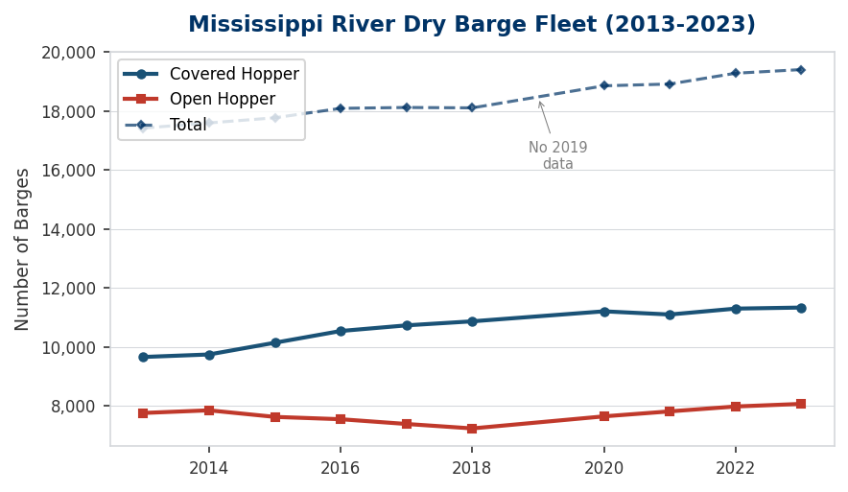
Figure 2.1: Fleet Size Trend — Covered vs Open Hopper (2013-2023)

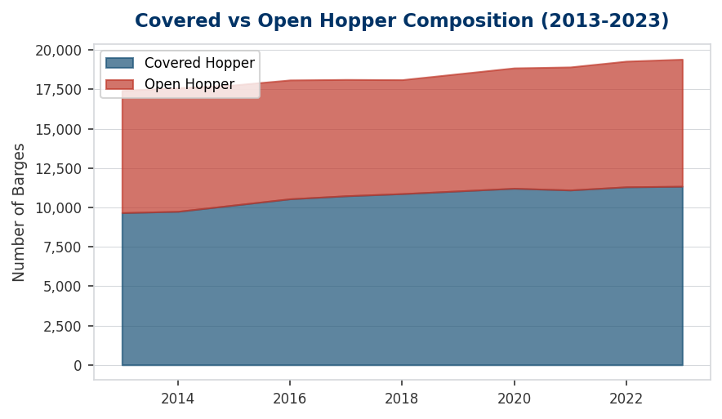
Figure 2.2: Covered/Open Composition Shift Over Time

Physical Specifications by Type
Type | Count | Avg Length | Avg Beam | Avg NRT | Avg Cap (tons)
Covered | 11,337 | 200 ft | 35 ft | 1,044 | 2,055
Open | 8,070 | 206 ft | 39 ft | 2,567 | 1,826

Standard jumbo covered hoppers measure approximately 200 x 35 feet with cargo capacity of 1,500-1,800 tons. Open hoppers are dimensionally similar but offer higher volume capacity for lighter bulk commodities such as coal, aggregates, and scrap. Newer builds increasingly adopt the 200 x 35 jumbo footprint, which has become the industry standard for both types.

3. Fleet Age & Replacement Analysis

Age Distribution (2023)
Age Range | Total | Covered | Open | % of Fleet
0-4 | 1,094 | 376 | 718 | 5.6%
5-9 | 1,858 | 1,369 | 489 | 9.6%
10-14 | 2,858 | 2,093 | 765 | 14.7%
15-19 | 2,920 | 1,437 | 1,483 | 15.0%
20-24 | 2,917 | 1,939 | 978 | 15.0%
25-29 | 4,173 | 2,598 | 1,575 | 21.5%
30-34 | 1,695 | 677 | 1,018 | 8.7%
35-39 | 397 | 18 | 379 | 2.0%
40+ | 1,495 | 830 | 665 | 7.7%

The current fleet has an average age of 21.3 years and a median of 22.0 years. The distribution is right-skewed, with a significant tail of older vessels built during the 1990s construction boom when Jeffboat and multiple regional yards were operating at full capacity.
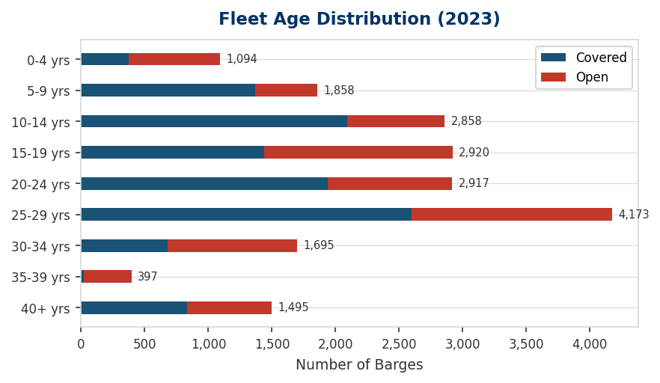
Figure 3.1: Fleet Age Distribution by 5-Year Bucket (2023)

Build Decade Cohort Analysis
Build Decade | Total | Covered | Open | Avg Age | Retirement Status
1930s | 1 | 0 | 1 | 89 | Retirement imminent
1940s | 29 | 5 | 24 | 77 | Retirement imminent
1950s | 64 | 5 | 59 | 69 | Retirement imminent
1960s | 98 | 46 | 52 | 57 | Retirement imminent
1970s | 638 | 446 | 192 | 47 | Retirement imminent
1980s | 1,275 | 376 | 899 | 39 | Retirement imminent
1990s | 6,485 | 3,763 | 2,722 | 27 | Approaching retirement
2000s | 5,487 | 3,232 | 2,255 | 18 | Mid-life
2010s | 4,396 | 3,118 | 1,278 | 10 | Current
2020s | 934 | 346 | 588 | 2 | Current

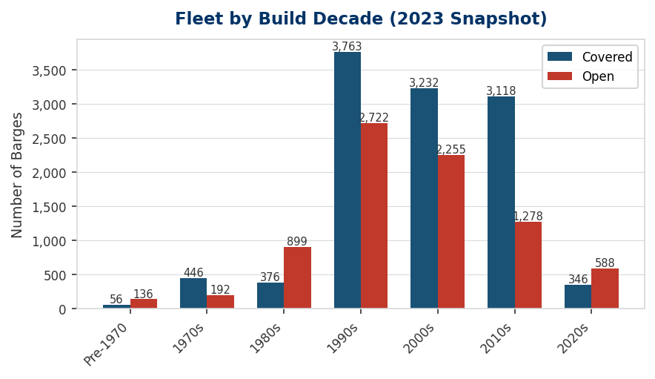
Figure 3.2: Fleet by Build Decade — Covered vs Open

Approximately 7,760 barges (40.0% of the fleet) are 25 years old or older, placing them at or beyond typical economic life for inland dry cargo service. Assuming standard scrapping at age 30-35 and current new-build capacity of 300-500 covered and 100-200 open units per year, the industry faces a structural deficit in replacement tonnage through at least 2030.

New Construction Trends (2000-2023)
Build Year | Total | Covered | Open
2010 | 765 | 604 | 161
2011 | 681 | 509 | 172
2012 | 569 | 379 | 190
2013 | 363 | 227 | 136
2014 | 289 | 255 | 34
2015 | 466 | 369 | 97
2016 | 654 | 458 | 196
2017 | 205 | 127 | 78
2018 | 244 | 160 | 84
2019 | 160 | 30 | 130
2020 | 379 | 180 | 199
2021 | 234 | 26 | 208
2022 | 166 | 116 | 50
2023 | 155 | 24 | 131

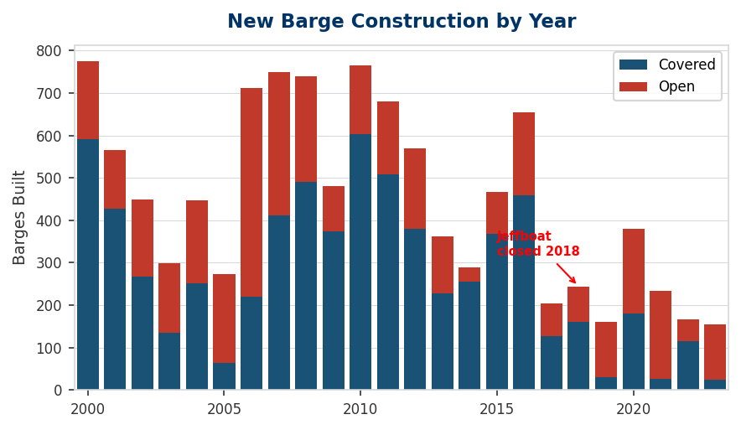
Figure 3.3: New Barge Construction by Year (2000-2023, Jeffboat closure annotated)

The closure of Jeffboat in Jeffersonville, Indiana in 2018 marked a watershed moment for the inland barge construction industry. At its peak, Jeffboat produced over 1,000 barges annually and was the dominant builder of both covered and open hopper barges. Post-closure, construction has shifted primarily to Arcosa Marine Products (formerly Trinity Industries' inland barge division) facilities in Arkansas and Heartland Barge in Louisiana. Combined output from these remaining yards does not fully replace Jeffboat's capacity.

4. Operator Market Share

Top 15 Operators (2023)
Operator | Total | Covered | Open | Avg Age | Market Share
Ingram Barge Company | 4,310 | 2,578 | 1,732 | 21.1 | 22.2%
ACBL | 2,830 | 1,979 | 851 | 24.0 | 14.6%
ARTCO | 1,598 | 1,562 | 36 | 23.9 | 8.2%
Crounse Corporation | 1,365 | 42 | 1,323 | 18.7 | 7.0%
Marquette Transportation Company | 1,039 | 880 | 159 | 16.4 | 5.4%
Cargo Carriers | 735 | 710 | 25 | 21.8 | 3.8%
Flowers J. Russell Inc. | 724 | 486 | 238 | 13.8 | 3.7%
Campbell Transportation Company | 650 | 43 | 607 | 26.9 | 3.3%
Murray American Transportation | 386 | 0 | 386 | 30.6 | 2.0%
Parker Towing Company | 323 | 49 | 274 | 13.8 | 1.7%
Heartland Barge Management | 321 | 235 | 86 | 3.5 | 1.7%
Canal Barge Company | 315 | 2 | 313 | 19.5 | 1.6%
CGB Trust 2009 | 273 | 273 | 0 | 12.4 | 1.4%
M/G Transport | 271 | 31 | 240 | 14.5 | 1.4%
PML, Inc. | 215 | 215 | 0 | 16.1 | 1.1%

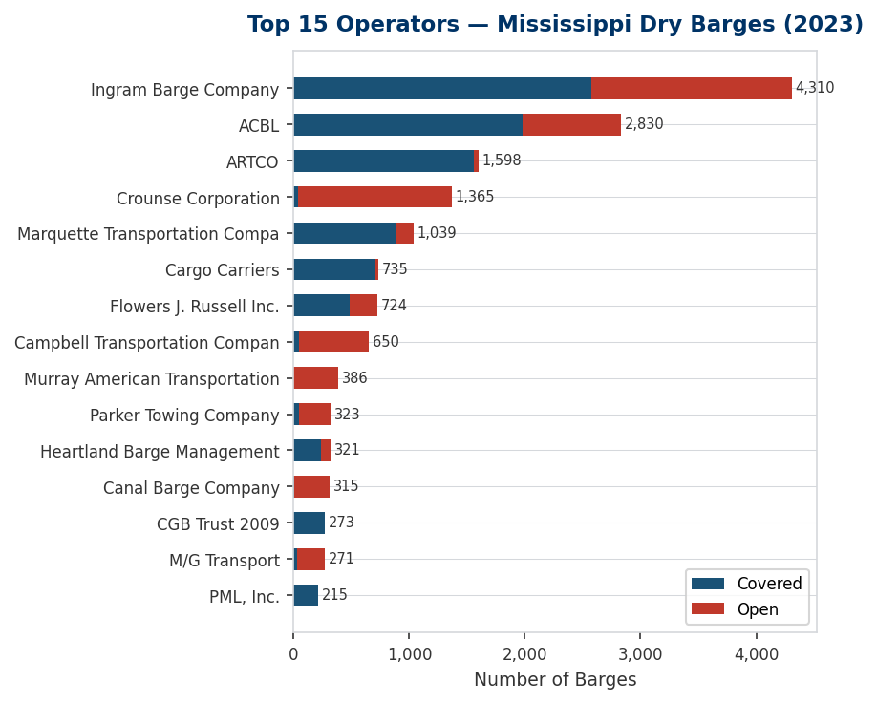
Figure 4.1: Top 15 Operators — Mississippi Dry Barges (2023)

Ingram Barge Company commands the largest dry barge fleet on the Mississippi with 4,310 barges (22.2% market share), operating a mixed fleet of covered and open hoppers. ACBL follows with 2,830 barges (14.6% share). The top three operators collectively control 45.9% of the fleet, indicating a moderately concentrated market structure.

Market Concentration
Metric | Value | Interpretation
Top-3 Share | 45.9% | Moderately concentrated
Top-5 Share | 58.6%
Top-10 Share | 73.6%
HHI Index | 953 | Unconcentrated (<1500)
Total Operators | 286 | Long tail of small fleet operators

With an HHI of 953 and 286 registered operators, the Mississippi dry barge market has a classic structure: a handful of large fleet operators supported by a long tail of small and mid-size companies, many of which operate fewer than 50 barges. This fragmentation in the lower tier creates acquisition opportunities for buyers seeking to consolidate market position.
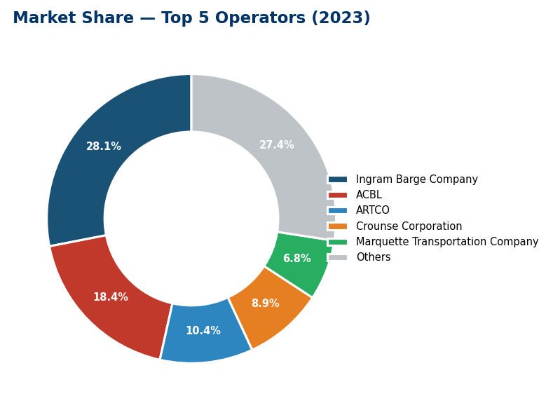
Figure 4.2: Market Share — Top 5 Operators (2023)

The 'Unknown/Unregistered' category represents barges where the USACE operator record has no matching entry in the operator master file — typically vessels in temporary layup, pending registration transfer, or owned by entities that have not filed current operator documentation. This is a normal artifact of the USACE data collection process.

5. Demand Drivers

Grain & Agricultural Exports
Year | Corn Exports (M bu) | Soybean Exports (M bu) | Corn Price ($/bu) | Soybean Price ($/bu)
2015 | 1,898 | 1,936 | $3.61 | $8.95
2016 | 2,293 | 2,174 | $3.36 | $9.47
2017 | 1,956 | 2,129 | $3.36 | $9.33
2018 | 2,432 | 1,748 | $3.61 | $8.60
2019 | 1,770 | 1,682 | $3.56 | $8.57
2020 | 2,753 | 2,266 | $4.53 | $10.80
2021 | 2,471 | 2,116 | $5.45 | $13.30
2022 | 2,107 | 2,031 | $6.54 | $14.20
2023 | 1,664 | 1,720 | $4.65 | $12.50
2024E | 2,300 | 1,800 | $4.35 | $10.80

Grain remains the single largest cargo category on the Mississippi River, accounting for approximately 60% of covered hopper barge demand. The river system handles roughly 60% of U.S. grain exports, with the Gulf export corridor (New Orleans/South Louisiana) serving as the primary funnel. Covered hopper fleet utilization correlates closely with harvest volume, Gulf export pace, and competitiveness of U.S. grain pricing versus South American alternatives.
USDA long-term baseline projections (2024-2033) project corn exports averaging 2.3-2.5 billion bushels annually and soybean exports at 1.8-2.0 billion bushels. These projections assume normalized trade relations with China, continued growth in global livestock production, and steady ethanol demand under the Renewable Fuel Standard. Upside catalysts include expanded sustainable aviation fuel mandates and growing protein consumption in Southeast Asia.

Coal Production & Decline Trajectory
Year | U.S. Coal Production (M short tons) | YoY Change | River-Moved (est.)
2015 | 897 | -10.4% | ~180M tons
2016 | 728 | -18.8% | ~150M tons
2017 | 774 | +6.3% | ~155M tons
2018 | 756 | -2.3% | ~150M tons
2019 | 706 | -6.6% | ~140M tons
2020 | 535 | -24.2% | ~105M tons
2021 | 578 | +8.0% | ~115M tons
2022 | 595 | +2.9% | ~120M tons
2023 | 507 | -14.8% | ~100M tons
2024E | 475 | -6.3% | ~95M tons

U.S. coal production has declined roughly 45% from its 2008 peak of 1.17 billion short tons, driven by natural gas price competitiveness and utility fleet retirements. The EIA Annual Energy Outlook projects continued decline, with domestic coal production falling below 400 million tons by 2030. This decline directly reduces demand for open hopper barges, though the impact is partially offset by growth in aggregates, steel scrap, and industrial mineral movements.

Seasonal Patterns & Low-Water Risk
Barge demand follows strong seasonal patterns tied to the agricultural calendar. The fall harvest (September-November) generates peak demand for covered hoppers as grain moves downriver to Gulf export elevators. Spring planting season creates a secondary demand peak as fertilizer moves upriver. Coal movements are more evenly distributed but spike during summer utility demand peaks and winter heating seasons.
The 2022 low-water event on the Lower Mississippi — the worst in decades — demonstrated the system's vulnerability to drought conditions. Barge loadings were restricted to 60-70% of capacity for extended periods, effectively reducing fleet carrying capacity by 30-40% and creating severe congestion at key choke points. Climate projections suggest such events may become more frequent, creating both risk (capacity disruption) and opportunity (more barges needed per ton of cargo during restricted draft periods).

6. Supply Side — Construction & Secondhand Market

Active Inland Barge Builders
Builder | Location | Status | Est. Annual Capacity | Specialization
Arcosa Marine Products | Ashdown, AR / Madisonville, LA | Active | ~400-600 barges | Covered & open hoppers, tank barges
Heartland Barge | Brownsville, PA | Active | ~150-250 barges | Open hoppers, deck barges
Jeffboat | Jeffersonville, IN | CLOSED (2018) | — | Was largest; covered & open hoppers
Conrad Shipyard | Morgan City, LA | Active (limited) | ~50-100 barges | Specialty barges, limited hopper
Metal Shark / Horizon | Various | Active (limited) | ~25-50 barges | Niche builders

The inland barge construction market is effectively a duopoly following Jeffboat's closure. Arcosa Marine Products, spun off from Trinity Industries in 2018, operates the largest remaining facilities and accounts for roughly 60-70% of new covered hopper production. Heartland Barge in Brownsville, Pennsylvania focuses primarily on open hoppers and deck barges. Combined new-build capacity across all active yards is estimated at 500-850 barges annually — well below the 1,000-1,500 units Jeffboat alone could produce at peak.

New Construction Cost Benchmarks
Barge Type | Size | 2018 Cost | 2023 Cost | Lead Time
Covered Hopper (Jumbo) | 200 x 35 ft | $550,000-$650,000 | $750,000-$950,000 | 18-24 months
Covered Hopper (Standard) | 195 x 35 ft | $500,000-$600,000 | $700,000-$850,000 | 15-20 months
Open Hopper (Jumbo) | 200 x 35 ft | $400,000-$500,000 | $550,000-$700,000 | 12-18 months
Open Hopper (Standard) | 195 x 35 ft | $350,000-$450,000 | $500,000-$650,000 | 10-15 months

New construction costs have increased 35-50% since 2018, driven by steel price inflation, labor shortages in the inland fabrication trades, and reduced competition. Current lead times of 18-24 months for covered hoppers (the highest-demand type) make secondhand acquisition the only near-term option for operators seeking to expand fleet capacity.

Secondhand Barge Value Estimates
Barge Age | Covered Hopper Value | Open Hopper Value | Condition Notes
0-5 years | $600,000-$800,000 | $450,000-$600,000 | Near-new; premium for recent builds
5-10 years | $400,000-$600,000 | $300,000-$450,000 | Prime acquisition target range
10-15 years | $250,000-$400,000 | $200,000-$300,000 | Requires survey; coating condition key
15-20 years | $150,000-$250,000 | $120,000-$200,000 | Significant remaining life if maintained
20-25 years | $80,000-$150,000 | $60,000-$120,000 | Approaching end of economic life
25+ years | $30,000-$80,000 | $25,000-$60,000 | Scrap value floor; limited commercial use

Secondhand values remain elevated relative to historical norms due to the construction capacity constraint. Well-maintained covered hoppers under 10 years of age trade at a significant premium, as they represent immediately deployable capacity without the 18-24 month wait for new construction. The scrap value floor (steel content at prevailing scrap prices) provides a hard downside of approximately $25,000-$40,000 per barge.

7. M&A Landscape

Notable Recent Transactions
Year | Target | Acquirer | Deal Details | Significance
2021 | ACBL (American Commercial Barge Line) | Emerged from Ch. 11 (Platinum Equity) | ~2,300 barges; restructured debt | Largest fleet; consolidated 3 legacy operators
2022 | Marquette Transportation | Redwood Capital (merged into) | Combined with Canal Barge Co | Created significant mid-tier competitor
2023 | Canal Barge Company | Redwood/Marquette | Folded into Marquette platform | Further consolidation of mid-tier
2023 | Kirby Corp inland barge acquisitions | Kirby Corporation | Selective fleet purchases | Tank barge leader expanding dry cargo
2024 | Ingram Barge — no change | Ingram Industries (private) | Market leader; not for sale | Family-owned; strategic anchor

The inland barge industry has undergone significant consolidation over the past five years, driven by the economics of scale in fleeting operations, towing, and barge maintenance. ACBL's emergence from Chapter 11 in 2021 under Platinum Equity ownership consolidated multiple legacy operators (including AEP River Operations and early ACBL entities) into a single platform. The Redwood Capital/Marquette/Canal Barge combination created a formidable mid-tier competitor with diversified geographic coverage.

Valuation Benchmarks
Metric | Range | Notes
EV / Barge | $80,000-$180,000 | Varies by fleet age and condition; blended
EV / EBITDA | 5.0x-7.5x | Higher for contracted fleets with stable cash flows
Price / Net Asset Value | 0.7x-1.2x | Discount for older fleets; premium for young fleets
$/ton cargo capacity | $50-$120/ton | Depends on barge type and utilization

Transaction multiples in the inland barge sector have historically ranged from 5-7x EBITDA for fleet-focused deals. Premiums are commanded by operators with long-term customer contracts, modern fleet age profiles, and strategic geographic positioning (particularly operators with strong Gulf presence for grain export logistics). Distressed situations — as seen in the ACBL bankruptcy — can offer significant discounts to replacement cost.

Potential Strategic Buyers
The current landscape of likely acquirers includes: (1) existing barge line operators seeking fleet expansion (Ingram, ACBL, ARTCO, Marquette), though each faces different strategic constraints; (2) private equity firms with inland marine portfolio companies, following the Platinum Equity/ACBL model; (3) international logistics companies seeking Mississippi River exposure; and (4) agricultural commodity firms pursuing vertical integration of their supply chains, as ADM and Cargill have historically done through ARTCO and their respective barge operations.
For a new entrant or mid-tier consolidator, the ideal acquisition target would be a fleet of 200-500 barges with average age under 15 years, existing customer relationships in the grain corridor, and either owned or long-term leased fleeting capacity. Such platforms exist primarily in the lower Mississippi and Ohio River systems.

8. Historical Trends & 10-Year Summary

10-Year Fleet Summary
Year | Total Fleet | Covered | Open | Avg Age | Over 30 Yrs
2013 | 17,423 | 9,661 | 7,762 | 16.6 | 2,811
2014 | 17,598 | 9,746 | 7,852 | 17.0 | 2,646
2015 | 17,773 | 10,144 | 7,629 | 17.5 | 2,695
2016 | 18,092 | 10,542 | 7,550 | 18.2 | 2,453
2017 | 18,122 | 10,733 | 7,389 | 18.0 | 2,204
2018 | 18,108 | 10,870 | 7,238 | 18.1 | 2,028
2020 | 18,856 | 11,209 | 7,647 | 19.4 | 2,496
2021 | 18,917 | 11,101 | 7,816 | 20.2 | 2,613
2022 | 19,283 | 11,301 | 7,982 | 20.6 | 3,223
2023 | 19,407 | 11,337 | 8,070 | 21.3 | 3,587

Over the 2013-2023 period, the Mississippi dry barge fleet grew by 1,984 units (11.4%). The structural shift from coal to grain is clearly visible in the covered/open ratio: covered hoppers grew from 55% to 58% of the total fleet. This shift reflects both new covered hopper construction for agricultural service and the gradual attrition of older open hoppers formerly deployed in coal trades.
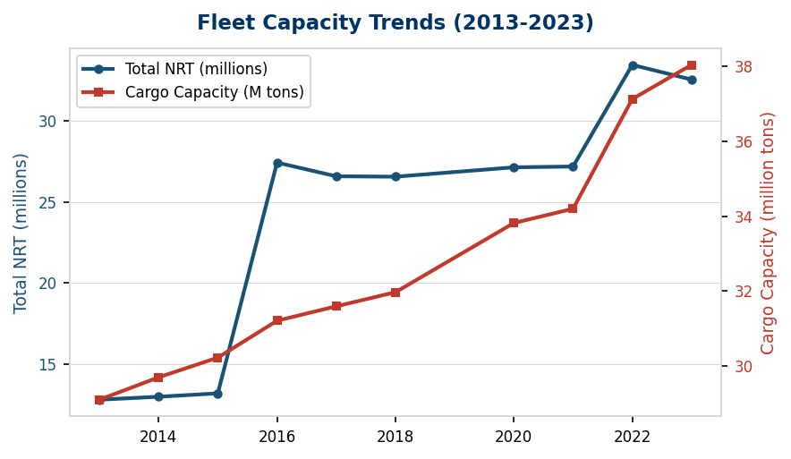
Figure 8.1: Fleet Capacity Trends — NRT and Cargo Tonnage (2013-2023)

Average fleet age has shifted from 16.6 years in 2013 to 21.3 years in 2023. The number of barges over 30 years old has increased from 2,811 to 3,587, reflecting the competing dynamics of continued service of legacy assets versus scrapping and replacement.

Appendix A: Operator Fleet Summary (2023)
Complete listing of all 286 registered operators of Mississippi River dry hopper barges in the 2023 USACE fleet data. Sorted by total fleet size descending.
Operator | Total | Covered | Open | Avg Age | Oldest | Newest
Ingram Barge Company | 4,310 | 2,578 | 1,732 | 21.1 | 1968 | 2018
ACBL | 2,830 | 1,979 | 851 | 24.0 | 1965 | 2016
ARTCO | 1,598 | 1,562 | 36 | 23.9 | 1965 | 2018
Crounse Corporation | 1,365 | 42 | 1,323 | 18.7 | 1983 | 2023
Marquette Transportation Company | 1,039 | 880 | 159 | 16.4 | 1971 | 2020
Cargo Carriers | 735 | 710 | 25 | 21.8 | 1981 | 2020
Flowers J. Russell Inc. | 724 | 486 | 238 | 13.8 | 1993 | 2020
Campbell Transportation Company | 650 | 43 | 607 | 26.9 | 1976 | 2013
Murray American Transportation | 386 | 0 | 386 | 30.6 | 1978 | 2006
Heartland Barge Management | 363 | 275 | 88 | 8.8 | 1980 | 2023
Parker Towing Company | 323 | 49 | 274 | 13.8 | 1995 | 2022
Canal Barge Company | 315 | 2 | 313 | 19.5 | 1967 | 2020
CGB Trust 2009 | 273 | 273 | 0 | 12.4 | 1997 | 2013
M/G Transport | 271 | 31 | 240 | 14.5 | 1995 | 2021
PML, Inc. | 215 | 215 | 0 | 16.1 | 1981 | 2016
SCF Marine | 146 | 119 | 27 | 25.5 | 1972 | 2021
Frank Bryan, Inc. | 145 | 0 | 145 | 53.7 | 1946 | 2012
Cooper Marine & Timberlands | 121 | 34 | 87 | 20.6 | 1968 | 2022
Florida Marine Transporters | 117 | 27 | 90 | 3.6 | 2007 | 2020
Ceres Consulting, LLC | 115 | 55 | 60 | 8.9 | 1993 | 2022
GE Capital | 113 | 111 | 2 | 31.1 | 1980 | 2007
Jem Transportation, Inc. | 112 | 99 | 13 | 16.9 | 1993 | 2022
Oakley Barge Line, Inc. | 111 | 111 | 0 | 13.7 | 1993 | 2013
Terral River Service, Inc. | 98 | 82 | 16 | 18.7 | 1947 | 2015
Robert B. Miller & Associates, Inc. | 88 | 72 | 16 | 21.3 | 1975 | 2021
Fifth Third Equipment Finance Compa | 86 | 20 | 66 | 20.6 | 1989 | 2016
U.S. Bancorp Equipment Finance, Inc | 77 | 77 | 0 | 26.3 | 1995 | 2000
Cargill, Inc. CMNA | 75 | 75 | 0 | 11.2 | 1995 | 2020
Illinois Marine Towing, Inc. | 74 | 25 | 49 | 20.4 | 1981 | 2009
Pine Bluff Sand & Gravel Co. | 70 | 0 | 70 | 17.4 | 2000 | 2021
The St. Paul Barge Line, Inc. | 69 | 69 | 0 | 16.7 | 1993 | 2015
Wilmington Trust Co. Trustee | 66 | 66 | 0 | 26.3 | 1996 | 1997
Mulzer Crushed Stone, Inc. | 61 | 0 | 61 | 16.8 | 1996 | 2022
CGB Enterprises | 59 | 46 | 13 | 46.3 | 1969 | 1981
Panzera Marine Transportation, Inc. | 55 | 55 | 0 | 6.3 | 1993 | 2021
Hines Furlong Line, Inc. | 54 | 12 | 42 | 0.0 | 2023 | 2023
Middle River Marine | 54 | 5 | 49 | 23.3 | 1978 | 2007
JPMorgan Chase Bank, N.A. | 50 | 50 | 0 | 26.0 | 1997 | 1997
MKJ, Inc. | 50 | 50 | 0 | 17.3 | 1996 | 2020
Fleet Properties, LLC | 48 | 15 | 33 | 40.1 | 1967 | 1992

Operator | Total | Covered | Open | Avg Age | Oldest | Newest
Weeks Marine | 46 | 0 | 46 | 10.9 | 1944 | 2021
Luhr Bros., Inc. | 43 | 1 | 42 | 31.7 | 1954 | 2019
Savage Services Corp. | 42 | 42 | 0 | 14.0 | 2009 | 2009
Regions Equipment Finance Corporati | 41 | 0 | 41 | 24.0 | 1999 | 1999
McDonough Marine Service | 39 | 35 | 4 | 10.8 | 1977 | 2021
Lone Star Industries (St. Louis Div | 37 | 37 | 0 | 35.8 | 1962 | 2007
River Salvage Company, Inc. | 33 | 8 | 25 | 35.6 | 1952 | 2010
Brennan Marine, Inc. | 31 | 25 | 6 | 40.8 | 1974 | 2010
Norman Brothers, Inc. | 29 | 29 | 0 | 26.6 | 1996 | 1997
Riverland Resources, Inc. | 28 | 28 | 0 | 41.7 | 1970 | 2008
Three Rivers Marine & Rail Terminal | 27 | 0 | 27 | 33.1 | 1989 | 1990
Serodino, Inc. | 27 | 15 | 12 | 26.3 | 1989 | 2001
Everbank Commerical Financial Inc. | 25 | 25 | 0 | 19.0 | 2004 | 2004
Graestone Logistics, LLC | 24 | 0 | 24 | 23.8 | 1998 | 2000
Gatx Corporation | 23 | 23 | 0 | 24.0 | 1999 | 1999
Associated Terminals | 23 | 22 | 1 | 24.3 | 1997 | 2001
Mcginnis, Inc. | 22 | 9 | 13 | 40.2 | 1974 | 1998
Industry Terminal & Salvage Co. | 22 | 15 | 7 | 35.0 | 1979 | 2000
Lake Lee Leasing, LLC | 22 | 0 | 22 | 3.4 | 2006 | 2021
Jrf, LLC | 20 | 18 | 2 | 21.3 | 1993 | 2013
Huskey, Linda | 19 | 19 | 0 | 18.9 | 1994 | 2017
Wells Fargo Equipment Finance | 18 | 10 | 8 | 19.8 | 1983 | 2015
Central Boat Rentals, Incorporated | 17 | 0 | 17 | 21.2 | 1978 | 2014
Zito Towing, Inc. | 17 | 7 | 10 | 33.4 | 1972 | 1999
SCF Lewis & Clark Fleeting | 16 | 12 | 4 | 39.4 | 1973 | 2008
Canton Marine Towing Co. Inc. | 15 | 13 | 2 | 52.3 | 1946 | 1980
4-k Marine, LLC | 14 | 2 | 12 | 15.4 | 1999 | 2012
St. John Fleeting | 14 | 7 | 7 | 39.3 | 1966 | 2002
Big Valley Equipment, LLC | 14 | 0 | 14 | 25.0 | 1998 | 1998
Capital Sand Co. | 13 | 0 | 13 | 36.2 | 1947 | 2019
Allease, Inc. | 13 | 13 | 0 | 43.0 | 1978 | 1981
Zito Fleeting, Inc. | 13 | 4 | 9 | 43.2 | 1967 | 1991
Brennan, J. F., Co. | 13 | 0 | 13 | 16.6 | 1999 | 2013
Dubuque Barge & Fleeting Svc. | 13 | 1 | 12 | 45.6 | 1957 | 2002
S.m.i. Marine Transportation, L.p. | 13 | 1 | 12 | 25.9 | 1976 | 2013
Peru Terminal | 13 | 4 | 9 | 42.1 | 1970 | 1990
Shawnee Marine Enterprises, Inc. | 12 | 12 | 0 | 17.3 | 1993 | 2020
Flowers Family Investments | 12 | 8 | 4 | 20.3 | 1999 | 2006
Reco Transportation, Inc. | 12 | 0 | 12 | 26.0 | 1997 | 1997
Gray, J. R., Inc. | 12 | 0 | 12 | 25.6 | 1979 | 2008

Operator | Total | Covered | Open | Avg Age | Oldest | Newest
Romance Arkansas Barges, LLC | 11 | 11 | 0 | 13.1 | 2007 | 2013
Rlh Transportation, LLC | 11 | 9 | 2 | 1.7 | 2021 | 2022
Yager Materials, LLC | 11 | 0 | 11 | 12.0 | 1969 | 2017
Crown Transport Company | 10 | 3 | 7 | 32.0 | 1984 | 1998
Goldman Interest LLC | 10 | 0 | 10 | 26.0 | 1997 | 1997
M-i Drilling Fluids Co. | 10 | 10 | 0 | 39.3 | 1957 | 1998
War Admiral, LLC | 10 | 4 | 6 | 43.5 | 1977 | 1982
Broussard Brothers, Inc. | 9 | 1 | 8 | 39.2 | 1978 | 1996
Towline River Services, Inc. | 9 | 0 | 9 | 31.0 | 1992 | 1992
Tcf National Bank | 9 | 8 | 1 | 20.4 | 2002 | 2007
Kosmos Cement, Cemex, Inc. | 9 | 9 | 0 | 59.3 | 1947 | 1983
Orion Marine Construction | 8 | 2 | 6 | 31.0 | 1959 | 2008
Lafarge North America | 8 | 0 | 8 | 26.9 | 1996 | 1997
Greenville Marine Leasing, LLC | 8 | 6 | 2 | 18.6 | 1999 | 2013
Adams Ventures, LLC | 8 | 8 | 0 | 16.8 | 1996 | 2012
Sunflower Enterprises, LLC | 8 | 7 | 1 | 9.6 | 2001 | 2018
Weatherford Leasing, LLC | 8 | 8 | 0 | 12.8 | 2002 | 2013
Bellaire Vessel Management, LLC | 8 | 0 | 8 | 37.0 | 1980 | 1988
San Jacinto River Fleet Inc. | 7 | 6 | 1 | 42.4 | 1979 | 1982
Amherst Madison | 7 | 0 | 7 | 36.3 | 1978 | 1993
The Willard R. Sparks Revocable Tru | 7 | 5 | 2 | 29.1 | 1993 | 1994
Chouteau Marine Investors, LLC | 7 | 7 | 0 | 11.0 | 2012 | 2012
Arkhola Sand and Gravel Company | 7 | 0 | 7 | 26.9 | 1990 | 1999
Hooks, Mike, Inc. | 7 | 0 | 7 | 26.0 | 1974 | 2012
Mississippi Lime Co. | 7 | 5 | 2 | 49.1 | 1955 | 1998
Greer Industries Inc. | 6 | 0 | 6 | 17.0 | 2006 | 2006
Cooper/t. Smith Stevedoring Co. Inc | 6 | 2 | 4 | 35.8 | 1979 | 1990
Parsonage Marine Investments, LLC | 6 | 2 | 4 | 23.5 | 1993 | 2002
Pine Bluff Materials Co. LLC | 6 | 0 | 6 | 7.0 | 2016 | 2016
Genesis Marine, LLC | 6 | 0 | 6 | 14.0 | 2009 | 2009
Barge America; Trans Barge, Inc. | 6 | 6 | 0 | 32.3 | 1975 | 2000
Diamond Services Corp. | 6 | 0 | 6 | 14.7 | 2008 | 2009
Brown Water Marine Service, Inc. | 6 | 0 | 6 | 30.7 | 1971 | 1997
Southern Illinois Transfer, Inc. | 6 | 2 | 4 | 61.3 | 1958 | 1967
Evansville Marine Service, Inc. | 5 | 4 | 1 | 45.8 | 1973 | 1981
Cashman Equipment Corp. | 5 | 0 | 5 | 14.6 | 1979 | 2016
Denton Leasing, Inc. | 5 | 5 | 0 | 12.8 | 2007 | 2013
Carline Burnside 169, LLC | 5 | 5 | 0 | 42.2 | 1980 | 1981
Walter Marine Enterprises | 5 | 1 | 4 | 53.0 | 1947 | 1989
Kinder Morgan Petcoke | 5 | 0 | 5 | 33.6 | 1982 | 2019

Operator | Total | Covered | Open | Avg Age | Oldest | Newest
Mdl Barges, LLC | 5 | 5 | 0 | 26.4 | 1994 | 2000
Jpr Barge, LLC | 4 | 4 | 0 | 10.0 | 2012 | 2014
Garber Bros., Inc. | 4 | 2 | 2 | 8.5 | 2009 | 2019
Teague Brothers Sand & Gravel | 4 | 0 | 4 | 25.8 | 1996 | 2001
Tidewater Barge Lines, Inc. | 4 | 0 | 4 | 2.0 | 2021 | 2021
Cin Mar Marine Investments | 4 | 4 | 0 | 14.3 | 2008 | 2011
Standing Wave | 4 | 4 | 0 | 11.0 | 2012 | 2012
Crase Ventures, LLC | 4 | 4 | 0 | 9.5 | 2011 | 2015
D & M Barge Rentals, LLC | 4 | 0 | 4 | 19.0 | 2001 | 2011
Tate & Lyle Grain Terminal | 4 | 2 | 2 | 46.5 | 1965 | 1982
Vance Barge, LLC | 4 | 4 | 0 | 13.8 | 2002 | 2013
Bakery Trading Company | 4 | 4 | 0 | 26.3 | 1996 | 1997
Waterfront Services Company | 4 | 3 | 1 | 54.3 | 1963 | 1985
Armstrong Logistics Services, LLC | 4 | 0 | 4 | 40.0 | 1983 | 1983
Mothershead, Russ A. (Revocable Tru | 4 | 4 | 0 | 14.3 | 1997 | 2014
Nine Grand Marine, L. L. C. | 4 | 0 | 4 | 12.0 | 2008 | 2013
Joedot, LLC | 4 | 4 | 0 | 10.5 | 2012 | 2013
Beyel Bros. Marine Services, Inc. | 4 | 0 | 4 | 26.8 | 1991 | 2003
Riverdocks, Inc. | 4 | 2 | 2 | 41.0 | 1979 | 1990
Hoffarth, Jack M., Sr. | 4 | 4 | 0 | 17.8 | 2003 | 2008
Jefferson Barracks Marine Service, | 4 | 4 | 0 | 12.5 | 2010 | 2011
Jefferson City River Terminal | 4 | 4 | 0 | 14.8 | 2001 | 2014
Pitt Cox Barges | 4 | 4 | 0 | 29.0 | 1991 | 1997
Hoffarth, Jack M., Jr. | 4 | 4 | 0 | 17.8 | 2003 | 2008
Gnots Reserve, Inc. | 4 | 4 | 0 | 49.8 | 1966 | 1982
Gateway Dredging & Contracting, LLC | 4 | 0 | 4 | 23.5 | 1997 | 2002
Jjp, LLC | 4 | 4 | 0 | 10.5 | 2012 | 2013
Inland Dredging Company, LLC | 4 | 0 | 4 | 28.0 | 1995 | 1995
Barge Exchange | 3 | 0 | 3 | 46.0 | 1975 | 1980
Kaskaskia River Terminals | 3 | 3 | 0 | 44.0 | 1979 | 1979
Intercoastal Barge Cleaning, Inc. | 3 | 3 | 0 | 43.7 | 1977 | 1981
Price, Tracy L. | 3 | 3 | 0 | 18.7 | 2003 | 2007
Tom-mac Inc. | 3 | 0 | 3 | 35.7 | 1979 | 1992
Cdg Investments, LLC | 3 | 3 | 0 | 23.7 | 1993 | 2012
Cox Marine Corp. | 3 | 3 | 0 | 27.7 | 1992 | 1997
Waterfront Construction, Inc. | 3 | 0 | 3 | 36.0 | 1987 | 1987
Berwick Bay Transportation Co. Inc. | 3 | 0 | 3 | 19.3 | 1998 | 2007
Willard R. Sparks Grandchild Trusts | 3 | 2 | 1 | 29.0 | 1994 | 1994
Lmt 2015, LLC | 3 | 3 | 0 | 8.0 | 2015 | 2015
Joe S. Towing Co. | 3 | 0 | 3 | 33.0 | 1989 | 1991

Operator | Total | Covered | Open | Avg Age | Oldest | Newest
Mars, Inc. | 3 | 1 | 2 | 32.3 | 1981 | 1999
Matthew Canestrale Contracting | 3 | 0 | 3 | 33.7 | 1976 | 1996
Inland Barge Rentals, Inc. | 3 | 0 | 3 | 27.3 | 1995 | 1997
Khc Marine, LLC | 3 | 3 | 0 | 42.7 | 1979 | 1981
Lovvorn, Chris Pile Drivers, Inc. | 3 | 0 | 3 | 26.0 | 1977 | 2007
James Marine, Inc./paducah River Se | 3 | 0 | 3 | 40.7 | 1973 | 1994
Gulfstream Marine Fleet, LLC | 3 | 0 | 3 | 5.3 | 2016 | 2019
Garyville Ventures, LLC | 3 | 3 | 0 | 41.0 | 1974 | 1994
Accounting & Business Consulting Co | 2 | 0 | 2 | 51.0 | 1970 | 1974
A D M | 2 | 2 | 0 | 45.0 | 1978 | 1978
Service Welding & Shipbuilding, LLC | 2 | 2 | 0 | 39.0 | 1984 | 1984
Sheridan Barge LLC | 2 | 2 | 0 | 17.0 | 2006 | 2006
Eagle Marine Transport, LLC | 2 | 2 | 0 | 29.0 | 1992 | 1996
F F F & W Holdings | 2 | 2 | 0 | 23.0 | 2000 | 2000
Crain Bros., Inc. | 2 | 0 | 2 | 47.5 | 1969 | 1982
Denet Towing Service, Inc. | 2 | 0 | 2 | 46.5 | 1976 | 1977
Swift River Logistics | 2 | 2 | 0 | 10.0 | 2011 | 2015
Cash's Recycling | 2 | 1 | 1 | 54.0 | 1965 | 1973
U. S. Bank Equipment Finance Divisi | 2 | 2 | 0 | 23.0 | 2000 | 2000
Visscher Hammond Investments, LLC | 2 | 2 | 0 | 11.0 | 2012 | 2012
Bo-mac Contractors, Ltd. | 2 | 0 | 2 | 41.5 | 1980 | 1983
Tpg Mt. Vernon Marine, LLC | 2 | 2 | 0 | 42.0 | 1980 | 1982
Sea Side Partners, Inc. | 2 | 2 | 0 | 26.0 | 1997 | 1997
Gab Barges, LLC | 2 | 2 | 0 | 23.0 | 2000 | 2000
Hilltop Big Bend Quarry | 2 | 0 | 2 | 35.5 | 1975 | 2000
Hahn Ready Mix Co. | 2 | 0 | 2 | 47.0 | 1976 | 1976
Kirby Ocean Transport Company | 2 | 2 | 0 | 43.0 | 1978 | 1982
Kirby Offshore Marine Operating, LL | 2 | 2 | 0 | 39.0 | 1978 | 1990
River Front Limestone, LLC / Three | 2 | 0 | 2 | 24.0 | 1999 | 1999
Jantran, Inc. | 2 | 2 | 0 | 30.5 | 1971 | 2014
Kinder Morgan Marine Services LLC | 2 | 0 | 2 | 42.5 | 1980 | 1981
Kam 2 Investments, Inc. | 2 | 1 | 1 | 14.0 | 2002 | 2016
Kjjr Investors, LLC | 2 | 2 | 0 | 6.0 | 2014 | 2020
Kanawha Crane and Construction, Inc | 2 | 0 | 2 | 46.0 | 1977 | 1977
Massman Construction Co. | 2 | 0 | 2 | 2.0 | 2021 | 2021
Marrs Investments, Lc | 2 | 2 | 0 | 12.0 | 2010 | 2012
National Maintenance & Repair, Inc. | 2 | 0 | 2 | 47.5 | 1969 | 1982
Wrs & Associates | 2 | 1 | 1 | 29.5 | 1993 | 1994
Welcome Fleet, LLC | 2 | 0 | 2 | 42.0 | 1979 | 1983
Bertucci Contracting Corporation | 2 | 0 | 2 | 55.5 | 1967 | 1968

Operator | Total | Covered | Open | Avg Age | Oldest | Newest
Berry Brothers General Contractors, | 2 | 0 | 2 | 29.0 | 1981 | 2007
Bbs Barger Service | 2 | 0 | 2 | 50.0 | 1973 | 1973
Atlas Towing Co. | 1 | 0 | 1 | 52.0 | 1971 | 1971
B & J Corporation | 1 | 0 | 1 | 42.0 | 1981 | 1981
Belle Chasse Marine Transportation, | 1 | 0 | 1 | 4.0 | 2019 | 2019
Big River Investments, LLC | 1 | 1 | 0 | 28.0 | 1995 | 1995
Vss Holding Corp. | 1 | 1 | 0 | 7.0 | 2016 | 2016
Vt Halter Marine, Inc. | 1 | 0 | 1 | 19.0 | 2004 | 2004
Warren Paving, Inc. | 1 | 1 | 0 | 27.0 | 1996 | 1996
Wepfer Marine of Calvert City, LLC | 1 | 1 | 0 | 43.0 | 1980 | 1980
Mississippi Marine Corp. | 1 | 1 | 0 | 50.0 | 1973 | 1973
Mrb Investments LLC | 1 | 1 | 0 | 13.0 | 2010 | 2010
New Johnsonville Marine Service, In | 1 | 1 | 0 | 10.0 | 2013 | 2013
Nugent Sand Company | 1 | 0 | 1 | 44.0 | 1979 | 1979
Pacific Western Bank, Successor by | 1 | 1 | 0 | 23.0 | 2000 | 2000
Mandeville Barge 2011b, LLC | 1 | 1 | 0 | 12.0 | 2011 | 2011
Mandeville Barge 2012, LLC | 1 | 1 | 0 | 11.0 | 2012 | 2012
Marine Tech, LLC | 1 | 0 | 1 | 20.0 | 2003 | 2003
Material Sales Co. Inc. | 1 | 0 | 1 | 46.0 | 1977 | 1977
Matteson Marine Service | 1 | 1 | 0 | 59.0 | 1964 | 1964
Mcbride River Services,llc | 1 | 1 | 0 | 42.0 | 1981 | 1981
Mirco Industries, Inc. | 1 | 0 | 1 | 52.0 | 1971 | 1971
Knobbe Grain, LLC | 1 | 1 | 0 | 13.0 | 2010 | 2010
Lhoist North America | 1 | 1 | 0 | 57.0 | 1966 | 1966
Lmp Barge Rentals, Inc. | 1 | 0 | 1 | 21.0 | 2002 | 2002
Lrw Transport, LLC | 1 | 1 | 0 | 8.0 | 2015 | 2015
Mandeville Barge 2011, LLC | 1 | 1 | 0 | 12.0 | 2011 | 2011
Jms Marine Services, LLC | 1 | 0 | 1 | 34.0 | 1989 | 1989
K B Marine, LLC | 1 | 1 | 0 | 13.0 | 2010 | 2010
Kapper, Patrick Irrevocable Insuran | 1 | 1 | 0 | 11.0 | 2012 | 2012
Kinder Morgan Decatur, Inc. | 1 | 0 | 1 | 26.0 | 1997 | 1997
Patterson, E. J., Inc. | 1 | 0 | 1 | 16.0 | 2007 | 2007
Patton - Tully Marine, LLC | 1 | 0 | 1 | 8.0 | 2015 | 2015
River Cement Co. | 1 | 1 | 0 | 42.0 | 1981 | 1981
Intercoastal Marine Repair Inc. | 1 | 0 | 1 | 42.0 | 1981 | 1981
J S L Interests, Ltd. | 1 | 1 | 0 | 47.0 | 1976 | 1976
Gulf Materials, LLC | 1 | 0 | 1 | 61.0 | 1962 | 1962
Hall Towing, Inc. | 1 | 1 | 0 | 56.0 | 1967 | 1967
Hendricks River Logistics, LLC | 1 | 0 | 1 | 46.0 | 1977 | 1977
Henry Marine Service, Inc. | 1 | 0 | 1 | 25.0 | 1998 | 1998

Operator | Total | Covered | Open | Avg Age | Oldest | Newest
Hermann Sand & Gravel, Inc. | 1 | 1 | 0 | 31.0 | 1992 | 1992
Frizzell Barge, LLC | 1 | 1 | 0 | 11.0 | 2012 | 2012
Gault, E. Spivey | 1 | 1 | 0 | 30.0 | 1993 | 1993
Glick Equipment, LP | 1 | 0 | 1 | 31.0 | 1992 | 1992
Seminole Transportation, LLC | 1 | 1 | 0 | 9.0 | 2014 | 2014
Settoon Construction, Inc. | 1 | 0 | 1 | 21.0 | 2002 | 2002
Shamblin Stone, Inc. | 1 | 0 | 1 | 55.0 | 1968 | 1968
Devall Brothers Barge Line, L.c.c. | 1 | 0 | 1 | 12.0 | 2011 | 2011
Dillon, Todd a. | 1 | 1 | 0 | 30.0 | 1993 | 1993
Driver, Raymond, Sand Co. Inc. | 1 | 0 | 1 | 65.0 | 1958 | 1958
Durocher Marine (Kokosing Construct | 1 | 0 | 1 | 28.0 | 1995 | 1995
Fabrikant International Corp. | 1 | 1 | 0 | 7.0 | 2016 | 2016
Five M Trans. Corp. | 1 | 1 | 0 | 42.0 | 1981 | 1981
Fleet Boats, LLC | 1 | 1 | 0 | 38.0 | 1985 | 1985
Shreve Family Investments, LLC | 1 | 1 | 0 | 13.0 | 2010 | 2010
Skillet Fork Marine LLC | 1 | 1 | 0 | 9.0 | 2014 | 2014
Sorrells, Kent | 1 | 1 | 0 | 20.0 | 2003 | 2003
Sterling Equipment | 1 | 0 | 1 | 30.0 | 1993 | 1993
Sunsea Yacht Charters, Inc. | 1 | 0 | 1 | 16.0 | 2007 | 2007
Superior Equipment Corp. | 1 | 0 | 1 | 45.0 | 1978 | 1978
Superior Marine Ways | 1 | 0 | 1 | 33.0 | 1990 | 1990
T & T Marine Salvage, Inc. | 1 | 0 | 1 | 3.0 | 2020 | 2020
Clements, Kenth | 1 | 1 | 0 | 23.0 | 2000 | 2000
Crestwood Equity Company | 1 | 1 | 0 | 27.0 | 1996 | 1996
Crosby Offshore Marine Services, LL | 1 | 0 | 1 | 20.0 | 2003 | 2003
Daulton, Glenn E., Inc. | 1 | 0 | 1 | 2.0 | 2021 | 2021
Deluca, David T. | 1 | 1 | 0 | 26.0 | 1997 | 1997
Carline Management Company | 1 | 1 | 0 | 31.0 | 1992 | 1992
Carline's Geismar Fleet, Inc. | 1 | 0 | 1 | 60.0 | 1963 | 1963
Cenac Marine Services, LLC | 1 | 0 | 1 | 31.0 | 1992 | 1992
Central Contracting & Marine, Inc. | 1 | 1 | 0 | 42.0 | 1981 | 1981
Choctaw Transportation Co. Inc. | 1 | 1 | 0 | 68.0 | 1955 | 1955
Big River Shipbuilders, Inc. | 1 | 1 | 0 | 29.0 | 1994 | 1994
Boone Towing, Inc. | 1 | 0 | 1 | 13.0 | 2010 | 2010
Budrovich Marine Equipment LLC | 1 | 0 | 1 | 41.0 | 1982 | 1982
Burbrink, LLP | 1 | 1 | 0 | 9.0 | 2014 | 2014
C & P Barge Rentals LLC | 1 | 0 | 1 | 9.0 | 2014 | 2014
Cadman, Inc. | 1 | 1 | 0 | 62.0 | 1961 | 1961
Traylor Bros., Inc. | 1 | 0 | 1 | 42.0 | 1981 | 1981
Tucker - Roy Marine Towing & Salvag | 1 | 0 | 1 | 44.0 | 1979 | 1979

Operator | Total | Covered | Open | Avg Age | Oldest | Newest
Tug Leasing Corporation | 1 | 0 | 1 | 67.0 | 1956 | 1956
Vortex Marine Construction, Inc. | 1 | 0 | 1 | 79.0 | 1944 | 1944
Yazoo River Towing, Inc. | 1 | 1 | 0 | 56.0 | 1967 | 1967
Yeargan, Joseph R. | 1 | 1 | 0 | 29.0 | 1994 | 1994
Aquarius Marine, LLC | 1 | 0 | 1 | 43.0 | 1980 | 1980
American Milling, LP | 1 | 1 | 0 | 34.0 | 1989 | 1989

Methodology & Data Notes
This analysis is based on the U.S. Army Corps of Engineers (USACE) Waterborne Commerce vessel characteristics database, which tracks all documented U.S. commercial vessels by annual fleet snapshots. The dataset covers fleet years 2013-2023 with the exception of 2019, which is unavailable due to a gap in the USACE publication cycle.
Vessel scope includes all dry hopper barges (covered and open) registered in USACE region 4 (Mississippi River System). VTCC classification codes 4A40 (Open Hopper), 4A41 (Covered Hopper), 4A47 (Open Dry Cargo), and 4A48 (Covered Dry Cargo) are combined to account for the 2022 USACE reclassification of barge type codes. Prior to 2022, most covered barges were classified under 4A41; after reclassification, the same vessels appear under 4A48. This report normalizes across the reclassification boundary by grouping: Covered = 4A41 + 4A48, Open = 4A40 + 4A47.
Operator names are standardized using the USACE operator_name_std field where available, falling back to the raw operator_name. Some vessels have no operator match in the current master file and appear as 'Unknown/Unregistered' — this is a known artifact of USACE data collection and does not indicate vessels are out of service.
Market research data (grain prices, coal production, new build costs, secondhand values, M&A transactions) is sourced from USDA, EIA, and industry publications. These figures are approximate benchmarks and should be validated against current market conditions at the time of any acquisition decision.

