Real-Time Logistics Collaboration Platform
High-Level & Low-Level Design Document
Slack-style chat for logistics teams, with AI thread summarization
Hemut Trial Project — Round 2
Stack: Next.js · FastAPI · PostgreSQL · Redis · WebSockets · Anthropic Claude

Table of Contents

1. System Overview
This document specifies the High-Level Design (HLD) and Low-Level Design (LLD) for a Slack-style real-time collaboration platform built for a logistics company. Teams organize around channels such as #route-east and #warehouse-mumbai, exchange direct messages, see live presence, and reference shipments inline. A single, well-scoped AI feature — channel thread summarization — addresses the most acute real user pain in this domain: dispatchers and managers losing time catching up on long overnight threads.

1.1 Goals
- Reliable real-time messaging across channels and 1:1 DMs with correct ordering and at-least-once delivery.
- Durable storage in PostgreSQL; Redis for cross-worker pub/sub fan-out and lightweight caching (presence, rate limits).
- Logistics domain awareness woven through channel naming, mock shipment lookups, an inline shipment preview card, and a /shipment <id> slash command.
- One end-to-end AI feature (thread summarization) with streaming, source citations, and graceful fallbacks.
- Horizontal scalability toward 10,000+ concurrent connections.

1.2 Non-Goals
- Federation across multiple organizations / full multi-tenant billing.
- Voice / video calling and file storage beyond simple attachment references (bonus-only).
- Mobile-native client (the reference frontend is Next.js web).

2. Technology Stack
Layer | Technology | Why it was chosen
Frontend | Next.js 14 (App Router), React 18, TypeScript | SSR for fast login/auth pages, file-based routing, mature WebSocket client integration.
Styling / UI | Tailwind CSS, shadcn/ui | Rapid, consistent component styling for the Slack-style layout.
HTTP (forms) | Raw XMLHttpRequest | Mandated constraint — exposes full request lifecycle: progress, abort, timeout, error events.
Backend | FastAPI (Python 3.12), Uvicorn workers | Async-native, great WebSocket support, Pydantic validation, fast to build typed REST.
Realtime | Native WebSockets + Redis Pub/Sub | Push new messages, presence, and AI tokens; Redis fans out across workers.
Primary DB | PostgreSQL 16 | Durable, relational, strong indexing, BIGSERIAL gives monotonic message ordering.
Cache / Bus | Redis 7 | Pub/sub channel fan-out, presence TTL keys, rate-limit counters, AI summary cache.
ORM / Migrations | SQLAlchemy 2.0 (async) + Alembic | Typed models, clean versioned migrations.
Auth | JWT (access + refresh), bcrypt/argon2 | Stateless auth, role claims for admin actions.
AI | Anthropic Claude (claude-sonnet) via SDK | Strong summarization, streaming tokens, structured citations.
Testing | pytest, pytest-asyncio, httpx, fakeredis | Deterministic backend + AI tests with mocked LLM.
Infra | Docker Compose (Postgres + Redis), optional AWS RDS/ElastiCache | Reproducible local stack; cloud-ready.

3. High-Level Design (HLD)

3.1 Architecture at a Glance
The system is a classic three-tier app with a realtime fan-out bus. Stateless FastAPI workers sit behind a load balancer; each holds a set of live WebSocket connections. Because any worker may hold a given user's socket, every message and presence event is published to Redis and re-broadcast by all workers to their locally connected subscribers of that channel.
┌─────────────────────────────┐
│ Next.js Client (browser) │
│ REST via XHR + WebSocket │
└───────────┬─────────────────┘
│ HTTPS / WSS
┌───────────▼─────────────────┐
│ Load Balancer (sticky) │
└───────────┬─────────────────┘
┌─────────────────────┼─────────────────────┐
┌─────▼─────┐ ┌─────▼─────┐ ┌─────▼─────┐
│ FastAPI W1│ │ FastAPI W2│ │ FastAPI W3│
│ WS pool │ │ WS pool │ │ WS pool │
└──┬─────┬──┘ └──┬─────┬──┘ └──┬─────┬──┘
│ │ pub/sub │ │ │ │
│ └───────────────┴──── Redis ──────────┴─────┘
│ (pub/sub, presence TTL, rate-limit, cache)
│ read / write (durable)
┌──────▼───────┐ ┌──────────────────┐
│ PostgreSQL │ │ Anthropic Claude │
│ users/msgs.. │ │ (AI summaries) │
└──────────────┘ └──────────────────┘

3.2 Core Components
Component | Responsibility
Auth Service | Register/login, password hashing, JWT issuance & refresh, role claims.
Channel Service | Create / list / join / leave channels, membership + admin role enforcement.
Message Service | Persist messages (idempotent via client_msg_id), paginated history, edits.
Realtime Gateway | WebSocket lifecycle, auth handshake, subscribe to Redis channels, broadcast.
Presence Service | Online/away/offline via Redis TTL keys + heartbeats; publishes presence events.
Shipment Service | Mock shipment lookup by ID, entity tagging, optional outbound webhook.
AI Summarizer | Pulls window of messages, calls Claude with streaming, caches result, cites sources.

3.3 Key Real-Time Flows

Posting a message
- Client sends POST /channels/{id}/messages over XHR with a client-generated client_msg_id (idempotency key).
- Worker validates auth + membership, inserts row → DB assigns monotonic BIGSERIAL id.
- Worker PUBLISHes the serialized message to Redis channel chan:{channel_id}.
- All workers subscribed to that channel receive it and push it down each local WebSocket.
- Senders reconcile their optimistic message by matching client_msg_id, replacing it with the server row.

Reconnect & replay (low-connectivity drivers)
- Messages carry a monotonic server id. The client tracks the highest id it has seen per channel.
- On reconnect the client calls GET /channels/{id}/messages?after_id=X to replay anything missed.
- Heartbeats (ping/pong every 20s) with exponential-backoff reconnection keep presence accurate.

3.4 Scaling to 10,000+ Concurrent Users
- Stateless workers behind a sticky-session LB; scale horizontally by adding workers.
- Channel-scoped Redis pub/sub means a worker only broadcasts to sockets actually subscribed to that channel.
- Presence and rate-limit counters live in Redis, not worker memory, so any worker can serve any user.
- Hot-path reads (recent history, AI summaries) are cached; Postgres handles durable writes with proper indexes.
- Client-side batching/coalescing of render updates reduces UI churn under burst load.

4. AI Feature — Thread Summarization

4.1 Why this feature
In logistics, dispatchers and shift managers routinely return to channels with hundreds of overnight messages about delays, reroutes, and handoffs. The highest-value, lowest-risk AI application is a "Catch me up" summary that condenses a time window of a channel into key events, decisions, and open items. It directly removes a recurring time sink rather than chasing novelty.

4.2 How it works
- User triggers "Catch me up on #route-east (last 24h)" from the channel header.
- Backend fetches the message window from Postgres (capped, e.g. last 500 messages / 24h).
- A cache check hits ai_summaries; if a fresh summary for that window exists, it is returned instantly.
- Otherwise the messages are formatted with stable [#id] markers and sent to Claude with a grounded prompt.
- Claude streams tokens back; the worker relays them over WebSocket as type=ai so the UI renders live.
- The final summary plus source_message_ids is persisted to ai_summaries and the cache key is set in Redis.

4.3 Failure modes & mitigations
Failure mode | Mitigation
Hallucinated tracking IDs / ETAs | Ground strictly in retrieved messages; cite source [#id]; instruct model to never invent shipment data.
Out-of-context questions | Refuse and label clearly when the answer isn't in the window.
LLM latency / outage | Streaming for perceived speed; timeout + fallback to a deterministic extractive summary; cache reuse.
Cost | Cache by (channel, window); cap token input; only summarize on explicit request.
Prompt injection from chat text | Treat retrieved messages as untrusted data, never as instructions; system prompt isolation.
Trust / transparency | Every AI message is visually labeled and links back to cited source messages.

4.4 What would change in production
- Move from on-demand to incremental summarization (rolling summary updated as messages arrive).
- Add retrieval (RAG) over BOLs and shipment docs so summaries can cite documents, not just chat.
- Per-org model routing, usage metering, and guardrail/eval pipelines before responses surface.

5. Low-Level Design (LLD)

5.1 Entity Relationship Diagram
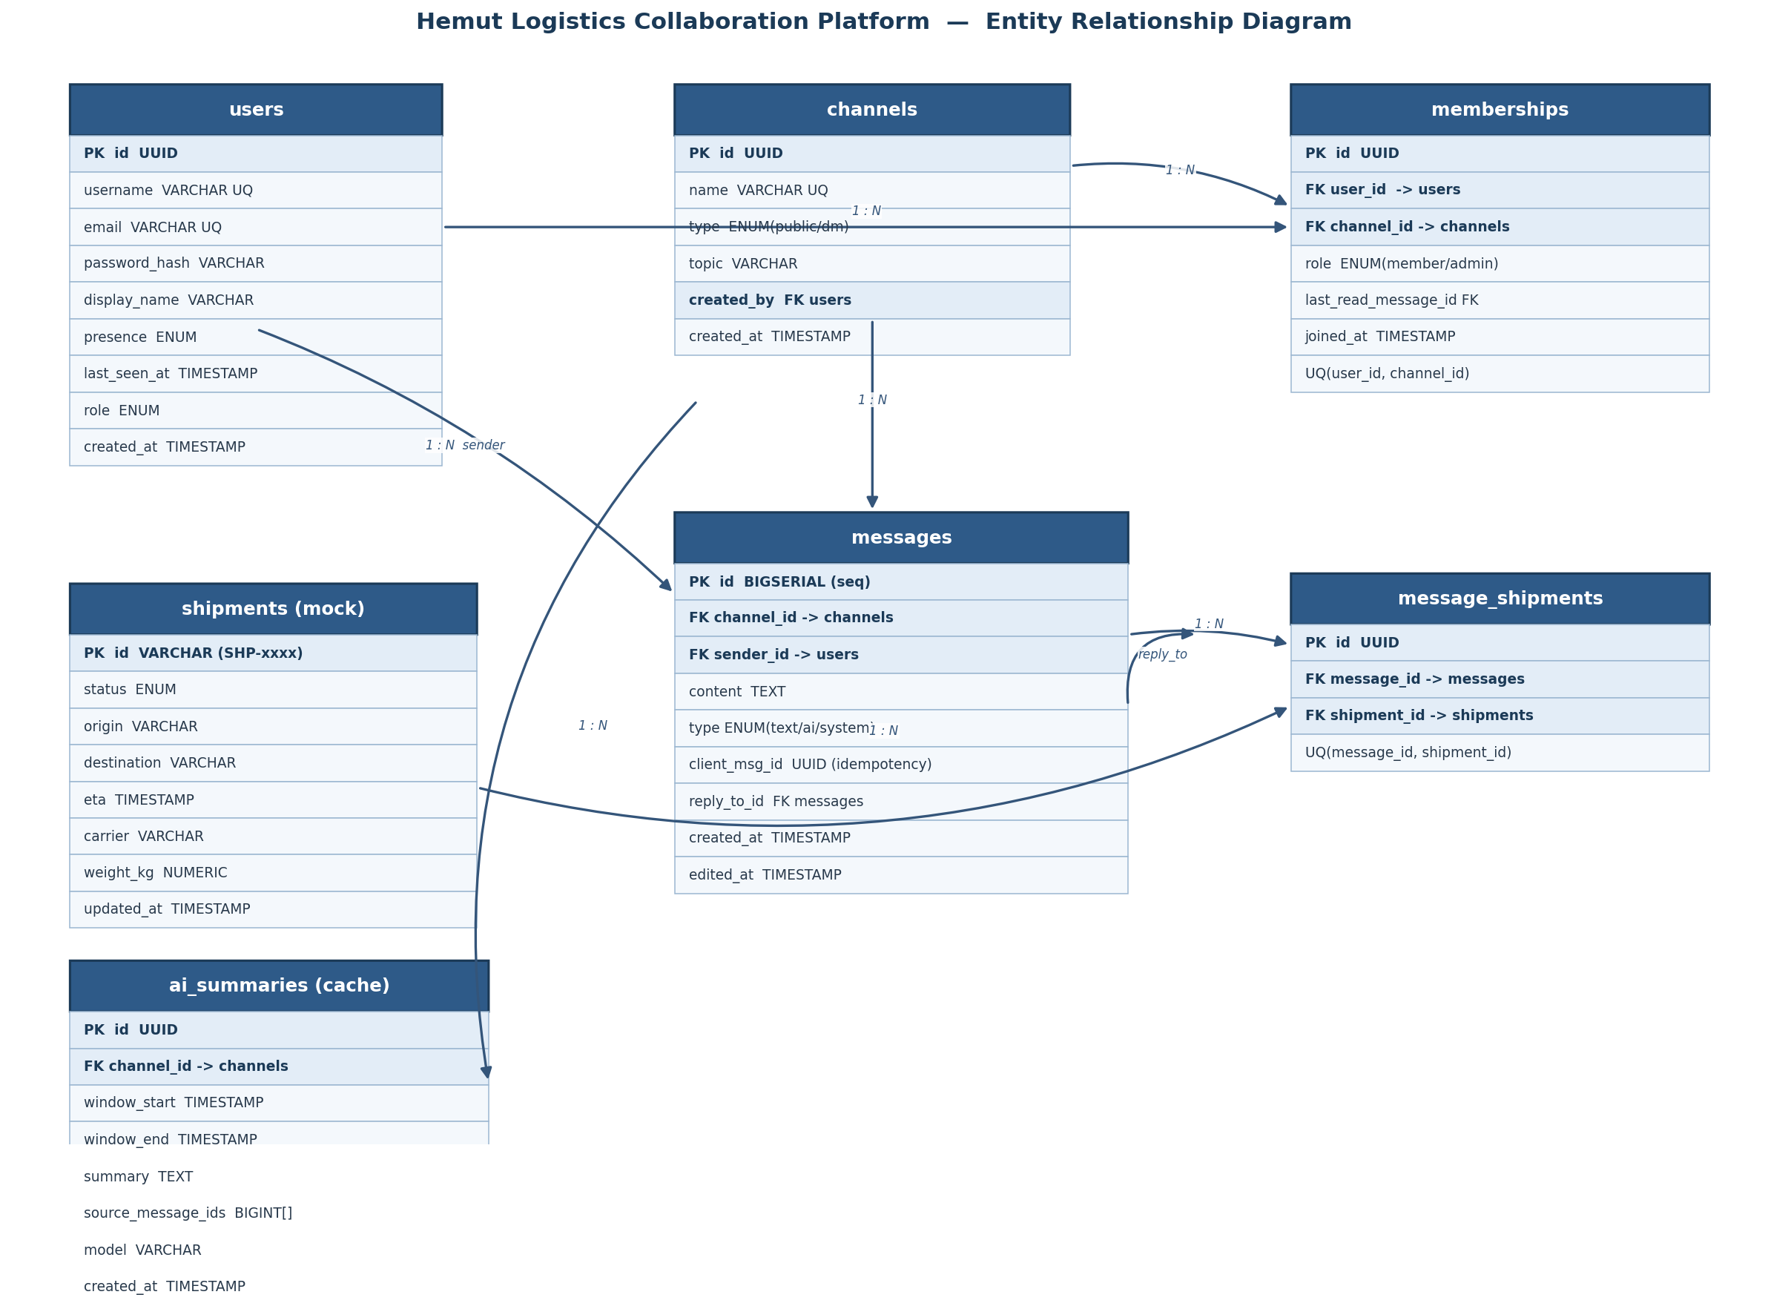
Figure 1 — ER diagram of the core schema. PKs highlighted; arrows denote 1:N relationships.

5.2 Data Models (Tables)

users
Column | Type | Notes
id | UUID PK | gen_random_uuid()
username | VARCHAR(40) UNIQUE | login handle
email | VARCHAR(255) UNIQUE | validated
password_hash | VARCHAR | argon2 / bcrypt
display_name | VARCHAR(80)
presence | ENUM(online,away,offline) | denormalized last state
last_seen_at | TIMESTAMPTZ | updated on heartbeat
role | ENUM(member,admin) | global role
created_at | TIMESTAMPTZ | default now()

channels
Column | Type | Notes
id | UUID PK
name | VARCHAR(80) UNIQUE | e.g. route-east; null/derived for DMs
type | ENUM(public,dm) | DM is a 2-member channel
topic | VARCHAR(255) | optional
created_by | UUID FK → users
created_at | TIMESTAMPTZ

memberships
Column | Type | Notes
id | UUID PK
user_id | UUID FK → users | indexed
channel_id | UUID FK → channels | indexed
role | ENUM(member,admin) | per-channel admin
last_read_message_id | BIGINT FK → messages | drives unread counts
joined_at | TIMESTAMPTZ
UNIQUE(user_id, channel_id) | constraint | no duplicate joins

messages
Column | Type | Notes
id | BIGSERIAL PK | monotonic → ordering & replay cursor
channel_id | UUID FK → channels | indexed (channel_id, id)
sender_id | UUID FK → users | server-derived, never client-trusted
content | TEXT | escaped on render
type | ENUM(text,ai,system)
client_msg_id | UUID | idempotency; UNIQUE(channel_id, client_msg_id)
reply_to_id | BIGINT FK → messages | threaded replies (bonus)
created_at | TIMESTAMPTZ | default now()
edited_at | TIMESTAMPTZ | nullable

shipments (mock)
Column | Type | Notes
id | VARCHAR PK | e.g. SHP-10293
status | ENUM(in_transit,delayed,delivered,...)
origin / destination | VARCHAR
eta | TIMESTAMPTZ
carrier | VARCHAR
weight_kg | NUMERIC
updated_at | TIMESTAMPTZ

message_shipments & ai_summaries
message_shipments links a message to one or more referenced shipments (join table, UNIQUE(message_id, shipment_id)) — populated when entity extraction detects an ID or a /shipment command is used. ai_summaries caches generated summaries keyed by channel + window, storing the model, summary text, and source_message_ids[] used for citation.

5.3 Indexing & Migrations
- Composite index on messages(channel_id, id) for fast in-order pagination and after_id replay.
- Unique index on messages(channel_id, client_msg_id) enforces idempotent inserts.
- Index memberships(user_id) and (channel_id); unique (user_id, channel_id).
- All schema changes flow through Alembic migrations — no ad-hoc DDL.

6. API & WebSocket Contracts

6.1 REST Endpoints
Method & Path | Purpose | Auth
POST /auth/register | Create user (DB-backed validation) | —
POST /auth/login | Validate credentials → JWT pair | —
POST /auth/refresh | Rotate access token | refresh
GET /channels | List joined channels + unread counts | user
POST /channels | Create channel | admin
POST /channels/{id}/join | Join channel | user
POST /channels/{id}/leave | Leave channel | user
GET /channels/{id}/messages | History, paginated (?after_id / ?before_id&limit) | member
POST /channels/{id}/messages | Post message (idempotent) | member
POST /dm/{user_id}/messages | Post / open a 1:1 DM | user
GET /shipments/{id} | Mock shipment lookup | user
POST /channels/{id}/summarize | Trigger AI summary (streams over WS) | member

6.2 WebSocket Protocol
Single multiplexed socket at /ws?token=<jwt>. Client subscribes to channels; server pushes typed events.
// client → server
{ "op": "subscribe", "channel_id": "uuid" }
{ "op": "unsubscribe", "channel_id": "uuid" }
{ "op": "ping" }
// server → client
{ "type": "message", "channel_id": "...", "data": { id, sender_id, content, created_at } }
{ "type": "presence", "user_id": "...", "state": "online|away|offline" }
{ "type": "ai_token", "channel_id": "...", "delta": "partial text..." }
{ "type": "ai_done", "channel_id": "...", "summary_id": "...", "sources": [12,15,18] }
{ "type": "pong" }

6.3 Redis Key Map
Key / Channel | Type | Use
chan:{channel_id} | pub/sub | Message + AI fan-out across workers
presence:{user_id} | string + TTL (~30s) | Online detection via heartbeat refresh
rl:{user_id}:{window} | counter + TTL | Rate limiting message posts
sum:{channel_id}:{window} | string + TTL | Cached AI summary lookup

7. Frontend Design

7.1 Required Screens
- Login / Register — credential validation against DB; XHR-based form submission.
- Sidebar — joined channels (#route-east, #warehouse-mumbai), unread badges, presence dots.
- Channel view — real-time messages with sender + timestamp, optimistic send + reconcile.
- Direct message view — 1:1 conversation reusing the message component.
- Logistics surface — inline shipment preview card + /shipment <id> slash command.

7.2 XHR Form Handling (mandated)
All auth/form submissions use raw XMLHttpRequest, wrapped in a Promise to expose the full lifecycle:
function xhrPost(url, body, { timeout = 8000 } = {}) {
return new Promise((resolve, reject) => {
const xhr = new XMLHttpRequest();
xhr.open('POST', url);
xhr.setRequestHeader('Content-Type', 'application/json');
xhr.timeout = timeout;
xhr.upload.onprogress = (e) => onProgress(e.loaded / e.total);
xhr.ontimeout = () => reject(new Error('Request timed out'));
xhr.onerror = () => reject(new Error('Network error'));
xhr.onabort = () => reject(new Error('Aborted'));
xhr.onload = () =>
(xhr.status >= 200 && xhr.status < 300)
? resolve(JSON.parse(xhr.responseText))
: reject(new Error(xhr.responseText));
xhr.send(JSON.stringify(body));
return () => xhr.abort(); // abort handle
});
}

7.3 Real-Time State (React)
- WebSocket lives in a single context/provider; handlers read latest state via refs to avoid stale closures.
- Cleanup on unmount closes subscriptions and clears timers to prevent memory leaks.
- Incoming messages are inserted in id-order; duplicates dropped by id; optimistic ones reconciled by client_msg_id.
- Reconnect logic replays via after_id and resubscribes to all open channels.

8. Security
Threat | Mitigation
XSS | Escape/sanitize message content on render; no dangerouslySetInnerHTML.
CSRF | Token-based auth in headers (not cookies for API) + CSRF tokens where cookies used.
Message spoofing | Server derives sender_id from JWT; client-supplied sender is ignored.
Tenancy / channel leak | Every query scoped by membership; membership checked before read/write.
Admin action abuse | JWT role claims + FastAPI dependency guard; admin actions audit-logged server-side.
Prompt injection | Retrieved chat treated as untrusted data, isolated from system instructions.
Brute force / spam | Redis rate-limit counters on login and message posting.

9. Testing Strategy
- Auth: register/login happy paths + duplicate username, bad password, expired token.
- Channels: create/join/leave, membership enforcement, admin-only create rejection for members.
- Messaging: post + fetch history pagination; idempotency via repeated client_msg_id; ordering by id.
- Realtime: simulated reconnect replays missed messages via after_id; no duplicates.
- AI feature: tested with a mocked Claude response so CI is deterministic and non-billable; asserts citations map to real message ids and out-of-context refusal path.
# Deterministic AI test — mock the LLM
async def test_summary_cites_sources(client, monkeypatch):
async def fake_stream(*a, **k):
yield "Overnight: SHP-10293 delayed [#12]. Reroute approved [#15]."
monkeypatch.setattr(ai.client, 'stream_summary', fake_stream)
res = await client.post('/channels/CH/summarize')
assert res.status_code == 200
assert set(res.json()['sources']) <= {12, 15} # only real msg ids

10. Deployment & Configuration
Local development uses Docker Compose to bring up Postgres + Redis; the FastAPI app and Next.js client run alongside. Production maps cleanly to AWS: RDS (Postgres), ElastiCache (Redis), and containerized workers behind an ALB with sticky sessions.
Configuration via .env (never committed):
DATABASE_URL=postgresql+asyncpg://app:pass@db:5432/hemut
REDIS_URL=redis://redis:6379/0
JWT_SECRET=<random-256-bit>
JWT_ACCESS_TTL=900
ANTHROPIC_API_KEY=sk-ant-...
AI_MODEL=claude-sonnet-4-6

10.1 Repository Layout
hemut-logistics-chat/
├── backend/
│ ├── app/
│ │ ├── api/ (auth, channels, messages, shipments, summarize)
│ │ ├── core/ (config, security, deps)
│ │ ├── models/ (SQLAlchemy models)
│ │ ├── realtime/ (ws gateway, redis pubsub, presence)
│ │ ├── ai/ (summarizer, prompt, mock)
│ │ └── main.py
│ ├── alembic/ (migrations)
│ └── tests/
├── frontend/ (Next.js app, xhr client, ws provider)
├── docker-compose.yml (postgres + redis)
├── .env.example
└── README.md (setup, architecture, AI write-up, tradeoffs)

11. Design Tradeoffs Summary
Decision | Chosen | Tradeoff accepted
Message ordering | DB BIGSERIAL monotonic id | Single-writer ordering vs distributed clock complexity.
Delivery guarantee | At-least-once + idempotency key | Client dedupes; simpler than exactly-once.
Presence | Redis TTL + heartbeats | Slight delay on offline detection vs constant accuracy.
AI summarization | On-demand + cache | Not instant on first call; far lower cost than always-on.
DMs | Modeled as 2-member channels | Reuses all channel logic; minor over-generalization.

