**NUnit HandsOn**

1. **1 -)**
2. **Meaning of Unit Testing and Its Difference from Functional Testing**

**Unit Testing**:

* Unit testing is a type of software testing where individual components or functions of a software are tested in isolation.
* It focuses on the **smallest testable part** of the code like a method or function.
* Mocking is often used to **simulate dependencies**, so the unit being tested is isolated from external systems like databases or APIs.

**Functional Testing**:

* Functional testing is a **higher-level** test that validates the software system against the functional requirements/specifications.
* It tests **end-to-end scenarios** including integration between components.

1. **Types of Testing**

· **Unit Testing**: Tests individual methods or components.

· **Functional Testing**: Validates the system works as intended (business logic).

· **Automated Testing**: Uses tools or scripts to run tests automatically.

· **Performance Testing**: Checks system performance under load (e.g., response time, throughput).

1. **Understand the benefit of automated testing**

· **Speed**: Tests run faster than manual tests.

· **Repeatability**: Can run frequently and consistently.

· **Coverage**: Tests can cover a large codebase efficiently.

· **Early Bug Detection**: Catches regressions early in development.

· **Cost-Effective**: Saves time and resources in the long term.

1. **Explain what is loosly coupled & testable design**

**Loosely Coupled**:

* Components do **not heavily depend** on one another.
* We can **swap dependencies** (e.g., with mock objects) easily.

**Testable Design**:

* Code is structured in a way that makes it easy to test.
* **Interfaces**, **dependency injection**, and **mocking frameworks are used**.

1. **Write your first testing program to validate a calculator addition operation**

using NUnit.Framework;

[TestFixture]

public class CalculatorTests

{

[Test]

public void Add_TwoNumbers_ReturnsSum()

{

var calc = new SimpleCalculator();

double result = calc.Addition(3, 4);

Assert.AreEqual(7, result);

}

1. }**Understand the need of [SetUp], [TearDown] & [Ignore] attributes.**

**· [SetUp]:** Runs **before** each test. Good for initializing resources.

**· [TearDown]:** Runs **after** each test. Good for cleanup.

**· [Ignore]:** Temporarily skip a test (e.g., if the feature isn’t ready).

1. **Explain the benefit of writing parameterised test cases.**

· Reduces **code duplication**.

· Allows testing **multiple input-output combinations** easily.

· Increases **test coverage** with minimal code.

**Main Test for (CalcLibrary.Tests) :-**

using CalcLibrary;

using Microsoft.VisualStudio.TestTools.UnitTesting;

using NUnit.Framework;

using System;

namespace CalcLibrary.Tests

{

[TestFixture]

public class CalculatorTests

{

private SimpleCalculator _calculator;

[SetUp]

public void Setup()

{

_calculator = new SimpleCalculator();

}

[TearDown]

public void TearDown()

{

_calculator = null;

}

[TestCase(10, 5, 15)]

[TestCase(0, 0, 0)]

[TestCase(-3, -6, -9)]

[TestCase(8, 12, 20)]

public void Addition_ValidInputs_ReturnsCorrectResult(double a, double b, double expected)

{

double result = _calculator.Addition(a, b);

NUnit.Framework.Assert.That(result, Is.EqualTo(expected));

}

}

}

**Test Results:**

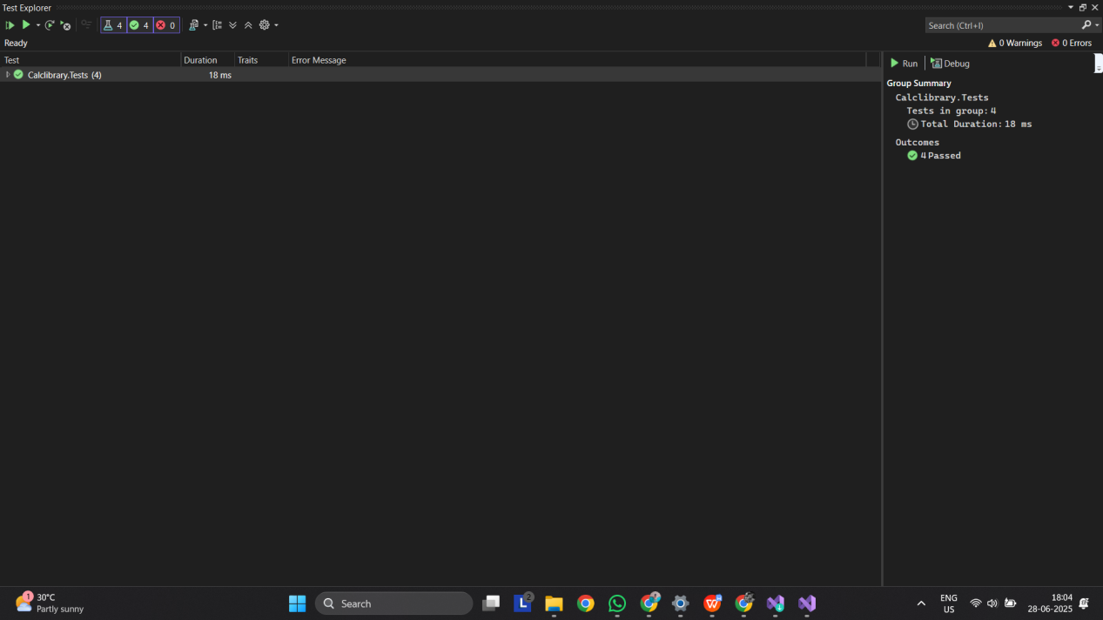

**Q. 2 -)**

## 1. Demonstration on Parameterized Test Cases Using an Example

### Implementation:

**Calculator Method (SimpleCalculator.cs)**

csharp

CopyEdit

public double Addition(double a, double b)

{

return a + b;

}**Test Case (CalculatorTests.cs)**

csharp

CopyEdit

[TestCase(3, 4, 7)]

[TestCase(10, 20, 30)]

[TestCase(-5, 5, 0)] public void Addition_ValidInputs_ReturnsCorrectResult(double a, double b, double expected)

{

double result = _calculator.Addition(a, b);

Assert.AreEqual(expected, result);

}

**Explanation:**  
Parameterized tests reduce code duplication and allow testing of multiple input-output combinations efficiently. The [TestCase] attribute is used to run the same test logic with various inputs and expected outputs.

## 2. Demonstrate on Testing Methods That Return a Value

### Implementation:

**Subtraction Method (SimpleCalculator.cs)**

csharp

CopyEdit

public double Subtraction(double a, double b)

{

return a - b;

}

**Test Case (CalculatorTests.cs)**

csharp

CopyEdit

[TestCase(10, 5, 5)]

[TestCase(0, 0, 0)]

[TestCase(-3, -6, 3)]

[TestCase(8, 12, -4)] public void Subtraction_ValidInputs_ReturnsCorrectResult(double a, double b, double expected)

{

double result = _calculator.Subtraction(a, b);

Assert.AreEqual(expected, result);

}

**Explanation:**  
This demonstrates how to test a return value using Assert.AreEqual.

## 3. Demonstrate on Testing Methods That Throw an Exception

### Implementation:

**Division Method (SimpleCalculator.cs)**

using System;

csharp

CopyEdit

public double Divide(double a, double b)

{

if (b == 0)

throw new ArgumentException("Cannot divide by zero");

return a / b;

}

**Test Case with Exception Handling (CalculatorTests.cs)**

csharp

CopyEdit

[Test]public void Divide_ByZero_ShouldThrowException()

{

try

{

_calculator.Divide(10, 0);

Assert.Fail("Division by zero");

}

catch (ArgumentException ex)

{

Assert.That(ex.Message, Is.EqualTo("Cannot divide by zero"));

Assert.That(ex, Is.TypeOf<ArgumentException>());

}

**Explanation:**  
This demonstrates how to test error conditions using try-catch, Assert.Fail, and verifying the exception type and message.

## 4. Demonstrate on Testing Void Methods

### Implementation:

**Class Methods (SimpleCalculator.cs)**

csharp

CopyEdit

private double result;

public void AllClear()

{

result = 0;

}

public double AddAndStore(double a, double b)

{

result = a + b;

return result;

}

public double GetResult() => result;

**Test Case (CalculatorTests.cs)**

using static System.Net.Mime.MediaTypeNames;

csharp

CopyEdit

[Test]public void AddAndClear_ResultShouldBeZeroAfterClear()

{

_calculator.AddAndStore(5, 5);

Assert.AreEqual(10, _calculator.GetResult());

_calculator.AllClear();

Assert.AreEqual(0, _calculator.GetResult());

}

**Explanation:**  
This test demonstrates how to validate the result of a method that changes internal state and has no return value.

## 5. Explain Why Testing a Private Method Is Not Beneficial

**Explanation:**  
Testing private methods is not a good practice because it breaks object-oriented principles such as encapsulation. Private methods are implementation details and should be tested indirectly via public methods. This avoids tight coupling between test logic and internal code structure and allows greater flexibility during refactoring.

## 6. Explain Mocking Framework and Its Usage

**Explanation:**  
A mocking framework like Moq is used to simulate the behavior of dependencies such as databases, web services, or file systems. This isolates the unit under test and allows testing of components independently from their environment.

**Interface (IMailSender.cs)**

using System;

using static System.Net.Mime.MediaTypeNames;

csharp

CopyEdit

public interface IMailSender

{

bool SendMail(string to, string message);

}

**Dependent Class (CustomerComm.cs)**

csharp

CopyEdit

public class CustomerComm

{

private readonly IMailSender _mailSender;

public CustomerComm(IMailSender mailSender)

{

_mailSender = mailSender;

}

public bool SendMailToCustomer()

{

return _mailSender.SendMail("cust123@abc.com", "Hello!");

}

}

**Test Using Moq (CustomerCommTests.cs)**

csharp

CopyEdit

using Moq;

[Test] public void SendMailToCustomer_ShouldReturnTrue_WhenMailIsSent()

{

var mockSender = new Mock<IMailSender>();

mockSender.Setup(x => x.SendMail(It.IsAny<string>(), It.IsAny<string>())).Returns(true);

var comm = new CustomerComm(mockSender.Object);

bool result = comm.SendMailToCustomer();

Assert.IsTrue(result);

}

**Explanation:**  
In this test, Moq is used to create a fake implementation of the IMailSender interface. This makes the test independent of the actual email sending logic.

**Main Test Code (CalcLibrary.Tests_New) :-**

using NUnit.Framework;

using CalcLibrary;

using System;

namespace CalcLibrary.Tests_New

{

[TestFixture]

public class MathLibraryTests

{

private MathLibrary _math;

[SetUp]

public void Setup()

{

_math = new MathLibrary();

}

[TestCase(10, 5, 5)]

[TestCase(0, 0, 0)]

[TestCase(-4, -4, 0)]

public void Test_Subtract(int a, int b, int expected)

{

Assert.AreEqual(expected, _math.Subtract(a, b));

}

[TestCase(2, 3, 6)]

[TestCase(-2, 4, -8)]

[TestCase(0, 9, 0)]

public void Test_Multiply(int a, int b, int expected)

{

Assert.AreEqual(expected, _math.Multiply(a, b));

}

[TestCase(10, 2, 5)]

[TestCase(9, 3, 3)]

public void Test_Divide(int a, int b, int expected)

{

Assert.AreEqual(expected, _math.Divide(a, b));

}

[Test]

public void Test_Divide_By_Zero()

{

try

{

_math.Divide(5, 0);

Assert.Fail("Division by zero");

}

catch (ArgumentException ex)

{

Assert.That(ex.Message, Is.EqualTo("Cannot divide by zero"));

}

}

[Test]

public void Test_Add_And_Clear()

{

_math.Add(7, 3);

Assert.AreEqual(10, _math.GetResult);

_math.AllClear();

Assert.AreEqual(0, _math.GetResult);

}

}

}

**Test Result :**

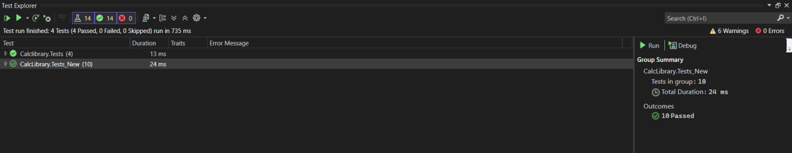

**Q . 3 -)**

**Main Test Code (UtilLib.Tests) :-**

using NUnit.Framework;

using UtilLib;

using System;

namespace UtilLib.Tests

{

public class UrlHostNameParserTests

{

private UrlHostNameParser parser;

[SetUp]

public void Setup()

{

parser = new UrlHostNameParser();

}

[TestCase("https://www.example.com/path", ExpectedResult = "www.example.com")]

[TestCase("https://google.com/search", ExpectedResult = "google.com")]

public string ParseHostName_ShouldReturnCorrectHostName(string url)

{

return parser.ParseHostName(url);

}

[Test]

public void ParseHostName_ShouldReturnHost()

{

string result = parser.ParseHostName("https://test.com/page");

Assert.AreEqual("test.com", result);

}

[Test]

public void DummyVoidMethod_Test()

{

Assert.Pass("Dummy void test executed.");

}

[Test]

public void ParseHostName_ShouldThrowExceptionForInvalidUrl()

{

try

{

parser.ParseHostName("invalid-url");

Assert.Fail("Expected exception was not thrown.");

}

catch (FormatException ex)

{

Assert.That(ex.Message, Is.EqualTo("Url is not in correct format"));

}

}

}

}

**Test Result :**

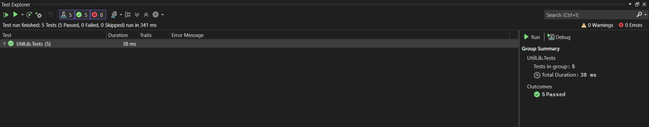

**Q . 4 -)**

**Main Test Code (AccountsManagerLib.Tests) :-**

using NUnit.Framework;

using AccountsManagerLib;

using System;

namespace AccountsManagerLib.Tests

{

[TestFixture]

public class AccountsManagerTests

{

private AccountsManager _manager;

[SetUp]

public void Setup()

{

_manager = new AccountsManager();

}

[Test]

public void ValidateUser_ValidUser11Credentials_ReturnsWelcomeMessage()

{

var result = _manager.ValidateUser("user_11", "secret@user11");

Assert.That(result, Is.EqualTo("Welcome user_11!!!"));

}

[Test]

public void ValidateUser_ValidUser22Credentials_ReturnsWelcomeMessage()

{

var result = _manager.ValidateUser("user_22", "secret@user22");

Assert.That(result, Is.EqualTo("Welcome user_22!!!"));

}

[Test]

public void ValidateUser_InvalidCredentials_ReturnsInvalidMessage()

{

var result = _manager.ValidateUser("wrong_user", "wrong_pass");

Assert.That(result, Is.EqualTo("Invalid user id/password"));

}

[Test]

public void ValidateUser_EmptyUserId_ThrowsFormatException()

{

var ex = Assert.Throws<FormatException>(() =>

{

_manager.ValidateUser("", "secret@user11");

});

Assert.That(ex.Message, Is.EqualTo("Both user id and password are mandatory"));

}

[Test]

public void ValidateUser_EmptyPassword_ThrowsFormatException()

{

var ex = Assert.Throws<FormatException>(() =>

{

_manager.ValidateUser("user_11", "");

});

Assert.That(ex.Message, Is.EqualTo("Both user id and password are mandatory"));

}

}

}

**Test Result :**

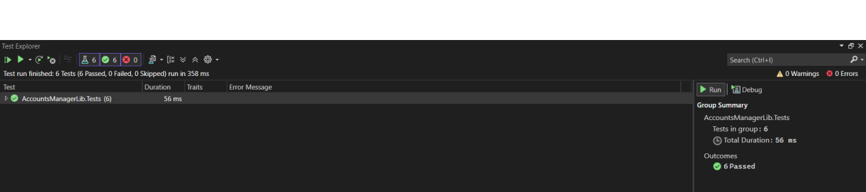

**Q . 5 -)**

**Main Test Code (CollectionsLib.Test) :-**

using NUnit.Framework;

using CollectionsLib;

using System.Linq;

namespace CollectionsLib.Test

{

[TestFixture]

public class EmployeeManagerTests

{

private EmployeeManager _manager;

[SetUp]

public void Setup()

{

_manager = new EmployeeManager();

}

[Test]

public void GetEmployees_ShouldNotContainNulls()

{

var employees = _manager.GetEmployees();

Assert.That(employees, Is.All.Not.Null);

}

[Test]

public void GetEmployees_ContainsEmployeeWithId100()

{

var employees = _manager.GetEmployees();

Assert.That(employees.Any(e => e.EmpId == 100), Is.True);

}

}

}

**Test Result :**

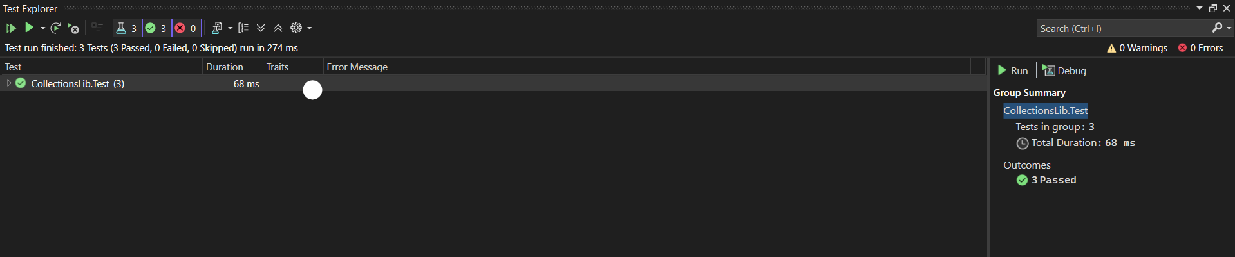



**Q . 6 -)**

**Main Test Code (FourSeasonsLib.Tests) :-**

using NUnit.Framework;

using FourSeasonsLib;

using System.Collections;

using System;

namespace FourSeasonsLib.Tests

{

[TestFixture]

public class SeasonDetectorTests

{

private SeasonDetector _detector;

[SetUp]

public void Setup()

{

_detector = new SeasonDetector();

}

[Test, TestCaseSource(nameof(MonthSeasonPairs))]

public void GetSeason_ValidMonth_ReturnsCorrectSeason(string month, string expectedSeason)

{

var result = _detector.GetSeason(month);

Assert.That(result, Is.EqualTo(expectedSeason));

}

[Test]

public void GetSeason_InvalidMonth_ThrowsArgumentException()

{

Assert.Throws<ArgumentException>(() => _detector.GetSeason("hello"));

}

static IEnumerable MonthSeasonPairs

{

get

{

yield return new TestCaseData("February", "Spring");

yield return new TestCaseData("March", "Spring");

yield return new TestCaseData("April", "Summer");

yield return new TestCaseData("May", "Summer");

yield return new TestCaseData("June", "Summer");

yield return new TestCaseData("July", "Monsoon");

yield return new TestCaseData("August", "Monsoon");

yield return new TestCaseData("September", "Autumn");

yield return new TestCaseData("October", "Autumn");

yield return new TestCaseData("November", "Autumn");

yield return new TestCaseData("December", "Winter");

yield return new TestCaseData("January", "Winter");

}

}

}

}

**Test Result :**

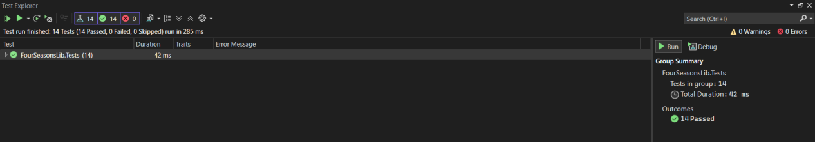

**Q . 7 -)**

**Main Test Code (LeapYearCalculatorLib.Tests) :-**

using NUnit.Framework;

using LeapYearCalculatorLib;

namespace LeapYearCalculatorLib.Tests

{

[TestFixture]

public class LeapYearCalculatorTests

{

private LeapYearCalculator _calculator;

[SetUp]

public void Setup()

{

_calculator = new LeapYearCalculator();

}

[TestCase(2000, 1)]

[TestCase(2016, 1)]

[TestCase(2400, 1)]

public void IsLeapYear_LeapYears_Returns1(int year, int expected)

{

var result = _calculator.IsLeapYear(year);

Assert.That(result, Is.EqualTo(expected));

}

[TestCase(1900, 0)]

[TestCase(2019, 0)]

[TestCase(2100, 0)]

public void IsLeapYear_NonLeapYears_Returns0(int year, int expected)

{

var result = _calculator.IsLeapYear(year);

Assert.That(result, Is.EqualTo(expected));

}

[TestCase(1500, -1)]

[TestCase(10000, -1)]

[TestCase(0, -1)]

public void IsLeapYear_InvalidYears_ReturnsMinus1(int year, int expected)

{

var result = _calculator.IsLeapYear(year);

Assert.That(result, Is.EqualTo(expected));

}

}

}

**Test Result :**

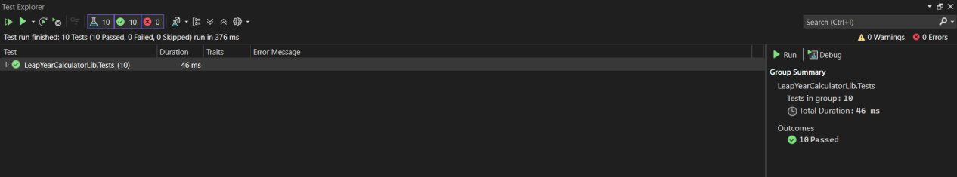

**Q . 8 -)**

**Main Test Code (UserManagerLib.Tests) :-**

using NUnit.Framework;

using UserManagerLib;

using System;

using System.Collections;

namespace UserManagerLib.Tests

{

[TestFixture]

public class UserTests

{

private User _user;

[SetUp]

public void Setup()

{

_user = new User();

}

[Test, TestCaseSource(nameof(NullOrEmptyPANInputs))]

public void ValidatePANCardNumber_NullOrEmpty_ThrowsNullReferenceException(string input)

{

var ex = Assert.Throws<NullReferenceException>(() => _user.ValidatePANCardNumber(input));

Assert.That(ex.Message, Is.EqualTo("Invalid Pan Card Number"));

}

[TestCase("ABCDE123")]

[TestCase("ABCDE123456")]

public void ValidatePANCardNumber_InvalidLength_ThrowsFormatException(string input)

{

var ex = Assert.Throws<FormatException>(() => _user.ValidatePANCardNumber(input));

Assert.That(ex.Message, Is.EqualTo("Pan Card Number Should contain only 10 characters"));

}

[Test]

public void ValidatePANCardNumber_ValidInput_ReturnsValid()

{

var result = _user.ValidatePANCardNumber("ABCDE1234Z");

Assert.That(result, Is.EqualTo("Valid"));

}

static IEnumerable NullOrEmptyPANInputs()

{

yield return new TestCaseData((string)null);

yield return new TestCaseData("");

}

}

}

**Test Result :**

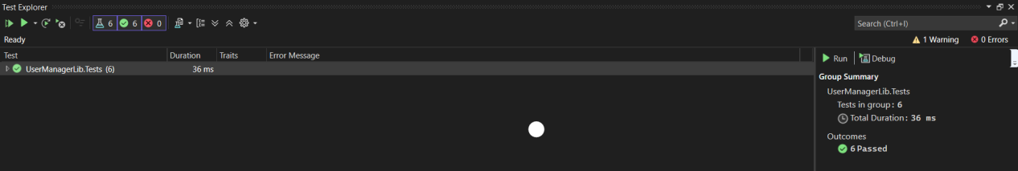



**Q . 9 -)**

**Main Test Code (ConverterLib.Tests) :-**

using NUnit.Framework;

using ConverterLib;

namespace ConverterLib.Tests

{

[TestFixture]

public class ConverterTests

{

private Converter _converter;

[SetUp]

public void Setup()

{

_converter = new Converter();

}

[TestCase(0, 273.15)]

[TestCase(100, 373.15)]

[TestCase(-273.15, 0)]

public void CelsiusToKelvin_ReturnsExpected(double celsius, double expectedKelvin)

{

var result = _converter.CelsiusToKelvin(celsius);

Assert.That(result, Is.EqualTo(expectedKelvin).Within(0.01));

}

[TestCase(0, 0)]

[TestCase(1, 2.20462)]

[TestCase(10, 22.0462)]

public void KilogramToPound_ReturnsExpected(double kg, double expectedPound)

{

var result = _converter.KilogramToPound(kg);

Assert.That(result, Is.EqualTo(expectedPound).Within(0.01));

}

[TestCase(0, 0)]

[TestCase(1, 0.621371)]

[TestCase(5, 3.106855)]

public void KilometerToMile_ReturnsExpected(double km, double expectedMile)

{

var result = _converter.KilometerToMile(km);

Assert.That(result, Is.EqualTo(expectedMile).Within(0.01));

}

[TestCase(0, 0)]

[TestCase(1, 0.264172)]

[TestCase(10, 2.64172)]

public void LiterToGallon_ReturnsExpected(double liter, double expectedGallon)

{

var result = _converter.LiterToGallon(liter);

Assert.That(result, Is.EqualTo(expectedGallon).Within(0.01));

}

[TestCase(1, 0.85)]

[TestCase(10, 8.5)]

[TestCase(100, 85)]

public void USDToEuro_ReturnsExpected(double usd, double expectedEuro)

{

var result = _converter.USDToEuro(usd);

Assert.That(result, Is.EqualTo(expectedEuro).Within(0.01));

}

}

}

**Test Result :**

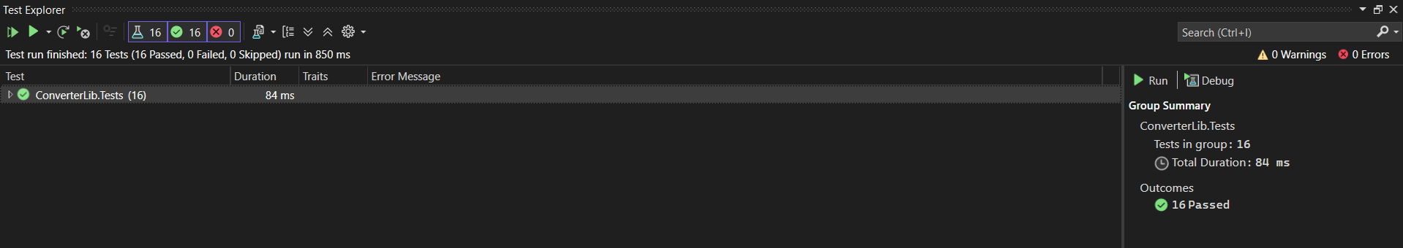

**\*\* Moq HandsOn \*\***

#### 1. ****File: IMailSender.cs****

namespace CustomerCommLib

{

public interface IMailSender

{

bool SendMail(string toAddress, string message);

}

}

#### 2. ****File: MailSender.cs****

using System.Net;

using System.Net.Mail;

namespace CustomerCommLib

{

public class MailSender : IMailSender

{

public bool SendMail(string toAddress, string message)

{

MailMessage mail = new MailMessage();

SmtpClient smtpServer = new SmtpClient("smtp.gmail.com");

mail.From = new MailAddress("your_email_address@gmail.com");

mail.To.Add(toAddress);

mail.Subject = "Test Mail";

mail.Body = message;

smtpServer.Port = 587;

smtpServer.Credentials = new NetworkCredential("username", "password");

smtpServer.EnableSsl = true;

smtpServer.Send(mail);

return true;

}

}

}

#### 3. ****File: CustomerComm.cs****

namespace CustomerCommLib

{

public class CustomerComm

{

private readonly IMailSender _mailSender;

public CustomerComm(IMailSender mailSender)

{

_mailSender = mailSender;

}

public bool SendMailToCustomer()

{

return _mailSender.SendMail("cust123@abc.com", "Some Message");

}

}

}

**Project 2: CustomerComm.Tests**

1. **File: CustomerCommTests.cs**

using NUnit.Framework;

using Moq;

using CustomerCommLib;

namespace CustomerComm.Tests

{

[TestFixture]

public class CustomerCommTests

{

private Mock<IMailSender> _mockMailSender;

private CustomerCommLib.CustomerComm _customerComm;

[OneTimeSetUp]

public void Init()

{

_mockMailSender = new Mock<IMailSender>();

_mockMailSender.Setup(m => m.SendMail(It.IsAny<string>(), It.IsAny<string>())).Returns(true);

_customerComm = new CustomerCommLib.CustomerComm(_mockMailSender.Object);

}

[Test]

public void SendMailToCustomer_ShouldReturnTrue_WhenMailIsSent()

{

bool result = _customerComm.SendMailToCustomer();

Assert.That(result, Is.True);

}

}

}

**Output**

