# **Leveraging Data Intelligence to Revitalize GDS Grands' Market Position**

# By Hritik Saini & Shruti Tiwari

**Table of Contents**

|  |  |  |
| --- | --- | --- |
| **S. No** | **Particulars** | **Page No.** |
| **1** | **Table of Content** | **1** |
| **2** | **Introduction** | **2** |
| **3** | **Project Scope and Objective** | **2** |
| **4** | **Problem Statement** | **2** |
| **5** | **Project Overview** | **3** |
| **6** | **Architecture of the Project** | **3** |
| **7** | **Tools and Components Used** | **4** |
| **8** | **Data Flowchart** | **5** |
| **9** | **Step by Step Process for Project Execution** | **6** |
| **10** | **Insights from analysis** | **9** |
| **11** | **Conclusion** | **13** |

**Introduction**

In the ever-evolving landscape of modern business, data has emerged as the cornerstone for informed decision-making. As industries continue to embrace digital transformation, the ability to extract actionable insights from vast datasets becomes paramount. This data-driven paradigm shift presents both challenges and opportunities, particularly in optimizing processes, enhancing efficiency, and driving innovation.

In this context, our project aims to harness the power of data analysis to unlock valuable insights that can drive strategic decision-making within our organization. Our team has **Hritik Saini,** a seasoned Senior Analyst at our esteemed MNC based in Pune and **Shruti Tiwari**, a 2nd-year B.Tech student in Computer Science, deeply passionate about Data Science and Artificial Intelligence Eager to unravel complexities and innovate. Our team is poised to explore and leverage data to its fullest potential.

**Project Scope and Objectives**

Our project revolves around analysing diverse datasets to uncover patterns, trends, and correlations that offer actionable insights. With a focus on leveraging our expertise in Computer Science and Engineering, particularly in data analysis, we aim to address key business challenges and opportunities through the following objectives:

1. **Identifying Key Performance Indicators (KPIs):** Determine relevant metrics and KPIs aligned with organizational goals and objectives.
2. **Data Collection and Preparation:** Aggregate and preprocess data from various sources, ensuring data integrity and quality.
3. **Exploratory Data Analysis (EDA):** Conduct in-depth exploratory analysis to understand data distributions, anomalies, and relationships between variables.
4. **Statistical Modelling and Predictive Analytics:** Apply advanced statistical techniques and predictive modelling to forecast future trends and outcomes.
5. **Visualization and Communication:** Communicate insights effectively through compelling data visualizations and reports, tailored to different stakeholders.

**Problem Statement**

**GDS Grands owns multiple five-star hotels across India. They have been in the hospitality industry for the past 20 years. Due to strategic moves from other competitors and ineffective decision-making in management, GDS Grands are losing its market share and revenue in the luxury/business hotels category.**

**As a strategic move, the managing director of GDS Grands wanted to incorporate “Business and Data Intelligence” in order to regain their market share and revenue. However, they do not have an in-house data analytics team to provide them with these insights.**

**Their revenue management team had decided to hire a 3rd party service provider to provide them insights from their historical data.**

**Task:**

**Mr. Analyst is the data analyst. He has been briefed about the task in the**

**stakeholder business review meeting. Now Imagine yourself as Mr. Analyst and**

**play the role of the new data analyst who is excited to build this dashboard and**

**perform the following task:**

**• Create the metrics according to the metric list.**

**• Create a dashboard according to the mock-up provided by stakeholders.**

**• Create relevant insights that are not provided in the metric list/mock-up dashboard.**

**Leveraging Data Intelligence to Revitalize GDS Grands' Market Position**

**In an ever-evolving landscape of the hospitality industry, maintaining a competitive edge is paramount. GDS Grands, a stalwart in the luxury hotel sector for the past two decades, faces unprecedented challenges as strategic maneuvers from competitors coupled with management inefficiencies have eroded their market share and revenue streams. In response to this pressing situation, the managing director of GDS Grands has initiated a strategic pivot towards integrating "Business and Data Intelligence" to reclaim lost ground and bolster revenue.**

**Recognizing the critical role of data analytics in strategic decision-making, GDS Grands has embarked on a journey to harness insights from their extensive historical data. However, lacking an in-house data analytics team, they have opted to enlist the expertise of a third-party service provider to glean actionable insights from their wealth of data.**

**As the appointed data analyst, entrusted with the pivotal task of guiding GDS Grands back to prosperity, we are excited to embark on this journey. Armed with a comprehensive understanding of the challenges faced and the stakeholders' aspirations, we are prepared to execute the following tasks:**

**Task Overview**

**In alignment with the stakeholder's vision and objectives, our primary responsibilities encompass:**

**Metric Definition and Creation: Develop a set of key performance indicators (KPIs) tailored to GDS Grands' unique business landscape. These metrics will serve as the cornerstone for evaluating performance and guiding strategic initiatives.**

**Dashboard Design and Implementation: Translate stakeholder expectations and requirements into a visually intuitive and informative dashboard. This dashboard will serve as a centralized hub for accessing critical insights and monitoring key metrics in real-time.**

**Insight Generation: Extend beyond the predefined metric list and dashboard mock-ups to uncover hidden patterns, trends, and correlations within the data. By leveraging advanced analytics techniques, we aim to provide novel insights that empower GDS Grands to make informed decisions and gain a competitive edge.**

**Through diligent analysis, strategic visualization, and innovative insights, we are confident that our collaboration with GDS Grands will yield tangible results. Together, we will navigate the complexities of the hospitality industry, charting a course towards renewed prosperity and dominance in the luxury hotel sector.**

**As we embark on this transformative journey, we are committed to leveraging the power of data intelligence to drive sustainable growth, enhance operational efficiency, and position GDS Grands as a leader in the global hospitality landscape.**

**Architecture of the Project**

**1. Data Preprocessing:**

* **Extracted data from the provided files (dim_date, dim_hotels, dim_rooms, fact_aggregated_bookings, fact_bookings) using appropriate data ingestion tools or scripts.**
* **Cleansed and preprocessed the data to handle missing values, duplicates, and inconsistencies.**
* **Performed data transformations such as data type conversions, aggregations, and joins to prepare the data for analysis.**
* **Enriched the datasets by combining relevant information from different sources.**

**2. Metric Calculation:**

* **Utilized the provided metrics list to calculate the required KPIs and metrics based on the available data.**
* **Aggregated and calculated metrics such as revenue, total bookings, average rating, total capacity, successful bookings, occupancy rate, total canceled bookings, and cancellation rate.**

**3. Dashboard Development:**

* **Developed a user-friendly dashboard according to the mock-up provided by stakeholders.**
* **Utilized dashboarding tool Power BI to visualize the calculated metrics and insights.**
* **Designed interactive and informative visualizations to facilitate easy interpretation and exploration of data.**

**4.Insight Generation:**

* **Beyond the predefined metrics and dashboard mock-up, generated additional insights by analysing the data.**
* **Identified trends, patterns, and anomalies in the data that could provide valuable strategic insights for GDS Grands.**
* **Utilized advanced analytics techniques like predictive modelling or clustering to uncover hidden patterns in the data.**

**5.Report Generation and Presentation:**

* **Compiled the generated insights into comprehensive reports along with actionable recommendations.**
* **Presented the findings to stakeholders, including the managing director and revenue management team, through detailed presentations.**
* **Communicated the impact of the insights on strategic decision-making and revenue optimization for GDS Grands.**

**Tools and Components Used:**

1. **Python**

**Python was used for the process of data preprocessing like data exploration and data cleaning with the help of python libraries such as Numpy, Pandas etc.**

1. **Excel**

**Excel was used for storing and exploring the data extracted.**

1. **Powerre BI**

**Power BI was the data visualization tool used to develop the interactive and very user-friendly dashboard and data modelling, which provides us with various insight related to the analysis we performed on the data. Power BI components such as slicer, edit query, DAX queries and different visualization patterns helps us to model and present in a very relative and understandable manner.**

**Data Flowchart**

**Start**

**|**

**|-----Data Ingestion-----|**

**|**

**v**

**Extract Data from Files (dim_date, dim_hotels, dim_rooms, fact_aggregated_bookings, fact_bookings)**

**|**

**v**

**|-----Data Preprocessing-----|**

**|**

**v**

**Cleanse and Preprocess Data**

**|**

**v**

**|-----Metric Calculation-----|**

**|**

**v**

**Calculate Metrics (Revenue, Total Bookings, Average Rating, Total Capacity, Successful Bookings, Occupancy Rate, Total Canceled Bookings, Cancellation Rate)**

**|**

**v**

**|-----Dashboard Development-----|**

**|**

**v**

**Develop User-Friendly Dashboard**

**|**

**v**

**Visualize Metrics and Insights using Dashboarding Tools (Power BI)**

**|**

**v**

**Design Interactive and Informative Visualizations**

**|**

**v**

**|-----Insight Generation-----|**

**|**

**v**

**Generate Additional Insights Beyond Predefined Metrics and Dashboard Mock-Up**

**|**

**v**

**Identify Trends, Patterns, and Anomalies**

**|**

**v**

**|-----Report Generation and Presentation-----|**

**Step by Step Process for Project Execution**

**After going through the problem statement and understanding the requirement, we imported the data into the Python editor for preprocessing of the data. In preprocessing, we cleaned the data removing all the duplicates and null values from the columns which were not supposed to contain these values.**

**We calculated the mean rating value of all the 25 Outlets of the GDS Grand given by the customer based on the services provided.**

**After this we imported the data to a new excel file from where we uploaded that data into Power BI to perform different table joins and data modelling techniques.**

**After getting the tables joined with appropriate metrices, we performed the analysis on the data and tried to represent it in the form of a dashboard as can be seen in the pictures below.**

**This is the main screen of the dashboard containing crucial and important insights for the data of the hotels provided. Here we have also categorized city wise and represented it in such a way that you can select the way you want to see the data in, like if you want to see the overall data you can do that by opting Select All option, or if you want the insights based on the city then you are free to chose the city of your choice and see the data related to that.**

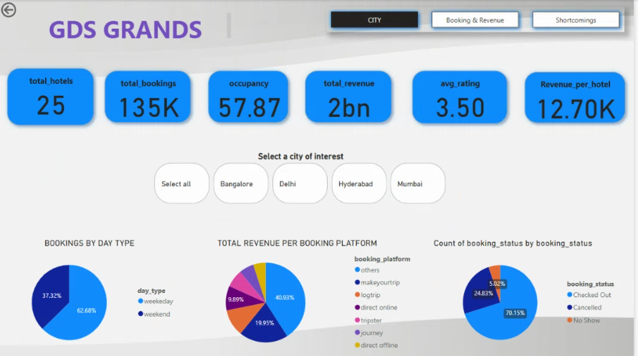

**Insights from the Analysis**

* **Overall Analysis**

**From the analysis of the data, as can be seen in the dashboard above, there are total 25 hotels across the country. From these 25 hotels, the group is receiving a total of 135K bookings in the time provided in the data. The average occupancy in the hotels is around 58%. Talking about the customer experience and ratings received, the hotels are rated on an average of 3.5. Total revenue generated during this period was around 2Bn.**

* **City Wise Analysis**
* **Bangalore**

**From the analysis of the data for the city Bangalore, as can be seen in the dashboard above, there are total 6 hotels across the country. From these 6 hotels, the group is receiving a total of 32K bookings in the time provided in the data. The average occupancy in the hotels is around 56%. Talking about the customer experience and ratings received, the hotels are rated on an average of 3.3. Total revenue generated during this period was around 420Mn.**

* **Delhi**

**From the analysis of the data, as can be seen in the dashboard above, there are total 5 hotels across the country. From these 5 hotels, the group is receiving a total of 24K bookings in the time provided in the data. The average occupancy in the hotels is around 61%. Talking about the customer experience and ratings received, the hotels are rated on an average of 3.7. Total revenue generated during this period was around 295Mn.**

* **Hyderabad**

**From the analysis of the data, as can be seen in the dashboard above, there are total 6 hotels across the country. From these 6 hotels, the group is receiving a total of 35K bookings in the time provided in the data. The average occupancy in the hotels is around 58%. Talking about the customer experience and ratings received, the hotels are rated on an average of 3.5. Total revenue generated during this period was around 325Mn.**

* **Mumbai**

**From the analysis of the data, as can be seen in the dashboard above, there are total 8 hotels across the country. From these 8 hotels, the group is receiving a total of 43K bookings in the time provided in the data. The average occupancy in the hotels is around 58%. Talking about the customer experience and ratings received, the hotels are rated on an average of 3.51. Total revenue generated during this period was around 669Mn.**

* **Bookings By Day Type**

**In this section we have analysed the data based on the number of the booking made for the weekdays and weekends. From this we got the insight that most number of bookings are made for the weekdays (5Days) and weekends (2Days) got the almost equal. So, if going as per the insights, we can conclude from this data that most visitors are booking for the weekends, so GDS Grands group should focus on the weekends bookings to make most of their business.**

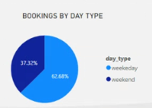

* **Total Revenue Per Booking Platform**

**Total revenue per booking platform represents the bookings made through various platforms like direct website bookings, third party website/apps booking, offline bookings and booking made via other means.**

**So, here we can see most of the business is coming through the various means of online booking. Based on this insight, the target audience for the marketing and other strategies should be the online audience. Also, the other means of booking needs to be identified and for them also, different and relevant strategies should be made accordingly. For offline means hotels should focus on the local partnerships like with cab drivers, shop owners etc.**

* **Booking Status**

**This pie graph helps us to identify that out of the total bookings made how many bookings are completed successfully and how many not. Here, we can see around 70% bookings were completed successfully where customers checked out. Around 25% bookings were cancelled which is a point of concern for the hotels.**

**Hotels should look up on the factors which are leading to the cancellation of the booking on this scale and try to improve the shortcomings.**

* **Total Booking based on Hotel Category**

**Hotels of the GDS Grand group provide rooms for two categories, i.e. Business and Luxury. Based on the insights drawn from the data we can see that in Mumbai, most visitor are those who are staying in Luxury category hotels while for Delhi, it’s the highest among all the cities where percentage of rooms being booked is of the Business hotels. So, hotels should focus accordingly on the target audience based on Luxury and Business hotels.**

* **Total Revenue by room class**

**In a particular hotel, rooms provided are of four categories namely, Elite, Premium, Presidential and Standard. So here we have insight that in each city, which room is generating the highest and lowest revenue. Like in Mumbai, Elite rooms are generating most of the revenue so focus there should be on providing more elite rooms and also on improvising the standard of the other room types also.**

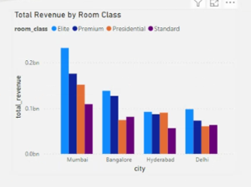

* **Total Capacity and Occupancy by Week number**

**The provided to us was from the week 19 to week 32. Based on this data, we put a check on the total capacity of the hotel to the total number of hotel rooms being occupied. Here you can see the trend for the room occupancy that hotels were occupied mostly during the week 26 – week 30 and less occupied for the period of week 21 – week 22.**

* **Best Rated and Lowest Rated hotels**

**Visitor upon successful completion of their stay duration rated the hotels based on the experience they had and services of the hotel.**

**Here two tables are there, which provide us with the insight that which hotels are top rated, and which are poorly rated.**

**Hotels which are top rated provide the best customer service and experience and need some minor improvements based on the suggestions received from the customer.**

**Poorly rated hotels need to look upon their services and should make significant changes to provide the customer with best service so that those they prefer the same hotels during their next visit and suggest to others.**

* **Cancellation of the bookings**

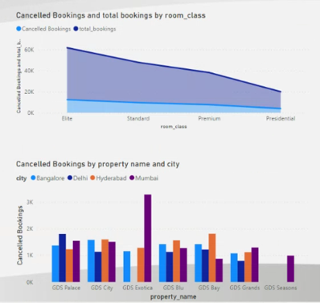**Following two tables provides us with the data that from the total booking that were made how many are getting cancelled based on the room type. Here we can see the trend that cancellation is most and booking trend goes in a decreasing manner from Elite to Presidential rooms.**

**The second table is based on the number of bookings cancelled based on the Hotel name and city. Here we can see that most of the cancellation made are from Mumbai’s GDC Exotica. So, these hotels needs to look up on their cancellation pattern and accordingly take suitable measures to improve and minimise the cancellation of the bookings.**

**Note: All the insights shown above are for the overall country hotels, we can analyse and get the insights based in the city also just by selecting the city.**

**Conclusion**

In a rapidly changing business environment, the ability to extract actionable insights from data is no longer a luxury but a necessity for sustainable growth and competitive advantage. Through this data analysis project spearheaded by Hritik Saini and Shruti Tiwari, we are committed to driving value and fostering a culture of data-driven decision-making within our organization.

As we embark on this journey, we are poised to unlock new possibilities, drive innovation, and chart a path towards greater success in the digital age.