**RingDoorBell - Data Mining**

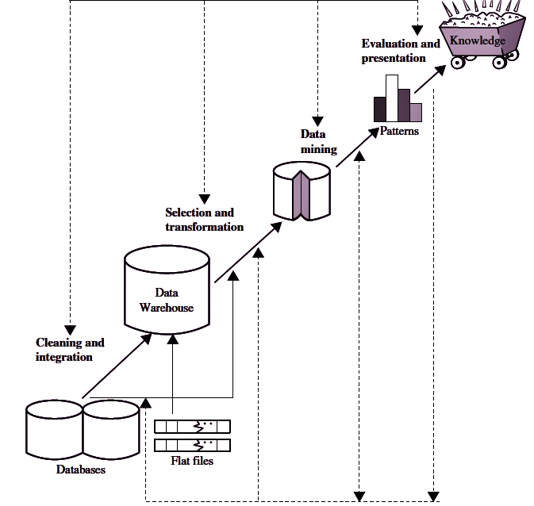

Source: Overview of the KDD process - https://www.studyglance.in/dm/display.php?tno=4&topic=Knowledge-Discovery-from-Data-%28KDD%29

1. **Data Selection phase:**
2. **For familiar faces detection:**

* Collect images of faces from doorbell camera footage
* Gather labeled images of known individuals (e.g. family members, frequent visitors)
* Include a diverse set of facial images with different angles, lighting conditions, and expressions

1. **For logo detection**:

* Acquire images of various logos from packages, delivery vehicles, etc.
* Obtain a dataset of common brand logos for training
* Include logos in different sizes, orientations, and partial views

1. **Data Preprocessing phase:**

* Clean the image data by removing blurry or extremely low-quality images
* Normalize image sizes and resolutions for consistency
* Apply noise reduction techniques to improve image quality
* For faces, detect and crop facial regions using facial landmark detection
* For logos, isolate logo regions within images using edge detection and segmentation.

1. **Data Transformation phase:**

* Convert images to a suitable format for machine learning (e.g. arrays of pixel values)
* Perform feature extraction:
* For faces: Extract facial features like distances between eyes, nose shape, etc.
* For logos: Extract shape descriptors, color histograms, and texture features
* Encode categorical data (e.g. person names, logo brands) into numerical format
* Normalize feature values to a common scale

1. **Data Mining phase:**

* Split the data into training, validation, and test sets
* **For familiar faces:**
  + Train a deep learning model (e.g. Convolutional Neural Network) on the facial images
  + Fine-tune the model using transfer learning from pre-trained face recognition models.
* **For logo detection:**
  + Implement object detection algorithms (e.g. YOLO, Faster R-CNN) for logo localization
  + Train a classification model to identify specific brands once logos are detected
* Optimize model hyperparameters using techniques like cross-validation.

1. **Interpretation/Evaluation phase:**

* Evaluate model performance using metrics such as accuracy, precision, recall, and F1-score
* Analyze confusion matrices to identify common misclassifications
* Perform error analysis on incorrectly classified samples
* Test the system in real-world scenarios to assess its practical effectiveness
* Gather user feedback on the accuracy and usefulness of notifications.

1. **Knowledge Extraction:**

* Create a database of familiar faces and their associated information (names, relationships)
* Develop a catalog of recognized logos and their corresponding brands
* Generate insights on visitor patterns, package delivery frequencies, and brand preferences
* Implement a system for continuous learning, allowing users to correct misclassifications and add new faces/logos over time
* Use the acquired knowledge to enhance the doorbell camera's functionality, such as customizing notifications based on recognized individuals or prioritizing alerts for unfamiliar faces