**INSTRUCTIONS FOR ROUND 2**

**Read the INSTRUCTIONS carefully before you start. Try to remove all the bugs in site.**

* The design given to you is a single page website.
* The Output should be as per Design given.
* All CSS properties should be as per design.
* The site should not refresh on clicking any of the buttons.

INSTRUCTIONS:-

1. On hovering over options on navbar , it should display respective dropdown list.



2. There is Animation to ‘WEB DESIGN IDEAS’.

3. FORM:

1. If form is submitted without any input it should display error message.

With red input box.

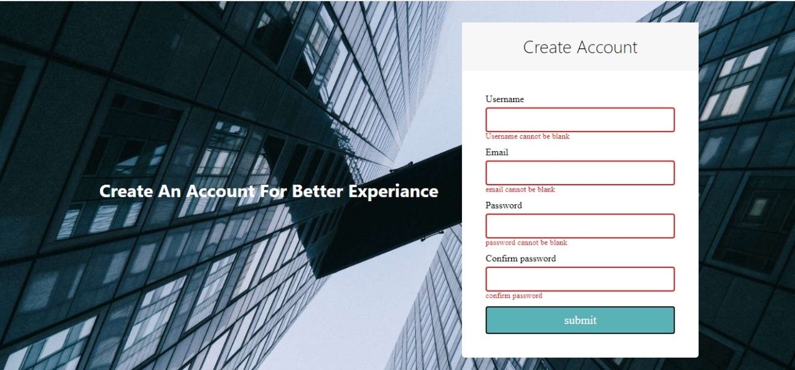

2. If the field is filled then it should display green input box.

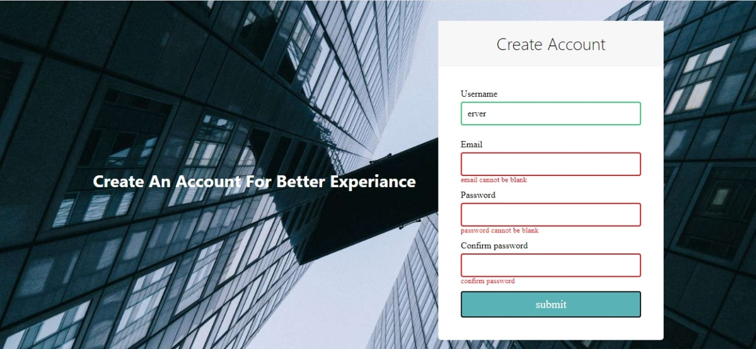

3. It should also take email in correct format .

4. Passwords should also match while confirming. If password does not match it should display error massage

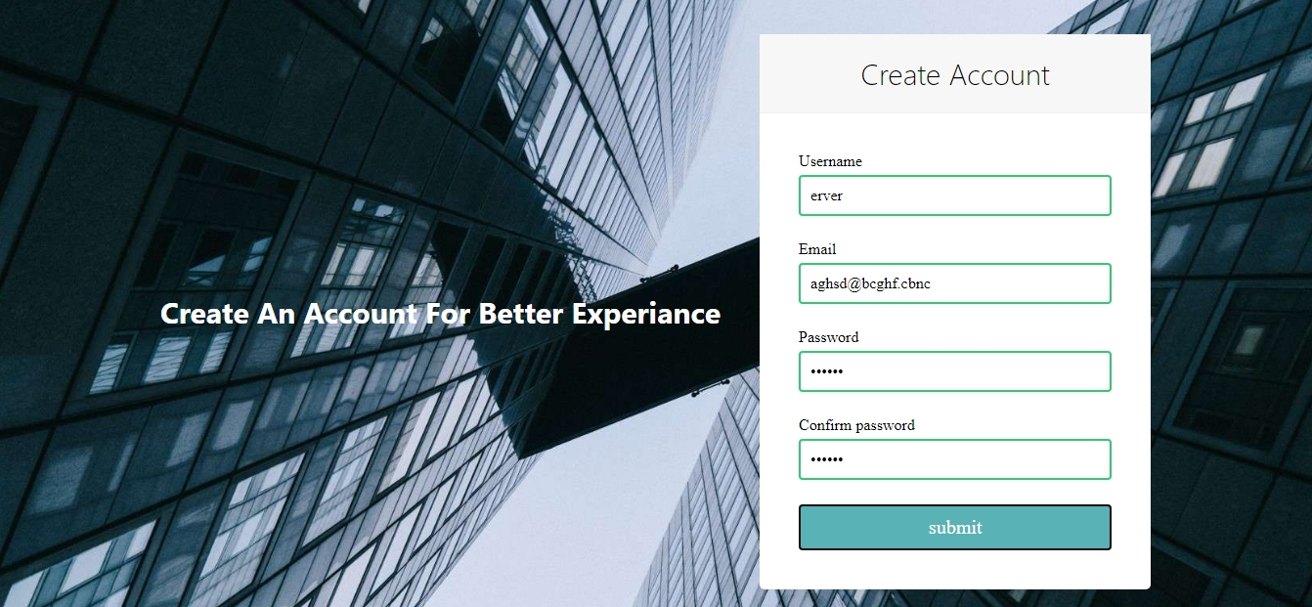

**ALL THE BEST!!! DO YOUR BEST!!**