EX. No. 1.1 — DESIGN AND DRAFT THE GIVEN 2D SKETCH
AIM:
To create the given dimensioned 2D mechanical sketch using Autodesk Fusion 360.
REQUIREMENTS:
1. Autodesk Fusion 360
2. Computer running Windows 10 or a supported operating system
3. Mouse or touchpad for sketching and dimensioning
4. Units set to millimetres (mm)

PROCEDURE:
- Open Autodesk Fusion 360 and create a new design. Set the document units to millimetres.
- Choose Create Sketch and select the XY plane (or another suitable planar workspace).
- 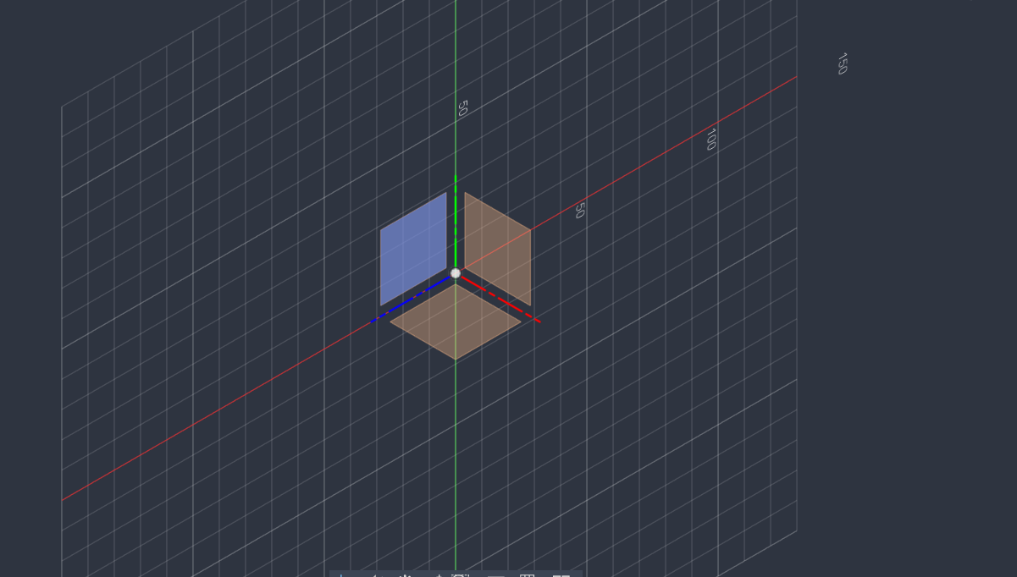

- Draw horizontal and vertical construction centre-lines through the origin. Use them to keep the sketch symmetrical.
- Draw the central concentric circles at the origin. Apply the radii shown on the drawing, including the central opening and the circular boundary around it. Circle of diameter 32,42,80 on same centre.
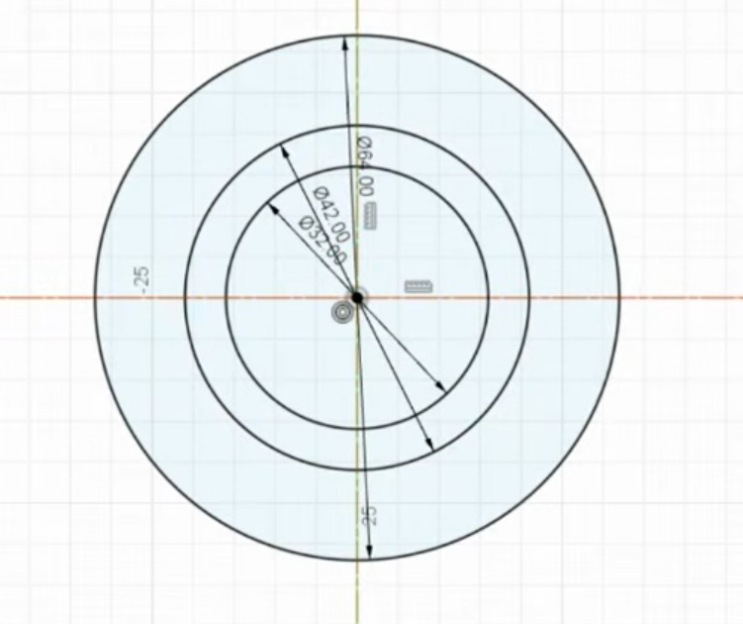
- Draw the four outer circular features on the horizontal and vertical arrangement shown in the reference. Apply the indicated R15 dimensions to the circular ends and use the shown centre spacing dimensions to position them with same center draw R21 circle and now draw another circle with horizontal line R15 and R20 circle .
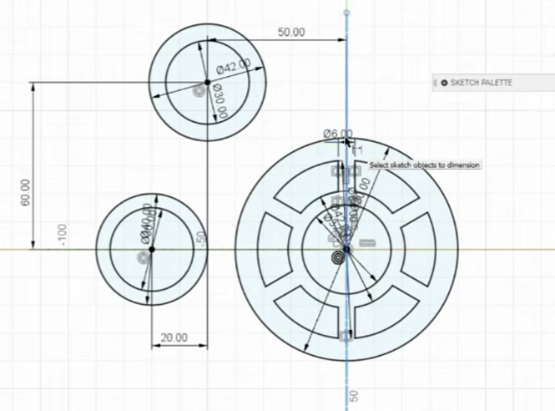
- Create the upper and lower outer lobes using circles/arcs with the indicated R21 radii. Position them symmetrically about the horizontal centre-line and constrain their locations using the dimensions on the drawing.

- Connect the outer lobes and side features with tangent arcs/lines, using the indicated R20 and R21 radii where shown. Apply tangent constraints so adjoining curves meet smoothly.

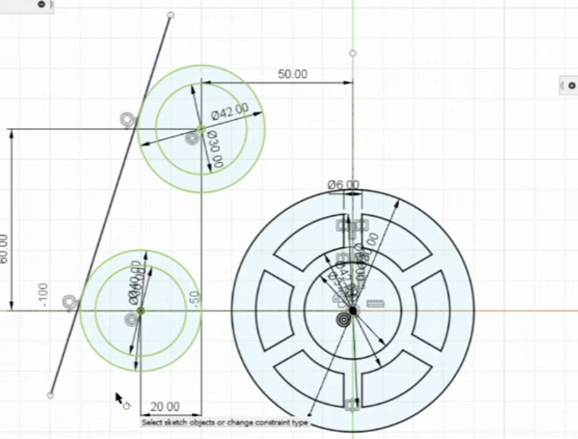
- Add the inner circular ring and the six repeated openings around the centre. Draw one opening first, using the dimensions indicated in the sketch, then use Circular Pattern about the main centre to create six equally spaced instances.

- Use the Trim tool to remove extra circle and arc segments, producing the final outer boundary and the six openings in the central ring.

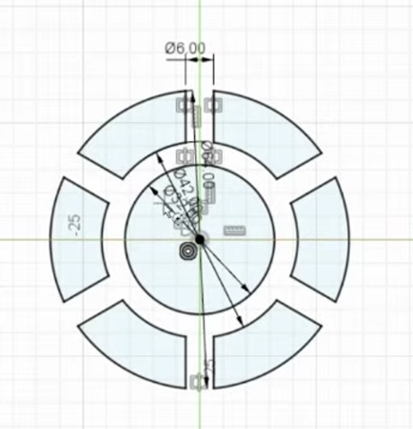
11.Take a R20 circle and tangent it with R40 and R21 and trim according to the image and using the mirror tool mirror both horizontal and vertical.
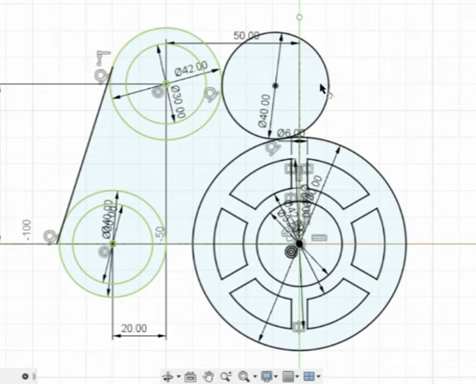

- Use the Sketch Dimension tool to enter the remaining dimensions, including the 50 mm offsets, 60 mm vertical offsets, and the radii marked on the reference. Confirm the geometry remains symmetric.
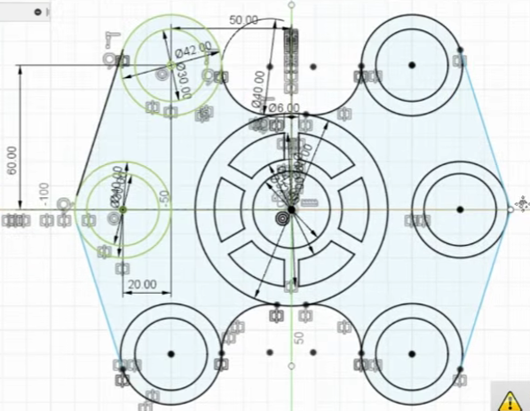
- Inspect the sketch against the reference image. Ensure the profiles are closed where required and that no unwanted construction geometry remains.
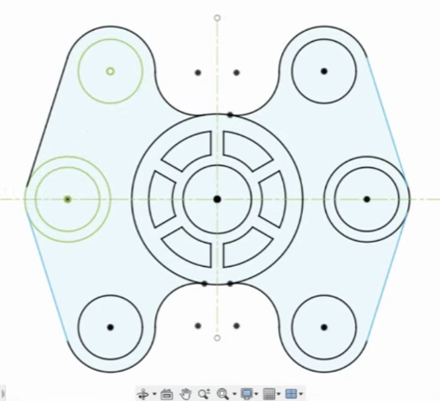
- Click Finish Sketch. If a 3D model is required for the record, select the closed profile and use Extrude with the thickness specified .

RESULT:
The given 2D sketch was drafted in Autodesk Fusion 360 using the dimensions and geometric relationships indicated in the reference drawing.
SKETCH:

OUTPUT:


