



**Client Service Coordinators V1.1**

**Eclipse Requirements**

Contents

1 Introduction 3

1.1 Purpose of the Business Requirements 4

1.2 Stakeholders 4

1.3 Assumptions 4

2 Requirement Catalogue 6

3 Functional Requirements 13

3.1 Creation of New Project Lines – Requirement ID CSC 001 13

3.2 Categorisation of Notes - Requirement ID CSC 002 17

3.3 Filter for Active Resources - Requirement ID CSC 003 20

3.4 Notes from Screen - Requirement ID CSC 004 22

3.5 Creation of automatic Project Codes - Requirement ID CSC 005 25

3.6 Addition of Assignment Contact Field - Requirement ID CSC 006 28

3.7 Addition of Assignment Role Field – Requirement ID CSC 006 28

3.8 Addition of value to ‘Type’ dropdown - Requirement ID CSC 006 29

3.9 Addition of Flight Risk Status - Requirement ID CSC 006 30

4 Exclusions 31

5 Reports 34

5.1 Renewals Report 34

5.2 Incomplete Timesheet Report 35

6 Appendix 36

6.1 Stakeholder Analysis 36

## Introduction

The purpose of this document is to evaluate and analyse the requirements provided by Janine Bryce, Client Operations Manager, on the 4th September in the CSC Eclipse Requirements V7.0 document to further ascertain the needs and benefits of improvements to the system. The document provided contains the requirements that relate to the general functions of the Client Service Coordinators (referred to as CSC’s hereafter) and specific changes that are needed to support the Service Level Agreement’s for one of the Company’s customers.

For the purpose of this document, the requirements relating to the general functions of CSC’s will be examined, with a separate document being produced to detail the client specific changes.

Background

The Client Service Coordinator team currently own several manual trackers which require updating and maintenance on a daily basis. Data is dispersed across multiple data sources which presents problems with consolidating and modifying information and represents a security risk as errors cannot be tracked, managed or recovered from quickly.

Through the introduction of the requirements below auto-generated reports will be produced and so reduce the CSC’s reliance on trackers. Standardised reports will be created and the team will be able to maintain their data in a single centralised location in Eclipse. This in turn will drive efficiency improvements, reduce the risk of errors and will remove the need to update spreadsheets.

### Purpose of the Business Requirements

The business requirements outlined here will drive efficiency improvements and introduce standardised information as well as eliminate the duplication of data from spreadsheet trackers into Eclipse. The enhancement of the existing Eclipse application will support the CSC’s and provide additional functionality..

This will be achieved through:

* Consolidation of the data into one centralised location driving in-depth automated reporting.
* The replacement of manual spreadsheet trackers
* A reduction in administration time for CSC’s.
* Standardisation of reports; and
* Minimising the risk of human error

### Stakeholders

The Client Service Coordinators are the main stakeholders whose business interests are aligned with these requirements. The Contract’s team and Practice Management team will also need to be considered throughout the project as some of the requirements will impact areas of the application used by them.

The Key Stakeholder Analysis document provides a generic breakdown of the vested individuals and their interest in the project (see Appendix 6.1).

### Assumptions

Some general assumptions about the system and these requirements must be made.

These will include:

* Use of the term ‘employees’ refers to both billable permanent members of staff and contractors
* Current permission schemes for users will remain the same
* Reports generated from this system will be done in SSRS
* Data will be protected and confidential
* All users must have secured access to the system

## Requirement Catalogue

The Requirement Catalogue provides a clear overview of the requirements provided by the Client Service Coordinators and the justification and information that is needed to proceed with the implementation of changes to the system.

The requirements will be prioritised accordingly:

**Must** **have (M)** – *a requirement that is mandatory and must be implemented*

**Should have** **(S)** – *a requirement that should be included as it is a high-priority item. If needed it can be deferred for a short period.*

**Could have (C)** – *a requirement which is desirable but may not be implemented due to time and budget*

**Won’t have (W)** – *a requirement that will be deferred until a later date*

|  |  |  |  |  |  |
| --- | --- | --- | --- | --- | --- |
| **Eclipse V2.2 - Client Service Coordinators** | | | | | |
| **Author:**  **D. Smith** | **Date:**  **1/10/2014** | | **Version:**  **0.1** | **Status:**  **Requirement** | **Signed Off:** |
| Requirement ID | | CSC 001 | | | |
| Requirement Name | | Creation of new project line | | | |
| Business Area | | Client Service Coordinators | | | |
| Source | | Janine Bryce | | | |
| Owner | | Janine Bryce | | | |
| Priority | |  | | | |
| Type of Requirement | | Functional | | | |
| Requirement Description | | User shall be able to add new project line from ‘Edit Resource (Employee/Contractor)’ screen | | | |
| Acceptance Criteria | | A new project line is created with new data saved. | | | |
| Justification | | To streamline the process the user should be able to directly create a line from the current project screen with updated data rather than having to raise a new project line from the original project code database. | | | |
| Comments | | Contracts team will also be affected and they have also been approached.  The following reports use ‘Start Date’ and ‘End Date’ so will need to be considered for any knock-on effect – Forecast Returns, Net Project Start Date, Project Resources, Project Summary, Resource Allocation All Users.  The following considerations to only allow the most recent project line to be editable should be considered. | | | |
| Related requirements | |  | | | |
| Resolution | |  | | | |

|  |  |  |  |  |  |
| --- | --- | --- | --- | --- | --- |
| **Eclipse V2.2 - Client Service Coordinators** | | | | | |
| **Author:**  **D. Smith** | **Date:**  **1/10/2014** | | **Version:**  **0.1** | **Status:**  **Requirement** | **Signed Off:** |
| Requirement ID | | CSC 002 | | | |
| Requirement Name | | Introduction of Note Types | | | |
| Business Area | | Client Service Coordinators | | | |
| Source | | Janine Bryce | | | |
| Owner | | Janine Bryce | | | |
| Priority | |  | | | |
| Type of Requirement | | Functional | | | |
| Requirement Description | | User shall be able to categorise notes within the system | | | |
| Acceptance Criteria | | Notes are saved in the system with a record of the note type. Reports will be able to pull through specific note types. | | | |
| Justification | | Report users are increasingly interested in seeing notes in reports that can provide some extra detail. Having the ability to pull through specific notes to reports based on their criteria type will mean that users no longer have to keep the last updated comment up–to-date for it to appear in reports. The introduction of note types will also help maintain a well-documented audit trail of notes. | | | |
| Comments | | This incorporates the need of other business areas to report on certain notes in the system for example ‘Bench’ report only requires the latest Resourcing comment. A comprehensive list of note type will need to be gathered. | | | |
| Related requirements | |  | | | |
| Resolution | |  | | | |

|  |  |  |  |  |  |
| --- | --- | --- | --- | --- | --- |
| **Eclipse V2.2 - Client Service Coordinators** | | | | | |
| **Author:**  **D. Smith** | **Date:**  **1/10/2014** | | **Version:**  **0.1** | **Status:**  **Requirement** | **Signed Off:** |
| Requirement ID | | CSC 003 | | | |
| Requirement Name | | View Active Resources only | | | |
| Business Area | | Client Service Coordinators | | | |
| Source | | Janine Bryce | | | |
| Owner | | Janine Bryce | | | |
| Priority | |  | | | |
| Type of Requirement | | Functional | | | |
| Requirement Description | | User shall be able to filter out inactive resources from ‘Manage Project’ screen | | | |
| Acceptance Criteria | | User can view only active resources on ‘Manage Project’ screen | | | |
| Justification | | When working on the ‘Manage Project’ screen all resources (active and inactive) are shown against the project code and are not organised into any order. To help hide those inactive resources from the list the introduction of a filter would allow the CSC’s to update end dates more efficiently. | | | |
| Comments | | The system will default the list to ‘Active Resources’ | | | |
| Related requirements | |  | | | |
| Resolution | |  | | | |

|  |  |  |  |  |  |
| --- | --- | --- | --- | --- | --- |
| **Eclipse V2.2 - Client Service Coordinators** | | | | | |
| **Author:**  **D. Smith** | **Date:**  **1/10/2014** | | **Version:**  **0.1** | **Status:**  **Requirement** | **Signed Off:** |
| Requirement ID | | CSC 004 | | | |
| Requirement Name | | Add Notes from ‘Edit Resource (Employee/Contractor)’ screen | | | |
| Business Area | | Client Service Coordinators | | | |
| Source | | Janine Bryce | | | |
| Owner | | Janine Bryce | | | |
| Priority | |  | | | |
| Type of Requirement | | Functional | | | |
| Requirement Description | | User shall be able to add notes relating to a resource from the ‘Edit Resource (Employee)’ screen | | | |
| Acceptance Criteria | | User can add notes from this screen. These notes are saved in the corresponding Notes tab. | | | |
| Justification | | When updating details of an employee associated with a particular project the user has to exit the ‘Edit Resource (Employee)’ screen and back in to each individual’s record to update notes. When working from the ‘Manager Project’ screen in the Project module this is a particularly time-consuming task. | | | |
| Comments | | The note will be saved into the corresponding notes tab in the Resource record. | | | |
| Related requirements | | CSC 002 | | | |
| Resolution | |  | | | |

|  |  |  |  |  |  |
| --- | --- | --- | --- | --- | --- |
| **Eclipse V2.2 - Client Service Coordinators** | | | | | |
| **Author:**  **D. Smith** | **Date:**  **1/10/2014** | | **Version:**  **0.1** | **Status:**  **Requirement** | **Signed Off:** |
| Requirement ID | | CSC 005 | | | |
| Requirement Name | | Auto-generation of Project Code | | | |
| Business Area | | Client Service Coordinators | | | |
| Source | | Janine Bryce | | | |
| Owner | | Janine Bryce | | | |
| Priority | |  | | | |
| Type of Requirement | | Functional | | | |
| Requirement Description | | User shall be able to create a new project with the system generating a new Project code | | | |
| Acceptance Criteria | | New project code is generated numerically | | | |
| Justification | | Project codes are currently added to excel spreadsheet which is entered manually into the system. This has a risk of human error and can easily be mitigated by the introduction of auto-generated project codes. | | | |
| Comments | | The project code will be created after the user has saved the information into the database. | | | |
| Related requirements | |  | | | |
| Resolution | |  | | | |

|  |  |  |  |  |  |
| --- | --- | --- | --- | --- | --- |
| **Eclipse V2.2 - Client Service Coordinators** | | | | | |
| **Author:**  **D. Smith** | **Date:**  **1/10/2014** | | **Version:**  **0.1** | **Status:**  **Requirement** | **Signed Off:** |
| Requirement ID | | CSC 006 | | | |
| Requirement Name | | Minor interface changes | | | |
| Business Area | | Client Service Coordinators | | | |
| Source | | Janine Bryce | | | |
| Owner | | Janine Bryce | | | |
| Priority | |  | | | |
| Type of Requirement | | Functional | | | |
| Requirement Description | | User shall be able to use minor interface changes | | | |
| Acceptance Criteria | | Minor interface changes should behave as expected. | | | |
| Justification | | To help aid usability of Eclipse system for the CSC team, minor interface changes and additions will be included | | | |
| Comments | | These minor changes incorporate field additions and inclusions of new dropdown values. | | | |
| Related requirements | |  | | | |
| Resolution | |  | | | |

## Functional Requirements

### Creation of New Project Lines – Requirement ID CSC 001

When a permanent billable employee or a contractor receives a contract extension and/or a rate change to their current project, then the information in the system must be updated to reflect this. To create a well-documented audit trail each change must be reflected as a new project line raised against the employee’s allocated project code.

This requirement involves the user being able add new entries into the project in a more efficient manner. It is envisaged that when a CSC needs to adjust the dates/rates in Eclipse for a resource then upon clicking ‘New Line’ a new project line will be saved into the project without overwriting any previous information (as seen in Figure 1). The user will also need to be able to edit current information without creating a new line if not required.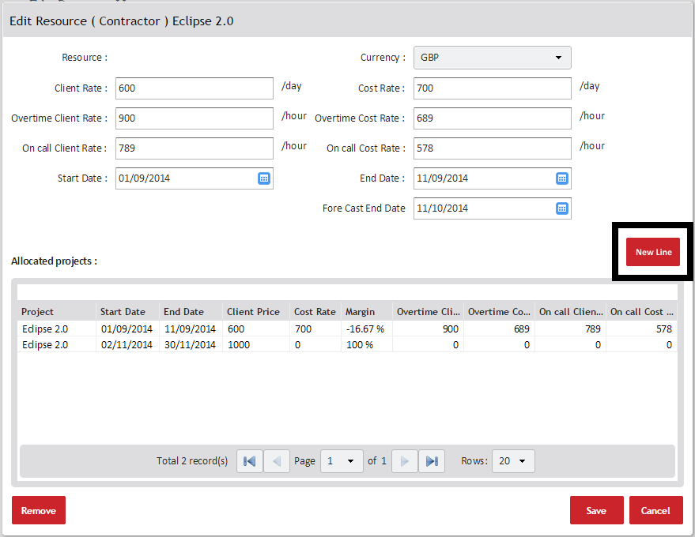

Figure - Edit Resource (Employee) Project Screen

Below is a workflow demonstrating the new process of updating project details in the system.



The table below explains the basic assumptions of system:

|  |  |
| --- | --- |
| **Use Case Id: CSC 001** | |
| Use Case Name | Creation of new project line |
| Description | This use case describes how the user can edit project details and create a new project line |
| Actors | Client Service Coordinators  Contract’s Specialist |
| Basic Flow | System Actions |
| 1. User searches for employee in ‘Resource Menu’ | 1. System displays ‘Resource Menu’ |
| 1. User selects relevant employee | 1. System displays employee’s ‘Resource Record’ |
| 1. User clicks on ‘Project Tab’ | 1. System display Project Menu |
| 1. User clicks on current project | 1. System displays ‘Edit Resource (Employee)’ screen |
| 1. User updates end date and rate fields |  |
| 1. User clicks on ‘New Line’ | 1. System creates new project line in ‘Allocated Projects’ with updated details and saves data |
| Alternative Flow | System Actions |
| 1. User searches for employee in ‘Resource Menu’ | 1. System displays ‘Resource Menu’ |
| 1. User selects relevant employee | 1. System displays employee’s ‘Resource Record’ |
| 1. User clicks on ‘Project Tab | 1. System display Project Menu |
| 1. User clicks on current project | 1. System displays ‘Edit Resource (Employee)’ screen |
| 5. User edits fields | 5. |
| 6. User clicks on ‘Save’ | 6. System updates current detail |
| Non-Functional Requirements |  |
| Pre-Conditions | Employee is already allocated to a project |
| Post-Conditions | System updates a new project line without overwriting previous information |

### Categorisation of Notes - Requirement ID CSC 002

In order to replace the existing spreadsheet trackers, the CSC team need to be able to record and report on information that directly relates to the renewal of employees and contractors. To allow the system to report specifically on these notes, the introduction of ‘note types’ will allow the user to enter information relating to a specific note category.

Figure 2 details the screen that will be presented to the user when a new note is to be added to the system,

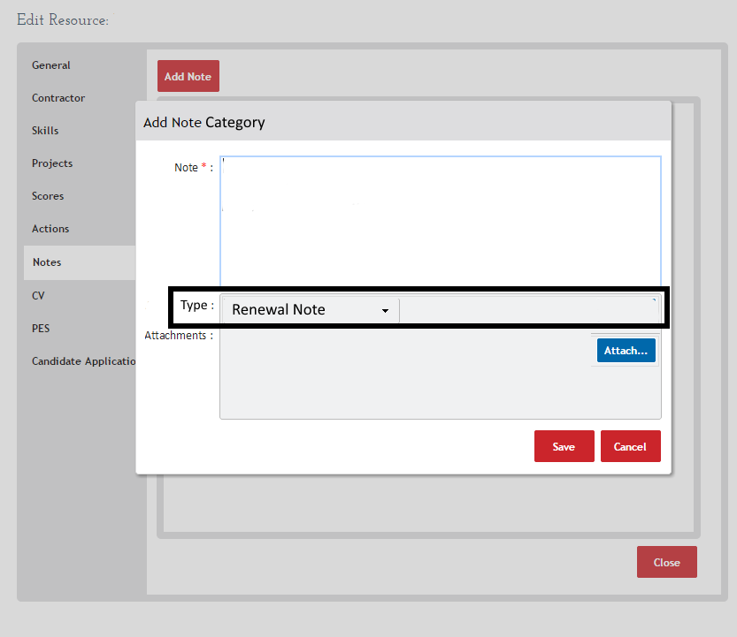

Figure 2 – Add Note Screen

Below is a workflow demonstrating for adding notes defined by categories in to the system.



The table below explains the basic assumptions of the system:

|  |  |
| --- | --- |
| **Use Case Id: CSC 002** | |
| Use Case Name | Categorisation of notes |
| Description | This use case describes how notes will be categorised. |
| Actors | All Eclipse Stakeholders |
| Basic Flow | System Actions |
| 1. User clicks on ‘Note Tab’ | 1. System displays Note screen |
| 1. User clicks on ‘Add Note’ | 1. System display ‘Note Categories’ |
| 1. User select correct note type | 1. System displays text box |
| 1. User enters text |  |
| 1. User clicks on ‘Save’ | 1. System saves data into Note tab |
| Alternative Flow | System Actions |
|  |  |
| Non-Functional Requirements |  |
| Pre-Conditions | Employee has been created in system |
| Post-Conditions | Note is saved with a category type |

### Filter for Active Resources - Requirement ID CSC 003

When working from the ‘Manage Project’ screen, all billable employees and contractors who have been allocated to a project code appear listed in no particular order. This results in difficulty when trying to access information quickly for active employees only.

A default filter will be applied to this screen to so that only active employees are displayed and so simplify the process for the Client Service Coordinators.

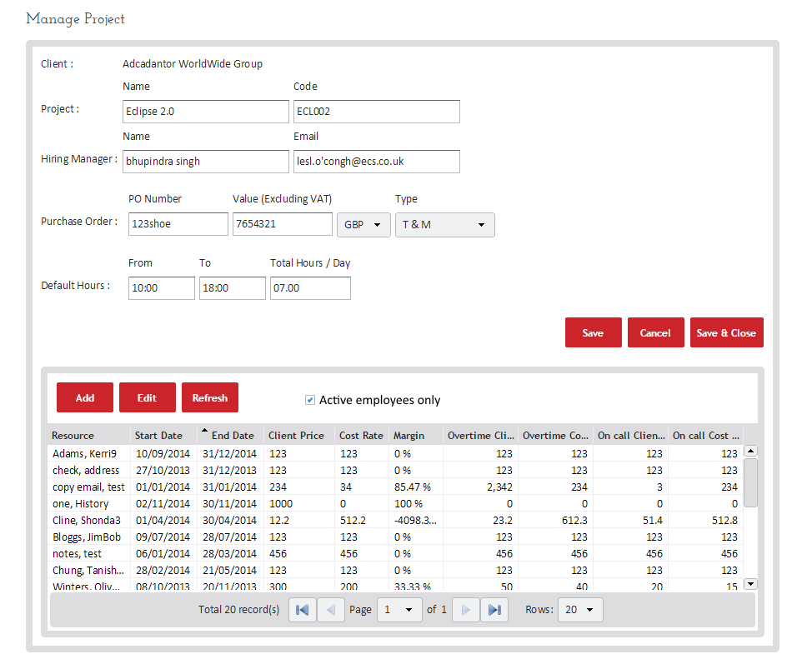

Figure 3 – Manage Project Screen

The table below explains the basic assumptions of system:

|  |  |
| --- | --- |
| **Use Case Name: CSC 003** | |
| Use Case Name | Filter for active resources |
| Description | This use case describes how the user will be able to filter active from inactive resources against a particular project code |
| Actors | Client Service Coordinators |
| Basic Flow | System Actions |
| 1. User clicks ‘Projects’ | 1. |
| 2. User clicks on ‘Client’ and selects correct client | 2. System shows ‘Client Projects’ screen |
| 3. User selects correct project | 3. System shows project screen defaulted to active users only |
| Alternative Flow | System Actions |
| 1. User clicks ‘Projects’ | 1. |
| 2. User clicks on ‘Client’ and selects correct client | 2. System shows ‘Client Projects’ screen |
| 3. User selects correct project | 3. System shows project screen defaulted to active employee only |
| 4. User unchecks ‘Active Resources’ only | 4. System display all employees associated with project |
| Non-Functional Requirements |  |
| Pre-Conditions | Employees are allocated to the correct project code |
| Post-Conditions | Filter will show the correct list of employees |

### Notes from Screen - Requirement ID CSC 004

When updating employees’ details from the ‘Manage Project’ screen within the Project module, there is no direct route to add a note to an individual’s record without exiting the module completely. This results in a time consuming process where the CSC’s have to move between two different modules in Eclipse to maintain and update information.

To make the system more accessible, users must be able to add notes from the ‘‘Edit Resource (Employee)’ screen whilst working from the Project module.

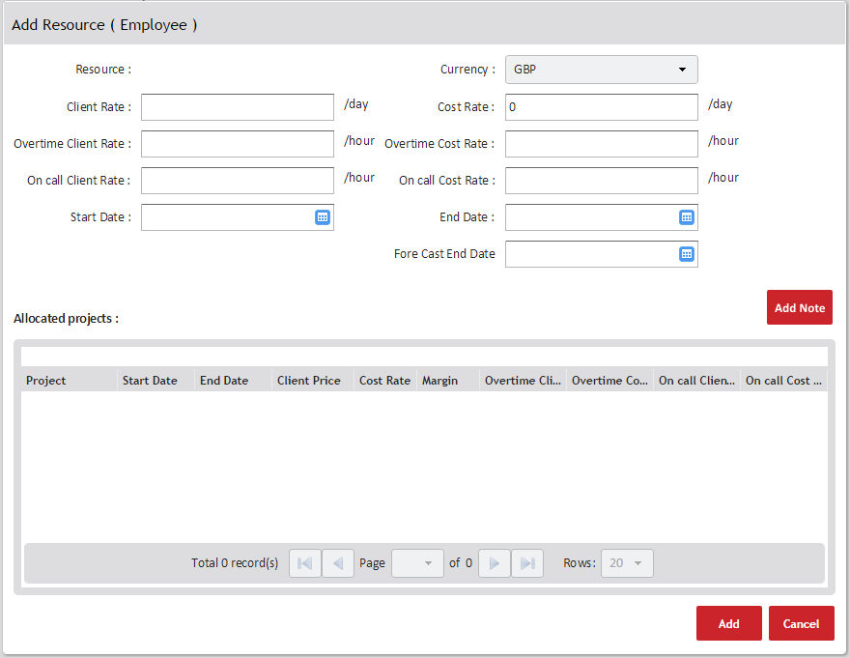

Figure 4 – Edit Resource (Employee) Project Screen with Add Note Button

This workflow demonstrates adding notes from the ‘Edit Resource (Employee)’ screen.



The table below explains the basic assumptions of system:

|  |  |
| --- | --- |
| **Use Case Id: CSC 004** | |
| Use Case Name | Creation of notes from Projects module |
| Description | This use case describes how the user can add notes to an resource from within the Project module |
| Actors | Client Service Coordinators |
| Basic Flow | System Actions |
| 1. User clicks ‘Projects’ | 1. System displays ‘Projects’ menu |
| 2. User clicks on ‘Client’ and selects correct client | 2. System display related client projects |
| 3. User selects correct project | 3. System shows ‘Manage Project’ screen |
| 4. User selects correct employee | 4. System displays the ‘Edit Resource (Employee)’ screen |
| 5. User clicks on ‘Add Note’ button | 5. System display Note Categories |
| 1. User select correct note type | 1. System displays text box |
| 1. User Enter text |  |
| 1. User clicks on ‘Save’ | 1. System saves data into note tab |
|  | 1. System returns user to ‘Edit Resource (Employee)’ screen |
| Alternative Flow | System Actions |
|  |  |
| Non-Functional Requirements |  |
| Pre-Conditions | Employees are allocated to the correct project code |
| Post-Conditions | Note has been saved into database of correct employee. |

### Creation of automatic Project Codes - Requirement ID CSC 005

The CSC’s currently maintain a spreadsheet to track project codes entered into Eclipse. This manual process can be time-consuming and can easily introduce errors and data corruptions if the sheet is not saved.

Instead the system will generate the next project code from the ‘Manage Project’ screen thus eliminating duplication or the wrong code being added to the wrong account.

Figure 5 depicts how the ‘Save’ button will generate a new project code based on a number sequence and following the current format of PCXXXXX.

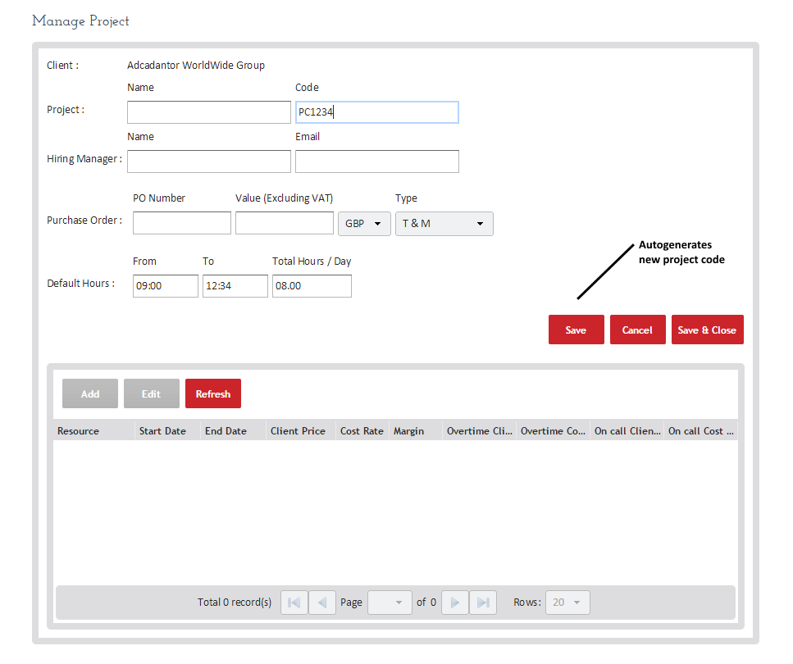

Figure 5 – Manage Project Screen

Below is a workflow demonstrating the creation of auto-generated project codes from the system:



The table below explains the basic assumptions of system:

|  |  |
| --- | --- |
| **Use Case Id: CSC 005** | |
| Use Case Name | Auto-generation Project Codes |
| Description | This use case describes how the system will auto-generate a new project code |
| Actors | Client Service Coordinators |
| Basic Flow | System Actions |
| 1. User clicks ‘Projects’ | 1. System displays ‘Projects’ menu |
| 2. User clicks on ‘Client’ and selects correct client | 2. System display related client projects |
| 3. User clicks on ‘Add’ | 3. System displays blank ‘Manage Project’ Screen |
| 4. User enters relevant details | 4. |
| 5. User clicks on ‘Save’ | 5. System saves details and generates Project Code |
| Alternative Flow | System Actions |
|  |  |
| Non-Functional Requirements |  |
| Pre-Conditions | Project Code does not already exist in system.  User has clicked on ‘Add’ Project. |
| Post-Conditions | New Project Code is generated. |

### Addition of Assignment Contact Field - Requirement ID CSC 006

The inclusion of an ‘Assignment Contact’ field to the ‘Manage Project’ Screen will let the CSC’s record and report on the customer contact associated with each project.

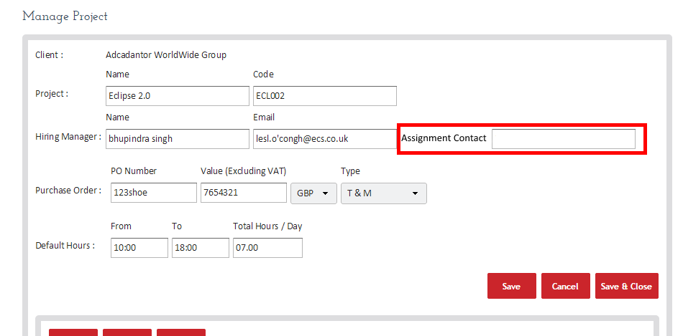

### Addition of Assignment Role Field – Requirement ID CSC 006

The inclusion of an ‘Assignment Role’ field to the ‘Edit Resource (Employee/Contractor)’ screen will let the CSC’s record and report on the assignment role the employee has with the client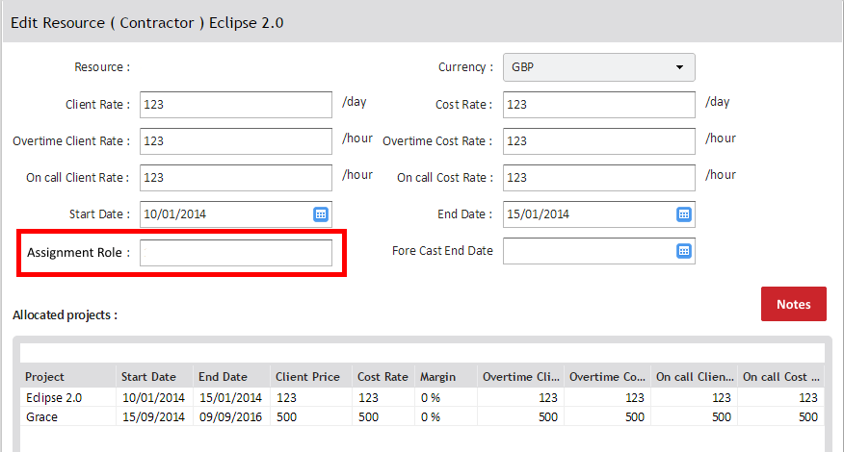

### Addition of value to ‘Type’ dropdown - Requirement ID CSC 006

The inclusion of a new value to the existing ‘Type’ dropdown on the ‘Manage Project’ Screen will be included to record the various billing methods for each project. Everyone associated with that project will be on the same billing method.

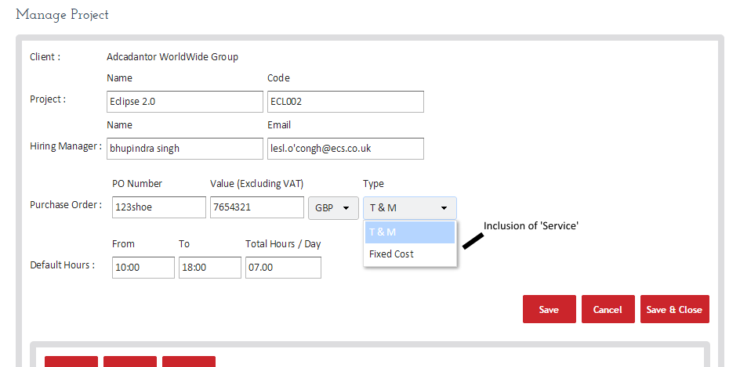

### Addition of Flight Risk Status - Requirement ID CSC 006

In the past there has been a need to flag and monitor the possibility of contractors leaving projects early or deciding to not renew upcoming extensions. To allow the CSC’s to monitor the retention of contractors and to mitigate such risks, a flight risk dropdown has been requested.

To add further value, an alert notification will be sent to the CSC team highlighting any employees recorded as a potential risk. This will encourage the CSC’s to follow up with the employee and mitigate the risk of early termination of contracts.

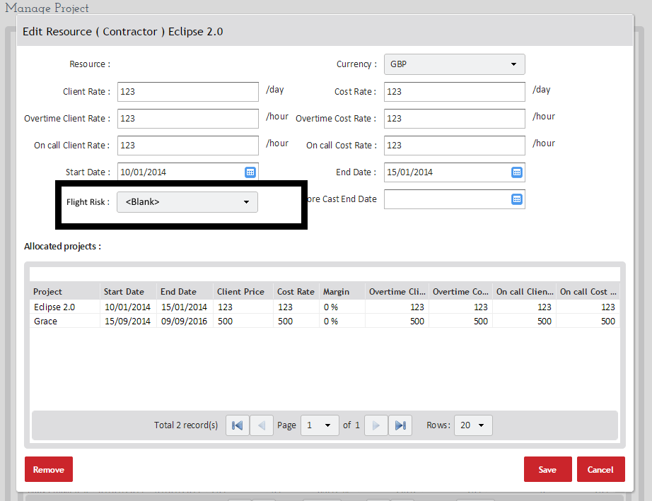

## Exclusions

In the CSC Eclipse Requirements V.7 document provided by Janine Bryce there were some additional requirements which cannot be met at this time.

These are briefly explained below:

|  |  |  |  |  |  |
| --- | --- | --- | --- | --- | --- |
| **Eclipse V2.2 - Client Service Coordinators** | | | | | |
| **Author:**  **D. Smith** | **Date:**  **01/10/2014** | | **Version:**  **1.0** | **Status:**  **Requirement** | **Signed Off:** |
| Requirement ID | | CSC 008 | | | |
| Requirement Name | | Change of architecture | | | |
| Business Area | | Client Service Coordinators | | | |
| Source | | Janine Bryce | | | |
| Owner | | Janine Bryce | | | |
| Priority | | W | | | |
| Type of Requirement | | Functional | | | |
| Requirement Description | | User shall be able to add project information from the ‘General’ screen | | | |
| Acceptance Criteria | |  | | | |
| Justification | | A requirement to have an employee’s contract date and rates fields moved to the ‘General tab’ to reduce the number of clicks required to update information was examined.  On further investigation of this requirement, the system would need to undergo a significant core architectural change that could not be achieved quickly nor is a business priority | | | |
| Comments | |  | | | |
| Related requirements | |  | | | |
| Resolution | | Closed | | | |
| **Eclipse V2.2 - Client Service Coordinators** | | | | | |
| **Author:**  **D. Smith** | **Date:**  **01/10/2014** | | **Version:**  **1.0** | **Status:**  **Requirement** | **Signed Off:** |
| Requirement ID | | CSC 009 | | | |
| Requirement Name | | Updating end date | | | |
| Business Area | | Client Service Coordinators | | | |
| Source | | Janine Bryce | | | |
| Owner | | Janine Bryce | | | |
| Priority | | W | | | |
| Type of Requirement | | Functional | | | |
| Requirement Description | | User shall be able to update end dates from ‘Manage Project’ screen | | | |
| Acceptance Criteria | | None | | | |
| Justification | | The ability to update end dates from ‘Manage Project’ screen was also requested. However, the current process in place is the most efficient method therefore no development is required | | | |
| Comments | |  | | | |
| Related requirements | |  | | | |
| Resolution | | Closed | | | |

|  |  |  |  |  |  |
| --- | --- | --- | --- | --- | --- |
| **Eclipse V2.2 - Client Service Coordinators** | | | | | |
| **Author:**  **D. Smith** | **Date:**  **01/10/2014** | | **Version:**  **1.0** | **Status:**  **Requirement** | **Signed Off:** |
| Requirement ID | | CSC 010 | | | |
| Requirement Name | | Time Sheet Development | | | |
| Business Area | | Client Service Coordinators | | | |
| Source | | Janine Bryce | | | |
| Owner | | Janine Bryce | | | |
| Priority | | W | | | |
| Type of Requirement | | Functional | | | |
| Requirement Description | | User shall be able to view timesheet actions | | | |
| Acceptance Criteria | | None | | | |
| Justification | | Announcements relating to timesheet actions were also discussed and analysed. With similar business needs from other areas of the business the development of dashboards within the system would be a better objective that meets several more requirements. This is a major development to the system and further requirement gathering will be necessary. | | | |
| Comments | |  | | | |
| Related requirements | |  | | | |
| Resolution | | Closed | | | |

## Reports

### Renewals Report

To allow the CSC’s to remove the trackers a ‘Renewals’ report will be created.

The report will include the parameter that allows the user to filter and select between multiple clients and those employees who are active or in-active against live projects.

It must be stated clearly that the in-active selection should take into account employees who are still working for another client but are now considered ‘in-active’ against on the client chose.

Note the renewal report will need the start date from the beginning of the project code assignment not the beginning of a rate change.

The following fields will need to be included in the renewals report :

* Client
* ECS Division
* Start Date \*\**this is driven by the start date at the beginning of the assignment - not a start date that relates to date or rate changes*
* End Date ** *this will change to reflect the most recent end date against the project code*
* Forecast End Date
* Number of days remaining on PO (days before the end date)
* Employee Name
* Location
* Assignment Role
* Contract or Permanent
* Cost
* Sell
* Margin
* Billing Type
* Project name
* Project Code
* Client contact
* Renewal comments
* Flight Risk status

There should also be some logic built into this report that is based on a RAG status highlighting the number of days remaining on the PO. The PO dates is represented by the end date.

The RAG logic will be determined by:

* Red = <2 weeks
* Amber = 2-6 weeks
* Green = >6 weeks

### Incomplete Timesheet Report

To help provide a snapshot of the timesheet status the introduction of a summary box should be included within the Incomplete Timesheet Report.

This will let the team see a quick summary of the total timesheets that are outstanding by issue.

### Reports to consider

The following reports use ‘Start Date’ and ‘End Date’ so will need to be considered for any knock-on effect from requirement ID CSC 001 – Forecast Returns, Net Project Start Date, Project Resources, Project Summary, Resource Allocation All Users.

## Appendix

### Stakeholder Analysis

Janine Bryce – Client Operations Manager *(Project Owner)*

Michelle Reade – Senior Client Service Coordinators *(Senior User)*

Ryan Andrews – Senior Client Service Coordinators *(Senior User)*

Rachel Munro – PES Compliance Manager (*Business User*)

Neil Davidson – Services Director

Deborah Smith – Business Analyst

Martin Boylen – Chief Operations Officer

Graeme Kirk – Head of IT

Bhupindra Singh – Head of Application

|  |  |  |  |  |  |  |  |  |
| --- | --- | --- | --- | --- | --- | --- | --- | --- |
|  | Client Operations Managers | Senior Client Service Coordinators | PES Compliance Manager | Service Delivery Executive | Business Analysis | Chief Operations Officer | Head of IT | Head of Application |
| Business Case | A | C | I | C | I | I | I | I |
| Project Initiation Document | A | C | C | C | R | I | I | I |
| Interview Notes | C | C | C | I | R |  |  | S |
| Workshop Notes | C | C | C | I | R |  |  | S |
| Requirements Catalogue | A | C | I | I | R | I | S | C |
| Use Case Diagrams | I | C | I | I | R | I | S | C |

**Responsible** – *person responsible of creating documents*

**Accountable** – *person or role accountable for the quality of task*

**Support** – *person or role that provides assistance*

**Consulted** – *provides information that is input to the product*

**Informed** – *stakeholders that are informed about a task but may not contribute directly*