Variables
console.log("test ")

const accountId = 23355;
let accountEmail = "siddharthnaudiyal@gmail.com";
var accountPassword = "Sidhu#daf";
accountCity = "Jaipur";

console.table([accountEmail,accountId,accountPassword,accountCity])

const means it cant be changed
let and var difference = we use let instead of var because in modern day javascript it solves a problem of scope (“{ }”) var was like if u change var it also changes var in whole code irrespective of scope but let only assign value at that scope.
Don’t use var because of issue in block scope and functional scope.
- You can assign value in variable without let var const too. It is possible in javascript
- And if you let a variable without any value inside it. Node js would show undefined value

Datatypes

Number 2 to power 53
Bigint
String
Boolean true false
Null stand alone value like you wont return zero if you temperature app aint working youll use null cuz zero is value
Undefined
Symbol unique

Object

Typeof it tells you type of data types but type of null is object

Data Conversion

let score = 33
let score2 = "45"

console.log(typeof(score))

let valueInNumber = Number(score2)

console.log(valueInNumber)
console.log(typeof valueInNumber)

Typeof() to know the type and Number() to convert it into number
- Syntax would be N capital or starts with capital
- When changing number if its not a number in string it will return NaN(not a number)
- Null would be converted to 0
- Undefined would be converted to NaN
- But they all would be typeof number

let isLoggedIn = 1

let isBoolean = Boolean(isLoggedIn)
console.log(isBoolean)

- 1 in Boolean is true
- 0 in Boolean is false
- “ “ is false
- “Siddharth” is true

Conversion
console.log(null > 0)//false
console.log(null == 0)//false
console.log(null>=0) //it converts null to zero (true)

console.log("2"==2) //true because it converts string to number auto
console.log("2"===2)// falase as it checks its data type too

Data types Summary

Primitive Data types – strings, number, bigInt, Boolean, null, undefined ,symbol.
They all call by value – that means when make changes they are copy not the actual thing in memory

Non Primitive (Refrence) - Array, Object and Functions
JavaScript is a dynamically typed language ✅
That means:
- You don’t need to declare the type of a variable when you create it.
- The type is determined at runtime (when the code runs), not at compile time.
- A variable can hold different types of values at different times.

const score = 100 // Number datatype
const scoreValue = 100.3 // num
const isLoggedIn = false // boolean
const outsideTemparture = null // null
let userEmail; // undefined

const value = Symbol('124')
const value2 = Symbol('124')
console.log(value2===value) // false they are unique

Datatype of null is Object

Stack and heap memory

Stack(primitive) as a copy data
let myname = "siddharth"
let anotherName = myname
anotherName = "sid"

console.log(myname)
console.log(anotherName)

it doesn’t change the name of my name

and Heap ( non primitive) original data

let UserOne = {
email: "siddharth@gmail.com",
pass: "whatver"
}

let UserTwo = UserOne;

UserTwo.email = "hellw@gmail.com"

console.log(UserOne.email) //hellw@gmail
console.log(UserTwo.email) //hellw#gmail

it has changed cuz its pointing towards that memory not creating a copy

Strings

Concatination of strings should be done by backstrick ` ` and ${ } to add and conctatinate string
const name = "SId"
const height = 44;

// let nameHeight = name + height;

// console.log(nameHeighta)

let nameHeight2 = `my name is ${name} and my height is ${height}`

console.log(nameHeight2)

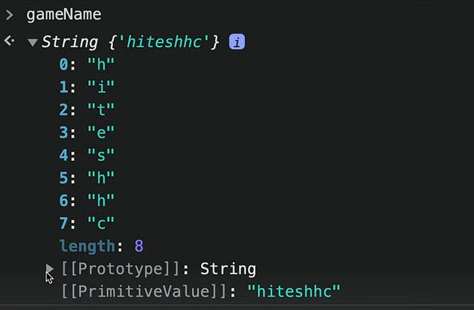
strings is also an object collection of key value pair

let gameScore = new String ("hello")

console.log(gameScore)
defining a string. Normal string also look like this in background
let gameScore = new String ("hello")

console.log(gameScore)

console.log(gameScore[0])
console.log(gameScore.__proto__) // this is not empty it will show alot of property if you see this in broweser

Strings Methodology
console.log(a.charAt(2)); // telss the location of string at index 2
console.log(a.toUpperCase()); // converts to uppercase
console.log(a.indexOf("i")); // returns the index of i in a

Slicing of Strings

let newString = a.substring(0,3) // doesnt obey negative value it will start from start
console.log(newString)

const anotherString = a.slice(-8,4) // it will obey negative value as well it will start from the end too
console.log(anotherString)

.trim() – used usually when you are taking a form from user and he fills spaces in front or back unknowingly or knowingly
b = " hello kutta "
console.log(b) // output : hello kuttaa
console.log(b.trim()) // output : hello kutta (this removes the spaces from front and back)

.replace() – to replace something in url or something
const url = "https://www.google.com/siddharth%20naudiyal"

console.log(url.replace("%20","-"))

.include
console.log(url.includes("sid"))

Numbers and Maths

let score = 30
console.log(score)

let gameScore = new Number(882) // this will set this as number and will give prototype in console of browser
console.log(gameScore)

Functions for number
.tostring ()
console.log(gameScore.toString()) // this will help to get all the strings function in number by converting

.tofixed()
console.log(gameScore.toFixed(2)) // this will show 882.00 means till two decimal places
usually used in ecommerce websites
.toprecision()
let nameScore = 898.93

console.log(nameScore.toPrecision(3))
it will round off till the number you have given.
.toLocaleString()
const hundreds = 1000000000

console.log(hundreds.toLocaleString("en-In"))// for indian decimals en-In is used
this will put decimals according to digits leaving localestring as it is will give you American decimal system.

Maths

Maths library comes inbuilt in javascript
console.log(Math);
Object [Math] {}
It is object
Go to browser and see more property of maths
Functions of maths

Math.abs()- absolute value
console.log(Math.abs(-4));// will turn -4 into 4 but not 4 into -4 it gives the absolute value

Math.round() – math.round off
console.log(Math.round(4.343)); // output will be 4

Math.ceil and Math.floor – as name suggests ceil means ceiling and floor means ground it will round off number if ceil it will give bigger number and floor will give nearest smaller number
console.log(Math.floor(4.343)); // output 4
console.log(Math.ceil(4.343)); // output 5

Most importantly we have :
Math.random() – it will give us a random number between 0 to 1
console.log(Math.random()) // this will give random no between 0 to 1
console.log((Math.random()*10) + 1) // multipy by 10 gives 0 to 10 but we dont need zero as value so +1
console.log(Math.floor((Math.random()*10) + 1))// floor will remove all the decimal value

to get range we have
const max = 20;
const min = 10;

console.log(Math.floor(Math.random() * (max - min + 1)+ min))

remember this formula

Dates

It is object in javascript

const myCreatedDate = new Date(2023, 0 ,11) // Wed Jan 11 2023

console.log(myCreatedDate.toDateString())

in js month starts from 0.
const myCreatedDate = new Date("2004-11-23") // Tue Nov 23 2004,

console.log(myCreatedDate.toDateString())

months will not start from zero if you put it inside string yyyy-mm-dd

let myTimeStamp = Date.now()
console.log(myTimeStamp)// this will return time in miliseconds 143554353426556
console.log(myCreatedDate.getTime()) //this will convert date in miliseconds 343215145

used in time buzzer to get milliseconds who won or in booking apps you have to compare time in milliseconds.

myCreatedDate.toLocaleString("defualt",{
weekday:"long";
})

We can customize.toLocaleString with many features.

Array

Array is collection of multiple data stored in a single variable.
- Array in javascript is resizeable (you can add more items afterwards)
- Can contain different types of data
- 0 based indexing
- It creates shallow copy (heap memory) / same reference point
- Means if you change array you are changing the original.

let myarr = [0,2,3,4,5]
let myarr2 = new Array(1,3,"sid")

console.log(myarr)
console.log(myarr2)

creating array [ ] or new Array( )
when you see it on console you get prototype and inside prototype you get another prototype object one.

Methods in array
Arr.push () - insert item at last
myarr.push(8)
console.log(myarr)

arr.pop( ) = removes the last element in array
arr.unshift = adds element to the start of the array we are adivised not to use this because shifting array could be time consuming process consuming and get a load on the memory if we have a big array.
Arr.shift( ) = it is pop but removes element from the start of the array

Some checking functions
Arr.includes( ) = tells you that it exist in the array or not. Returns value in Boolean
let array = [1,2,3,5,5,6,"sid", "kutta"]

console.log(array.includes(1)) // boolean true

arr.indexOf() = tells you the index of the something you put inside the function
console.log(array.indexOf("sid"))

for conversion
arr.join( ) = it joins converts the array into string and return with comma separated values.
const newArr = array.join()

console.log(newArr)

Splice and Slice
console.log("A ",array) //A [ 1, 2, 3, 5, 5, 6, 'sid', 'kutta' ]
console.log("b ",array.slice(0,7)) //b [ 1, 2, 3, 5, 5, 6 ]
console.log(array)// [ 1, 2, 3, 5, 5, 6, 'sid', 'kutta' ]
console.log("c ",array.splice(0,7))//c [1 2, 3,5, 5, 6,'sid']

console.log(array) //[ 'kutta' ]

slice(0,6) – 0 is the start index and 6 is the 6 places it slices and into the part but doesn’t change the original array
splice()- does the same thing but changes the original array.
Diffrence between push and concat and spread
Push =
let marvelHeros = ["IronMan","Spiderman","Captain"]
let dcHeros = ["batman","superman","flash"]

marvelHeros.push(dcHeros)
console.log(marvelHeros)

[
'IronMan',
'Spiderman',
'Captain',
[ 'batman', 'superman', 'flash' ] this puts array inside the array.
]

Concat
let marvelHeros = ["IronMan","Spiderman","Captain"]
let dcHeros = ["batman","superman","flash"]

allHeros = marvelHeros.concat(dcHeros)
console.log(allHeros)

Spread
Spread means spread example glass being broken into pieces all the water get in same thing
allHeros = [...dcHeros,...marvelHeros]
console.log(allHeros)
syntax [] imagne it like we burst water bubble inside a container array all their elements get collected there mostly used in.

Flat()
let anotherArray = [1,2,3,4,[5,6,7],[2,3,44,[23434,33]]]

let realArray = anotherArray.flat(Infinity)
console.log(realArray)

this is used when you have array inside array inside array or like a lot of ghichpich
.flat(number of depth) who much you want to flat.
Use .flat(infinity) tips and tricks

Is of from in array

Used in data scraping
console.log(Array.isArray("siddharth")) // false
console.log(Array.from("siddharth")) // ['s', 'i', 'd','d', 'h', 'a','r', 't', 'h']

Array.isArray() tells you that is it a array or not
And array.from coverts into the array
Gives empty array if it cant covert it to array []

Of
let score1 = 100
let score2 = 200
let score3 = 300

let total_score = Array.of(score1,score2,score3)
console.log("Array of scores are ",total_score)

Objects

We can declare objects in two ways litreals and Constructors

When we make object using Constructors it makes a singleton ( singleton means this object is unique it is one of its kind)

Litreals don’t create objects as a singleton

const names = {
name1: "sid",
name2: "tannu",
name3: "saksham",
name4: "sejal"
}

Object

Accessing
We got two ways dot method . and [] method

dot method
console.log(names.name1)

bracket method (prefferd)
console.log(names["name1"])

remember that it should be on strings when you put key there

putting symbol data type in the object
// objects litreals

const mysym = Symbol("key1");

const names = {
name1: "sid",
[mysym]:"this is key1",
name2: "tannu",
name3: "saksham",
name4: "sejal"
}

console.log(names[mysym])

this will return value as a symbol not as a string this is the only way to get it like that.

To override current value
names.name1 = "the_sid_supreme"

object.freeze()
names.name1 = "the_sid_supreme"
console.log(names.name1);
Object.freeze(names)

This will make the object freeze meaning no more changes ahead.

Adding greetings from object
names.greeting = function () {
console.log(`hello ${this.name1}`)

}

console.log(names.greeting())

so with already existing object we added greeting
with this.name and you should write greeting() not greeting because it will return annonymus function as output.

Object through constructor

Declaring object through constructor creates a singleton.
Declaration in constructor
- Singleton
const TinderApp = new Object(); // this creates a singleton means its unique object

- Literal
const tinder = {}

Object inside a object
const RaindropPlayer = {
fullName:{
first:"siddharth",
last:"Naudiyal"
},
id:{
user:"1",
user2:"2"
}
}

To access use dot operator
Console.log(RaindropPlayer.fullname)

Combining the object
Method 1 – { }
const obj1 = {
1:"a",
2:"b"
}
const obj2 = {
3:"a",
4:"b"
}

let obj3 = {obj1,obj2}
console.log(obj3);

let obj3 = { }
Method 2 = assign()
const obj1 = {
1:"a",
2:"b"
}
const obj2 = {
3:"a",
4:"b"
}

// let obj3 = {obj1,obj2}
let obj3 = Object.assign({},obj1, obj2)
console.log(obj3);

Method 3 = Spread ( most used)
let obj3 = {...obj1,...obj2}

… for spread operator

Object.keys (_)= it is used to get all the keys from an object and return value inside a array

console.log(Object.keys(obj1));

Object .values ( ) = same just for values
Object.entries = return whole object inside a array

Object.hasOwnProperty = it mean that do you have property inside the array that we put inside this function
console.log(Object.hasOwnProperty("1"));

Destructoring 0f Object

Preffered syntax for getting a element out of the array would be this.
const course = {
id: "1245",
course:"SID_SUPREME",
instructor: "THe sid himself"
}

const {instructor} = course;

console.log(instructor)

{ } you can add that then print using console.log into a string
We can change name too
Const {instructor: inst} = course;
This will give it a nickname of sort

Declaration of function

Another way of declaring a function
const sumtwo = function (num){
return num + 1;

}

console.log(sumtwo(1))

but in this way if we put sumtwo() function before declaring it won’t run but if you run it different manner it will run.

this and arrow function

.this is used for referring to the current context means the inside the scope
const userData = {
username: "SId",
email: "Siddharthnodiyal@gmail"
,
welcomeMsg: function() {
console.log(`hey how are you ${this.username}`)
}
}

userData.welcomeMsg() // sid
userData.username = "kala"
userData.welcomeMsg()// kala

this value for browser is windows which means dom model
and for node environment it is empty object.
You cant use this in FUNCTIONSSSSS

Api

its like having going to restaurant asking for food who that food is gonna make in backend is not our headache
the data that comes from backend was first xml format but now it is Json format
Json format is nothing but like object

You can get some dummy api and use json formatter org for understanding and learning about the format of json

Functions

function saymyname(){
console.log("s")
console.log("i")
console.log("d")
console.log("d")
console.log("h")
console.log("a")
console.log("r")
console.log("t")
console.log("h")
}

saymyname // function refrence

saymyname()

console.log inside function and return t
console.log we should nt use because the value we get in return we cant use that in our program
return value can be use and stored inside another thing
- Return is like a end of the function anything you have written after that wont run
- function sumOf(num1, num2) {
- return num1+num2;
- console.log("sid")
- }
This clog wont run after return getting my point ??

function greeting (username){
return `hello how are you ${username}`
}

console.log(greeting("Siddharth ji"))
if you put console.log (greeting() ) empty it will return undefined as output
hello how are you undefined
function greeting (username){
if (username==undefined) {
console.log("saale shi se daal ")
return
}
return `hello how are you ${username}`
}

Look at this

REST OPERATOR
So the rest and spread operator are same they are … but there use case differ
function cartOfUser(...num){
return num
}

console.log(cartOfUser(1,2,2,3,33));
in this function you can see that we have only one parameter and a lot of arguments so it’ll return this as an array.

DATA FROM OBJECT
const userdata = {
buys: "Iphone cable",
fullName: "Siddharth"
}

function userPurchase(data) {
return `${data.fullName} Placed an order for ${data.buys}`
}

console.log(userPurchase(userdata))
first method

Scope levels

function one(){
let username = "Sid"
function two(){
let website = "TheSidSupreme.com"
console.log(username);

}
console.log(website);

}

console.log(one())

So accessing something in function, first you should know that there can be functions inside a function.
Think of function as parent and function inside function as children
If parent gives icecream to children its cool but children don’t give icecream to there parent
Same in this case we can see that function two can access function variables but function one cant use function two variable.

All this is scope based scope inside scope can access parent scope.

Arrow function

const sumtwo = (num1,num2) => {
return num1+num2;

}

console.log(sumtwo(10,20))
method 1
you’ll have to write return in { }

method2 you'll don’t have to write return in ( ) * ( USED IN REACT)
const addTwo = (num1,num2) => (num1+num2)

console.log(addTwo(10,20));

IIFE( immediately invoked Function expression)

Example like if we have An IIFE is like writing a magic spell that works the moment you write it — no need to say “Abracadabra” later.
Like you have a app that you want database to launch as soon as the app starts
It is also used to prevent pollution from global scope like bche bde se icecream maang skte h
To stop them asking for icecream we have hidden the Icecream

Used for immediate execution and preventing global variable pollution
(function Sid(){
console.log("Database is connected")
})();

SEMI COLON IS NEEDEDD IN THIS OTHERWISE THIS WONT END
Syntax function is wrapped around ( ) and then () for execution in that time only.

NAMED IIFE – function with name is called named iife and arrow function is called iife

Js execution context

Global execution context this is stored inside THIS keyword in js.
Everyone has their different execution context like Node.js, bun , deno everyone has different execution
Context .
In Browser = value of Global execution context is window.
Js is single threaded

Types of execution Context :
- Global execution context
- Function execution context
- Eval execution context

Javascript code execution has two phases:
- Memory creation phase
- Execution phase

Step by step code execution
- Global execution = stored in this keyword
- Memory is allocated
Example. Val1 = undefined
val1 = 10; // memory created val1 - undefined
val2 = 20;

function addNum(num1,num2) { // addnum = defination (wholefunction)
return num1+num2;

}

console.log(addNum(val1,val2)); //undefined """"""""""""""""""""""""""
console.log(addNum(10,2)); //undefined in memory creation cycles

- Execution Phase
Val1 = 10
Val2 – 20

AddNUm = creates new variable environment + execution thread
Then a new memory phase for that function
Num1 = undefined
Num2 = undefined

Then new execution phase for that function (also get deleted after work is done)
Num1 = 10
Num2 – 20
Return value gets to the global variable context (first mention)

Control flow
Flow of the code like which code should run when you are logged out and which should run when you are not logged out.

If statement
if (true) {
console.log("statement is running")
}

Until the value is true it will run

Else

Else if

Switch case
Think switch case as a lock and key operation when we have different values we use switch case
Used in redux or something

switch (key) {
case value:

break;

default:
break;
}

Think key as In lock’s key and to check with we have value

let realWeek = 3;

switch (realWeek) {
case 1:
console.log("Monday");
break;
case 2:
console.log("Tuesday");
break;
case 3:
console.log("Wednesday");
break;
case 4:
console.log("Thrusday");
break;
case 5:
console.log("Friday");
break;
case 6:
console.log("Saturday");
break;
case 7:
console.log("Sunday");
break;

default:
console.log("no match")
break;
}

Truthy and Falsy statement
Some statement are neither truth or nor false code just assume whether its truth or false
const userEmail = "siddharthnod@gmail.com"

if (userEmail) {
console.log("we got the email")
}else{
console.log("we haven't got the email")
}

In this case you can see email is not a comparative value or any true false value
Empty string is False

All falsy value
- False
- 0
- -0
- BigInt 0n
- “ “
- Null
- Undefined
- NaN
Other than this everything is truthy value

Suprising Truthy value
- “0” zero inside a string
- ‘false’ inside a string
- [ ] empty array
- { } empty object
- Function( ) { }

Nullish Coalescing Operator (??)
Works on null and undefined value
let val1 = 0??10

used in something like firebase or something where you get multiple value or null or undefined value can ruin the flow of our code to prevent that from happening it chosses one or two value I’ll read more about it later.

Terniary Operator
Used for if else condition in one line syntax’
Condition ? true : false

Loops/iterations

For loop
Ykk basic syntax

to change array into string
let SidsArray = ["devil, zaider, king of wolves, egoist"]

for (let i = 0; i < SidsArray.length; i++) {
const element = SidsArray[i];

console.log(element);

}

Break
It takes you out of the loop

Continue
It continues the loop but skips that one for one time like code will still run but that part will be skipped

While
let index =0;

while (index<=10) {
console.log(index)
index++

}

Do-while
It will run once then check the condition…..

For of (mostly used for arrays) loop
used in for array, strings, object or etc to get inside them
// for of loop

const arr = [1,2,3,4,5,6,]

for (const num of arr) {
console.log(num)
}

// this is string
const greeting = "Hey Master Sid How Are You??"

for (const greet of greeting) {
if(greet===" "){
continue;
}
else{
console.log(greet)
}
}

Maps

The map object holds key-value pairs and remembering the original insertion of order of the keys

Key features –
No duplicate values
const map = new Map()

map.set("IN","India")
map.set("SL","Shri lanka")
map.set("KR","Korea")
map.set("USA","United State of America")

// for of loop for map

for (const [key,value] of map) {
console.log(key, "this is value : ", value)
}

Map .set for setting key value pair
If you use key without bracket in for of function It wont return only the key because something real systax is with that square brackets.
It wont work with OBJECTS

For in (used for objects mostly)

for (const key in myobj) { // to get the key
console.log(key)
}
for (const key in myobj) { // to get the object
console.log(myobj[key])
}
for (const key in myobj) { // to get key object both
console.log(`key ${key} and its value : ${myobj[key]}`)
}

For Each loop ( array)

const arr = ["cpp","python","ruby","bobie"]

arr.forEach((value) => {
console.log(value)
}
)

arr.forEach((value, index , wholeArray) => {
console.log(value, index, wholeArray)
}
)

You can print values of the array one by one , then index of that array , then the whole array.

Another example of for each where we have a array who has object inside of it we will see this very often times in real world scenarios.

const dotExtension = [

{
languageName: "JavaScript",
Extension: "js"
},

{
languageName:" python",
Extension:" py"
},
{
languageName: "ruby",
Extension:"rb"
},
{
languageName: "Java",
Extension: "java"
}
]

console.log(dotExtension)

dotExtension.forEach((item) => {
console.log(item)
}
)

For each loop doesn’t return any value if you store it in a variable and all.

To store variable we have filter()

const numbers = [1,2,3,4,5,6,7,8]

const newNumbers = numbers.filter( (num) => num > 2
)
const newNumbers = numbers.filter( (num) =>
{
return num > 2 // return is imp other way of getting same array you got below in output

})

console.log(newNumbers) // [ 3, 4, 5, 6, 7, 8 ]

const newNumbers2 = numbers.filter( (num) => {
console.log(num)
}
)

console.log(newNumbers2)

// 1
// 2
// 3
// 4
// 5
// 6
// 7
// 8
// []

Filter method

It is used for filtering and get the value you want, filter,map these value are similar in use.

Learn reduce method im not getting it yet

Reduce
Used mostly in cart functionality
const course = [
{
item: "sid course of technology",
price: 100
},
{
item: "sid course of management",
price: 100
},
{
item: "sid course of bussiness",
price: 100
},
{
item: "sid course of money",
price: 100
},
]

const total_price = course.reduce((accumilator,item ) => accumilator+item.price,0)

console.log(total_price)

in this way we can add to cart things got my point sid?

DOM manupilation

Window.document

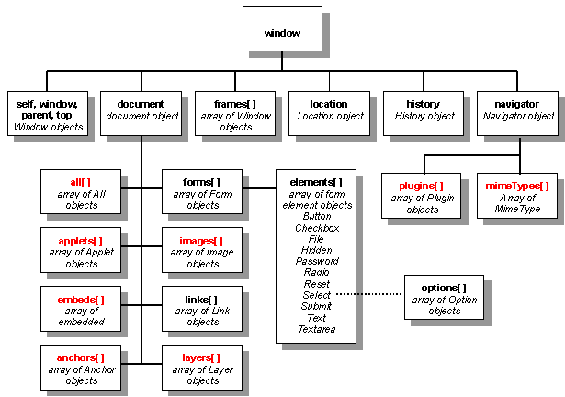

Window.document.div.p like you can access all this using this

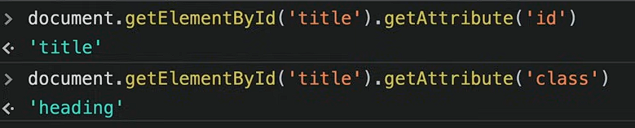
It gets the attribute like id and whats the id it will tell.
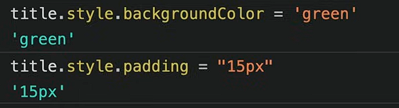

Difference between innerText vs textContent
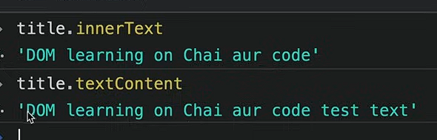
Text content will show that all the hidden element inside the html which is hidden by any css property

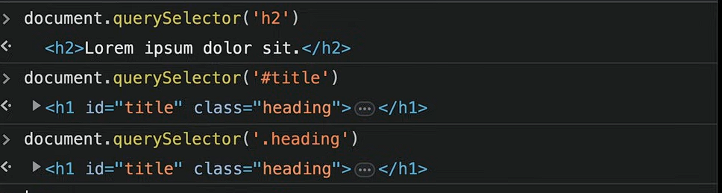
This will only print first one
Query selector returns the nodelist which looks like array but it is not an array.
We can only use forEach loop in that

getElementByclassname returns HTMLCollection which we cant use forEach loop and all those
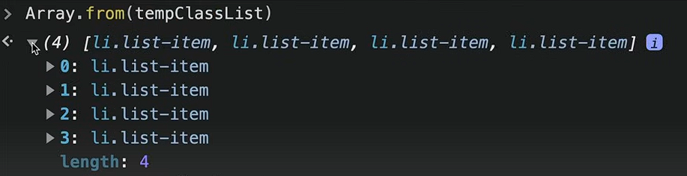
We use Array.from for converting it into a array.

Children and parents

console.log(parent.children[0])

.children to enter the parents thing

Parent.firstElementChld = gives the first element of the children
.lastElementChild = gives the last element of the the children
.parentElement = tells the parent element of the selected

Creating element using DOM

document.createElement("div")

to add class and id

div.className = "main"
div.id = Math.round(Math.random()*10+1)

if you want to add attribute which is not conventional you can add your attribute

div.setAttribute("set","wet")

to add element inside that div
first method
div.innerText = "Sid is supreme"
second method ( more optimized and more used it saves a one round trip so developers prefer this)

const text = document.createTextNode("sid is superb")

div.appendChild(text)

New optimized trick for newListOpt
function newListOpt(langName) {
const list = document.createElement("li")
const textnode = document.createTextNode(langName)
list.appendChild(textnode)

document.querySelector(".programmingLang").appendChild(list)
}
newListOpt("typescript")

To remove element A
||

Events in js

Onclick = alert(“heleow”);
We can add this to our html and it will alert but we shouldn’t use this approach. Instead Use event listeners;

const button = document.getElementById("btn")
button.addEventListener("click",function(){}, false)

addeventlistner has Three parameters “ click and all submit etc“ , function() {}, false
false is hidden because it is usually false from the get go so you don’t have to write it but in some cases or interview you need to know that false’s true objective.

//attachEvent was first use in times of internet explorer
// jquery –

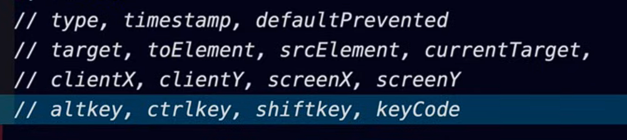

Event propagation ( true and false is used here )

For false: ( default yhi rheta h) BUBBLING UP ;
So when you have event listener in two things like in ul and inside the ul
So first thing will print is BUBBLING UP means bubble niche se upar jata h likewise inside ul will first be activated then ul .

For true: Capturing mode
When you capture something in net like fish then the net is form bigger than inwards
Then ul will print first then inside ul
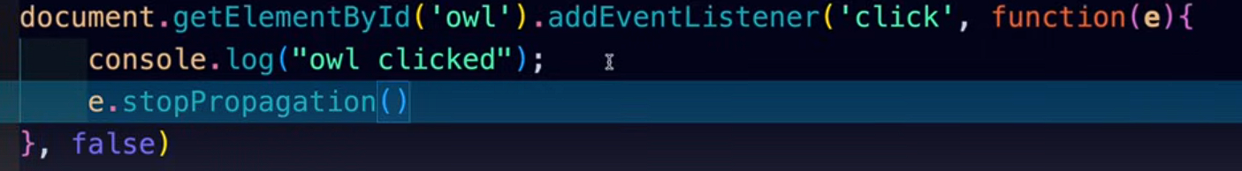
This will stop the bubbling
e.stopPropagation

const button = document.getElementById("btn")
button.addEventListener("click",function(e){
e.preventDefault();
const remove = e.target.parentNode
remove.remove();
}, false)

Remove() ; function

Asynchronous CODE

Javascript is synchronous
Single threaded

Execution context
Execute one line of code at a time
Console.log( 1 )
Console.log (2 )
Each operation waits for the first one to complete

Blocking code and No blocking code

Blocking code = block the flow of program , read file sync
No blocking code = doesn’t block the flow of program, read file async

Biggest blocking code is To read files

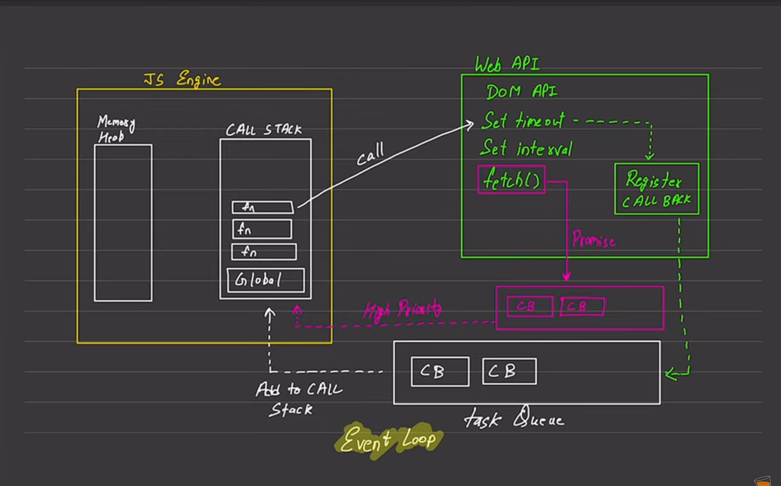

Async

Set timeout
It will work after some time.

setTimeout(function(){
console.log("working")
},4000)

One time thing is set timeout it will work one time. Set intervals works more than one time

Can add to function as well
const print = () => {
console.log("yolo")
}

setTimeout(print,4000)

we can change text after few seconds too.
const print = () => {
document.querySelector("h1").innerHTML= "THIS has changed after few seconds"
}

setTimeout(print,4000)

Clear Timeout
Clear timeout stops the set timeout from happening. We add it to event listenter to it stopping it we can make a button and all.

Set interval
setInterval(function(){
console.log("sid")
},1000,”hey”)

This will keep running after an interval of time.
Whats different from set timout nd set interval is you can pass argument like string at this too

Clear interval
Used to clear interval

API

Json formatter
It is used to format api data in a form we can understand or write that inside the code.

Randomuser .me
To get random api’

Promise

The promise object represents the eventual completion (or failure) of an asynchronous operation and its resulting value.
A promise is in one of these states:
- Pending: initial state, neither fulfielled nor rejected.
- Fulfilled: meaning that the operstion was completed successfully
- Rejected: meaning that the operation failed.
Resolve() => then()
Reject() => catch()
Finally(function(){“this will run eventually”})
const newPromise = new Promise(function(resolve,reject){});

resolve

const newPromise = new Promise(function(resolve,reject){
setTimeout(function(){
console.log("database has managed")
resolve();
},2000)
});

newPromise.then(function(){
console.log("this has been resolved")
})

Resolve = then newpromise.then( anfn)

To do this in one part
new Promise(function(resolve, reject){
setTimeout(function(){
console.log("been 10 sec")
resolve()
},10000)
}).then(function(){
console.log("Its working")
})

.then only works when you put resolve function in it.

Value in resolve()
new Promise(function(resolve, reject){
setTimeout(function(){
console.log("been 10 sec")
resolve({
userName:"siddharth",
Email: "siddharthnodiyal323"
})
},1000)
}).then(function(user){
console.log(user)
})

We can pass values in resolve mostly it’ll be object.

Async and Await function

async function consumePromiseFive() {
const promise = await PromiseFive;
console.log(promise)
}

consumePromiseFive()

async and await works just fine but it doesn’t have the catch functionality which is used for Error throwing.

For error catching use try and catch
async function consumePromiseFive() {
try {
const promise = await PromiseFive;
console.log(promise)
} catch (error) {
console.log("error ara bhaijaan")
}
}

Data would be In this format for async await

async function users() {
try {
const response = await fetch("https://jsonplaceholder.typicode.com/users")
const parsejson = await response.json()
console.log(parsejson)
} catch (error) {
console.log("couldnt parse because",error)
}
}

users()

through try and catch .

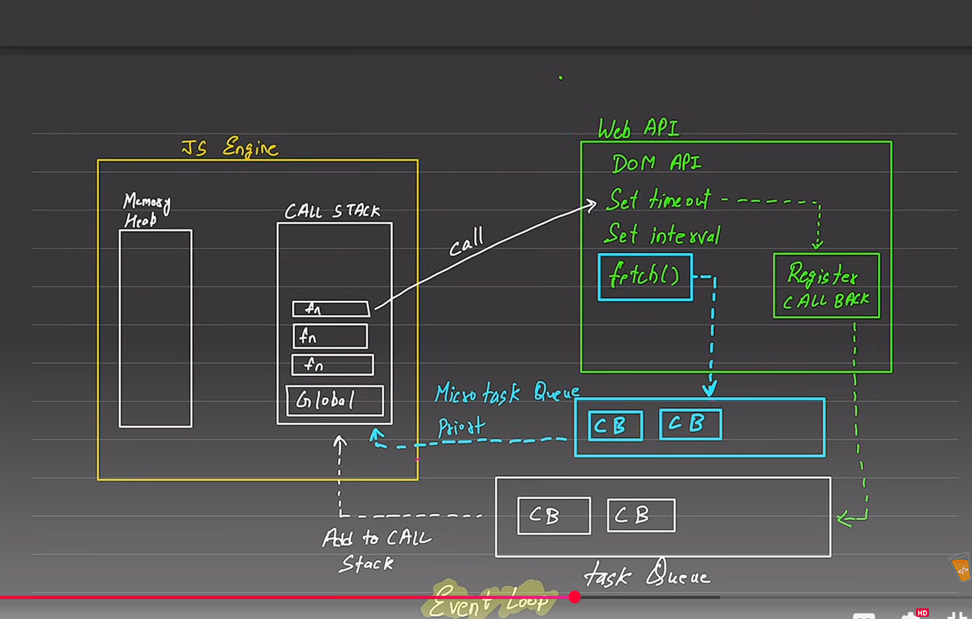
Fetch queue
It is run first that blue line

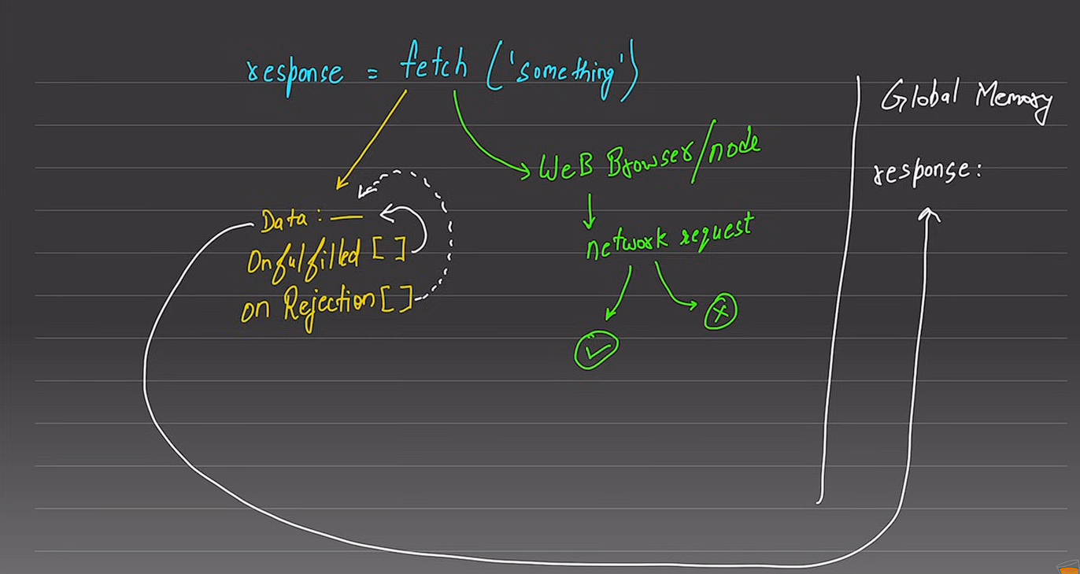

OOP in js
Js has prototype
JavaScript is an object-oriented language, but it’s prototype-based, not class-based like Java or C++.
Objects are created from other objects (prototypes), and ES6 classes are just syntactic sugar over this system.

OBJECT –
Collection of properties and methods
Tolowecase

Part of oops
- Object Literals

-constructors
- prototypes
- Classes
- Instances (new, this)

4 pillars
Abstraction
Definition:
Abstraction means hiding complex implementation details and showing only what’s necessary.
In JavaScript:
We achieve abstraction using classes and methods — we expose only what’s needed for the user and hide the internal working.

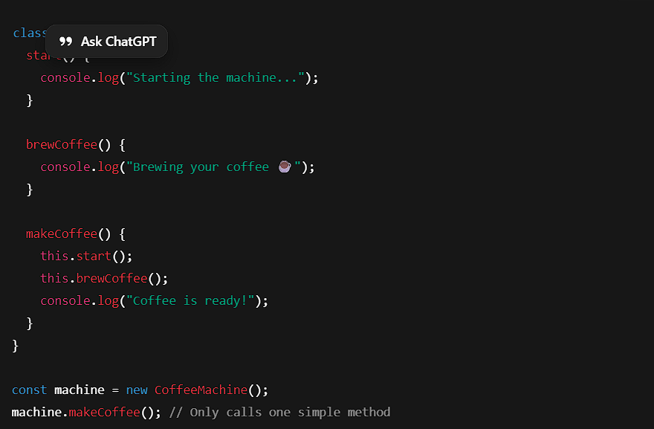

Encapsulation
Definition:
Encapsulation means keeping data (properties) and methods (functions) together inside a class — and restricting direct access to some of them.
In JavaScript (ES2022+):
We can use private fields using #.
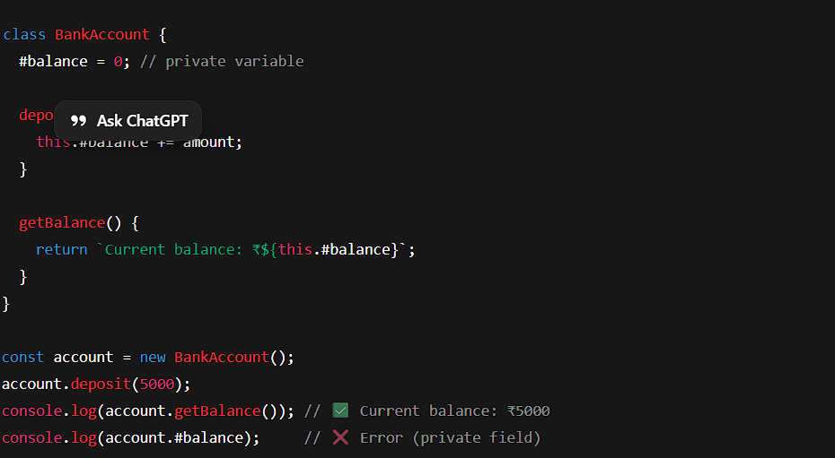

Inheritance
Definition:
Inheritance means one class (child) can use the properties and methods of another class (parent).
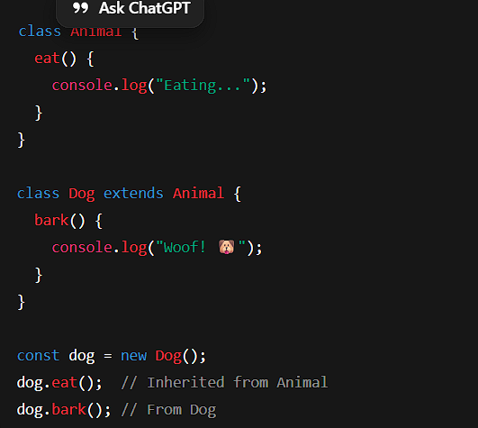
The Dog class inherits from Animal.
It reuses code and can add its own behavior.

Polymorphism
Definition:
Polymorphism means one method behaves differently depending on which object is using it.
(“Poly” = many, “Morph” = forms)

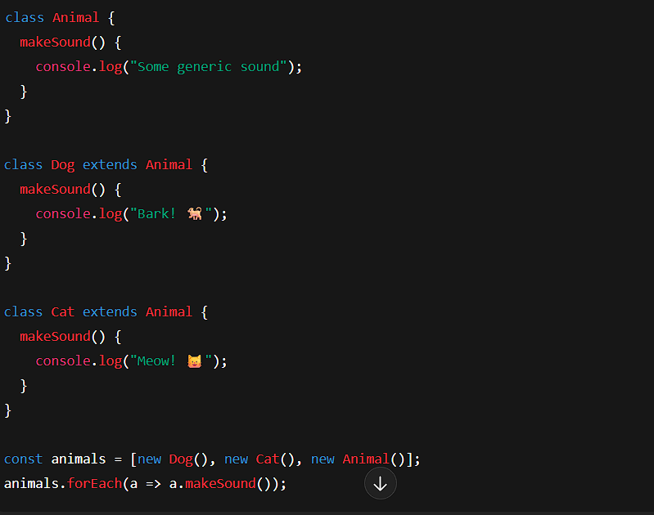
Bark! 🐕
Meow! 🐱
Some generic sound

The same method name (makeSound) behaves differently for each class.
That’s polymorphism.
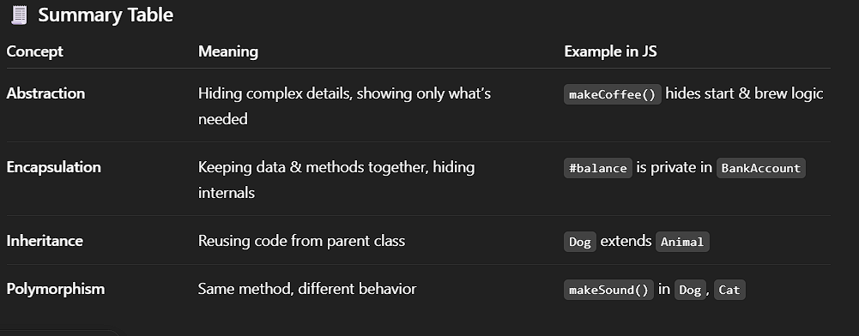

Literal object and this keyword
const user = {
username: "Siddharth",
age: 20,
details: function(){
console.log( `Hey ${this.username} you turned ${this.age} Years Old isnt it amazing`)
return;
}
}

console.log(user.details())

this is used to state that we are talking about this scope other wise it will say username and age is undefined. ( current context) means the whole object

Constructor Function

Write new before calling any function will make it not change the previous function
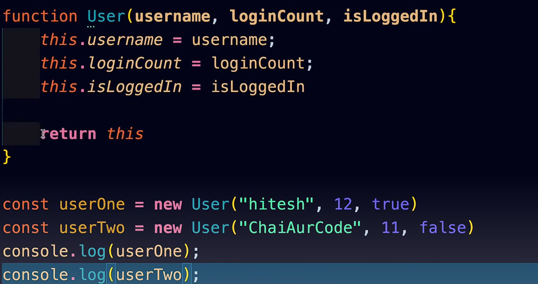

Create Prototype
function createUser(username,score){
this.username = username
this.score = score;
}

createUser.prototype.incriment = function(){
this.score++;
}

const chai = new createUser("CHai",55)
const tea = new createUser("Tea",10)

createuser.Prototype.incriment uske andar apna function.

Inheritance
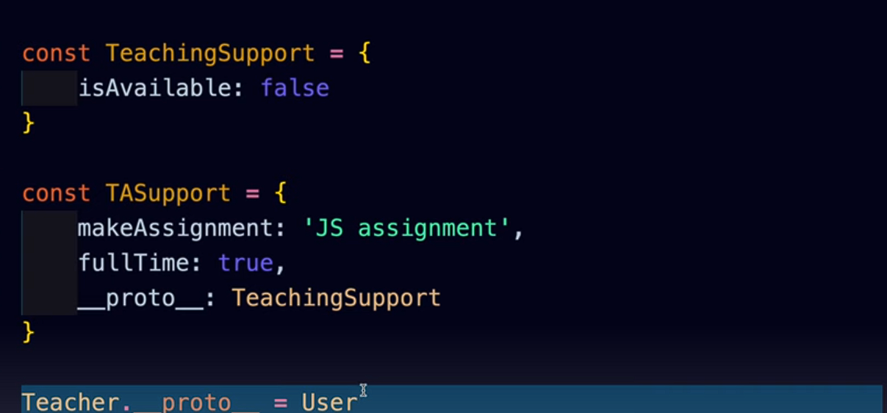

Modern syntax
This means the teachingsupport inherits it property to the teacher.

Call

function setUsername(username){
this.username= username;
console.log("called")
}
function users(username,email,password){
setUsername.call(this,username)
this.email = email;
this.password = password;
}

console.log(new users("Sid","sidd#gagagd","hasshass"))

this calls from different function add value to it, its like a connection between them.

Classes in js

As such classes don’t exist in js its just way of writing in syntax of class unlike other programming languages like java c++.
After Es6

Constructor is called as soon as New keyword is called.
class user {
constructor(name, email, password){
this.name = name
this.email = email
this.password = password
}

encryptPass(){
return `${this.password} is you password `
}

}

const sid = new user("sid","siddharthnaudiyal144","hahahah")
console.log(sid.encryptPass())

inheritance

super keyword is used to get the value from the parent
class user{
constructor(username){
this.username = username
}

logme(){
console.log(`Username is ${this.username}`)
}
}

class teacher extends user{
log2(){
console.log(super(username))
}
}

Extend and super

Instance of
This tells us that ki they inherited the property of that class or not?

Static keyword
class user{
constructor(username){
this.username = username
}

logMe(){
console.log(`username is : ${this.username}`)
}

static createID(){
return `abc`
}
}

const user1 = new user("Siddharth")

console.log(user1.createID())

static keyword is used to prevent access of that function from general public.
Not even child can access it .

class React {
constructor(){
this.library = "React"
this.server = "https://www.localhost3000/"
document.querySelector("#btn").addEventListener("click",this.handleClick).bind(this)

}

handleClick(){
console.log("button is clicked ")
console.log(this.server)
}
}

const app = new React()

you can see document queryselector is using handleclick function but this.server is not accessible from inside the handleClick because this in that is
actually referring to the button in html not in this

so we wrote .bind(this) so that server and library this will also go with that .

Getter and setter

class user {
constructor(username,password){
this.username = username
this.password = password
}

get password(){
return `${this._password + 767}`.toUpperCase() // this value is given
}
set password(value){
this._password = value // this value is stored
}
}

const user1 = new user("SID",0)

console.log(user1.password)

this is new code.

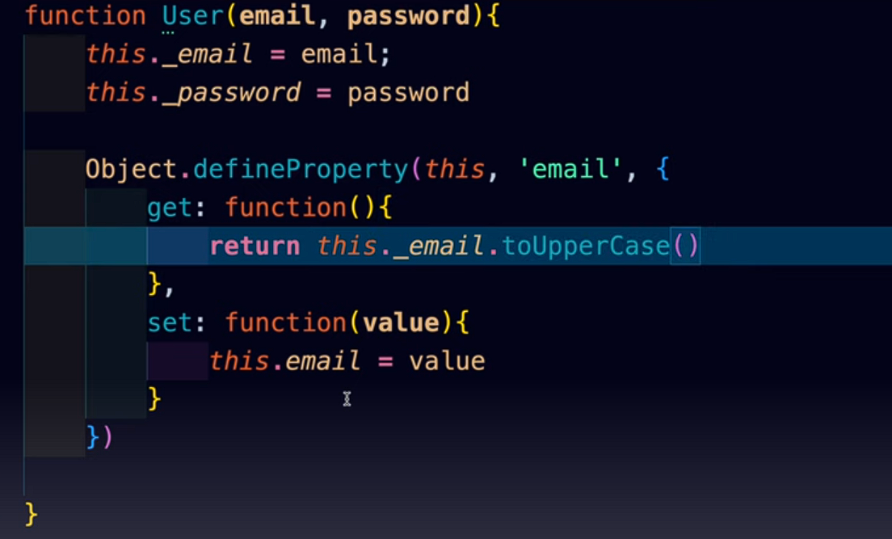
This is old code.
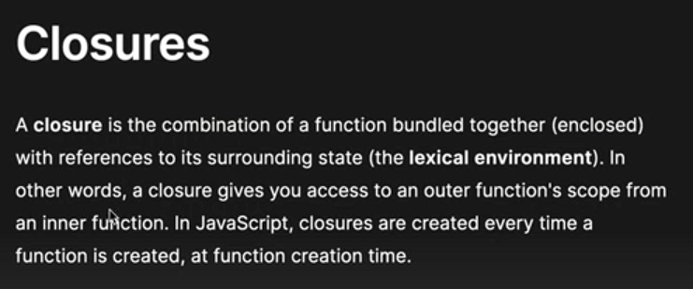

Lexical scoping
It means that child function ( ) can access variable from parent function but parent function cant access variable form child function

And two child function can also not access variable from the same function.
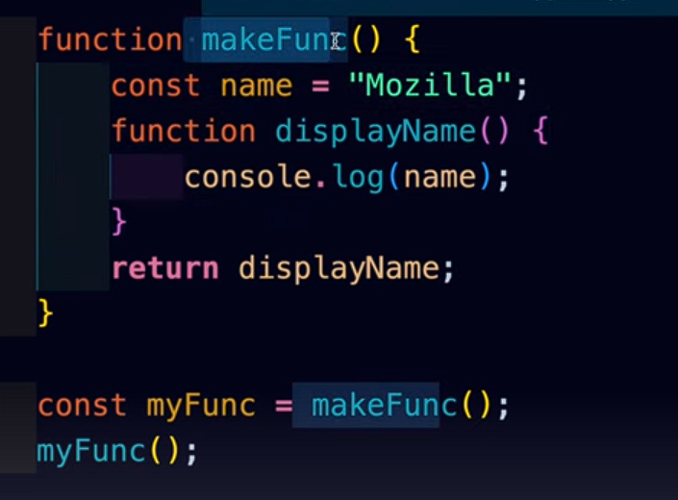

When we return displayname() not only displayname is returned but also the scope they are using means to use name inside that const name = mozilla bhi jayega
When we return whole function is Closure

Real world example for closure
