BMEN 600 Midterm Research Plan – Group 11

GitHub repository: https://github.com/thesixtium/bmen-600-group-11

Introduction and Motivation
People with complex mobility needs often have limited personal freedom, and restoring independence is a central goal of assistive technology. Brain–computer interfaces (BCIs) that decode electroencephalography (EEG) could let these users control mobility devices directly, but low decoding accuracy remains a barrier to reliable real-world use [1]. Decoding is difficult because EEG has a low signal-to-noise ratio, is nonstationary within and across sessions, differs between individuals, and is usually recorded in small datasets.
We hypothesize that recurrent spiking neural networks (RSNNs) suit this problem because their structure resembles the circuits that generate the signal. EEG reflects the summed activity of large, densely and recurrently connected cortical populations, and this recurrence is thought to support temporal integration, short-term memory, and activity across multiple timescales. Spiking neural networks (SNNs) capture part of this biology: the membrane potential gives each neuron its own memory, and event-driven spiking suits low-power embedded BCIs. Feedforward SNNs, however, have no loops between neurons, so temporal context rests on single-neuron dynamics alone. An RSNN adds trained connections between neurons that can form loops. This differs from a neuron’s own membrane memory and from liquid state machines, whose recurrent connections are random and fixed with only the readout trained. We expect trained inter-neuron recurrence to model the temporal structure of EEG more faithfully and to be more robust to its noise and variability.
To our knowledge, an RSNN with trained recurrent connections has not been used as a BCI EEG decoder. Spiking EEG decoders are mostly feedforward, and recurrence has appeared only as one component of larger architectures (Section 2). The closest recurrent SNN, MotorSRNN, decodes cortical spike trains, not EEG. This project therefore asks: Does an RSNN outperform a feedforward SNN at decoding motor imagery EEG from BCI Competition IV dataset 2a under a subject-level, cross-session evaluation? Answering it will show whether trained inter-neuron recurrence improves spiking EEG decoders and so whether RSNNs can contribute to higher-accuracy BCIs.

Background and Research Gap
EEGNet is a compact convolutional neural network (CNN) for EEG decoding [2] and the basis of both our baselines: the EEGNet architecture as an artificial neural network (ANN), retrained under our protocol, and a feedforward SNN made by converting the trained ANN to a spiking network of the same architecture, carrying over the weights and approximating activations with spike rates [3], [4]. The converted SNN is the direct comparator for our RSNN because it decodes the same data on identical folds, and the ANN shows how much accuracy conversion costs. EEGNet suits this role because it is small (one configuration has 796 trainable parameters on this dataset [2]), which makes a parameter-matched RSNN practical; because it performed similarly to larger CNNs and slightly above filter-bank common spatial patterns (FBCSP) in cross-subject classification on this dataset [2]; and because newer models routinely report results against it [5]–[7].
SNNs have already been applied to motor imagery decoding, including on dataset 2a [8]–[10]. Some studies convert a trained ANN, as we do: lighter networks reduce conversion error [8], and a converted EEGNet performed comparably to its ANN [9]. Others train SNNs directly with surrogate gradients, which replace the non-differentiable spike function with a smooth approximation during backpropagation [11]. These models can approach CNN accuracy at lower estimated energy cost [8]–[10], although SNNs have generally been less accurate than comparable CNNs [10]. The converted models are feedforward [8], [9], so temporal context is carried only by each neuron’s membrane potential.
Recurrent SNNs have performed well on other temporal signals. Recurrent networks of adaptive spiking neurons reached state-of-the-art SNN results on speech and gesture benchmarks at publication [12], and recurrent SNNs outperformed feedforward SNNs on monkey motor cortex recordings [13], [14]. Cortical spike trains, however, are already spikes, whereas EEG is a continuous scalp signal that must first be encoded. For EEG motor imagery, recurrence has appeared only as one component of larger spiking architectures [15], [16]. Removing spiking long short-term memory (LSTM) units lowered accuracy on the PhysioNet dataset, but trials from all subjects were pooled into random splits [15], so the result does not show whether the benefit holds for a new session of an individual subject. Lim and Kim compared a recurrent model with a convolutional SNN on dataset 2a, but used within-subject k-fold cross-validation with no held-out session or statistical testing [16].
To our knowledge, no study has used an RSNN with trained recurrent connections as the EEG decoder and compared it with a feedforward SNN on dataset 2a using a held-out session and subject-level statistics. Our project makes this comparison. Because the converted SNN and RSNN also differ in architecture and training (Section 4), the result shows whether a parameter-matched RSNN decodes more accurately but cannot attribute a difference to recurrence alone.

Dataset and Responsible Use
We use BCI Competition IV dataset 2a, a four-class motor imagery EEG dataset recorded at Graz University of Technology by the Institute for Knowledge Discovery and the Institute for Human-Computer Interfaces (Brunner, Leeb, Müller-Putz, Schlögl and Pfurtscheller) and released in the fourth BCI Competition [17], [18]. We accessed it through the Mother of All BCI Benchmarks (MOABB) [19] on October 8, 2026, which also supplies the session 2 labels. The EEGNet authors evaluated four-class decoding on it [2], giving our ANN a reference point, and later models are routinely evaluated on it [5]–[7].
Nine subjects (A01–A09) each completed two sessions on different days. Each session has six runs of 48 trials (12 per class), giving 288 trials per session and 576 per subject, balanced by design [18]. After a 1.25 s arrow cue at t = 2 s, subjects imagined left-hand, right-hand, both-feet, or tongue movement until t = 6 s, without feedback (Fig. 1) [18]. EEG was recorded from 22 Ag/AgCl electrodes at 250 Hz (0.5–100 Hz band-pass, 50 Hz notch). Three EOG channels were also recorded but must not be used for classification, and an expert marked artifact trials [18]. The input is the multichannel post-cue epoch and the output is the four-class label (nominal chance accuracy 25%).
The independent case is the subject, not the trial, because trials from one subject and session share electrode placement, impedance, and neural state. Our protocol (Section 4) pretrains on other subjects’ session 1 data, fine-tunes on the target subject’s session 1, and tests on that subject’s session 2, which is never used for training, validation, or checkpoint selection. Results are summarized per target subject, giving nine cases. Because each subject’s session 1 also trains the models for the other eight, the cases are only approximately independent, which we treat as a limitation. The EEGNet authors reported cross-subject accuracies near 40% without target-subject data [2], so because we add fine-tuning, we retrain rather than reuse published numbers.
The data are openly available. The providers require crediting the recording groups, done above, and citing one paper from the dataset description [18]; we cite Naeem et al. [20]. Subjects are identified only by code, but we treat coded EEG as potentially identifying: we will not attempt to link subjects to other sources, will report results only in aggregate or by code, and will not redistribute raw files. The documentation we consulted reports no demographics, consent procedures, or ethics approval, and nine subjects from one laboratory, system, and montage are a small, narrow sample, so we cannot assume the results generalize to users with complex mobility needs. The synchronous, cue-based, offline paradigm also differs from online use [17]. The providers caution that small improvements may be random fluctuation and that evaluation data should not be used for model selection [17], so we fix hyperparameters without test data.

Proposed Methods and Evaluation
Software and code. Analyses use Python: MOABB for data loading, PyTorch and snnTorch for the models, scikit-learn and SciPy for metrics and statistics, and the University of Calgary’s ARC Cluster for computation. We will write a preprocessing and fold-generation pipeline, the model code (ANN, conversion, RSNN), and an evaluation module. Seeds and configurations are logged.
Preprocessing. Following EEGNet [2], the 22 EEG channels (EOG excluded) are resampled to 128 Hz, band-pass filtered at 4–40 Hz, and epoched 0.5–2.5 s after cue onset, giving a 22 × 256 input per trial. Artifact-marked trials are retained to preserve class balance. The EEGNet paper cites earlier work for any remaining preprocessing, so we will confirm whether further steps are needed.
Models. Three models are evaluated.
- ANN: EEGNet with ELU activations and a 32-sample temporal kernel [2] (EEGNet-4,2 is the starting point; configuration to be finalized). Training follows EEGNet: Adam with default parameters, categorical cross-entropy, 500 epochs, lowest-validation-loss weights, and dropout of 0.25 for cross-subject training and 0.5 for fine-tuning.
- SNN: the trained ANN converted by carrying over its weights, with activations approximated by spike rates. The prediction is the output neuron with the highest spike count. Conversion details, including simulation steps, are not yet decided.
- RSNN: an input projection, one recurrent layer of leaky integrate-and-fire (LIF) neurons in which every neuron connects to every other, and a linear four-class readout. The recurrent weights are trained with surrogate-gradient backpropagation through time, using the ANN’s optimizer, loss, epochs, and checkpoint rule. Neuron hyperparameters are copied from the converted SNN, and the neuron count is set so the trainable parameter count is similar to the converted SNN’s, which may differ slightly from the ANN’s. Both spiking models receive the same input representation, to be finalized with the conversion details.
The converted SNN and RSNN differ in architecture and training as well as recurrence, there is no recurrence-free control, and the RSNN is not tuned for itself, so a difference cannot be attributed to recurrence alone.
Protocol. Following EEGNet’s cross-subject design, for each target subject the session 1 data of five of the other eight subjects form the training set and those of the remaining three the validation set. Ten random draws with seeds give 90 folds per model. Unlike EEGNet, each pretrained model is then fine-tuned on the target subject’s session 1 (80% training, 20% stratified validation, 100 epochs) and tested on session 2 (288 trials). We therefore describe the protocol as cross-subject pretraining with within-subject, cross-session fine-tuning. All models share identical folds, and the SNN is converted from the fine-tuned ANN.
Outcome and comparisons. Accuracy is the primary measure, as in EEGNet and because low accuracy is the barrier identified in Section 1. We also report Cohen’s kappa (chance-corrected), macro-averaged F1 (which does not reward models strong on only some classes), and per-class confusion matrices. Balanced accuracy equals accuracy here because each test session has 72 trials per class. SNN versus RSNN answers the research question, ANN versus RSNN places the RSNN against the baseline architecture, and ANN versus SNN quantifies accuracy lost in conversion.
Avoiding misleading results and showing uncertainty. The subject is the independent case, so the 10 repeats are averaged to one value per subject, model, and metric, giving nine paired observations (EEGNet’s mean ± SE over all 90 folds [2] treats non-independent folds as independent). Because a classifier can exceed nominal chance by chance with finite samples [21], each result is compared with a significance threshold based on the actual number of test trials and confirmed by a 10,000-permutation label test, and only results passing both are called above chance. Differences are tested with an exact two-sided Wilcoxon signed-rank test (no normality assumption at n = 9) with Holm correction across the three comparisons. We report the median paired difference with a bootstrap 95% confidence interval over subjects, plus per-subject mean ± SD across repeats and mean ± SD across subjects.

Preliminary Results

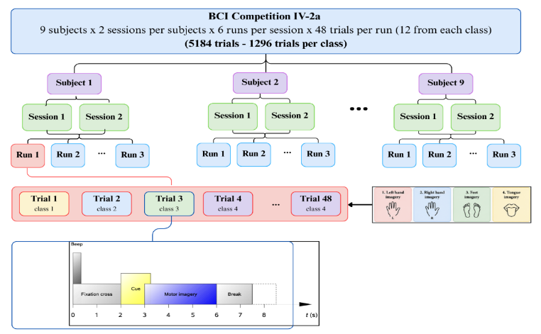
Fig. 1. Structure of BCI Competition IV dataset 2a: 9 subjects × 2 sessions × 6 runs × 48 trials (12 per class) = 5,184 trials (1,296 per class), with the timing of a single trial.
Dataset structure. Through MOABB’s motor imagery paradigm [19], the default 2–6 s window yielded 5,184 epochs (9 subjects × 2 sessions × 6 runs × 48 trials; 1,296 per class; Fig. 1), each with 22 EEG channels × 1,001 samples at 250 Hz (EOG channels are dropped by default). We used this window for exploration only. The modelling pipeline uses the EEGNet preprocessing in Section 4 (128 Hz, 0.5–2.5 s after cue).
Spectral content. The grand-average power spectral density (Fig. 2a) shows a prominent peak near 10 Hz, consistent with alpha activity and potentially sensorimotor mu rhythms (8–13 Hz) associated with motor imagery [22], [23], and only small peaks near 20 Hz in the beta band (13–30 Hz). Low-frequency power may partly reflect EOG artifacts, and a sharp 50 Hz peak persists despite the acquisition notch filter, possibly from residual line interference. Both observations support the 4–40 Hz band-pass filter, which we apply at the same pipeline stage as EEGNet [2].
Class differences. Absolute band-power topographies showed no clear differences between classes, so Fig. 2b shows each class’s log band-power difference from the all-class mean. Hand imagery lowers mu and beta power over sensorimotor areas, more strongly over the hemisphere opposite the imagined hand, while tongue imagery shows higher-than-average power and feet imagery a smaller shift, consistent with the literature on mu and beta topographies [23]. The clear left–right difference fits MOABB’s within-session benchmark, where mean accuracy across its pipelines is 81.10% for left versus right hand but 61.34% across all four classes [24]. These are within-session, pipeline-averaged figures, so they give context rather than a baseline for our protocol. The harder four-class problem motivates testing whether an RSNN can capture temporal patterns that average band power misses.
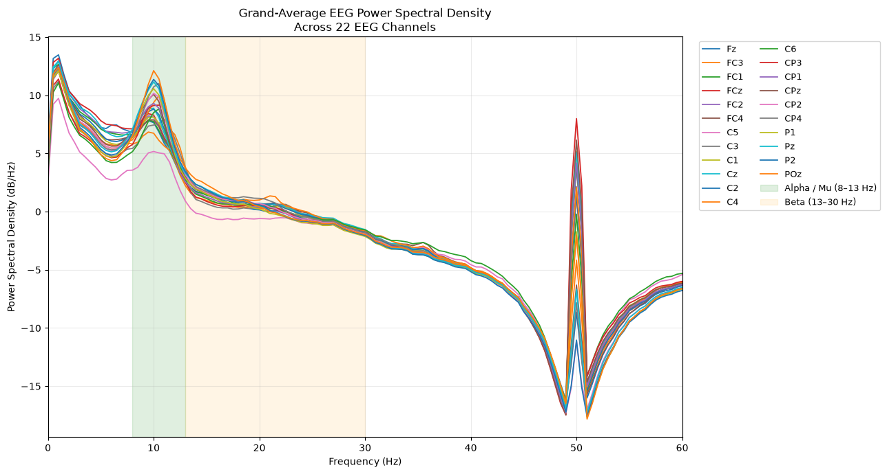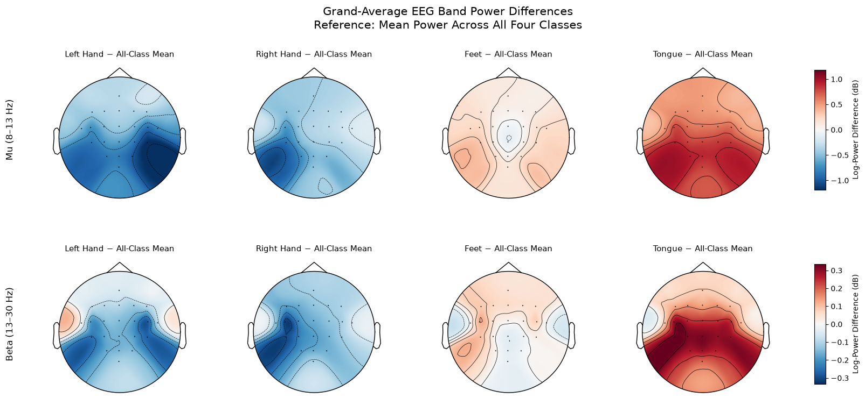
Fig. 2. (a) Grand-average power spectral density across all nine subjects, one line per EEG channel (original reference, unfiltered); dotted lines mark the mu band edges, the upper beta edge, and 50 Hz. (b) Grand-average log band-power difference between each class and the all-class mean for the mu (8–13 Hz, top row) and beta (13–30 Hz, bottom row) bands; columns are left hand, right hand, feet, and tongue.
Implications and remaining work. These results confirmed our filter choice and did not change the research question. The dataset can support a subject-level comparison of a parameter-matched RSNN with a converted feedforward SNN, but it cannot attribute a difference to recurrence alone (Section 4), and nine subjects from one laboratory limit generalization (Section 3). Before final submission we must finalize the EEGNet configuration and conversion details, train all three models on the 90 folds, and validate the pipeline for leakage.

Teamwork and Project Plan
A = Amir, L = Lex, P = Pahan. Work below begins after this plan is submitted on October 16 and ends with the final project submission on December 4. Dates follow the course schedule.
Dates (2026) | Milestone | Lead
Oct 19–23 | Finalize preprocessing, generate the 90 folds, implement the ELU EEGNet; data analysis ready for Team Discussion 6 (Oct 23) | P (data), L (model)
Oct 19–30 | Write evaluation code (metrics, chance threshold, permutation test, Wilcoxon, Holm, bootstrap) | A
Oct 26–Nov 2 | Train the ANN on all folds, convert to SNN; present first results at Team Discussion 7 (Oct 30) | L
Oct 26–Nov 6 | Implement the RSNN, match its parameters to the converted SNN, train on all folds | L
Nov 2–6 | Validate pipeline (leakage check, ANN sanity check) for Team Discussion 8 (Nov 6) | P, A
Nov 9–13 | Reading Week: buffer for remaining compute runs | –
Nov 16–20 | Comparison, statistics, figures; begin manuscript (Team Discussion 9, Nov 20) | P (analysis), L, A
Nov 23–27 | Peer review (Nov 23); revise manuscript; finish GitHub documentation | L, P, A
Nov 27–Dec4 | Rehearse and give oral presentation; submit manuscript and repository (Dec 4) | L, P, A

Data and Code Availability
The dataset is openly available from the BCI Competition IV site [18] and through MOABB [19]; we do not redistribute raw files. The code is at https://github.com/thesixtium/bmen-600-group-11, whose README links the data source and provides scripts that load and preprocess the data. Analyses use Python (MOABB, PyTorch, snnTorch, scikit-learn, SciPy), with training on the University of Calgary ARC Cluster.
AI-Assisted Work
Microsoft Copilot helped write the code that generates the preliminary results, and Claude helped improve the clarity of the text. Team members wrote the content first and used AI only to clean it up. Sources were selected and read by team members, and AI was not used to find or generate references, so reference verification was not needed. Team members reviewed the AI-assisted code by reading through it afterward.
Author Contributions
Pahan generated the preliminary-results data and wrote the Preliminary Results section. Amir carried out the literature review. Lex was responsible for the remaining work in the research plan and GitHub.

References
[1] N. Padfield, J. Zabalza, H. Zhao, V. Masero, and J. Ren, “EEG-based brain-computer interfaces using motor-imagery: Techniques and challenges,” Sensors, vol. 19, no. 6, Art. no. 1423, 2019, doi: 10.3390/s19061423.
[2] V. J. Lawhern, A. J. Solon, N. R. Waytowich, S. M. Gordon, C. P. Hung, and B. J. Lance, “EEGNet: A compact convolutional neural network for EEG-based brain–computer interfaces,” J. Neural Eng., vol. 15, no. 5, Art. no. 056013, 2018, doi: 10.1088/1741-2552/aace8c.
[3] Y. Wang, H. Liu, M. Zhang, X. Luo, and H. Qu, “A universal ANN-to-SNN framework for achieving high accuracy and low latency deep spiking neural networks,” Neural Netw., vol. 174, Art. no. 106244, 2024, doi: 10.1016/j.neunet.2024.106244.
[4] B. Rueckauer, I.-A. Lungu, Y. Hu, M. Pfeiffer, and S.-C. Liu, “Conversion of continuous-valued deep networks to efficient event-driven networks for image classification,” Front. Neurosci., vol. 11, Art. no. 682, 2017, doi: 10.3389/fnins.2017.00682.
[5] H. Altaheri, G. Muhammad, and M. Alsulaiman, “Physics-informed attention temporal convolutional network for EEG-based motor imagery classification,” IEEE Trans. Ind. Informat., vol. 19, no. 2, pp. 2249–2258, 2023, doi: 10.1109/TII.2022.3197419.
[6] Y. Song, Q. Zheng, B. Liu, and X. Gao, “EEG Conformer: Convolutional transformer for EEG decoding and visualization,” IEEE Trans. Neural Syst. Rehabil. Eng., vol. 31, pp. 710–719, 2023, doi: 10.1109/TNSRE.2022.3230250.
[7] R. Mane et al., “FBCNet: A multi-view convolutional neural network for brain-computer interface,” 2021, arXiv:2104.01233, doi: 10.48550/arXiv.2104.01233.
[8] X. Liao, G. Li, Y. Wang, L. Sun, and H. Zhang, “Constructing lightweight and efficient spiking neural networks for EEG-based motor imagery classification,” Biomed. Signal Process. Control, vol. 100, Art. no. 107000, 2025, doi: 10.1016/j.bspc.2024.107000.
[9] Y. Chen, W. Sun, and M. Meng, “Self-rectifying integrate-and-fire neuron and collaborative trim training framework for SNN-based EEG motor imagery classification,” Brain Sci., vol. 16, no. 6, Art. no. 592, 2026, doi: 10.3390/brainsci16060592.
[10] C. Zhang, W. Pan, and C. Della Santina, “NiSNN-A: Noniterative spiking neural network with attention with application to motor imagery EEG classification,” IEEE Trans. Neural Netw. Learn. Syst., vol. 36, no. 8, pp. 14298–14312, 2025, doi: 10.1109/TNNLS.2025.3538335.
[11] E. O. Neftci, H. Mostafa, and F. Zenke, “Surrogate gradient learning in spiking neural networks: Bringing the power of gradient-based optimization to spiking neural networks,” IEEE Signal Process. Mag., vol. 36, no. 6, pp. 51–63, 2019, doi: 10.1109/MSP.2019.2931595.
[12] B. Yin, F. Corradi, and S. M. Bohté, “Accurate and efficient time-domain classification with adaptive spiking recurrent neural networks,” Nat. Mach. Intell., vol. 3, no. 10, pp. 905–913, 2021, doi: 10.1038/s42256-021-00397-w.
[13] T. Liu et al., “motorSRNN: A spiking recurrent neural network inspired by brain topology for the effective and efficient decoding of cortical spike trains,” Biomed. Signal Process. Control, vol. 99, Art. no. 106745, 2025, doi: 10.1016/j.bspc.2024.106745.
[14] T. Liu, J. Gygax, J. Rossbroich, Y. Chua, S. Zhang, and F. Zenke, “Decoding finger velocity from cortical spike trains with recurrent spiking neural networks,” in Proc. IEEE Biomed. Circuits Syst. Conf. (BioCAS), 2024, pp. 1–5, doi: 10.1109/BioCAS61083.2024.10798222.
[15] P. Gong, P. Wang, Y. Zhou, and D. Zhang, “A spiking neural network with adaptive graph convolution and LSTM for EEG-based brain-computer interfaces,” IEEE Trans. Neural Syst. Rehabil. Eng., vol. 31, pp. 1440–1450, 2023, doi: 10.1109/TNSRE.2023.3246989.
[16] J.-G. Lim and S.-E. Kim, “Spatio-temporal spiking attention recurrent neural network for EEG-based motor imagery classification,” in Proc. Int. Conf. Electron., Inf., Commun. (ICEIC), 2025, pp. 1–4, doi: 10.1109/ICEIC64972.2025.10879689.
[17] M. Tangermann et al., “Review of the BCI Competition IV,” Front. Neurosci., vol. 6, Art. no. 55, 2012, doi: 10.3389/fnins.2012.00055.
[18] C. Brunner, R. Leeb, G. R. Müller-Putz, A. Schlögl, and G. Pfurtscheller, “BCI Competition 2008 – Graz data set A,” Graz Univ. Technol., Graz, Austria, 2008. Accessed: Oct. 15, 2026. [Online]. Available: https://www.bbci.de/competition/iv/desc_2a.pdf
[19] V. Jayaram and A. Barachant, “MOABB: Trustworthy algorithm benchmarking for BCIs,” J. Neural Eng., vol. 15, no. 6, Art. no. 066011, 2018, doi: 10.1088/1741-2552/aadea0.
[20] M. Naeem, C. Brunner, R. Leeb, B. Graimann, and G. Pfurtscheller, “Separability of four-class motor imagery data using independent components analysis,” J. Neural Eng., vol. 3, no. 3, pp. 208–216, 2006, doi: 10.1088/1741-2560/3/3/003.
[21] E. Combrisson and K. Jerbi, “Exceeding chance level by chance: The caveat of theoretical chance levels in brain signal classification and statistical assessment of decoding accuracy,” J. Neurosci. Methods, vol. 250, pp. 126–136, 2015, doi: 10.1016/j.jneumeth.2015.01.010.
[22] H. Yu, S. Ba, Y. Guo, L. Guo, and G. Xu, “Effects of motor imagery tasks on brain functional networks based on EEG mu/beta rhythm,” Brain Sci., vol. 12, no. 2, Art. no. 194, 2022, doi: 10.3390/brainsci12020194.
[23] D. J. McFarland, L. A. Miner, T. M. Vaughan, and J. R. Wolpaw, “Mu and beta rhythm topographies during motor imagery and actual movements,” Brain Topogr., vol. 12, pp. 177–186, 2000, doi: 10.1023/A:1023437823106.
[24] “moabb.datasets.BNCI2014_001,” MOABB Documentation. [Online]. Available: https://moabb.neurotechx.com/docs/generated/moabb.datasets.BNCI2014_001.html. Accessed: Oct. 15, 2026.

