**Homepage**

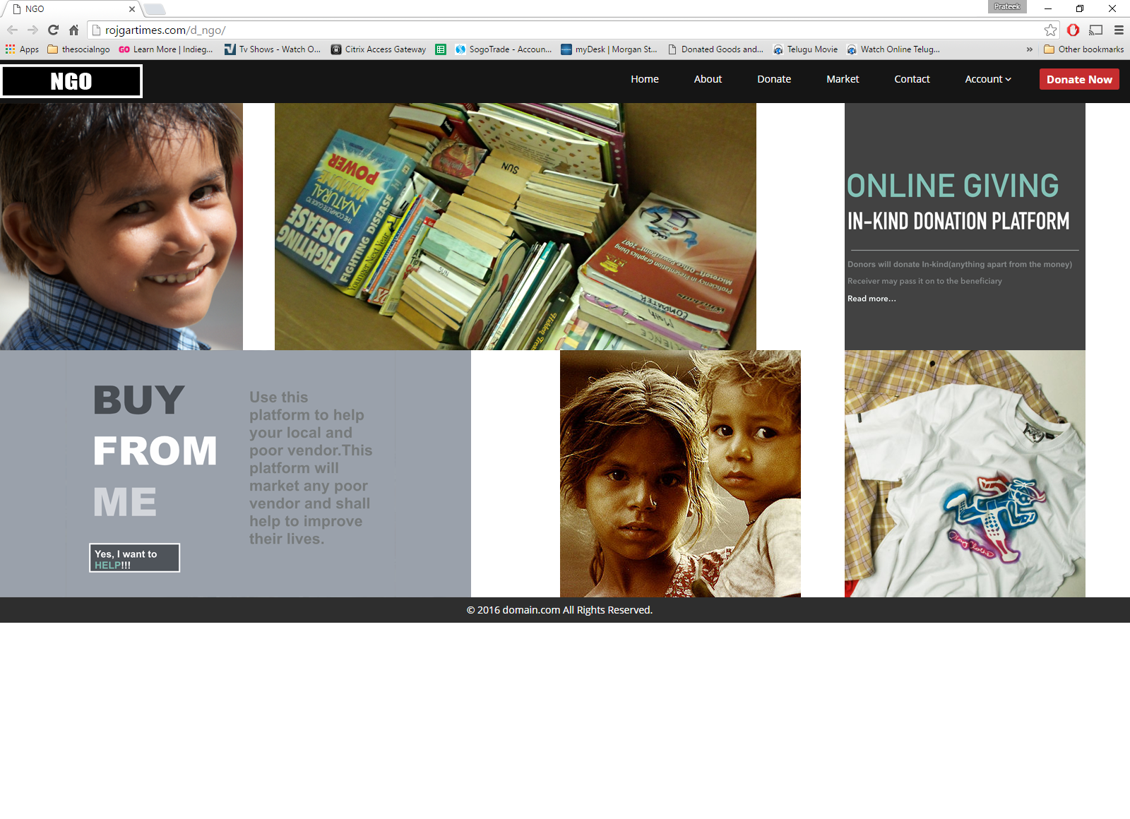

1. Logo on top
2. Name – THESOCIALNGO
3. Menu – Home, Humanity bazaar, social marketing, the platform, prayas scoialngo foundation, contact, Donate
4. Pictures must be clickable taking to the desired page
   1. Humanity bazaar
   2. Social Marketing
   3. Platform
   4. Prayas socialngo foundation
   5. Donate
5. Responsive for mobile
6. Must be able to use without login – no login required

**Humanity bazaar**

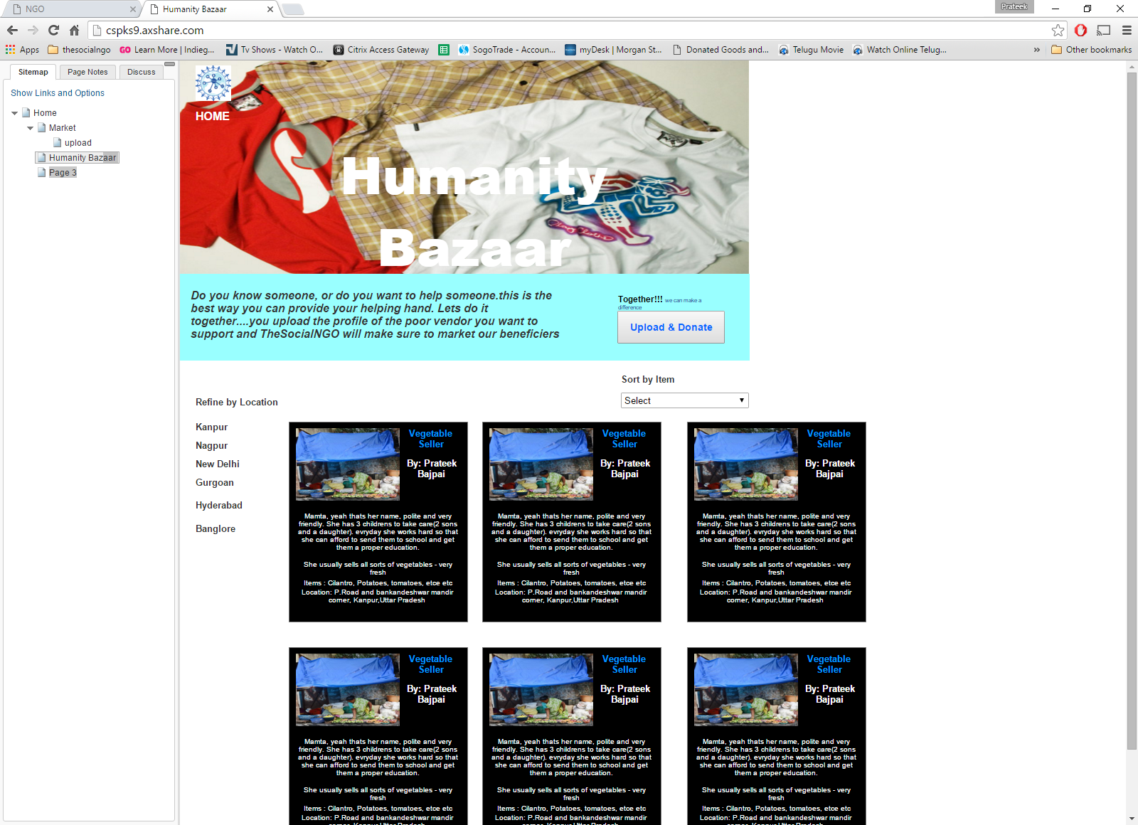

1. Banner
2. Upload button – modal overlay

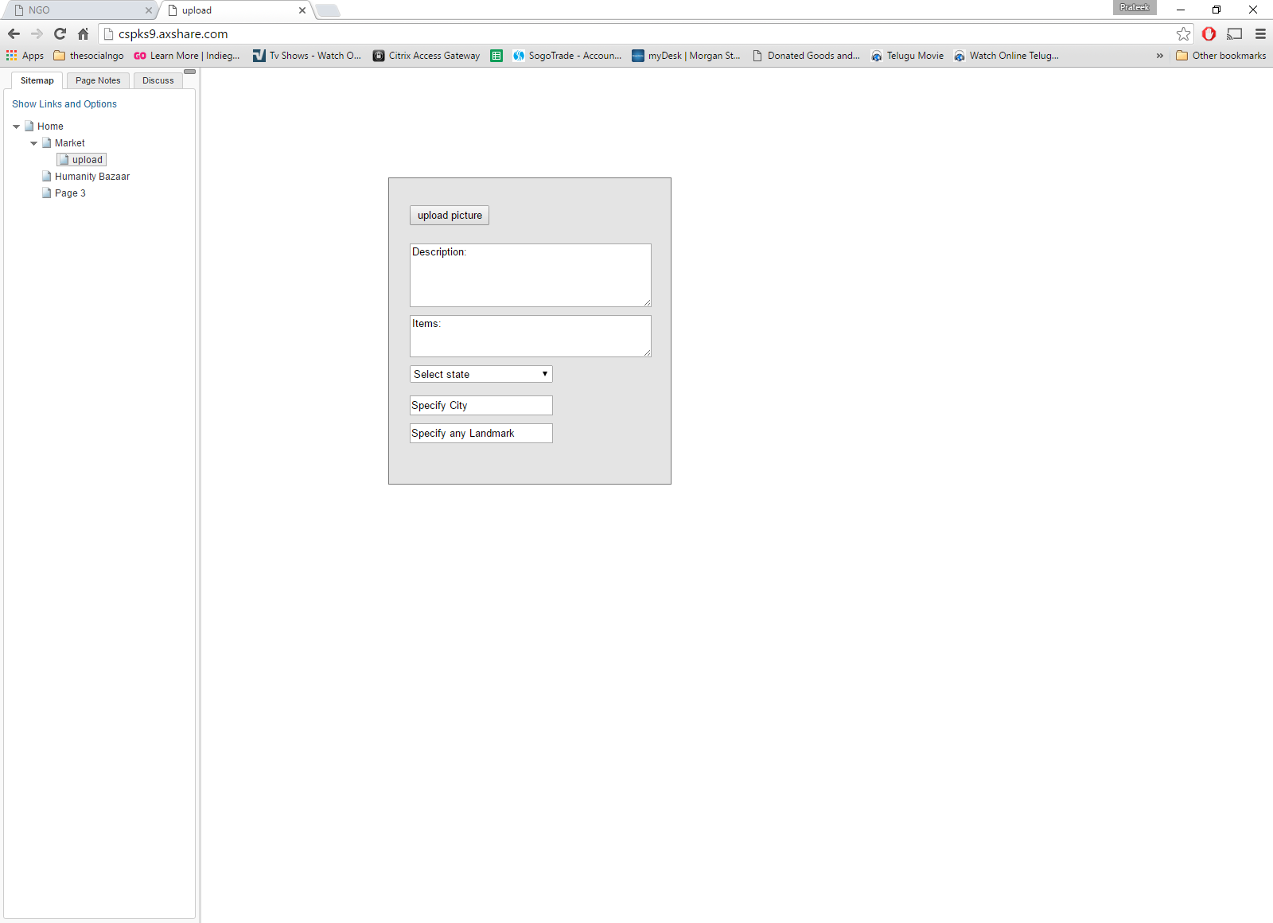

* 1. Form to upload a picture and other description
     1. Picture – take a picture or upload
     2. Description 500 char
     3. Item
     4. Contact name
     5. Contact no.
     6. Pickup location

Note: you may send and make (Prayas socialngo foundation) as pickup location, if that’s feasible for you!!!

1. Location filter
2. Sort by item
3. Search bar
4. Admin access to delete and update

**Social Marketing**



1. Banner
2. Upload button - modal overlay



* 1. Form to upload a picture and other description
     1. Picture – take a picture or upload
     2. Description 500 char
     3. Item
     4. State
     5. City
     6. landmark
     7. Contact name
     8. Contact no.

1. Location filter
2. Sort by item
3. Search bar
4. Admin access to delete and update

**Donate**

Note: 80G is in process, we wont be able to provide a receipt.

Send in your checks @ address

**Prayassocialngo foundation**

link to the website www.psf.com