Updates

1. Humanity Bazaar

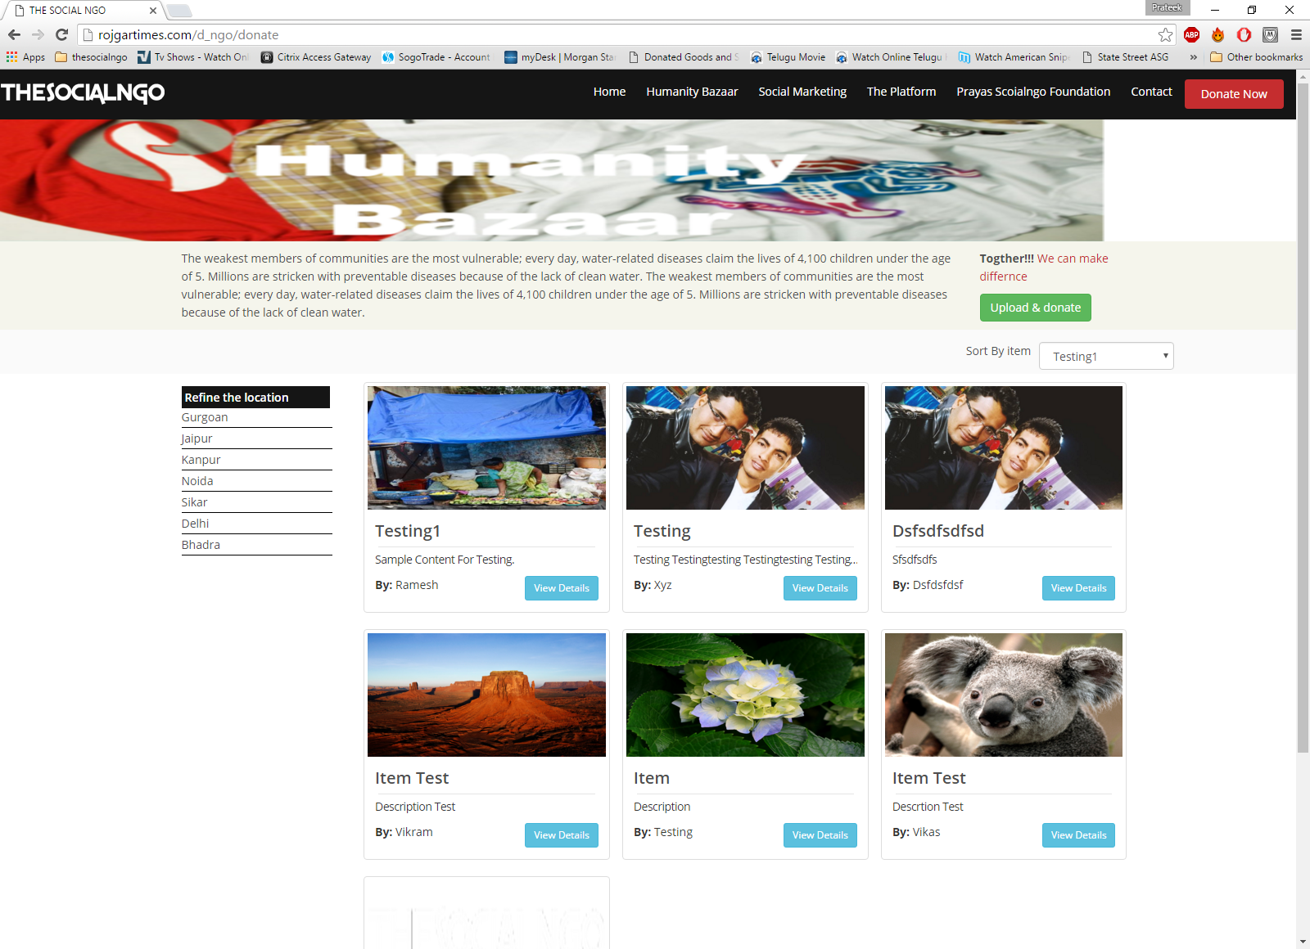

1. Banner – width is not of full length
2. Banner change – please see attached
3. Refine by location - Change to ascending order alphabetically



1. Sort by Item - ascending order alphabetically

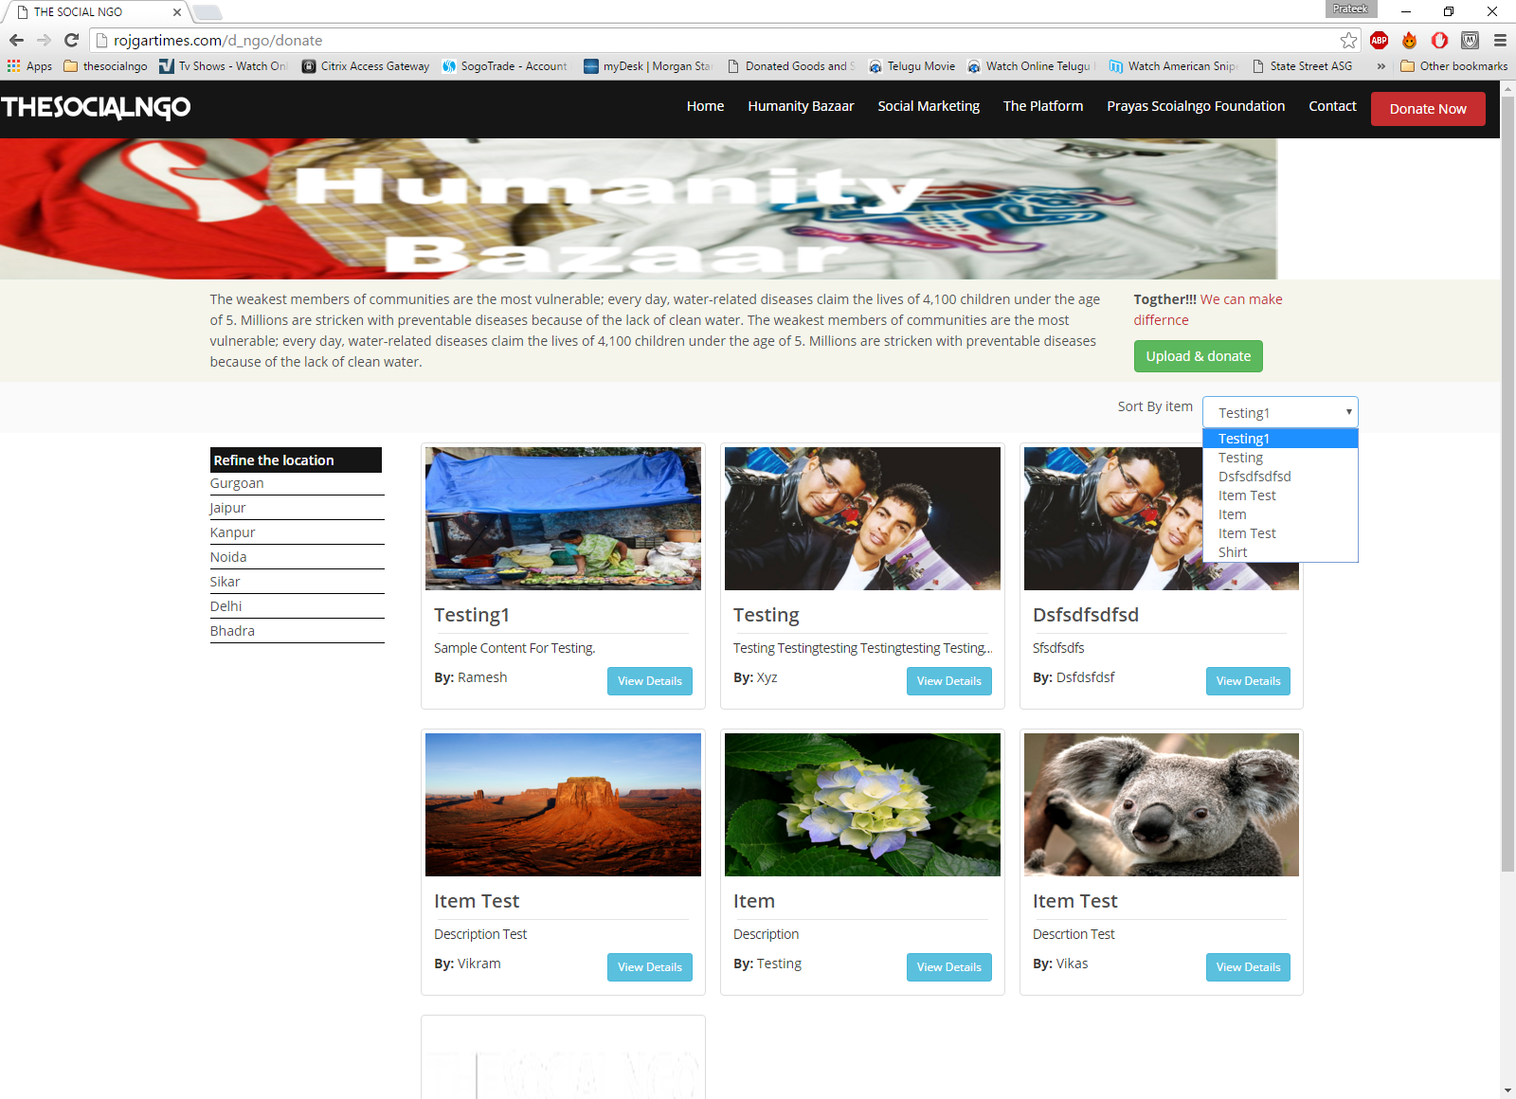

1. Upload and donate
   1. Remove Note: 80G is in process

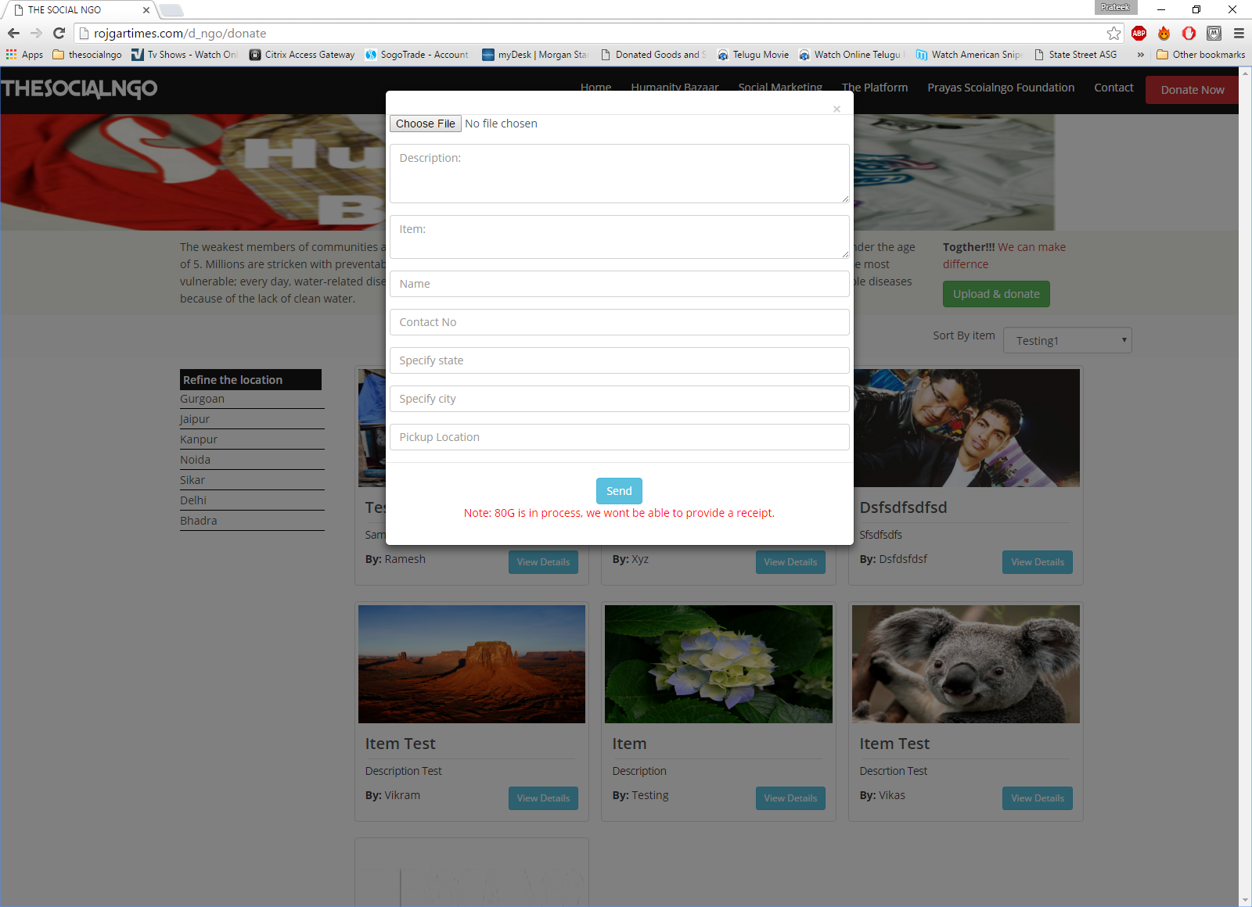

1. Social Marketing

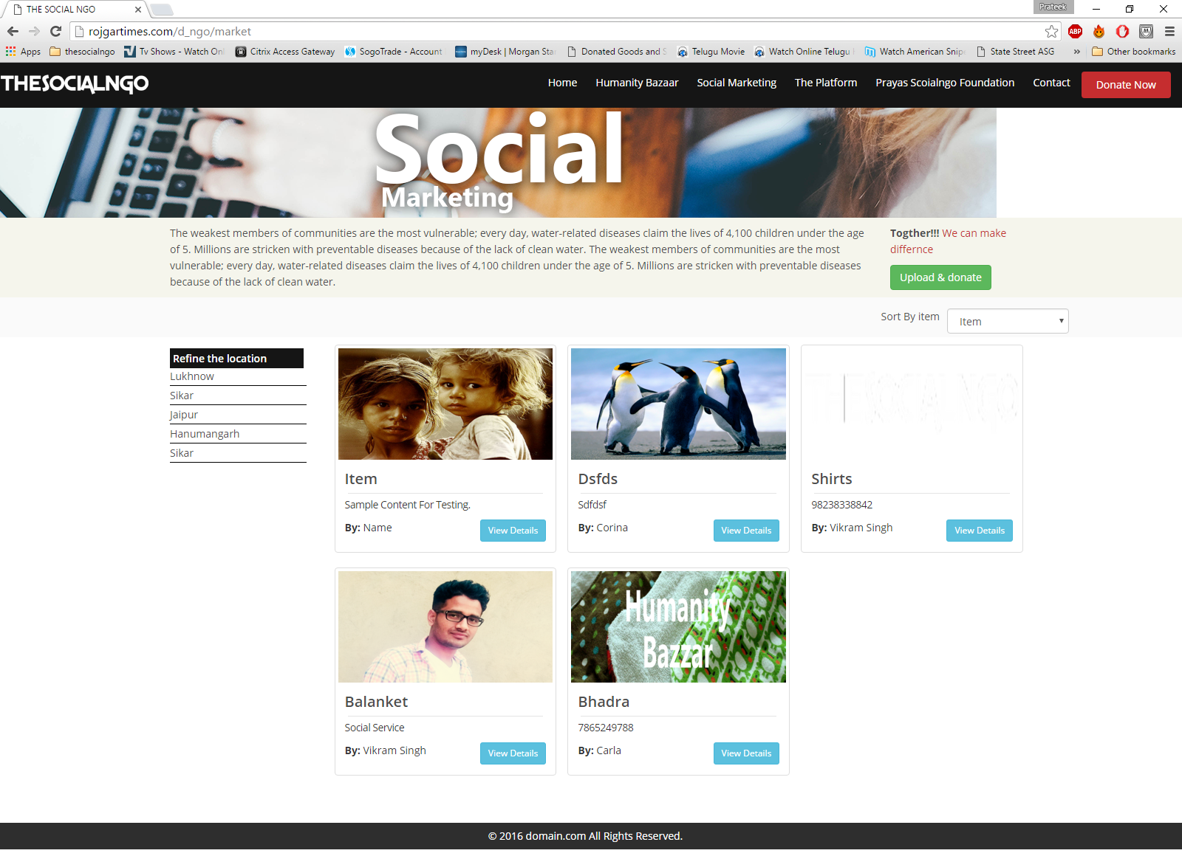

1. Banner – width is not of full length
2. Banner change – please see attached
3. Refine by location - Change to ascending order alphabetically



1. Sort by Item - ascending order alphabetically



1. Upload and **Market**
2. Remove pickup location