AI LAB MANUAL 03
EVIDENCE FILE
Muhammad Obaidullah (24l-0509)

Question 1
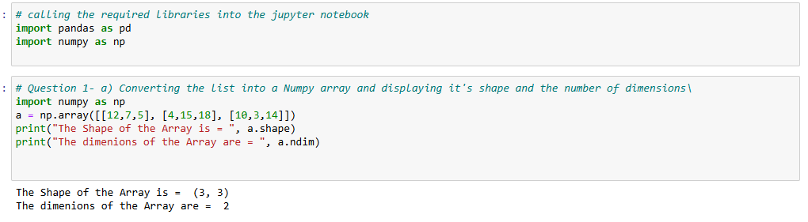
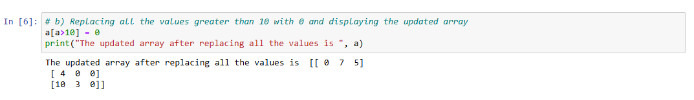
Question 2
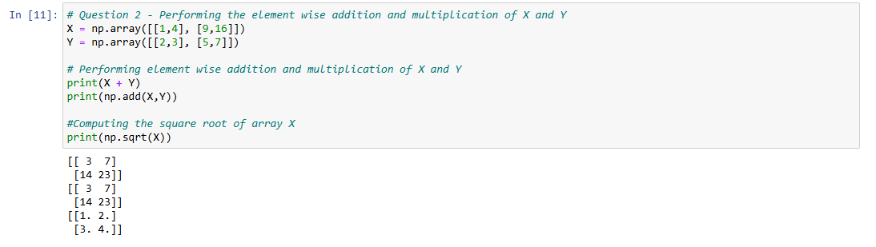
Question 3
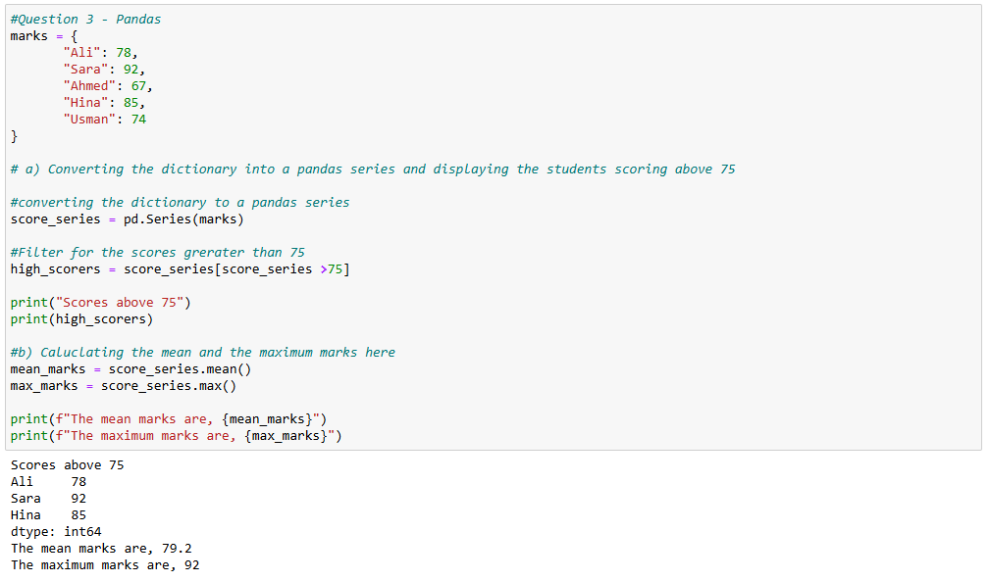

Question 4
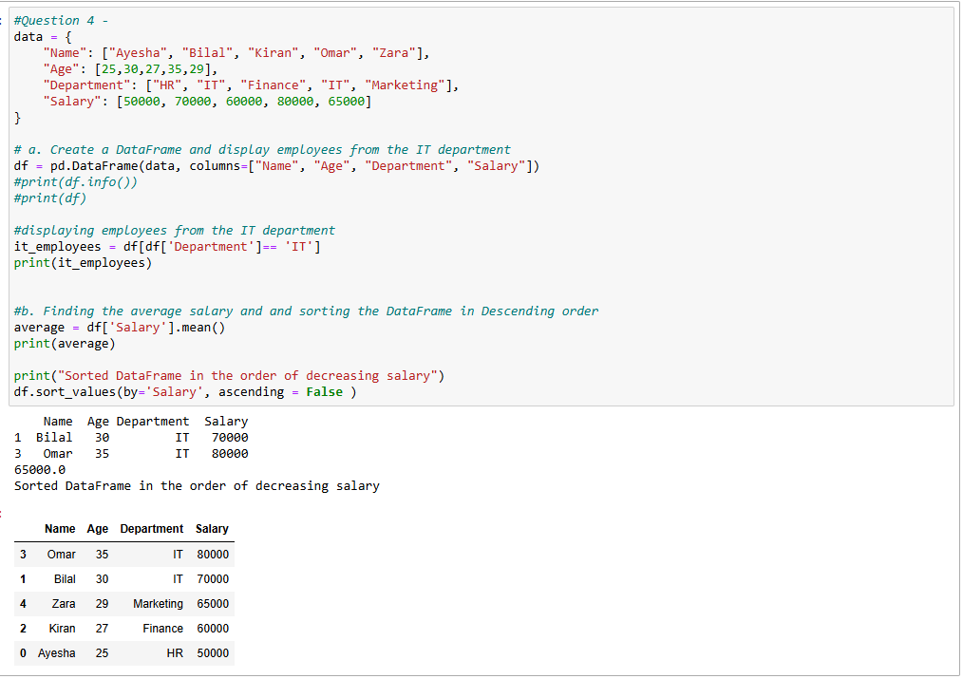

Question 5
